Manufacturing Design and Technology
acma5002
Edwards, Anneliese
2024

Task 1

Abstract
The focus of the project is to redesign a robotic gripper in order to improve the manufacturability of the component to allow it to be mass produced. Key objectives include, identifying the end users wants and needs, identifying new manufacturing methods and applying the changes to the design of the gripper.

The gripper solution currently being produced consists of 10 main components as well as 16 bolts in addition to nuts and washers. This would take considerable time to produce due to the complexity of the assembly and the requirement for the component to be assembled manually. For the component to be mass produced at a rate of 1000 components per week several design and manufacturing changes should be considered to reduce the production time and assembly time of the component to allow for increased scale production.
Concept Design Appraisal
Robot grippers will have expected customers across a diverse range of industries and applications. Due to the versatility of the uses of robotics, grippers will be used in a variety of sectors, including.
- Manufacturing and assembly – robotic grippers will be used in the handling of parts as well as in component assembly. This will be the case across several industries including, Automotive and electronics.
- Warehouse and Logistics – In warehouse and logistics, robotic grippers are commonly used for picking, packing, and sorting orders within the E-Commerce field. Robots are also commonly used in distribution centres for material handling, palletizing and depalletizing.
- Food and Beverage – Robot grippers are used within food manufacturing for the handling of raw and processed food products. They can also be used in the packaging process for moving, packing, and sorting items.
- Pharmaceutical – Robot grippers are commonly used in the medical field for the precise handling of medication and medical components. They are also used for assembling delicate and complex medical devices, where precise assembly is required.
(Tai, 2016)

A QFD or Quality Function Deployment, is a structured methodology used in product development, to translate customer requirements into specific engineering and technical specifications. A benefit of using QFDs is that they are centred around customer needs and wants and therefore prioritizes these aspects, allowing them to be implemented into the design and development of the product. This ensures the final product closely aligns with the customers ‘wants’, ensuring higher customer satisfaction. By ensuring a product better meets the needs and wants of a customer, this can create a competitive advantage in the market, this is also supported by the fact that during the development of the product, cost is considered during the QFD process and is minimized, similarly key features are prioritized to ensure the product is desirable to the end user.
(Duong, 2020)
A QFD was produced for the robotic gripper, this was based around needs and wants of the end user, this is expected to predominantly be those in industry, such as manufacturing and assembly, it is also possible that robotic grippers could be supplied to educational fields such as engineering schools or universities. As well as functional aspects, such as gripper strength, range of motion and material strength, other factors such as aesthetics will need to be considered to ensure the product is desirable to the end user.
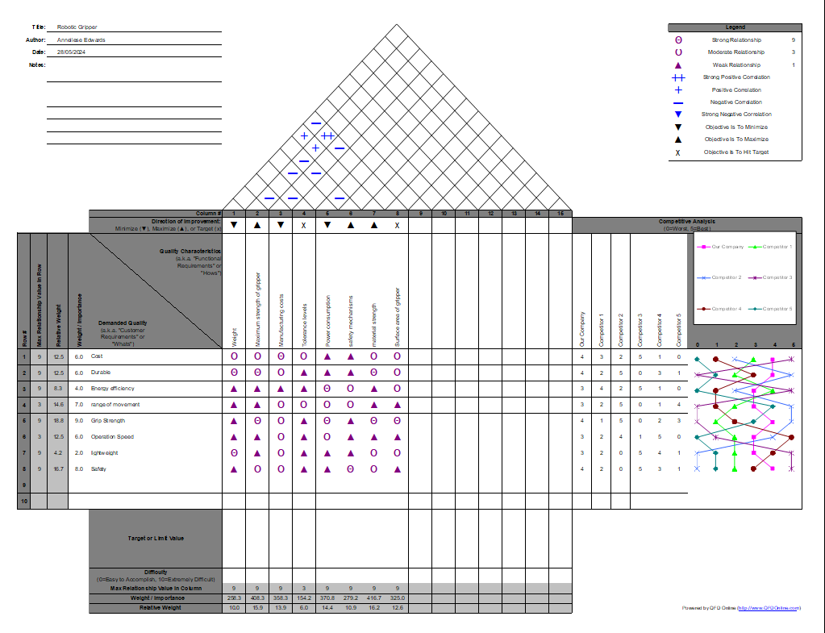
The QFD highlighted several key design features which will need to be considered during the re design of the product, this includes the cost, which will be a considerable factor for the end user. Other key aspects include, the gripper area and gripper strength, this will determine the end applications of the component, as the strength will determine what tasks the gripper will be able to complete, for example, a gripper which can only carry 1kg, will likely not be used in warehouse and packing, as it will only be able to move limited items and a stronger robotic arm would be required to move larger items. Therefore, the strength of the gripper will be one of the key factors the end user will consider when choosing a robotic gripper in the market, this was therefore considered when developing the QFD.
(Baohua, 2020)

(Morgan, 2024)
A design specification was then produced for a robotic gripper. A design specification is a document used to outline the requirements, characteristics, and constraints of a product to ensure is meets the needs and wants of the end user. It is used as a guideline during the development process to ensure the product meets the requirements of the specification. (Geddes, 2022)
The design specification for the robotic gripper included the functional requirements of the product, which includes, the maximum weight the gripper should hold, the grip force as well as the width or size of the item the gripper can hold. These aspects will be imperative when the end customer is deciding on a robotic gripper as this will be one of the main constraints. Other aspects included in the design specification include, the accuracy requirements of the product, the sensor feedback, and the materials it could be made from in order to meet customer requirements and expectations.
Design requirement
The aim of the redesign of the robot gripper is to solve any issues related to converting the manufacturing process from small scale production to large scale production, or approximately 1000 units a week. In order to achieve this, the robotic gripper should be simplified in order to allow them to be produced in larger quantities.
Constraints
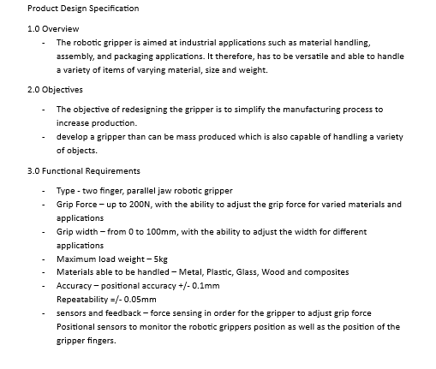
The main constraint of the redesign is the capabilities of the robotic gripper. Several changes can be made; however, they need to ensure the gripper is still functional and is able to meet the requirements of the end user. It is important to ensure customer satisfaction in the product, therefore, as well as the product being functional, it should be reasonably priced to ensure it will be desirable in the market.

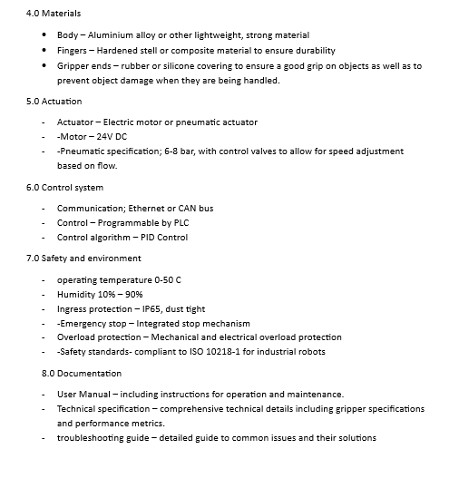
(Reqi Systems Engineering Articles, 2023)

After developing a QFD and a design specification for the robotic gripper it was determined that the durability of the product was important, therefore it should be made of lightweight, durable materials, such as aluminium. The grippers could also be lined with rubber to prevent damage to the surface of objects when they are being handled, this will also enhance the grip of the robotic arm on the object.
Another important aspect to consider is the cost of producing the product, therefore, other manufacturing processes should be considered to reduce the cost of the materials of the product as well as the cost of assembling the product.
FMEA
An FMEA or Failure Mode and Effect Analysis is used in order to anticipate issues that may happen during the design and manufacture of a product, what this will affect and what can be done in order to prevent the errors from occurring, including actions that can be implemented to prevent them. An FMEA also works using an RPN rating so that the company can prioritise which errors could be the most problematic and which need to be resolved first. (ASQ.org, n.d.)
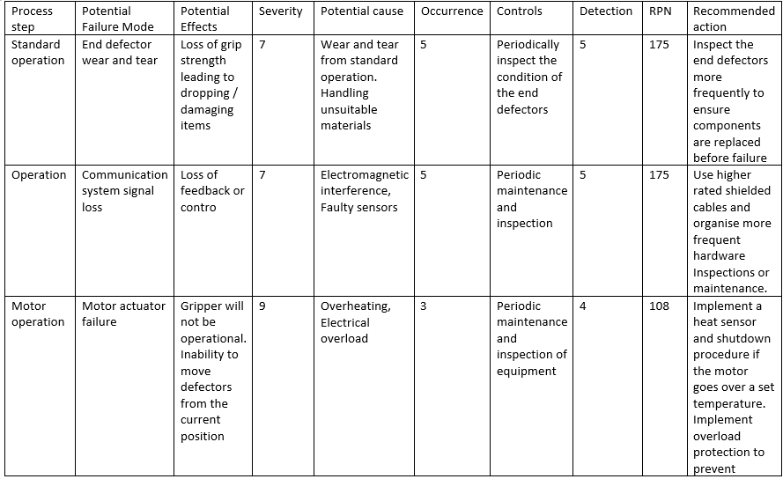
This is calculated using a severity rating of 1-10, with 10 being the most severe and an occurrence value of 1-10 with 10 being the most likely to occur and a detection value of 1-10, with 10 being most likely to be detected before occurrence. These are all multiplied together to achieve the RPN value. The higher the value, the riskier the error and therefore, the more important it is that a resolution is found and put in place before the error occurs.
(Penn, 2022)

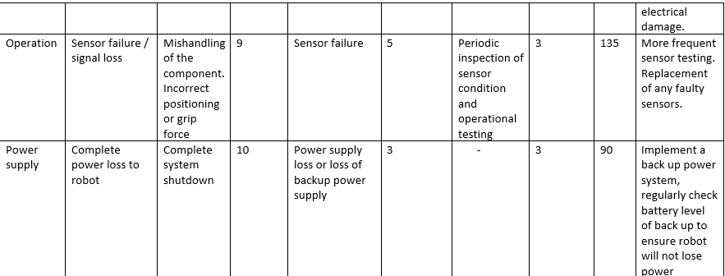
SCAMPER
SCAMPER is a problem-solving technique used in design and manufacturing in order to generate ideas or to improve existing designs and ideas. The acronym stands for.
- Substitute – the process of replacing a part of the product, process or problem with something else.
- Combine – the process of merging 2 or more parts ideas or processes to produce something new.
- Adapt – the process of modifying a product or process in order to serve a new or different purpose.
- Modify – the process of changing the size or shape of a product to enhance or reduce features.
- Put to another use – the process of identifying a way the product can be used that is different from the originally intended use.
- Eliminate – the process of removing elements from a part or process that are unnecessary in order to simplify the product or process.
- Rearrange – the process of changing the layout or sequence of a process or parts to improve efficiency.
(Dam, 2024)
By applying SCAMPER to a design process, it is possible for new ideas to be identified by looking at a product or process from all angles, encouraging ‘outside the box’ thinking, allowing for innovative ideas. By applying the SCAMPER ideals to the redesign of the robotic gripper, I found that the best way to simplify the design is to combine elements in order to eliminate components and assembly steps in the manufacturing process.
Proposed design changes
A design change that could be used to reduce the number of components and assembly required in the product is combining parts 1 and 3 in the assembly. This would reduce the parts required in the assembly by 2 and would remove 4 screws from the assembly process. These parts could be combined by changing the manufacturing process of this component. Suitable processes include injection moulding or forms of 3D printing such as Selective laser sintering. This would allow for the components in the end defector to be produced in one component compared to the current 2, due to the shape of the end defector it would not be possible to combine them using typical methods such as machining due to the complex shape.
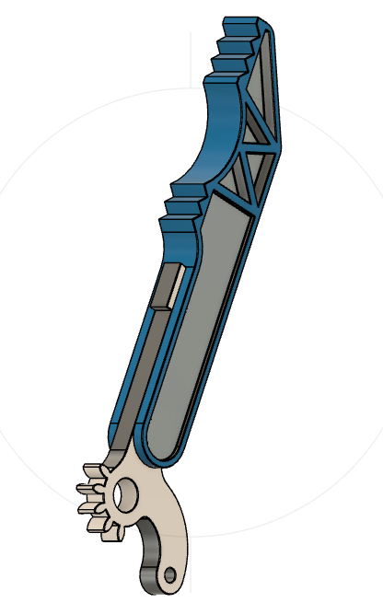
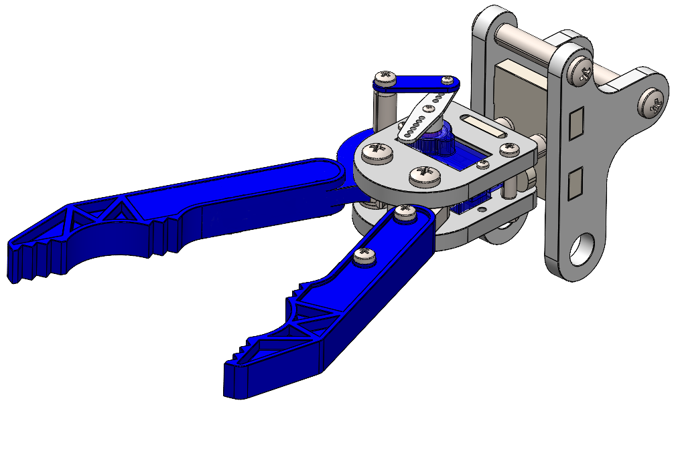
After design change
Before Design change

Injection moulding is the process of injecting molten material into a hollow mould in order to produce a specific shape. The initial set up cost of injection moulding can be expensive due to the requirement to produce a new, custom-made mould for the process. However, once the initial set up is complete, it is an efficient and low-cost manufacturing process as is require little manual intervention. It is also ideal for high volume production as the process of injecting material into the mould and cooling is quick compared to other manufacturing processes. Another benefit of this method of production is that even in high quantities each product will be identical, therefore will ensure consistency throughout the manufacturing process. (Engineering Product Design, 2023)
Selective laser sintering could also be used to produce the component in metal, such as aluminium or plastic. Selective laser sintering or SLS is a powder-based additive manufacturing technology which uses a laser to fuse metal powder together, material is then stacked, layer by layer in order to form a printed part. (Gan, 2020) a benefit of using SLS is it can produce complex parts which are not able to be produced by typical manufacturing processes such as machining. It is also able to produce highly durable components and is typically used to produce components in the automotive and aerospace industry. SLS can save time and reduce costs when producing lower scale product runs, as there is no material loss to supports, or expensive tooling or moulds to be produced. A negative of using this from of production is that printing will take longer than other manufacturing processes such as injection moulding. (3D Systems, n.d.)
Another change I would recommend for the robotic gripper is combining parts 6 (2) and 7. This would reduce the overall component count by 2. This change could also be completed by producing the component as one whole piece. Similarly, to the first change, this could be done by producing the component with injection moulding or SLS.
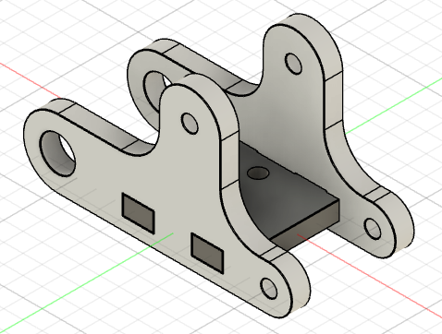
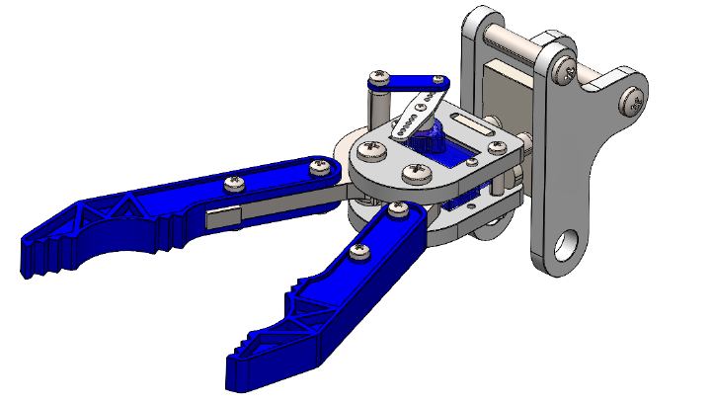

Since SLS is a more time-consuming process, I would recommend that the company utilises injection moulding for both components. The longer the production time for each part, the less cost effective they will be. As the aim of the design change is to increase the volume of production, the speed in which each part can be produced will be one of the main factors to consider. However, as well as reducing time, it is important that the overall cost of producing each unit is kept to a minimum to maximise company profits, this will be one of the main drivers for the company. The mould making process for starting injection moulding can be costly, however this cost will be made back by the increased rate of production over time. Therefore, I would consider injection moulding the most cost and time effective method in order to increase the production of the components for the robotic gripper. (Gold, 2023)
It’s also important to consider the environmental impact of the manufacturing process as well as the life cycle of the product. Environmental impacts need to be considered throughout the manufacturing process, delivery of the component as well as when it is thrown away. A low impact material should be chosen, be this recycled, biodegradable or renewable. (Binns, 2019)
Another important way to ensure the process is environmentally friendly is to limit the amount of waste produced. In the case of injection moulding, there should be very little waste produced. However, due to the material choice being infinitely recyclable, any waste material will be able to be reused in the process. (Binns, 2019)
In industry it is expected that robotic components will have a long product life cycle, as customers will be reluctant to pay for expensive components frequently. Therefore, the component needs to be durable to ensure it lasts for a reasonable amount of time. Aluminium is highly durable and can withstand extreme weather conditions and temperatures. Another benefit is that aluminium doesn’t rust or corrode. It should therefore have a long product life. Then at the end of its life as a robotic gripper component, the aluminium can then be melted down and reused infinitely, making it a great material for environmentally conscious manufacturers. (The Aluminium Association , n.d.)
Conclusion
In conclusion I would consider the changes made to the robotic gripper successful, the changes made will reduce the manufacturing and assembly time of the gripper as well as reducing the overall cost of the materials. These changes should be beneficial for the company when transitioning the gripper to mass production. The materials choses are also environmentally friendly and can easily be recycled, therefore, improving the environmental impact of the manufacturing process.

Task 2

Abstract
The focus of the project is to identify a component for redesign, which will be suitable for manufacture by additive manufacturing. Suitable manufacturing processes were identified and analyzed to ensure the right manufacturing process for the application. Limitations and issues were identified for the process, such as porosity and inhomogeneity and shrinkage and mitigated to ensure the product would be suitable for the application. Once key design factors were considered, such as material shrinkage, the final design was created using AutoCAD.
The component chosen for design is a wafer stand for use in semiconductor process testing. For certain aspects of testing during wafer processing development, it is necessary for the wafer to be placed on a surface or held for inspection or tests such as adhesion tests which must be done manually. In this situation the wafers are currently placed on a flat metal surface, which can lead to the wafer sliding along the surface, leading to damage or to the wafer falling from the surface. In order to prevent this, I suggest the design of a wafer stand in order to securely hold the wafer while tests are completed. The current design is a flat aluminium plate with nothing to secure the wafer. Changes that could be made to improve this design is to add upright pieces around the edge of the wafer in order to prevent it from sliding. Another design improvement that could be made is feet to raise the platform up, in order to allow a vacuum wand underneath of the holder to accurately place the wafer on the surface. Another change that could be made, is producing a stand for each size of silicon wafer (75mm, 150mm, 200mm and 300mm) to ensure that the wafer is secure on the stand.
There are several design processes that could be utilised when developing a new product, this includes hand drawings, physical modelling or generative design. The most environmentally friendly of which being generative design. This is because changes can be made to the design without any material wastage. The design can be made, tested and changed all within the design software. This will lead to less cost associated with the design process for aspects such as material use and tooling. As it leads to less material wastage, as design changes can be made in the CAD software, it minimises the waste created by the project, minimizing the environmental impact of the project. (Davi, 2021)
There are several wafer sizes and thicknesses dependant on the process, therefore, several stands would be required. In order to produce several sizes / prototypes, it would be recommended to use 3D printing, which will allow for several stands to be produced without having to make dedicated tooling for each size. Minimizing the cost of the project, as well as the environmental impact. If a mould would have to be made for every size of wafer, this would lead to significant tooling costs as well as the possibility of several design iterations, leading to significant wastage of time and resources. (Xometry , 2022)

There are several forms of 3D printing available that would be suitable in the application of prototyping the wafer stand. These include.
- Stereolithography (SLA)
Stereolithography is a 3D printing technology that works by building layers of Polymerised liquid photopolymer resin, each later is set using a UV laser. SLA can produce components with highly detailed features with an excellent quality surface finish. In SLA the build plate moves down as each layer of the materials is deposited. (Lakkala, 2023)
- Fused Deposition Modelling (FDM)
Fused deposition modelling is a 3D printing technology that works by extruding a melted plastic onto a build plate, layer by layer, to create a component. The filament is extruded through a heated nozzle, allowing it to be melted as it is being deposited. The build plate moves down as each layer of filament is deposited. FDM uses a wide variety of filament materials, typically thermoplastics, for example, ABS, Nylon, TPU and PLA. However, other specialist filament materials are available, such as carbon fibre. (Penumakala, 2020) (Rajan, 2022)
A benefit of using stereolithography over Fused deposition modelling, it that photopolymer resin is biocompatible, making it suitable for a wide range of applications, including medical and dental implants or models. This is ideal for the wafer stand as a wide variety of gases and chemicals are used within the semiconductor industry, therefore, if any residues were on the surface of the wafer, it is possible they would react to other materials. It is also suitable for prototyping as it is capable to make detailed, complex components with a smooth finish. Therefore, making it ideal for high-quality one-off prototypes. However, a negative of this form of 3D printing is that it requires post curing once the deposition is finished, components will also need for the support structures to be removed. Support structures are required during deposition for structural stability and to prevent warping before the resin is cured. This adds on time and therefore, cost to the project. Another negative is that the material is not as strong as those used in other 3D printing methods, such as FDM. However, due to the fact silicon wafers weigh very little, the photopolymer resin will be sufficiently strong enough in this application. (Xometry, 2023)
I would choose STL over FDM for the wafer stand as it is able to produce a high-quality finish prototype with a smooth surface, due to the fact the film and profiles on wafers are so miniscule, when testing, the surface the wafer is placed on must be flat, therefore, using a prototyping method that gives the best quality surface finish would be sensible for this project. Another benefit to SLA producing a smoother surface finish is that it reduces the number of sites on the product where chemicals can penetrate the surface. (Protolabs , n.d.)
SLA resins also commonly produce components with a higher density and lower porosity that FDM prints. Porosity is the measure of a void in a product, it is measured as a ratio between the total volume of a product and the volume of pore. It can be characterised as an open structure within a material. Porosity in SLA can be caused by several factors, including, incomplete curing, therefore leaving partially cured areas of resin, creating micro-voids. As well as resin impurities caused by contaminants in the mixture. The layering process can also lead to porosity if there is poor adhesion between the layers. (Fernland, 2017)
Another benefit of using SLA, is that due to the fact the print is done in layers, the components tend to have more isotropic mechanical properties, meaning they typically have consistent strength across the x, y and z planes. However, the print is weakest in the Z plane as it is perpendicular to the layers of the print. The direction in which the laser melts and polymerises the resin, determines the directional properties of the material, it can therefore, effect the mechanical properties of the material. This is due to the difference in orientation of the polymer chains that are formed during the polymerisation process when the resin is set with the UV laser. This variation can be one of the causes of inhomogeneity in the material, this refers to a lack of uniformity throughout the material. Other causes of inhomogeneity in SLA prints are, variations in resin composition, this can be caused by contaminants or fillers, another cause is lack of or inconsistent adhesion between the resin layers in the print, Poor adhesion can cause mechanical weakness in the material. (Xometry, 2023) (3DSOURCED, 2024)
in SLA prints, porosity can be mitigated by ensuring high quality resins and used and are properly mixes and free of contaminants. Another method of preventing porosity is ensuring the component is completely cured by optimizing parameters such as laser intensity, exposure time and the thickness of each print layer. Post-process curing can also be completed to ensure all the part is sufficiently cured. Additional resin can also be added to porous areas post processing to seal in any voids in the component. (Radtech, 2023)
As well as preventing porosity in the print, it is important to allow for shrinkage of the material post polymerisation. As the liquid resin changes from a liquid to a solid, the volume of the material changes. In SLA, the part can shrink further when exposed to UV light post curing. This can lead to components being smaller than originally designed. Therefore, in order to prevent this, an allowance for shrinkage should be integrated into the design of a product. Ideally, a product should be prototyped to measure the exact amount of shrinkage that will occur. The design can then be upscaled in CAD to allow for the reduction in volume. Shrinkage can also be estimated using simulation software. Polymerised resin shrinks on average ~3.3 – 4.3%, therefore, an average of approximately ~3.8% shrinkage can be used to up size the CAD model to ensure it is the correct dimensions post shrinkage. (J, 2017)
In stereolithography, residual stress comes from the polymerisation process, this is due to the different rate of curing and shrinkage in the material. There are several factors which can affect the residual stress in the material including, layer thickness, UV intensity, exposure time and post curing conditions. In order to minimise residual stress in the material, stress relief measures such as post curing and thermal annealing can be used. Another method to reduce stress is to deposit thinner layers and reduce UV intensity. (Fraunhofer, n.d.) (Zhao, 2023)

FMEA
An FMEA or Failure Mode and Effect Analysis is used in order to anticipate issues that may happen during the design and manufacture of a product, what this will affect and what can be done in order to prevent the errors from occurring, including actions that can be implemented to prevent them. An FMEA also works using an RPN rating so that the company can prioritise which errors could be the most problematic and which need to be resolved first. (ASQ.org, n.d.)
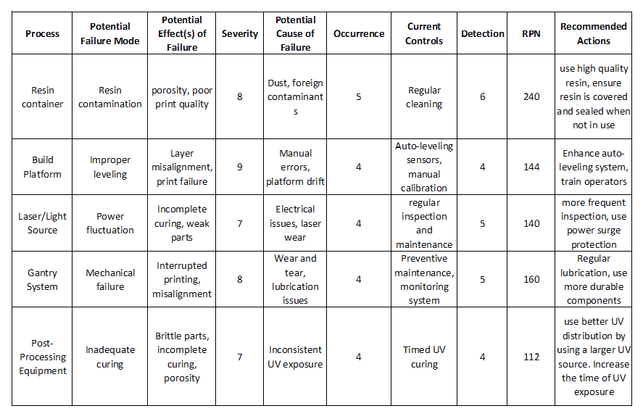
This is calculated using a severity rating of 1-10, with 10 being the most severe and an occurrence value of 1-10 with 10 being the most likely to occur and a detection value of 1-10, with 10 being most likely to be detected before occurrence. These are all multiplied together to achieve the RPN value. The higher the value, the riskier the error and therefore, the more important it is that a resolution is found and put in place before the error occurs.

(Penn, 2022)

Quality Function Deployment
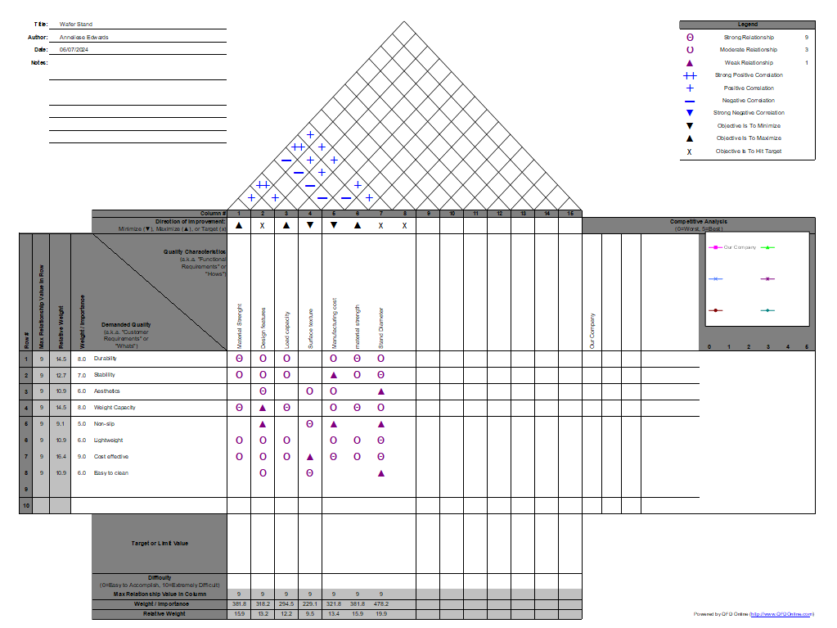
A QFD or Quality Function Deployment, is a structured methodology used in product development, to translate customer requirements into specific engineering and technical specifications. A benefit of using QFDs is that they are centred around customer needs and wants and therefore prioritizes these aspects, allowing them to be implemented into the design and development of the product. This ensures the final product closely aligns with the customers ‘wants’, ensuring higher customer satisfaction. By ensuring a product better meets the needs and wants of a customer, this can create a competitive advantage in the market, this is also supported by the fact that during the development of the product, cost is considered during the QFD process and is minimized, similarly key features are prioritized to ensure the product is desirable to the end user. (Duong, 2020) (Morgan, 2024)

After completing a QFD based upon the design of the wafer stand, it was determined that the most important aspects of the design are cost, lightweight and durable. The main points found in the Failure mode analysis are preventing contamination of the resin preprocessing by ensuring it is in a clean, sealed container to prevent any debris or other contaminants from entering the resin. Another recommended point is to regularly inspect and maintain the 3d printing equipment to prevent any misalignment in the prints or interrupted printing.
The selected manufacturing process to produce the wafer stand is stereolithography (SLA) using Photopolymer resin. This material, if correctly cured, is very durable, with good isotropic mechanical properties.
It’s also important to consider the environmental impact of the manufacturing process as well as the life cycle of the product. Environmental impacts need to be considered throughout the manufacturing process, delivery of the component as well as when it is thrown away. A low impact material should be chosen, if possible, be this recycled, biodegradable or renewable. (Binns, 2019)
Resin is typically not an environmentally friendly material as it is not biodegradable and can be toxic it its liquid form. Therefore, if using resins, the company should be ethically conscious and ensure no resin is disposed of incorrectly to ensure the health of people, animals and plant life nearby. Resin should also be handled and stored correctly, is a cool dry place, in a sealed contained, stored upright. To ensure the quality of the resin and to ensure there are no accidental leaks. (Stanfield, 2024)
In order to produce CAD models of the wafer stand, Autodesk Fusion was used. Autodesk is a computer aided design (CAD) software that can be used in order to produce and edit 3D models. This software can also be used for design analysis and optimisation. (Ahmad, 2022)
In order to produce the CAD model of the wafer stand, an outline was firstly produced I the Autodesk software. When deciding upon the size of the wafer stand, it was decided to firstly produce a 200mm stand, as this is the most used size. However, as well as allowing 200mm diameter for the wafer itself, 2mm was allowed around the outside to prevent cracking the wafer when placing it on the stand. As well as this a ~3.8% shrinkage allowance was added to ensure the stand was the correct size post print. This took the diameter from centre to the inside edge of the uprights to 211.75mm.
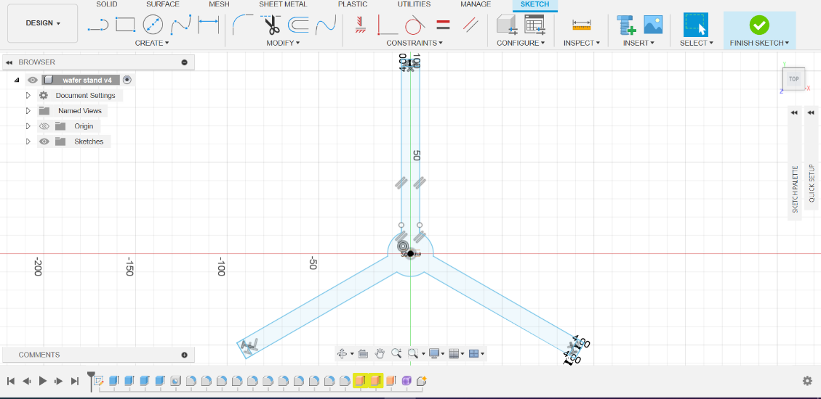

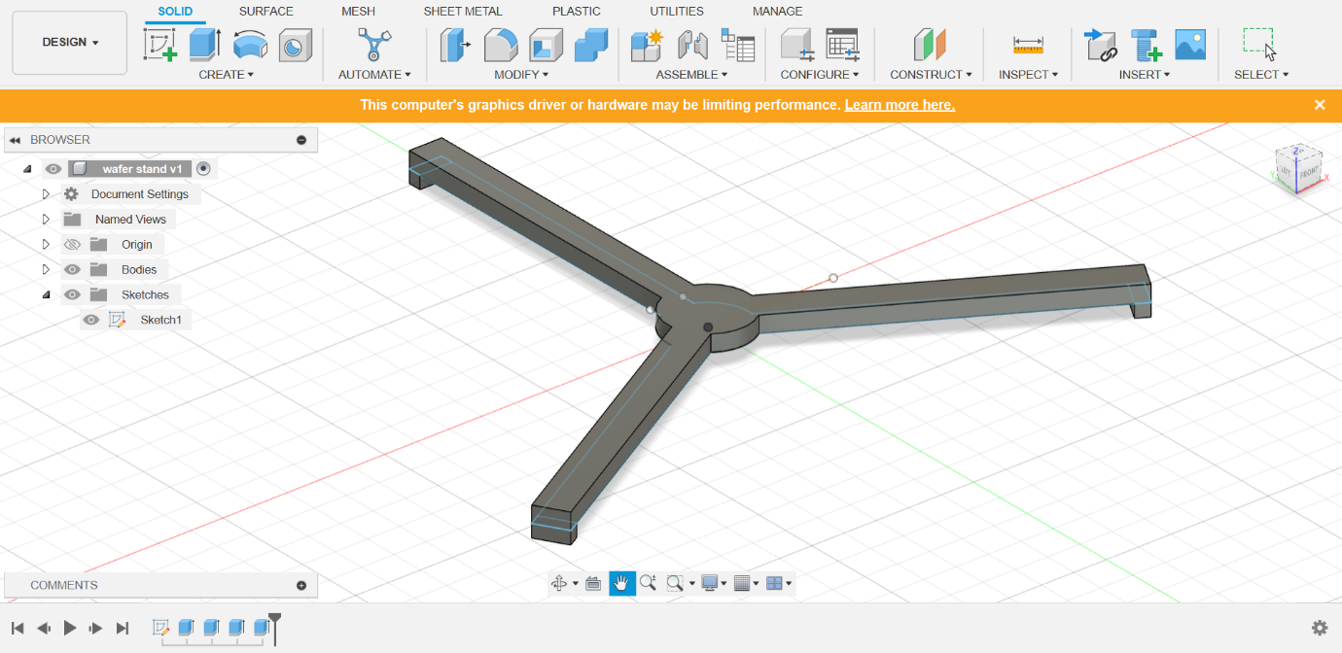
After this, 4mm high extrusions were added to each of the 3 sections, this will prevent the wafer from sliding off the wafer stand.

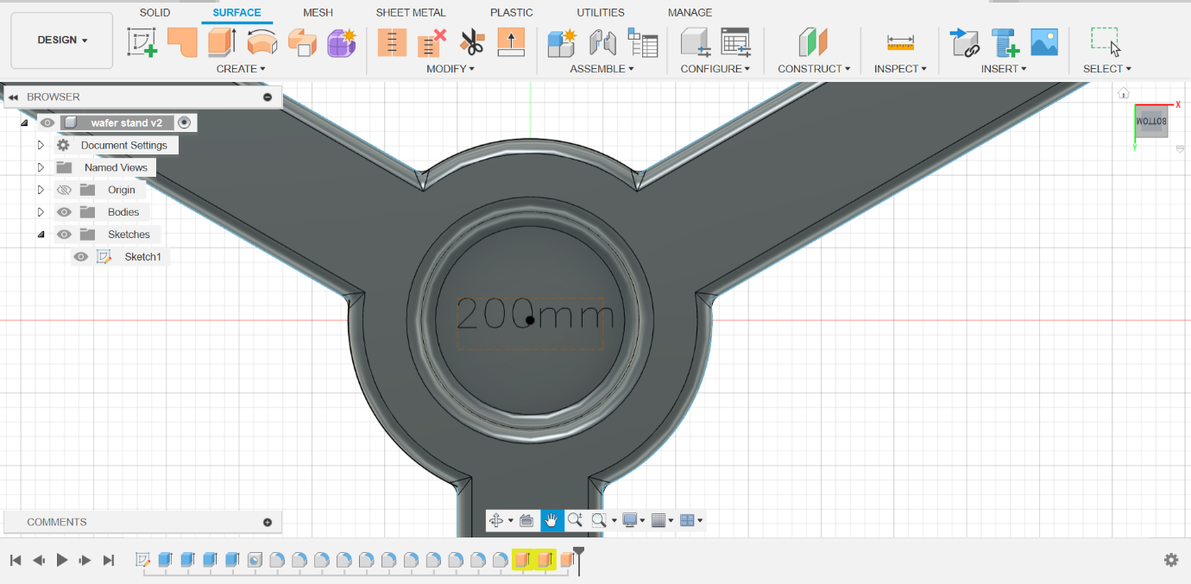
A depressed centre was then added in order to allow a size label to be added without it affecting the surface the wafer will be sat on. This was added to the centre of the stand and recessed into the material 2mm to ensure it will not interfere with any measurements when the stand is in use. Finally, in the centre of the wafer stand 200mm was added to indicate what size wafer the stand would be used for. Each edge of the stand also had 1mm fillets applied to them to ensure there were no sharp edges on the stand that could scratch, crack or damage the silicon wafers.
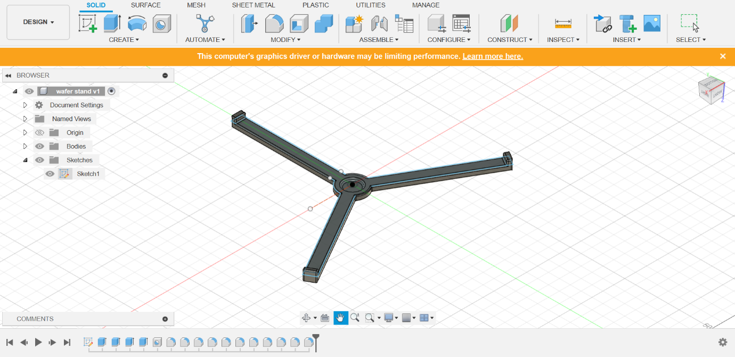

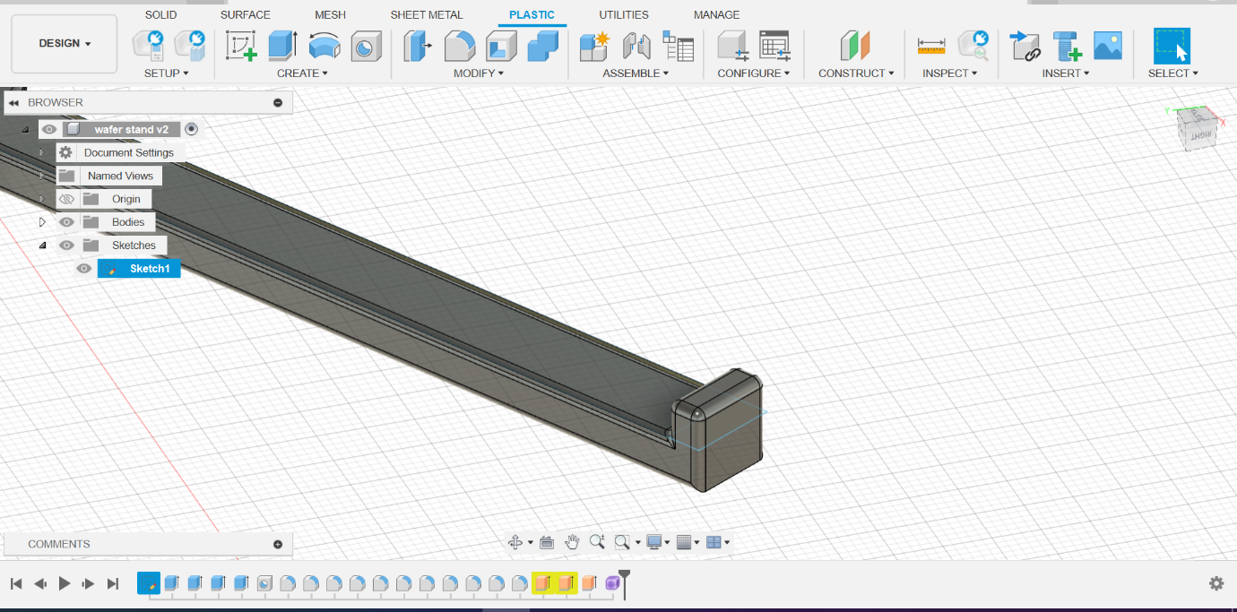
Conclusion
I would consider the design project a success, as the product is suitable for the end application as a wafer stand. The design is simply, yet functional and can easily be changed in CAD to adjust to different wafer sizes. The resin should be sufficiently durable for the application and due to the fact, it is nonreactive, it will be safe for use within the anticipated environment. By implementing the found mitigating factors it will also be possible to prevent shrinkage and porosity in the model.

References
3D Systems, n.d. Selective laser sintering. [Online]
Available at: https://www.3dsystems.com/selective-laser-sintering
[Accessed 31 05 2024].
3DSOURCED, 2024. Stereolithography. [Online]
Available at: https://www.3dsourced.com/guides/stereolithography-sla/#:~:text=Stereolithography%203D%20printing%20uses%20photo-polymerization%20to%20produce%203D,as%20Vat%20Polymerization%20%E2%80%94%20via%20a%20light%20source.
[Accessed 06 07 2024].
Ahmad, K., 2022. What is autocad and what is it used for?. [Online]
Available at: https://www.makeuseof.com/what-is-autocad/
[Accessed 06 07 2024].
ASQ.org, n.d. FMEA. [Online]
Available at: https://asq.org/quality-resources/fmea
[Accessed 03 07 2024].
Baohua, Z., 2020. State-of-the-art robotic grippers, grasping and control strategies, as well as their applications in agricultural robots: A review. Computers and electronics in agriculture , Volume 177.
[Accessed 31 05 2024]
Binns, R., 2019. The importance of good design to reduce environmetal impact. [Online]
Available at: https://blog.rrc.co.uk/2019/12/23/the-importance-of-good-design-to-reduce-environmental-impact/
Dam, R. F., 2024. Scamper: How to Use the Best Ideation Methods. [Online]
Available at: https://www.interaction-design.org/literature/article/learn-how-to-use-the-best-ideation-methods-scamper
[Accessed 31 05 2024]
Davi, J., 2021. 5 Advantages of Manual Drafting and CAD Drafting. [Online]
Available at: https://www.urcadservices.com/post/2018/01/04/five-advantages-of-manual-drafting-and-cad-drafting
[Accessed 03 07 2024]
Duong, T., 2020. A novel model based on similarity measure and quality function deployment on interval neutrosophic sets for evaluation and selection market segments. Journal of Intelligent & Fuzzy Systems, 38(4).
[Accessed 03 07 2024]
Engineering Product Design, 2023. Injection Moulding. [Online]
Available at: https://engineeringproductdesign.com/knowledge-base/injection-moulding/
[Accessed 03 07 2024]
Fernland, G., 2017. Causes and remedies for porosity in composite manufacturing. IOP Conference Series Materials Science and Engineering , 139(1).
[Accessed 06 07 2024]
Fraunhofer, n.d. SimGen - Residual stresses and warpage in stereolithography. [Online]
Available at: https://www.additiv.fraunhofer.de/en/research/software-simulation/simgen---residual-stresses-and-warpage-in-stereolithography.html#:~:text=Resins%20for%20stereolithography%20shrink%20during%20polymerization.%20During%20the,and%20the%20shape%20of%20the%20c
[Accessed 06 07 2024].
Gan, X., 2020. Powder quality and electrical conductivity of selective laser sintered polymer composite components. oodhead Publishing Series in Composites Science and Engineering, Volume 2, pp. 149-185.
Geddes, D., 2022. What is a product design specification. [Online]
Available at: https://technicalfoamservices.co.uk/blog/what-is-a-product-design-specification-pds/
[Accessed 01 06 2024]
Gold, K., 2023. Cost Drivers in Manufacturing: Managing Complex Interactivity. [Online]
Available at: https://www.apriori.com/blog/cost-drivers-in-manufacturing-managing-complex-interactivity/#:~:text=Direct%20and%20Variable%20Costs%201%20Material%20cost%20drivers,considered%20and%20classified%20as%20a%20critical%20variable%20cost.
[Accessed 03 06 2024]
J, D. R., 2017. Analytical methods for the measurement of polymerization kinetics and stresses of dental resin-based composites: A review. Dental research journal , 07(06), p. 2024.
[Accessed 06 07 2024]
Lakkala, P., 2023. Additive manufacturing technologies with emphasis on stereolithography 3D printing in pharmaceutical and medical applications: A review. International Journal of Pharmaceutics, Volume 5.
[Accessed 06 07 2024]
Morgan, R., 2024. Manufacturing and design technology lecture , s.l.: s.n.
Penn, R., 2022. Risk priority number. [Online]
[Accessed 10 06 2024]
Available at: https://www.isixsigma.com/dictionary/risk-priority-number-rpn/
Penumakala, P. K., 2020. A critical review on the fused deposition modeling of thermoplastic polymer composites. Composites Part B: Engineering, Volume 201.
[Accessed 03 07 2024]
Protolabs , n.d. What’s the right resin for SLA? 3D printing materials compared. [Online]
Available at: https://www.hubs.com/knowledge-base/sla-3d-printing-materials-compared/
[Accessed 06 07 2024].
Radtech, 2023. Safe handling of 3D Printing resins. [Online]
Available at: https://radtech.org/safe-handling-of-3d-printing-resins/
[Accessed 06 07 2024].
Rajan, K., 2022. Fused deposition modeling: process, materials, parameters, properties, and applications. The international Journal of Advanced Manufacturing Technology , 120(1).
[Accessed 03 07 2024]
Reqi Systems Engineering Articles, 2023. The ultimate product design specification. [Online]
Available at: https://reqi.io/articles/the-ultimate-product-design-specification
[Accessed 10 06 2024]
Stanfield, S., 2024. Is Resin Eco Friendly? 9 Important Facts You Should Know. [Online]
Available at: https://citizensustainable.com/resin-eco-friendly/
[Accessed 06 07 2024].
Tai, K., 2016. State of the Art Robotic Grippers and Applications. Robotics , 5(2).
[Accessed 03 06 2024]
The Aluminium Association , n.d. Sustainability. [Online]
Available at: https://www.aluminum.org/sustainability
[Accessed 03 06 2024].
Xometry , 2022. 3D printing vs injeciton moulding. [Online]
Available at: https://www.xometry.com/resources/3d-printing/3d-printing-vs-plastic-injection-molding/
[Accessed 01 07 2024]
Xometry, 2023. SLA vs. FDM: Differences and Comparison. [Online]
Available at: https://www.xometry.com/resources/3d-printing/sla-vs-fdm-3d-printing/#:~:text=SLA%20produces%20parts%20with%20excellent%20surface%20finish%20and,whereas%20FDM%20produces%20functional%20parts%20with%20high%20strength.
[Accessed 01 07 2024]
Zhao, L., 2023. Regulation of residual stress in stereolithography printing of ZrO2 ceramics. Ceramics international, 07(06), p. 2024.
[Accessed 06 07 2024]

