MANAGING PROJECTS IN THE ORGANISATION
Title: Managing projects in the organisation
Module Code: BMSK 5004.
Student Number:1709425.
Lecturer Name: Joy Botu
Student Name: Theresa king Addo-Danquah.
Contents

Introduction 3
Part 1: Evaluation of project management tools and techniques 3
Critical evaluation of different tools and techniques 3
Project management tools 3
Project management Techniques 4
Appropriate project technique and tools for the selected project 8
Part 2: Planning for project 9
Starting the project 9
Initiation of the project 11
Directing the project 13
Managing Product Delivery 15
Managing stage boundary 15
Project Closing 15
Part 3: Evaluation of own ability to manage project 16
Conclusion 19
References 20

Introduction
Aldi, UK has to consider a project several times to implement any strategic planning. As a solution of this problem, Aldi are considering rescheduling their outlets which have been considered in this report. However, achievement of proper success from the strategic planning is highly dependent on the proper and efficient management of their project. Thus, knowledge about project management tools and techniques are crucial for the management of business. Aldi UK is the third largest UK based retailer in the world which is facing a challenge in controlling their operational cost in recent periods.

Part 1: Evaluation of project management tools and techniques

Critical evaluation of different tools and techniques
In general, saying project management is the combination of different tasks that are performed to achieve a target strategic goal. However, following same techniques and tools for all projects will definitely not provide a good and proper outcome. Every project has separate attributes and criteria that require different types of tools and techniques application to ensure the successful outcome to the business management. Based on this requirement, several project tools and techniques have been discovered over times. Some common tools and techniques have been discussed and evaluated below,

Project management tools
Gantt chart: It is the most popular project management tool that represent the project tasks along with their duration. The most important advantage of this tool is that the tool provides visual presentation of project tasks and related duration. Thus, it becomes easier for project leader to track the timescales for the project. The tool also helps to make effective management of resources in the project. Finally, it helps to track project progress status as well. The most noticeable disadvantage of the tool is that it requires too much effort and skills to prepare and update the Gantt chart properly. Another problem is that all tasks cannot be viewed in a single Gantt chart (Sinclair, 2016).
Logic Network: another popular tool of project management is the logic network. It shows the sequential flows of project tasks over the lifetime of the project. The most important advantage that leads people to use the logic network is that it helps to track the milestone and the critical path of the project process. But the major problem of this tool is that it takes time and cost highly. Along with this, lack of proper skills and efficiency may create severe error and thus can mislead the project team causing great loss (Chafets, 2018).
Work Breakdown Structure (WBS): Work Breakdown structure is the most detail tool that provides detail list of project tasks and activities. This structure generally provides a hierarchy structure of project tasks from which a project leader can classify the tasks in different stages. Thus project leader can have a clear view about the sequence of project tasks and the tool also provide a good hand in planning the project management process. The major advantage of this tool is that it reduces the risk of missing any important task of project. It also helps to identify the key milestones of the project. It covers the whole view of the project process. Thus, it helps to determine the accurate project cost and schedule. The major disadvantage of work breakdown structure is that it can become outdated easily and update of the structure is sometimes tiresome and complex. Another disadvantage is that work breakdown structure does not provide any specific order of task and thus it can be deceiving for the viewer (Indelicato, 2017).

Project management Techniques
Agile Technique : Agile technique of project management is mainly popular among such business who wants to develop or improve any software related strategic decision i.e. the project is undertaken for software development. Thus, any business related to IT operation or any business that wants incorporate or improve the IT related operation in its business prefers agile technique for managing the project. Agile uses sprint method in its process. Sprint method refers short term development process in each stage of project. In its sprint approach, agile suggests sprint following for each stage of project. Each sprint repeats some steps and forward to other stage only when the prior stage provides the successful outcome.
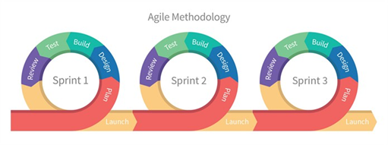
Figure 1 Agile Technique, Source: (Deeprose, 2012)
The advantage of using the technique is that it ensures the proper and effective satisfaction of customers because it ensures a continuous improvement environment. It also focusses highly on people’s reaction rather than the process only. Close monitoring is ensured in this technique thus project team can be on track to get the expected outcome properly. Due to its sprint nature in process, it helps to make continuous adaption with the change of requirement. It attracts continuous focus on technical expertise, excellence and the good designing of process and product (Jindal, 2016).
The major disadvantage of this technique is that the process frequently misses the proper documentation that leads them to improper management many times and thus the outcome become less effective. As it is customer focused technique, the process becomes highly complex and ineffective when the customers cannot become sure about their requirement clearly. Many opinions can make the process a failure.
Waterfall technique: The oldest technique followed for project management is the waterfall technique. As it is the oldest technique, it is the simplest technique as well. Generally, the technique suggests to follow a sequence of activities in the project management. Linear sequential model is followed in this technique. Business generally uses this technique for machinery engineering, existing software improvement or development, new product development etc. Here all the stages are followed sequentially and no two stages can be done simultaneously.
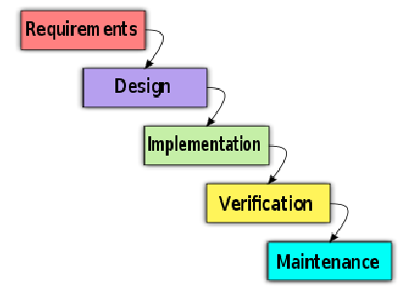
Figure 2 Waterfall Technique. Source: (Heerkens, 2015)
The advantage of waterfall technique is that it ensures proper control and leadership during the project process. It is the simplest technique thus team members face no problem in understanding the method. As one stage is completed at a time and no simultaneous completion of two or more stages is allowed, monitoring and controlling becomes easier and thus the performance and progress of project remains on track. The technique provides best result when the project is small.
The disadvantage of the technique is that the technique is highly rigid and allows very small room for modification and update. If any error occurs in any stage, the technique requires to start over the whole process from the very beginning which is time consuming and costly. Such condition sometimes let the project to lose its effectiveness. When the project is large, the technique cannot provide proper and effective result. It allows little room for change and thus the technique is unable to incorporate the change in requirement emerged suddenly. Thus it includes high level of risk and uncertainty (Dalcher, 2015).
Scrum Technique: this technique can be defined as the modern and expanded version of agile technique. It is one of the modern technique for project management. In present day, scrum technique is used in such project which is highly knowledge and expertise focused. Scrum technique can be used separately in any project or it can be added with other project management technique to reduce the shortcoming of that project management technique. Scrum technique is highly used in such project which is very complex in process.
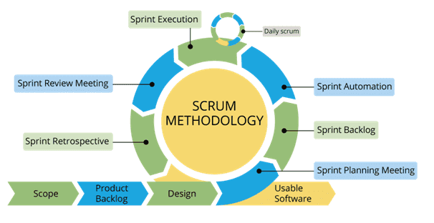
Figure 3 Scrum Technique. Source: (Aktins, 2012)
The most important advantage of scrum methodology is that it ensures the effective use of resources like time and cost. It provides better result when the project is fast moving and complex in process. Through this technique, the project team gets clear view about their performance and thus managing and leading them becomes easier in this technique. Another major advantage of this technique is that the technique ensures the incorporation of feedback from key partners like customers, shareholders etc.
The major disadvantage of this technique is that the technique creates major ambiguity as it lacks of definite end date for each task. If the collaboration of project team is less and all the members are not committed and cooperative, the technique will face failure in managing a project. Lack of skills and expertise can be a big obstacle in the way of achieving the success for the technique (Mokhonko and Pimonova, 2019).
Prince 2 Technique: It is a complex but process based project management technique where each stage of the technique incorporates number of tasks that are done based on some principles. When the project is long and ongoing in nature, Prince2 technique is used. This technique provides better result in controlled environment in a business.
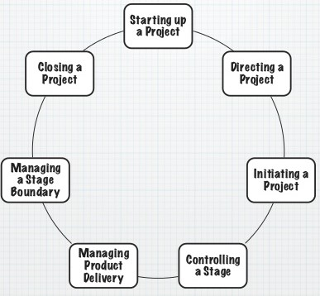
Figure 4 Prince2 Technique. Source: (Vinall, 2016)
The advantage of the technique is that it helps the project team to be focused on project aim and objectives. It helps the project leader to review the project planning and progress regularly and thus helps to keep the process updated. The technique is flexible enough to let the project leader to update or modify the project planning any time incorporating the change of requirement. It focuses on better communication between the stakeholders and the management and thus helps to derive the successful outcome.
The major disadvantage of the technique is that the technique is complex and cost consuming. Another problem is that the technique requires high efficiency and skills to provide a successful outcome (Vaníčková, 2017).

Appropriate project technique and tools for the selected project
Rescheduling of outlets of Aldi UK is a long and on-going project. Along with this the project focuses on market requirement and cost benefit result to make decision about rescheduling. Again, the project needs to be implemented within strong monitoring and controlling management environment to ensure the successful outcome of the project. Every stage of the project requires review to ensure that proper steps are being taken. Considering all these factors, it can be said that Prince2 Technique will be appropriate for the project.
During the project planning, Work break down structure and Gantt chart will be used as the project tool to represent the task planning and scheduling.

Part 2: Planning for project
Project Topic: Rescheduling of Outlets
Company Name: Aldi UK

Starting the project
Project background: UK economy is being threatened due to BREXIT issue over last few years. Economists have already forecasted that the economy is going to face around 6% downturn within next few years. Responding to the political turmoil due to this, inflation of UK is also increasing. In 2018, inflation has increased to 2.44% while it was 2.13% in 2017. Increase of inflation is decreasing the purchasing power of customers shrinking the opportunity of profitability (Ons.gov.uk, 2019). Decrease of purchasing power put more pressure on the business who operates business on low price strategy like Aldi UK. Cost of doing business is increasing every year in UK. Only in 2018, it has increased by 5%. All the established business is struggling to manage their cost. Operating cost of Aldi has increase by around 18% in 2018 (Aldi.co.uk, 2019). The situation may worsen up if the economy takes downturn as forecasted. Thus, it is high time for Aldi UK to focus on reducing the operating cost. Recent survey has proved that small outlets of Aldi UK is making loss due to high operational cost where large outlets are developing economies of scale to cope with increase of cost. Considering all these factors, project of rescheduling the outlet has been undertaken.
Project aim and objectives: The aim of the project is to reduce cost through rescheduling of outlets of Aldi UK. The objectives of the project required to achieve the aim are as follows,
- To find out the most loss producing small outlets
- To conduct analysis to see whether there is potentiality of such outlets to recover the loss and incurs profit
- To list up the outlets that have no such good potentiality.
- To closed down such faulty outlets
- To open up large outlets in lucrative marketplaces
- To find out and implement continuous monitoring and improvement process in business operation
Expected outcome: After implementation, it is expected that Aldi UK will be able to enjoy the following outcomes,
- Operating cost is expected to decrease by 25%
- Sales will boost up by 20%
- Profit is expected to increase by around 30%
- Economies of scales will be achieved by around 12%
- Market share is expected to increase by 3% in UK market
- Global market presence will remain unchanged and no impact will be made due to shut down of outlets as new large outlets will be opened.
Project scope: The project will cover the rescheduling of outlets established in London and North West at first. Based on the successful outcomes from this project, further planning and project will be undertaken for other regions. Thus, other regions except London and North West in UK and other countries will not be covered under this project. The major deliverables of the project are the cost reduction which is anticipated to affect the profitability of the company more adversely in near future and the project is expected to provide the solution for this problem effectively. Though there is some limitations for the project like time and cost, it is expected that the project will provide best possible favorable outcome.
Project Assumption: However, there are some assumptions that have been considered during preparing the project plan. The assumptions are as follows,
- The project team has the required skills to perform their task properly.
- Project leader has effective and enough leadership quality and skills to lead the team properly and successfully.
- Sources will be available for collecting the resources and project team will have the ability to collect the resources properly.
- Project team will have access to all resource sources

Initiation of the project
Stakeholder planning: Stakeholders are the main concern for any project as they will be affected mainly due to the outcome of the project (Pinto, 2019). Stakeholder planning for the project is as follows,
Stakeholders | Managing way
Project Sponsor  (managing Director) | Periodical update and progress report will be provided about the project. Project sponsor will be kept updated first for any change in project planning and action.
Shareholders (limited) | As Aldi UK. Is still a private limited business, it has very limited numbers of shareholders. They will also be kept updated about the action, planning and progress report through quarterly and yearly report.
Customers | As customers are ones who will be affected first by the project, they will be informed about the initiation and completion of the project, new address of outlets etc. through mass advertising, media and social sites.
Creditors | Creditors will be informed periodically and proper and timely repayment of their fund and interest will be ensured.
Suppliers | Suppliers will be ensured and informed that their business relation and dealings will not be affected. Only the supply point will be changed.

Timescales & Cost planning: The project will be initiated from 1 August, 2019 and it is expected total 5 months will be required to complete the project. The expected ending date of the project is 31 December, 2019.
However, total expected cost of the project is £60.7mn. The details of the project cost is as follows,
Cost Items | Amount (£ mn)
Outlet survey | 1.5
Market research | 0.5
Resources | 15.6
Project team development | 0.8
Shut down of small faulty outlets | 6.4
Opening of new large retail outlets | 10.2
Other project related cost | 25.7
Total | 60.7

Resource Planning: Financing of the project will be arranged from two sources. They are bank loan and capital from Managing Director (a prime shareholder of Aldi UK). 50% of financing will be collected from HSBC Holdings Bank and Lloyds Bank. 50% of capital will be provided by the managing director of Aldi UK.
Not much furniture will be required to buy as most of them will be sourced from the outlets that will be shut down. However, some furniture and computers etc. that will be required more, will be bought from the selected suppliers. Some it resources will be required to establish internal network and these will be arranged from renowned IT resource providers in UK.
The major human resource of the project is the project team. The members of the team will be sourced from the inside of the company. Along with them some third parties will be added to the project team like IT establishing expert, lease contractor etc.
Quality Planning: The quality and success of the project will be measured based on the following standards,
- Completion of the project within target time scales
- Completion of the project within target budget
- Efficient use of resources
- Completion of project with stipulated resources
- Successful and quality achievement of expected outcomes from project.

Directing the project
Project management Structure: Project management structure actually reflects the management bodies of whole project team that will be followed strictly as leadership and followers stage during the project implementation. However, a structure will be followed as well during the project implementation for Aldi UK. It also represents the management hierarchy structure for project management under Aldi UK. The structure is as follows,
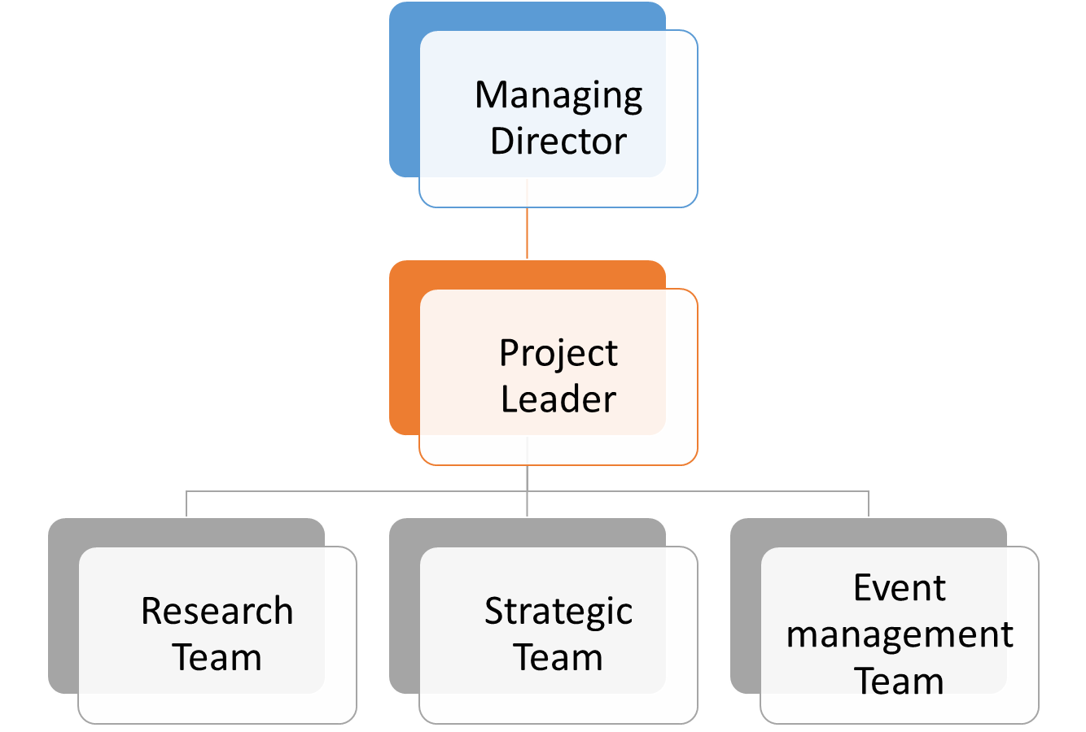
Figure 5 Project management Structure. Source: Author
Communication Planning: Project leader will maintain the liaison communication between managing director and other project teams. Project leader provides periodical update report to managing director and conveys the order of managing director to other sub project teams. All the sub project team will be supervised by a supervisor and they make liaison communication between his or her team and the project leader. They keep project leader updated about the performance progress of their team and conveys the direction of project leader to project team members. Project team members will communicate to supervisor and in special cases they will be able to communicate with project leader directly as well.
Key staff planning: Key staff planning includes the definition of responsibilities for key staffs in the project. Key staff planning for the project is as follows,
Key Staffs | Key Responsibilities
Project leader | - Direct the supervisor about the action according to planning  - Review the performance of project team periodically  - Monitoring and direction about controlling action  - Keep the managing director updated about progress of project
Supervisors | - Leading the project team actively according to direction of project leader  - Monitoring and supervising the performance  - Keeping project leader updated about the progress and performance of team  - Implement the controlling action
Project Team members | - Perform the actions according to the direction  - Keeping active contact with supervisors about requirement

Risk management planning: Risk is the integral part of any project planning and prior planning to manage the probable risk is crucial (Meredith, 2019). Risk register for the project to show the risk planning is as follows,
Risk | Score | Management planning
Financial risk | 42 | - Collection of updated and proper information  - Practical and effective budget planning  - Strict monitoring on budget
Resource Risk | 56 | - Practical and updated information requirement  - Proper management and strong monitoring assurance
Quality Risk | 48 | - Proper implementation of plan  - Periodic review  - Proper monitoring and controlling

Managing Product Delivery
Work Breakdown Structure (WBS): It refers the details of major tasks that have to be performed in the project. Here tasks are presented classifying them under major headings. The work breakdown structure (WBS) for the project is as follows,
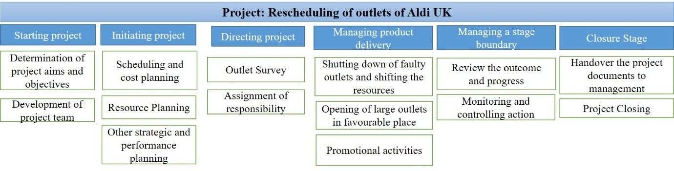
Figure 6 WBS. Source: Author
Gantt chart represents the tasks of the project along with their duration allocated to complete the task in the project. It will help the project leader to track the timescale of the project.
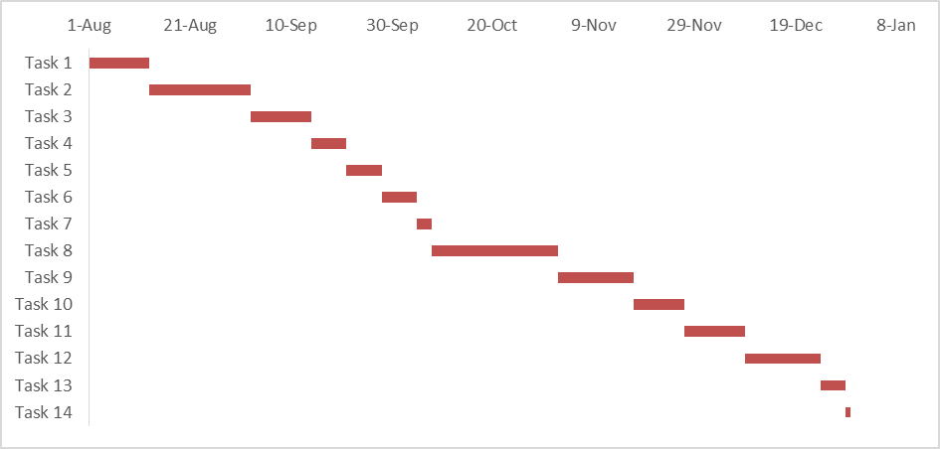
Figure 7 Gantt chart. Source: Author

Managing stage boundary
Project leader will review the progress and performance at this stage. If the outcome is on track as expected, current planning will be continued. If any deficiency is found, controlling action will be taken to bring the performance on track. Current planning will be modified accordingly.

Project Closing
After outcome is derived as expected, the documentation of outcome will be handed over to the management of Aldi UK. Project team members will be reassigned to their old responsibilities in which they were assigned before the project and project will be closed down.

Part 3: Evaluation of own ability to manage project
Measuring own ability by oneself is always a difficult task as it may lead to over-estimation or underestimation of one’s ability. However, rating own ability will be easier if it can be judged through the eye of other person. It means one can identify his or her ability or inability if other person who knows the person well, can list up the strength and weakness for that person. Again, taking one person’s opinion will not be able to provide proper direction. It is important to take opinion of several persons and those persons have to be known well. If the other person does not know me well, there opinion about me will not be proper. Moreover, the persons have to be such who have worked with me for different tasks. The reason is that if the person does not work with me or does not see me working closely, his or her opinion about my ability will not be proper. Thus, three conditions have to be focused crucially while selecting persons from whom I can take opinion regarding me. These three conditions are-
- Opinion have to be taken from several persons, depending on one person’s opinion will not be appropriate.
- The selected persons have to be such who know me very well
- The selected persons have worked with me or observed me working closely.
Focusing on these conditions, I have selected 20 persons from my classmates who can provide me opinion about my ability to manage project. I prepared a question paper where open end questions have been added regarding my strength and weakness and then I provided the question papers to these 20 classmates of mine. However, to ensure avoiding biases, I didn’t put any name options in the question paper and let them answer without my presence. However, examining all the responses, I have listed up some of my strengths and weakness that have been mentioned by more than 30% respondents. Based on their opinion, my strength to manage a project are,
- I am punctual and prefer to follow the plan strictly.
- I have a positive attitude towards mistakes and always prefer to take the learning from mistakes.
- I am extrovert and can maintain a good relationship with other.
- I have a good network maintenance and communication skill.
- I prefer to see factors from the very deep root and always try to find better solution for the problems.
- I believe in democratically decision-making process.
My weaknesses emphasized by them are,
- I become so concerned to one problem that sometimes unnecessary and lead me to wastage of time.
- I still have many lacking in my knowledge background and skills.
- Sometimes I become too much optimistic about outcome that sometimes lead me to the wrong direction.
However, strengths are good points of measuring my ability in managing the project but I still have some crucial weakness. Without overcoming these weaknesses, it will be difficult for me to manage a project successfully in future. So it is high time for me to take care of my weaknesses. I need to take steps to overcome these weaknesses so that I can be able to manage project in better way in future in my career life. Based on this I have prepared my self-development plan. The planning is as follows,
Aim | Activity Plan | Target Completion time
To enhance the control ability about my focus and determination | I want to participate in different project programs where I will be able to work with experienced and skilled project leader. I want to hold such position there where I will be able to practical decision-making process. Moreover, I will be able to work in team. Real life project management and making active performance there taking the responsibilities will help me to decide where to focus and which to avoid so that time is not wasted. | I have a plan to participate in such at least 4 project programme within next 4 years.
To improve the knowledge level regarding project management | To ensure this, I want to participate in different project management related courses. Along with this, I also want to participate in professional degrees related to project management like PMP etc. I hope participation of such courses and professional degrees will help to improve my knowledge background regarding project management. Such courses require to complete different assignment and work paper on small-scale real-life project. Thus, it will help me to know how to use the academic knowledge in real life project. | I have a plan to complete such 1 course and 1 professional degree related to project management within next 5 years.
To enhance the expertise level regarding project management. | To ensure this, I want to participate in different workshops, training programs etc. related to project management tasks and activities. Such workshop learning and training programs will help to increase my expertise and skills level regarding project management activities. | I want to participate in at least 4 workshops and 5 training programs related to project management within next 1.5 years.

Conclusion
After completion of the report, it can be said that knowledge about different aspects of project management tools and techniques are highly crucial for ensuring a successful project management planning. Appropriate use of such tools and techniques ensures the effective management of a project and thus successful achievement of goal will be ensured.

References

Aktins, A. (2012). The project. North Sydney, N.S.W.: Random House Australia.
Aldi.co.uk. (2019). ALDI UK | Homepage. [online] Available at: https://www.aldi.co.uk/ [Accessed 18 Jul. 2019].
Chafets, Z. (2018). The project. New York: Warner Books.
Dalcher, D. (2015). Going Beyond The Waterfall: Managing Scope Effectively Across the Project Life Cycle. Project Management Journal, 46(1), pp.e2-e2.
Deeprose, D. (2012). Project management. Oxford, U.K.: Capstone Pub.
Heerkens, G. (2015). Project management. [Place of publication not identified]: Mcgraw-Hill Education.
Indelicato, G. (2017). Book Review: Project Portfolio Management: Tools and Techniques. Project Management Journal, 38(2), pp.101-101.
Jindal, D. (2016). Review of Agile Project Development Technique. International Journal Of Engineering And Computer Science.
Mokhonko, G. and Pimonova, K. (2019). SCRUM METHODOLOGY IN PROJECT MANAGEMENT ON PHARMACEUTICAL ENTERPRISES. Economy and Society, (20).
Ons.gov.uk. (2019). Consumer price inflation, UK - Office for National Statistics. [online] Available at: https://www.ons.gov.uk/economy/inflationandpriceindices/bulletins/consumerpriceinflation/june2019 [Accessed 18 Jul. 2019].
Pinto, J. (2019). Project Management. Harlow, United Kingdom: Pearson Education Limited.
Sinclair, A. (2016). The Project. London: Faber and Faber.
Vaníčková, R. (2017). Application of PRINCE2 Project Management Methodology. Studia Commercialia Bratislavensia, 10(38), pp.227-238.
Vinall, G. (2016). The project. Scripture Union.

