Danielle Sophie Calo
Evidence Based Practice
CIPD: 89415482

Report Wordcount: (3532)
The report outlines an overview on how people practitioners can use Evidence Based Practice within an organisation. The different topics aim to provide an overview on how effective decision making can be used.
1.1
CIPD (2024) confirms that people professionals are faced with challenges around making effective decisions in the workplace. Evidenced based practice supports the individual to make better-informed decisions by using reliable sources and not taking shortcuts. The CIPD Profession Map (CIPD,2024) outlines the following core values, knowledge and up to date knowledge.
There are three values of the Profession Map:
Principles led – going beyond policy and process to do what is right – taking a personal approach to understand how the individual is feeling and how it will impact them, by listening to their concerns.
Evidence-based – using a range of credible evidence and expertise to make better decisions, that have the desired impact (CIPD, 2024).
Outcomes Driven – focusing on work which creates value for people and organisations
Oxford Review (2023) outlines that to make effective decision making, the information used needs to be well- researched and well evidenced.
Within this are four sources of evidence for EBP:
1 – Research/scientific evidence – Peer reviewed research / scientific literature. In an organisation like the NHS during the candidate screening process there is anonymity with sourcing and selecting candidates
2 – Work Based Research (Trial and error testing) – undertaking a pilot with staff within an organisation to improve a process. This could include data, facts and figures from the organisation.
3. Feedback from organisation and customers/clients/stakeholders – developing internal tools and taking feedback from stakeholder groups/on 1:1 basis from colleagues. This is often done within organisations to learn how we can improve staff experience on processes, or to improve organisational culture.
4. Practitioner experience and expertise – use the professional experience and judgement of colleagues who are trained within this area.
People Practitioners are able to use the 6A’s when collating evidence to ensure that they are able to draw on reasonable conclusion and that it remains unbiased in making decisions CIPD (2024)
The 6 A’s are outlines as follows: Asking, Acquiring, Appraising, Aggregating, Applying and Assessing
A people practitioner is able to use the values of the profession map in conjunction with the 6A’s to help support effective decisions in the workplace. Large organisations have to consider not just the staff but also its stakeholders and the impact it will have. For example, if there is a change in policy in procedure it’s important to understand the deeper impact on all parties. Asking for and assessing feedback received could help support a decision on resolving a complaint. When making decisions on amending a policy or procedure all aspects need to be considered before an outcome is reached (CIPD,2023)
People Management (2023) provides an insight on whether Evidence Based practice is relevant for People practice. It highlights key facts that are relevant to any large organisation and as one example in particular this could be relevant to assessing wellbeing in the workplace. This is to ensure that members of staff are at their best when at work and know where to go for support.

1.2
Pestle is an example of an environmental analysis tool that can be used to help challenges faced and provide opportunity for better understanding. Pestle’s acronym is Political, Economic, Social Technological, Legal and Environmental (CIPD, 2024a). The use of the PESTLE tool can provide the opportunity to help better performance and deliver on what is critical, by helping organisations make strategic decisions (CIPD, 2024a).

One disadvantage of the PESTLE tool, is it is seen as a simplistic tool to understand the wider business, however one advantage would be that it encourages organisations to spot opportunities and maximise them fully. A good example of where this will work well within a HR function could be to review how employees are rewarded.

Pestle Analysis (2019) provides an insight that within some organisations there are bonuses received based on performance, however it can be argued it might be more beneficial to reward staff based on results. Within the organisation I work within there is the opportunity for international nurse recruits to seek for a higher starting salary via higher salary protocol that if they can evidence sufficient experience within their field from previous employment, they can be based on the midpoint of a pay scale. This is outlined within their offer letter and can encourage the individual to feel valued to be recognised and paid fairly in line with their experience. Pestle will provide an insight as to what is consistent with other such organisations.

SWOT & Pestle Analysis (2024) highlights that there are there are disadvantages to using Pestle alone as the focus on external factors or reviewing salary as an example could be seen as not enough research for paying higher salary and this may also need to be repeated at a later stage for other candidates to ensure consistency.

The advantages of Pestle can provide the practitioner with awareness of how an organisation can remain cost effective and it can be used to potentially retain an grow the existing organisation (reference, date).

A method to understand and diagnose issues within an organisation could be through focus groups or surveys. ‘Organisation design is a fundamental part of what makes an organisation successful, and HR’s ability to influence the activities and shape the outcomes is a key element of being a people practitioner. (CIPD,2023)
Through undertaking surveys within an organisation this would help support understand where there is need for development. With increased fast paced environments, it can be difficult to keep up with what is required. Galbraith’s Star Model can be applied as it looks at Strategy, Structure, Processes, Rewards Systems, People and Policies, (Tools Hero, 2022)

There could also be competing factors such as reduction in budget, also staff headcount might change. In order for the business to operate effectively it would be an opportunity to seek feedback from employees and understand how improvements can be made i.e with innovation or with additional training required to undertake their role.

1.3

Critical Thinking within an organisation is key to help the way you reflect, develop ideas and consider the viewpoints of others (CIPD, 2019)
CIPD (2019) highlights that there are three components that are key as a critical thinking
1. Ability to critique – provide
2. Think about the way that they construct arguments and opinions
3. The ability to identify when others are using critical thinking

When applying critical thinking within the workplace it is important to remember that this is not to discount people’s perspective or feelings. It is seen as a tool to be used by people practitioners to help support and understand how a positive impact can be made.(Mindtools, 2024).
HR Magazine (2019) highlights that it’s important to take on-board all information available and listening to other viewpoints is key to improving the workplace. Critical thinking will avoid making bias decisions in the workplace and not just make decisions on group-think findings. Critical thinking can help people practitioners slow down their thinking, and give them confidence in their decisions, before implementing any changes (CIPD, 2019).
Within an organisation people practitioners need to consider that within the workplace that there is going to be a variance with perspective based on varying culture backgrounds. As an example within my workplace regular feedback is sought from international staff seeking feedback through ‘cultural conversations sessions.’ They are asked how we can improve the experience for candidates arriving from overseas. There are regular workshops and feedback surveys shared asking to rate their experience, and to highlight any particular challenges faced. It is difficult to critique without considering the feelings and opinions of those that have experienced a new environment.
Through adopting the three components of critical thinking it can help improve narrow mindedness, provide an open and honest culture and also provide support to line managers on how they can work together with their staff to create a positive working environment.

This doesn’t come without challenges as in some instances there is a difference with certain policies and procedures in place within our organisation. In order to provide opportunity for fairness and consistency it could be argued that providing clear expectation for staff in terms of policy and guidelines for the member of staff to follow also providing openness and willingness to accept feedback from employees within the workplace to improve on performance or issues.

1.4
CIPD (2024b) highlights that people practitioners are faced with making challenging decisions within the workplace and they need to understand what works to make it better.
Within an organisation it is important to consider that the information used to make decisions is consistent and considers different perspectives. It can be difficult to not fall to ‘group- think’ and the rationale needs to be well thought through. (Mindtools, 2022)
It is key for a people practitioner to consider that when making decisions that it is important to measure the impact on the individual within the workplace and how this will overall impact the organisations performance

Firstly Kepner & Tregoes Model (2023-2024) can add be used for a rationalised approach using the following method:
Situational Appraisal – helps provide clarity around complex issues and can help you mind map by creating a structure action plan
Problem Analysis – Help understand where the issues are and how to overcome
Decision Analysis – This will help support the people practitioner to look at all of the facts and viewpoints
Potential Problem Analysis – This will help to plan for any potential risks and provide an insight on how these can be mitigated (Kepner & Tregoes,2024).
Kepner & Tregoes model could be used within a workforce planning for an organisation. It will allow the people practitioner to identify gaps within areas that might recover additional staff coverage i.e during busier periods within a HR function or as an example within my organisation during a period of business continuity within a hospital site. The requirement to have additional staff is key, and it will be good practice to consider past experiences, gather feedback from both staff and managers on where there are areas of improvement required, and also to undertake a necessary action plan to ensure that the business operates as normal to maintain effective and operational. This will ensure that a more rounded decision is made and encourage people practitioner not to be tunnel-visioned.
Secondly the PDCA cycle known as Demings cycle ‘Plan,Do,Check,Act’ is a tool used for management and improvement. Bitesize Learning (2015) demonstrates a cycle diagram of the 4 stages;
Plan – Identify the issue
Do – Quickly try out a solution
Check – See if it works
Act – Launch or adjust

As a people practitioner this method could be used to identify an issue with a particular internal HR process. Within my own organisation the development of new online self-referral tool has been discussed by the Occupational Health team. The current tool that is in place was via email and it faced issues where there were delays with responses to individuals, prolonged wait times and also staff not feeling supported. In order to rectify this issue the Occupational Health team conducted a survey with staff around how do they currently feel supported at work. This is a key thing within the workplace as being supported within the workforce as at times it can be stressful and challenging.
By following the key steps of the PDCA cycle this will help simplify the process and help map-out a way forward. The tool I currently in pilot stage ‘check – to see if it works’ so far from regular feedback and updates the process is receiving positive feedback. Therefore, the people practitioners are ensuring that it’s working effectively by looking at all feedback and working towards a balanced approach whilst taking on board all viewpoints to ensure that prior to full roll out the best-balanced decision is being made.

1.5
Ethics is the study of ‘what is morally right and what is not’ Cambridge Dictionary (2024).
McCombs School of Business (2018) highlights how Individuals use ethics to make decisions within their everyday lives within personal life. Within a workplace this can be treated as whether staff are doing what is right because of their moral standing.
When applying Ethics within the workplace as a people practitioner they need to ensure that they are making the right decision based on values and beliefs. Within the workplace there will be outlined values which forms apart of the strategy and contributes towards the communities it serves in. This is to ensure that decisions made are fair and consistent and based on ‘doing the right thing.’
CIPD (2015) research report Ethical decision-making: Eight Perspectives on workforce dilemmas provides to support people practitioners. This can be supportive to making decisions as ethics impact both the workplace and on our own personal lives. The eight ethical lenses are outlined as Fairness, Merit, Markets, Democracy,Well-being, Rights and Duties, Character and Handing Down.

CIPD (2023) highlights that it is key to have ethics at the heart of professionalism, to ensure that all parties are acting with integrity and that we work in a conducive environment. People Practitioners are also guided to follow the code of conduct when applying Ethics to make moral based decisions.

There are two ethical perspectives that can influence decision making and they are as follows:
Deontological ethics – this determines right and wrong. Whilst also keeping in mind that it is only human to make mistakes (BBC,2015)
It is key to have an open approach as a people practitioner so a fair based decision can be made. This is due to individuals having different points of view. However it can be argued that all would understand the (don’t lie, steal or cheat based on our moral compass).
HR Magazine (2019b) discusses that ethics can be used by a HR function when we think about all the things that may be requires such as wellbeing policies and compliance. It will avoid negative feedback and help decrease the level of work based problems. Each organisation will have an employee handbook which outlines policies and procedures that will highlight what behaviours are expected from staff whilst at work.
As a people practitioner it is also beneficial to seek feedback on what can be improved. As having values that are aligned closely to its employees will provide a positive work place.
Secondly the Equity theory Tools Hero (2024) is the practice for treating employees with fairness and providing equal opportunities for growth. This will help development of staff within the workplace and eliminate favouritism and create a level playing field.
HR Digest (2023) highlights that this can be used within a workplace to retain staff and provides further opportunity to shape the success and reputation of an organisation. A further insight to this can encourage motivation within an individual to perform better at work if they feel valued, and have opportunity to progress within their career. This practice can be put into place by undertaking a development review with members of staff to understand their performance, and identify areas of where support might be needed through coaching or additional learning needs.
All organisations have to adhere to the Equality Act (2010) is considered. The Act has 9 protected characteristics: age, disability, gender reassignment, marriage and civil partnership, pregnancy and maternity, race, religion or belief, sex and sexual orientation.
As an example within people practice the practitioner can use the ethical lenses. Fairness and Wellbeing could be considered as an example within the scenario where a member of staff requires additional support if they are pregnant. It is key for the staff member to feel supported and understand how whether the role if ‘heavy-duty; is still the right thing for them at a later stage of pregnancy. Through discussions and check-ins it might be beneficial for them to be redeployed at a certain stage of their pregnancy to lighter duties and remove judgement.

3.1

In order for an organisation to succeed it needs balance of successful financial performance and non-financial elements. For a business to succeed and to deliver and grow it requires effective input by its employees.
CIPD (2018) highlights that there is a positive benefit with the investment in human capital and the creation of value. It can be argued that investment in staff will help increase profits. However, without investment in colleagues and taking time to understand the stakeholders’ requirements and people practitioners also need to consider that investment is employee-engagement/customer engagement is also key.
The definition for each of the different measures are outlined as follows:
Non-Financial Performance – this is the metrics used to understand the success in terms of customer satisfaction, employee engagement, and the sustainability (reference, date)
Financial Performance – this is the balance sheet of the company, and an evaluation of its assets, liabilities, expenses, revenue and profitability (CFI, 2015-2024)
Sim Institute (2020) highlights how a company can have a balanced scorecard not just through financial performance but investment within its workers and processes.
It is key for as a people practitioner to not just focus on the balance sheet but also to be aware that investment in people will also drive success.
Financial Performance:
To measure Financial Performance within an organisation you can look at how much spend is being used for agency workers vs substantive staff. At my workplace the use of agency staff was very high even though the number of available vacancies for Band 5 Staff Nurses had been reduced to a mass recruitment of overseas nurses. It was putting pressure financially on the organisation as the cost of agency workers is on an hourly rate which is far more costly via an external agency compared to a substantive member of staff. The additional cost was significantly more at the weekend to cover key areas such as Emergency Department and shortages of qualified nurses within wards. The health board were tasked over a twelve-month period to reduce the bank and agency spend this meant ensuring that areas were undertaking effective workforce planning, reviewing rotas and annual leave. This exercise overall between 2023 – 2024 saved the health board £800k spend on agency staffing.
Non-Financial Performance: People Practitioners are able to use Key Performance Indicators within an organisation which will help look at metrics and see where value can be added alongside achieving profit. People Managing People (2024) provides an insight that taking time to understand how staff are feeling engaged within the workplace by undertaking an engagement surveys. KPI’s can also be used to measure the average time to hire, measure wellbeing and confirm percentages of mandatory and statutory training completed.
PWC (2020) provides a positive annual report as it provides percentages around turnover of staff, people engagement score and doesn’t just focus on the financial aspects.

3.2 explain how people practices add value in an organisation and identify two methods that might be used to measure the impact of people practices. (AC 3.2)
Measuring the impact of people practice is used by organisations to analyse the data about their ‘staff (CIPD, 2024b)
CIPD (2024b) confirms that by taking a critical and systemic approach to examining people data, people practitioners are able to provide insights into what can be done to drive organisational change. By undertaking this on a regular basis and in depth it will create the opportunity to spot trends and to also add value to the organisation.
There are two methods that can be used to measure the impact of people practice within an organisation
Quantitative data: The numbers of employees and average age.
Qualitative data: Qualitative data is understanding the what’ why and how of something (Scribbr, 2022)
Cost Benefit Analysis – this can be used to compare projected costs and estimated costs to understand if it makes sense from a business perspective.
Harvard Business School Online (2019) highlights that when this is put into practice it analysis the benefits of data driven decision making. As an example within people practice this could be used to understand whether it would be beneficial to improve the attraction for staff. This could be applied for a recruitment attraction campaign and used to make the organisation more attractive for candidates to apply for a particular role if it’s a hard to recruit to area. By looking at varied sources such as the why it’s hard to recruit to? The cost of how much the extra campaign might cost will help support a decision.
Validation and Evaluation – measurement of Human Resource Management activity to make informed business decisions.
Within people practice this can be used for changes within a business environment. Strategically within an organisation there are two components the people and their skillset alongside the costs associated with staff or business costs.
Cambridge University Press (2019) discusses the collaboration of finance staff and HR can create a positive outcome to help create better performance. This is beneficial for the business and will for the provide more employee engagement and potentially leading to increased performance. Applying this further in HR could be to understand and compare costs of new training roll-outs and also understand trends in employee satisfaction, and to understand employee retention rates.

Part 2: Quantitative and Qualitative Data Wordcount (720)

Quarter 1 – Performance Review Judgements by percentage across department

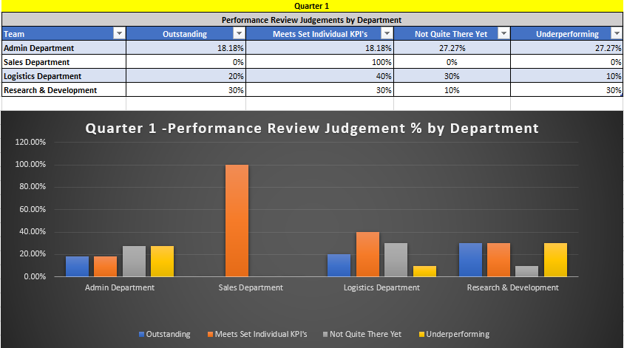

Quarter 2 – Performance Review Judgements by percentage across department

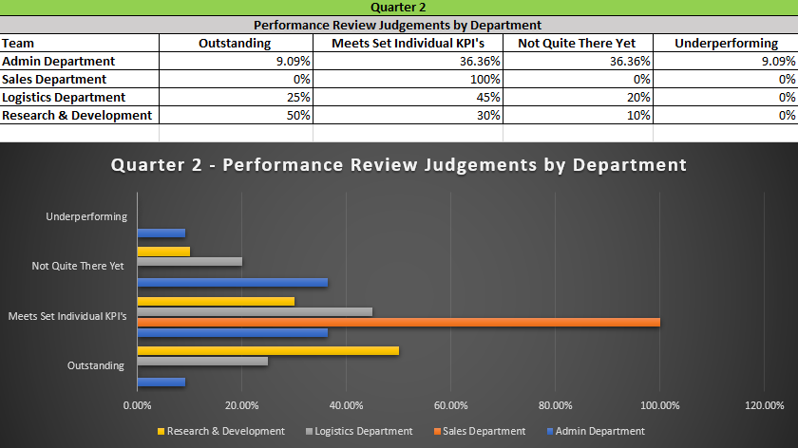

4% Bonus Payments to Employees with Outstanding Performance across Quarter 1 & Quarter 2

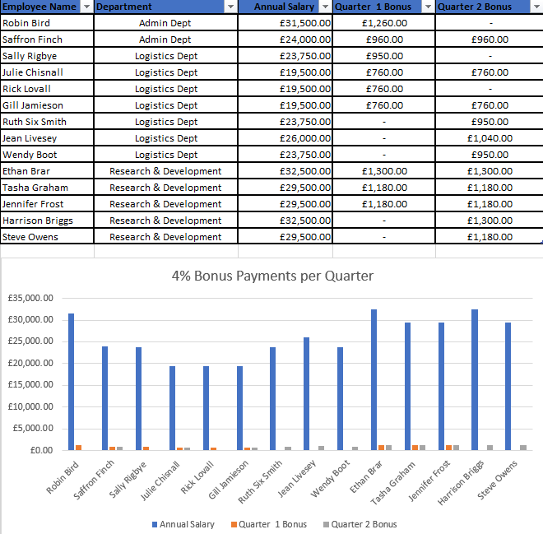

Bonus Payout by Organisation

Recommendations:
From reviewing Quarter 1 & Quarter 2 performance judgement reviews there is one department out of four that all employees are Meeting set KPI’s. The highest percentage of outstanding performance across Quarter 1 at 30% & Quarter 2 at 50% is within Research & Development team.
Across 54 employees there were 15 members of staff who had outstanding performance with only 6 individuals achieving outstanding across both quarters.
Immediate actions:
Undertake further coaching and development within the organisation to help increase performance with staff who are under achieving or not meeting their KPI’s
Potentially reviewing the reward package within the organisation to review whether staff can be rewarded in different ways other than just for achieving outstanding performance focus targets. This could have a positive impact on staff morale and create a positive working environment
Encouraging those members of staff who are outstanding to share best practice around what works well for them in achieving outstanding performance

Table 2:

Overview: From the Table showing feedback responses from 50 line managers. It shows that 68% of managers felt they had no concerns when applying ratings when conducting appraisals. 8% confirmed they were good at providing feedback and agree performance targets. 22% both said they were confident in the ability to assess employees daily, and that they are given enough to prepare for employee appraisals. 88% highlighted that they had not received training to undertake employee appraisals.
Recommendations:
Areas for Improvement: It would be recommended that line managers had additional training provided to them to be able to undertake performance reviews. As 74% confirmed they disagreed that they had no issue in challenging underperformance. Addressing this early on will help both support the individual’s performance and also coach the manager to monitor performance closely and more frequently.
Risks of not training managers properly: This could have an impact on their individual staff performance if areas for improvement or support aren’t identified. It could lead to staff making mistakes within their role, decreased moral if not supported and create a negative working environment. To identify such areas for development this can be done in regular 1:1s.
Managing time effectively: It would also be key for managers to set aside more dedicated time to undertake appraisals as only 6% confirmed they were given time to prepare for employee appraisals.

Feedback responses from 235 Employees:

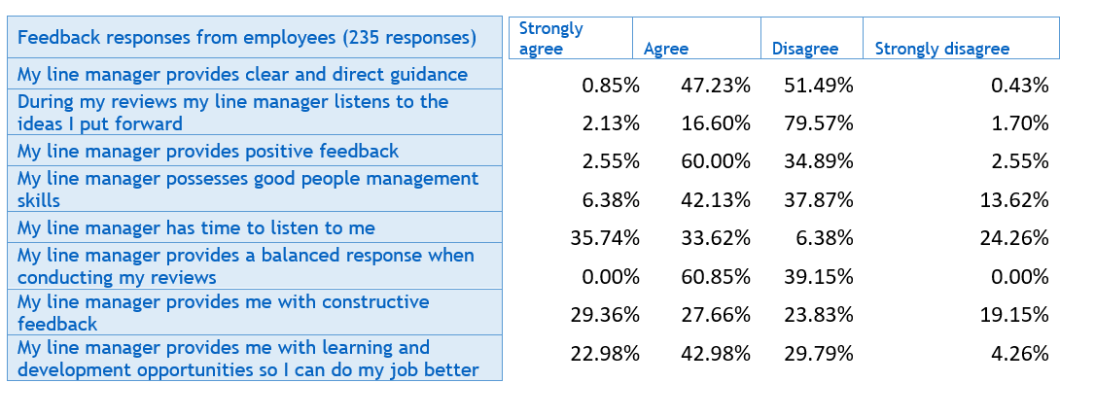

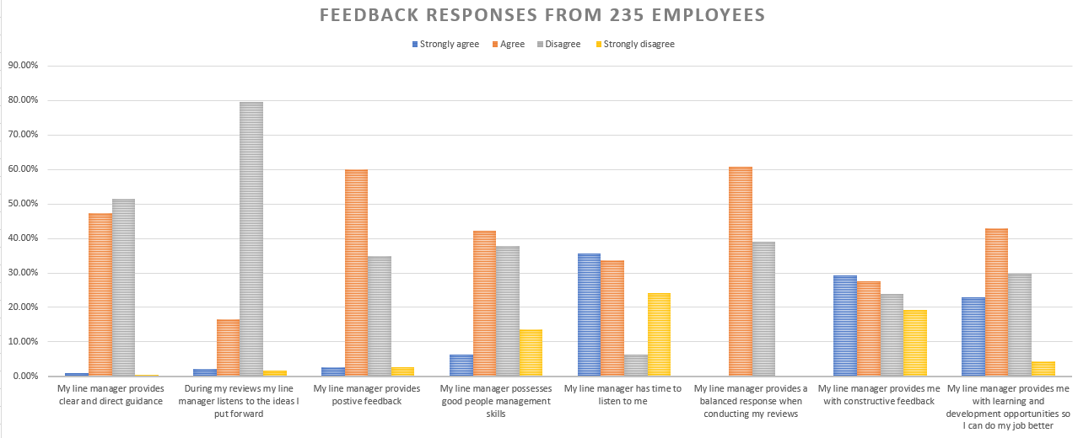

Overview:
From the feedback response from employees the highest percentages at 60% within the Agree category for the line manager providing positive feedback and to providing a balanced response when conducting their reviews. 79.57% disagreed that their line managers listen to the ideas that they put forward. There is equal split of majority of employees between Agree (47.23%)/ Disagree (51.49%) for the line manager providing clear and direct guidance. Alongside Strongly Agree (35.74%) /Agree for manager having the time to listen to the staff member.

Recommendations:
High risk area to address is the 79.57% where staff disagreed with that they felt as if their manager took on board their ideas and only 16.60% felt listened to. This will have an impact on staff morale therefore Senior management will need to ensure that this point is addressed with line managers to understand the reasons behind this through potentially holding a feedback session with the line managers to identifying training and development.
The next area that will need to be reviewed is where staff felt as if their manager was able to provide direct and clear guidance. 47.23% agreed and 51.49% disagreed. There could be a risk of miscommunication between line manager and staff which could potentially lead to mistakes being made in work. As an example if an individual is making errors with a particular process this could impact on the service/stakeholder.
Risks for staff not feeling listened to could mean decrease in morale, not feeling supported within the work place and also have an impact on retention. Health and wellbeing of individuals is also to be considered as it can also have a detrimental impact on an individual if they don’t feel supported at work.

Bibliography:
BBC (2015)
https://www.bbc.co.uk/ethics/introduction/duty_1.shtml
(Accessed on 30/09/2024)
Bitesize Learning (2015) – Plan, Do, Check, Act – The PDCA cycle
https://www.bitesizelearning.com/resources/pdca-plan-do-check-act
(Accessed on 30/09/2024)
Cambridge Dictionary (2024) Ethics Meaning
https://dictionary.cambridge.org/dictionary/english/ethics
(Accessed on 30/09/2024)
Cambridge University Press (2019) – 10 Strategic HR Evaluation
https://www.cambridge.org/core/books/abs/strategic-human-resource-management/strategic-hr-evaluation/D93967A0963D787AFE35B
(Accessed on 30/09/2024)
CFI (2015-2024) – Financial Performance
https://corporatefinanceinstitute.com/resources/accounting/financial-performance/
(Accessed on 30/09/2024)
CIPD (2015) – Ethical decision-making: Eight perspectives on workplace dilemmas
https://www.cipd.org/globalassets/media/knowledge/knowledge-hub/reports/ethical-decision-making-2015-eight-perspectives-on-workplace-dilemmas_tcm18-9564.pdf
(Accessed on 30/09/2024)
CIPD (2018) Research report Part 2 – Measurements report
https://www.cipd.org.globalassets/media/knowledge/knowlege-hub/reports/creating-and-capturing-value-at-work_2018-who-benefits-part-2_tcm18-37078.pdf
(Accessed on 30/09/2024)
CIPD (2019) Critical Thinking Episode 154: (Podcast)
https://www.cipd.org.uk/uk/knowledge/podcasts/critical-thinking/
CIPD (2023) – Evidence- based HR; Make better decisions and step up your influence
(Accessed on 30/09/2024)
https://www.cipd.org.en/knowledge/factsheets/organisational-developmement-design-factsheet/
CIPD (2023) – Ethical practice and the role of people professionals
https://www.cipd.org/uk/knowledge/factsheets/ethics-role-hr-factsheet/#what-is-ethical-practice-in-organisations
(Accessed on 30/09/2024)
CIPD (2024) – Fact Sheet - Evidence-based practice for effective decision-making
https://www.cipd.org/uk/knowledge/factsheets/evidence-based-practice-factsheet/
(Accessed on 30/09/2024)
CIPD (2024a) – Pestle Analysis
https://www.cipd.org/uk/knowledge/factsheets/pestle-analysis-factsheet/#what-is-a-pestle-analysis
(Accessed on 30/09/2024)
CIPD (2024b) – Fact Sheet - Evidence-based practice for effective decision-making
https://www.cipd.org/uk/knowledge/factsheets/evidence-based-practice-factsheet/
(Accessed on 30/09/2024)
CIPD (2024b) – People Analytics
https://www.cipd.org/uk/knowledge/factsheets/analytics-factsheet/#one
(Accessed on 30/09/2024)
Equality Act (2010)
https://www.equalityhumanrights.com/equality/equality-act-2010
(Accessed on 30/09/2024)
Harvard Business School Online (2019) – Business Insights
https://online.hbs.edu/blog/post/cost-benefit-analysis
(Accessed on 30/09/2024)
HR Magazine (2019)
https://www.hrmagazine.co.uk/content/comment/improving-the-workplace-through-critical-thinking
(Accessed on 30/09/2024)
HR Magazine (2019b) – Ethics and HR
https://www.hrmagazine.co.uk/content/features/ethics-and-hr/#
(Accessed on 30/09/2024)
HR Digest (2023)
https://www.thehrdigest.com/importance-ethics-in-human-resources-management/#
(Accessed on 30/09/2024)

Kepner & Tregoes Model (2023-2024)
https://kepner-tregoe.com/faqs
(Accessed on 30/09/2024)
McCombs School of Business (2019)
https://www.youtube.com/watch?v=NMbIKpkKYao
(Accessed on 30/09/2024)
Mindtools (2024) – What is Critical Thinking - Mind Tools Video
https://www.mindtools.com/a4dzgwa/critical-thinking-video
(Accessed on 30/09/2024)
Oxford Review (2023) – The Essential Guide to Evidence - Based Practice
(Accessed on 30/09/2024)
https://oxford-review.com/evidence-based-practice-essential/guide/
People Managing People (2024) – 29 HR KPIs to Help you Hit Strategic Goals
https://peoplemanagingpeople.com/strategy-operations/hr-kpis/
(Accessed on 30/09/2024)
People Management (2023)
https://www.peoplemanagement.co.uk/article/1845833/considering-application-relevance-evidence-based-hr
(Accessed on 30/09/2024)
Pestle Analysis (2019)
https://pestleanalysis.com/pestle-analysis-for-human-resources-how-pestle-affects-hr/
(Accessed on 30/09/2024)
Sims Institute (2020) – The Balance Score card Explained – Youtube Video
https://www.youtube.com/watch?v=zf-d-O7hVhM
(Accessed on 30/09/2024)
Scribbr (2022) What is Qualitative Research? Methods & Examples
https://www.cipd.org.uk/uk/knowledge/factsheets/analytics-factsheet/
(Accessed on 30/09/2024)
SWOT & Pestle Analysis (2024)
https://swotandpestleanalyis.com/importance-of-pestle-analysis-uses-advantages-disadvantages/
(Accessed on 30/09/2024)
Tools Hero (2022)
www.toolshero.com/management/jay-galbraiths-star-model /

(Accessed on 30/09/2024)
Tools Hero (2024) – Adams Equity Theory of Motivation
https://www.toolshero.com/psychology/adams-equity-theory/
(Accessed on 30/09/2024)

