
Skills for the Workplace
Module Assignment Submission
Student Name: | Yvonne Frazer
Student Number: | 1605792
Module No: | EMP4009
Module Title:  Lecturer: | PROJECT PLANNING  DR REXON NTING

Statement of Confirmation of Authenticity
By the act of making this submission, the student declares that this is the work of the student named above. The work has not, in whole or in part, been knowingly presented elsewhere for assessment, or where assessment has been built on a previous assessment, this has been identified. Where materials have been used from other sources it has been properly acknowledged. If this statement is untrue, the student acknowledges that an assessment offence has been committed.
Attention is drawn to the plagiarism and unfair practice policies of both the University and of ILM.

1.3 Project Initiation Document (PID)  (Blank PID to copy and paste into your assignment to fill in) | Tick when complete
Section 1 – What is the project all about?

Project Title
- Noir Flowers
Background
- Noir Flowers are an online seller of everlasting roses who have realised that they lack capital investment in their company which will deliver increased growth of customer base, products and profits via a retail unit.
Purpose
- The purpose of the project is to open a retail unit In Kennington Business Park following the creation of a business plan that secures the capital investment needed.
Objectives (and how they will be measured)
The objectives are:
- Increase client base and market share (Increased Number of orders)
- Gain Capital Investment (Offer of Investment)
- Open a retail unit (Secure Business Premises)
Project scope
- To gain a larger share of the market from the £2bn available by delivering a unique product
Exclusions from scope
- None
Deliverables (including dates of completion)
Monthly figures to be presented to Director on (30th each Month) by:
- Sales Manager
Constraints
- The implementation date of the project will depend on the date capital investment is secured
Assumptions
- Not applicable
Section 2: Why should this project go ahead?

Business case: Project Benefits
- Securing a larger customer base
- Increasing profits
- Unique Products
- New marketing strategy
Options
- Purchase Business Premises
- Lease Business Premises
- Stay as online only
Cost and Timescale
- £12000 – 1 month

Cost/Benefit Analysis
Model for calculating the price of a product:

- Purchase price for 1 rose: £1
- Transport costs = £0 (the supplier ensures transport)
- Value Added Tax (for 100 pieces) = 20% => 20% * 100 = £20
- The price with VAT for 100 roses is: £120
- The company will apply its own commission of 30% => 30% * 120= £36
- Box cost: £14
- The sale price for one bouquet is 120 * 30% + 14 = £170.

In order to reach the break-even point in the first month then we will have to sell around ‘247’ bouquets to cover overheads:

- Profit = Q*Price – Costs = 247*170-42000=0

Risk Analysis: Risk Identification
- Environmental risks like chemical handling and structural inconsistencies (malfunction in cooling system)
- Delivery risks like accidents
- Workplace risks like slippery or lifting heavy boxes
- Financial risks like seasonal fluctuation and risk of losses and spoilage

Risk prevention
- Develop a healthy environment with safety rules
- Training
- Risk assessments
- Insurances including liability and spoilage

Risk Management
- Ensure exposure to harmful substances is under control.
- Reduce risk when handling or storing items that are heavy down.
- Full training programme
- Risk assessments prior to the working day
- Knowing and evaluating hazards and risks.
- Manage workers compensation scheme
- Manage Insurances
Risk Monitoring
- Director to initiate training and monitoring for risks
Section 3: Who will work on the project?

Roles and Responsibilities
- The project team will include the Director, Sales Manager, Sellers IT Manager and Accountant;
- IT Manager to create a new website featuring the retail unit and new marketing campaign;
- IT Manager to take responsibility for the installation of new equipment;
- IT Manager to take responsibility for the training of staff on use of new equipment;
- Sales Manager to monitor overall sales;
- Accountant to monitor income and expenditure;
Director to undertake post-implementation Review.
Project Organisation Chart/Structure diagram

Names of: Project Sponsor
Not applicable
Project Manager (PM)
Director
Section 4: How and when will the project be delivered?

Initial Project Plan
- Secure capital funding
- Find premises in Kennington Business Park;
- Set up the location where retail sales will take place;
- Acquisition of 5 cooling devices for flowers;
- Acquisition of computers, office items, phones;
- Purchase of one more delivery van with cooling system;
- Acquisition of the company vehicle;
- Staff employment;
- Upgrade online site;
- Launch ad campaigns

Assignments/Milestones

List milestones here |  | List times when they should be achieved by here
Finding location | 01.01.2018
Spatial planning | 01.01.2018
Cooling system | 1.02.2018
IT systems | 1.02.2018
Office items | 1.02.2018
Furniture | 1.02.2018
Van | 15.02.2018
Car | 15.02.2018
Staff employment | 15.04.2018
Site | 15.04.2018
Ad campaigns | 15.05.2018
Total

Schedule (Gantt Chart)
Provide a Gantt chart (use the one in Excel) showing the project schedule in detail.
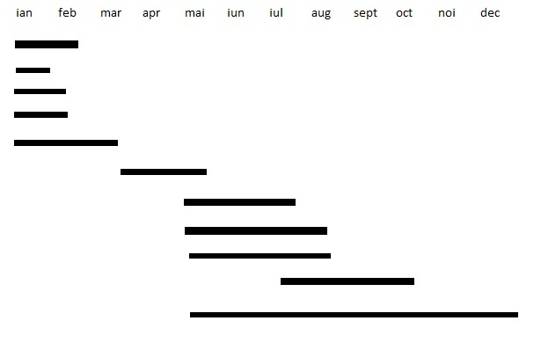
You need a running order here of the various parts of the project.
What will happen?
How long will it take?
When will it start?
When will it finish?
What must be done before each action can begin?

Human Resource Requirements:
- IT Manager
- Accountant
- Sales Manager
Support Staff
- Sellers
Additional Staff
- Driver
Project Control: Monitoring mechanisms
- The project will be monitored by regular monthly reports to the Director from the Sales Manager and Accountant

Communication channels and schedules
- Once the project plan has been agreed by the Senior Management Team, all staff will be advised of any changes by circular.
Quality Control
- The effectiveness of the project will be evaluated from the regular monthly reports.

