SIntroduction
The aim of my simulations is to input random data, modulate it, add noise, demodulate the signal, and then test the demodulated signal against the original signal to establish a bit error rates at different noise levels. Different amplitude and phase shift keys will be tested and to get accurate results, 10 simulations will be done. The 4 different models that will be tested are ASK, PSK, QPSK and QAM. There are different use cases for each one of these models for example, ASK modulators are typically used for very short-range wireless transmission applications, such as wireless keys or tyre pressure sensors [2] (goes into greater detail on this along with other variants of ASK), this is because there is limited noise during the transmission. As ASK systems don’t work well with noise. It does however work very well for fibre optics and with no noise it can transmit data very quickly with high precision. QPSK is better used in long range transmission, such as satellite communication or video calls, due to it being able to handle noice better and be able to send 2 bits of data simultaneously allowing for high speeds, making it very efficient at these roles. PSK’s, although similar to QPSK’s they can only send 1 bit of data during transmission. This makes them very effective in blue tooth communication [4] as it has a very limited range but can send information quickly. QAM specialises in WIFI, due to it sending 4 bits of data simultaneously. This allows for extremely high speeds of data to be transmitted; however, noise can very easily affect the transmission, giving it a rather limited range. In chapter 2 of figure [1] it has useful information on the base principles of these systems as at heart they use ac to dc converters and vice versa to transmit information though the use of waves.

ASK
ASK modulation works by changing the amplitude of the carrier wave, when a digital signal is present a binary 1 is represented by the amplitude staying the same. When the binary value is 0 the amplitude is decreased. There are different methods to accomplish this, either a conventional convertor, or what I have used in the simulations a simple switch. The switch uses the data to switch between sending the carrier signal and a no modulated signal. Then demodulating the signal, it multiplies the received signal by the carrier signal, then goes through a low pass filter to smooth out data to remove any inaccuracies within the data.
Simulink model
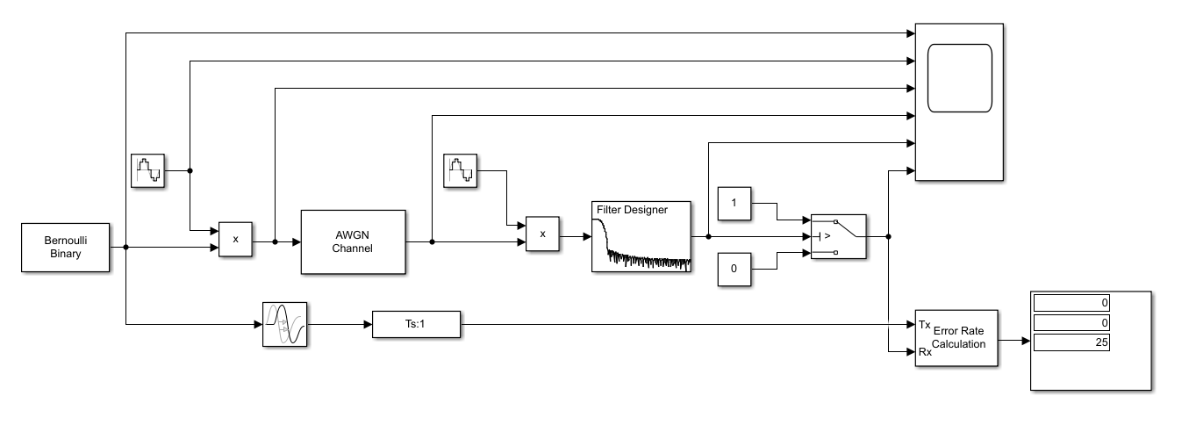
Figure x is my model of an ASK Modem, both sine waves are identical and are time based using simulation time with a frequency of 2*pi*10, with a low pass filter running at 1000hz F[ass set to 5 and Fstop at 75. Setting this up I could run my simulations with a 25 sample time.

Results

Figure x shows a graph of the ten tests done, plotted against the average error rate, with the error bars set at the standard deviation. At 10db of noise there is no error in the de modulated signal and at -18db there is an average fail rate off 0.5, this mean that when de modulating a signal has a 50% chance of each bit to be correct, therefore it is impossible for the signal to be interpreted correctly, as it can’t decipher which 50% is correct.
Discussion
To start the simulation, although not plotted, the test was run with no noise present. This gave me an accuracy of 100%, which proved that my simulation model was correct. This gave me a starting base to add noise into the system and see how it reacted, allowing me to fill out my table to get an average bit error rate. At noise ration of 0db I had an average of just below 1 bit in every 25 be incorrect. The reason for the error is the noise induced on the signal is at the correct amplitude to bypass the filter and cause an error. As the noise ration increases the average bit error goes up relative to the increase in noise. Once it hit the signal ration of -15db, the gradient of change in the error rate decrease. The reason for this is the error rate is already close to 50%, so takes longer to reach the fail rate.
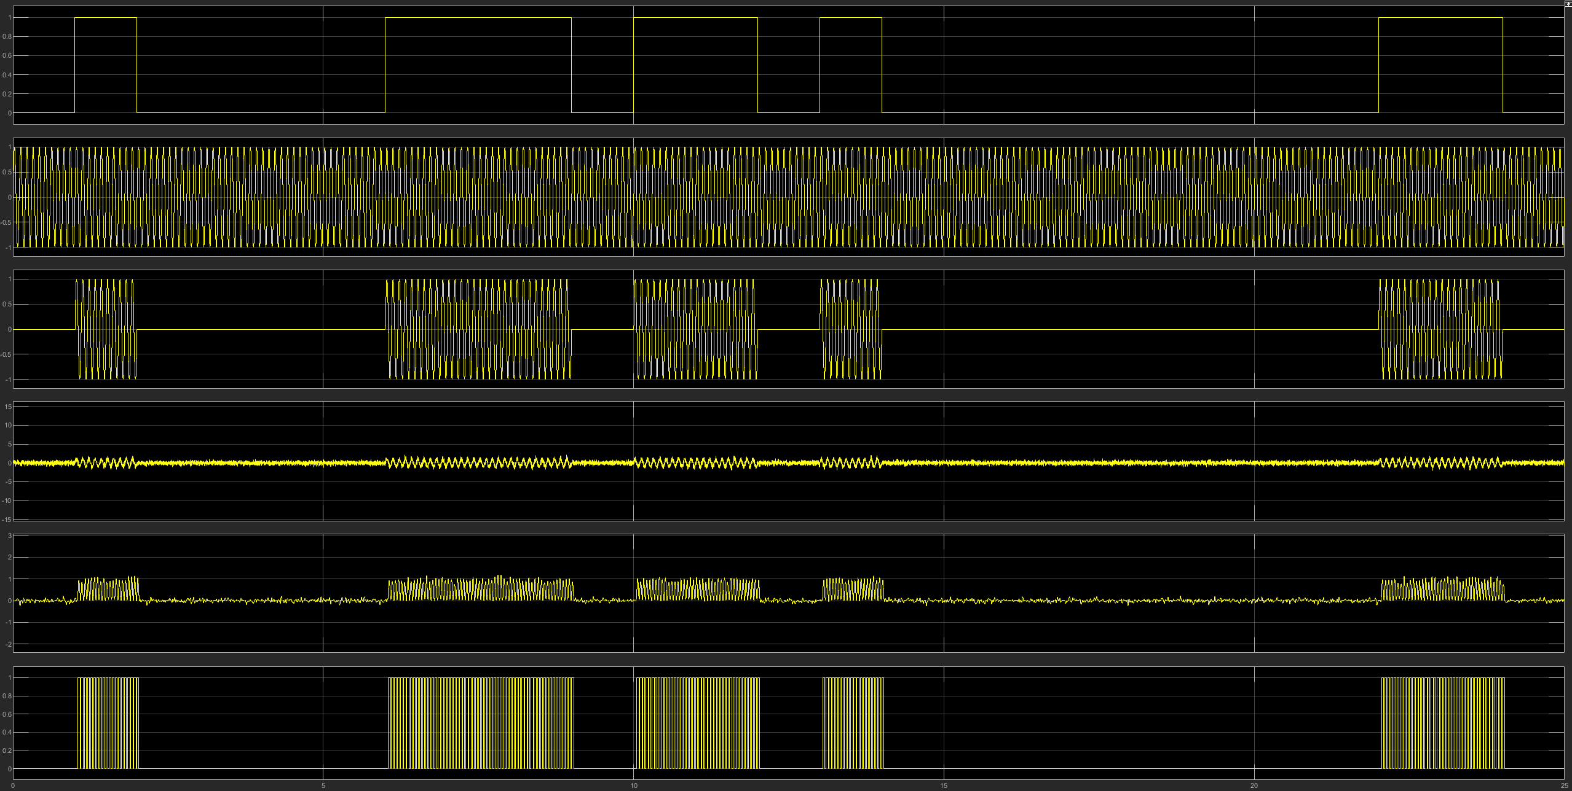
The screen shot of the scope shows the signals inputted and outputted and any variants in between, at a noise ration of -10db. The sixth line of results is the final de modulated signal. When the signal is rapidly switching between 1 and 0, a digital 1 is represented, when the signal is at a much lower switching rate a digital 0 is represented. Line five in the scope is the signal after line four has been filtered, showing the filter removing the majority of the noise from the signal. Then going through a switch were show deviation from the original signal more clearly. The deviation occurs because false readings occur because there is only 1 switch point, determining if the signal is a digital 1 or 0. This allows noise to rapidly trigger the switching point to create false readings.
PSK
Phase Shift Keying (PSK) works by using 2 different phases to represent 2 digital bits. These 2 phases are always inverse of one another, allowing for data to be transferred across the system. A binary 1 is represented by the normal phase, binary 0 is represented by the inverse phase, allowing for systems to understand what is being transferred.
Simulink model
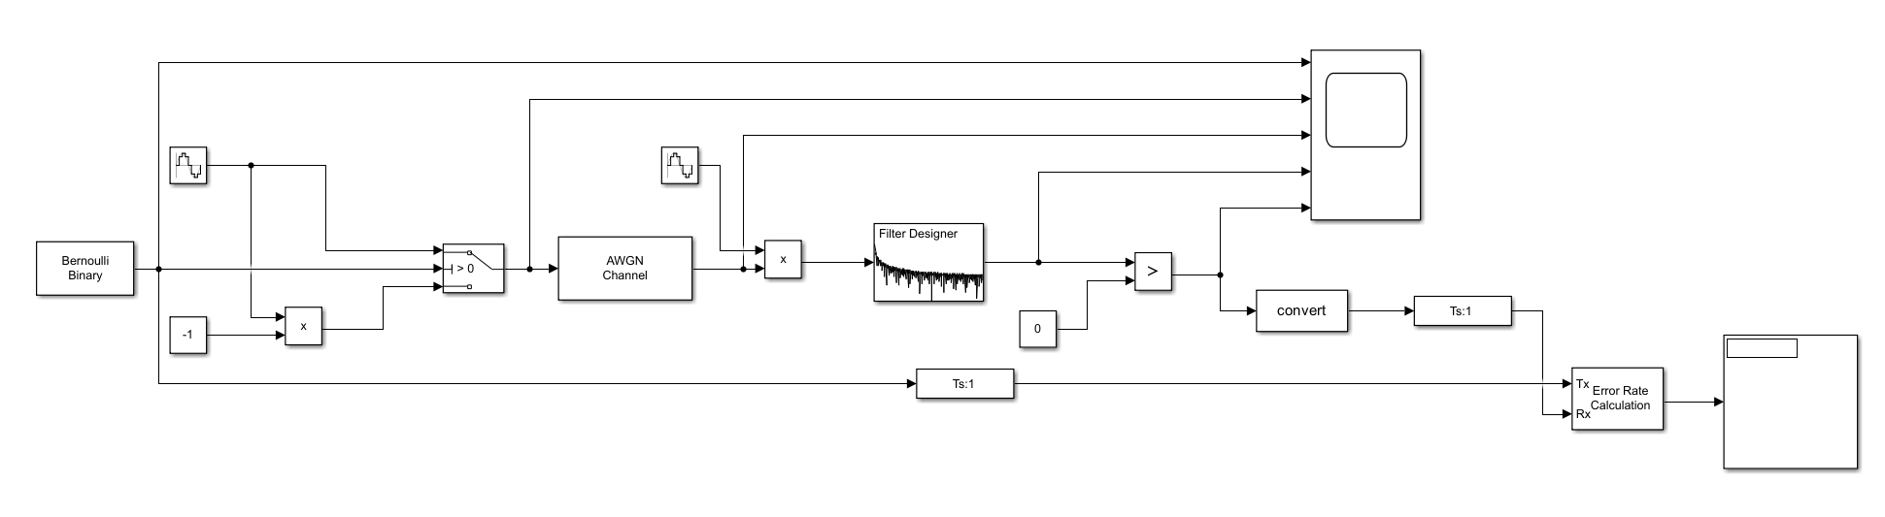
The diagram above is my Simulink model for a PSK. The sine waves are the same, with time set as simulation time, with the frequency set at 2*pi*2, and a sample time of 1/1000. To create the inverse wave, I used a product of the sine wave and multiplied by -1. The filter is set 1000hz, with Fpass at 0.025 ans an Fstop of 0.125.
Results

As you can see from the graph, the PSK deals well with noise, as no errors occur until -15db. At -42db the system has a fail rate of 0.5, where information becomes unrecoverable, and the system breaks. However, the PSK is close failing at -30db, but it still takes another 12db to break down.
Discussion
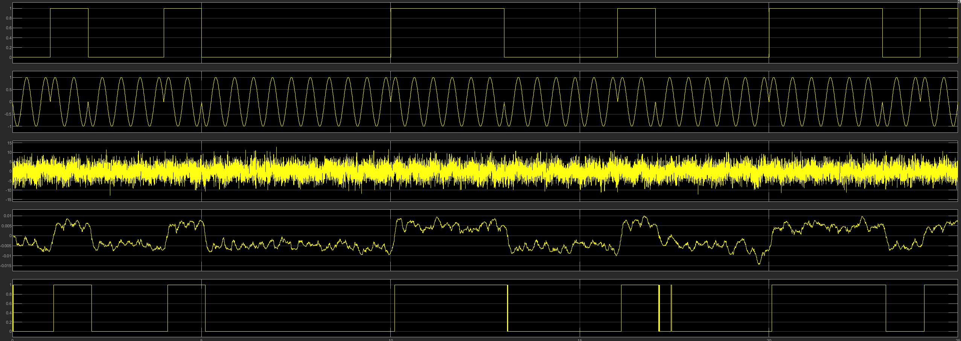
To prove my system was functional no noise was used as a testing point to prove the model was working. Low levels of noise don’t really affect the system because it doesn’t trigger a change in phase over long enough periods of time. As seen from the screen shot of the scope, noise can still trigger minor interference, but won’t affect the data, due to the sample rate, because the noise isn’t intrusive enough to continually stay on the switching level causing changes. However, with more noise present the switching level is continually pushed triggering multiply errors as the system believes these are phase shifts.

QPSK
Quadrature Phase Shift Keying (QPSK) works by modulating two bits at the same time, then uses one of four carrier phases, allowing for double the bit rate whilst using the same bit rate as a PSK. QPSK works by shifting the phase of the frequency to represent a change in the bit.
Simulink model
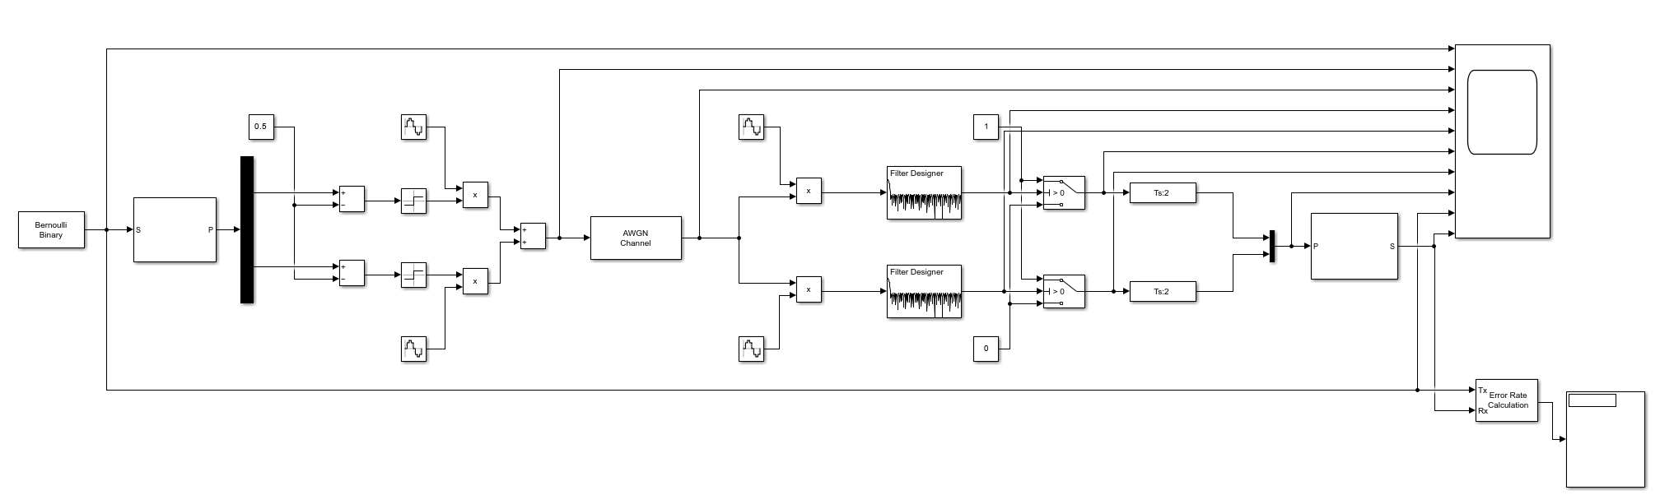
Figure x shows my model of the QPSK modem. The 2 top sine waves use simulation time with a frequency of 2*pi*10 with a phase of 0, whilst the bottom ones have a phase of pi/2, making them 90 degrees out of phase. The filters are identical, set at 100hz an Fpass of 0.75, a Fstop of 2.25 and an Astop at 30db.
Results

The graph shown displays the average bit error rate across 10 attempts, vs the noise ration. At -5db the first error inkling of possible errors shows up, indicating the model is starting to fail. By the time you get to -30db the model has failed, as it’s reached a 50% fail rate.
Discussion
Again, simulations were done with no noise to ensure the model was working. After 10 simulations at various noise levels, I plotted a graph showing the oddities of the results. I believe -15db and -20db are both curious results, as there is only a 0.2 average bit rate error between them. I believe they should be further apart, this would be proved in further test, giving more accurate results. At -20db the simulation didn’t have any error in the bit rate, I believe this skewed the results making the average -20db lower than expected. 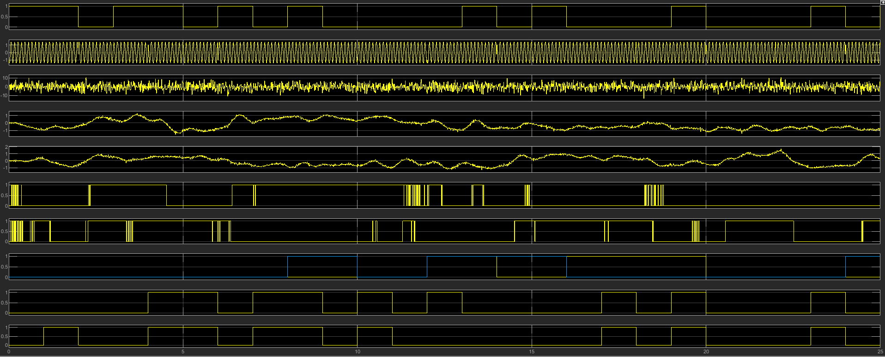
The screen shot of the scope shows the before and after modulation and de modulation, along with what the filters are doing. Where QPSK is transferring more data across the same band width as a PSK but it can be affected by noise as it is a lot more sensitive, due to combining 2 signals together, so it can send grey encoded data, meaning its easier for noise to interfere with the signal as it can trigger a switch in two directions giving incorrect data as an output.

QAM
Quadrature Amplitude Modulation (QAM), is a mix between PSK and ASK, as it uses both shifts, in phase and amplitude to send information through a carrier wave. 16 QAM uses a square grid that is grey encoded, this enables QAM to send more information, as you can send 4 bits along the same bandwidth, however this comes with draw backs as it susceptible to noise, due to these points being very close in the grid.
Simulink model
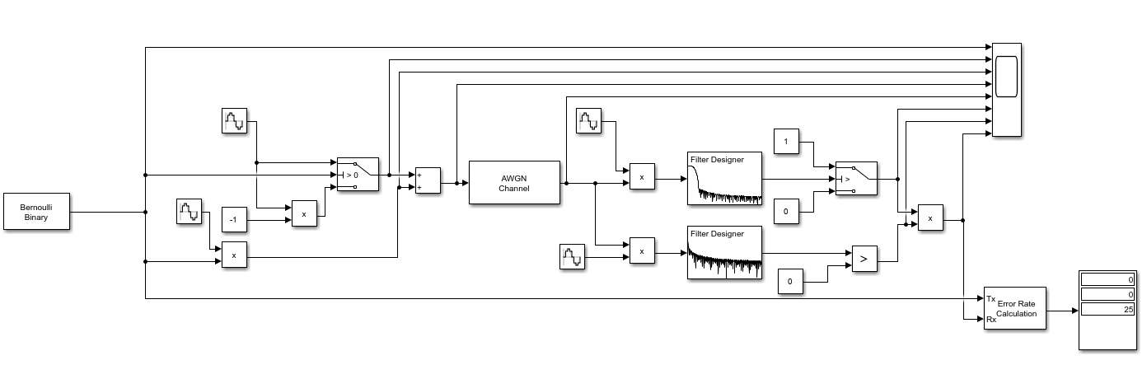
All sine waves are set to 2*pi*2 with a sample rate 1/10000, however both filters are different, the top design uses the filter from the ASK and the bottom uses one from PSK.
Results

From my testing the graph was produced which shows the system I have designed is capable of handling up to -20db of noise without any errors. It then rapidly jumps up close to the bit fail rate but fluctuates for another 12db’s before finally reaching the fail rate.
Discussion
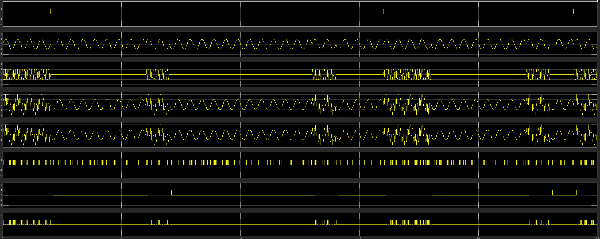
My model of a QAM works very well with noise because I’ve combined my PSK with my ASK. This works really well because after de modulating the signal I multiply them both together meaning for a digital 1 to be outputted by the system both the amplitude and the phase would have to be correct, making my system very capable with noise.
A 16QAM however would be the opposite to this because it would be sending 4 bits of data down the transmission line, this would be susceptible to noise because only 1 bit must be wrong for an incorrect result. This makes QAM very good at high-speed data transfers where limited noise is present.

Conclusion
To conclude my over all testing I felt like the Simulink modelling and the test run very conclusive and gave me accurate results. To ensure my results have less deviation more simulations would have to be run to make my results more accurate.
My results show the use cases of each model. Highlighting both their strengths and vulnerabilities. For example, my results of the ASK modem shows its inability to deal with noise, proving it wouldn’t be very useful at longer ranges, but due to its cheap design it makes it ideal for fibreoptics and short range wireless transmission, such as wireless keys. In comparison, my results for QPSK prove it can deal well with noise making it ideal for long range transmissions, such as satellite communication, along with its ability to send 2 bits of data simultaneously. However, it is rather expensive to make, therefore making it impractical for short range use. PSK is best used for Bluetooth technology [3] chapter 22 show this as it describes how audio amplifier works and how information is transmitted making PSK good for Bluetooth along with my results demonstrate this, as my model was able to deal with a signal to noise ratio of -15db before 1 bit on average was incorrect. This makes it excellent for this applications as its somewhat cheap to make, whilst having a moderate range, with slow transfer rate. QAM was the last model tested, with my results showing the opposite of its role. The reason I believe this occurred, is because my mode combined both ASK and PSK, whereas a 16 QAM workd slightly differently, as its able to send 4 bits of data in 1 bandwidth making it extremely useful in WIFI technology. However, it is vulnerable to noise therefore it has limited range. Whereas my model send 1 bit of information in a bandwidth, but deals really well with noise, making it best for use in long range transmissions.
Abstract
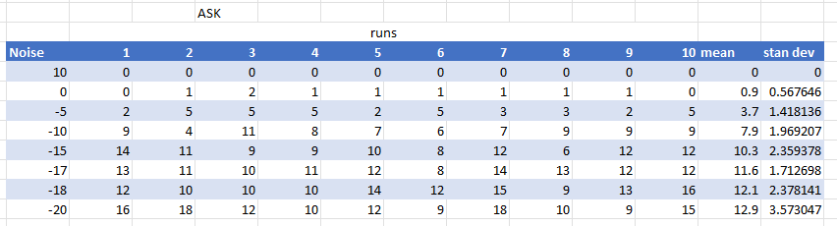
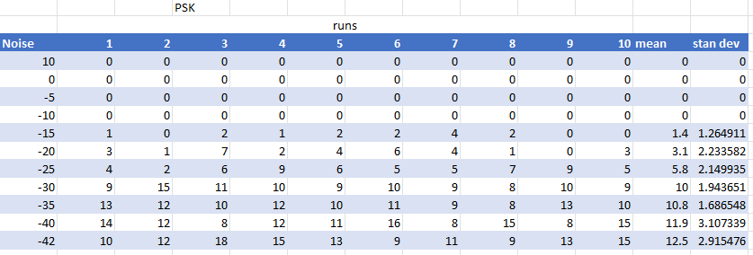
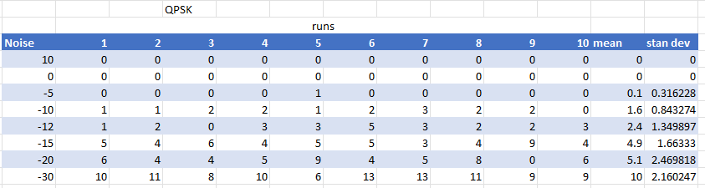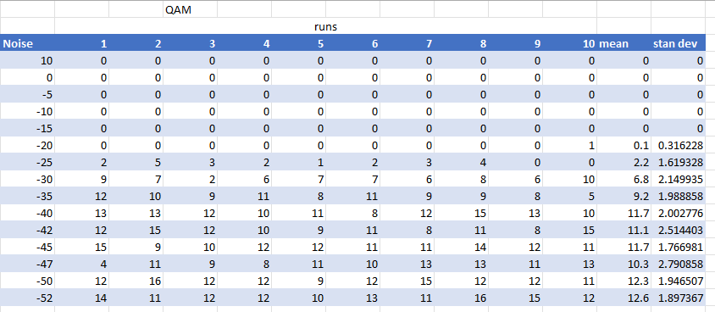

[1]
Thyagarajan, K.S. (no date) Introduction to digital signal processing using MATLAB with application to Digital Communications, Google Books. Available at: https://books.google.co.uk/books?hl=en&lr=&id=eL5dDwAAQBAJ&oi=fnd&pg=PP5&dq=Digital%2BSignal%2BProcessing%2Band%2BCommunications&ots=tOOM4W2Qi6&sig=f7UhMyviyDXlNj1yVhVCE1-1xG8#v=onepage&q=Digital%20Signal%20Processing%20and%20Communications&f=false (Accessed: 01 November 2023).
[2]
I'm OOK. You're OOK? (2009, April 8). Mixed-signal and digital signal processing ICs | Analog Devices. https://www.analog.com/en/technical-articles/im-ook-youre-ook.html#:~:text=Amplitude%20shift%20keying%20(ASK)%20is,0'%20in%20its%20simplest%20form.(Accessed: 01 November 2023).
[3]
Smith, S. W. (1999). The scientist and engineer's guide to digital signal processing (2nd ed.). California Technical Pub.
[4]
Digital Communication - Phase Shift Keying. (n.d.). Online Tutorials, Courses, and eBooks Library | Tutorialspoint. https://www.tutorialspoint.com/digital_communication/digital_communication_phase_shift_keying.htm
(Accessed: 01 November 2023).

