University of Wales Trinity Saint David
School of Engineering
Software report
ACCA4017
Jericho Uzzell
1702201
06/04/20

- Introduction: [page 3]
- Exercise 1: [page 3-4]
  - Planning and discussing problems; [page 3]
  - Outcome; [page 4]
- Exercise 2: [page 4]
  - Planning and discussing problems;
  - Outcome;
- Exercise 3: [page 5]
  - Planning and discussing problems;
  - Outcome;
- Exercise 4: [page 6]
  - Planning and discussing problems;
  - Outcome;
- Exercise 5: [page 7]
  - Planning and discussing problems;
  - Outcome;
- Conclusion; [page 8]
- Appendix; [page 9-36]

1.Introduction
The tasks for this documentation posed different challenges each time, those being validation, making the information easy to understand and error handling. By sticking to the guides that were made in Visio for each task, we can expect that the code would be easy to understand and sticks to the requirements of the task.
This report also includes documentation within the source code, this will assist future developers on adding more to the code, removing code or fixing bugs. This is available in the appendix alongside the Visio diagrams.

1. Exercise 1

2.1. Planning and discussing problems
The plan for this is task was done using Visio (figure 1, figure 2, figure 3, figure 4, figure 5, figure 6 and figure 7), the idea behind this exercise was to allow the user to enter values, one for a book title, the second for a length and the third for a product count. After assessing the requirements, it was concluded that the user would only need to enter letters and numbers for the book name, numbers with decimal for the length and number(s) only for the product count.

This gave us the understanding of the requirements for writing the code, so having a function to go through each value of a string, checking if it was a letter or number for the book title, putting the length through a function, checking for if it was a double and using the same function for checking letters and numbers for the product count, checking if only numbers were present.

By having these functions and having functions that essentially can be used for two things explicitly limits the amount of code around the project, it can allow for change without changing code in different files and more.

The only problem was when it came to validate each value of a string, checking if it was a letter or number. In other languages, this can be extremely simple. Without using external libraries, C++ does not have anything to do this – as such this function was required to be created. The code also had to support the feature to search for letters and numbers, letters or numbers only, as a result, this function can serve three purposes.

2.2. Outcome
The project as current, works extremely well, overcoming the validating of the letters and numbers was simple however was still a problem, but it was the only problem. As it is such a simple project, there would be no reason to change anything, and improvements to it might not be necessary.

If the user sticks to letters and numbers for the name, a whole number or a decimal number for the length and a number for the product count then the user will have no errors.

2. Exercise 2

2.1. Planning and discussing problems
The plan for this task was done in Visio (figure 3, figure 8, figure 9, figure 10, figure 11, figure 12 and figure 13), the intention behind this project was to allow the user to input a value (height and width) for a big object, input values (height and width) for a smaller object and a radius of a circle within it.

There were many things to consider for this project, those being, dealing with size differences between the larger and smaller object, the radius of the circle and the best way of displaying the information.

The main problem to overcome, was to get the maths correct. This task is required to be as accurate as possible, also helping the user if they input a wrong value would need to be done. This can be done by allowing the user to enter a length for the bigger object, then checking if the smaller object was more than the bigger object.

The code would also need to check if the radius of the circle was more than the bigger object, if so, inform the user to change the radius.

2.2. Outcome
The outcome was promising, the code works well if you of course make the bigger object more than twenty. Improvements for this project, would be to check the bigger objects value, if it was less than twenty (height and/or width) inform the user, so the smaller object and radius can give better results – as if you entered 10 for height and/or width for the bigger object, then you would not be able to continue due to the radius being bigger than the biggest object.

3. Exercise 3

3.1. Planning and discussing problems
Planning exercise three seemed quite straight forward, the requirement was for the user to enter as many prices as they would want, and it would calculate the value from GBP to Euro, the planning was done using Visio (figure 3, figure 14, figure 15, figure 16, figure 17, figure 18 and figure 19). Unfortunately, due to limitations and although conforming to a dynamic memory allocation (DMA) specification, the user would have to know how many prices they would want to loop through, contrary to the pan of having as many as you wanted and typing a letter “n”, to stop looping.

The program would need to loop through the set amount of prices the user specified, checking if the value entered was correct (if it was anything other than a number). Once the user had entered their values, the code should go through all the prices, convert that price into Euro’s and then add the GBP to a total, of which should also be converted into Euro. Resulting in you knowing how much a specific amount of GBP would be in Euro and how much in total it would be all together.

Overall, there were no main problem to be concerned about in reference to converting the currency, the only minor inconvenience was dealing with DMA, which was resolved by having the user enter a number for how many prices they wished to convert.

3.2. Outcome
The user needs to know how many prices they would like to convert and then enter the correct value type into the loop. If the price was wrong, the code will inform the user and then will re-loop the code, once the correct values were entered, it would convert the price into Euro.

4. Exercise 4

4.1. Planning and discussing problems
The requirements for this task for to create a two-player game for two players, planning this involved a lot of ease of use, error handling and how would a player win. The planning was done using Visio (figure 20, figure 21 and figure 23), where player one would start, they would be required to enter three places using coordinates for where their treasure was hidden -- they could not reuse a coordinate.

Player two was then required after player one entered their values, to find all three treasures. They had three lives, if they hit a coordinate where they have not attempted, they would lose a life, if they guess a coordinate where they already guessed, they would not lose a life. The code will check if the coordinate where player two entered, had treasure present, if it did not it would mark that as an “N”, for nothing found. If treasure was found, it would mark it as the traditional, “X” marks the spot and if the coordinate had not been attempted, it would show “-”.

If player two failed and ran out of lives, it would show the missing treasure as “M”, for treasure already found and places already attempted it will still show the usual indicators of “X” and “N”.

A problem that the code had to deal with, was clearing the screen preventing cheating, making the coordinate system easy to use and helping the user if they have an error.

4.2. Outcome
The code seems to work well, the way it deals with errors, how it deals with users input and the way it presents the attempts is good. The game plays well, quite bland however works, but a way to improve it would be to have colour, red for if you ran out of lives and yellow if you found treasure.

5. Exercise 5

5.1. Planning and discussing problems
The plan for this task was to allow two players to play chess. Players choose their own piece to move and then the location for the piece to move to. If the piece that was moved hits an enemy piece, the player is notified and then that piece is removed – the players piece will appear in that location. The plan for this task was written in Visio (figure 23).

The main problem to was for how the player would be able to move their own piece and not an enemy piece, another issue was moving those pieces to areas where they were legally allowed to in chess. Each players piece is labelled, “1” for player one and “2” for player two. Once all of one player pieces are removed, then the player who still stands wins!

5.2. Outcome
The game of chess on this task works well, however improvements are needed! These improvements are as follows:
- A player should not be allowed to move their own piece to another area where their piece is located;
- A player should not be allowed to move to a coordinate that is out of reach by one step;
Once those issues have been resolved, then this game of chess would be fantastic, the game does have methods of reporting errors which is user friendly, it allows the user to retry if they entered a wrong coordinate for their piece or for the placement of their piece.

4.Conclusion
In conclusion, there are always improvements to be made when writing code so documenting your code is essential for future developers after you are reading it (even for you as you can forget what the code does). Stating what the code does, why it does it and so on can be a factor of five minutes to understand compared to hours or days.

Planning your projects is also an essential thing to do, if you fail to write down what the task is needing to do, how it should do it and/or fail to future prove elements of it, can result in a lot of rewriting, difficulty understanding and/or error(s) occurring with the code.

6.Appendix
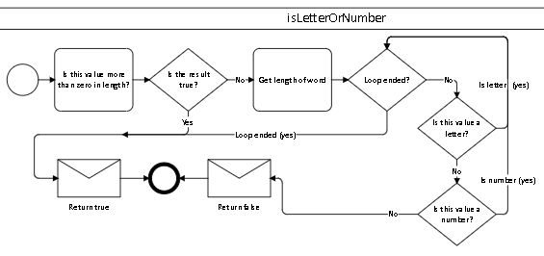
Figure 1
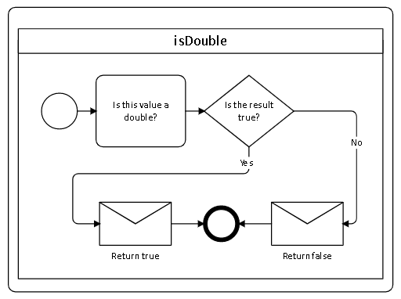
Figure 2

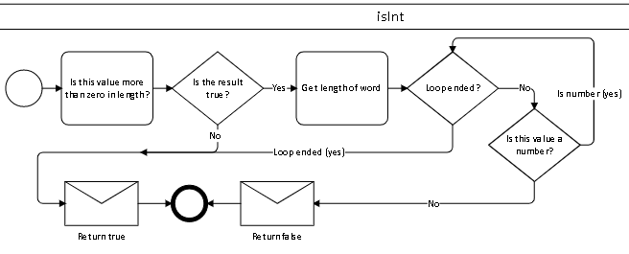
Figure 3
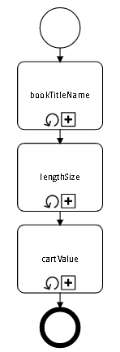
Figure 4
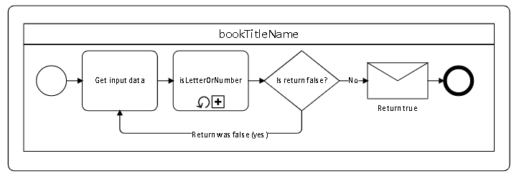
Figure 5

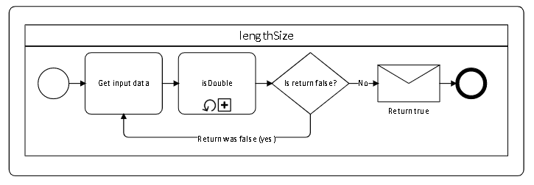
Figure 6
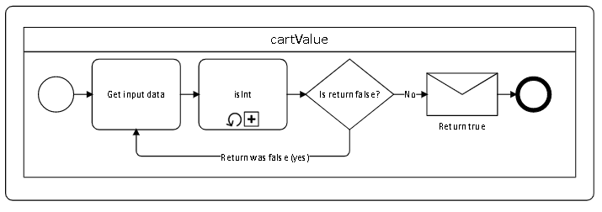
Figure 7

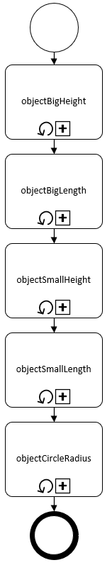
Figure 8

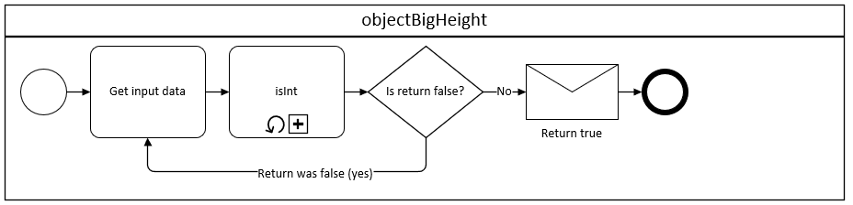
Figure 9
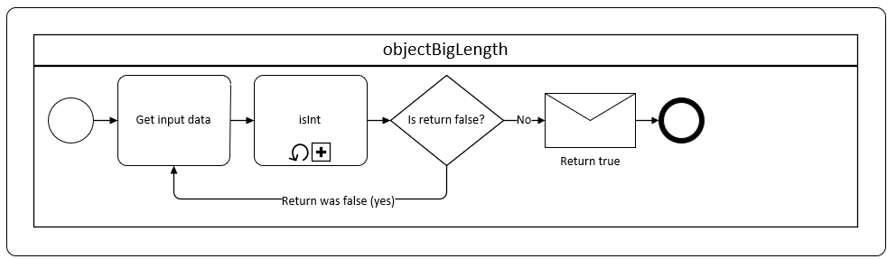
Figure 10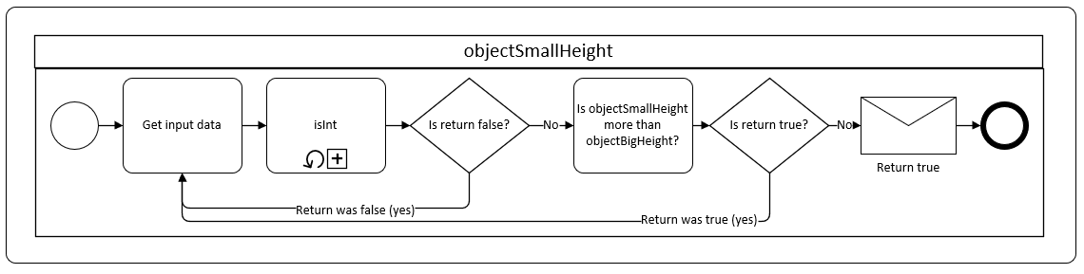
Figure 11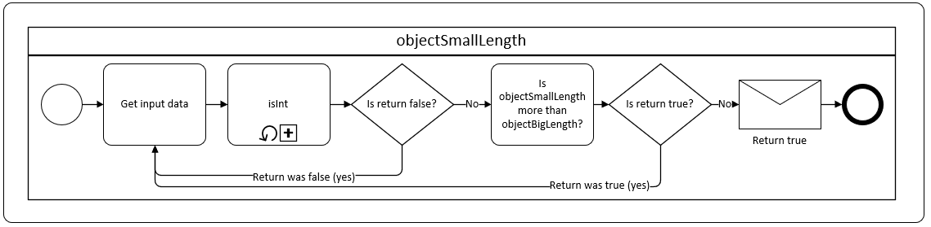
Figure 12

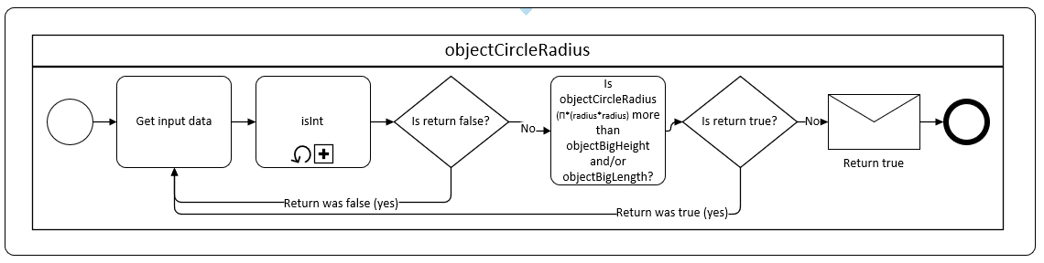
Figure 13

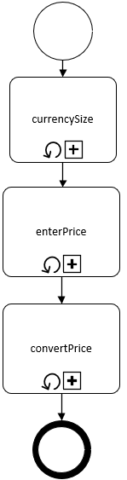
Figure 14

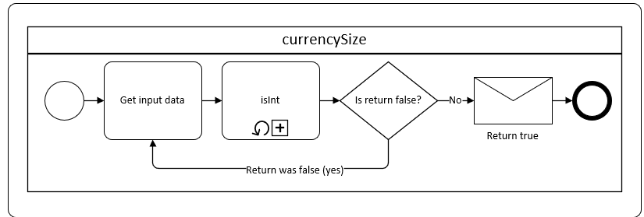
Figure 15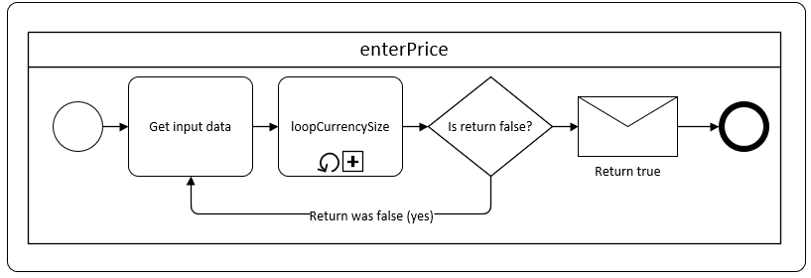
Figure 16

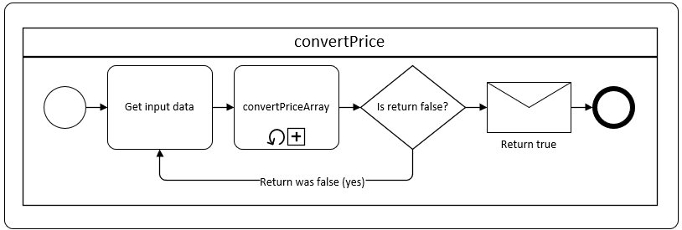
Figure 17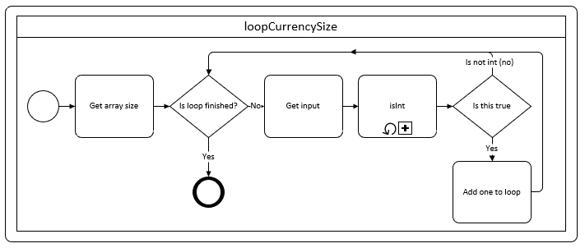
Figure 18

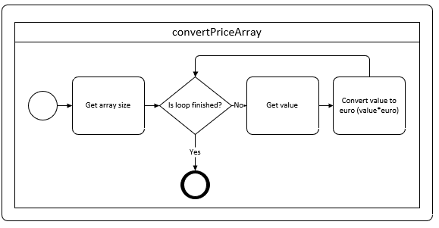
Figure 19

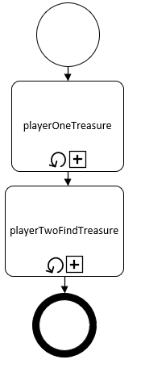
Figure 20
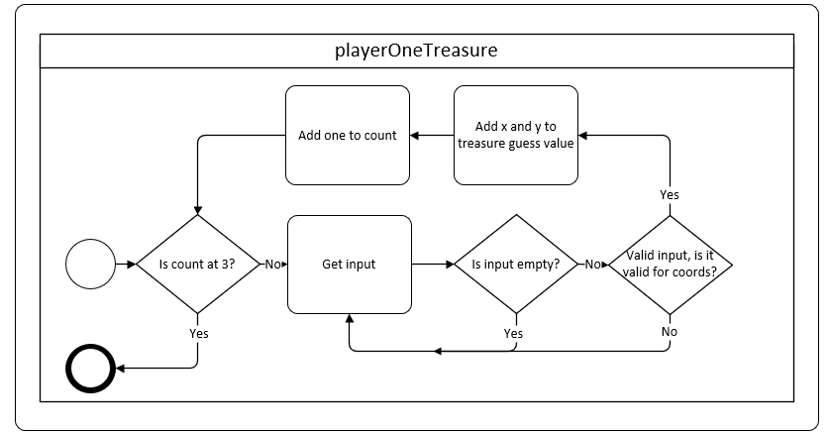
Figure 21

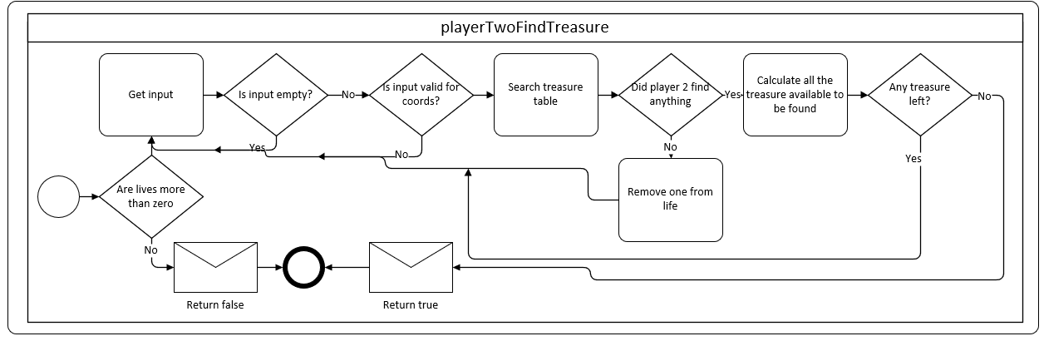
Figure 22

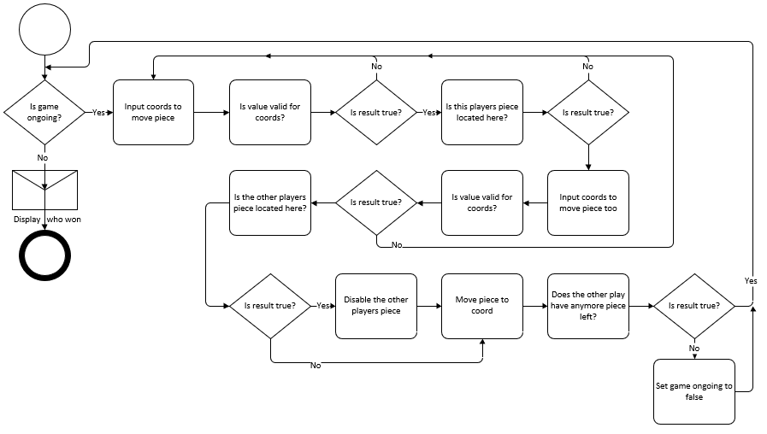
Figure 23

Task 1
#include <iostream>
#include <sstream>
#include <string>
#include <string.h>

using namespace std;
//sub-function of letter_number;
bool letter_number__letter(string word) {
//these are the letters allowed...easiest way of assessing if the character is any of these;
string letters[26][2] = { {"a","A"},{"b","B"},{"c","C"},{"d","D"},{"e","E"},{"f","F"},{"g","G"},{"h","H"},{"i","I"},{"j","J"},{"k","K"},{"l","L"},{"m","M"},{"n","N"},
{"o","O"},{"p","P"},{"q","Q"},{"r","R"},{"s","S"},{"t","T"},{"u","U"},{"v","V"},{"w","W"},{"x","X"},{"y","Y"},{"z","Z"} };
for (int e = 0; e < 26; e++) {
if ( (word == letters[e][0] || word == letters[e][1]) && word!=" ") {
//cout << word << " -- [" << letters[e][0] << "-" << letters[e][1]<<"]";
return true;
}
}
return false;
}

//sub-function of letter_number;
bool letter_number__number(string word) {
//this is the numbers allowed;
string numbers[10] = { "0","1","2","3","4","5","6","7","8","9" };
for (int e = 0; e < 10; e++) {
if (word == numbers[e]) {
return true;
}
}
return false;
}

bool letter_number(string word,int type) {
/*
@word=string;
@type=int;
0=both;
1=letters only;
2=numbers only;
# function checks if this {word} ONLY has words and/or letters -- it can have both!;
# Special charaters like, but not limited to: $,£,%; cannot be used;
*/
int length = word.length();
if (length == 0) { return true; }
for (int i = 0; i < length; i++) {
string search = word.substr(i, 1);
if (type == 0 || type == 1) {
//letters or both
if (letter_number__letter(search)==false) {
//returned false...is this both number and letter?
if (type==0) {
if (letter_number__number(search)==false) {
//type==letter&number but {search} was not a number;
return false;
}
}else{
return false;
}
}
}
if (type == 0 || type == 2) {
//numbers or both
if (letter_number__number(search)==false) {
//returned false...if this both number and letter?
if (type == 0) {
if (letter_number__letter(search)==false) {
//type==letter&number but {search} was not a letter;
return false;
}
}else{
return false;
}
}
}
}
return true;
}

bool is_double(double number){
double word;
return ((std::istringstream(number)>>word>>std::ws).eof());
}

int main(int argc, char** argv) {
/*
TASK:
> Show how variables can contain different types of values by declaring three variables that will contain a book title,
a measure of length (e.g. 4.74cm) and the number of products in a shopping cart (e.g. 4).
> Prompt the user to input these values and display them on the screen.
> Provide validation of the input where appropriate.
*/

stringstream stream;
string input = "", book_title="";
int cart_products = 0;
double length = 0.0f;
bool allow = false;

//we loop until the condition has been met. condition to be met:
// ... must NOT have anything other than letter(s) or number(s);
// ... must not be more then 30 in length;
// ... must not be less than 3 in length;
while (allow==false) {
cout << "Enter book title name: ";
getline(cin, input);
stream.str(input);
stream >> book_title;
stream.clear();
if (book_title.length() < 3 || letter_number(book_title,0) == false || book_title.length() > 30) {
cout << "You are required to stick to three criteria's: Three minimum characters, letters and/or numbers AND no more than thirty letters/numbers!\n";
}else {
allow = true;
}
}
allow = false;//set var to false for the next con

//we loop until the condition has been met. condition to be met:
// ... must be double or whole number;
// ... length cannot be less than 0.0 (prevents - numbers);
while(allow==false){
cout << "Enter length (must be like 0.0 OR 0): ";
getline(cin, input);
stream.str(input);
stream >> length;
stream.clear();
if (is_double(length)==false || length < 0.0) {
cout << "You are required to stick to two criteria's: Length must be a decimal and length must be 0.0 or more!\n";
}else {
allow = true;
}
}
allow = false;

//we loop until the condition has been met. condition to be met:
// ... value is ONLY number(s);
// ... number is no more than 60;
while(allow==false){
cout << "Enter cart value: ";
getline(cin, input);
stream.str(input);
stream >> cart_products;
stream.clear();
if (letter_number(input,2)==false||cart_products>60) {
cout << "You are required to stick to two criteria's: The input must be a number and it cannot be more than 60 products!\n";
}else {
allow = true;
}
}
cout << "\nYou have set the following:\nBook name: \""<< book_title <<"\";\nLength: "<< length <<";\nCart products: "<< cart_products;
}

Task 2
#include <iostream>
#include <sstream>
#include <string>
#include <string.h>
#define pi_rd 3.14159
using namespace std;

bool letter_number__number(string word) {
//this is the numbers allowed;
string numbers[10] = { "0","1","2","3","4","5","6","7","8","9" };
for (int e = 0; e < 10; e++) {
if (word == numbers[e]) {
return true;
}
}
return false;
}

bool letter_number(string word) {
/*
@word=string;
# function checks if this {word} ONLY has words and/or letters -- it can have both!;
*/
int length = word.length();
if (length == 0) { return "1"; }
//we will loop the entire length of the {word}, checking if any of the characters do not contain a number;
for (int i = 0; i < length; i++) {
string search = word.substr(i, 1);
if (letter_number__number(search) == false) {
//the character at {i} is not a numeric value...return false;
return false;
}
}
return true;
}

int main(int argc, char** argv) {
/*
TASK:
> Allow the user to enter the dimensions of shape shown below (Figure 1), then calculate and display the area of the shape.
> Note: The areas shown in white are empty.
*/

stringstream stream;
string input = "";
float square_b_height, square_b_width, square_s_height, square_s_width, radius, radius_sq, area;
while (true) {
cout << "Enter height for the larger square/rectangle: ";
getline(cin, input);
stream.str(input);
stream >> square_b_height;
stream.clear();
if (letter_number(input) == false || square_b_height == 0) {
//the console in input contained something other than a number, loop again;
cout << "You need to enter all numbers, the numbers cannot be negative -- also the height cannot be 0!\n";
}
else {
//their input was good, let us continue;
break;
}
}
while (true) {
cout << "Enter width for the larger square/rectangle: ";
getline(cin, input);
stream.str(input);
stream >> square_b_width;
stream.clear();
if (letter_number(input) == false || square_b_width == 0) {
//the console in input contained something other than a number, loop again;
cout << "You need to enter all numbers, the numbers cannot be negative -- also the width cannot be 0!\n";
}else {
//their input was good, let us continue;
break;
}
}

while (true) {
cout << "Enter height for the smaller square/rectangle: ";
getline(cin, input);
stream.str(input);
stream >> square_s_height;
stream.clear();
if (letter_number(input) == false || square_s_height == 0|| square_s_height >= square_b_height) {
//the console in input contained something other than a number, loop again;
cout << "You need to enter all numbers, the numbers cannot be negative -- also the height cannot be 0 -- also the smaller height cannot be larger than "<< square_b_height <<"!\n";
}
else {
//their input was good, let us continue;
break;
}
}
while (true) {
cout << "Enter width for the smaller square/rectangle: ";
getline(cin, input);
stream.str(input);
stream >> square_s_width;
stream.clear();
if (letter_number(input) == false || square_s_width == 0 || square_s_width>= square_b_width) {
//the console in input contained something other than a number, loop again;
cout << "You need to enter all numbers, the numbers cannot be negative -- also the width cannot be 0 -- also the smaller height cannot be larger than " << square_b_width<< "!\n";
}
else {
//their input was good, let us continue;
break;
}
}
while (true) {
cout << "Enter radius for the circle: ";
getline(cin, input);
stream.str(input);
stream >> radius;
stream.clear();
if (letter_number(input) == false || radius == 0) {
//the console in input contained something other than a number, loop again;
cout << "You need to enter all numbers, the numbers cannot be negative -- also the radius cannot be 0!\n";
}
else {
//check if the radius is bigger than the biggest value of the object.
radius_sq = pi_rd * (radius * radius);
if (radius_sq >= square_b_height || radius_sq >= square_b_width) {
cout << "Whoops, the value you entered is more than the biggest value possible, please alter the radius by one numeric value!\n";
}else {
//it seems fine, let us let them out and show them to calculations!
break;
}
}
}

area = (square_b_width * square_b_height) - (radius_sq + (square_s_width* square_s_height));
cout << "Area="<<area<<"\nBig height="<<square_b_height<<", width="<<square_b_width<<"\nSmall height="<<square_s_height<<", width="<<square_s_width<<"\nRadius="<<radius<<" | "<< radius_sq <<"!\n";
}

Task 3
#include <iostream>
#include <sstream>
#include <string>
#include <string.h>
#define euro 1.14
using namespace std;

bool isNumerc__number(string word) {
//this is the numbers allowed;
string numbers[10] = { "0","1","2","3","4","5","6","7","8","9" };
for (int e = 0; e < 10; e++) {
if (word == numbers[e]) {
return true;
}
}
return false;
}

bool isNumber(string word) {
/*
@word=string;
# function checks if this {word} ONLY has words and/or letters -- it can have both!;
# Special charaters like, but not limited to: $,£,%; cannot be used;
*/
int length = word.length();
if (length == 0) { return true; }
for (int i = 0; i < length; i++) {
string search = word.substr(i, 1);
if (isNumerc__number(search) == false) {
//returned false...if this both number and letter?
return false;
}
}
return true;
}

int main(int argc, char** argv) {
/*
TASK:
> (a) Ask the user to enter an arbitrary set of prices in GBP into an array and display all the entered prices.
> (b) Add all the prices together and display the result.
> (c) Convert the overall total to Euros and display it.

*/

stringstream stream;
string input = "", *ptr, price = "";
int dma_size=0, local;
float total=0;
while (true) {
cout << "Enter size: ";
getline(cin, input);
stream.str(input);
stream >> dma_size;
stream.clear();
if (isNumber(input) == false) {
cout << "Input was not numberic, try again." << endl;
continue;
}
ptr = new string[dma_size];
break;
}
for (int i = 0; i < dma_size; i++) {
cout << "Enter price: ";
getline(cin, input);
stream.str(input);
stream >> price;
stream.clear();
ptr[i] = price;
}

for (int i = 0; i < dma_size; i++) {
float local = atof(ptr[i].c_str());
cout << "GDP="<< ptr[i] <<" , to euro="<<(euro * local)<<"\n";
total = total + local;
}
cout << "Total GDP=" << total << ", to euro=" << (euro * total) << "\n";
}

Task 4
#include <iostream>
#include <sstream>
#include <string>
#include <string.h>
using namespace std;

//sub-function of isNumerc;
bool isNumerc__number(string word) {
//this is the numbers allowed;
string numbers[10] = { "0","1","2","3","4","5","6","7","8","9" };
for (int e = 0; e < 10; e++) {
if (word == numbers[e]) {
return true;
}
}
return false;
}

bool isNumber(string word) {
/*
@word=string;
# function checks if this {word} ONLY has words and/or letters -- it can have both!;
# Special charaters like, but not limited to: $,£,%; cannot be used;
*/
int length = word.length();
if (length == 0) { return true; }
for (int i = 0; i < length; i++) {
string search = word.substr(i, 1);
if (isNumerc__number(search) == false) {
//returned false...if this both number and letter?
return false;
}
}
return true;
}

bool table_correctgrid(string word) {
if (word.length() < 1) { return false; }
if (word.substr(1, 1) != "," || isNumber(word.substr(0, 1)) == false || isNumber(word.substr(2, 1)) == false) { return false; }
return true;
}
bool table_isCoordCorrect(int i) {
if (i<0||i>7) { return false; }
return true;
}

bool table_foundEntry(int x, int y,int treasure[3][2],int count) {
for (int i = 0; i < count; i++) {
if (treasure[i][0] == x && treasure[i][1] == y) {
return true;
}
}
return false;
}
bool table_hasThisBeenGuessed(int x, int y, int guesses[8][8]) {
if (guesses[x][y]!=0) {
return true;
}
return false;
}

int main(int argc, char** argv) {
/*
TASK:
> Build a two player game where the first player hides 3 hidden treasures and the second has to guess where they are by entering the X and Y coordinates of a location on an 8x8 grid.
> The player starts with 3 lives. If they fail to find the treasure then an N character should be placed on the grid and they lose a life.
> An X should be displayed if they find the treasure, and they win if they discover all three treasures.
> The player grid should be re-displayed after each guess, as well as appropriate messages such as “You found the first treasure”.
> The game might look like this:
*/

stringstream stream;
string input = "";
int x, y, treasure[3][2] = { {0,0},{0,0},{0,0} }, lives = 3, count = 0, attempts = 0, correct=0;
int guesses[8][8] = {
{0,0,0,0,0,0,0},
{0,0,0,0,0,0,0},
{0,0,0,0,0,0,0},
{0,0,0,0,0,0,0},
{0,0,0,0,0,0,0},
{0,0,0,0,0,0,0},
{0,0,0,0,0,0,0}
};
cout << "The grid wil be 8x8, player one to enter their values:\n";
while (count<3) {
cout << "Enter tresure, format of (1,2): ";
getline(cin, input);
stream.str(input);
stream >> input;
stream.clear();
if (table_correctgrid(input)==false) {
//error, format was not correct. required {nan},{nan} -> 0,0;
cout << "The format was not correct, we required {number},{number}, for example, 0,0" << "\n";
continue;
}
//we need to check whether if the x and y are within the confinds of the map;
x = atoi(input.substr(0, 1).c_str());
y = atoi(input.substr(2, 1).c_str());
if (table_isCoordCorrect(x)==false) {
cout << "The X coord (far left number) was more than 7 or less than 0." << "\n";
continue;
}
if (table_isCoordCorrect(y)==false) {
cout << "The Y coord (far right number) was more than 7 or less than 0." << "\n";
continue;
}

//has the user already used this x and y?
bool found = table_foundEntry(x,y,treasure,count);
if (found == true) {
cout << "You have already used X="<<x<<" and Y="<<y<<"! Please choose another." << "\n";
continue;
}

//add the number to the guesses
treasure[count][0] = x;
treasure[count][1] = y;
count++;
}
system("CLS");
cout << "Player two is now playing, please enter your values...remember the format of {x},{y}, for example: 1,2:\n";
while (lives >= 0 && correct!=3) {
cout << "You current lives: "<<lives<<", attempts: "<<attempts<<"\n";
for (int i = 0; i < 8; i++) {
cout << (i==0?" ":"") << i << (i!=7?" | ":"\n");
}
for (int e = 0; e < 8; e++) {
cout << e;
for (int i = 0; i < 8; i++) {
string gue = (guesses[e][i]==0?"-":guesses[e][i]==1?"N":"X");
cout << (e==1?" ":" ")<< gue << " ";
}
cout << "\n";
}
cout << "Your guess {x},{y}: ";
getline(cin, input);
stream.str(input);
stream >> input;
stream.clear();
system("CLS");

if (table_correctgrid(input)==false){
//error, format was not correct. required {nan},{nan} -> 0,0;
cout << "The format was not correct, we required {number},{number}, for example, 0,0" << "\n";
continue;
}
//we need to check whether if the x and y are within the confinds of the map;
x = atoi(input.substr(0, 1).c_str());
y = atoi(input.substr(2, 1).c_str());
if (table_isCoordCorrect(x)==false) {
cout << "The X coord (far left number) was more than 7 or less than 0." << "\n";
continue;
}
if (table_isCoordCorrect(y) == false) {
cout << "The Y coord (far right number) was more than 7 or less than 0." << "\n";
continue;
}

//check if the treasure was found:
bool found = table_foundEntry(x, y, treasure, count);
attempts++;
if (found == true) {
cout << "You found teasrue!\n";
guesses[x][y] = 2;
cout << "\n\n\n";
correct++;
continue;
}
//they failed to find treasure, remove one life and then mark on grid;

//have they already guessed here?
cout << "\n\n\n";
if(table_hasThisBeenGuessed(x,y,guesses)==false) {
//they have not, take a life and add a guess on the grid;
cout << "\tYou guessed wrong!!\n";
guesses[x][y] = 1;
lives--;
}else {
cout << "\tYou have already guessed here!\n";
}
}
system("CLS");
if (lives <= 0) {
cout << "You ran out of lives! Aw damn, try again if you would like, this is the grid shown below with the missing treasure.\nX=Found treasure, M=Missing treasure, N=Wrong guess, -=Not attempted\n";
for (int i = 0; i < 8; i++) {
cout << (i == 0 ? " " : "") << i << (i != 7 ? " | " : "\n");
}
for (int e = 0; e < 8; e++) {
cout << e;
for (int i = 0; i < 8; i++) {
string gue = (guesses[e][i] == 0 ? "-" : guesses[e][i] == 1 ? "N" : "X");
if (gue == "-") {
//does the treaure exist here?
for (int q = 0; q < 3; q++) {
if (treasure[q][0] == e && treasure[q][1] == i) {
//it does...well let us mark it:
gue = "M";
}
}
}
cout << (e == 1 ? " " : " ") << gue << " ";
}
cout << "\n";
}
} else {
cout << "You found all the treasure, well done!\n";
}
}

Task 5
#include <iostream>
#include <sstream>
#include <string>
#include <string.h>
using namespace std;

//sub-function of isNumerc;
bool isNumerc__number(string word) {
//this is the numbers allowed;
string numbers[10] = { "0","1","2","3","4","5","6","7","8","9" };
for (int e = 0; e < 10; e++) {
if (word == numbers[e]) {
return true;
}
}
return false;
}

bool isNumber(string word) {
/*
@word=string;
# function checks if this {word} ONLY has words and/or letters -- it can have both!;
# Special charaters like, but not limited to: $,£,%; cannot be used;
*/
int length = word.length();
if (length == 0) { return true; }
for (int i = 0; i < length; i++) {
string search = word.substr(i, 1);
if (isNumerc__number(search) == false) {
//returned false...if this both number and letter?
return false;
}
}
return true;
}

bool table_correctgrid(string word) {
if (word.length() < 1) { return false; }
if (word.substr(1, 1) != "," || isNumber(word.substr(0, 1)) == false || isNumber(word.substr(2, 1)) == false) { return false; }
return true;
}
bool table_isCoordCorrect(int i) {
if (i < 0 || i>8) { return false; }
return true;
}

bool table_foundEntry(int x, int y, int checker[12][3]) {
for (int i = 0; i < 12; i++) {
if (checker[i][1] == x && checker[i][2] == y && checker[i][0]==1) {
return true;
}
}
return false;
}

int main(int argc, char** argv) {
/*
TASK:
> Build a checkers game (Figure 3).
> You will need to consider how you will display the board, and how you will represent the players checker pieces.
> The interesting problem in this exercise is to determine a method for moving the player pieces and determining when a player has taken a piece.
*/

stringstream stream;
string input = "",piece="";
bool found = false, player_inturn=false,game_ongoing=true;
int x1, y1, x2, y2, key, o_pl, winner, count = 0, attempts = 0;;
int players[2][12][3] = {
//player one
{
{1,1,1},{1,3,1},{1,2,2},{1,1,3},{1,3,3},{1,2,4},{1,1,5},{1,3,5},{1,2,6},{1,1,7},{1,3,7},{1,2,8}
},
//player two
{
{1,7,1},{1,6,2},{1,8,2},{1,7,3},{1,6,4},{1,8,4},{1,7,5},{1,6,6},{1,8,6},{1,7,7},{1,8,8},{1,6,8}
}
};
while (game_ongoing==true) {
for (int pl = 0; pl < 2; pl++) {
if (game_ongoing == false) { break; }
//piece = (pl==0?"1":"2");//1=player one, 2=player two;
o_pl=!pl;
cout << "X> ";
for (int i = 1; i < 9; i++) {
//display the boards
cout << i << " " << (i==8?"\n ---------------\n":"");
}
for (int i = 1; i < 9; i++) {
//display the boards numbers (left side)
cout << i;
//does player one exist here?
// we need to go through the row;
for (int r = 1; r < 9; r++) {
//go through player one and two;
piece = "";
for (int q = 0; q < 12; q++) {
if (players[0][q][1] == i && players[0][q][2] == r && players[0][q][0] == 1) {
piece = "1";
break;
}
if (players[1][q][1] == i && players[1][q][2] == r && players[1][q][0]==1) {
piece = "2";
break;
}
}
cout << (r==1?" ":" ") << (piece==""?"-":piece);
}
cout << endl;
}
cout << "Y^\n";
//add input field for this player!
player_inturn = true;
while (player_inturn == true) {
cout << "\n\nPlayer " << (pl == 0 ? "1" : "2") << " turn.\nWhat piece do you wish to move? Remember, {y},{x}: ";
getline(cin, input);
stream.str(input);
stream >> input;
stream.clear();

if (table_correctgrid(input) == false) {
cout << "The format you provided was incorrect, try again." << endl;
continue;
}
x1 = atoi(input.substr(0, 1).c_str());
y1 = atoi(input.substr(2, 1).c_str());

if (table_foundEntry(x1, y1, players[pl]) == false) {
//okay we did not find anything at that coord...return error and reloop;
cout << "Did not find your piece at that coord, try again\n";
continue;
}
//now we need a place to move it;
//get x2 and y2
cout << "\n\nEnter grid to move this peice to.\nWhat piece do you wish to move? Remember, {x},{y}: ";
getline(cin, input);
stream.str(input);
stream >> input;
stream.clear();
if (table_correctgrid(input) == false) {
cout << "The format you provided was incorrect, try again.\n" << endl;
continue;
}
x2 = atoi(input.substr(0, 1).c_str());
y2 = atoi(input.substr(2, 1).c_str());
//is x2 and y2 within the grid?
if (table_isCoordCorrect(x2) == false) {
//x2 incorrect;
cout << "X2 was outside of the confinds of the grid, try again.\n" << endl;
continue;
}
if (table_isCoordCorrect(y2) == false) {
//y2 incorrect;
cout << "Y2 was outside of the confinds of the grid, try again.\n" << endl;
continue;
}

for (int i = 0; i < 12; i++) {
if (players[pl][i][1] == x1 && players[pl][i][2] == y1 && players[pl][i][0] == 1) {
//found it;
key = i;
}
}
//cout << "Moved enemy="<< o_pl <<" key="<<key<<" x1="<<x1<<" y1="<<y1<< endl;
//check if the checker is within one thing

system("CLS");
players[pl][key][1] = x2;
players[pl][key][2] = y2;
key = -1;
//now check if you his the enemy checker;
for (int i = 0; i < 12; i++) {
//cout << players[o_pl][i][1] << "|"<<x2<<" " << players[o_pl][i][2]<<"|"<<y2 << " ENM="<<o_pl << endl;
if (players[o_pl][i][1] == x2 && players[o_pl][i][2] == y2 && players[o_pl][i][0] == 1) {
//found it;
key = i;
}
}
if (key != -1) {
//interception...kill that peice
players[o_pl][key][0] = 0;
cout << "HOT DAMN! You struck an enemy peice!\n";
}

for (int i = 0; i < 12; i++) {
//cout << players[o_pl][i][1] << "|"<<x2<<" " << players[o_pl][i][2]<<"|"<<y2 << " ENM="<<o_pl << endl;
if (players[o_pl][i][1] == x2 && players[o_pl][i][2] == y2 && players[o_pl][i][0] == 1) {
//found it;
key = i;
}
}

//anymore of the enemies checkers?
count = 0;
for (int i = 0; i < 12; i++) {
if (players[o_pl][i][0] == 0) {
//found it;
count++;
}
}
cout << count << endl;
if (count>= 12) {
//this player has expired all their checkers!
cout << "Game ending" << endl;
game_ongoing = false;
winner = pl;
}
attempts++;
player_inturn = false;
}
}
}
system("CLS");
cout << "Player " << (winner == 0 ? "1" : "2") << " WINS! Combined, you had "<< attempts<<" attempt"<<(attempts==1?"":"s");
}

