31/07/025
Shimranbanu Liyakat Shaikh (2419481)

Supporting Materials for NatureGarden Security Framework
Data Security, Governance & Compliance (ACCA7028)

Introduction
This supporting document contains implementation visuals, frameworks, and tables mentioned in the main report. The supporting document will provide detailed artefacts of the risk assessment matrix, BYOD workflow, SLA template, and audit checklist which was developed for NatureGarden's governance framework
These artefacts are supportive documents for the Component 2 Report that was submitted, as part of the ACCA7028 module. The artefacts exhibit implementation visuals, sample templates and other design work referenced in the main report. The artefacts have been offered to elaborate on the governance, risk, compliance, and security (GRC&S) implementation strategy presented for NatureGarden (NG).

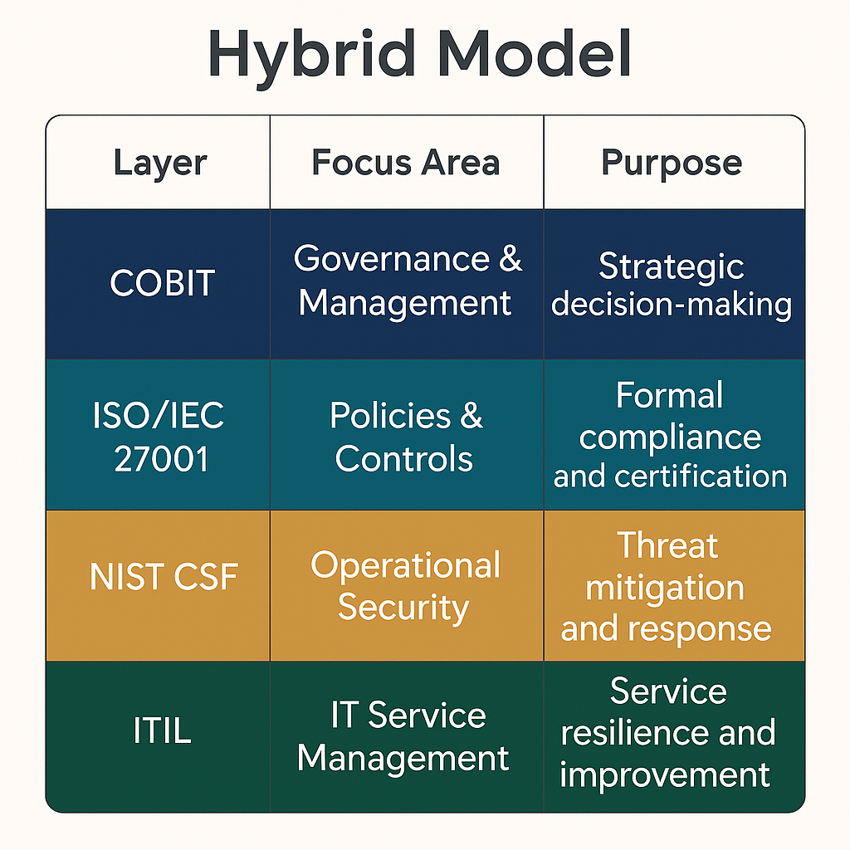
- Governance Framework Overview

Figure 1: Integrated Governance and Security Framework (Hybrid Model)
This layered model integrates COBIT, ISO/IEC 27001, NIST CSF, and ITIL to ensure strategic alignment, regulatory compliance, and operational flexibility.

- BYOD Policy Implementation Workflow
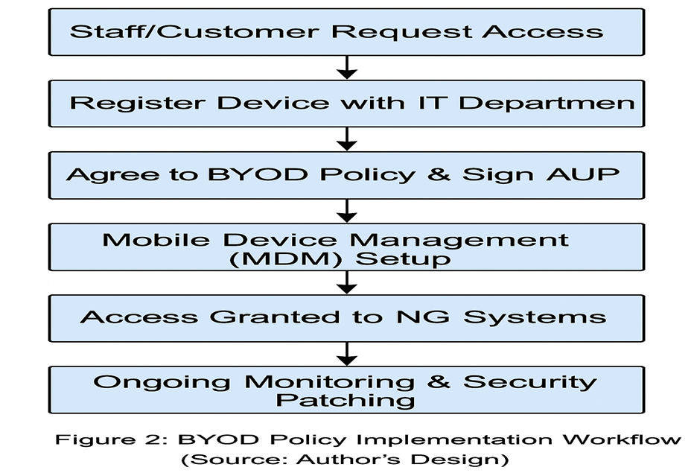

Figure 2: BYOD Access Approval Flow
This workflow ensures all personal devices undergo security screening and policy alignment before access is granted.

3. Risk Assessment Matrix
Table 1: Risk Matrix Based on NIST Guidelines
Asset | Threat | Likelihood | Impact | Risk Level | Mitigation
Customer Data | Unauthorized access | High | High | Critical | MFA, RBAC, Encryption, SIEM Monitoring
Wireless Network | Rogue Access Point | Medium | High | High | WPA3, IDS/IPS, Regular Scans
BYOD Devices | Malware | High | Medium | High | MDM, Antivirus, Conditional Access
Intellectual Property | Insider Threat | Low | High | Medium | DLP Tools, Activity Logs, NDAs

5. Audit Checklist Overview
NatureGarden have established a structured, routine internal audit program to help maintain consistent compliance and operational resilience. The IT Security Team collaboratively assesses BYOD policy compliance on a quarterly basis to assess how well personal devices comply with security protocols and mobile device management reference. The Security Operations Centre (SOC) scans each wireless access point on a monthly basis to monitor for vulnerabilities and identify unauthorized access. The Infrastructure Team conducts a weekly data backup integrity check in order to ensure important data are maintained and are restorable. Lastly, the Legal & Compliance Unit conducts an annual audit of AI tools to monitor for algorithmic bias and transparency, understanding that AI capabilities are changing rapidly, and must indicate what tools are used, how they are used, and to ensure ethical uses in line with evolving regulatory obligations. These ongoing controls help to bolster NG’s proactive security culture and minimize the risk of compliance failures.
Appendix B: Internal Security Controls Audit Sample

6. Regulatory Compliance Matrix (Excerpt)
Region | Regulation | Required Action
EU | GDPR | Appoint DPO, map personal data, regular audits
India | DPDPA (2023) | Consent management, local data storage
USA (California) | CCPA | Update privacy policy, allow data opt-out
Healthcare Data | HIPAA | Implement PHI safeguards, train staff

7. Innovation Lab Roadmap (2025-2026)

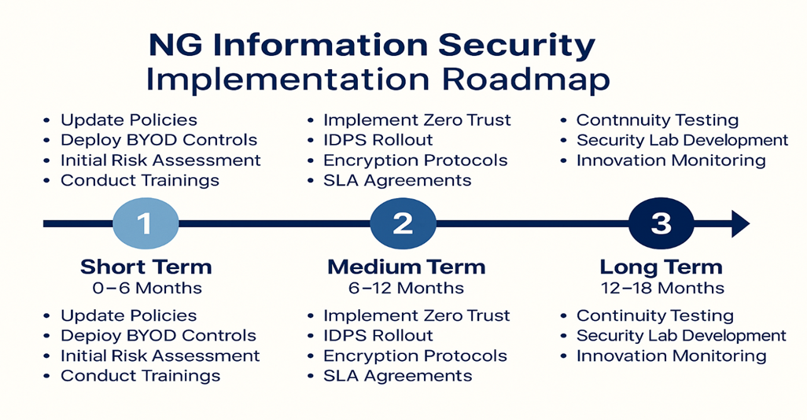
NG Information Security Implementation Roadmap

8. Policy Examples
- Sample AUP
- Users shall not install unapproved software
- All data shall be stored ONLY on company-approved cloud services
- Sample BYOD Policy
- Mandatory encryption
- Required periodic security compliance checks
- Mapping incident response plan

These artefacts are included as support materials for the Component 2 report for ACCA7028. They represent evidence of a practitioner-led design and implementation plan to secure NG's IT infrastructure in accordance with accepted standards. All diagrams and tables are developed in support of the governance model discussed in the main report.



