
Applied Leadership and Management in the Workplace
Module Assignment Submission
Student Name: | Lauren King
Student Number: | 2418617
Module No: | BMSK4014
Module Title: | Problem Solving and Decision Making

Statement of Confirmation of Authenticity
By the act of making this submission, the student declares that this is the work of the student named above. The work has not, in whole or in part, been knowingly presented elsewhere for assessment, or where assessment has been built on a previous assessment, this has been identified. Where materials have been used from other sources, it has been properly acknowledged.
If this statement is untrue, the student acknowledges that an assessment offence has been committed.
Attention is drawn to the plagiarism and unfair practice policies of both the University and of ILM.

Table of Contents

Problem Solving and Decision-Making 3
Section 1: Introduction 3
Section 2: 5 Whys Technique 3
Section 3: Mind Mapping 4
Section 4: Ishikawa (fishbone) Diagram 4
Section 5: Decision-Making Technique: Grid Analysis 5
Section 6: Cost-Benefit Ratio 8
Section 7: Stakeholder Communication Plan 8
7.1 Stakeholder Analysis 9
Section 8: Monitoring Progress in the Workplace 10
8.1 Gantt Chart Monitoring 11
Section 9: Technology Support in Decision-Making 12

Problem Solving and Decision-Making

Section 1: Introduction
A complex problem refers to a situation that cannot be resolved through simple or routine methods. Unlike straightforward problems with clear solutions, complex problems are usually caused by more than one thing, can be uncertain, and often have different parts that are linked together. They might not have all the information needed, people may have different opinions about them, and the results can be hard to predict. This makes them difficult to solve. To deal with complex problems, we need to think carefully, be creative, and use clear decision-making steps to find the best solution. (Lindsley, 2022).
In a dog grooming salon, maintaining a steady and loyal customer base is crucial for business success. A noticeable decline in clientele can quickly lead to reduced profits, making it a complex problem that requires strong leadership, strategic thinking, and effective decision-making.
This assignment explores how the issue of losing clients was identified, the possible reasons behind the decline, and how leadership approaches were used to analyse the situation and take positive action. By applying practical problem-solving techniques and decision-making models within the salon context, this work demonstrates how leadership in a small business setting can directly impact customer retention and overall business performance.
The key issue facing the dog grooming salon is a steady decline in returning customers, which has directly impacted profits. After reviewing client patterns and gathering informal feedback, it became clear that the lack of a structured booking system was a major contributor to the problem.
Without a proper booking system in place, appointments were often managed manually, leading to frequent scheduling errors, double bookings, and missed opportunities to fill available slots.
The scope of the problem extends across several critical functions within the business, impacting both internal operations and external client relationships. One of the most significant areas affected is client experience and satisfaction, particularly for repeat and time-sensitive customers who expect a reliable and efficient service. The absence of a formal booking system leads to delays in communication, missed appointments, and limited availability, all of which contribute to a poor customer experience. (Hill S, 2023).
Staff productivity is also compromised, as considerable time is spent managing appointments manually and resolving avoidable errors. This reduces the time available for delivering services and supporting clients effectively. Manual processes increase the likelihood of mistakes such as double bookings, missed appointments, or miscommunication with clients, which can create frustration for both staff and customers.
Over time, this can lower staff morale, increase stress levels, and negatively affect the overall quality of service. Implementing more efficient systems or streamlined processes could help free up staff time, allowing them to focus on core responsibilities and improve client satisfaction.
From an operational perspective, the lack of structured scheduling often leads to underutilised appointment slots, causing inefficiencies and missed revenue opportunities. The disorganisation can also harm the salon’s reputation, as dissatisfied clients may leave negative reviews or share their experiences through word of mouth, potentially deterring new customers.
Furthermore, the problem significantly impacts customer retention. In a competitive market, clients are more likely to move to salons that offer convenient, user-friendly booking systems. As a result, the lack of digital infrastructure places the business at a disadvantage and weakens its ability to compete effectively.
In summary, this is not an isolated issue affecting a few transactions—it influences the entire workflow of the salon, undermining both professionalism and operational efficiency.

Section 2: 5 Whys Technique
The 5 Whys technique is highly valuable for pinpointing complex problems in the workplace because it helps systematically identify the root cause rather than just addressing surface-level symptoms. By repeatedly asking “why” in response to an issue, you can peel away layers of contributing factors until the fundamental cause is revealed (Atlassian, 2025):
- Why are we losing clients? – Because they’re unhappy with the booking process.
- Why is the booking process frustrating? – Because it’s slow and unreliable.
- Why is it unreliable? – Because there is no formal booking system.
- Why is there no formal system? – Because appointments are managed manually.
- Why is it still manual? – Because a digital system hasn’t been researched or implemented.

Introducing an efficient, user-friendly booking system is the best decision for my business because it directly addresses several key operational and strategic challenges. Firstly, it enhances customer satisfaction by providing clients with a simple and convenient way to book appointments, reducing frustration caused by missed calls or scheduling errors. Satisfied clients are more likely to return and recommend the service to others, supporting client retention.
Secondly, it helps to reduce administrative errors. Manual booking methods are prone to mistakes such as double bookings, missed appointments, or miscommunications. Automating this process ensures more accurate scheduling, allowing the business to operate more smoothly and professionally.
Thirdly, the system allows for better time management. By freeing up time previously spent on manual administration, I can focus on core business activities, such as providing high-quality grooming services, engaging with clients, and developing business growth strategies.
Finally, these improvements collectively support profitability. Streamlined processes and higher client retention lead to more consistent revenue, while reducing errors and inefficiencies lowers operational costs. This decision aligns with both short-term operational needs and long-term strategic goals, making it a practical and sustainable choice for the business.

Section 3: Mind Mapping
Once the core issue of declining clientele was identified, I used Mind Mapping to generate and organise potential contributing factors and solution ideas. This creative technique allowed me to visually capture a broad range of possibilities without prematurely dismissing any options. By grouping related ideas, patterns began to emerge, which informed the more detailed analysis carried out using the Ishikawa diagram.
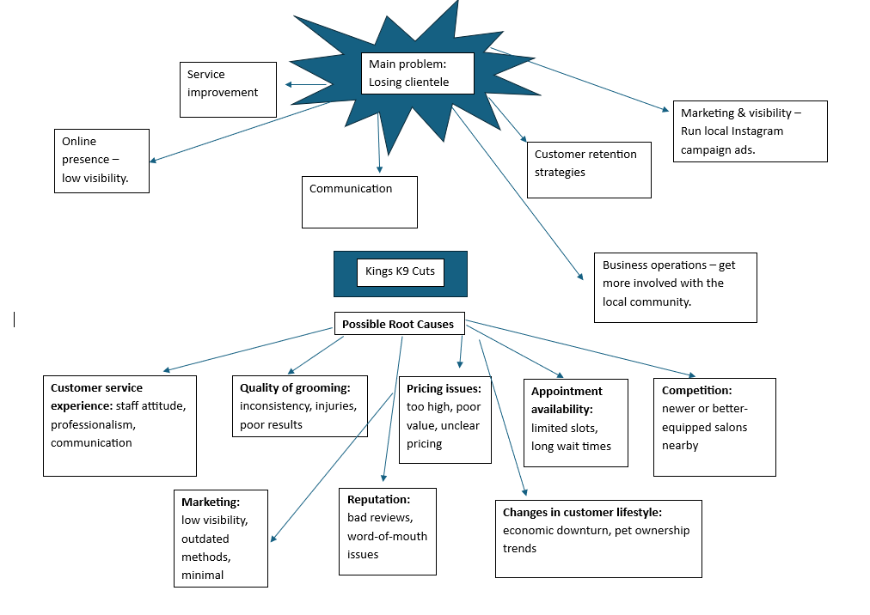
Mind Mapping helped me capture and connect all possible causes and solutions for the decline in clientele, revealing patterns and priorities that informed later analysis. It provided a creative yet structured starting point for deeper problem-solving in my dog grooming business.

Section 4: Ishikawa (fishbone) Diagram
To fully explore the root causes of the declining clientele and loss of profit, a Fishbone Diagram (Ishikawa Analysis) was then used. This technique helps visually organise potential causes of a problem by categorising them under key areas, enabling a deeper understanding of contributing factors. The central issue identified was: “Loss of Clients and Profit.”
The analysis was broken down into six main categories commonly used in service-based industries: People, Processes, Technology, Environment, Management, and Customer Service.
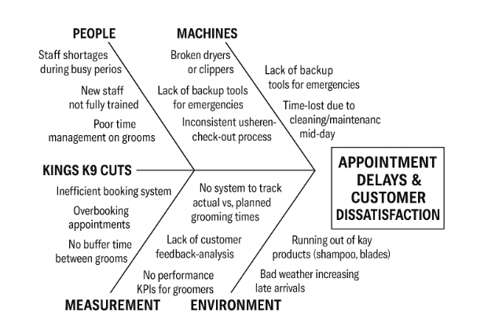

The Ishikawa diagram has provided a structured and visual method for identifying the root causes behind the loss of clientele and profit at Kings K9 Cuts. By categorising potential causes into key areas, it became clear that the problem is not solely due to the absence of a booking system but is also linked to broader operational and management issues.

Factors such as overwhelmed staff, inconsistent appointment handling, lack of automation, and poor customer booking experiences have all contributed to long waiting times and a decline in client satisfaction. These issues combined have impacted both the efficiency of the salon and the loyalty of its customer base.
This analysis highlights the importance of addressing the problem through a holistic approach, ensuring that any solution implemented—such as a new booking system—is supported by appropriate training, better processes, and ongoing management oversight.

Section 5: Decision-Making Technique: Grid Analysis
Following the identification of the root causes using the Ishikawa diagram, several possible solutions were proposed to address the decline in clientele and profit at Kings K9 Cuts. To select the most suitable option, a Grid Analysis was carried out. This decision-making technique allowed for a structured comparison of different solutions based on key factors relevant to the business.

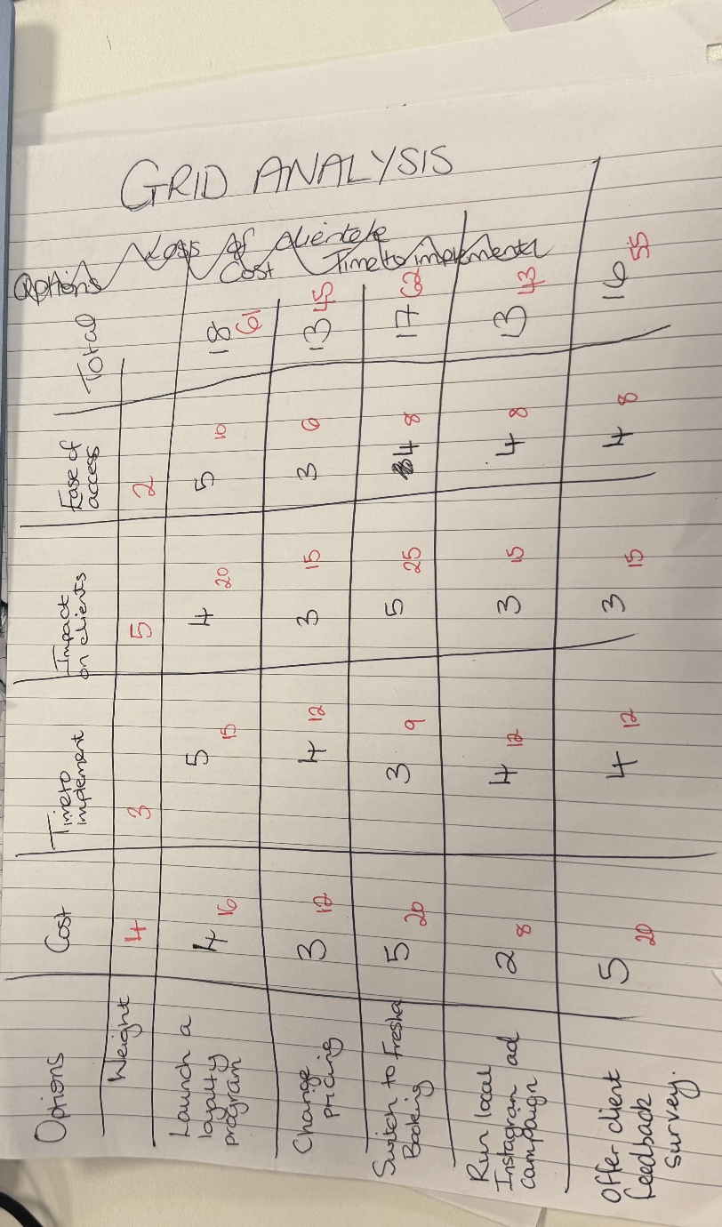

I used a Grid Analysis because it provided a clear and unbiased way to compare solutions side by side, using the criteria most important to my dog grooming business. It turned a complex decision into a logical, evidence-based choice that I can confidently justify. By assigning weightings to each criterion, I was able to prioritise factors such as customer satisfaction, cost efficiency, and time management, ensuring that the decision aligned with both short-term operational needs and long-term business goals.
The grid also highlighted potential trade-offs between options, allowing me to make a balanced choice rather than focusing on a single advantage. Ultimately, using a grid analysis increased my confidence in the decision-making process, provided a clear rationale that could be communicated to stakeholders, and demonstrated a structured approach to solving complex problems in my business.

Step 1: Identifying the Options
The following options were considered:
- Launch a Loyalty Programme
- Change pricing
- Implement the Fresha Booking system
- Run a local Instagram ad campaign
- Offer a client feedback survey

Step 2: Setting Decision Criteria
Each option was evaluated against the following criteria:
- Cost – Affordability and long-term financial impact
- Ease of Implementation – How quickly and easily it could be set up
- Impact on Customer Experience – How much would it improve client satisfaction
- Staff Efficiency – Effect on daily workload and stress levels
- Scalability – Suitability for future business growth.

Step 3: Scoring and Weighting
Each evaluation factor was weighted according to its importance to the business:
- Cost (25%)
- Ease of Implementation (15%)
- Customer Experience (30%)
- Staff Efficiency (20%)
- Scalability (10%)
Each solution was scored on a scale of 1–5 against each metric. The scores were then multiplied by the weighting to give a weighted total for each option.
Step 4: Results
The analysis showed that implementing an online booking system scored the highest overall. While it required a small upfront cost and some staff training, it offered the most benefits in terms of improving the client experience, reducing manual workload, and providing a scalable solution for future growth. In contrast, continuing with the current manual system scored lowest due to its ongoing inefficiencies and poor customer impact.
Conclusion
The Grid Analysis supported a clear and evidence-based decision: to implement an online booking system as the most effective and sustainable solution to the problem. This method ensured that all relevant factors were considered fairly and helped avoid bias or rushed decision-making.

Section 6: Cost-Benefit Ratio
A cost-benefit analysis was carried out to evaluate the financial impact of implementing an online booking system. After estimating all associated monthly costs and benefits, the cost-benefit ratio was calculated at 6.11, indicating that for every £1 spent, the business could gain over £6 in return.
Kings K9 Cuts – Online Booking System
Item | Estimated Value (Monthly)
COSTS
Booking software subscription | £30
Staff training (one-off cost) | £100 (spread over 12 months = £8.33 a month
Admin time during setup | £50
Total monthly cost | £88.33

BENEFITS
3 more clients per week (£30 each) £360
Fewer no-shows (saving) £60
Time saved on admin (extra grooming slot) £120
Total Monthly Benefit = £540
Cost-Benefit Ratio
Cost Benefit Ratio = £540 / £88.33 = 6.11

Interpretation:
For every £1 spent, the salon gains roughly £6.11 in return. This suggests that investing in an online booking system is a highly cost-effective solution. This result strongly supports the decision to implement the solution, both in terms of profitability and long-term value.

Section 7: Stakeholder Communication Plan
The table below aims to support the implementation of key changes in response to the ongoing issue of declining clientele within my dog grooming business. It outlines how effective communication with stakeholders—such as staff, clients, and suppliers—will be used to promote transparency, encourage engagement, and support informed decision-making throughout the improvement process. Clear and consistent communication is crucial for establishing trust and reducing resistance to change (Clampitt, 2021).

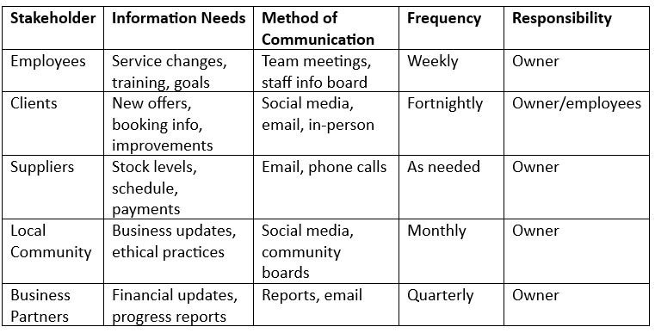

This communication plan ensures that each stakeholder receives timely and relevant information in a way that suits their needs. Employees and clients require the most frequent updates, as they are closely involved in daily operations and service delivery. Suppliers and business partners, while less involved in day-to-day activities, still require clear and consistent communication to support the business's ongoing success. By assigning clear responsibilities and using a structured approach, this plan helps build trust and supports the successful delivery of business changes.

7.1 Stakeholder Analysis
The following presents a stakeholder analysis for my dog grooming business, focusing on the issue of losing clientele. It explores each stakeholder’s potential contributions, level of participation, and influence on the decision-making process. This helps identify which stakeholders should be engaged more closely during the implementation of business improvements.
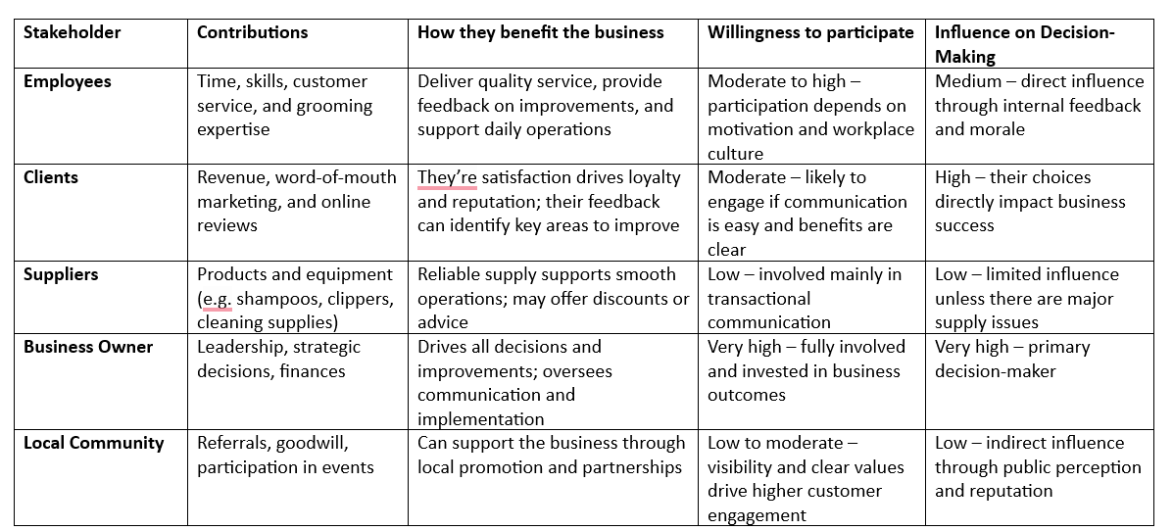
This analysis highlights that clients and employees are the most influential stakeholders in addressing the loss of clientele, due to their direct impact on service quality and customer satisfaction. The business owner remains the key decision-maker, but success depends on effective collaboration and communication with all stakeholders. By understanding each group’s role and level of influence, I can prioritise engagement strategies and make more informed decisions to support business growth.

Section 8: Monitoring Progress in the Workplace
Monitoring plays a crucial role in the effective management of a business. It enables decision-makers to assess whether current strategies are aligned with the company’s goals and to identify areas requiring improvement. According to best practices in business management, monitoring involves the regular review of key performance indicators (KPIs), budgets, processes, and outcomes to ensure that objectives are being met (Kabonga, 2019).
One of the main benefits of monitoring is that it helps keep goals clear. When businesses regularly check how well they are doing compared to their targets, they stay focused and don’t lose direction. Monitoring also helps measure how well the business is performing, like tracking customer happiness, sales, and productivity. (Tredgold, 2019).
Monitoring also helps spot problems early. For example, if customer interest drops in weekly reports, the business can fix the issue quickly before it affects profits. This is important for managing risks and preventing bigger problems.
Additionally, monitoring supports ongoing improvement by showing what’s working and what isn’t. By looking at performance data often, teams can make their processes better and respond to changes in customer needs.
From a money perspective, monitoring helps keep spending and income on track. Businesses can adjust their budgets as needed and make informed decisions based on facts rather than guesswork.

8.1 Gantt Chart Monitoring
To address the decline in clientele and profit caused by the absence of a booking system, a structured project plan is essential. A Gantt chart will be used to visually map out each phase of the solution—from identifying system requirements to full implementation and review. This tool enables clear scheduling, task allocation, and progress tracking.
Kerzner (2017) explains that Gantt charts are essential tools for visualizing project timelines and identifying decision points.
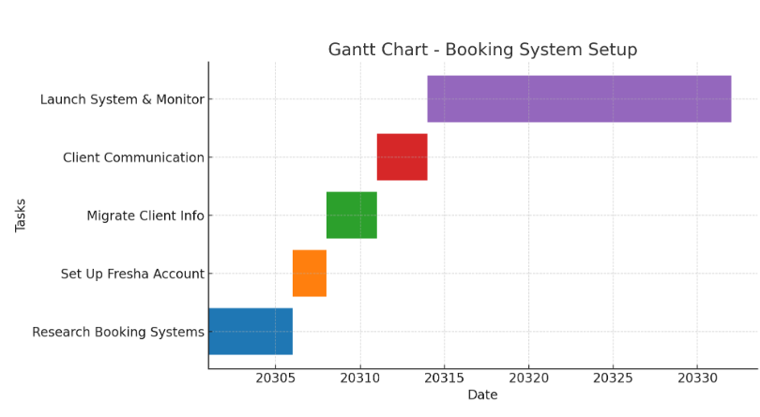
I chose to use a Gantt chart to monitor my progress because it provides a clear visual representation of each step I need to take in solving my complex problem - losing clientele and profit due to not having a booking system in place. The chart allows me to break down the overall project into smaller, manageable tasks with defined start and end dates. This helps me to see not only what needs to be completed but also the order in which tasks must be done.
By using the Gantt chart, I can track progress against deadlines, identify any delays quickly, and ensure I stay on schedule to implement the booking system. Overall, it acts as a practical tool for organisation, time management, and accountability, increasing the likelihood of solving my problem effectively and regaining client trust and profit. (Bortoff C, 2024).

Section 9: Technology Support in Decision-Making
To support my research and analysis, I made use of AI-assisted tools such as Quillbot and ChatGPT to help identify potential areas for further investigation and to generate alternative perspectives on my findings. I critically reviewed and refined these suggestions to ensure they were relevant, accurate, and aligned with the assignment requirements.

Section 10: Conclusion

This assignment explored the complex problem of declining client retention and profitability at Kings K9 Cuts. Through the use of problem-solving tools such as the 5 Whys, Mind Mapping, and Ishikawa Diagram, I was able to identify the root causes of the issue, particularly the lack of an efficient booking system. A Grid Analysis provided a structured way to evaluate potential solutions, with an online booking system emerging as the most effective and sustainable option. Cost-benefit analysis confirmed the financial viability of this choice, and a Gantt chart, along with a stakeholder communication plan, ensures structured implementation and monitoring. Overall, applying these techniques has demonstrated how structured problem-solving and evidence-based decision-making can improve customer satisfaction, staff efficiency, and long-term profitability in a small business setting.

Section 11: References
American Society for Quality. (2025). What is Problem Solving? Steps, Process & Techniques. Asq.org. https://asq.org/quality-resources/problem-solving

Atlassian. (2025). Run a 5 Whys Exercise with Your Team to Identify Root Causes. Atlassian. https://www.atlassian.com/team-playbook/plays/5-whys

Bottorff, C. (2024, February 2). What Is a Gantt Chart? Here Are the Basics. Forbes Advisor; www.forbes.com. https://www.forbes.com/advisor/business/software/what-is-a-gantt-chart/

Bryan. (2022, February 1). What is complex problem-solving and how can I do it? Bryan Lindsley. https://bryanlindsley.com/what-is-complex-problem-solving/

CMI. (2020, March 31). Problem Solving. CMI. https://www.managers.org.uk/knowledge-and-insights/resource/problem-solving/

Communicating for Managerial Effectiveness. Google Books. Published 2016. https://books.google.co.uk/books/about/Communicating_for_Managerial_Effectivene.html?id=w35ZDwAAQBAJ&redir_esc=y

Gordon. (2019, September 11). 5 Ways To Monitor Your Business Performance. Gordon. https://gordontredgold.com/5-ways-to-monitor-your-business-performance/

Hayes, A. (2024). Cost-Benefit analysis: How it’s used, pros and cons. Investopedia. https://www.investopedia.com/terms/c/cost-benefitanalysis.asp

How To Monitor a Project (With Tips). Indeed Career Guide. Published 2025. Accessed August 3, 2025. https://www.indeed.com/career-advice/career-development/monitoring-a-project

Huang, V. (2023, June 13). Complete Guide to Gantt Charts for Project Management. Blog.harvestr.io. https://blog.harvestr.io/ganttchart

Indeed Editorial Team. (2021, June 2). Complex Problem-Solving: Definition and Steps. Indeed Career Guide. https://www.indeed.com/career-advice/career-development/complex-problem-solving

Kabonga, I. Principles and Practice of Monitoring and Evaluation: A Paraphernalia for Effective Development. Africanus Journal of Development Studies. 2019;48(2). doi: https://doi.org/10.25159/0304-615x/3086
‌
Kerzner, H. (2017). *Project management: A systems approach to planning, scheduling, and controlling* (12th ed.). Wiley.
‌
‌Satyamedh Nandedkar. (2025, February 24). Managerial Communication: Importance, Types, Barriers & Tips. Plutus Blog. https://plutuseducation.com/blog/managerial-communication/

