School of Engineering

Proposal for Independent Project
ACMA 6013

Paul Benbow
2014803
17/09/2023



Table of Contents
Introduction 1
Aims 1
Relevance 2
Timeline 2
Literature Survey 2
Work Completed To Date 2
Next Steps 2
Appendix A 3
Appendix B 8
Appendix C 16
Appendix D 17
Bibliography 18

Figure 1 Kiln 2 Born Heater 1

Introduction
This proposal suggests an investigation based on further work detailed in a report (Appendix A) and a presentation (Appendix B) which identifies inefficient gas consumption of a born heater at Vale Clydach.
The report was commissioned by Vale Europe Ltd in 2012 as a response to a comparison made between monthly Natural Gas meter readings feeding two born heaters.
Clydach Refinery uses the ‘Mond Process’ to extract a near perfect Nickle product from Nickle Oxide sinter (TNOS), which has been processed in Matsusaka, Tokyo.
The initial reaction required in the ‘Mond Process’ involves a ratio of TNOS and Nickel Sulphate being heated to 400°C. This is achieved by propelling Hydrogen gas which has been heated, into a rotating vessel (kiln), as the mixture of raw material flows in the opposite direction. The objective of the reaction is to reduce the material by removing impurities such as Iron and Cobalt, a by-product of the reaction is the formation of water vapour.
The ‘Mond Process’ at Clydach is automated and controlled by a Distributed Control System (DSC) through which, process set-points and control strategy can be adjusted to suit the process environment. Instrumentation such as; Thermocouples, Gauge Pressure Transmitters and Differential pressure Transmitters are used to measure process variable such as; temperature, flow and pressure. The control strategy embedded in the DCS makes any required adjustment to the process variable with an actuating device, typically a butterfly control valve.
Clydach refinery has two separate process lines which performs this process, each have a Born Heater (Figure 1), that is used to heat Hydrogen Gas to the required temperature. Kiln 2 Born heater has been found to be less efficient than Kiln 1 with an annual energy consumption of 19,032,426KWh Verses 14,267,761KWh (CR PLus Ltd, 2013).
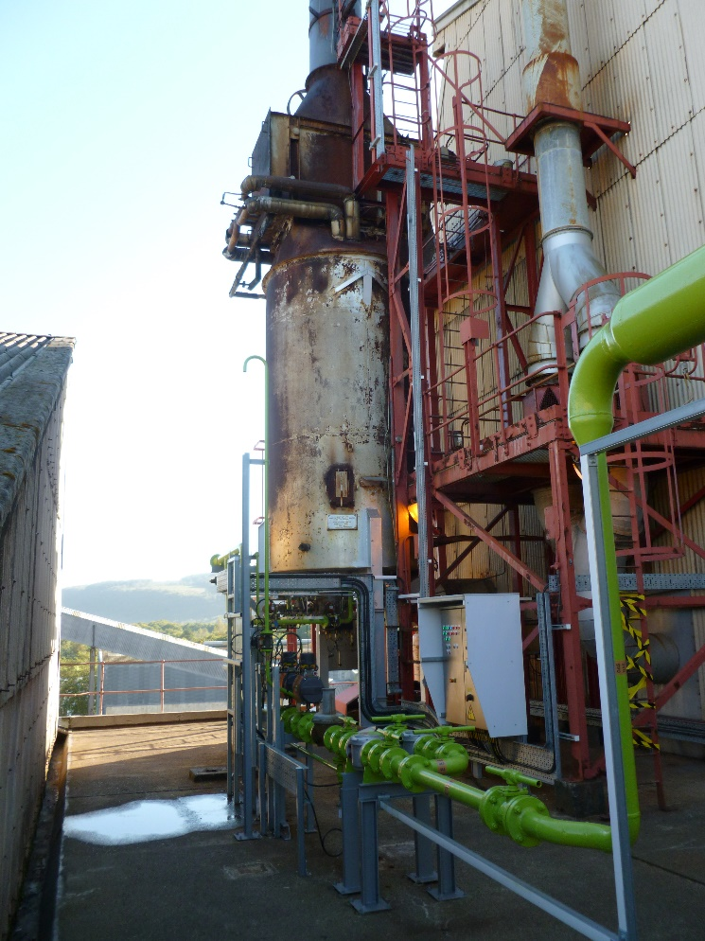
Figure 1 Kiln 2 Born Heater

Aims
The original report (Appendix A), focuses on the losses incurred by Kiln 2 Born Heater however, assumptions have been made during that investigation. Little attention was given to the inputs that are required for the born heater to perform its function and, how the quality of said inputs effect its efficiently.
For instance, a datum temperature of 9°C, an assumption of 100% purity and an assumption of a pressure of 1.5 Bar were used to model Hydrogen flowing into each of the Born heater (Davies, 2012). This suggests that there was little consideration to the effects of how the process inputs entering a Born Heater could affect its efficiency.
The aim of this report is to identify and then to evaluate all inputs required for a Born Heater to perform its function. Particular attention shall be made to the quality of; Hydrogen gas flowing to the born heater and how this could create a disturbance to the control system which tries to maintain a desired temperature set-point.

Relevance
Material science topics shall be researched to understand thermal conductivity of gases, in particular Hydrogen and any other gases that are a composite of the process gas flowing into the Born Heater.
Knowledge of control and automation shall be used to establish the control strategy of the Born Heater, a focus shall be how and where the process variable is measured then, what control philosophy is used to adjust the temperature within the born heater.
If analysis suggests possible improvements to the quality of the afore mention input into the Born Heater then, it is likely that a sound knowledge of the systems control strategy will be required so, further work such as; adjustment to system configuration, can be discussed.
Process gases will need to be analysed and documented therefore an appropriate measuring system shall need to be created, this will draw on Six Sigma knowledge to design a system that considers process capabilities. Other Six Sigma tools likely to be used during this project will include; Process Mapping; Root cause Analysis; Failure Mode and Effect Analysis.

Timeline
The timeline shown in Appendix C shows milestones which need to be achieved for the an adequate presentation of project information and progress can be made during the Interim Oral Examination.
A subsequent timeline will be presented in the interim Oral Examination which inform of the proceeding activities which will require completion before the ‘Final Dissertation Report’ hand-in date.

Literature Survey
An understanding of how gases absorb energy will be required therefore, information from sources such as Ahsan (2011), and Whitley, et al. (2014).
In depth Knowledge of how the ‘Mond Process’ works will be taken from Mond Process (2020), and operational process manuals.
The purity of the Hydrogen gas that is to be heated by the Born Heater shall have to be verified. It is unknown to the author if this facility exists at the refinery however, research of methods used shall be explored with literature such as; Arrhenius, et al. (2020).

Work Completed To Date
A cooperative industrial partner, Christopher Stirling a member of the Refinery’s Technical Department, has provided background information of Natural Gas meter readings (Appendix D).

Next Steps
As the timeline shown in Appendix C illustrates, the project requires research. Collation of available information is required to establish a sound working knowledge of the process.

Appendix A
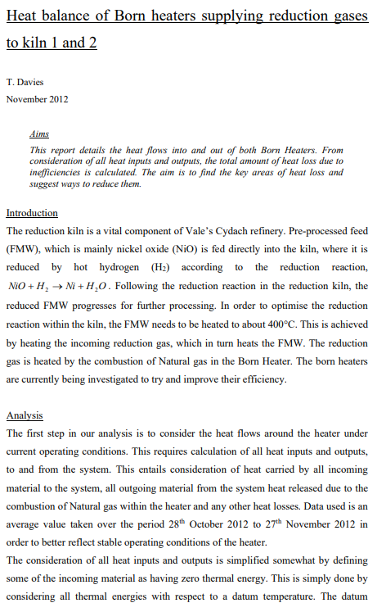
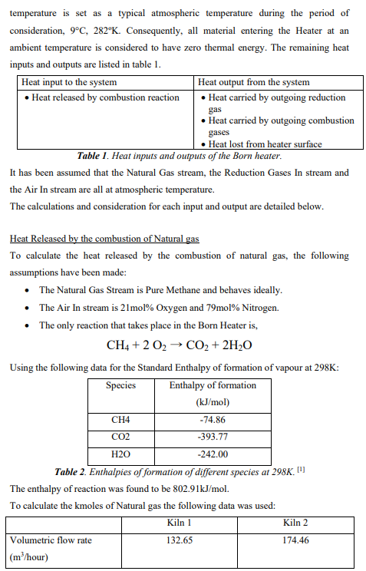
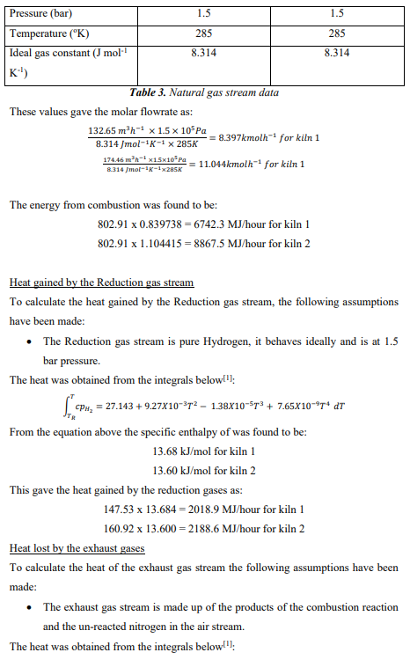
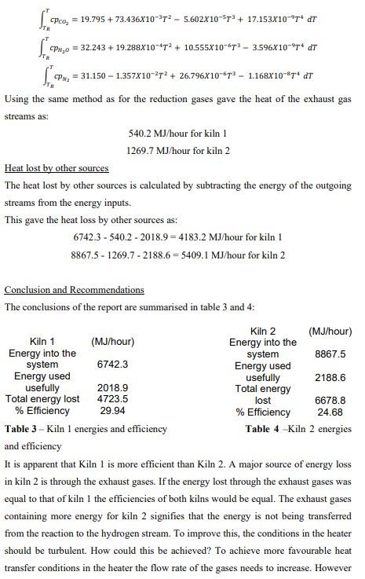
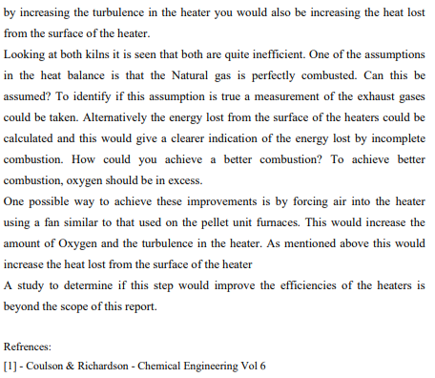

Appendix B
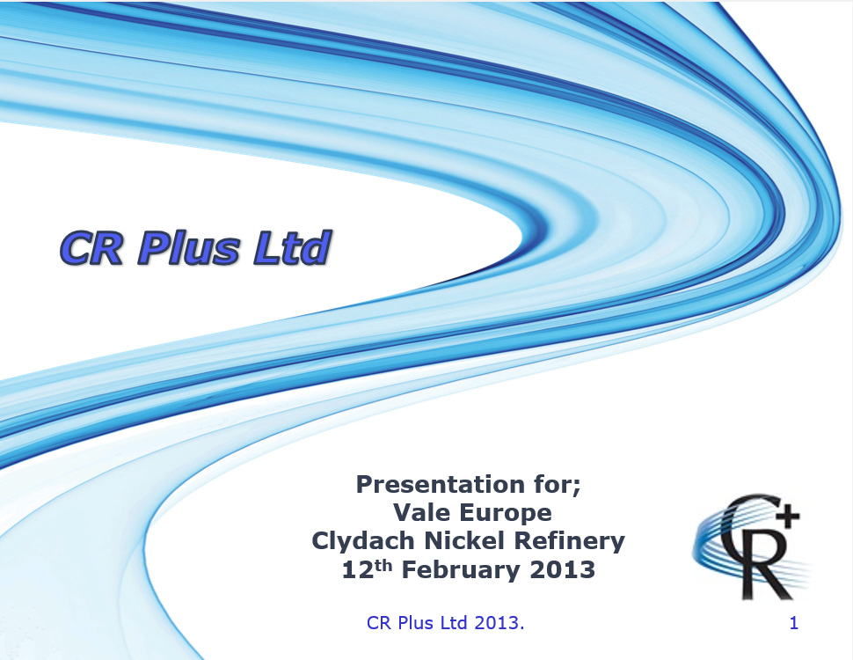

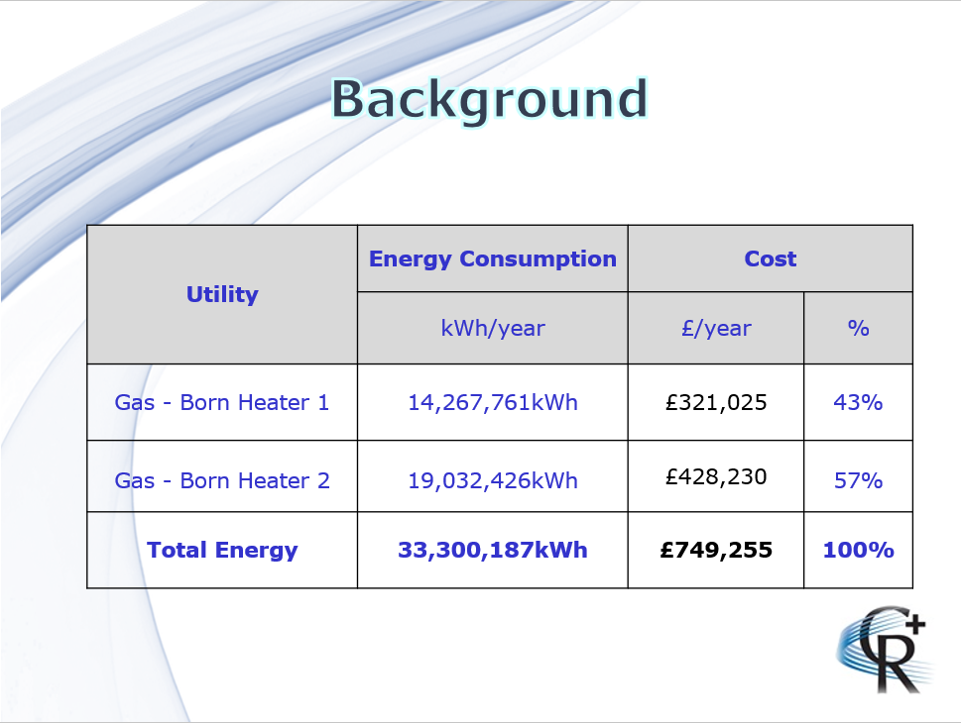

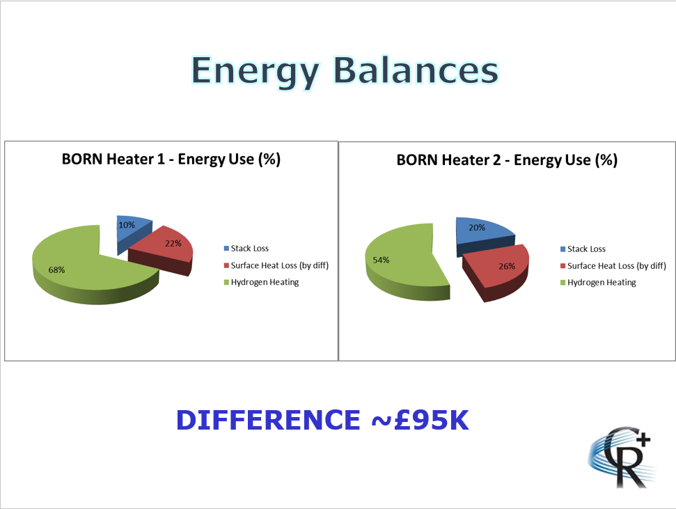

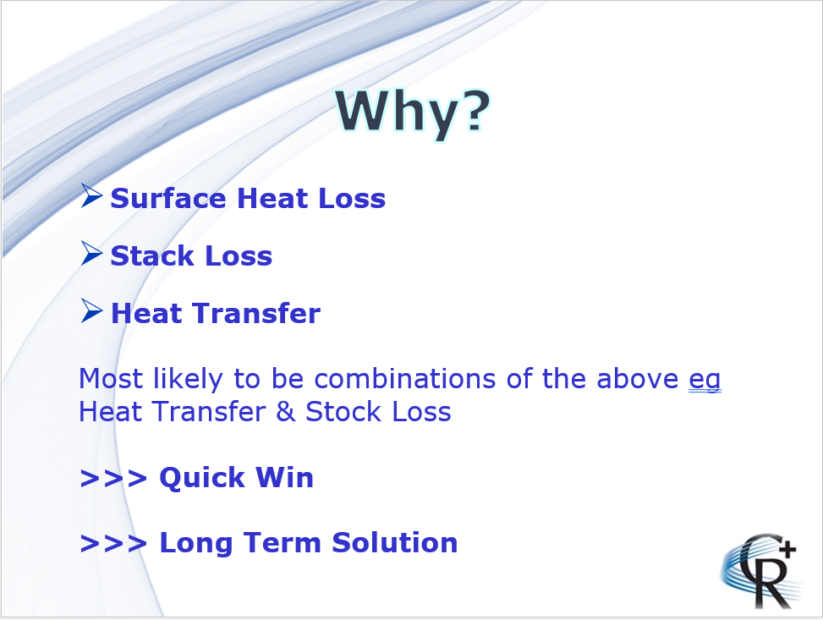

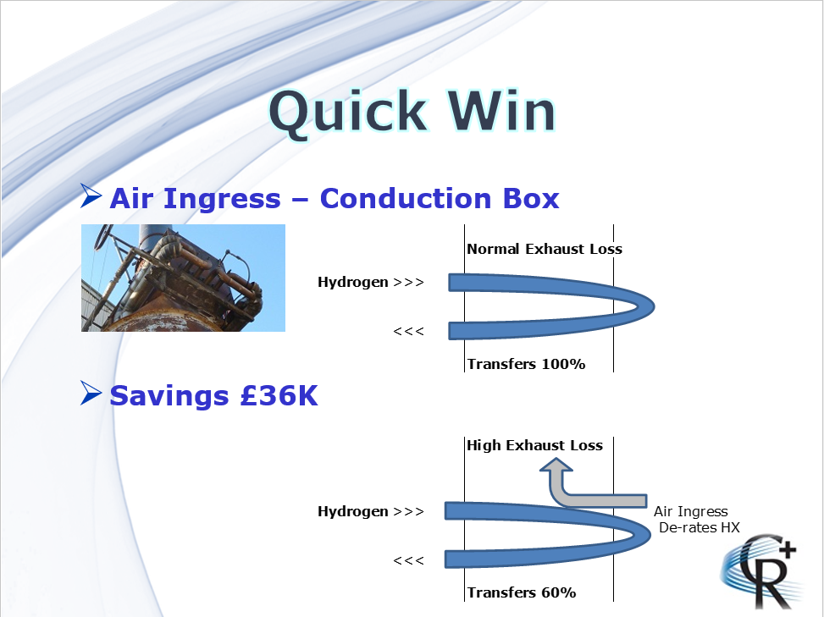

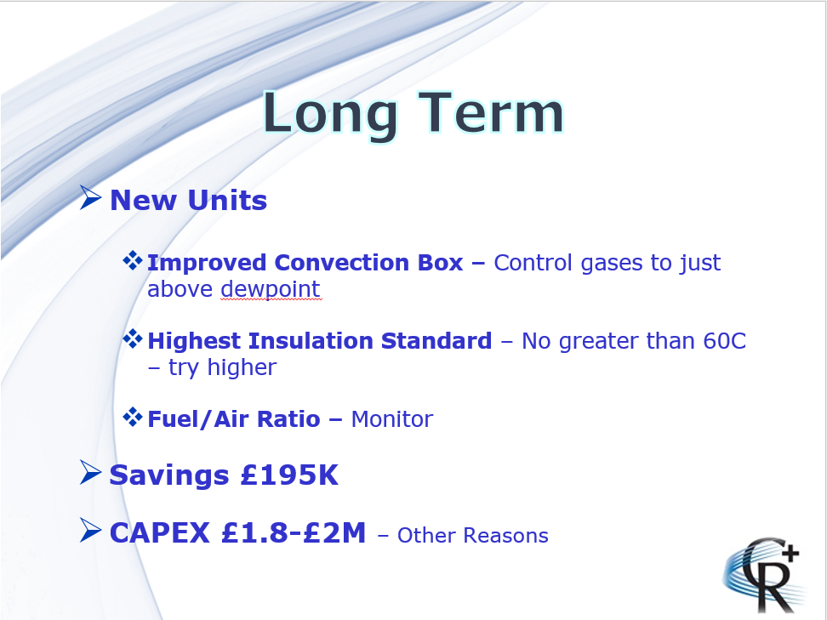
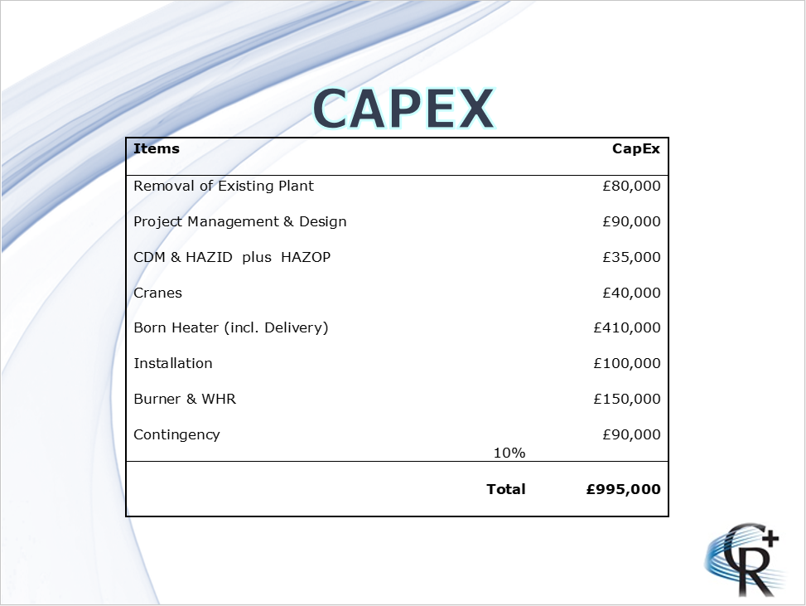
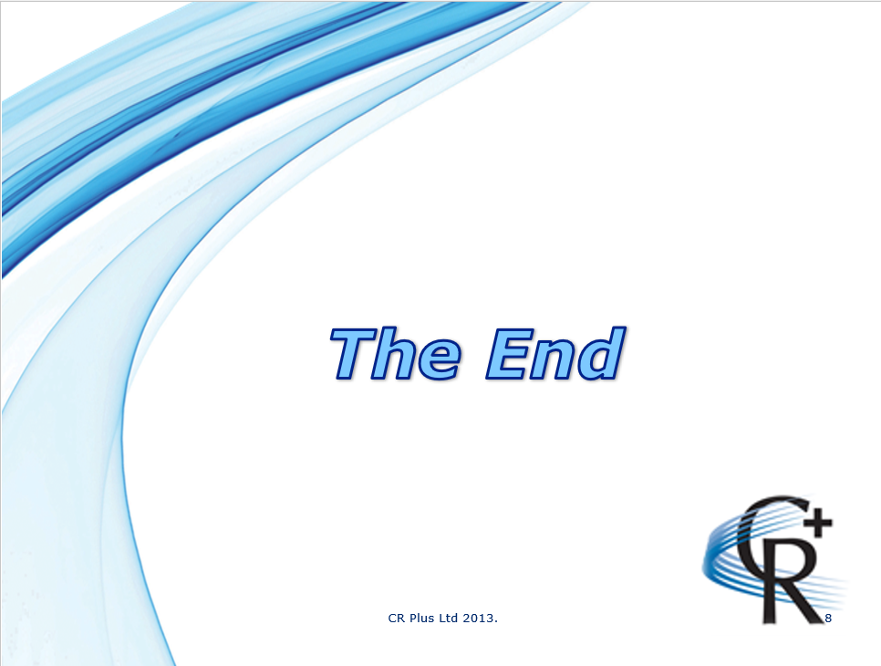

Appendix C

Appendix D
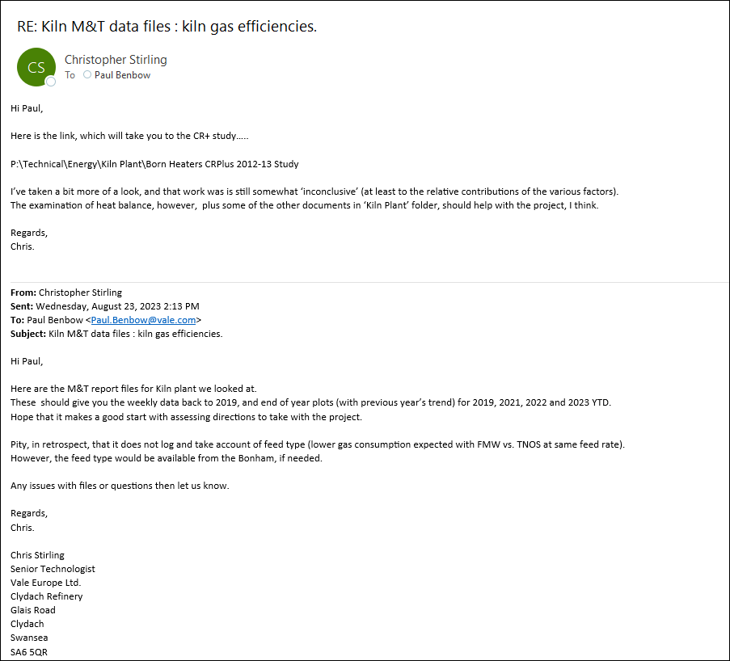

Bibliography
Ahsan, A., 2011. Convection and Conduction Heat Transfer. Swinburne: InTachOpen.
Arrhenius, K. et al., 2020. Development and evaluation of a novel analyser for ISO14687 Hydrogen purity analysis. Measurement science & Technology, 31(7).
CR PLus Ltd, 2013. Born Heater Potential v1 - 12 Feb 2013, s.l.: CR Plus Ltd.
Davies, T., 2012. Heat Balance of Born heaters suppliying reduction gases to kiln 1 and 2, s.l.: CR Plus Ltd.
Mond Process, 2020. A Dictionary Of Chemistry. 8 ed. Oxford: Oxford University Press.
Whitley, H. D. et al., 2014. Lenard-Balescu Calculations and Classical Molecular Dynamics Simulations of Electrical and Thermal Conductivities of Hydrogen Plasmas. Contribution to Plasma Physics, 55(2-3), pp. 192-202.

