

Programme: MSc Data and Artificial Intelligence
Module Code: ACCA7022
Module: Advanced Statistical Programming
Assignment Title: Data Analysis

Word Count: 2,133

Table of Contents
Task 1 - Air Quality Analysis of the Port Talbot Hourly Air Quality Dataset 2
Introduction to the Dataset 2
Task 1.1 Data Import and Preparation 2
Task 1.2 Descriptive Statistics 3
Task 1.3 Exploratory Visualization 4
Task 1.3.1 Time Series Analysis 4
Task 1.3.2 Scatter Plot Analysis 5
Task 1.4 Correlation Analysis 7
Task 1.5 Hypothesis Test 9
Task 1.6 Seasonal Group Analysis Using One-Way ANOVA 10
Task 1.8 Summary 12
Task 2 - Reflective Summary 13
Statement on AI Usage 14
References 15

Task 1 - Air Quality Analysis of the Port Talbot Hourly Air Quality Dataset

Introduction to the Dataset
The Port Talbot Hourly Air Quality dataset consists of hourly data for pollutants and weather variables from 2015 to 2024. It makes it easy to analyse the trend, relationships, and seasonal variations in air pollution in R.

Task 1.1 Data Import and Preparation
The dataset was imported into the R environment by reading it in with the readr package method of read_csv(). The data were pre-processed to ensure quality and uniformity for analysis [1]. Since there were many "No data" values, all these were treated as missing values and converted to “NA” so that R was able to exclude missing observations during statistical analysis. Status columns were not kept as they were not required for the analyses needed.

Figure 1 Source code for Importing CSV Data and NA Transformation
All pollutant and weather variables were changed to numeric values and the Date column was converted to a recognised date format. Combined DateTime variable was created for time-series visualisation [2].
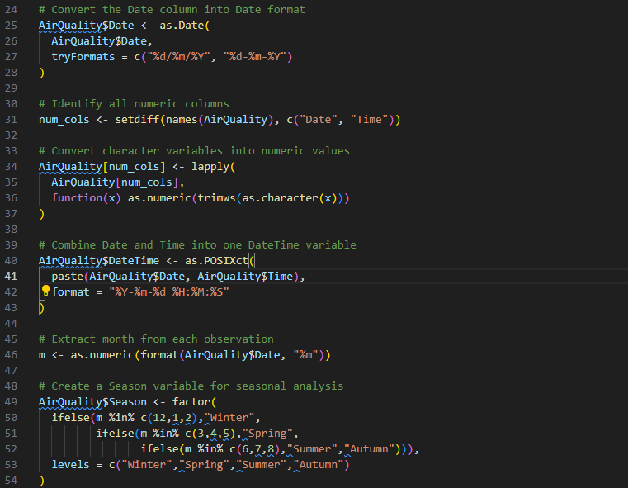
Figure 2 Type Conversion Code
Furthermore, a season variable (Winter, Spring, Summer and Autumn) was created based on the month of observation for the purpose of comparing observations across seasons.
The cleaned data set consisted of 87,672 hourly observations and 15 variables, which is a large sample to conduct descriptive and inferential statistical analysis.
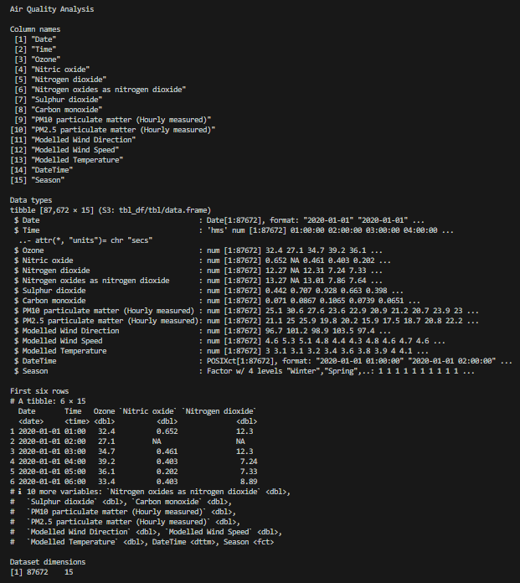
Figure 3 Data Imported and Dimensions

Task 1.2 Descriptive Statistics
Descriptive statistics were created to gain knowledge of the distribution of pollutant concentrations and weather data [3].
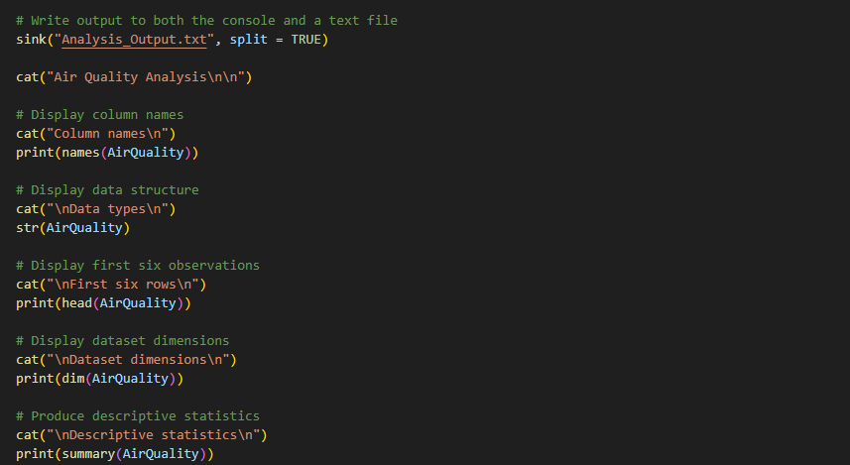
Figure 4 Source code for Descriptive Statistics
The average concentration of ozone was nearly 53.0 µg/m³, varying from almost 0 to nearly 165 µg/m³. The overall mean concentrations of PM2.5 were 9.3 μg/m³, with a few extreme pollution situations with PM2.5 concentration above 200 μg/m³. The maximum value observed was PM10 at 575μg/m³, which means that there were also periods of extremely poor air quality.
Several variables had missing observations due to the original data set having measurements with the label “No data”. Substitution of these values was not done, and instead it was finalized to exclude these records from further analyses, which in turn minimized the chance of bias.
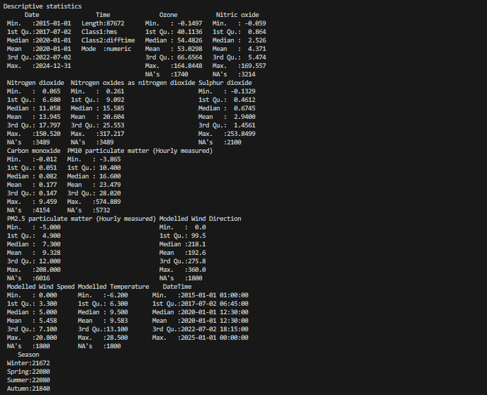
Figure 5 Descriptive Statistics

Task 1.3 Exploratory Visualization

Task 1.3.1 Time Series Analysis
Time-series plots were made for the concentration of both ozone and PM2.5 to examine the long-term behaviour from 2015 to 2024.
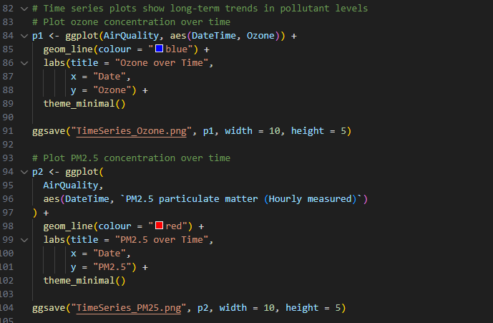
Figure 6 Source Code for Time-series line-chart plotting
The ozone time-series is almost always fluctuating during the total study period and peaks almost every year, seasonally. The concentrations fluctuated greatly with time but there was no clear trend of increase or decrease with time. In general, ozone showed a cyclic pattern similar to the seasonal variation in the atmosphere [4].
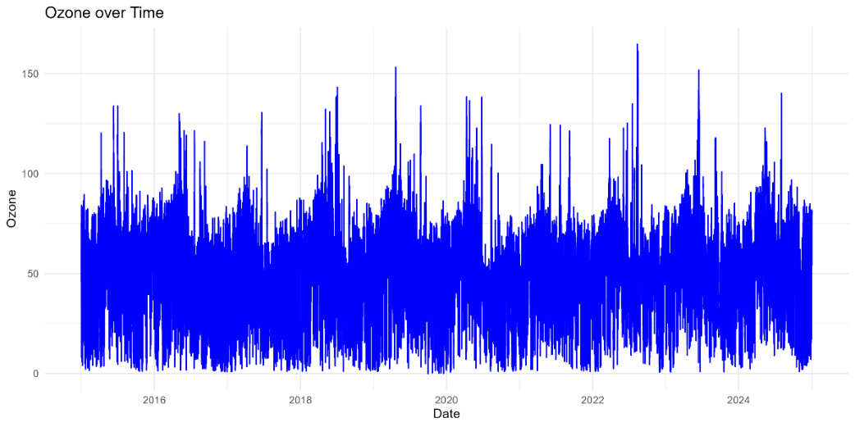
Figure 7 Time Series Analysis of Ozone Pollutant
The time-series of PM2.5 was later conducted, that shows relatively low background concentrations for most observations, but with a number of distinct spikes above 200μg/m³. The separate peaks indicate occasional episodes of pollution, rather than ongoing poor air quality.
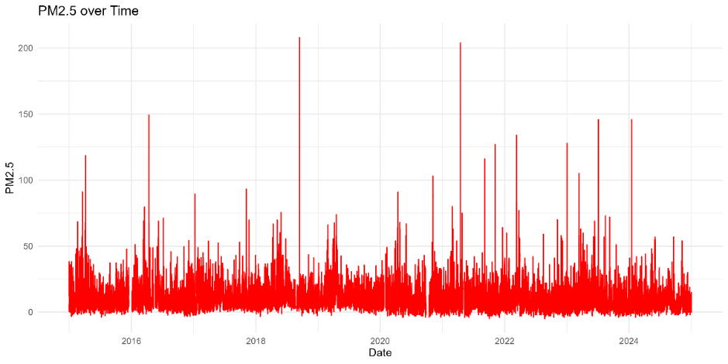
Figure 8 Time Series Analysis of PM2.5 Pollutant

Task 1.3.2 Scatter Plot Analysis
The relationships between selected pollutant and meteorological variables were investigated using scatter plots [5].
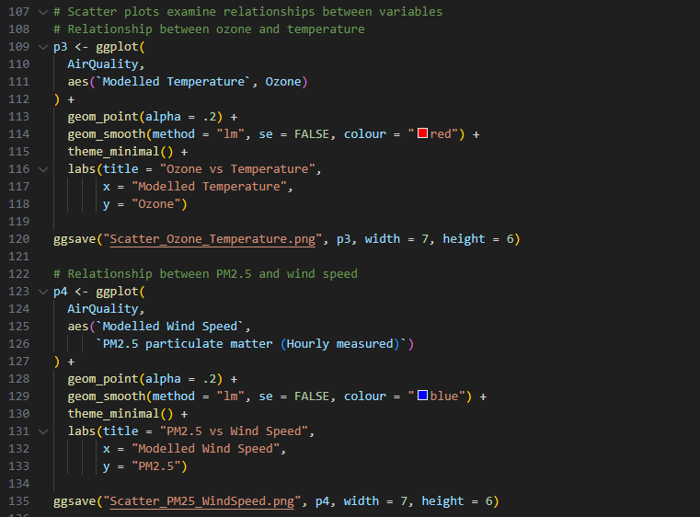
Figure 9 Source Code for Scatter Plot Analysis
There is a positive linear trend between the concentration of ozone and modelled temperature. The regression line fitted suggests that there is an overall trend of increasing ozone concentrations with increasing temperatures. Also, as can be seen, there is a significant amount of scatter around the fitted line, however, indicating that there are other factors besides temperature that affect the formation of ozone [6].
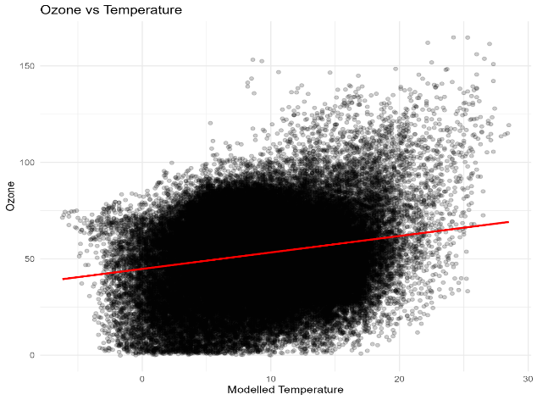
Figure 10 Ozone-Temperature Scatter Plot
The scatter plot of PM2.5 concentration versus wind speed, on the other hand, shows a very weak-correlation. The regression line is very flat, suggesting that the wind attribute alone doesn't have a significant impact on PM2.5 concentrations in this set of data.
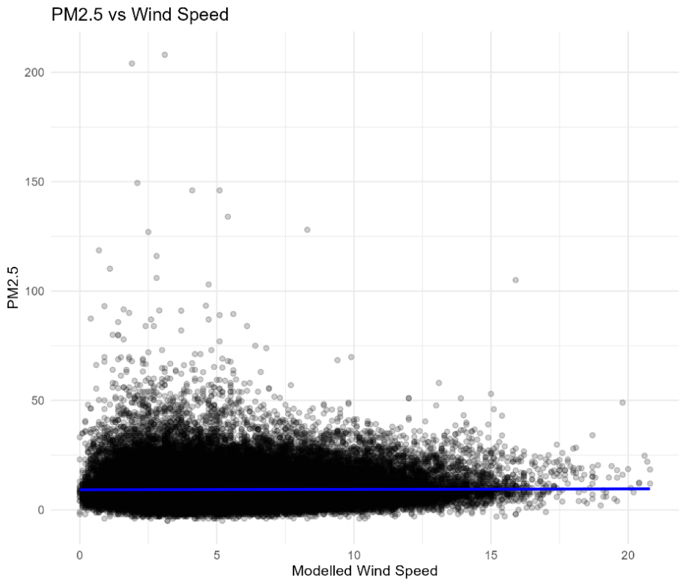
Figure 11 PM2.5-WindSpeed Scatter Plot
The visualisations show that ozone is more closely correlated with meteorological conditions than PM, but that there is significant natural variability in both.

Task 1.4 Correlation Analysis
Pearson correlation analysis was used to measure the relationships between the major pollutants. This is the method where a statistical metric that assesses the direction and strength of a linear relationship between two continuous variables is used for understanding correlation between multiple variables in a dataset [7].
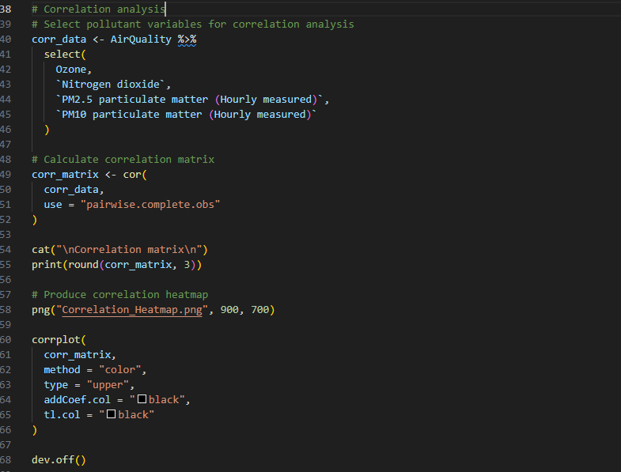
Figure 12 Correlation Mapping Source Code
The moderate positive correlation was found between PM2.5 and PM10 with r = 0.605. This indicates that the concentration of both particulate pollutants tends to rise together, probably due to the fact that they are emitted from the same sources [8].
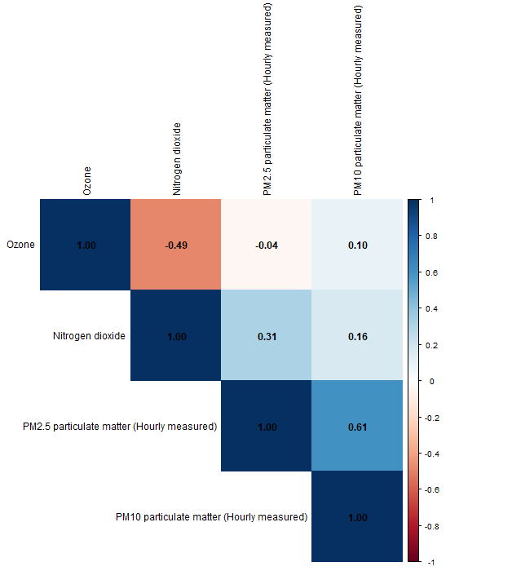
Figure 13 Correlation Matrix
A moderate negative correlation was found between ozone and NO2 (r = -0.486). The inverse relationship is consistent with well-known atmospheric chemistry that relates ozone formation and nitrogen oxides through the photochemical reaction.
There was only a weak positive correlation between N2O and PM2.5 (r = 0.315) and very weak positive correlation between O3 and PM10 (r = 0.100). The correlation heatmap displays these relationships in graphical form with their corresponding correlation coefficient (r) values, with the relationships being indicated by the intensity of the colour. The correlation heatmap clearly shows these relationships in the form of a colour coded matrix which shows the intensity of the colour to indicate the correlation coefficient (r) value for each combination of variables.
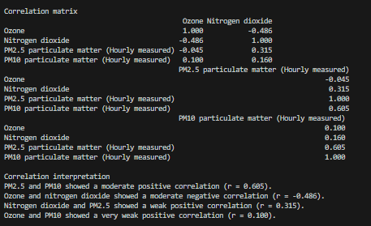
Figure 14 Correlation Analysis Interpretation
In overall terms, the correlations show that there are positive influence between the particulate pollutants, while the correlation of ozone is different from the correlation of nitrogen dioxide because ozone is generated in the atmosphere as a result of chemical processes [9].

Task 1.5 Hypothesis Test
An independent samples Welch’s t-test was conducted to assess if there was a difference between periods of high and low wind speed in ozone concentrations.
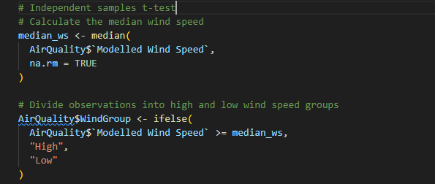
Figure 15 Welch t-test Source Code
H₀: μA = μB; High wind speed concentration of O₃ is equal to low wind speed concentration of O₃.
Alternative Hypothesis (H₁): The mean ozone concentration is different for high wind speed vs low wind speed.
The result of the analysis was highly significant (t = 86.53, p < 0.001). The mean concentration of ozone during the higher wind speed period was about 58.7 μg/m³ while the lower wind speed period was 47.2 μg/m³.
The p-value is well below the 0.05 level of statistical significance, so the null hypothesis is rejected. The results yield strong statistical evidence for the difference in ozone between the wind speed groups.
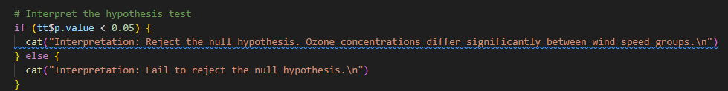
Figure 16 Hypothesis Condition Check Source Code
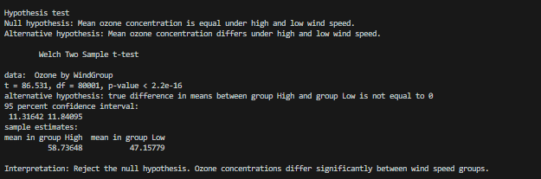
Figure 17 Welch Independent Samples t-Test Comparing Ozone Concentrations between High and Low Wind Speed Groups

Task 1.6 Seasonal Group Analysis Using One-Way ANOVA
A one-way Analysis of Variance (ANOVA) was used to see if the mean concentration of O3 was different across seasons. A one-way ANOVA is a hypothesis test that determines if the means of three or more groups differ substantially for a single factor [10].
A null hypothesis (H₀): The average level of O₃ is the same for all seasons.
Alternative hypothesis (H₁): At least one of the seasonal means is different.
The ANOVA test yielded a very significant result (F = 2851, p < 0.001), meaning that the seasonal variation is statistically significant in affecting the concentration of ozone.
Given the overall test was significant, Tukey HSD post hoc analysis was done to determine which seasons were different.
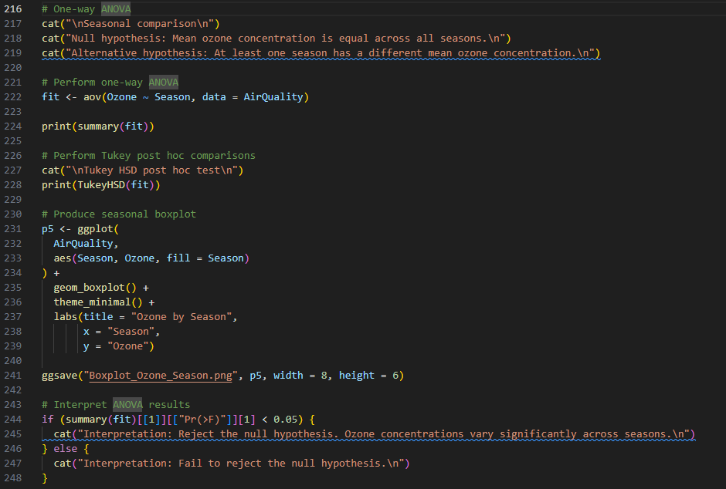
Figure 18 ANOVA Test and Tukey HSD Source Code
The results indicated that there was a significant difference for each pair in the seasons. The highest average ozone concentration was observed during spring, and the lowest during autumn. While the difference in size was small for Winter and Summer, the difference was also significant considering the large sample size.
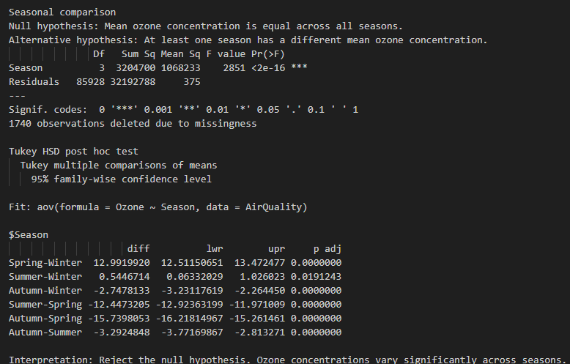
Figure 19 One-Way ANOVA and Tukey HSD Results for Seasonal Ozone Concentrations
This information is reinforced by the seasonality box plot. The highest median ozone occurs in the spring with many upper outliers, and the lower central values of ozone occur in summer and autumn. The inter-seasonal spread of observations is also different, which reflects differences in average concentration and also variability [11].
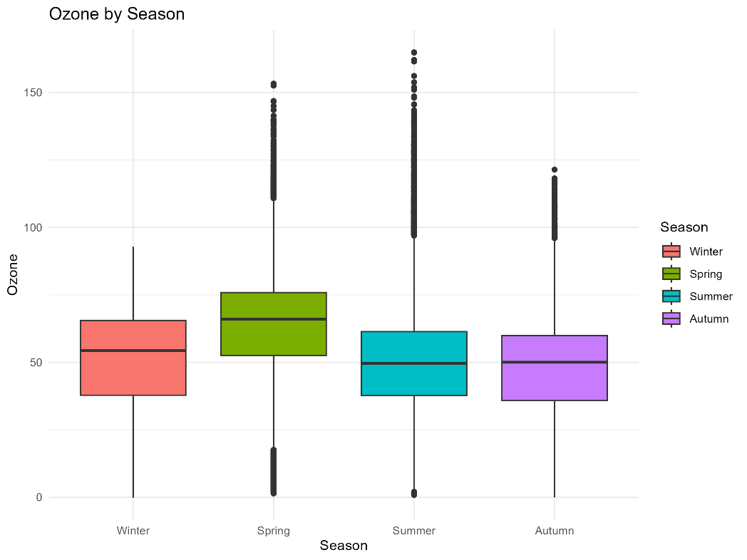
Figure 20 Distribution of Ozone Concentrations across Seasons
The results indicate that ozone concentrations are highly dependent on the atmospheric conditions during the different seasons of the year, with higher ozone concentrations occurring during the warmer seasons.

Task 1.8 Summary
The above analysis was a success as it blended descriptive, visualisation and hypothetical statistical techniques to explore the pattern of air quality in Port Talbot. Clear seasonal cycles and occasional pollution episodes were observed in time-series plots. The scatter plots indicated positive relationship between ozone concentration and temperature, while PM2.5 had little association with wind speed. Moderate correlation was found between some pollutants, such as PM2.5 and PM10, by correlation analysis. Lastly, the differences in ozone concentration in wind speed groups and seasons were statistically significant in both the Welch t-test and One-way ANOVA approaches, thus indicating that there is significant evidence of air quality differences due to meteorological conditions within the study area.

Task 2 - Reflective Summary

This project provided me with valuable practical experience in applying statistical analysis and data visualisation techniques in R using a large real-world environmental dataset. My overall approach was to develop a structured and reproducible workflow that began with importing and cleaning the dataset before progressing through descriptive statistics, exploratory visualisation, correlation analysis and inferential statistical testing. I organised the code into logical sections with clear comments so that each stage of the analysis could be easily understood, maintained and reproduced [12]. Throughout the project, I realised that writing clear and well-structured code is just as important as producing accurate statistical results because it simplifies debugging, improves readability and supports reproducible research.
Selecting appropriate visualisations was one of the most important decisions during this project. I used line graphs to display ozone and PM2.5 concentrations over time because they are well suited for showing long-term changes in continuous environmental observations [2]. These visualisations allowed me to identify seasonal fluctuations, recurring annual patterns and occasional pollution episodes. For example, the ozone time-series showed repeated seasonal cycles, while the PM2.5 graph highlighted several periods of unusually high pollution. The ozone time-series graph was produced using ggplot2, allowing long-term changes in ozone concentrations to be visualised clearly over the study period.
To investigate relationships between pollutants and meteorological variables, I selected scatter plots with fitted regression lines. These plots effectively displayed both the overall trend and the variability within the observations [5]. The relationship between ozone and temperature showed a positive trend, whereas PM2.5 and wind speed demonstrated only a weak association. I also produced a correlation heatmap because it summarised multiple pairwise relationships between pollutants within a single figure, making it much easier to compare correlation strengths than examining several individual scatter plots. Finally, boxplots were used to compare ozone concentrations across the four seasons because they clearly displayed differences in median values, variability and potential outliers while supporting the interpretation of the ANOVA results [10].
Although these visualisations communicated the main findings effectively, I also recognised some limitations in my approach. The dataset contained more than 87,000 hourly observations, which resulted in crowded time-series plots that made subtle long-term patterns more difficult to identify. If I were to repeat this project, I would aggregate the data into monthly averages before plotting to improve readability while still preserving seasonal trends. This experience taught me that selecting appropriate visualisations depends not only on the type of data but also on the size and complexity of the dataset.
Several challenges were encountered during the analysis. The largest issue involved numerous "No data" values, which prevented accurate statistical calculations. I resolved this by converting these entries into NA values before performing any analysis. Another challenge involved variable names containing spaces and special characters, such as PM2.5 and PM10, which initially caused syntax errors. Learning how to correctly reference these variables improved both my R programming skills and confidence. I also expected stronger relationships between pollutants and weather variables; however, the statistical analysis demonstrated that several correlations were weaker than anticipated. This reinforced the importance of relying on objective statistical evidence rather than assumptions when interpreting results.
Completing this project significantly improved my understanding of data cleaning, exploratory data analysis, hypothesis testing and statistical interpretation in R. I became more confident in using packages such as dplyr, ggplot2 and corrplot, while also gaining a better understanding of selecting appropriate statistical techniques to answer different research questions [15]. More importantly, I learned that effective data analysis requires both technical programming skills and critical evaluation of statistical findings rather than simply producing graphs or numerical outputs.
If I were to undertake this project again, I would improve the analysis by creating monthly aggregated time-series visualisations, checking statistical assumptions before selecting hypothesis tests, and developing interactive dashboards using plotly or Shiny. These improvements would enhance both interpretation and user interaction. Overall, this assignment strengthened my statistical programming skills and increased my confidence in analysing real-world environmental datasets. The knowledge and experience gained from this project will be valuable in future academic research and my future career in data science and artificial intelligence [12], [15].

Statement on AI Usage
AI assistance was only taken in order to perform generic research on pollutants and their effects on weather. AI was also subtly used to find authentic research materials on this subject, which have been referenced throughout this report.

References
[1] V. Çetin and O. Yıldız, "A comprehensive review on data preprocessing techniques in data analysis," Pamukkale Üniversitesi Mühendislik Bilimleri Dergisi, vol. 28, no. 2, pp. 299–312, 2022.
[2] Ó. P. Lamigueiro, Displaying Time Series, Spatial, and Space-Time Data with R. Boca Raton, FL, USA: Chapman and Hall/CRC, 2018.
[3] D. L. Hahs-Vaughn and R. Lomax, An Introduction to Statistical Concepts. London, U.K.: Routledge, 2020.
[4] N. Kawano, T. Nagashima, and S. Sugata, "Changes in seasonal cycle of surface ozone over Japan during 1980–2015," Atmospheric Environment, vol. 279, p. 119108, 2022.
[5] R. I. Kabacoff, R in Action: Data Analysis and Graphics with R and Tidyverse. New York, NY, USA: Simon & Schuster, 2022.
[6] M. D. Cattaneo, R. K. Crump, M. H. Farrell, and Y. Feng, "On binscatter," American Economic Review, vol. 114, no. 5, pp. 1488–1514, 2024.
[7] A. J. Ashok, S. Faiz, R. H. Ali, and T. A. Khan, "Data-driven baseline analysis of climate variability at an Antarctic AWS (2020–2024)," Digital, vol. 5, no. 4, p. 50, 2025.
[8] A. Keshavarzi and V. Kumar, "Spatial distribution and potential ecological risk assessment of heavy metals in agricultural soils of Northeastern Iran," Geology, Ecology, and Landscapes, vol. 4, no. 2, pp. 87–103, 2020.
[9] V. Shah, D. J. Jacob, R. Dang, L. N. Lamsal, S. A. Strode, S. D. Steenrod, K. F. Boersma, S. D. Eastham, T. M. Fritz, C. Thompson, and J. Peischl, "Nitrogen oxides in the free troposphere: Implications for tropospheric oxidants and the interpretation of satellite NO₂ measurements," Atmospheric Chemistry and Physics, vol. 23, no. 2, pp. 1227–1257, 2023.
[10] N. Milanes-Baños, "Step-by-step one-way ANOVA analysis with the Jamovi Program," Mexican Journal of Medical Research ICSA, vol. 12, no. 23, pp. 22–26, 2024.
[11] M. G. Baker, R. C. Aster, R. E. Anthony, J. Chaput, D. A. Wiens, A. Nyblade, P. D. Bromirski, P. Gerstoft, and R. A. Stephen, "Seasonal and spatial variations in the ocean-coupled ambient wavefield of the Ross Ice Shelf," Journal of Glaciology, vol. 65, no. 254, pp. 912–925, 2019.
[12] Y. Xie, "knitr: A comprehensive tool for reproducible research in R," in Implementing Reproducible Research. Boca Raton, FL, USA: Chapman and Hall/CRC, 2018, pp. 3–31.
[13] A. Abid, M. J. Zhang, V. K. Bagaria, and J. Zou, "Exploring patterns enriched in a dataset with contrastive principal component analysis," Nature Communications, vol. 9, no. 1, p. 2134, 2018.
[14] P. Mishra, U. Singh, C. M. Pandey, P. Mishra, and G. Pandey, "Application of Student's t-test, analysis of variance, and covariance," Annals of Cardiac Anaesthesia, vol. 22, no. 4, pp. 407–411, 2019.
[15] J. Chumnaul and M. Sepehrifar, "Smart data analysis V2: A user-friendly software for non-statisticians," PLOS ONE, vol. 19, no. 7, p. e0297930, 2024.

