Carmen-Liliana Dinca| STUDENT ID: 1919499

Developing relationships and workplace achievements
BMSW5102
Table of Contents
Introduction: 2
Critical assess: 2
The HRM Guest model 2
Fresh Direct HRM Guest model Applied 2
Company model outcome 3
Identify and Recommendation: 4
Social Learning Theory: 4
Vroom’s Expectancy Theory: 5
Kahn Work Engagement Theory: 5
Conclusion: 6
SWOT and PDP: 6
SWOT Analysis 6
Personal Development Plan (PDP): 7
References 8

Introduction:
This paperwork have as purpose to assess and identify the company faced issues. As a HR specialist I had been employed to analyse the Fresh Direct company case study in order to create a good strategy to resolve the company issues. To do that I segmented the report in three main part and I used multiple theory to identify, assess, recommend and solve the company issues and need which are included in the first two parts and in the third part I implement a strategy for the company using SWOT Analysis and creating a Personal Development Plan for the Fresh Direct Company.

Critical assess:
As a specialist Human Resources manager , I will critically assess the procedures that had been deployed by Fresh Direct company. To do that I will use the Guest Model of HRM by first explaining the model and after I will apply the model to the company case study.

The HRM Guest model
According with Alan Price, The HRM Guest model have been create by in 1997, the Guest model emphasizes on the assumption that Human Resources manager has specific strategies to begin with, which demand certain practices and when executed will result in outcomes. The Guest model of HRM have 6 dimensions of analysis, which are: HRM strategy; HRM practices; HRM outcomes; Behaviour outcomes; Performance outcomes and the Financial outcomes dimension. (Price, 2011)the model is focused to prescriptive in the sense that it is based on the assumption that HRM is distinctively different from traditional personnel management. Further to understand each dimension I will lay down below the definition for each of them:
HRM strategy- is what is the company focused about.
HRM practices- is about the Recruitment, training, compensation and relation.
HRM outcomes- is the result of the HRM practice by commitment, quality and Flexibility.
Behaviour outcomes- is about how company motivate and cooperate with
Performance outcomes- is about the productivity, quantity, turnovers and negativity.
Financial outcomes- is about profit and RIO
(SHARMA, 2009)

Fresh Direct HRM Guest model Applied
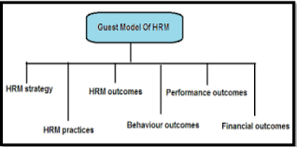
The model it will help the Fresh Direct company to see how they are developing, in order to reach a new strategy to good define an action plan. Further to ensure the that, I apply the model to the Fresh Direct company case study:
HRM Strategy- According with the case study, the Fresh Direct company is focus to grows and distribute fresh food. The company delivery the fresh food such as fresh vegetables directly to the customers using online platforms. The customer can chose what food want to buy and it will be delivered directly to his door. Due to the COVID pandemic, the company had receive more customers and there was more workforce needed in order to complete the sells.
HRM practices- Because the company was expend they needed to have more employees. To increase the workforce volume, the company start recruiting. The company owner posted online the job advert for farmhands. In order to apply to the job the candidate was needed to send the CV to the company email and after that to be selected by the company for further step, the interview. The interview was online with a duration of 20 minutes and if the candidate pass the interview take the job. Further the candidate become a new starter employee which will receive an induction about how the farm work and 2 weeks training , all received by the all existing employees.
HRM outcomes- unfortunately the outcome of the recruitment decrease the quality of the product and the customers trat to receive lates deliveries.
Behaviour outcomes- analysing the HRM outcome I deduct that the company didn’t motivate the employees both new and existing one enough in order to develop the workforce in the right direction .
Performance outcomes- Because the new starters didn’t receive a proper training as they had been trained by the existing staff, not by a proper trainer or coach, the performance of the company decrease which have a big impact to the company, as the customers had not been satisfy because they receive, late delivery, wrong orders, or bad quality or quantity of the product in compare with what actually the customer ordered.
Financial outcomes- due to the low services received by the customers, the company profits and liquidity decrease as the number of customers decrease too. Also there had been a lot of inside company loss, because having employees who are not properly trained, they can do a lot of mistakes, which could lead to loss of stock.

Company model outcome
Looking at the model analyse, the outcome is that the company had been facing a lot of issues during the years, and they will need more investments to be able to grow back. To do that, the company need to ensure that the existing employees and the new employees are proper trained, motivate in order to increase the company performance, to decrease the loss and damage, and to add back value.

To achieve that, the company need to bring, good couch/trainers, new trainings idea to help the employees to develop in the company, and then to find how to motivate them. Usually, the employees can be motivated by a company monetary or non monetary. Monetary motivation is by increasing the employees salary; adding performance bonus; more holiday paid in exchange of overtimes hours. And non monetary where the company can motivate the employees by valuing they work and including them in the company, for example the employee can be motivate with ‘star of the month’ which every month the most hard worker employee will become the star of the month and will receive all the appreciation from the company. And in this way, the employee will be happy and motivate to work hard and qualitative for the company. (Fayol, 1949)

Identify and Recommendation:
As we asset the Fresh Direct company in the first part of the report, it can be seen that the company have a major issue regarding the recruitment, and keeping the employees motivate at the workplace. As a HR specialist, my duty is after I analyse the company situation, is to take further actions in order to solve the problem. For that I will implement solutions by using three suitable theories to the company issues.
The company was focus from the beginning to recruit more candidates in order to ensure that they have enough workforce to complete all the company orders, and delivery, because of that the first theory I will use and recommend is the Social Learning theory.

Social Learning Theory:
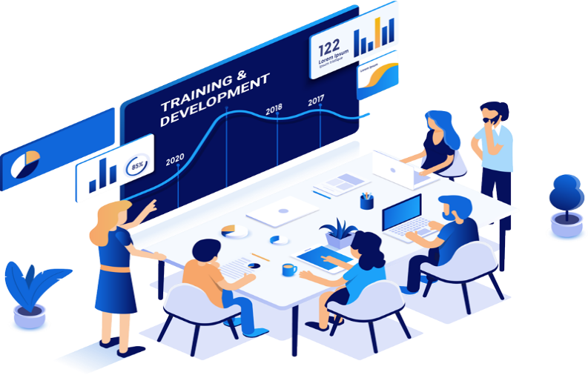
The second part of the report, it start with the Social learning theory from multiple reasons, for example to unsure that from now on everyone is trained correctly which will ensure that the employees will have all the learning and resources to do they work properly as the Albert Bandura's Social Learning Theory is focus on the organizational training programs where the mental state can be made positive regarding the induction, training and development programs where the case company also follow already a part of this theory as it allows the employees to learn from the surrounding and provides an environment where they can learn from their supervisors/managers and co-workers. The theory approach takes thought processes into account and acknowledges the role that they play in deciding if a behaviour is to be imitated or not where the explanation of human learning is by recognizing the role of mediational processes. The practice this theory to the company, there are four mediational processes proposed by Bandura:
Attention: For a behaviour to be imitated, it has to grab our attention. Attention is extremely important in whether a behaviour influences others imitating it. The individual needs to pay attention to the behaviour and its consequences and form a mental representation of the behaviour. Much of social learning is not immediate, so this process is especially vital in those cases.
Reproduction: allows us to perform a behaviour that we would like to imitate but that is not always possible. We are limited by our physical ability and even if we wish to reproduce the behaviour, we cannot unless we have the physical ability to do so. This influences our decisions whether to try and imitate it or not
Motivation: is defined as the rewards and punishment that follow a behaviour. If perceived rewards outweigh the perceived costs (if there are any) then the behaviour will be more likely to be imitated by the observer. If the vicarious reinforcement is not seen to be important enough to the observer, then they will not imitate it. (Bandura, 1977) (Bhattacharya, 2015)
For the Fresh Direct company case, it needed to be followed and more focus on the Motivation process as the company have a gap on that which had as result a lot of profit loss. And because of that the next recommended theory is Motivation theory.

Vroom’s Expectancy Theory:
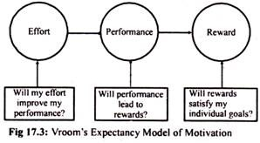
Vroom’s Expectancy Theory Is one of the most widely accepted explanations and a cognitive process theory of motivation. The theory is focus on the basic notions that people will be motivated to do a high level of effort , and take more responsibilities when they believe there is a relationships between the effort they do, the performance they achieve, and the outcomes/ rewards they receive and the keys of the expectancy theory of motivation are Valence where is about value or strength one places on a particular outcome or reward. Then is Expectancy which It relates efforts to performance, and the Instrumentality which is about the belief that performance is related to rewards. Which can be use For the Fresh Direct existing and new employees to motivate the engage in the company duties and add the company value. (Vroom, 1982) (Miner, 2005)

As the Theory explain, motivating the employee bring to the Fresh Direct company a lot of benefits which at this certain case is vital for the company. But the motivation also need engagement from the employees to the company as those linked together will add value and high performance to the company and also will bring a big benefit to the employees as they will be more happy working for the company. To achieve that, Fresh Direct will also need an engagement theory in order to deal with the employees, and for that, the next theory is an engagement theory suitable for Fresh Direct Company.

Kahn Work Engagement Theory:

The purpose of work engagement theory is to promote a strong relationship between the employee and his job, as Kahn’s theory is focuses on the conditions that allow individuals to bring their "whole selves" into the workplace are determined by three major aspects that influence whether an employee can meaningfully connect with the organisational mission, business culture, and everyday activities of the role by meaningfulness, safety, and availability.
- Meaningfulness: the purpose behind the work.
- Safety: An employee that feels psychologically safe in the work environment, who does not fear facing judgment or consequences from teammates or higher management, is more likely to contribute and feel positive about those contributions.
- Availability: an employee's capacity to perform a role both physically and mentally.
While challenge is important for growth and satisfaction, an employee should feel that the demands of the position are reasonable and achievable and Khan understand and through this theory promote employee needs and a more holistic approach to employee engagement by support staff in all areas of need. Applying that the Fresh Direct company will could further to solve they current problems and achieve they goals having not only more employees, but satisfy employee, who are engage to the job.
(Byrne, 2014) (Kahn, 1990)

Conclusion:
For the two main part of the report it can be concluded that the Company face major problems to deal with the recruitment and keeping the employees satisfy and motivate. For that there had been three useful models recommended to the company to use in order to solve the problems and achieve the company goals. Now having all the research and recommendation needed the report can finish the last and most important part which is about creating a good strategy and plan of implementation for the Fresh Direct Company in order to help them to successful achieve and set realistic goals.

SWOT and PDP:
As I have all the information needed regarding the company the next step to help them to achieve and set goals is first to create a SWOT Analysis .

SWOT Analysis
- The company Strength:
according to the case study is that they grow and made fresh food which can be delivered directly to the customers via online, which was also a bug advantage during the Covid Pandemic periods.
- Company weaknesses:
Unfortunately the company fail to complete the customers orders and delivered the same quality of the product due to higher demand and not enough proper trained workforce.
- Fresh Direct Opportunity:
Fresh Direct Company have the opportunity to expend, develop and grow by implementing new action plans and bring new ideas and implementations in the recruitment and training and development sector.
- Company Threats:
due to a higher demand of workforce and bad services the company could lose the customers.

In order to avoid the company threats to come true and lose all they customers, as a HR specialist my job is not only to identify the problem and come with recommendation, I also need to implement new strategies for the company and come with solutions and implementation and a good defined plan for the company to follow. And to accomplish that the last step in this paperwork is a Personal Development Plan designed for the company needs.

Personal Development Plan (PDP):
In order to take actions for the company , the best way is to create a Personal Development Plan which will give a solution the company problem and a way to implement it and set new goals in detail
Objective | Success criteria | Actions | Implementation | Cost | Duration
Improve training department | The objective can be measured by the customers feedback regarding the quality and delivery of the product | To improve the training department is needed to be use proper learning theories, which in this case can be use the Social Learning Theory | To implement those action the company will hire recruitment and training specialist to deliver to the existing and new employees proper training | 10.000£ | 3 Months
Increase performance | By checking the employee performance | To increase the employee performance it will be used the Motivation theory and the work engagement theory | The company will implement a set performance which will be 90%; the performance bonus, star of the month, new overtime payrate. | The performance bonus rate will be 20p per hour when the employee do more the 90%, and the overtime will be paid with 1.5 per hour | 1 Month

Now as everything had been set, the company will be able to solve the faced issues and continue to grow keeping the customers happy and loyal, and the employee happy and engaged.

References
Bandura, A., 1977. Social Learning Theory (Prentice-Hall Series in Social Learning). 1 ed. United States: Prentice-Hall: Pearson.
Bhattacharya, D. K., 2015. Training and Development:. South Asian Journal of Management, 24(4), pp. 173-177.
Byrne, Z. S., 2014. Understanding Employee Engagement Theory, Research, and Practice. 1 ed. New York: Taylor & Francis.
Fayol, H., 1949. General and industrial management. 1 ed. Paris, French: Sir Isaac Pitman & Sons, Ltd.
Kahn, W. A., 1990. Psychological Conditions of Personal Engagement and Disengagement. Academy of Management Journal, 3(4), pp. 692-724.
Miner, J. B., 2005. Organizational Behavior I Essential theories of motivation and leadership. 1 ed. United Kingdom: M.E. Sharpe.
Price, A., 2011. Human Resource Management. 4 ed. s.l.:Cengage Learning.
SHARMA, S., 2009. HANDBOOK OF HRM PRACTICES: Management Policies and Practices. 1 ed. New Delhi, India: Global India Publications Pvt. Limited.
Vroom, V. H., 1982. Work and Motivation. 1 ed. United Kingdom: R.E. Krieger Publishing Company.

