Foreign Languages and Cultural Awareness

Cultural Awareness
Hotel Handbook

Module Code: BMIH5003
Student’s Name: Otilia Ghinet
Student’s ID: 1922158
Lecturer’s Name: Rodrigo Fernandes Aguilera

Executive Summary

This report is having the main subject comparing two countries, Denmark and Philippines in matter of their cultural behaviors. For this reason, Hofstede’s Cultural Dimensions tools is willing to be used in order to give a precise image if how a hotel in Denmark should be prepared to embrace the Philippine guests and at the same time, to create for them a great experience without overpassing the cultural boundaries. The main key findings are regarding the fact that while Denmark’s and Philippine’s culture are kind of different, the hotel employees should be aware of how they should greet the Philippine guests in order to respect their traits and be able to deliver an excellent experience.

Table of Contents
Executive Summary 2
Introduction 4
Denmark 4
Philippines 5
Country Analysis 7
Hotel’s “DO’s” and “DO NOT” List 8
Conclusion 8
References 9

Introduction

There are substantial disparities between the ability of people of different ethnicities to draw conclusions and make crucial decisions, as well as their perspectives on the world, so in other words, if you teach your employees a second language or employ intercultural communication strategies, it's probable that their interactions will change dramatically. (Lam & Cheung, 2018)

The good news is that it is not required to be proficient or even fluent to reap the benefits, since research has demonstrated that it is the use of the language that makes the difference and it may be feasible to increase staff members' capacity to articulate issues, so enhancing the team's overall productivity, the hotel's culture and environment, and the quality of communication with international visitors. (Angel et a., 2022)

Denmark
Denmark is not just home to some of the world's happiest people, but also one of the most developed countries in terms of income, sustainability, openness, quality of life, health care, education, and pensions. (Nomad Sunveiled, 2020)
In Denmark, Danish is the national language, and it is important to be informed that everything operates electronically and cashless, so receipts may be sought and provided online. This protects Danish people from having to wait, which would have been inconvenient and time-consuming. (Seferou, 2018)

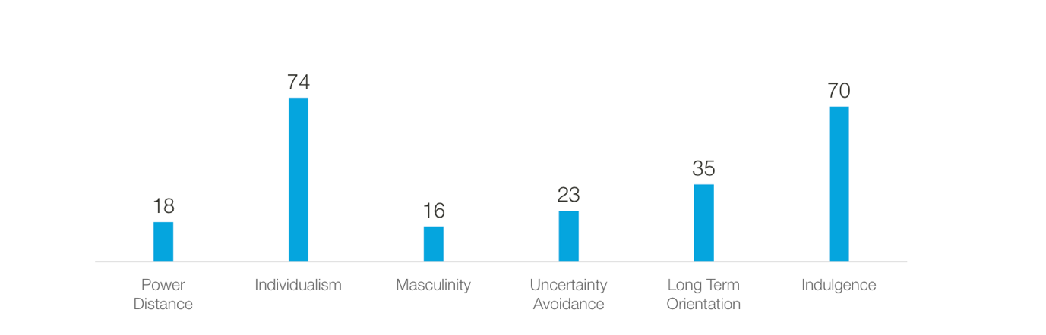
(Hofstede Insights, 2022)

In Hofstede’s Cultural dimensions, Denmark ranks lowest in this category with 18 points, so a person’s practical skills impress the Danes while first names and frank discussion characterize the workplace. Consultation excites workers. Individualist Denmark scored 74 and this shows a strong desire for a self-sufficient society. Denmark is Feminine, scoring 16 on this criteria, so Maintaining a work-life balance in feminine nations ensures everyone is included. A good manager supports and involves employees in decision-making. Denmark scores 23 in uncertainty avoidance and this illustrates that Danes do not require professional structure and regularity and also, accept sudden plan changes and new conditions as their workdays involve it. Danish culture scores 35. Such civilizations seek the absolute Truth and think conventionally but also, value traditions, spend little, and prioritize rapid returns. Denmark is indulgent with a 70 and it should be mentioned that Societies with high Indulgence scores often indulge their urges to have fun and enjoy life as they are optimistic and joyful. (Hofstede Insights, 2022)

Philippines

The Philippines is made up of 7,641 islands, which has resulted in the development of a great deal of linguistic diversity among the country's native peoples. Even though there are now 183 living languages, only Filipino is acknowledged by the government of the Philippines as being the country's official language. (Every Culture, 2021)
There is an 80% chance that any two random individuals in the Philippines will grow up speaking different languages, making the Philippines one of the countries with the highest linguistic diversity in the world. (Temelkova, 2022)
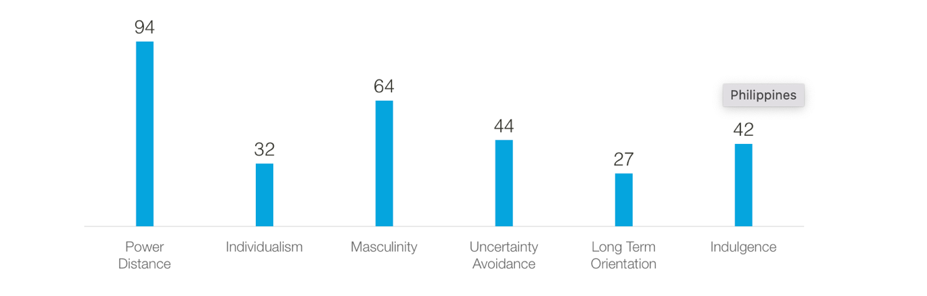
(Hofstede Insights, 2022)

Hierarchical society earns the Philippines a 94. This implies that people are prepared to accept a hierarchical structure where everyone has a role without explanation. Philippines culture is collectivistic with a 32 score. The member's long-term commitment to their "group"—a family, extended family, or extended connections—demonstrates this. Loyalty is valued most in collectivist societies. Masculine societies like the Philippines score 64 on this factor. This categorization suggests that Filipinos prioritize earning a living over living fully. However, low salaries and a struggling economy explain this. The Philippines scored 44 on ambiguity avoidance. Their poor score reflects this. Residents of low-UAI areas believe that only required rules should be enforced, and if they are unclear or ineffective, they should be repealed. The Philippines scored 27—more normative than pragmatic. Thus, inhabitants in such states seek ultimate Truth and think normatively. Philippines culture is restrained, scoring 42 out of 100. Poor communities are characterized by cynicism and pessimism. Unlike Indulgent civilizations, Restrained societies value free time less and govern how people indulge their impulses. (Hofstede Insights, 2022)

Country Analysis
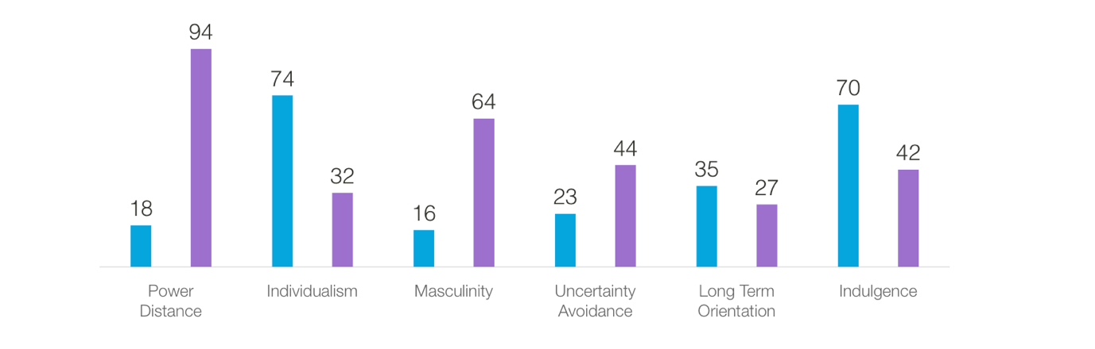
(Hofstede Insights, 2022)
- BLUE: Denmark
- PURPLE: Philippines

This five-star hotel provides free WiFi access and has a concierge service available to its guests and for the convenience of its visitors, the hotel has a front desk that is open around the clock, provides room service, and operates a currency exchange. (Booking, 2022)
Based on Hofstede’s Dimensions, the above image that analyzes the cultural differences between Denmark and Philippines, it is important to mention the fact that the power distance is different, and this relates to the fact that NH hotel’s employees should be aware that the Philippine guests will expect to be lead in their rooms and been given directions within the hotel. On the other hand, guests from Philippines are most likely travelling with their families and friends, so more rooms are required usually. Due to the fact that Philippines takes part as a masculine society, if they encounter an issue, they will most likely fight, so the Danish employees should be prepared to conciliate them and have the patience to handle with their stress. While Danish people are stricter with the rules, the NH hotel employees should expect that Philippian people not to be the same and have the patience to explain the rules as often as it is needed. In matter of long-time orientation, the countries have similar cultures and for this reason, there should not be encountered any kind of issues while in matter of indulgence, the hotel employees, will need to use their optimism in order to enhance a good spirit for the Pilipino guests as they tend to be more pessimistic. (Ferreras, 2019)

Hotel’s “DO’S” and “DO NOT” List

DO | DO NOT
- Be patient and explain multiple times if the guests do not understand something  - The hotel employees should go with the guests to show them the room  - Have the ability to work under pressure  - Be able to work with groups of guetss and manage the rooms | - Lose patience  - Forget about details  - Be unprofessional  - Lose control of things

Conclusion
In conclusion, being aware of the cultural dimensions of other countries while being in the hospitality industry is one of the most important things while the aim is to boost the business and attract the internationals eyes. For this reason, hotel employees should be trained and develop skills that will enable them to be able to handle multi-cultural guests and at the same time to provide excellent service on the behalf of the hotel.

References
- Ángel L. Coves-Martínez, Carmen M. Sabiote-Ortiz, Dolores M. Frías-Jamilena, (2022) Cultural intelligence as an antecedent of satisfaction with the travel app and with the tourism experience, Computers in Human Behavior, Volume 127
- Booking, (2022), NH Collection Copenhagen, [Available Online: www.booking.com], Accessed 07/11/2022
- Every Culture, (2021), The Philippines, [Available Online: https://www.everyculture.com/No-Sa/The-Philippines.html], Accessed 07/11/2022
- Ferreras J., (2019), FILIPINO HOTELIERS SHARE INDUSTRY TIPS, INSIDER INFO & MORE, posted 04/12/2019, [Available Online: https://www.tripzilla.ph/filipino-hoteliers-tips/14264/], Accessed 07/11/2022
- Hofstede Insights, (2022), What About Denmark? [Available Online: https://www.hofstede-insights.com/country/denmark/], Accessed 07/11/2022
- Hofstede Insights, (2022), What About the Philippines? [Available Online: https://www.hofstede-insights.com/country-comparison/the-philippines/], Accessed 07/11/2022
- Lam R. Cheung C., (2018), Towards an understanding of the culturally intelligent behaviour of hotel service employees, posted 02/06/2018, [Available Online: https://doi.org/10.1080/15980634.2018.1517955], Accessed 07/11/2022
- Nomad Sunveiled, (2020), 24 INTERESTING AND FUN FACTS ABOUT DENMARK, [Available Online: https://nomadsunveiled.com/facts-about-denmark/], Accessed 07/11/2022
- Sefereou A., (2018), 13 Facts That Will Change What You Think About Denmark, posted 02/01/2018, [Available Online: https://theculturetrip.com/europe/denmark/articles/13-facts-that-will-change-what-you-think-about-denmark/], Accessed 07/11/2022
- Temelkova I., (2022), Languages of the Philippines: Everything You Need to Know, posted 20/04/2022, [Available Online: https://www.milestoneloc.com/languages-of-the-philippines/], Accessed 07/11/2022

