Ways of Thinking
  - Claire Tilling

Manifesto Writing:

Eight Statements of beliefs, work and practices (not included in word count)

- Art practice is about finding yourself, so try out as many different approaches as possible. Be multidisciplinary. Don’t limit yourself to one art form.

- Anything can be art material. One mans’ junk is an artist’s beating heart.

- Artistic objects can be stand alone or part of a larger collection. Displaying gives the project closure.

- Found materials have a history that can evoke excitement. Art evolves the original object into a new form.

- Art starts a conversation. Let the material speak to you. Materials magnetised toward each other, asking to be combined to form something new.

- Doing art is like a warm hug. Being in an art environment is like a cocoon.

- Never fully know your work because it is evolving.

- The artist is not the work, the artist is the work. Art and personality are one.

Manifesto Statements (500 words)

My first key statement is ‘Anything can be art material...’. One artist I admire that uses repurposed materials for her art is Jane Atfield. She uses post-consumer waste and discarded plastic to make new items such as furniture (Greenhalgh, 2002). This is relevant to my work because found and repurposed material is used for most of my art. The end result does not always incorporate found objects, but found objects are usually behind the inspiration, observational drawing, and collecting of objects. Found items are often incorporated into my work and can be used for making moulds for casting, or used directly in the piece. For example, I collect a lot of things from the beach which end up in my art. This includes seaweed and barnacle shells that had morphed into something else through the process of creating art from something that was lying on the beach.

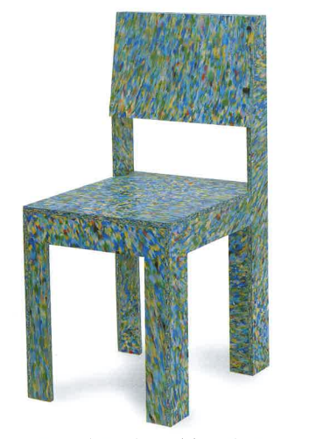
Figure 1: Chair - Recycled materials, Jane Atfield (1994)

The next important statement is ‘Found materials have a history that can evoke excitement…’. I am fascinated by the collections of Mark Dion whose pieces are presented in categorised installations and ‘cabinets of curiosity’ (Graziose- Corrin, et al., 1997). “Once collected and processed Mark Dion created an artwork from the objects and artefacts” (Tate, 2022). When collecting things for my own art, I like to question the journey of the item. I have collected various pieces that have washed up on the beach that could be decades old, or longer. Where had it come from? What was its purpose? Who owned it? How did it get there?
I am interested in the environmental aspects of using found objects, not only from the point of view of repurposing instead of buying new materials, but also from the point of view of the artist being in touch with their own environment. I like to be in touch with the world we live it and have around us to use for inspiration without having to look too far. Artist Helen Frost creates art “in response to the litter and marine debris that I find on my walks… I do not collect pretty driftwood or beautiful stones but rather the junked and the jettisoned” (Helen Frost, 2022). This resonates with me as I collect in a similar way, such as old pieces of wood, old pieces of clothing, ceramics and many others.

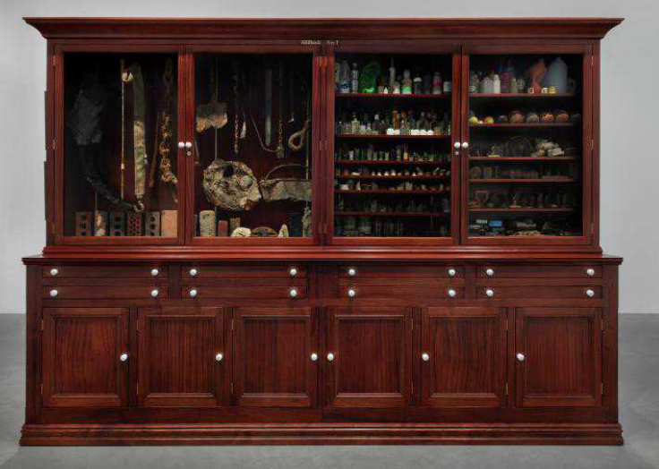
Figure 2: Thames Dig, Mark Dion (1999)
I take inspiration from Tracey Emin, whose work is always varied and uses mixed media, such as “painting, drawing, writing, photography, printmaking, sculpture, applique, poetry, neon works, film, video, performance and installation” (Brown, 2008, p. 7). This leads to the last important statement, which is ‘Never fully know your work because it is evolving’. I do not have a signature style or process, and I do not want to. My overactive imagination works fast in processing many ideas at once, and I like to do as many of my ideas as I can. When I am making, I try things out, experiment, sample, and do many renditions of the work, losing myself practice. I almost always end up on a different path to where I started, and I allow myself free thinking as I am making. Even after closing a project, I still have several ideas for moving it on.

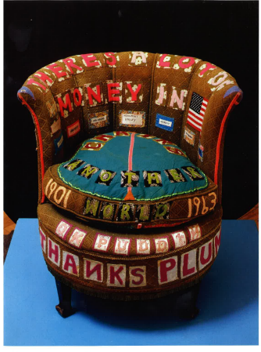
Figure 3: There's a lot of Money in Chairs, Tracey Emin, (1994)

References
Brown, N. (2008) Tracey Emin. London: Tate Publishing.
Graziose- Corrin, L., Kwon, M. & Bryson, N. (1997) Mark Dion. London: Phaidon Press.
Greenhalgh, P. (2002) The Persistence of Craft. London: A & C Black.
Helen Frost, (2022) Helen Frost Artist. [Online]
Available at: https://helenfrostartist.com/
[Accessed 31st October 2022].
Tate, (2022) Digging the Thames with Mark Dion. [Online]
Available at: https://www.tate.org.uk/art/artworks/dion-tate-thames-dig-t07669/digging-thames-mark-dion
[Accessed 31st October 2022].

Observational Writing (500 words)

Semiotic analysis is the study of decoding the intended meaning of a text. According to Saussure’s theory, the elements within a sign are made up the signifier and the signified… add to this from the library books.
The art piece I will analyse is Tracey Emin’s Hotel International (1993). The piece is an applique blanket consisting of layered fabric letters and images stitched onto a 257x240 sheet. Applique is a piece of ornamental needlework where fabric is sewn or stuck to form a picture or pattern (Oxford Languages, 2022). The aspects of semiotics used to analyse this will be; material, scale, and colour.

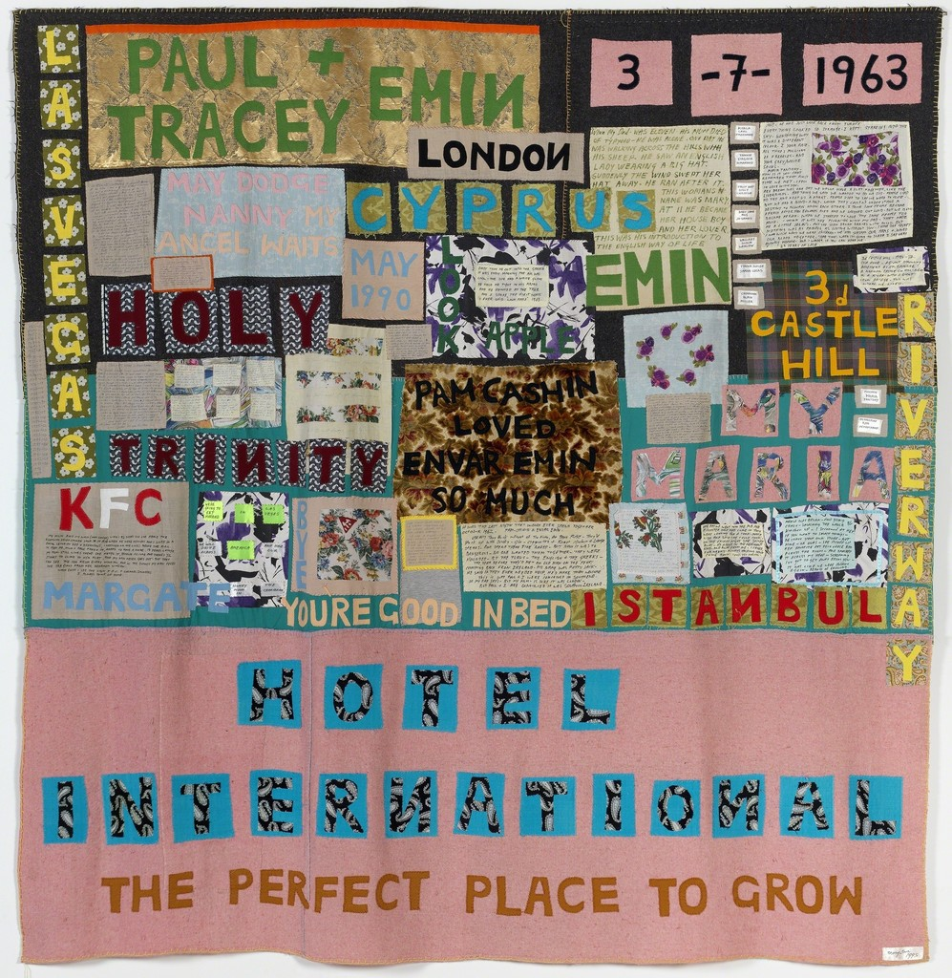
Figure 4: Tracey Emin, Hotel International, 1993
My initial perception is that this is a feminist piece of work as it uses a traditionally feminine medium (textiles and sewing) using colours associated with femininity (pink and soft pastels) to create a domestic household item (blanket) juxtaposed with shocking statements such as ‘you’re good in bed’ and a variety of letters, symbols and statements. The bedding suggests domesticity, as it looks like a patchwork quilt.
The first signifier is the choice of material. The patterned fabrics layered onto the blanket come from a blanket she had as a child, and an old family sofa (Brown, 2008). Other patterned fabrics used look like they could be from dresses, curtains or sheets. However, Emin rejects feminist labels (Brown, 2008). Instead, the blanket could signify pain, loss or death. “Blankets are regularly seen on television covering emancipated concentration-camp, disaster and refugee victims… they are historically used in ceremonial remembrance of the dead” (Brown, 2008 p.37). Blankets could also signify security or comfort. “Almost everyone has a favourite doll, an aging teddy, or an unravelling blankie… Adults and children alike treasure these creature comforts because they offer security, lifelong friendship, and the smell of home” (O'Halloran 2002). Psychologists call this transitional comfort objects that are used for reassurance. The stitching used includes blanket stitching which also links back to the blanket as an object.
The words in her piece can be seen as anchorage as it helps to fix the meaning within the sign (Rose, 2022). The words used help to convey Emin’s background and roots. These include places her family are from, personal letters to family, important dates, her church and other texts relating to her upbringing. The different sizes of the words could signify different emphasis or importance, but some of these stand out more than others due to their placement, colour and background pattern. The words that stand out the most are ‘Paul & Tracey Emin’, ‘3 – 7 – 1963’ and ‘The perfect place to grow’, suggesting this is about her experiences growing up. All her text is in uppercase in various sizes, except the handwritten letters, which could further emphasis their importance to her. The words and handwritten letters are very personal, which could signifier what Carl Jung calls the shadow self, the personal part of yourself that is usually hidden (Jung, 1966).
A fascinating aspect of this piece is the scale. The largeness of it could signify being consumed or enveloped, or being small in relation to it, as representative of childhood.
To conclude, since undertaking this analysis, my perception has changed – define why

References
Brown, N. (2008) Tracey Emin. London: Tate Publishing.
Hall, S. (2012) This Means That: A User’s Guide to Semiotics 2nd Ed, London: Lawrence King Publishing
Jung, C. (1966) The Collected Works of C.J. Jung Volume 7, 2nd Ed, translated by R. F.C. Hull, London: Routledge
O'Halloran, B. (2002) Creature Comforts: People and Their Security Objects, Boston: Houghton Mifflin
Oxford Languages (2022) Applique, online available at: https://languages.oup.com/ [accessed on 22.11.2022].
Rose, G. (2022) Visual Methodologies: An Introduction of Researching with Visual Materials, 5th Ed, London: Sage Publishing

- Identify an image and write a semiotic analysis. Choose 3 key aspects of semiotics and use them to simplify and focus your writing. Conclude by assessing how your understanding of the image has changed.
- Include image.
- Use a minimum of 3 books per task. Additional research sources could be journal/newspaper articles or online sources.
- Possible artwork Tracey Emin – stitched work, stitches are symbolic, meanings of words
- Materials - Bedsheets - choice of material could represent domesticity or sexuality
- Words – 1-3 key words, what are the meanings, text style? Hand-written or typeset in style
- Scale – choice of size – large meaning being consumed, enveloped, lost, small – representative of childhood, Gulliver’s travel
- Colour – what certain colours represent
- Theory – Freud, trauma healing

Practice-based writing (500 words)

- Write about an object or artefact.
- Explore and discover your thinking through writing. Think reflectively and develop your thinking by pushing your initial reactions through further reading, and individual practice responses around the artefact’s theme (for example create personal drawings, designs, or paintings, or sculpture, or music, photography, or other creative practice) and then critically summarise the results of your process through the lens of your work.
- Include image
- Use a minimum of 3 books per task. Additional research sources could be journal/newspaper articles or online sources.
Objects - boots? Photograph the boots and write down initial questions, potato famine? Emigration? Was the Oystermouth boot form a fisherman? These questions are initial thoughts, then research the history of the areas for possible answers. Mud preserved the leather. Then do something with the boot for the personal part, then say the plans eg. cast for glass <br> Use these notes to start practice-based writing task.

