Landscape Report
Llanllyr Farm, Ceredigion

Introduction
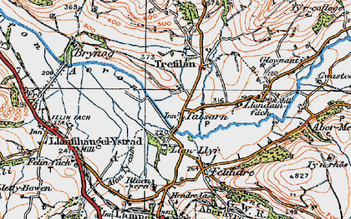
Llanllyr Farm lies within the Aeron Valley in Ceredigion, around 3 km south of Aberaeron and near the floodplain of the River Aeron. The site is best known as the location of the medieval Cistercian nunnery of Llanllyr, founded by Rhys ap Gruffudd during the late twelfth century (Coflein, 2020, Murphy, 2017). However, archaeological investigations undertaken over the last decade suggest that the significance of Llanllyr extends beyond its medieval occupation. Excavations undertaken by the University of Wales Trinity Saint David have identified evidence for prehistoric activity within the landscape characterised by wetlands, low mounds of dry ground, and extensive marsh deposits (Wales247, 2019). These discoveries suggest that Llanllyr formed part of a much wider archaeological landscape that was repeatedly utilised over long periods of time.
Figure 1 Map of Talsarn, Francis Frith, 1923
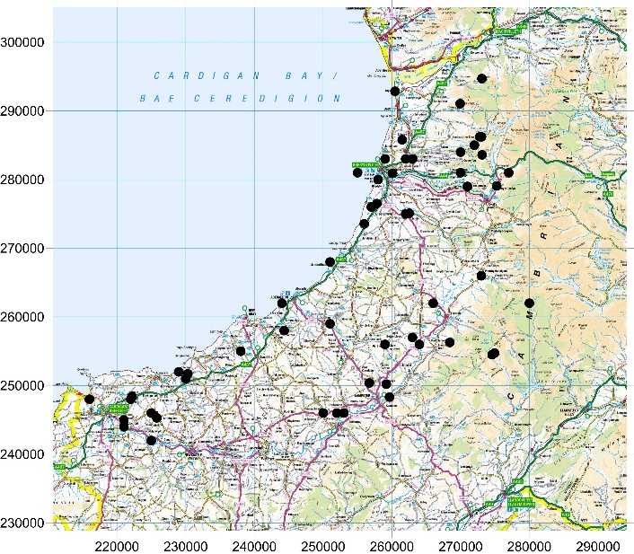
This report examines the Llanllyr landscape through examining its environmental setting, evidence for prehistoric activity, and the later establishment of the Cistercian nunnery. Particular attention is paid to the relationship between human activity and the marshy environment of the Aeron Valley, as this appears to have been a defining characteristic of the landscape from prehistory onwards. Landscape archaeology emphasises the importance of understanding sites within their wider environmental and cultural contexts rather than viewing them as isolated locations (Johnson, 2010).
Figure 2 Map of Neolithic sites around Ceredigion, 2026

The Physical Landscape
Llanllyr is on a low river terrace above the floodplain of the River Aeron. The modern house and surrounding farmland are situated on relatively level ground that drains towards small streams and wetland areas associated with the valley floor (Discover Ceredigion, 2024). Historic and archaeological investigations indicate that extensive marshland once occupied much of the surrounding landscape, with areas of slightly elevated ground forming islands within wetter environments (Murphy, 2017). The Aeron Valley is known for its abundance of springs and water sources. Modern commercial exploitation of these springs continues through the Llanllyr water bottling operation, demonstrating the continuing importance of local hydrology within the landscape (Parks and Gardens UK, 2024). The valley floor consists largely of alluvial and wetland deposits which have accumulated through river activity and seasonal flooding. These conditions would have created a landscape of considerable environmental diversity, combining marsh, wet pasture, woodland, open water and areas of dry ground suitable for settlement. From an archaeological perspective, wetlands are often highly significant because they preserve evidence that may be lost elsewhere. Waterlogged environments can preserve organic remains, pollen, seeds and timber structures, providing opportunities for environmental reconstruction (Van de Noort, 2011). Although preservation conditions at Llanllyr appear variable, investigations have identified water-management earthworks and a timber structure interpreted as a possible medieval drain, suggesting long-term attempts to control and exploit water within the landscape (Murphy, 2017).
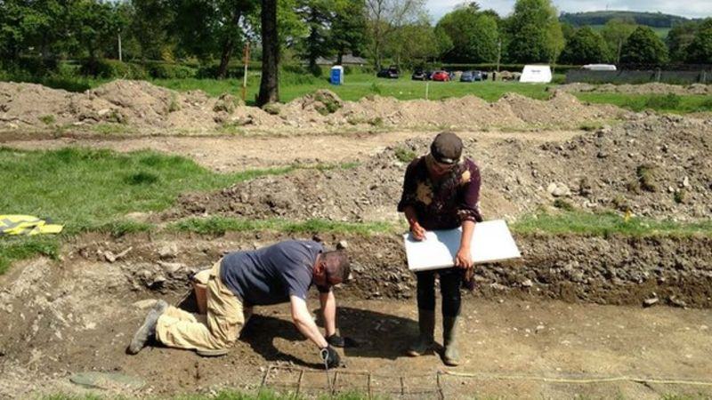
The importance of the wetland environment is reflected in recent excavations undertaken by UWTSD. Archaeologists identified low mounds surrounded by marshland which may have represented islands of dry ground during prehistory (Wales247, 2019). These elevated areas appear to have attracted repeated human activity, suggesting that settlement choices were strongly influenced by hydrology and access to stable ground. The marshy character of the landscape is particularly significant because wetlands frequently attract human activity despite the challenges they present. Wetlands provide access to water, fertile soils, grazing land and natural resources while also acting as natural boundaries within the landscape (Van de Noort, 2011). Across Britain wetland environments have often produced evidence for both settlement and ritual activity, with communities adapting to seasonal flooding and fluctuating water levels. The low mounds identified during excavations at Llanllyr may therefore represent particularly attractive locations within the wider marshland environment because they provided relatively dry and stable ground while remaining closely connected to valuable wetland resources (Murphy, 2017).
Figure 3 Previous Llanllyr excavation, UWTSD, 2014

A Prehistoric Marshland Landscape
Although Llanllyr is usually associated with its medieval nunnery, increasing evidence suggests that the wider landscape was already important during the Neolithic period. Excavations undertaken in 2019 recovered flint artefacts and a polished stone axe from deposits associated with low mounds surrounded by marshland (Wales247, 2019). Archaeologists suggested that these islands of dry ground may have served as focal points for prehistoric activity within what was otherwise a wet and challenging environment. The wider distribution of prehistoric monuments shown within the supplied mapping reinforces this interpretation. Chambered cairns occur through coastal and inland Ceredigion, while stone circles and polished stone axe finds demonstrate widespread prehistoric occupation and movement across the region. Significantly, several of these sites cluster within landscapes similar to Llanllyr, where river valleys meet areas of upland pasture and wetland environments. The distribution of polished stone axes is particularly noteworthy. During the Neolithic period axes were not merely practical tools but also socially significant objects associated with woodland clearance, agriculture and potentially ritual activity (Bradley and Edmonds, 1993). Their presence within the Aeron Valley suggests participation in wider networks of movement and exchange extending across Wales and even further. The discovery of a polished stone axe at Llanllyr therefore places the site within a broader prehistoric landscape rather than representing an isolated find (Wales247, 2019).
River valleys often acted as natural routeways linking communities and facilitating movement through the landscape (Bradley, 1998). Llanllyr’s position within the Aeron Valley may therefore have contributed to its attractiveness as a location for settlement and activity. The concentration of prehistoric sites throughout Ceredigion indicates that the region was far from the edge during the Neolithic and Bronze Age periods. Wetlands frequently held symbolic significance during prehistory. Across Britain and Ireland, rivers, bogs and marshes have produced evidence for the deliberate deposition of artefacts, including stone tools, metalwork and human remains (Van de Noort, 2011). While there is currently insufficient evidence to interpret Llanllyr as a ritual wetland site, the combination of marshland, elevated islands and prehistoric artefacts raises important questions regarding the role of the landscape within Neolithic society. The prehistoric evidence therefore suggests that Llanllyr occupied a favourable position within the Aeron Valley long before the establishment of the medieval nunnery. Rather than viewing the site solely through its medieval history, it may be more appropriate to regard Llanllyr as part of a long lived cultural landscape repeatedly selected for human activity.

The Cistercian Landscape
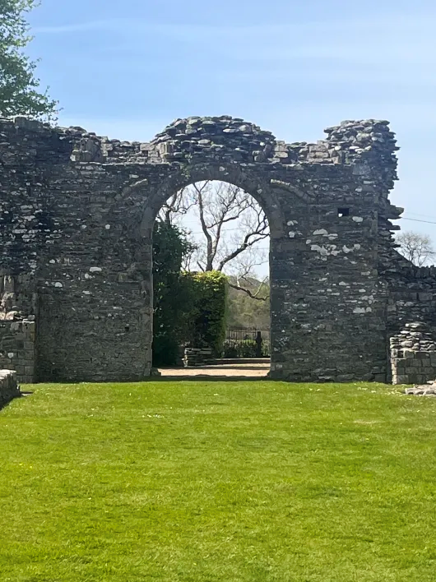
The most historically significant phase of activity at Llanllyr began with the foundation of the Cistercian nunnery during the 1180s by Rhys ap Gruffudd (Coflein, 2020a). Llanllyr is particularly important because it was one of only two medieval Cistercian nunneries established in Wales (Murphy, 2017). Documentary and archaeological evidence implies that the community was associated with the nearby monastery of Strata Florida, one of the most influential Cistercian foundations in medieval Wales (Robinson, 2006). The Cistercians were renowned for their engagement with landscapes and environmental management. Across Britain they frequently established monasteries in marginal environments including valleys, wetlands and upland areas (Bond, 2004). These locations provided opportunities for agricultural improvement while also reflecting the monastic ideals of isolation and contemplation. Llanllyr appears consistent with this wider pattern. The nunnery was established near water sources and within a landscape that required active management. This point is strengthened by archaeological investigations that have identified evidence for water management features within woodland close to the presumed monastic site (Murphy, 2017). These features may represent attempts to drain, control or utilise water resources associated with the marshland environment. Water held both practical and symbolic significance within Cistercian landscapes. Monastic communities required reliable water supplies for domestic use, agriculture, milling and sanitation, while water features frequently formed important elements of monastic design (Bond, 2004). The persistence of springs, pools and water gardens at Llanllyr may therefore reflect a long tradition of water management extending back to the medieval period.
Figure 4 Strata Florida Abbey, I Lewis, 2025
Despite the historical importance of the nunnery, locating its precise position has proven difficult. Excavations undertaken by Dyfed Archaeological Trust between 2014 and 2015 identified evidence for a post-dissolution mansion and associated features but failed to conclusively locate the convent buildings themselves (Murphy, 2017). Still, archaeological evidence including medieval pottery and a dendrochronologically dated timber structure demonstrates medieval activity within the surrounding landscape (Murphy, 2017). The apparent absence of substantial standing remains may also reflect the nature of the landscape. Building materials were frequently reused following the Dissolution of the Monasteries, while agricultural activity and waterlogged conditions may have obscured or destroyed surface evidence (Medievalists.net, 2014). The medieval landscape of Llanllyr therefore survives largely through subtle earthworks, documentary references and archaeological traces rather than visible architecture. The close relationship between Llanllyr and Strata Florida is also significant. As one of the most influential Cistercian foundations in Wales, Strata Florida played an important role in shaping the religious, political and economic landscape of medieval Ceredigion (Robinson, 2006). Llanllyr's position within this wider monastic network would have connected the site to broader systems of land management, agricultural production and religious authority extending across western Wales.

Landscape Continuity and Change
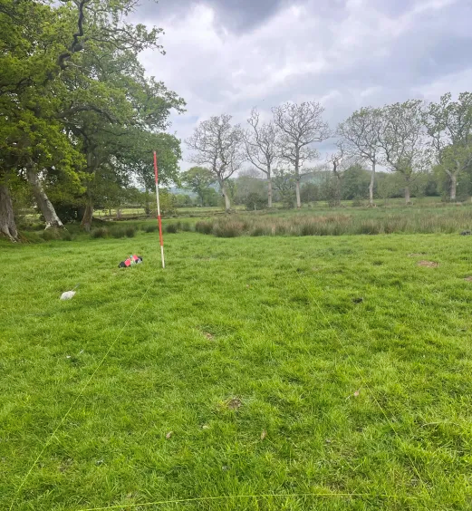
One of the most interesting aspects of Llanllyr is the continuity of human engagement with the landscape. Prehistoric communities utilised islands of dry ground within marshland environments (Wales247, 2019). Medieval religious communities then established a nunnery within the same valley, taking advantage of water resources and fertile agricultural land (Murphy, 2017). Following the Dissolution, the site evolved into a post-medieval estate before becoming the modern agricultural landscape visible today (Coflein, 2020b). This continuity demonstrates the importance of environmental factors in shaping human activity. While social, economic and religious systems changed dramatically across time, access to water, fertile soils and stable ground remained constant influences on settlement decisions (Johnson, 2010). The marshland landscape that initially attracted prehistoric activity may therefore have indirectly influenced the later establishment of the Cistercian foundation. Landscape archaeologists have long argued that human communities repeatedly return to favourable locations because environmental advantages persist across generations (Aston, 2002). Llanllyr provides a strong example of this phenomenon, with evidence for repeated occupation and land use spanning several thousand years.
Figure 5 Llanllyr farm excavation area, I Lewis, 2026

Conclusion
The evidence examined within this report demonstrates that Llanllyr should be understood as a complex archaeological landscape shaped by longterm interaction between people and environment. While the medieval Cistercian nunnery remains the most historically visible phase of occupation, the wider landscape contains evidence for activity extending back into prehistory. The discovery of Neolithic artefacts, combined with the broader distribution of chambered cairns, stone circles and polished stone axes throughout Ceredigion, suggests that the Aeron Valley formed part of an important prehistoric landscape long before the establishment of the nunnery (Wales247, 2019). The marshland environment appears to have been a particularly influential factor throughout this sequence. Rather than acting as a barrier to settlement, the wetlands provided resources, fertile land and strategic locations for occupation. The low islands of dry ground identified during recent excavations may have attracted repeated use precisely because they offered stability within a waterlogged environment. This pattern appears to continue into the medieval period, when the Cistercian community established itself within the same landscape and undertook measures to manage and exploit local water resources (Murphy, 2017). Llanllyr therefore represents an excellent example of landscape continuity, where different communities separated by thousands of years repeatedly engaged with the same environmental features. The archaeological significance of the site lies not only in the remains of the nunnery but also in the longterm relationship between people, water and landscape within the Aeron Valley. Future archaeological investigation, particularly environmental analysis and further exploration of the marsh deposits, has the potential to reveal additional evidence for how successive communities adapted to and transformed this landscape.

Bibliography
Barker, P. (1993) Techniques of Archaeological Excavation. 3rd ed. London: Routledge.
Carver, M. (2009) Archaeological Investigation. London: Routledge.
Coflein (2020) Llanllyr Site Record (NPRN 700011). Available at: https://coflein.gov.uk/en/site/700011/
Coflein (2020) Llanllyr House Site Record (NPRN 5654). Available at: https://coflein.gov.uk/en/sites/5654
Discover Ceredigion (2024) Aeron Valley and Mynydd Bach. Available at: https://www.discoverceredigion.wales
Fleming, A. and Barker, L. (2008) ‘Monks and Local Communities: The Late Medieval Landscape of Troed y Rhiw’, Medieval Archaeology, 52, pp. 261–290.
Harris, E.C. (1989) Principles of Archaeological Stratigraphy. London: Academic Press.
Johnson, M. (2010) Archaeological Theory: An Introduction. 2nd ed. Oxford: Wiley-Blackwell.
Murphy, F. (2017) Survey and Excavation at Llanllyr Medieval Nunnery and Post-Medieval Mansion, Ceredigion, 2014–2015. Dyfed Archaeological Trust.
Orton, C., Tyers, P. and Vince, A. (1993) Pottery in Archaeology. Cambridge: Cambridge University Press.
Schiffer, M.B. (1987) Formation Processes of the Archaeological Record. Albuquerque: University of New Mexico Press.
Wales247 (2019) ‘New Stone Age Artefacts Found During Llanllyr Archaeological Dig’. Available at: https://www.wales247.co.uk/new-stone-age-artefacts-found-during-llanllyr-archaeological-dig
Parks and Gardens UK (2024) Llanllyr Historic Landscape Record. Available at: https://www.parksandgardens.org/places/llanllyr
Medievalists.net (2014) ‘Medieval Nunnery Discovered in Wales’. Available at: https://www.medievalists.net/2014/06/medieval-nunnery-discovered-wales/
Aston, M. (2002) Interpreting the Landscape. London: Routledge.
Bond, J. (2004) Monastic Landscapes. Stroud: Tempus.
Bradley, R. (1998) The Significance of Monuments: On the Shaping of Human Experience in Neolithic and Bronze Age Europe. London: Routledge.
Bradley, R. and Edmonds, M. (1993) Interpreting the Axe Trade: Production and Exchange in Neolithic Britain. Cambridge: Cambridge University Press.
Rippon, S. (2000) The Transformation of Coastal Wetlands: Exploitation and Management of Marshland Landscapes in North-West Europe During the Roman and Medieval Periods. Oxford: Oxford University Press.
Robinson, D. (2006) The Cistercians in Wales: Architecture and Archaeology 1130–1540. London: Society of Antiquaries.
Van de Noort, R. (2011) North Sea Archaeologies: A Maritime Biography 10,000 BC – AD 1500. Oxford: Oxford University Press.

