

Module Name: Community Engagement
Title: Assessment 2 Community Engagement

Student Name: Pavel Bodushki – 2023711
Lecturer: Karen Howells
University of Wales Trinity Saint David
Module Code: LCBB4002
Term 2 Group 3
Table of Contents
Introduction 3
Reflective analysis 3
Conclusion 9
References 10

Introduction
Following the first assignment focused on planning and coordinating an Event for Crisis, the current reflective analysis has the goal to assess how the principles of community engagement of this charity organisation compares to other best practices. The emphasis of the report is placed on assessing the models, strategies and principles used for engaging communities and other stakeholders in certain projects and increasing their support and awareness of addressed issues. For the purposes of the analysis, Crisis is compared to another large charity organisation which is fighting homelessness in UK – Shelter foundation. The approaches of the two organisations are assessed in terms of community engagement approaches, communication channels, inclusion, community mapping, social media and impact analysis.

Reflective analysis
Based on the theoretical model of community engagement continuum, which was assessed in the previous assignment, the main principles in order to achieve active involvement of stakeholders include outreach, consult, involve, collaborate and shared leadership. The two organisations follow a similar strategy for fulfilling these (NIH, 2011).
Crisis and the “You are not Alone” day event aims to gather all stakeholders, who are interested and/or affected by the issues of homelessness at one place, with the aim to encourage their collaboration and cooperation. The main idea of the event is to increase awareness on the problems and risks of homelessness and provide partial solutions through helping those in need. The main community engagement tools, which are used for achieving this include campaigning, using the popularity of the foundation and its resources, such as own website, social media and adopting strategies to comply with the five principles identified above. This is reached through encouraging active involvement of related parties, providing informative and persuasive content; thereby, allowing stakeholders to provide feedback and giving them detailed information on how they can participate in the project and support other causes and events of the foundation. All this is also supported by information about past campaigns, events and some achievements. However, it should also be noted that no detailed data about collected donations and spending is published and communicated to the public. This can deteriorate the establishment of trust between community members and the foundation.
The other foundation engaged in addressing the issues of homelessness – Shelter, follows a similar strategy for community engagement. Its main website is not so user-friendly and organised like the one of Crisis, but provides more information on how donations and collected funds have been spent which increases transparency and tends to contribute to greater engagement of stakeholders due to higher credibility and trustworthiness. For example, it is communicated to the people that for every £1 of donation, 79p is spent directly for helping people through advice, support and campaigning, while 21p is spent on fundraising campaigns and activities (Shelter, 2021).
Figure 1 – Donations spending Shelter foundation
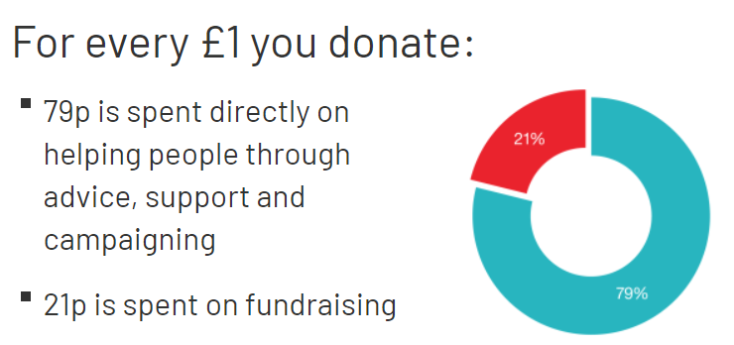
Source: Shelter (2021)
Moreover, Shelter foundation publishes annual reports providing more detailed information about its goals, strategies, activities and existing achievements. On the website of the foundation, the public can find and download annual reports from 2012 onwards. The annual reports of the foundation include information regarding achievements during the past year, strategic programmes which are planned and/or running, the activities if the foundation in England and Scotland, as well as the ways through which supporters can contribute to the development and operations of the organisation (Shelter, 2021). An extract of the annual report of the foundation is presented below, illustrating some of the specific data of what has been done in the year by the activities of the entity.

Figure 2 – Achievements of Shelter foundation 2019-2020
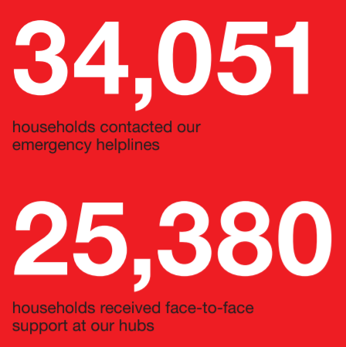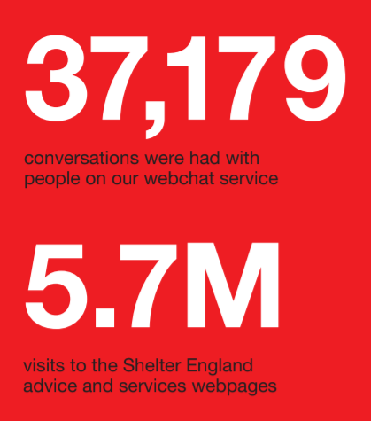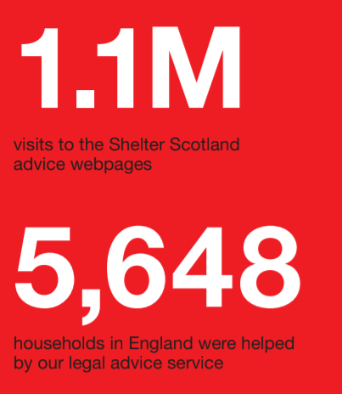
Source: Shelter (2021)
In terms of transparency and trust establishment, it can be concluded that the practice and approach of developing and publishing annual reports with detailed information about the activities of the organisation, leads to higher effectiveness and efficiency.
In terms of communication channels, both organisations use a similar approach. The main channels used to address community and stakeholders include official websites of the foundations, press releases, the use of printed materials on events, such as leaflets with statistics and other information related to the cause, public relations and social media. Both organisations use five social media platforms, as four of them overlap. Crisis uses Facebook, Instagram, Twitter, LinkedIn and YouTube, while Shelter uses the first four and TikTok. In order to analyse social media engagement, a brief research focused on investigating the followers base is conducted, as this can provide information regarding the audience reach and the potential commitment of target audiences of different stakeholders.
Crisis has 4.4K subscribers on YouTube, 110.8K followers on Twitter, 88.2K followers on Facebook, 32.3K followers on Instagram and 29.5K followers on LinkedIn. Shelter foundation has 39.2K followers on Instagram, 260.8K followers on Twitter, 174.5K followers on Instagram, 13.6K likes on TikTok and 41.3K followers on LinkedIn. This data shows that Shelter foundation has more followers on social media which also suggests that the engagement of stakeholders and community is greater.
The content published on social media by both organisations is related to their charity activities, the severity of homelessness problems in UK, the ways everybody can help and contribute to its resolution and discussions regarding attitudes and opinions towards different alternatives which can address the problem. This complies with several principles of community engagement. On one side, these areas are considered as directly relevant to the activities of the foundations which contributes to community members increasing their awareness about organisational functions and operations. Also, this content is perceived as interesting and with high potential to become viral, which will further contribute to the spread of information to other users on social media, and then attract their interest to the cause and the activities of the foundations.
In addition to that, as explained in the first assignment, the functionalities of social media also allow for better coordination and collaboration between different parties, which leads to better resource allocation and organisation of events and higher efficiency and improved results achieved by them. This also encourages higher participation and commitment rates of stakeholders, as it provides them with higher transparency, clarity regarding organisation and a platform for sharing their opinion and recommendations. This creates trust and closer relationship between audiences and community members. In the case of both foundations, the social media strategies are classified as effective in terms of achieving engagement, commitment and participation. All this also fulfils the requirements for outreach, consult, involve, collaborate and shared leadership, which represent the principles of community engagement continuum model (NIH, 2011).
Inclusion is also achieved by both organisations in a similar way, mainly focused on social media, developing policies of inclusion and eliminating discrimination and organising events which involve all related parties which are interested in the problem of homelessness. As explained in the proposed event project, it is aiming at including various stakeholders as it is believed that coordination and collaboration between them is key for the success of all campaigns of this sort. It should be pointed out that Shelter foundation places a greater attention on inclusion (at least based on the information communicated to the public which is accessible on its website), as when compared to Crisis organisation. This is based on the evidence that the organisation publishes a gender pay gap report every year along with its policies representing its commitment to equality and inclusion. Below is an extract of this report showing statistical data regarding the pay quartiles by gender, the identified percentage gap and the policies developed to address it.

Figure 3 – Gender pay gap Shelter
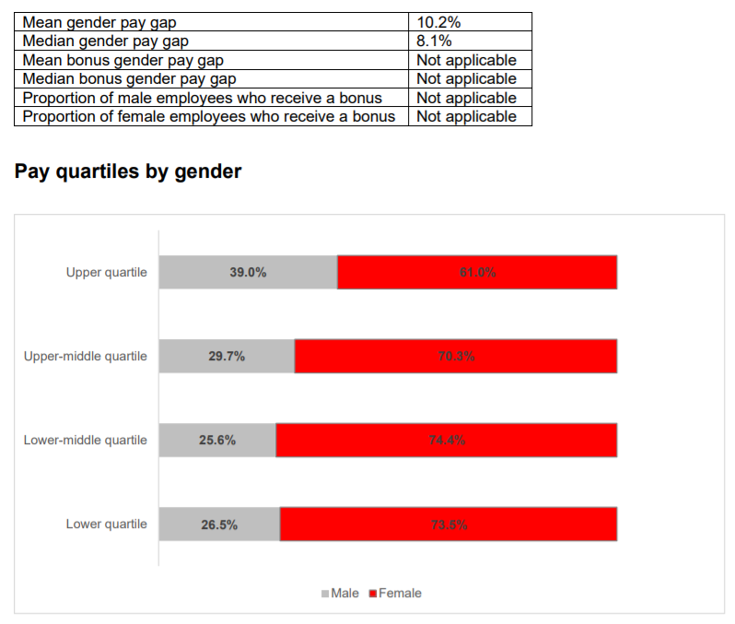
Source: Shelter (2021)
Crisis foundation does not have similar information published. This leads to the conclusion that Shelter organisation is more focused on inclusion and equality and communicates better its principles, strategies and policies to the community and other stakeholders.
In terms of community mapping, there is no official information about the specific method in which the two foundations are completing this process. However, it is assumed that both charities use the general principles of community mapping to fulfil this activity. By definition, community mapping is a tool used for mobilising communities, collecting information, lobbying government decisions and promote the provision of certain services which are claimed to contribute to better community development (WaterAid, 2005). Through using community mapping, communities and organisations can improve a certain problem, provide alternative solutions and engage more stakeholders into contributing to its resolution (WaterAid, 2005). Community mapping process generally undergoes 12 main stages, including (WaterAid, 2005).:
- Allocate resources for community mapping (including time)
- Identify target community groups
- Identify community leaders
- Carry out an initial ‘settlement profile’ (conduct survey of the settlement, estimate size of target group)
- Analyse community segments in greater detail (such as different demographic characteristics)
- Provide information to community members
- Design a map of community segments
- Add details and further data to analytical map
- Identify specific units in the community segments which will be addressed
- Collect and analyse data
- Verify data
- Use data for the purposes of the foundation operations and activities
It is assumed that the two foundations use a similar approach for identifying stakeholders and community segments which are targeted and aimed at including in different campaigns and initiatives organised by these entities. However, official information regarding the specific approaches used is not available.
When impact analysis is referred to, both organisations communicate their goals and objectives to the general public. This is considered to provide clarity about the future and contribute to greater engagement as supporters of the foundations are aware what achievements and results are forecasted and expected.
Crisis foundation publishes a plan with nine elements which is claimed to be the centre of its model of operation. These elements include researching into best practices in tackling with homelessness across the globe, analysing current situation in UK which reveals that 236,000 people suffer the worst forms of homelessness, setting specific objectives, such as ensuring a place to live, help people to keep their homes, preventing homelessness, analysing resources needed, engaging all stakeholders, as well as sharing existing achievements (Crisis, 2021). Some examples of what impact Crisis already achieved include the successful lobbying leading to government commitment to end rough sleeping by 2027, a £30 million funding provided to councils with high levels of rough sleeping, £28 million funding provided to three regional Housing First pilots and the enforcement of Homelessness Reduction Act implemented in 2018 (Crisis, 2021).
In terms of the achievements of Shelter foundation, as shown on some figures above, the specific achievements for each year and the allocation of collected funding are presented in its annual reports which are available on the organisation’s website and cover the period 2012-2021, so a historical tracking and analysis can also be performed. In addition to that, Shelter foundation also shares with its audience its future goals and commitments, including rights for renters having greater security by 2022 and people having housing rights by 2029, building enough social housing by 2022, providing housing support to those who struggle by 2022 and many more, all outlined in details and with respective actions to achieve them (Shelter, 2021).

Conclusion
After the comparison of the two organisations, it is clear that both are using the general principles for community engagement and operate in full compliance with the community engagement continuum model. Based on the accessed evidence, it can also be noted that Shelter foundation uses better strategies for communicating information addressing the needs of different stakeholders and increasing their commitment to the causes of the organisation. The foundation publishes annual reports, gender pay gap reports, policies and strategies to address inclusion and equality, future goals and details on past achievements. These topics are of high relevance in the context of achieving better stakeholder inclusion, engagement and transparency of actions. Crisis foundation also provides similar information to communities but it is not so detailed; thereby, preventing the achievement of the same level of transparency of operations and trust. Therefore, Crisis is recommended to fill the outlined performance gaps as a result of the comparative analysis.

References
Crisis (2021) How to End Homelessness in Great Britain? [online] Available: https://www.crisis.org.uk/ending-homelessness/plan-to-end-homelessness/ [Accessed: 27 August 2021]
NIH (2011) Principles of Community Engagement, [online] Available: https://synergy.dartmouth.edu/sites/default/files/docs/Principles_of_Community_Engagment_NIH_2ndEdition.pdf [Accessed: 26 August 2021]
Shelter (2021) How We Spend Your Money, [online] Available: https://england.shelter.org.uk/what_we_do/how_we_spend_your_money [Accessed: 30 August 2021]
Talmage, C. (2014) A Story About Storytelling: Enhancement of Community Participation Through Catalytic Storytelling, Community Development, Vol. 45(5), pp. 525-538.
WaterAid (2005) Community Mapping: a Tool for Community Organising, [online] Available: https://washmatters.wateraid.org/publications/community-mapping-a-tool-for-community-organising-2005-0 [Accessed: 31 August 2021]

