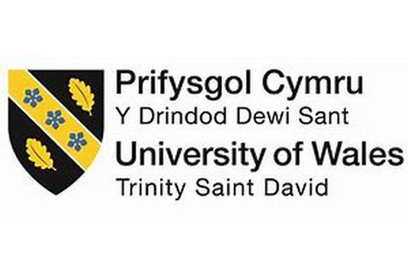

EFFECTIVE TEAM WORKING AND COMMUNICATION

ComponeNt 1

Report

Effective teamworkinG for team success

BMSW4002_BIRM

Lecturer: Akash Puranik
Student: Nicoleta Damian (2120244)

Summary

This report encompasses models and recommendations for working as a team for Next, where the team should launch a new line of children’s wear across the world. The following report will explain and lead to a successful launch whether people reach cooperation with others in an individualistic or collaborative way, their basic social skill sets, including conversing, paying close attention, and working more closely, as well as their collaborative abilities, such as cooperation, real worry for the team, or inter - personal consciousness. This report will provide and explain how to develop an effective team, types of roles needed to create an effective team, the barriers and challenges identified in working with a team for Next Plc.
A team is much greater than a collection of individuals. A team collaborates along a project to accomplish a particular desired goal. Working as a team involves management, cooperation, and coherence.
Impressive and relevant literature such as Belbin’s and Hackman’s models working within a team, as well as Coyle’s and Tuckman’s theories.

Table of content
- Summary ……………………………………………….2

- Table of content………………………………………..3

- Introduction ………………………………………….4-5

- Overview of team working ………………………..5-6

- Models of team developments ………………….7-11

- Team roles ………………………………………..11-13

- Discussion ………………………………………..13-15

- Conclusion and recommendations ……………. 15

- Reference list……………………………………..16-17

Introduction
Any corporation struggles to find success in isolation in today's fiercely dynamic business environment. Therefore, the majority of organisations nowadays have the attribute of having teams. According to proposed study case, it is possible for people to collaborate more effectively than when they work alone.
A team is a group of individuals who have joined together to work toward a shared objective.
A teamwork, according to Barnes (2008), will be a group of individuals that collaborate on a task in order to successfully achieve a particular aim or purpose.
Thus according West (2004), it's critical to consider an individual 's ambition, understanding, and abilities for working together as a team when forming a team rather than just the generally immutable components of their character, such like their personality.
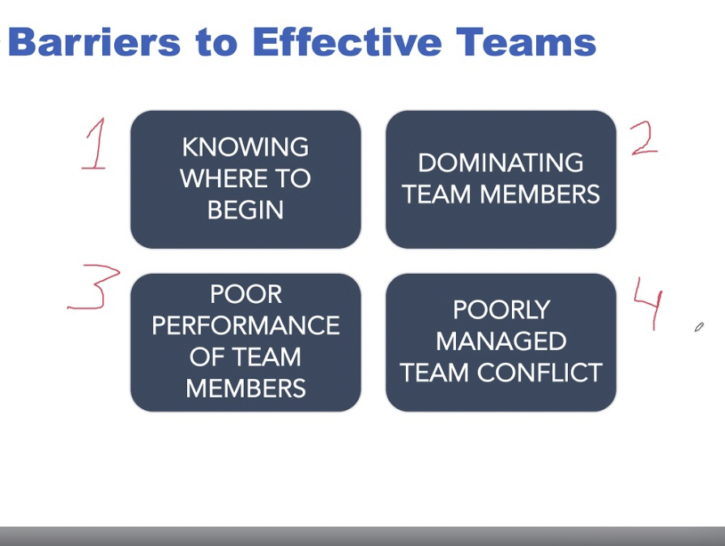
The above encompasses their preference for working as a team, whether people reach cooperation with others in an individualistic or collaborative way, their basic social skill sets, including conversing, paying close attention, and working more closely, as well as their collaborative abilities, such as cooperation, real worry for the team, or inter - personal consciousness.
This report will provide and explain how to develop an effective team, types of roles needed to create an effective team, the barriers and challenges identified in working with a team for Next Plc. Impressive and relevant literature such as Belbin’s and Hackman’s models working within a team, as well as Coyle’s and Tuckman’s theories.
Overview of teamworking
The concept behind teamwork is that a number of individuals will contribute significantly more when they work collaboratively than they could if they were operating alone (Barnes, 2008).
A team is much greater than a collection of individuals. A team collaborates along a project to accomplish a particular desired goal. Working as a team involves management, cooperation, and coherence.
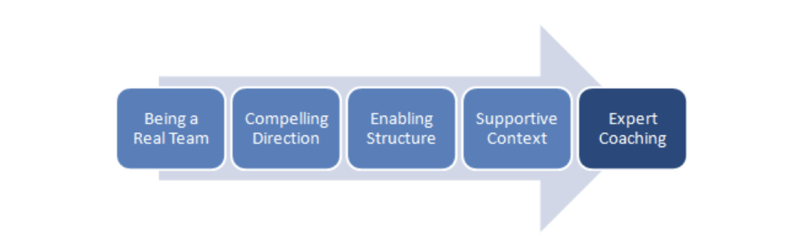
Characteristics of a Team
A team is characterised by a distinct, shared objective that is acknowledged and shared by all members.
If a group is to be deemed a team as opposed to a workgroup, Hackman (2009) has listed five fundamental requirements which should be fulfilled in our study case about managing a team for Next Pls:
Team has to be real.
Although teams are often formed within organisations, a few of these arrangements merely serve as teams in name. Real teams are made up of recognisable members who actively collaborate to collaborate towards a shared goal.
Team should have an inspiring goal.
Individuals must comprehend and support some mutual goals if they really are to be moving along a similar perspective.
Team requires facilitating systems and a clear plan.
The above entails managing people according to the proper standards as well as common interests while engaging the appropriate amount and type of individuals into the relevant duties in the right methods.
Teamwork requires specific resources.
The composition of a team' members, structures, various procedures, as well as the behaviours and results which are most valued or compensated fairly, must all be conducive to performance.
Teammates require skilled coaching.
At critical junctures in any team's development, a knowledgeable outsider should provide advice plus insights. Whenever it comes to coaching, excessively attention is paid to the person rather than teamwork and team processes.
A young team all must take some time to get accustomed to one another and their varied operating styles.
According to one belief, a team must pass through five phases of team growth before it would perform to the best of its abilities.
Tuckman's Model is the name given to these stages, which were developed by psychologist Bruce Tuckman.
In 1965, psychologist Bruce Tuckman made the original version of his idea. Teams were to go through the following developmental stages: forming, storming, norming, performing, and adjourning. Tuckman (1965)
It is claimed that such phases last from the first group meeting until the task is finished.
Each of these five phases is properly titled and contributes significantly to the formation of a highly efficient professional team.
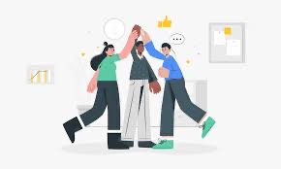
Models of team development
The teamwork and communication challenges are frequently present during team meetings. To ensure that the team for the Next Plc is a qualitative, effective and ready to ensure a successful lunch, is important to make sure that the team is a team and not just a group. The most suitable team development model that could be considered in this scenario is Hackman’s.
J. Richard Hackman created a workgroup management and design model based on research while he was employed at Harvard University in 2002. The reason why just certain groups were effective served as the focus of his investigation. He discovered the elements which may boost a team's likelihood of succeeding.
He listed the following factors as necessary to guarantee that your team is "a real team":

The group membership is consistent, the team boundaries are clear regarding who is within or outside of the group, and the members have a common task.
The first two components of a "real team" are directly under your management, but the consistency of the team members is frequently the most challenging part to maintain. If your workplace is project-based, it's likely that team consistency will only endure as longer as the task.
The structure of the team may become unstable due to the nature of the work.
The second component of this methodology is giving your squad an inspiring goal. This implies that you set your team clear objectives that are demanding and important.
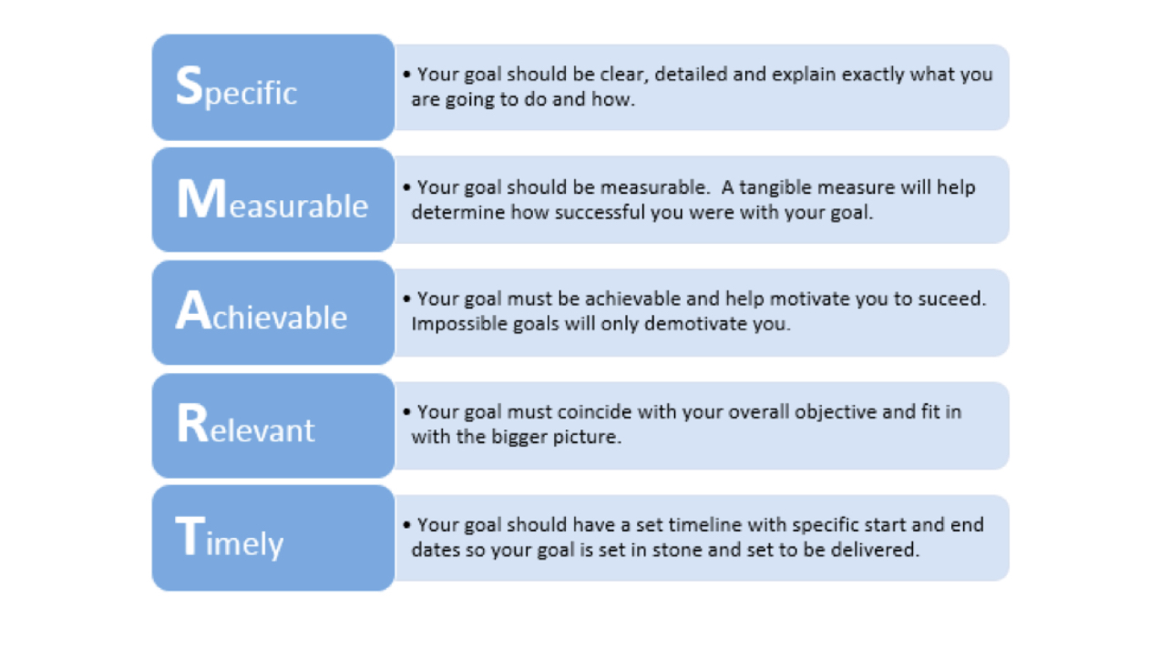
You have direct influence over objectives you establish for the team as a manager, regardless of the kind of team you are in charge of. You may also make sure to give your workers objectives that actively encourages workers. Smart objectives are Time-Bound, Specified, Measurable, Achievable goals, but also Relevant.

The third element that Hackman lists as having a significant impact on your team's success is the plan in which it operates. A few of these factors will be under your hands, while others will be determined by the form of the company.
The success of Next team will increase if you can provide them a range of duties to do.
You'll also need to make sure that some of the essential team members have great interpersonal skills. This ensures that the base for decision-making inside the team is persuading and persuasively made reasons instead of confrontation. Additionally, these social abilities will guarantee that behaviour is governed by solid rules.
Support is the fourth attribute needed to guarantee winning teams. Businesses require a supportive environment since they are composed of small teams that, when united, make up bigger groupings.
Three components make up this supporting system: reward, development, and information.
The incentive should be related to the company's or team 's success. The productivity and collaboration of the team should be rewarded as the foundation of this structure.
The improvement of each participant's abilities through an education system has to be the second component of the assistance.
The third component of help and assistance relates to the providing of data and ensuring easy access to the records and resources.
It is essential for you to be able to make sure your staff has access to the information and resources they require to advance their specific abilities.
You can benefit from the developments in communication and technology (computer systems, laptops, cellphones.). Your employees will be able to expand their abilities with the help of the greatest resources and knowledge available.
The Five Factor Model's final component is professional coaching and mentorship. You can determine whether members of the team need assistance with a job or who needs to work on their communication abilities by managing a team on a day-to-day basis.
You train the individual on how to better achieve this challenge and develop the skills they lack after this need has been discovered. You should be careful not to come across as overpowering, as this might drastically reduce the performance of a team. The latter is a drawback that Hackman (2009) emphasises in his study and will dramatically lower any team's success.
Tuckman's Four Stages and Hackman's Five Factor Model are probably to coexist in the majority of groups you will come across in the professional world.
Knowing which of the five components are prevalent in your business and at what phase your team was working will be helpful to you as a leader. You will be more able to modify your style of leadership as well as behaviours to fit your present group if you have a deeper awareness of the team dynamics.
The four-stage model developed by Bruce Tuckman from 1965 under the title "Tuckman's Stages for a Group" becomes one of the most important findings on team formation. According to this, there must be four main stages to the optimal group proposal procedure. These empower a team to address issues, identify answers, plus produce outcomes.
The formation of the team is the first phase of team development.
The work has been assigned and indeed the group has just been presented. Due to the tendency of team members to act autonomously at this point, it is an interesting social situation. Even though there might be good principles and pleasant vibes, there won't be any trust.
It's typical to talk about the following issues at this level of team development:
Abilities, backgrounds, and interest of each individual;
Project objectives;
The timespan,specific guidelines or regulations;
What different role each participant will take.
It's critical that the team begin to comprehend the role which each member will perform at this point.
When the initial exhilaration and good humour have worn off, the storming stage begins. Most probably, by this point, the project's gravity and realism had struck in.
At this point, personalities might start to appear and tensions might boil. The group may disagree on the best way to do a specific task or express any concerns.
Listening to a competent leader for direction at this point is essential.
At this point, everything start to calm down. Your team might get into the habit of cooperating to accomplish a shared objective.

Nevertheless, there may be a few crossovers between storming and norming throughout the norming stage. There still may be occasional instances of disagreement as additional duties are added.
Your team can find its rhythm on the stage when it is performing. Each member of the team is aware of the skills and shortcomings of the others and is comfortable sufficient with them to offer assistance.
Each team member is oriented at this point. They can also work there without being being watched.
It is a true accomplishment if your team advances to this stage because some groups don't. The group will strive to reach this level because this is when you can produce your greatest work.
It is possible to ignite imagination and boost team spirit when collaborating in a coherent and supporting team.
Tuckman (1977) didn't include the fifth and final stage – adjourning until 1977.
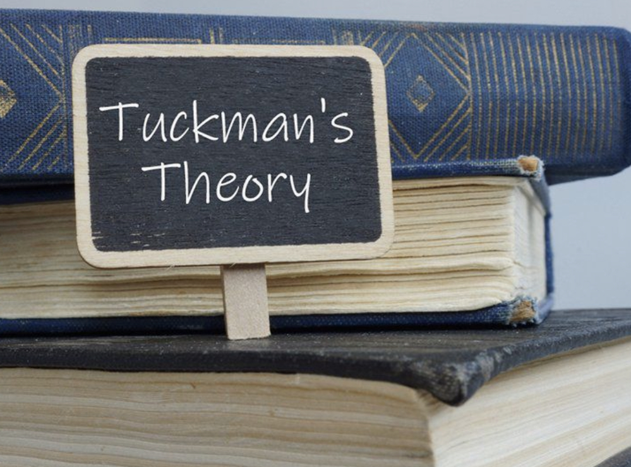
The team will break up after the project is finished.
As noticed the members of the Next team at the actual moment is between stages forming and storming.

Team roles
The model on team roles that Belbin (1981) created was expanded upon in his 1993 article. When a team is given a successful or failing job, the performance of the team can be seen using Belbin's model. Each person's designated position balances the team role within the group, and great performance is anticipated with significant participation of all roles. Each team participant's role has been identical in personal experience. Team role and functional role are two terms that Belbin distinguishes. A team must maintain the ideal balance between its functional responsibilities and its team roles.
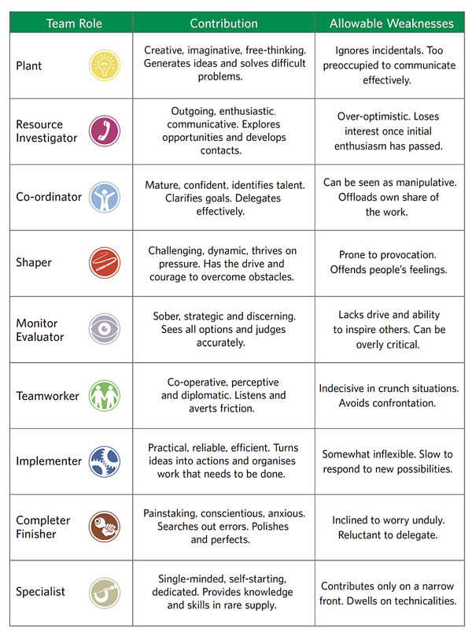
The four stages of limited team growth, however, are described as forming, storming, norming, and performing in Tuckman's theory. The fulfilment of tasks, termination of roles, and breakup of groups now make up the fifth step of adjourning. The features of the four categories are defined by Belbin's theory, which is useful for identifying the various team kinds. According to this concept, disputes and relationship difficulties arise throughout team development, and team building is reliant on communicating effectively and interpersonal maturation along with improved quality. This concept is helpful for many practitioners and team leaders in traditional settings. This paradigm states that each member performs predetermined tasks at the same location.
Belbin's (1981) assertion that no one person can possibly possess all the traits necessary to fulfil every business function is dead on. A person in a team is given the role of his choosing, and positions outside of his capabilities are minimized. Belbin developed the idea of roles in a team and how they contribute to the distinctive characteristics and skills of a team. The mixture of team roles within a team affects the effectiveness of that team. The individual roles in a team are shaped, to a lesser or larger level, by the Belbin roles. All nine of these positions, as described by Belbin, are not required in order to be successful.
Because some positions are paired up, it's important to note that five roles are all you need to succeed. For instance, a specialised role can be conducted by a Plants role included within nine roles of Belbin. The early stages of a project require concepts, thoughts, and connections, thus the responsibilities of resources and plants are more important at that time. When the project is finished, the implementers' and completers' duties each have a specific place in the team. The Belbin idea permits each role in a team to have a supporting role. The secondary role has the second-highest results-oriented skills. A role can serve multiple purposes in a team by doing this and developing into a second function player.
Belbin Team Roles emphasise group advantages while reducing group shortcomings, assisting teams in adapting to common objectives. As a result, the team can be more cohesive while also being flexible in a dynamic world and within this launch for Next Plc. Individual responses to change can differ.

Discussion
Working in groups fosters cooperation and promotes idea generation. As a consequence, creativity increases and productivity rises.
Two or more people will always be more effective than one at problem-solving, completing difficult challenges, and fostering innovation.
Everybody is diverse and has a variety of abilities, skills, and background. As a result, team members can assist you in gaining new perspectives.
The communication between team members is facilitated by cooperation. As a result, workplace relationships often improve, and workers gradually develop better communication skills.
Coyle (2018) identified the characteristics of an effective teamworking and explained that building safety, share vulnerability and establish purpose are the key points for success.
Working teams have always been a crucial component of the majority of companies, claims Barnes (2008). A person working completely alone in any business is extremely uncommon. In reality, one of the fundamental goals of commercial groups is to unite people so they can work more effectively together than they could if they worked alone (Aronoff & Ward, 1997).
In addition, a lot of work activities require a team of people to operate together, which is the fundamental definition of teamwork.
Real-time communication improves and increases with cooperation. All of this results in outputs of a higher calibre.
Better brainstorming can occur in an environment where staff members often express their thoughts, analyses, recommendations, and worries. This opens up a debate about novel concepts and various viewpoints, which leads to ongoing development.
As mentioned above is important to make sure that the people from different locations that are working for a Next launch are working as a team and provide a successful outcome. All the models of team development mentioned through the report must be considered to hit the goals set for Next kids clothing project.
It is clear from the scenario that there were various obstacles that needed to be taken into account and resolved. Gaps in communication is one of them.
Workers must have great communication skills to interact with coworkers, share their perspectives, listen to others, and communicate objectives when interacting with other teammates. Team members that have communication breakdowns may not be clear on what is expected of them or their roles. Groups can make a conscious effort to improve their communication abilities to close these disparities and interact more successfully.
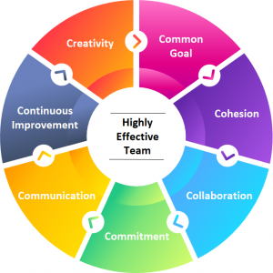
Inequitable decision-making is the second barrier identified in the research scenario.
One team member frequently takes on more responsibility than the others and predominates in making decisions in a team setting. This unequal working atmosphere frequently results from some team members being more outgoing, possessing more sophisticated skills, or favouring an individual working style. However, if members of the team who are more introverted and have a tendency towards collaboration feel that their opinions aren't valuable, they might begin to participate less. By democratising workflow and guaranteeing that all team members may contribute equally, team members can overcome unfair decision-making procedures.
The third obstacle in the scenario is a lack of conflict resolution abilities.
Team may experience conflict when they collaborate to achieve common objectives, but it's crucial that professionals know how to resolve these conflicts and move on. This can be a difficult task if you lack conflict resolution abilities. Teams can practise conflict resolution together through targeted professional development seminars and in-person utilising a predetermined approach to get past this obstacle.
Conclusion and recommendations
It can be useful to have a concept of what to anticipate when assembling a team to perform a specific task.
You can prepare yourself for what is coming by learning this concept and learning to recognise the phases in everyday life.
Based on the anticipated organisational demands, more chances and difficulties must be offered, as well as support for team members to succeed in this launch. Open mindedness and energy can be expected to attract the essential members of the team, who make up a significant portion of the keys to good team development, when an organisational climate is created.
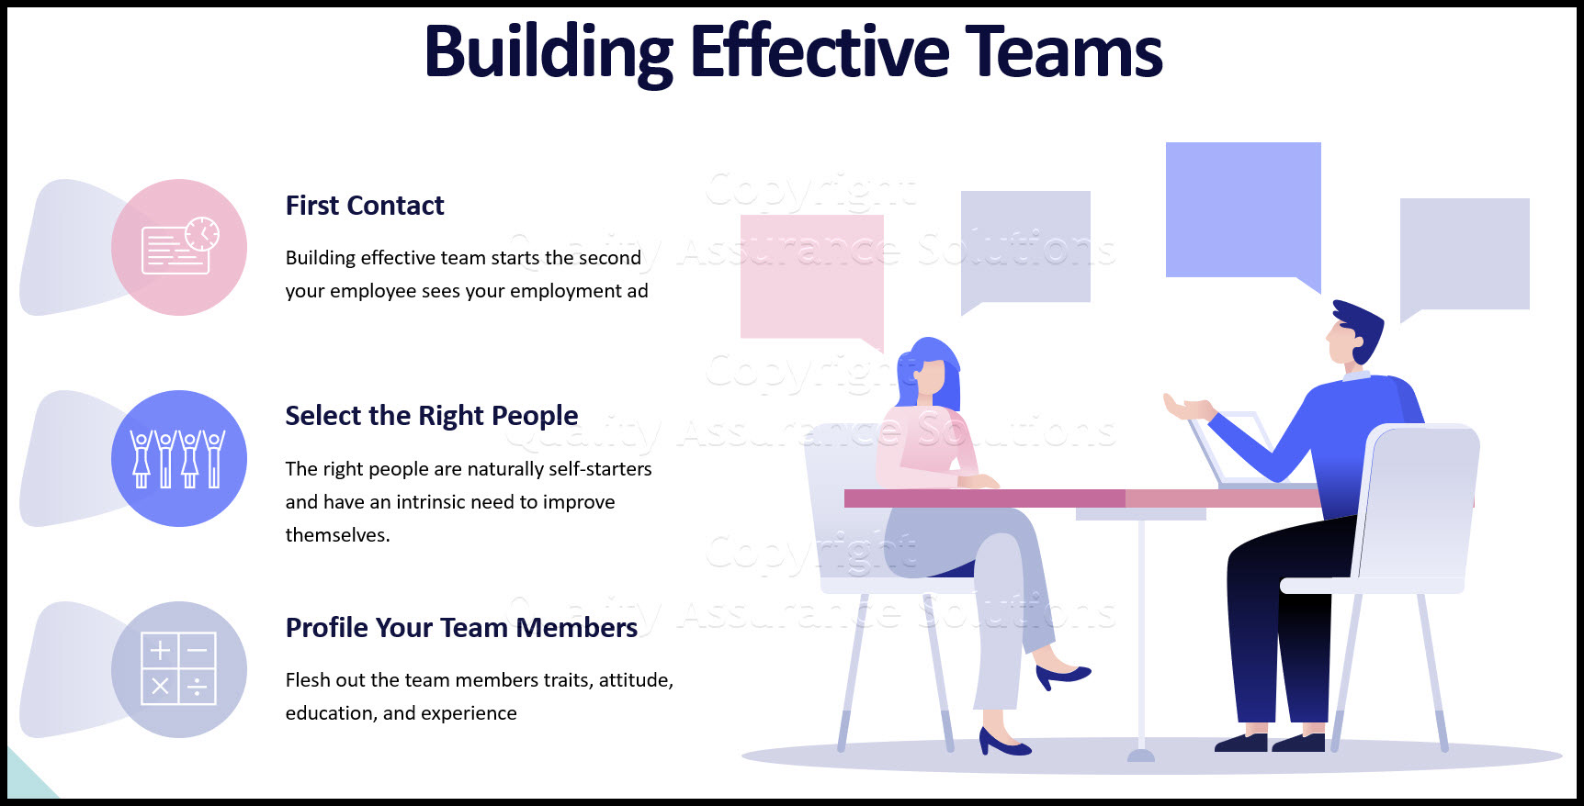
The main models for a effective teamworking and a successful launch as it was explained in this report, must be taken into consideration, as those help on recruiting the right people for the right task.
Reference list
Aronoff, C. E., Ward, J. L., 1997. Making Sibling Teams Work: The Next Generation. Georgia, US: Family Enterprise Publisher.
Barnes, D., 2008. Operations management: an international perspective. Hampshire, UK: Cengage Learning.
Belbin (2009). The Belbin guide to succeeding at work. London: A. & C. Black.
Beyerlein, M. M. & Johnson, D. A., 2001. Team development, Volume 5. West Yorkshire: Emerald Group Publishing.
Coyle, D. (2019). The Culture Code. Random House Uk.
Gaines, K., 2006. Leading Work Teams. Alexandria, VA: American Society for Training and Development.
J Richard Hackman (2002). Leading teams : setting the stage for great performances. Boston, Mass.: Harvard Business School Press.
‌J Richard Hackman (1965). Tests, questionnaires and tasks of the Group Effectiveness Research Laboratory : 1951-1964. Urbana, Ill.: Group Effectiveness Research Laboratory, Department Of Psychology, University Of Illinois.
‌Tuckman, B. W. Development sequence in small groups. Psychological Bulletin, 1965, 63(6), 384-399.
Small Business Trends. 2022. Getting Work Done: In Groups and Alone - Small Business Trends. [ONLINE] Available at: https://smallbiztrends.com/2016/03/advantages-and-disadvantages-of-teamwork.html. [Accessed 28 June 2022].
web.mit.edu. 2022. No page title. [ONLINE] Available at: https://web.mit.edu/curhan/www/docs/Articles/15341_Readings/Group_Dynamics/Tuckman_1965_Developmental_sequence_in_small_groups.pdf. [Accessed 27 June 2022].
www.belbin.com. 2022. No page title. [ONLINE] Available at: https://www.belbin.com/media/2307/belbin-team-role-summary-descriptions.pdf. [Accessed 30 June 2022].

