Swansea Council
Early Help Hub Conference.

Improving Outcomes for Young People.

The aim of the project is to plan, organise, and facilitate, an Early Help Hub conference themed as Improving Outcomes for Young People on the 13th March 2020. The purpose of this document is to firm out the high-level scope of work to be completed through the phases of the delivery of the conference.

The document provides a baseline for the projects management including timelines, resources, budget required and success factors. The document also sets out why and how the implementation phase should proceed using a masterplan to deliver a smooth progression through the initiation, planning and design, construction and execution, monitoring and control and completion phases of the project. The document aids the project leader’s task to ensure the conference is delivered to the scope of the brief, delivered within the time constraint, delivered with the expected quality and within the maximum budget approved by Welsh Government of £6500.00



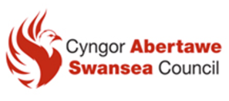

2020
Jonathan Hathaway 0551029
Leading and Managing Projects BMMB7010
15/01/2020

Leading and Managing Projects Assignment

Page

Executive Summary 3-4

1 Project Description and Business Case 5-8
1.1 Background
1.2 Project Objectives and Success Criteria
1.3 Success Criteria
1.4 Conference Outputs
1.5 Conference Outcomes
1.6 Dis-benefits
1.7 Out of Scope

2 Environmental Analysis. (Opportunities and Challenges) 9-26

2.1 PESTEL

2.2 Internal Environment
2.3 Stakeholder Analysis Mendelows Matrix
2.4 Mckinsey 7 S Model
2.5 Resources and Capabilities VRIO
2.6 Opportunities and Challenges
2.7 Educational Opportunities
2.8 Networking Opportunities
2.9 Morale Building
2.10 Updates
2.11 Solve Problems
2.12 Challenges
2.13 Budget Planning and Monitoring
2.14 Stake Holder Buy-in
2.15 Capacity Issues
2.16 Venue Co-ordination
2.17 Time Management
2.18 Delegate Expectations
2.19 Key Note Speakers
2.20 Managing Multiple Activities
2.21 Catering Provision.

3 Operational Requirements 27-30
3.1 Communication and Distribution List
3.2 Approvals Table.
3.3 Communication Plan
3.4 Risk Log
3.5 Project Plan and Timeline
3.6 Questionnaire

4 Financial Projections 31
5 Recommendations and Findings 32-33
5.1 Project Funding
5.2 Staff Resources
5.3 Attendance
5.4 Conclusions and Expected Benefits
Bibliography 34-37
Appendix 38-53

- Main Report 4,414 words excluding title page, contents, bibliography, appendices and tables
Executive Summary.
The following report provides the direction and understanding of designing, creating and implementing an Early Help Conference (EHH) directed at Improving the Outcomes of Young People. According to GAI. (2019). Conferences provide an opportunity to capture valuable updates in relation to the young people environment in a relatively short amount of time. These events offer delegates the opportunity to hear from invited experts, who often share their research and facilitate discussions about where the circumstances for young people are heading.
The objectives and success criteria of the project are to deliver the Improving Outcomes for Young People conference efficiently through the various phases of the project including initiation planning, design construction, execution monitoring and control and completion phases of the project. The Conference Lead is tasked to ensure that the conference is delivered to the scope of the brief, delivered within the time constraint, delivered with the expected quality and within budget.

The rationale for the (EHH) conference is to bring people together from differing geographical areas who share a common discipline or field in order to expand knowledge, find solutions to problems, learn beyond the field of interest and to present ideas and work to others. The Improving Outcomes for Young People conference aims to scrutinise and examine Government legislation including the Children and Families Act 2014, Children and Social Work Act, 2017 and the statutory guidance on how government legislation aspires to Improve Outcomes for Young People in the Working Together to Safeguard Children 2019 bill. The conference also aims to evaluate the Transforming Children and Young Peoples Mental Health 2019 bill and Young Persons Guide to the Children and Family 2019 guidance.

The report includes an evaluation of the external environment and internal environment deemed appropriate and relative to the delivering of the conference. The evaluation includes a PESTLE analysis, stakeholder analysis using a Mendelow framework and an assessment of the resource capability of the (EHH) using the Mckinsey 7’s, Peters, T. and Waterman, R. (1982), model and Barney and Hesterly (2006), VRIO model. As the conference is historically a bi-annual event the use of the models was deemed critical to the future feasibility, suitability and acceptability of future projects of this nature.

The report includes an assessment of the resources required for the conference and includes a time schedule for implementation, people involved for the delivery and the facilities required to host the conference. The plan also includes a risk register together with an assessment of their severity that could be could be critical to the success or failure of the conference. The rationale for incorporating a hybrid agile project management approach is due to the nature of the conference and it was deemed that an amalgamation of traditional structured methodologies and flexible agile approaches realise efficiencies, improve benefits, speed up delivery improve quality, and critically satisfy stakeholders.
The report includes a financial breakdown of the costs of the conference and a breakdown of the possible alternatives that produced costs within the approved budget of £6500.00. The report also includes a critical discussion of the staff costs whose costs are indirect and deemed irrelative to the costings because they are sunk. The hours directly attributed to the conference are not calculated and are out of scope.
The conference will be delivered on March the 13th 2020 at the Village Hotel Swansea. The budget and funding was confirmed for the conference in March 2019, although there is an element of uncertainty whether the conference will take place as a bi-annual event due to the environmental analysis conducted in this report. There are however clear expected benefits of holding a conference in terms of educational opportunities, networking with peers and industry experts as conferences of this nature facilitate an opportunity to capture business critical information in a short amount of time.

1 Project Description and Business Case
According to Portman, H. (2010), the Business Case consists of four generic building blocks including scope, time, resources, and the iteration of what would happen if the project did not go ahead. The Business Case provides the justification for the project by setting out the frame work in terms of these building blocks with sub criteria for the continued testing of project viability, project mandate, project background, project scope and project costs/benefits analysis.
Smith, N.J. (2008), also argues that the Business Case is the product of management activities and efforts. It establishes a mechanism to judge whether a project is and remains desirable, viable and achievable as a means to support decision making in its continued investment.
According to PRINCE2 methodology it provides the justification for the endeavor, though in other project management methodologies, the justification is a separate activity and encompasses the business case alongside the project objectives, scope, and context. Newell, M. and Grashina, M. (2004).
A Project Initiation Document (PID) has already been previously submitted and its purpose was to capture and record basic information needed to correctly define and plan the project. The PID should expand upon the project mandate and state what the project is aiming and planning to achieve and the reason for the importance of meeting these aims. The initial business Case (PID) must be a short and concise document focusing as much as possible on factual data and realistic estimates Young, T. (2004).
The project in this illustration is to hold a conference. A conference is generally understood to be a meeting of several people to discuss a particular topic. Lawrence, M. and McCabe, V. (2001). Conference types are numerous, ranging from academic, trade fairs, conventions and professional conferences. The Early Help Hub (EHH) conference is a cross cutting conference based around academia and a professional conference. An academia conference is where researchers present results, hold workshops and activities. A professional conference is where practitioners in a given profession deal with related matters or developments. Kliem, R. and Ludin, I. (1998).

The rationale for the Early Help Conference is to bring together people within the Swansea region who share a common discipline or field in order to expand knowledge, find solutions to problems, learn beyond the field or interest, and to present ideas and work to others.
The Improving Outcomes for Young People conference aims to scrutinise and examine Government legislation previously stated that are conditional in transforming the lives of vulnerable young people. Conferences provide an opportunity to capture valuable updates in relation to the young people environment in a relatively short amount of time GAI. (2019). These events offer delegates the opportunity to hear from invited experts, who often share their research and facilitate discussions about where the circumstances for young people are heading.

1.1 Background.
The Early Help Hub (EHH) is designated service created to ensure that all vulnerable young people and their families are offered the opportunity to engage with the appropriate service at the right time, working with them to build resilience and overcome barriers, enabling them to be well, thrive and become the best they can be. The (EHH) mission is to run a highly skilled, professional, multidisciplinary adolescent and family service capable of achieving the vision of the service and the wider visions of Swansea City Council.
It will do this through focusing on performance through utilising a robust cycle of continuous learning and improvement through the thorough and regular analysis of both qualitative and qualitative performance data. The service is dedicated to practice, utilising and developing an evidence based framework of practice that is fit for purpose, with a staff team that are trained and supported to skillfully and appropriately use the framework. The service applies itself to partnership by working in a truly integrated way with all other service providers, ensuring that services make sense to families and young people and that the development of the service is co-produced with its stakeholders and embeds the principles of rights based practice.
The (EHH) has long seen the opportunity to capture the three P’s of performance, practice and partnership through a vehicle of creating and delivering a conference. This is endorsed by the major stakeholder, Welsh Government who fund the event through a training and development budget dedicated to improve the outcomes of vulnerable young people.
1.2 Project Objectives and Success Criteria.
The criteria for project success of the project management effort tends to be restricted to cost time, quality and performance. Bredillet, P. (2005).

1.3 Project Success Criteria
- Attendance – Conference to attract 100 delegates
- Delivered on Time - Conference commences at 08.30 on the 13th March 2020
- Delivered to Budget – Budget approved is £6500.00
- Communication - Communication strategy implemented to attract 100 delegates
- Participant Satisfaction – Agenda and day plan formulated to be informative and enjoyable (Day plan appendix 6)
- Quality – Quality Industry renowned key note speakers employed
- Performance – Positive feedback satisfying measures and outputs for training (Questionnaire appendix 2)
Outputs maybe described as the tangible and intangible products that result from project activities. The outcomes can considered as midterm or futuristic results they are not seen as immediate. Outcomes can be described as the benefits that a project or intervention is designed to deliver. In this scenario this what the conference aims to achieve by the end of the session. Kliem, R. and Ludin, I. (1998).
1.4 Conference Outputs
- About us - Informing the participants about what the (EHH) do
- Build Morale- subjecting (EHH) staff to multi agencies
- Solve Problems- Workshops and case study approach
- Information exchange
- Brainstorming and idea generation
- Initiate review on legislation and guidelines
1.5 Conference Outcomes
- High standard of presentation embracing the theme of the conference and addressing the issues in the governmental acts.
- Each speaker to lead a small breakout group to discuss presentation. Abstract to Practitioners making improvements and discussing practice cases in relation to academic theory.
- Identify training needs, a greater understanding of the attendees who desire to undertake continuing professional development and learn about the processing of improvement.
- Create an enjoyable event.

1.6 Dis-benefits
- Impact on staff working capacity
- Opportunity cost- Loss of other training opportunities due to mutual exclusive decision making.
- Temporary change to work patterns, well-being issues and historically sickness.
- Behavioural change due to project stress of the staff involve in the conference team
- Delegates travelling to the conference – emphasis and trend towards digital meetings and conferences.
- Constraint on the number of delegates invited due to budget.
1.7 Out of scope.
The bid process was in place in January 2019 for the funding of this event. This has not been incorporated in the time-plan.
Notional costing – efficiency and effectiveness calculations with notional hourly rate of actual staff costs hypothesising whether the benefits of delivering a conference outweigh the costs. Tracking the return on investment will continue to be an important factor. Reporting on the event and its success is crucial to justifying a stakeholders spend and something that will be fundamental as budgets become further stretched and scrutinized. Shamel, C. (2012).

Environmental Analysis

2.1 PESTLE

Legal
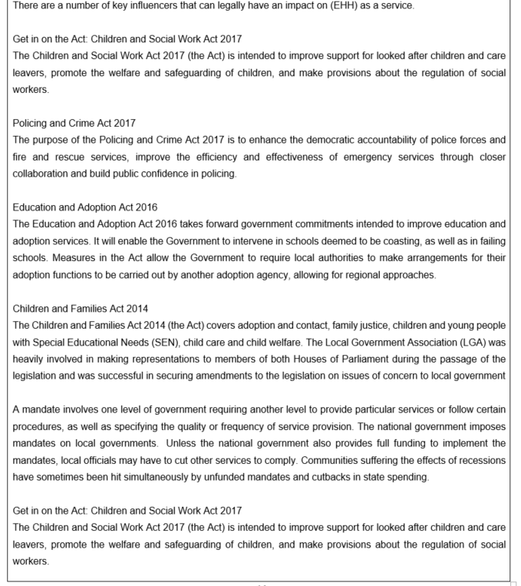
1110000

2.2 Internal Environment

he concept of project management capability is receiving attention from the business
firms that are trying to achieve sustainable competitive advantage.
he concept of project management capability is receiving attention from the business
firms that are trying to achieve sustainable competitive advantage.

2.6 Opportunities and Challenges.

2.7 Educational Opportunities

The educational aspect of a conference can expose new ways of conducting practises and possibilities on how to be more productive. One of the problems within the authority is that departments work in silo which can often be isolating. A conference can be a forum of ideas and trends and expose a variety of points of view which could offer solutions to impact future results. The content and subject matter provided by the key note speakers furnishes an academic viewpoint to compliment practitioner perspective.

2.8 Networking Opportunities

The conference can provide an opportunity to network and provide a multi-agency perspective. The intention is to provide a collaboration approach to networking and for delegates to get to know each other and what they contribute to improving outcomes for young people.
2.9 Build Morale:
The conference presents an opportunity to take staff away for a team-building event and is channel to build staff morale. The conference can encourage effective communication amongst employees and could also be vehicle to identify leadership skills and generally bring employees closer together
2.10 Brief Staff/Clients of Service Updates
The (EHH) conference provides a vehicle to inform the delegates of large operational changes. The (EHH) has recently undertaken a substantial restructure. The conference is a platform to invite delegates identified in the stakeholder analysis to inform them of changes to the service provision. The authority policies are reviewed and created when necessary and communication can become challenging.
2.11 Solve Problems:
The workshop arrangement is an opportunity to discuss various prescriptions to ongoing issues. The division of delegates into groups of differing skill-sets can formulate solutions and outlooks to current issues. The genesis behind the workshop arrangement is to generate forums of brainstorming and idea generation: A conference getaway dedicated to idea generation has historically proved to be worthwhile.

2.12 Challenges

2.13 Budget Planning and Monitoring.
Although this has been identified as a significant challenge akin to most projects, the budget allocation is approved and a buffer arrangement has been negotiated to mitigate the potential rising costs from initial planning. The buffer is a 10% variation from the initial planning costs and there is a condition that if further costs materialise, then permission from Welsh Government would need to be requested. In reference to the venue selection process a package with the Village Hotel has been negotiated with a discounted per head rate that encompasses all venue costs. The venue selection process clarified that not all venue providers included sundry costs in the hire of the premises and this eases and mitigates budget constraints.

2.14 Stakeholder Buy-In.
The bid process which is out of scope for this project was submitted in January 2019. For the Financial Year 2019-20, the stake holder approval and agreement has been confirmed. As the bid process is annual and the conference is bi – annual, future stakeholder buy-in maybe less accommodating. The foundations for the conference in 2020-21 are in preparation stage in 2019 -20 therefore the justification for future conferences somewhat depends on the success criteria for this event.

2.15 Capacity Issues.
Organising a conference that engages, informs and entertains delegates is a considerable undertaking and produces a strain on resources in terms of capacity of the team. The project team will be required to reorganise calendars and extra duties on top of what is already a strained service will require considerable leadership and motivational demands. To mitigate this issue there is a flex arrangement in place and hours above the normal call of duty can be made as a toil or flexi adjustment.

2.16 Venue Co-ordination.
Although an established rapport has been developed with the Village Hotel who are the venue provider, the co-ordination is a challenge as they are an outsourced provider. To mitigate the challenge a contract is in place and a communication policy established to enhance the business relationship.

2.17 Time Management.
Prioritising tasks, and scheduling them accordingly is arguably the greatest challenge associated with project management. The conference planning checklist is of little to no use if the conference team does not understand the associated timeline. At the time of this report the conference is on schedule for the 13th March 2020 and a time line and project planner is in situ. The primary challenge outstanding is the RSVP management as this will take considerable monitoring to confirm 100 delegates. The RSVPs is to be managed on-line and based on previous conferences that last minute baulking by a percentage of invites will be experienced. To mitigate the risk of low attendance, efforts have been made to construct a reserve list. At the time of this report however there are indications that the conference is over-subscribed and a rationale for sifting has been planned. There maybe scope for additional delegates to be included and utilise the agreed buffer. This will encounter an increase in costs from initial planning but it maybe a contingency option.

2.18 Delegate Expectations
The delegates are the most important element of any conference, because they decide if it’s a success or failure. The planners must gather as much information as possible about their likes, dislikes and motivations and this will help will help to meet their expectations of the event.

2.19 Key Note Speakers
Finding the right speaker for your conference is crucial because they will be representing the (EHH) as a service. The key note speaker is probably the primary reason for attendance and the delivery is what delegate listens to. The key note speakers therefore need to be able to convey any key messages in a clear and engaging way.

2.20 Managing Multiple Activities.
It is acknowledged that managing multiple activities simultaneously, is going to be a challenge. The project plan incorporates a comprehensive meeting schedule which will aid monitoring and feedback so that a provision can be made for material changes to the critical path.

2.21 Catering Provision.
The planning for food and beverage function is not one of the skill sets of our conference planning team and this area has been delegated to the Village Hotel as it is their core activity. This mitigates the risk of mis-calculations that can result in not having sufficient refreshments or overspending and waste. The cost of the catering is incorporated in the spend per head calculation. The conference team is required to supply time and numbers and the requirements of the delegates. The left over policy is to donating the food to homeless shelters

3 Operational Requirements.

Conference events have different themes and come in various different guises Rogers, T. (2013), argues that conferences all strive towards the same goal of connecting people both internal and external to the organisation. Rogers, T. (2013), also argues that small conferences of under 200 delegates should ideally be held in a hotel with meeting type facilities.

Ideally the hotel should be centrally located and logistically accessible by public transport. The hotel should be able to facilitate car parking as delegates will probably arrive via car Shone, A. and Parry, B. (2006).

The conference planners in this scenario devised a ranking index and financial template (appendix 6) the result of the exercise concluded that the Village Hotel displayed the optimum score to hold the 2019 (EHH) conference.

The Village Hotel possesses an auditorium or large meeting room to host the conference. Rogers, T. (2013), argues that the room is usually set up in theatre style but it was decided to use a banquet style layout using 10 tables of 10 delegates. The 10 delegates will be a selected mix of both internal and external stakeholders on each table. The mix will be selected by the conference panel to be a varied eclectic mix. The business support team will be responsible for the meet and greet table in the foyer of the hotel. The delegates will be shown to their tables and given a name badge, table number and conference pack. The conference pack is a part of the price per head included in the package.

There will be a designated space for serving coffee and refreshments, these can be consumed in the main auditorium or the designated coffee area. Jugs of Water will be served on each table and will be refilled by the Village Hotel conference team employed internally.

Technical specialists are supplied by the Village Hotel as part of the spend per head package and includes Audio Visual. The (EHH) will supply one technical specialist to cover presentations as some of the back-up lap tops belong to Swansea City Council. Shone, A. and Parry, B. (2006), note that the larger and the more complex the event the greater need for technical IT specialist.

The hotel consists of additional meeting rooms to hold workshops large enough to hold 50 people. A further consideration is that the key note speakers travel a considerable distance and a provision for room accommodation is advantageous. A discounted rate was negotiated for the key note speakers and the use of Gym and pool access.

Rogers, and Davison, (2017) maintain that there is an increase in conference demands reaching out for intermediary specialist to set up. The rationale for the EHH conference is to outsource the venue and catering and Audio Visual as in theory it mitigates some of the risk to organisations who practise event planning as a core activity.

3.1 Communication Distribution List for Conference Team.

3.2 Approvals Table.

Changes to project deliver require approvals from the following.

3.3 Communication Plan.

Internal stakeholders and internal invited delegates will be kept informed through the (EHH) bulletin board on the Swansea Council Intranet. Invites to the conference and RSVP will be Simon Arnold and copied in to the (EHH) inbox. Simon Arnold will log and map RSVP via a conference register. Special catering requirements will be mapped with RSVP returns. E.g. allergies, gluten free diets, halal and vegetarian/vegan.

For the purposes of this report the E-mail addresses have been omitted as personal information may conflict GDPR requirements. The day agenda and conference invite can be observed (appendix 4) (appendix 3). Strategic partners will utilise their own communication channels to publicise the event and inform their stakeholders in accordance with the agreed communication strategy.

3.4 Risk Log.

The risks identified for the project together with an assessment of their severity and actions that can be taken to mitigate or reduce the risk can be found in appendix 1 as part of the PID document.

3.5 Project Plan and Timeline.

The project plan can be found in appendix 1 as part of the PID document. The project approach will be an implementation of EHH resources and outsourced expertise in relation to venue facilitation and the use of Key note speakers. The project manager will oversee the activities, timescales and render remedial action where necessary.
3.6 A questionnaire has been developed to assess performance outcomes and customer satisfaction. The Performance Questionnaire can be found in the appendix 2.

4 Financial Projections / Conference Delivery Costs.

- All costs exclusive of VAT
- Approved budget excluding VAT £6500.00
- VAT irrelevant cost

5 Recommendations

The conditions for the success of this project have been stated as attendance, budget in terms of balancing the expenses with the income, participant satisfaction, and quality and performance
The following recommendations are proposals that the (EHH) should consider, if this project is to remain a future event. The recommendations have been subjected to feasibility, suitability and acceptability criteria e.g. if they are suitable to the EHH objectives, feasible to the resource availability and acceptable to stakeholders.

5.1 Project Funding / Budget.

It can be observed from the PESTEL analysis that at both central and local government level there is a risk that policy decisions and finances maybe diverted to statutory services and training budgets therefore will under scrutiny to be channelled into priority areas

It is imperative in the short and medium term that the (EHH) address whether the training budget will continue in its current form. There is also an emergent threat that the funding will be cut so there will be more emphasis placed on measures, tangible outputs and performance. It is therefore business critical for the current project to achieve the maximum delegate numbers so the performance measures can be generated.

In terms of suitability feasibility and acceptability, the project option of holding a bi-annual conference would comply with the present criteria, as it is just an extension of what the authority practise regularly. The suitability and feasibility should be accommodated but in the future it may not be acceptable to the key players’ high interest high power stakeholders identified in this report to hold a conference

5.2 Staff Resources.

The project demands considerable staff capacity. Employee capacity maybe defined as the number of available hours a team member has to work on a given project. Organising a conference and constructing a project team is labour intensive. The Project Planner utilised in this report demonstrates that it will take 130 days to initiate the funding and deliver the project. It must be stressed that the 130 days do not amount to the human hours consumed in initiating, designing and implementing the project.

It has been stated in this report that staff capacity has been utilised and no calculation has been attempted to calculate the true cost. This is debatable as the staff input in terms of hours has been treated as a sunk cost because as an authority the salaries are remunerated in the line of current duties and extra curricula assignments are not paid as overtime or additional hours. The true cost at an hourly rate therefore may significantly exceed the £6500.00 budget and this may not be acceptable in the future if there isn’t the spare capacity to deliver projects of this nature. This may have a bearing on the outputs and performance figures if true costs were calculated. The finance projections constructed in this report do not illustrate an hourly cost and is out of scope.

In terms whether the project should go forward, there is a commitment that the project will go ahead on March 13th 2020. The budget is confirmed and approved by key stakeholders.

5.3 Attendance.

The desired target audience to be reached can be redefined and extended. A marketing strategy would need to be developed to segment the most desirable targets. Communication methods and channels should be identified and what would be the most efficient and effective to the key gatekeepers of the organisations (EHH) want to engage with. A strategy or plan of action would need to be developed with budget resources responsibilities and timescales.

5.4 Conclusions and Expected Benefits

A key finding in the report is that (EHH) is a trusted brand underpinned by the corporate umbrella of Swansea City Council. The strong brand elicits goodwill and trust from the major funding stakeholders such as Welsh Government and the European Social Fund. The brand is internally recognisable to departments in Swansea City Council such as Education and Social Services and externally to partnership groups and police authorities. The (EHH) is a relatively unknown brand to the public and the only time a family or young person discovers the brand is when they require intervention. Greater awareness of the identity of the (EHH) is required to create a more robust strategic lock-in. The project of creating a conference will assist in this regard.
Bibliography

Apm.org.uk. (2019). Why do you need agile in project management? | APM. [Online] Available at: https://www.apm.org.uk/resources/find-a-resource/agile-project-management/why-do-you-need-agile-in-project-management/ [Accessed 5 Dec. 2019].

BBC News. (2019). Reality Check: Have youth service cuts led to more crime?. [online] Available at: https://www.bbc.co.uk/news/education-43668167 [Accessed 10 Jan. 2020].

Ben Leapman, H. (2019). Violent youth crime up a third. [online] Telegraph.co.uk. Available at: https://www.telegraph.co.uk/news/uknews/1576076/Violent-youth-crime-up-a-third.html [Accessed 10 Jan. 2020].

Bredillet, P. (2005). International Journal of Project Management. International Journal of Project Management, 23(1), p.86.

Careinspectorate.wales. (2019). Regulations, statutory guidance and National Minimum Standards: Children’s Services | Care Inspectorate Wales. [online] Available at: https://careinspectorate.wales/regulations-statutory-guidance-and-national-minimum-standards-childrens-services [Accessed 09 Jan. 2020].

Early Intervention Foundation. (2019). The cost of late intervention: EIF analysis 2016. [online] Available at: https://www.eif.org.uk/report/the-cost-of-late-intervention-eif-analysis-2016 [Accessed 10 Jan. 2020].

GAI. (2019). 8 Reasons to attend international academic conferences. [Online] Available at: https://www.globalacademicinstitute.com/8-reasons-to-attend-international-academic-conferences/ [Accessed 4 Dec. 2019].

GOV.UK. (2019). The young person's guide to the Children and Families Bill. [Online] Available at: https://www.gov.uk/government/publications/the-young-persons-guide-to-the-children-and-families-bill [Accessed 5 Dec. 2019].

GOV.UK. (2019). Transforming children and young people’s mental health provision: a green paper. [Online] Available at: https://www.gov.uk/government/consultations/transforming-children-and-young-peoples-mental-health-provision-a-green-paper [Accessed 5 Dec. 2019].
GOV.UK. (2019). Working together to safeguard children. [Online] Available at: https://www.gov.uk/government/publications/working-together-to-safeguard-children--2 [Accessed 5 Dec. 2019].

Gov.wales. (2019). Welsh Government|Guidance for Section 6 – The Biodiversity and Resilience of Ecosystems Duty. [online] Available at: https://gov.wales/topics/environmentcountryside/consmanagement/natural-resources-management/environment-act/guidance-for-section-6/?lang=en [Accessed 05 Jan. 2020].

Hayter, C. (2019). Overview of the UK population - Office for National Statistics. [online] Ons.gov.uk. Available at
https://www.ons.gov.uk/peoplepopulationandcommunity/populationandmigration/populationestimates/articles/overviewoftheukpopulation/mar2017 [Accessed 02 Jan. 2020].

Johnson, G. (2014). Exploring corporate strategy. 11th ed. Harlow: Pearson, p.399.

Kaplan, R. and Mikes, A. (2019). Managing Risks: A New Framework. [Online] Harvard Business Review. Available at: https://hbr.org/2012/06/managing-risks-a-new-framework [Accessed 4 Dec. 2019].

Kliem, R. and Ludin, I. (1998). Project management practitionerʼs handbook. 2nd ed. New York: AMACOM, p.113.

Lawrence, M. and McCabe, V. (2001). Managing conferences in regional areas: a practical evaluation in conference management. International Journal of Contemporary Hospitality Management, 13(4), pp.204-207.

Legislation.gov.uk. (2019). Children and Families Act 2014. [Online] Available at: http://www.legislation.gov.uk/ukpga/2014/6/contents/enacted [Accessed 5 Dec. 2019].

Legislation.gov.uk. (2019). Children and Social Work Act 2017. [Online] Available at: http://www.legislation.gov.uk/ukpga/2017/16/contents/enacted [Accessed 5 Dec. 2019].

Local.gov.uk. (2019). Brexit and local government. [online] Available at: https://www.local.gov.uk/topics/european-and-international/brexit-and-local-government [Accessed 12 Jan. 2020].

Newell, M. and Grashina, M. (2004). The project management question and answer book. New York: AMACOM, American Management Association.

Peters, T. and Waterman, R. (1982). In search of excellence. New York: Harper & Row.

Portman, H. (2010). PRINCE2? In Practice. 3rd ed. Zaltbommel: Van Haren Publishing, pp.61-63.

Rogers, T. (2013). Conferences and conventions. 3rd ed. Abingdon, Oxon: Routledge, pp.40-41.

Shamel, C. (2012). So You Want to Hold a Conference: Event Planning Resources [Searcher]. [Online] Callcenterinfo.tmcnet.com. Available at: https://callcenterinfo.tmcnet.com/news/2012/07/20/6452423.htm [Accessed 5 Dec. 2019].

Shone, A. and Parry, B. (2006). Successful event management. 2nd ed. London: Thomson Learning, pp.101-102.

Smith, N.J. (2008). Engineering project management 3rd ed. Oxford: Blackwell Publishing P.108
Swansea.gov.uk. (2019). Swansea - Strategies, plans and policies. [online] Available at: https://www.swansea.gov.uk/policies [Accessed 12 Jan. 2020].

The Independent. (2019). Government doubles funding for youth crime prevention as violence soars. [online] Available at: https://www.independent.co.uk/news/uk/politics/government-youth-funding-rising-crime-murder-robbery-knife-statistics-england-wales-a8469011.html [Accessed 13 Jan. 2020].

Young, T. (2004). The handbook of project management. 2nd ed. London: Kogan Page Ltd, pp.13-14.

- Your name: | Jonathan Hathaway (0551029)
- Name of (client) organisation | Swansea Council (Child & Family Services)
Appendix 1 Project Initiation Document

- Aim of the Project:

The aim of the project is to plan, organise, and facilitate, a Young Peoples Services conference themed as Improving Outcomes for Young People on the 13th March 2020. The maximum budget approved by Welsh Government (WAG) is £6500.00

- Objectives and Success Criteria of the Project:

The general objective of the designated project leader is to lead a team through the phases of the delivery of a conference. The intention is to deliver a smooth progression through the Initiation, Planning and Design, Construction and Execution, Monitoring and Control, and Completion phases of the project. The designated project leaders’ task is to ensure the conference is delivered to the scope of the brief, delivered within the time constraint, delivered with the expected quality and within budget.

Scope and Time Objective
Deliver the Improving Outcomes for Young People conference on the 13th March 2020 and Implementing a marketing communication plan to attract 100 delegates.
Budget
Utilising the maximum budget of £6,500 while gaining value for money and operating within the authorities’ procurement rules and accounting instructions.
Quality
Satisfying the performance outcomes and key performance indicators of (WAG) and the key stakeholders, whilst maintaining the reputation of the Child and Family Department to facilitate such an event. An additional objective is to receive positive feedback from delegates and evaluate the success criteria and key performance indicators of the conference from a customer perspective.

- Business Case.

The rationale for the YPS conference is to bring together people within the Swansea region who share a common discipline or field in order to expand knowledge, find solutions to problems, learn beyond the field or interest, and to present ideas and work to others.

The Improving Outcomes for Young People conference aims to scrutinise and examine Government legislation including the Children and Families Act 2014, Children and Social Work Act, 2017 and the statutory guidance on how government legislation aspires to Improve Outcomes for Young People in the Working Together to Safeguard Children 2019 bill, Transforming Children and Young Peoples Mental Health 2019 bill and Young Persons Guide to the Children and Family 2019 guidance.

Conferences provide an opportunity to capture valuable updates in relation to the young people environment in a relatively short amount of time (GAI, 2019). These events offer delegates the opportunity to hear from invited experts, who often share their research and facilitate discussions about where the circumstances for young people are heading.

Educational Opportunities.

One of the general objectives of the conference is the educational aspect. A multi-agency perspective can expose a variety of new points of view and initiate new ideas and trends which can impact future results. The facilitating of a conference can encourage new ways of developing Swansea Councils Child and Family Service and assists them in being more productive. Lawrence, M. and McCabe, V. (2001).

Networking with Peers and Industry experts.
Industry conferences provide an opportunity to network. Engagement and a collaboration approach can help to uncover new ideas and spark inspiration. The conference is a forum to get likeminded individuals to get to know each other on a personal level and contribute to mitigating the silo working scenario.

In summary the business case is to build morale internally as there are significant operational changes imminent within the service, brainstorming idea generation and information exchange in a fun but professional environment.

- Key Risks Associated with Project.

The following risks have been identified together with an assessment of their severity and actions that can be taken to mitigate or reduce the risk. Identifying and managing preventable risks is best managed through active prevention and monitoring operational processes Kaplan, R. and Mikes, A. (2019).

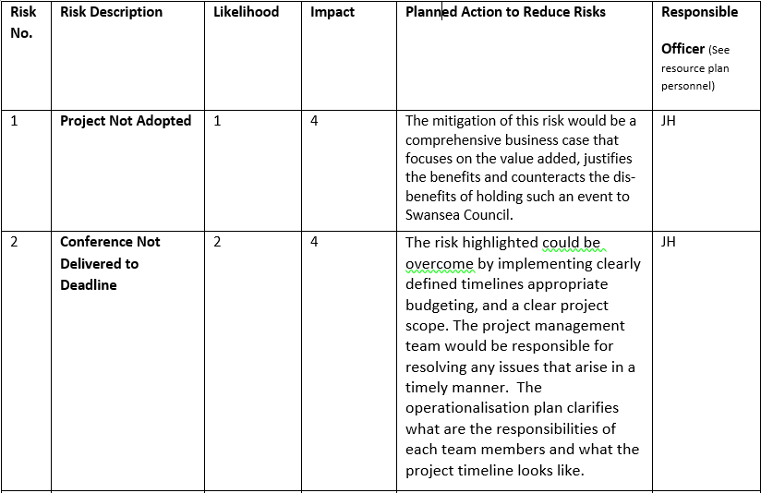
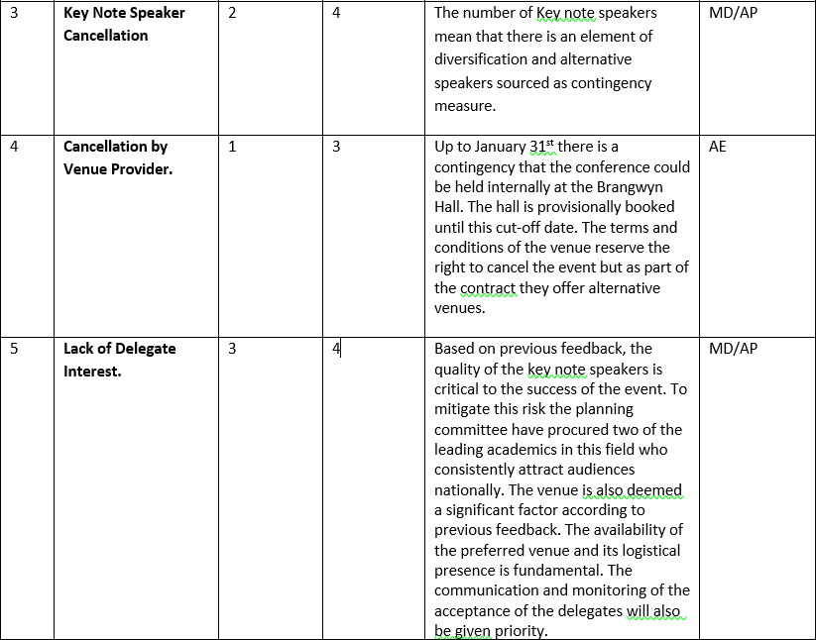
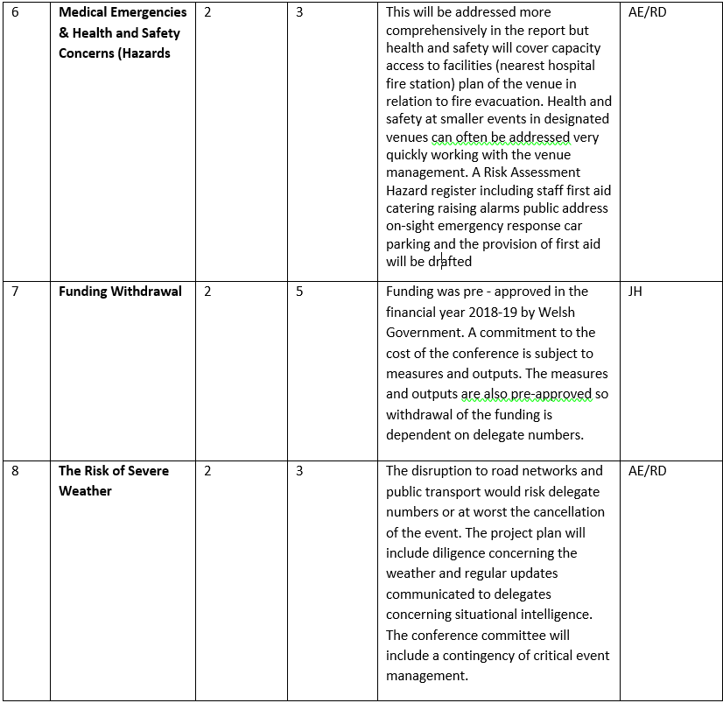

- List of Resources for Project Success.

Financing.

The financing for the conference £6500.00 is confirmed and approved by Welsh Government under a Young People Training and Development Grant. As the conference is a bi-annual event the actual ideology of the planned event has been submitted and approved. The risk that the funding will be withdrawn is low unless key performance indicators are not met e.g. low attendance. Previous conferences in 2017 and 2015 have been over - subscribed.

Venue / Location.

The constraint to consider for is the suitability and acceptability of the venue for the expected number 100 delegates. The parking situation has been historically critical for attendance. A shuttle system transportation is to be provided from the Civic Centre and Guildhall to overcome the possible limitation of spaces. An alternative venue as a contingency in the risk mitigation.

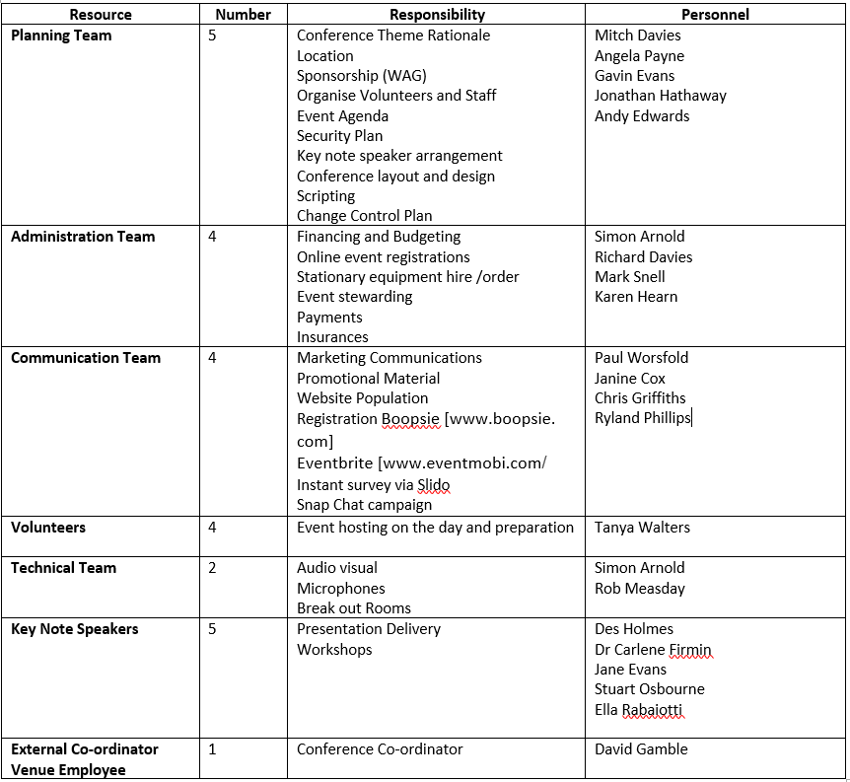

- Operationalisation.

The rationale for incorporating a hybrid agile project management approach is to meet the expectations of the stakeholders and conference requirements of meeting budget staying on schedule meeting scope and quality standards and expected benefits. Projects delivering end-user benefits is an agile principle which should also exist using traditional methodologies. Collaborative working will always: improve benefits; speed up delivery, improve quality, satisfy stakeholders and realise efficiencies. Apm.org.uk. (2019).

Project Plan

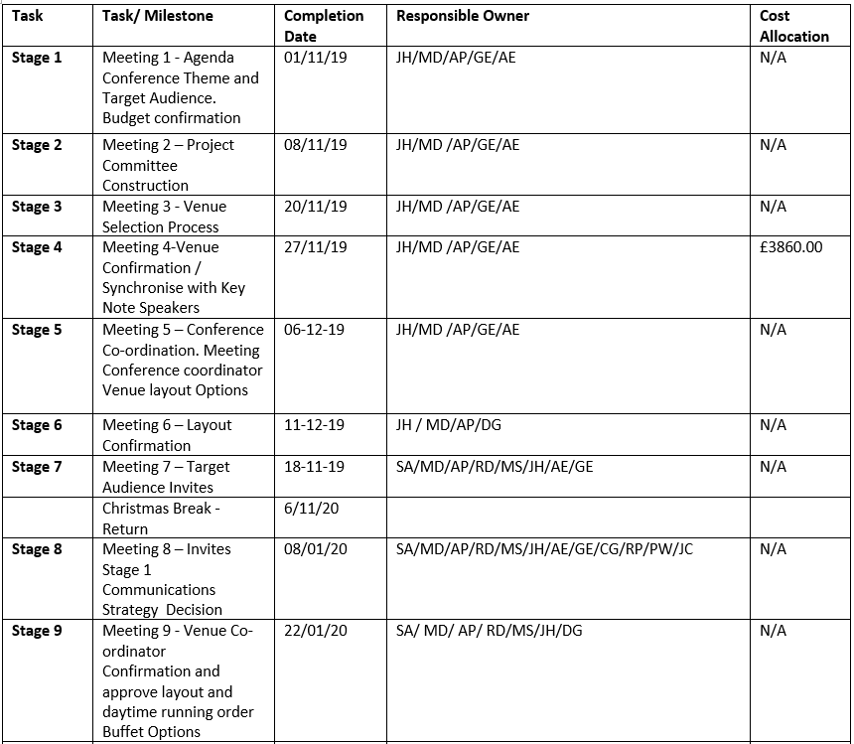

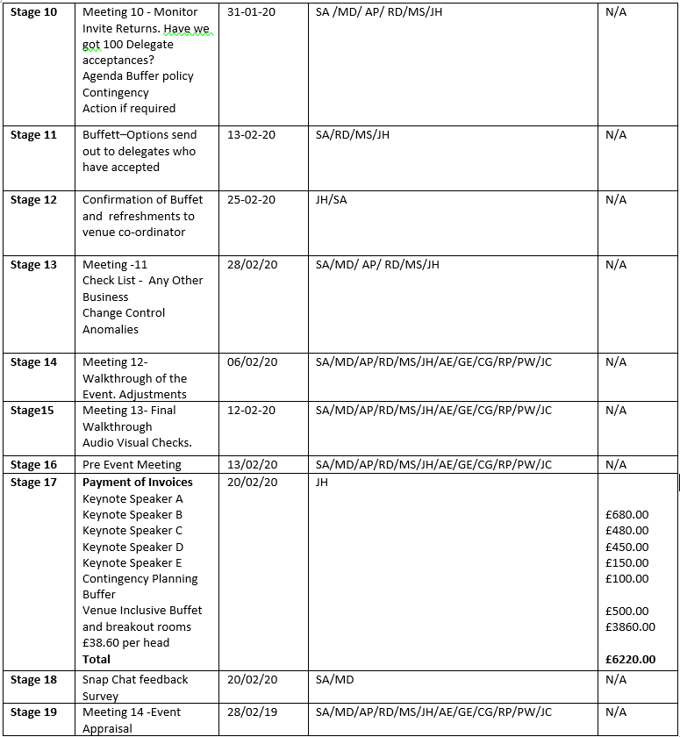

Appendix 2

Delegate Satisfaction Survey (EHH) Conference

- How likely would you recommend the conference to a colleague?

- Not at all likely
- Slightly
- Moderately likely
- Very Likely
- Completely Likely

- Overall how would you rate the conference?

- Excellent
- Very Good
- Good
- Fair
- Very Poor

- Please indicate how much you agree with the following statements:

 | Completely Agree | Agree | Neither Agree or Disagree | Disagree | Completely disagree
I felt welcome at the conference?
The conference was well organised?
I felt included included at conference?
The communication was professional?
The staff/organisers were friendly?
The staff organisers were helpful?
The conference was too long?
The conference met my expectations?
I am likely to participate in future (EHH) conferences?
The conference met its goals?
The conference content will make an impact on my work objectives?
I feel my feedback about the conference is valued?

- Please rate your level of satisfaction with the FOLLOWING

 | Completely  Satisfied | Very  Satisfied | Moderately  Dissatisfied | Not at all Satisfied | Extremely Dissatisfied
Venue
Key Note Speakers
Quality of Sessions
Amount of sessions offered
Dates of the conference

Please tell us about your experience of the EHH Conference Improving Outcomes for Young People: ____________________________________________________________________________________________
____________________________________________________________________________________________
____________________________________________________________________________________________
____________________________________________________________________________________________
____________________________________________________________________________________________
____________________________________________________________________________________________
____________________________________________________________________________________________
_____________________________________________________________________________________________
____________________________________________________________________________________________
____________________________________________________________________________________________
____________________________________________________________________________________________
____________________________________________________________________________________________
____________________________________________________________________________________________
____________________________________________________________________________________________
____________________________________________________________________________________________

Thank you for your time and input.
Your feedback will help us with our future conferences!

Appendix 3 : Mendelow Matrix

(EHH) Stakeholders  Welsh Government,  Swansea Mainstream Schools  EOTAS  Social Services Department  Education Department  Unions  Audit Commission  Members Councillors  Colleges of Further Education  Police authorities  Delivery Partnership Groups  Budget Holders Council Services  Employees |  | Interest
 |  | Low | High
Power | Low | Minimal Effort  Unions | Keep Informed  Police Authorities  Audit Commission  Colleges of Further Education  Employees
Power | High | Keep Satisfied  Welsh Government  Councillors Members  Education Department  Delivery Partnership Groups  Budget Holders  Partnership Groups | Key Players  Swansea Mainstream Schools.  Social Services Department  Directors

Appendix 4 . Staff Training and Development.

Outcomes

134 cases closed with improved well-being

41 YP with improved well-being

223 young people with increased school attendance
Outputs

508 - Families Supported
966 - Individuals supported
109 - Families supported through consultation

3,941 Sessions Delivered
202 Assessments completed
611 reviews
93 multi-agency meetings attended

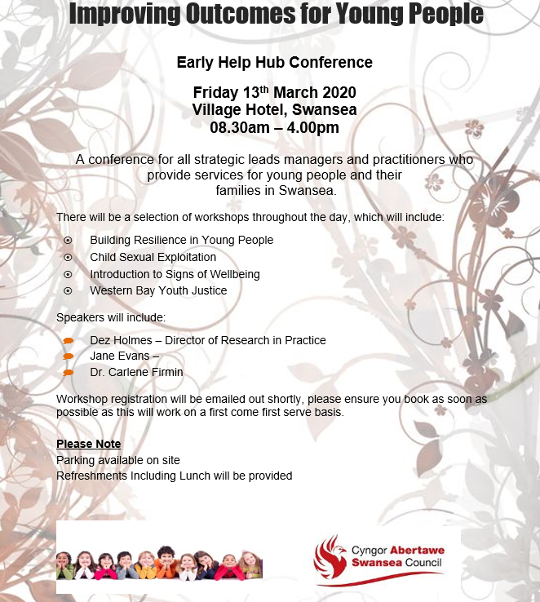

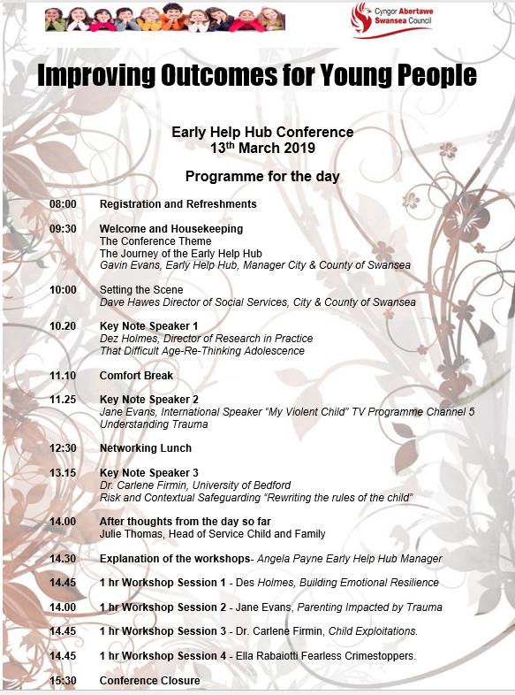

Venue Ranking Index
Appendix 7 Venue Ranking Index.

Desirability Index | Richard Ley Centre | Liberty Stadium | Brangwyn Hall | Village Hotel | Towers Hotel
Capacity | 3 | 3 | 3 | 3 | 3
Atmosphere | 4 | 4 | 24 | 4 | 4
Logistics | 4 | 5 | 3 | 4 | 2
Accessibility | 5 | 5 | 4 | 5 | 5
Layout | 5 | 4 | 4 | 5 | 4
Break-Out Rooms | 5 | 4 | 4 | 5 | 4
Parking Facilities | 5 | 4 | 1 | 5 | 4
Disability Access | 4 | 5 | 5 | 4 | 5
Adequate Toilet Facilities | 5 | 5 | 3 | 5 | 5
Cloakroom Facilities (March) | 5 | 5 | 3 | 5 | 5
Audio Visual Facilities | 4 | 5 | 3 | 4 | 5
Sound System (Acoustics | 4 | 4 | 2 | 4 | 4
Lighting (Darkened Rooms) | 4 | 5 | 2 | 4 | 5
Internet (WIFI) | 5 | 5 | 4 | 5 | 5
Support (Manager/ Liason) | 5 | 5 | 3 | 5 | 5
Hotel Proximity | 2 | 1 | 2 | 5 | 4
Adequate Security | 5 | 4 | 4 | 5 | 4
Cost | 3 | 2 | 2 | 4 | 3
Total | 77 | 75 | 76 | 81 | 76

Appendix 8: The Logic Model Price of Intervention Potential Savings to Statutory Services
Outputs

508 - Families Supported
966 - Individuals supported
109 - Families supported through consultation

3,941 Sessions Delivered
202 Assessments completed
611 reviews
93 multi-agency meetings attended

Activities

Lead Work Model –
Signs of Well-being Practice Model

Assessing, reviewing, Delivery of interventions, Co-ordination of support
Input/ Resources

4 area teams,
4 - Area Managers 4 - Practice Leads
21 Lead Workers

Budget - £1,489,711

Outcomes

134 cases closed with improved well-being

41 YP with improved well-being

223 young people with increased school attendance

Impact
Contribution to reduction in no’s YP and Families requiring statutory services – 362 Families

Contribution to the reduction of YP requiring the need for Educated other than at School (EOTAS) – 470

Potential Savings to statutory Services –
CINCS savings per family £1,672 (£1,627 x 362= £588,974)
Child Protection Plans – cost per plan - £5,583 (£5,583 x 362 = (2,021,046)
EOTAS Savings – Per individual £11,514
(£11,514 x 470 = £5,411,580)

YPS invested £2,933 per Family, which prevented a potential total of £18,724
(£11,514 (EOTAS), £1,672 (CINCS), £5,583 (CP Plans))

Cost per Session
£251.30

