A Traffic Light Signal System based on Deep Reinforcement Learning and Self-Adaptive Timing

In your abstract please also summarise its performance/ how well it meets its aims. Use some statistics to summarize this if it is appropriate to do so.
Place the abstract on its own page.

Please include a review/description of reinforcement learning in your lit review. Explain how it works and its place within the Deep Learning /NN subject area.

Explain in a little more detail the software/system you used here to implement your method. Place code or system properties/state in an appendix.
Be expected to demo your software solution in your viva.

Your conclusions are a little brief. Your references are very light. I was expecting a good few more references in your draft.

Some good comparisons in your evaluation. The graphs are helpful. Do you explain them in your discussions?



A Traffic Light Signal System based on Deep Reinforcement Learning and Self-Adaptive Timing
Pengchun Wu
Gordon Dickers
2021.11.12

Wales Institute of Science and Art/Athrofa Gwyddoniaeth a Chelf Cymru
School of Applied Computing/Ysgol Cyfrifiadura Gymhwysol

MAJOR PROJECT/MASTER’S PROJECT HANDBOOK

for

M.Sc. Applied Computing

2020/21

Appendix 1: Declaration and Form of Consent

DECLARATION

I, ............................................Pengchun Wu………………………………… declare that I am the sole author of this Project; that all references cited have been consulted; that I have conducted all work of which this is a record, and that the finished work lies within the prescribed word limits.

This work has not previously been accepted as part of any other degree submission.
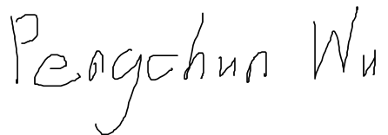
Signed : .

Date : ........2021.11.12...............

FORM OF CONSENT

I ________Pengchun Wu ___________ hereby consent that my Project, submitted in candidature for the M.Sc. Applied Computing, if successful, may be made available for inter-library loan or photocopying (subject to the law of copyright), and that the title and abstract may be made available to outside organisations.

Signed

Date _____2021.11.12_________

Where necessary replace M.Sc. Applied Computing with your named award.

Appendix 2: Ethics Approval Form
Ethics Approval Form

Before you complete this form, please take time to carefully consider the following questions:

Have you considered yet whether there are any problematic ethical issues in your proposed research project? If you have not you should talk to your Course Tutor or Supervisor.

Have you already completed an Ethics Approval Form? Yes – then you do not need to complete this form

No – please complete this form in as much detail as you can

Name:
Name:
Project/Research Title:
Name of Supervisor:
School/Dept.
Faculty: |  | End Date:
Proposed Start Date: |  | End Date:

1. Summary of planned research (please indicate below the purpose of your planned project/research, together with your aims, main research questions and research design – you should continue onto a separate sheet if necessary)

2. Methodology (You need to be clear about the methodology you intend to use in your study; this could include any number of methods, so either tick those shown below (where appropriate) or put the details in the box marked *)
 | Interviews |  | Participant Observation |  | Use of personal data
 | Focus groups |  | Questionnaire |  | Literature Review
 | Performance |  | Presentation |  | Other (state below)*

*

3. Participants - Does your proposed project/research involve human participants?

 | 1. Yes, as a primary source* |  | 2. Yes, as a secondary source* |  | No- go to section 4

*If you have ticked yes, it is likely you will need an Advanced CRB check before undertaking your study

If yes, indicate who your participants are:

 | Early years/Pre-School children |  | Adults - give details below
 | School age children |  | Vulnerable people - give details below
 | Young People aged 17-18
 | Unknown at this stage
4. Ethical issues - you should tick all that apply

 | Administration of drugs incl. alcohol |  | Deprivation
 | Unpleasant stimuli in any manner or form |  | Active deception or withholding information
 | Collection of highly personal information |  | Payment

5. Are there any ethical concerns other than those listed above? (continue onto a separate sheet if necessary)

6. If there are any ethical concerns, please state how you intend to minimise any risk of harm or distress that could be caused (continue onto a separate sheet if necessary)

You should enclose any materials (e.g. questionnaire, interview schedule), plus the Consent Form, and the Debriefing Sheet when submitting the Ethics Approval Form to your supervisor.

Student Signature ____________________________________________Date_______________

***************************************************************************
 | Advanced CRB check required |  | CRB confirmation received - Date:_______________
 | Recommendation of approval given at Faculty Level
 | Approval not given at Faculty level – forwarded for discussion at the next meeting of the University Ethics Committee
Comments:

Signature: (Assistant Dean/Head of School) _______________ ____________ Date: ________________

Faculty recommendation endorsed by the Ethics Committee | Chair’s Initials |  | Date

Abstract
Intelligent traffic light control is a key method to improve the efficiency of transportation system. The traditional traffic signal control system mainly obtains real-time intersection vehicle information through loop detectors and traffic cameras fixedly installed near the intersection, and fails to realize data sharing and event interaction with the vehicle subsystem in intelligent transport system (ITS). Moreover, from the perspective of control range, existing intelligent traffic light control usually only adjust phase or duration separately to real-time traffic, which limits the potential of further improving efficiency of traffic transportation. Recently, there exists an emerging trend of traffic light control via deep reinforcement learning technique. Although recent studies have shown their promising results, those methods based on deep reinforcement learning still preset fixed phase duration. For this sake, we propose a traffic light signal system based on deep reinforcement learning and self-adaptive timing based on the idea of dynamically adjusting both phase and duration. We test our system under different traffic flow rate vary from 0.2 veh/s to 1.3 veh/s. our method has good performance in all traffic flow rates among all methods. Besides, our method makes the traffic efficiency decrease very slowly. We also explore the relationship between optimal phase and traffic flow and find that the larger the traffic flow rate is, the longer the optimal phase duration is. We also verify the high adaptability of our traffic light control system in a whole-day traffic scene. our proposed method is obviously superior to other baselines. Not only the average waiting time is greatly reduced, but also the standard deviation is rather small.
content

Abstract 9
I Introduction 11
II Deep Reinforcement Learning 16
A. MDP 17
B. Policy and Value Function 19
C. DRL based on Value Function 20
D. DRL based on Policy Gradient 20
E. Actor-Critic Framework 21
III Related Work 25
IV Efficient green time utilization 26
V Method 30
Problem Statement 30
Agent Design 31
ICM-PPO Algorithm 32
Adaptive Timing 36
VI Experiment 38
A. Experiment Setting & Parameter Setting 38
B. Evaluation Metric 39
C. Training with Different Phase Duration Settings 40
D. Compared Methods 43
E. Performance on Synthetic Data 44
F. Performance of a Whole Day 49
VII Conclusion 53
References 54

I Introduction
Favorable traffic condition, as the basis of urban economic activities, plays a very important role in urban development, people's production and living standards. However, traffic congestion not only reduces transportation efficiency of cities, increases travel cost of citizens, but also leads to frequent traffic accidents, energy waste and environmental pollution [1,2]. Taking the United States as an example, in 2017, the average annual commuting loss cost of more than 60 hours caused by urban traffic congestion reached US $305 billion. It is estimated that 2% of the current fuel consumption is caused by congestion, which is expected to be close to 2.6% in 2020 and 4.2% in 2050 [8]. In China, the economic loss caused by traffic congestion is as high as 250 billion yuan every year according to statistics. Therefore, how to improve the efficiency of traffic management and reduce traffic congestion is a world-class issue of great concern.
The intersection is the bottleneck of traffic congestion, where multiple vehicle flows meet here. Vehicles in different flows need to be coordinated to pass quickly and orderly, which is mainly done by traffic signal light. Therefore, the traffic signal control of intersections is very important for traffic congestion control and traffic efficiency improvement [2,3].
Traditional traffic light control methods set a fixed phase sequence in a circle, and its signal timing is either the same or set according to historical traffic volume data [4]. However, due to the randomness of vehicle arrival, these fixed programs cannot adapt to the dynamic changes of complex traffic. At most, they can only change phase duration artificially during the peak hours, let alone the phase [5].
With the usage of detecting facilities such as loop detectors and camera detectors, traffic information like the number of incoming vehicles can be gathered, thus considerable adaptive traffic signal control systems are proposed one after another [6,7]. Adaptive traffic signal control should comprehensively consider the interaction between intersections, and take the traffic flow state of adjacent intersections as the consideration of adjusting the signal timing scheme (i.e. phase, period and green signal ratio of each phase system) at this intersection, so as to improve the overall traffic capacity. The traditional traffic control systems widely used abroad include scats, TRANSYT and SCOOT. SCATS is a selective system, and the optimization of its period, green signal ratio and phase difference is predetermined, which limits the optimization degree of timing scheme. TRANSYT, SCOOT, OPAC and RHODRS are all based on the model, and the establishment of the model requires accurate data such as traffic network and traffic flow. Because the traffic system is affected by many factors such as the setting of intersections, people's quality and habits, the distribution of surrounding facilities, weather and so on, it is a typical nonlinear, fuzzy and uncertain system. It is extremely difficult to obtain its accurate model. Moreover, these systems can rarely fully deal with the supersaturated traffic state, and their optimization methods cannot deal with large-scale traffic networks. Although Smart Nets / TUC is suitable for dealing with saturated traffic conditions, the frequency of real-time decision-making cannot exceed the maximum number of signal cycles.
Besides, some traditional optimization methods, such as fuzzy logic and genetic algorithm, are also applied in this field. Fuzzy control method is a powerful tool to deal with uncertain and nonlinear problems. It has the characteristics of strong real-time, robustness and simple and practical design. However, the generated rules are rough and have no learning ability, so it is difficult to meet the needs of intelligent traffic scheduling decision-making. Neural network has good approximation ability and learning ability for nonlinear system, but supervised learning is widely used in neural network learning, which requires a large number of learning samples to train neural network. The quality of samples will affect the control effect of neural network.
In the early stage, reinforcement learning has been applied to the field of traffic light control, but at this time, reinforcement learning is not combined with deep learning, which is primitive. Q learning algorithm is one of the most commonly used reinforcement learning algorithms at that time [35]. Wiering M. [36] applied Q-learning to the field of traffic signal control. Aiming at minimizing the cumulative waiting time of signal lights passed by all vehicles entering and leaving the city, he established a utility value function based on vehicles, and optimized the combination of vehicle selection of optimal path and minimizing single node delay. The effect is verified by simulation, but the principle and steps of the application of learning algorithm in traffic signal control are not described in detail.
Abdulhai B [37] aimed at optimizing the running time and applied Q-learning to control a single independent intersection based on the vehicle queue length. Li Ying and Cheng Xiangjun [38] used agent control with Q-learning ability to optimize signal timing at single intersection, and verified that it is better than timing control, but the components of Q function are different. Chen Yangzhou [39] combined agent technology with Q-learning algorithm to control the traffic flow of single intersection, and proposed a reward and punishment function suitable for traffic control. That is, when the saturation of the red phase is greater than that of the green phase, the relative alarm degree of the red phase dominates in the reward and punishment function, and the agent will be punished in most cases; In the later decision-making process, the control behavior selected by the agent facing similar traffic conditions is more inclined to switch the right of way to the next phase. On the contrary, the behavior selected by the agent is inclined to maintain the right of way of the current phase to the next decision-making time.
Lu Shoufeng [40] verified the superior effect of Q-learning control for the purpose of minimizing the total delay of vehicles entering the intersection. He Zhaocheng [41] and others used the design method of Q-learning reward and punishment signal based on fuzzy logic to combine Q-learning algorithm with BP neural network for online learning of intersections. Although there are many advantages for learning, there are still some problems that greatly limit the application of Q learning algorithm in practice, such as unable to deal with continuous state space, slow learning speed, unable to deal with multi-performance indicators and multi-agent system.
In recent years, with the development of Vehicular Ad-Hoc Networks (VANETs) and Internet of Things (IoT) techniques, real-time intelligent traffic light control becomes possible due to plenty of traffic information collected all the time [7, 26].
And in 2016, AlphaGo came as a famous deep reinforcement learning application [17]. After that, deep reinforcement learning is also used as a novel method for traffic light control. Li Li et al. apply the deep Q-learning network (DQN) framework to select optimal light phase for traffic intersections according to the traffic information as an image [9]. Wei H et al. further improve the DQN algorithm, and they synthesize various traffic information as state and use comprehensive reward rather than simplex one [10]. In another paper, Wei H. et al. combine attention network with deep reinforcement learning to realize the cooperative control of traffic lights in an area [11]. Those studies show promising results for traffic signal control.
Deep reinforcement learning method is very suitable for dynamic control of traffic lights, in order to achieve the long-term goals of reducing the average waiting time, driving time, carbon dioxide emissions and so on.
However, deep reinforcement learning methods mentioned above only control the phase of traffic light. The whole decision-making of traffic light should not only include which phase to choose, but also corresponding phase duration, that is, the length of green time. Although such deep reinforcement learning models select the best phase according to the state of intersection, the fixed time for each phase cannot always be appropriate, whether long or short. After all, the size of duration itself has a considerable impact on the performance of traffic control. For example, if the traffic density is high, such as morning rush hour, long phase duration is more conducive to the rapid moving of vehicles and reduces their delays. When the traffic density is low, such as middle night, the setting of short duration can reduce the unnecessary waiting time of vehicles.
The essential reason is that the traffic flow distribution at intersections is often uneven and dynamic. More precisely, the traffic flow in each direction is even different, and in constant change. Consequently, their theoretically most appropriate phase duration is constantly changing. Even if the optimal phase is selected according to the current traffic state, fixed duration cannot be changed. Even if further, different fixed duration is set for different phases, or there is an adjustment in the rush hour, this kind of control method is still rough and inflexible. It is better to dynamically adjust phase duration based on the real-time change of traffic flow.
A complete traffic light control should include the dynamic selection of phase and phase duration. If the best phase and corresponding duration are selected at each step, the traffic efficiency of intersections will reach the maximum.
Figure 1 shows a typical example of a scene where only the best phase is selected, without the best duration. In figure 1, Most of the vehicles in the direction of green light have passed the intersection, and the last vehicle is about to pass by, while a large number of vehicles in the direction of red light stop at the intersection. Obviously, it's time for phase change, but a large number of vehicles have to wait unnecessarily because the phase duration is fixed. This kind of situation often occurs, which reduces the traffic efficiency at intersections.
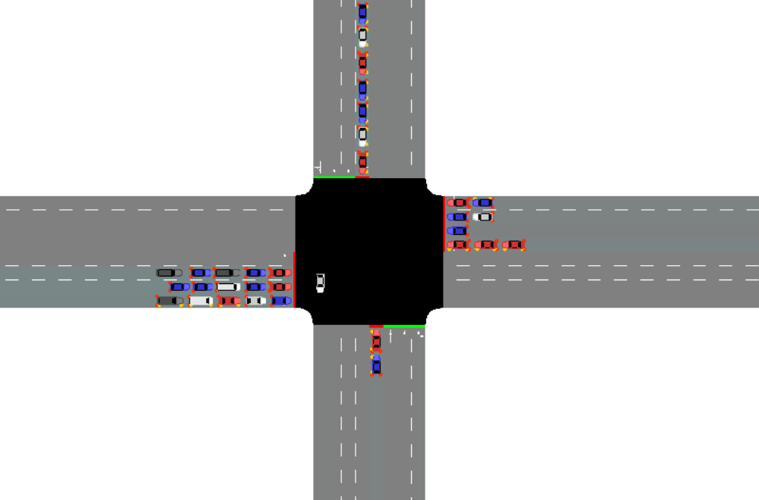
There are also some defects in the scene that only the best duration is selected without the best phase. Figure 2 depicts such a scene, as an instance. In Figure 2, current phase is East-West left turn, but in fact there are far more vehicles queuing in the north-south direction. Obviously the vehicles in the north-south direction should have been released first rather than vice versa, which would present most vehicles from having to wait for a few vehicles to go first. Therefore, the failure to dynamically select the optimal phase will also reduce the overall traffic efficiency.
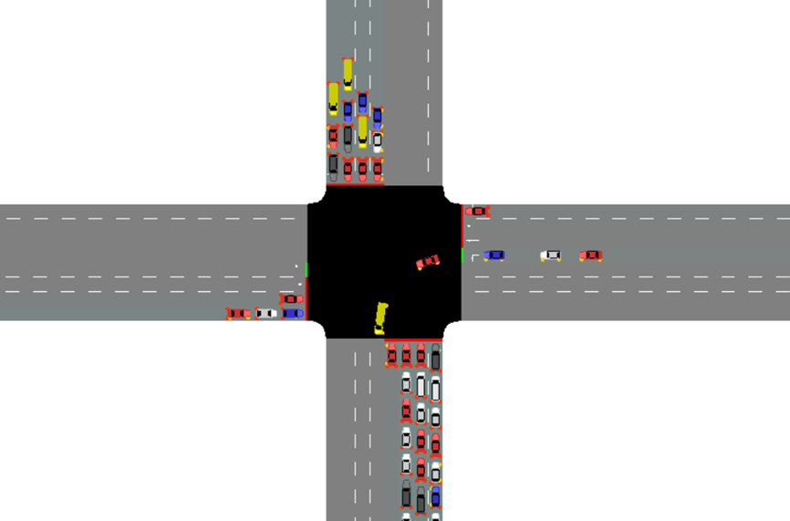
Figure 1: the scene that only the best duration is selected without the best phase
Figure 2: the scene that only the best phase is selected without the best duration

Based on analysis above, we propose a complete traffic signal control system to maximize traffic efficiency. The system combines deep reinforcement learning with self-adaptive timing, which makes our system dynamically select both appropriate phase and duration according to the real-time traffic situation. Firstly, we make phase decision based on deep reinforcement learning. Then we analyze the concept of effective green time, and design a self-adaptive timing method from the perspective of reducing invalid green time. We have proved the feasibility and superiority of our method through extensive experiments. The positive correlation between the optimal phase length and traffic flow is also explored through experiments.
The main contributions are listed as follows.
– We give an completely dynamic traffic light control mode, which is more efficient than any single control in scenarios with complicated and dynamic traffic flow.
– In the light of the completely dynamic control mode, we propose a novel control system that achieves whole decision-making of traffic light. The system combines reinforcement learning with adaptive timing, which makes our system dynamically select both appropriate phase and duration according to the real-time traffic situation. Specially, we make phase decision based on deep reinforcement learning, i.e. ICM-PPO, which is able to select the most appropriate phase at each step. Then we analyze
the concept of effective green time and find the effective utilization of green time is highly correlated with minimization of time loss. We hence design a new adaptive timing algorithm to adjust the optimal phase length from the perspective of reducing loss of green time.
– We conduct experiments on both synthetic and real-world data. The experimental results show its feasibility and superiority in different traffic flows and a whole day flow. We also explore the positive correlation between the optimal phase length and traffic flow through experiments, which means dynamic timing along with change of traffic flow is quite rational.
The rest of this paper is organized as follows. Section II comprehensively and in detail describes the basic concepts and various algorithms of deep reinforcement learning. Section III presents the literature review. Section IV demonstrates and analyzes effective green time. The framework and specific method is shown in Section V. The experimental results are shown in Section VI. Finally, the paper is concluded in Section VII.

II Deep Reinforcement Learning
First, let's introduce the content of in-depth learning. In the field of artificial intelligence, perception and decision-making ability are the key indicators to measure intelligence. Deep learning originated from artificial neural network (ANN), from the early multi-layer perceptron (MLP) to the optimization of multilayer neural network using error back propagation algorithm. However, due to the problems of gradient explosion or dispersion, the lack of training data and the limitation of computer hardware resources, the research of neural network has not made a breakthrough. In recent years, with the improvement of computing power and the growth of training data, deep neural network in the field of artificial intelligence includes image recognition, speech recognition and natural language processing (NLP) They have made a series of major breakthroughs by calculating the hierarchical characteristics or representation of observation data, learning a deep nonlinear network structure and realizing complex function approximation. Their models mainly include stacked auto encoder (SAE), restricted Boltzmann machine (RBM) and deep belief network (DBN), convolutional neural network (CNN), recurrent neural network (RNN) and its variant long short term memory (LSTM) depth network, etc.
Then, the formation of reinforcement learning algorithm theory can be traced back to the 1970s and 1980s. Tesauro et al. successfully used reinforcement learning to make backgammon reach the master level [13] (1992). Sutton et al. Wrote the first book systematically introducing reinforcement learning [14]. Kearns et al. Proved for the first time that the reinforcement learning problem can obtain the approximate optimal solution with a small amount of experience [15]. The confidence upper bound tree algorithm proposed by Kocsis et al. Has revolutionized the application of reinforcement learning in go games [16] (2006).
In December 2013, DeepMind team first demonstrated that machines use reinforcement learning algorithm to defeat human professional players in Atari game, which makes reinforcement learning algorithm attract the attention of the world; In March 2016, AlphaGo based on DRL and Monte Carlo tree search developed by DeepMind defeated Li Shishi, the top professional chess player of mankind, 4:1. DeepMind published the latest AlphaGo paper [17] in《Nature》, which made the DRL algorithm attract more scholars' attention.
Before DRL was proposed, there had been some research work on reinforcement learning combined with neural network [18-22], but due to the lack of training data and computing power, these research work only used neural network to reduce the dimension of data. In recent years, with the improvement of computer technology and artificial intelligence algorithms, the research of DRL is in the stage of rapid development, and many new algorithms have been proposed. Generally speaking, the widely recognized research directions of DRL algorithms mainly include deep Q network (DQN) based on value function and its related extensions Policy based DRL algorithms, such as deep deterministic policy gradient (DDPG), distributed approximate policy optimization (DPPO), and some other algorithm research work, such as asynchronous advantage actor critic (A3C), unsupervised reinforcement assisted learning (unsupervised reinforcement and auxiliary learning, unreal), etc.

MDP
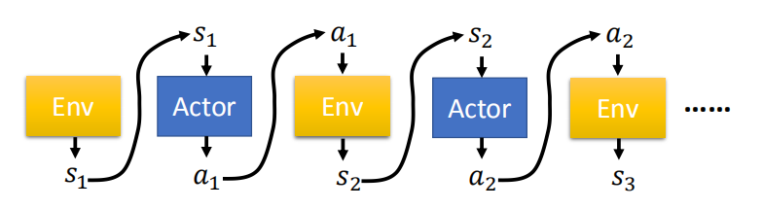
In reinforcement learning, agents (independent entities that can think and interact with the environment) interact with the environment all the time. A sequence will be generated during the interaction between agent and environment: $\text{Trajectory }τ=\left\{s_{1},a_{1},s_{2},a_{2},⋯,s_{T},a_{T}\right\}$
Figure 3: the process that the agent interact with environment
Markov decision processes (MDP) provides a mathematical model for modeling decision, which is a discrete stochastic control process. In a time step, the agent is in a state and selects an arbitrary action according to this state. In the next time step, the environment will reward the agent for the next state according to the current state and random action.
The Markov decision process can be described by Tuples$\left(s, a, p, r,γ\right)$, where $s$ is the finite state set, $a$ is the action space, $p$ is the state transition probability matrix, and $r$ is the reward function, $γ$ Is the discount factor.
Markov decision-making process is based on the basic Markov hypothesis, that is, the probability distribution of the next state is only determined by the current state, and any other historical information in the time series is irrelevant.
Therefore, we can simplify $p\left(s_{t+1}∣s_{t}…s_{1},a_{t}\right)$ to $p\left(s_{t+1}∣s_{t},a_{t}\right)$. Then the probability of the whole trajectory $τ$ is shown as follow:
$$\begin{aligned}&p_{θ}(τ) \\ &=p\left(s_{1}\right)p_{θ}\left(a_{1}∣s_{1}\right)p\left(s_{2}∣s_{1},a_{1}\right)p_{θ}\left(a_{2}∣s_{2}\right)p\left(s_{3}∣s_{2},a_{2}\right)⋯ \\ &=p\left(s_{1}\right)\prod_{t=1}^{T}{ }p_{θ}\left(a_{t}∣s_{t}\right)p\left(s_{t+1}∣s_{t},a_{t}\right)\end{aligned}$$
In this way, we can obtain the reward expectation of all experienced trajectories after enough attempts.
$${\overline{R}}_{θ}=\sum_{τ}{ }R(τ)p_{θ}(τ)=E_{τ∼p_{θ}(τ)}[R(τ)]$$
The goal of Markov decision process is to find a strategy to maximize the cumulative function of random reward. In other words, to find the optimal strategy π so as to maximize the total cumulative return expectation of all trajectory sequences under this strategy, that is,
$$π^{*}=\max_{π} ∫R(τ)p_{π}(τ)dτ$$
The learning mechanism of RL shows that it does not need supervision signals. On the one hand, it only needs to "exploit" the learned experience to select the action with the highest reward, on the other hand, "exploration" can get the highest reward state to avoid falling into local optimization, which makes the balanced exploration utilization in RL method become the focus of researchers. In addition, the appropriate reward mechanism largely determines the advantages and disadvantages of the strategy. At this stage, the reward is mainly defined by researchers with domain knowledge. Some scholars have begun to try to improve the original reinforcement learning algorithm with the help of human tutor signals, so that agents can better learn the desired actions [12]. RL algorithm can be divided into reinforcement learning based on value function and reinforcement learning based on strategy gradient. The former is difficult to overcome the problem of state disaster in the face of complex high-dimensional state space. With the development of deep neural network, the algorithm can directly extract features from the original high-dimensional data, so that the reinforcement learning algorithm based on value function and strategy gradient can be effectively combined, which can provide a good solution to the perceptual decision-making problem in complex states.

B. Policy and Value Function
Usually, state action value function and state value function are used to evaluate the quality of a state and action selection in a state of an agent in the environment. The expression is:
$$Q(s,a)=E_{π}\left[\sum_{h=0}^{∞}{ }γ^{k}R_{t+k+1}∣S_{t}=s,A_{t}=a\right]$$
The state action value function represents the expected return that can be obtained after the state 𝑠 selects the behavior 𝑎 according to the policy π.
The state value function represents the expected return that can be obtained by selecting behavior according to a certain strategy π under the state 𝑠. The expression is:
$$v(s)≐E_{r}\left[G_{t}∥S_{t}=s\right]=E_{π}\left[\sum_{k=0}^{∞}{ }γ^{k}R_{t+k+1}∣S_{t}=s\right]$$
The value function is the evaluation of the strategy. If the strategy π is a finite number, all the strategies π can be compared and the optimal strategy $π^{*}$ selected. The expression is:
$$∀s,π^{*}=arg⁡{maxV}^{π}⁡(s)$$
If the number of policies is large, it is difficult to implement. You can update the optimization results continuously in an iterative manner.
To optimize the strategy and select the best strategy. For a policy $π(a∣s)$, define its value function as$Q^{π}(s,a)$, set a new policy $π^{'}(a∣s)$, and the expression is:
$$π^{'}(a∣s)=\underset{a}{\arg{max}}Q^{π}(s,a)$$
Therefore, the optimal strategy can be obtained by this method: random initial strategy, calculate the value function of the strategy, and repeatedly update the new strategy according to the value function until the strategy converges to the optimal. The methods based on value function updating strategy mainly include dynamic programming, Monte Carlo method and time series difference algorithm.

C. DRL based on Value Function
In 2015, DeepMind team proposed DQN, which integrates neural network and Q-learning. It is an off-policy learning method. Its proposal solves the bottleneck of traditional q-form reinforcement learning. In reference [28], DQN only uses the original image of the adjacent 4-frame game as the input, and uses the original image with parameters θ as a function approximation, the convolution neural network outputs the Q value of optional actions in the current state through multiple convolution layers and full connection layers, and realizes an end-to-end learning method. As a pioneering work in the field of deep reinforcement learning, DQN has attracted the attention of many research teams. The early main improvements of DQN are introduced in literature [23], which mainly focus on the improvement of DQN algorithm and model. Since then, researchers have successively proposed some important extensions of DQN [29-34] to improve the stability and efficiency of the algorithm.

D. DRL based on Policy Gradient
Although the DQN algorithm based on value function and its related extended algorithms have achieved good results in many fields, the DQN output discrete state action value function is very weak for continuous action space problems. At the same time, compared with the DQN based on value function Q-learning, which uses the real value and estimated value of Q to carry out the back transmission of neural network error, the policy gradient in the DRL algorithm based on policy gradient is based on action probability, which makes the selected behavior more likely to be selected next time, and the probability of action selection is determined through the reward function, so as to complete the reverse transfer of neural network.
The policy gradient algorithm is optimized by gradient descent method. The goal of the strategy gradient approach is to find the optimal neural network parameter $θ^{*}$ to maximize the expectation of the total return function about the trajectory distribution.
Another reinforcement learning algorithm is the actor critic (AC) [24] method. The AC algorithm calculates the action value function and uses the advantage function as the evaluation of the action. The critic gives the estimation of the value function and evaluates the quality of the action. The actor outputs the strategy in the form of probability distribution according to the state. It combines reinforcement learning algorithms based on value (such as Q-learning) and action probability (such as policy gradient). The predecessor of actor in AC algorithm is policy gradient, which can select appropriate actions in continuous actions, and the predecessor of critic is Q-learning or other value based learning methods, compared with the policy grades of the traditional round update system, these methods can update in one step and improve learning efficiency.

E. Actor-Critic Framework
Actor-Critic framework is a combination of reinforcement learning and deep learning. Deep learning can carry out nonlinear fitting in an end-to-end way. In another aspect, it combines two parts: strategy gradient (Actor) and value function (Critic), that is, actor selects behavior based on probability, critic judges the score of behavior based on actor's behavior, and actor modifies the probability of next selection behavior according to the score of critic. This algorithm framework is widely used and commonly considered algorithm to solve various decision problems. Actor-Critic algorithm solves the problems of high bias based on value function method and high variance based on strategy method, that is, an agent can not only directly output the strategy, but also evaluate the advantages and disadvantages of the current strategy through value function. The deep neural network in deep learning is used to fit the output value function and strategy. With the continuous updating and iteration, the strategy will be closer to the optimal and the evaluation of value function will be more accurate.
Both actor and critic are actually neural networks.
- Actor neural network
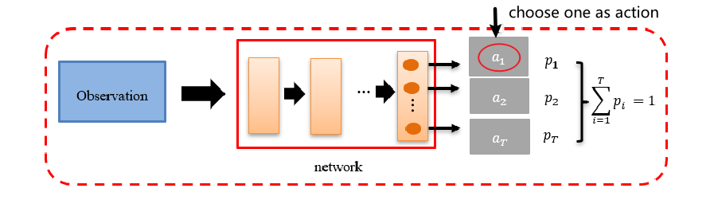
Actor is a strategy network $π_{θ}(a∣s)$, which is used to predict the probability distribution of behavior. The input of the neural network is the state observed by the agent, and the output is the probability distribution of the behavior to be taken by the agent, as shown in the figure below.
Figure 4: the network structure of Actor
- Critic neural network
Critic network is an evaluator. The input of neural network is the state, and the output is the value of the state. The evaluation is based on the state value function $v_{π}\left(s_{t}\right)$ under the current strategy, so as to optimize the probability of actor selection action. In short, when the actor selects the action based on probability and then moves to the next state, critic calculates the value function of the next state plus the difference (time difference error, TD error) between the immediate return obtained from the environment and the value function of the current state , if the value function of the next state is larger than the value function of the current state, then critic tells the actor that the probability of action selection in the current state should increase and vice versa. At the same time, TD error determines the amplitude of increase or decrease. Therefore, the core idea of AC method is to optimize the amplitude of action probability update in the actor according to TD error
In actual learning, no matter what action is executed, 𝑅(𝜏) may always be positive. Then the probability of executing any action will increase, but the increase range is different. Since the sum of the probability of action is one, after Angelica normalization, the less increase is equivalent to a decrease and the more increase is an increase. But the problem is that some good behaviors are not sampled, so these probabilities will inevitably decrease after normalization. In order to solve this problem, we add a baseline, 𝑅 ($τ^{n}$) − 𝑏 and introduce the parameter B baseline. In this way, if the reward of an action is very small, it will become negative after subtracting B, so that the reward is not always positive. Benchmark B can be replaced by the value function predicted by critical, that is $v_{π}\left(s_{t}\right)$.
At the same time, we find that in each episode, no matter whether an action is good or bad, it is always multiplied by the same weight 𝑅 (𝜏), which is obviously unfair. When the sampling times are not enough, we want the weight of each action to be different. The solution is to take the cumulative return of the remaining sequence after the action as the weight of the action, that is, how many rewards you get before executing an action has nothing to do with the action. It only affects the subsequent process. Therefore, replace 𝑅 with, where $T_{n}$ represents the time when the action is executed, and $t$ represents the time when the turn ends. Also consider the discount factor $γ$， Our strategy gradient is expressed as:
$$∇\overset{¯}{R_{θ}}\&≈\frac{1}{N}\sum_{n=1}^{N}{ }\sum_{t=1}^{T_{n}}{ }\left(\sum_{t=t^{'}}^{T_{n}}{ }γ^{t^{'}-t}r_{t^{'}}^{n}-V_{π}\left(s_{t}\right)\right)∇log⁡p_{θ}\left(a_{t}^{n}∣s_{t}^{n}\right)$$
This term $\sum_{t=t^{'}}^{T_{n}}{ }γ^{t^{'}-t}r_{t^{'}}^{n}-V_{π}\left(s_{t}\right)$ in the formula is called the advantage function $A^{θ}\left(s_{t},a_{t}\right)$, which means that the advantage function means how good the execution of this action is compared with other actions for the state 𝑠.
Finally, the strategy gradient is expressed as:
$$∇\overset{¯}{R_{θ}}\&=E_{\left(s_{t},a_{t}\right)∼π_{θ}}\left[A^{θ}\left(s_{t},a_{t}\right)∇log⁡p_{θ}\left(a_{t}^{n}∣s_{t}^{n}\right)\right]$$
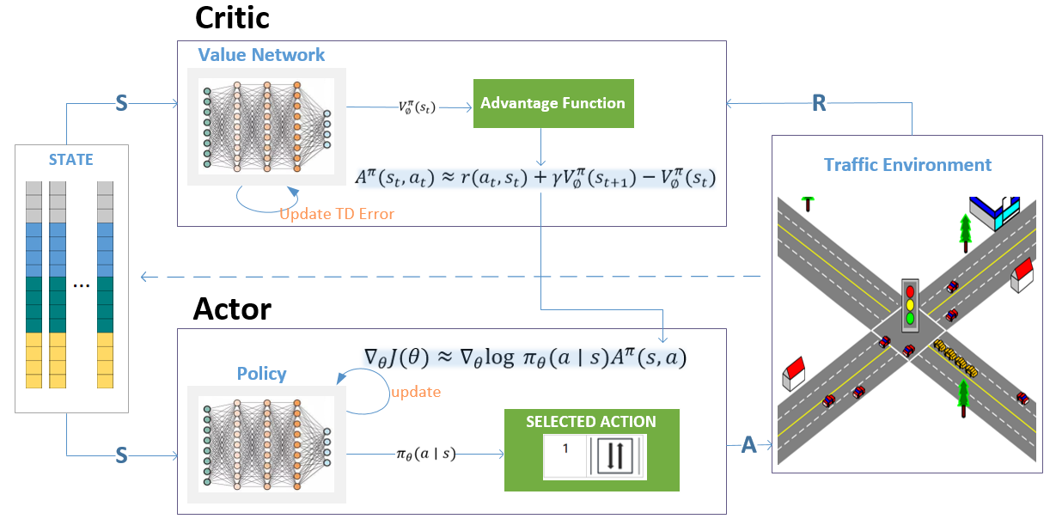
Its more intuitive structure and training process can be seen in Figure 5.
Figure 5: the structure and training process of Actor-Critic framework
Actor-Critic algorithm is an excellent algorithm. Deep neural network can simulate actors and through network parameters. We can obtain more details from the following algorithm table.
Actor-Critic Algorithm
Input: environment
Output: Optimal policy estimation $π_{θ}^{*}$
Parameters: learning rate of critic $α$, learning rate of actor $β$, discount factor y
Initialize policy weight $θ$, state value function weight $w$
For each episode do
Initialization status s
Get action $a$ according to policy $π_{θ}$
For each step do
(sampling) sampling $R$ and next state $s^{'}$ according to state $s$ and action $a$
(execution) obtain action a according to policy π (s; 0)
(estimated return) $δ←R+γ\hat{v}\left(s^{'},w\right)-\hat{v}(s,w)$
(strategy improvement) $w←w+βδ∇_{w}(s,w)$
(renewal value) $θ←θ+αδI∇_{θ}log⁡π(a∣s,θ)$
(update state) $s←s^{'}$
End
End
The parameters of critic are solved by deep learning. The basic Actor-Critic framework is relatively simple and can be regarded as an extension of the policy based method. In addition, the PPO algorithm used later is its derivative.
The problem of the traditional strategy gradient algorithm is that it is necessary to determine the super parameter step size, that is, the learning rate, when updating the parameters. If the step size is too small, it presents a slow learning state, and the convergence speed is very slow even if it converges; If the step size is too large, it is easy to fail to learn a good strategy, resulting in the final collapse. Therefore, when the strategy is updated, it is necessary to find a new strategy to make the value of the new return function monotonically increase.
John Schulman, a doctoral student from Berkeley, first proposed the solution. His trust region policy optimization (TRPO) [27] did not start from the update step (learning rate) of the policy gradient, but found an alternative loss function through theoretical derivation and analysis to approximate the objective function to the first order, the constraints are expanded by Taylor formula, and then the conjugate gradient method is used to solve the optimal update parameters. However, when the strategy is represented by deep neural network, because the conjugate gradient algorithm is used in TRPO algorithm, it will bring a huge amount of computation
In the same year, OpenAI scientists proposed an algorithm to solve TRPO by using one step, namely approximate policy optimization (PPO) [25]. The algorithm uses the loss function derived by TRPO and updates the parameters by using the method of random gradient descent. Then, on the basis of PPO, Google scientists combined with their powerful parallel computing ability to launch the distributed PPO algorithm (DPPO) again.
Compared with the above algorithm, the PPO algorithm proposed by Schulman et al can not only simplify the experimental process, but also adaptively adjust the parameters, and its performance is better than other strategy gradient algorithms at this stage. PPO achieves a new balance between the difficulty of implementation, sampling complexity and the time required for debugging. It will try to calculate a new strategy in each iteration, which can minimize the loss function and ensure that the deviation from the strategy of the previous iteration is relatively small. Therefore, after comprehensively comparing various latest DRL algorithms based on strategic gradient, this paper selects PPO algorithm to be applied to traffic signal control at urban intersections.

III Related Work
As a result of the stochastic characteristics of vehicle arrival in time and direction, conventional fixed-time systems with pre-set phase sequence and duration is quite ineffective for traffic light control.
Therefore, some adaptive methods adopt dynamic timing to improve traffic efficiency. Pei Chi Hsieh et al optimize the phase length based on genetic algorithm [43]. C. Tang et al. collect real-time traffic information based on fog computing system, and then calculate the optimal duration by genetic algorithm [44]. These methods improve the traffic efficiency to a certain extent.
Other methods are more than timing optimization. Based on a type of clustering algorithm, Shen et al. optimize the phase combination, that is, traffic flows in different directions are divided into rational phases. Besides, the time of a whole traffic light cycle is split into segments to maximize the utilization of green time via bilevel programming model. However, the total cycle time is still fixed [45]. In [46], both phase sequence and phase duration are optimized by fuzzy logic model. The author compares the effects of single timing optimization, single optimization of phase sequence and comprehensive optimization of the two. But its comprehensive optimization scheme effect is not ideal in phase control, which makes its performance is not even significantly better than that of fixed-time method. In [47], the authors think that traffic flow is the key factor to adjust phase lengths, which is similar to our ideal. But the traffic flow is only evaluated by queue length. Furthermore, they don’t consider dynamic phase adjustment and just find the need of separated left lane in high density traffic flow. In [48], Maythem et al design a complete traffic light control. To select phase, they regard the signalized intersection as a graph in which each vehicle flow stands for an edge. Additionally, their phase and duration decision was only based on queue length.
In the past, deep reinforcement learning model was only used for dynamic phase selection, but the duration was preset. Recently, some studies using reinforcement learning for traffic light control also realize the necessity of dynamic timing. In [10], Li et al. analyze the variation of phase duration ratio with traffic flow in each direction in their experiment. The experiment results show that the heavier the traffic flow is; the longer duration should be. In [42], Liang et al. also point out that fixed-length interval setting in previous reinforcement learning methods does not work well in many scenes. Therefore, the action is designed as four phases’ durations in a whole circle. But this kind of action is not very flexible that no phase duration can be adjusted until the end of the whole light circle. It may bring about a considerable such a nonadjustable interval may bring about considerable inefficiency, especially when the traffic flow is unstable. In addition, the method unable to make flexible phase decisions. In [49], Zhao et al. also realize the importance of dynamic timing, but they only determine the duration according to the number of vehicles, which is not particularly reasonable.

IV Efficient green time utilization
We believe that the optimal phase duration means the most effective utilization of green time, that is, to maximize the effective green time, or to minimize the loss of green time.
According to the U.S. Highway Capacity Manual (HCM), effective green time refers to the time allocated to a group of vehicles at the saturation flow rate, and its corresponding speed is the saturation speed [50]. Figure 3 shows the full utilization of green time. All vehicles directly cross the intersection at saturation speed without waiting, and current phase just ends when the last vehicle passes the stop line.
However, this ideal situation is very unlikely to happen. Due to the conflict of traffic flows in different directions, vehicles often have to stop and wait. On the other hand, the saturation flow rate will not last forever. Therefore, the loss of green time is inevitable in actual situation, and what we can do is to reduce the loss of time as much as possible.
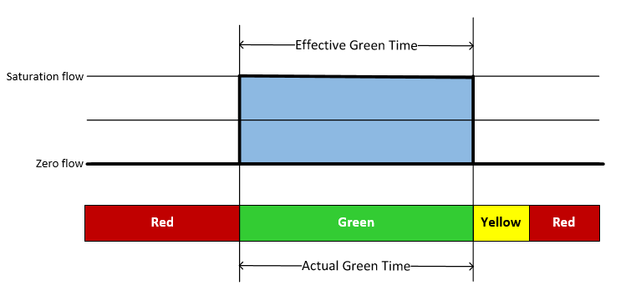
Figure 5: the full utilization of green time without time loss at all

The situation closest to saturation flow rate is the case that queuing vehicles start from a standstill and pass through the intersection, and the later traffic flow is usually unsaturated due to the randomness of vehicle arrival [51].
First, we define and analyze the effective green time in this case. However, it is difficult to calculate the effective green time directly because there are many factors affecting the saturation flow rate [52], so we regard it as the difference between the actual phase time and loss of time.
Effective green time is denoted by $g_{e}$, and its formula is as follows:
$$g_{e}=G +Y-t_{L}$$
Where $G$ is the actual green time, $Y$ is the duration of yellow light,$t_{L}$ is the loss time. In some countries such as China, $Y$ should be zero because vehicles are not allowed to pass after the yellow light is on.
Lost time refers to the time that is not effectively used by traffic flow in the phase, including start-up lost time and end-up lost time. Its formula is as follows:
$$t_{L}=I_{1}+I_{2}$$
Where $I_{1}$ is start-up lost time , $I_{2}$ is end-up lost time.
When the consecutive vehicles in the queue start to cross the stop line, they must have an acceleration process from zero to saturation speed, in which there is a time loss, just called as start-up lost time. As mentioned earlier, if all vehicles just pass the stop line at saturation speed at the beginning of the phase, start-up lost time is exactly zero, as shown in figure 6.
In order to calculate start-up lost time, we introduce the concept of departure headway.
Departure headway is the time difference of arriving the stop line between current vehicle and the previous one. For saturated traffic flow, each vehicle has the same headway, which is called saturated headway, and is recorded as $h_{s}$.
Firstly, we suppose there are N vehicles in the fleet. Since there is no vehicle in front of the first vehicle, its departure headway is the duration that it arrives to the stop line after the green light is on, which is called the first headway, recorded as $h_{1}$. Accordingly, the departure headway of the second vehicle is recorded as $h_{2}$; and so on $h_{i}$($i=1,2,3,…,n$).
This kind of data (departure headway) can only be obtained in real time due to the change of each vehicle speed and position. Differing from other methods which only consider the headway of vehicles in a single lane, we consider multi-lane Road, and regard vehicles in multiple lanes as the same traffic flow, so the headway will be smaller [54, 55].
During the start-up process, the first k vehicles do not reach the saturation speed when cross the stop line. Starting from k + 1 vehicles, however, there is no time loss since the traffic flow is saturated. The start-up lost time thus mainly comes from the first k vehicles, and the calculation formula can be as follows:
$$I_{1}=\sum_{i=1}^{k}{h_{i}}-\left(k-1\right)h_{s}=h_{s}+\sum_{i=1}^{k}{{(h}_{i}-h_{s})}$$
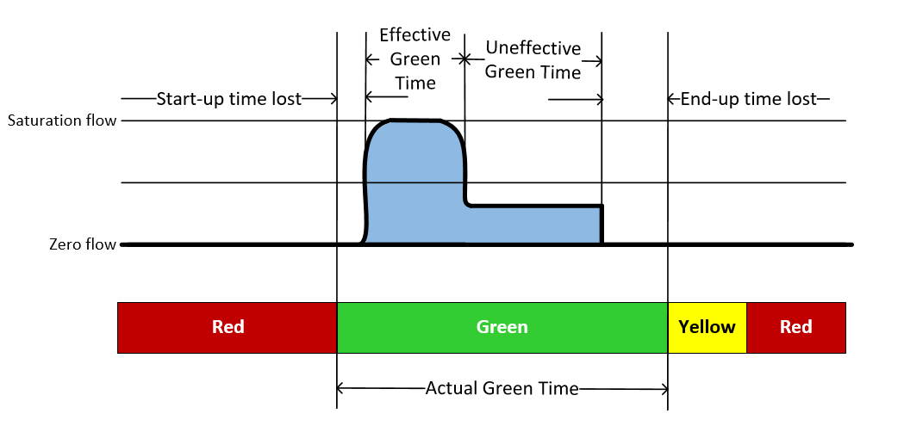
In figure 6, we can observe all types of lost time.
Figure 6: all types of lost time in a phase

There is a start-up loss time at the beginning of the phase, and then the traffic flow maintains saturated. However, after most of vehicles in the fleet pass through the intersection in the early phase, the remaining traffic flow becomes sparse and unsaturated. At this time, the departure headway gets larger and the throughput of the intersection is not as large as before, resulting in the low utilization of green time. During this period, green time is inefficiently used rather than entirely lost.
At the end of the phase, the vehicle closest to the intersection cannot pass the stop line in the remaining time, that is, its departure headway is greater than the remaining time of current phase, resulting in end-up lost time. The calculation formula is as follows:
$$I_{2}=t_{last}-t_{Y}$$
Where $t_{Y}$ is current phase remaining time, $t_{last}$ is the minimum headway.
Last, we use the green signal ratio to express the ratio of effective green time and actual phase time, denoted as λ.
The formula of green signal ratio is as follows:
$$λ=\frac{g_{e}}{G +Y}=\frac{G +Y-t_{L}}{G +Y}=1-\frac{t_{L}}{G +Y}$$
According to formula above, the less the loss of green time, the higher the utilization rate of green time.
Based on analysis above, we propose an adaptive timing algorithm from the perspective of reducing the loss of green time and improving the utilization rate of green light, which is described specifically in section V. Put simply, we detect all kinds of lost time in real time according to the real-time traffic information in a phase period. If the lost time exceeds a certain extent, we will terminate the current phase in advance to avoid the waste of green time.

V Method

Problem Statement
We focus on main intersections in urban area, and only consider the incoming vehicles. In this scenario, we assume that all vehicles are equipped with DSRC communication module. Within a certain range, all vehicles close to the intersection would send their real-time information such as speed, location to our traffic signal system through the vehicular wireless network [56].
For the above scenario, our traffic light signal system is designed with three modules: a receiver, a phase controller, as well as an adaptive timing controller. The receiver collects and processes real-time information from vehicles. The phase controller is actually a reinforcement learning model, i.e. PPO model that determines which phase is optimal at current time step. The adaptive timing controller is used to dynamically adjust current phase length.
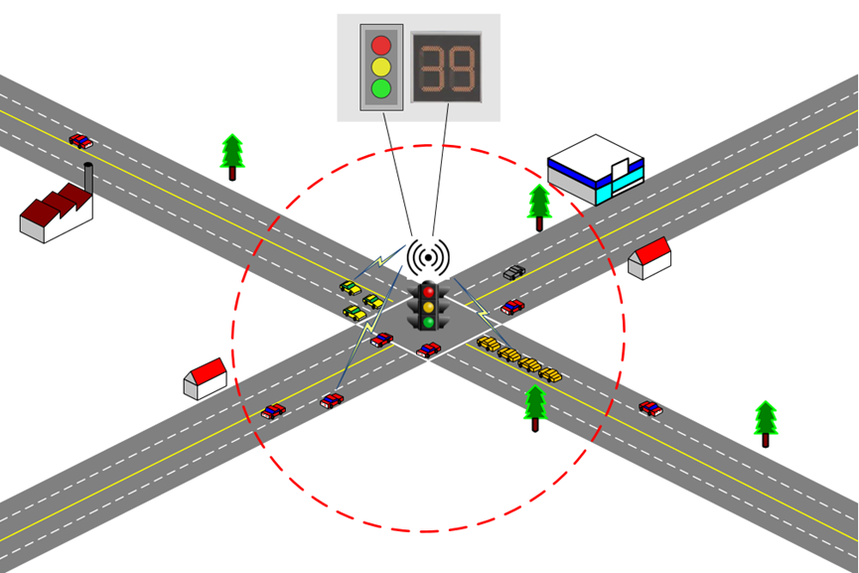
More precisely, the receiver processes all incoming vehicle information into vector representation of intersection state to input it into the phase controller to make reasonable phase decision. Next, the adaptive timing controller will detect the current green light utilization in real time and judge whether to terminate the phase in advance. The scenario is shown in Figure 7.
Figure 7: a typical intersection we focus on

Agent Design

（1）State
State is required to capture the situation of intersection accurately, in order to reasonable and accurate control from the reinforcement learning model.
traffic situation in four incoming directions are extracted to make up state respectively, within 400 meters of the intersection. This type of intersection usually has four phases, which are north-south straight and right turn, north-south left turn, east-west straight and right turn, as well as east-west left turn. We will then divide each entry road into two parts. This is because each road with incoming traffic flow consists of multiple lanes, in which straight and right turn lanes and left turn lanes are calculated separately because they are affected by different phases. Straight and right turn are always allowed in one phase, and left turn is allowed in another phase.
Next, we segment lanes in each part. More precisely, the lane of 400 meters is divided into 9 distinct segments, and then the number of vehicles in each segment is calculated. The closer to the intersection, the smaller the segment length.
In Table 1, the sequence and length of segments are shown in detail.
Table 1: the sequence and length of segments for each lane
Segment | 1 | 2 | 3 | 4 | 5 | 6 | 7 | 8
length | 7 | 7 | 7 | 7 | 12 | 20 | 40 | 60
Distance | 0~7 | 7~14 | 14~21 | 21~28 | 28~40 | 40~60 | 60~100 | 100~160
As a consequence, the state is a 64-dimension vector that consists of 8 set of lanes with 8 segments.

（2）Action
In our model, the reinforcement learning module is in control of traffic light phase. As depicted in Table 2, there are 4 phases in the context. In addition, we can see their corresponding rules and legends from the table. For example, when the phase is labeled one, cars from south or north are allowed to go straight or turn right.
Table 2: all actions and their corresponding rules
label | rules | legend
1 | $$south↔north$$
2 | $$west↔east$$ | 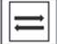
3 | $$south→west\&north→east$$ | 
4 | $$east→south\&west→north$$ | 

（3）Reward
Immediate reward is key to guiding the training of reinforcement learning model to achieve the maximum of optimization goal. In the problem of traffic light control, the most important goal is to improve the efficiency of vehicles passing through intersections, reduce the waiting time of vehicles and avoid congestion. In our setting,
Reward is the difference between the waiting time of two adjacent steps, which is in common use due to its high correlation with the optimization goal and easy implementation.
The reward at time step t is calculated by the following equation:
$$r_{t}=W_{t}-W_{t+1}$$
$W_{t+1}$ represents the total waiting time of all vehicles in incoming directions at the current time, $W_{t}$ is that at the previous time step. If a large number of vehicles pass the intersection smoothly via the traffic lights control, the number of vehicles in line will reduce, and the total waiting time of vehicles will be dramatically reduced. In other words, the agent will get greater rewards. It worth mentioned that only negative reward is calculated.

ICM-PPO Algorithm
The reason why we choose PPO algorithm is that it has stronger learning ability and robustness than Q-learning algorithms in traffic signal control scenario [23].
PPO algorithm is based on policy gradient method, which is different from Q-learning [24,25]. This kind of method directly learns the optimal policy in the interaction with environment. PPO algorithm has two structures: actor and critic. The actor interacts with the environment, that is, observing the environment and selecting an action to perform. And then the critic evaluates the actor's choice of action, i.e., how good or bad the action is. Both critic and actor are learning constantly. In the learning process, critic’s evaluation of action becomes more and more accurate. Under the guidance of critic, actor also understand what the optimal action is in different states.
I choose PPO algorithm to construct my reinforcement model due to its good performance and robustness. As for ICM (instinct curiosity module), it helps my PPO model explore more in complex traffic conditions. As a result, ICM-PPO has better training effect than the general RL model.

ICM module
The input is $s_{t}$, $a_{t}$, $s_{t+1}$. $s_{t}$ and $s_{t+1}$ be encoded into two vectors $ϕ\left(s_{t}\right)$ and $ϕ\left(s_{t+1}\right)$ through the feature extraction layer Feature Ext. Then $ϕ\left(s_{t}\right)$ and $ϕ\left(s_{t+1}\right)$ can be put into Inverse Model to infer the most likely action ${\hat{a}}_{t}$.
$${\hat{a}}_{t}=g\left(s_{t},s_{t+1}∣θ_{I}\right)$$
By using back propagation to minimize the error of${\hat{a}}_{t}$ and actual action $a_{t}$., the inverse model could learn the characteristics that are really affected by action. Because the action here is discrete, soft-max can be applied to ${\hat{a}}_{t}$, and then the corresponding loss function set through maximum likelihood estimation, i.e. $\min_{θ_{I}} L_{I}\left({\hat{a}}_{t},a\right)$.
Finally, $a_{t}$ and $ϕ\left(s_{t}\right)$ enter forward model together to predict $\hat{ϕ}\left(s_{t+1}\right)$, the formula is as follow.
$$\hat{ϕ}\left(s_{t+1}\right)=f\left(ϕ\left(s_{t}\right),a_{t}∣θ_{F}\right)$$
Because the predicted feature is a vector, and it is not clear what each element represents in the vector, a very intuitive idea is to use $L_{2}$ norm as loss, its calculation formula is as follows:
$$L_{F}\left(ϕ\left(s_{t+1}\right),\hat{ϕ}\left(s_{t+1}\right)\right)=\frac{1}{2}{∥\hat{ϕ}\left(s_{t+1}\right)-ϕ\left(s_{t+1}\right)∥}_{2}^{2}$$
Thus constructed curiosity reward, $r_{t}^{i}$ is shown as follow.
$$r_{t}^{I}=\frac{η}{2}{∥\hat{ϕ}\left(s_{t+1}\right)-ϕ\left(s_{t+1}\right)∥}_{2}^{2}$$
The difference between $\hat{ϕ}\left(s_{t+1}\right)$ and $ϕ\left(s_{t+1}\right)$ acts as the instinct reward $r_{t}^{i}$, in order to motivate the agent explore more, that is, curiosity. Instinct reward $r_{t}^{i}$ and environment reward $r_{t}^{e}$will merge to form the final reward.
Finally, we determine the learning goal of the agent as:
$\min_{θ_{P},θ_{I},θ_{F}} \left[-λE_{π\left(s_{t};θ_{P}\right)}\left[\sum_{t}{ }r_{t}\right]+(1-β)L_{I}+βL_{F}\right] s.t. 1≤β≤1,λ>1$，
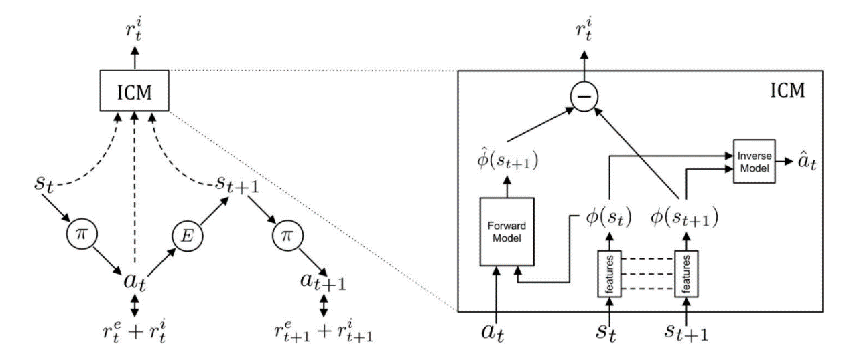
During training, due to $θ_{F}$ is constantly optimized, the agent will actively explore more unknown states for more curvature reward after the initial prediction is accurate.
Figure 8：ICM module structure diagram

PPO Algorithm
Actor-Critic framework is usually an online learning method, which means that when sampling data is used to update policy parameters, when policy parameters 𝜃 After the update, we have to resample the training data, that is, each batch of sampled data can only be used once. After calculating the strategy gradient, we need to resample the data. In order to convert online learning into offline learning, we use an Actor ($θ^{'}$) to interact with the environment to collect data, and then use the data collected by $θ^{'}$ to train strategy parameters$θ$. The parameters $θ$ can be updated multiple times with the same batch of training data to improve the update efficiency.
Through this kind of operation, PPO algorithm achieves training the current strategy using the trajectory obtained by other strategies.
- Importance sampling
Importance sampling is essentially to obtain a large number of samples according to a certain probability distribution to calculate the expectation of the function on the probability distribution of the samples. Its mathematical formula is expressed as:
$$E_{x∼p}[f(x)]=∫f(x)p(x)dx=∫f(x)\frac{p(x)}{q(x)}q(x)dx=E_{x∼q}\left[f(x)\frac{p(x)}{q(x)}\right]$$
In the formula, $p$ and $q$ represent different distributions. When we cannot calculate the expectation of the function 𝑓(𝑥) on the $p$ distribution from the sampling data of the $p$ distribution, we can calculate it from the sampling data of any $q$ distribution. However, when the above formula holds, i.e.
$${Var}_{x∼p}⁡[f(x)]≠{Var}_{x∼q}⁡\left[f(x)\frac{p(x)}{q(x)}\right]$$
It is necessary to correct the deviation with the weight $\frac{p(x)}{q(x)}$.
Therefore, we use the importance sampling method to obtain the strategy gradient as follows:
$$∇J^{θ^{'}}(θ)=E_{(st,at)∼π_{θ}^{'}}[\frac{P_{θ}(s_{t},a_{t})}{P_{θ^{'}}(s_{t},a_{t})}A^{θ}(s_{t},a_{t})∇log⁡p_{θ}(a_{t}^{n}∣s_{t}^{n})]$$
At this time, the new objective function is expressed as:
$$J^{θ^{'}}(θ)=E_{(s_{t},a_{t})∼π_{θ^{'}}}[\frac{p_{θ}(a_{t}∣s_{t})}{p_{θ^{'}}(a_{t}∣s_{t})}A^{θ^{'}}(s_{t},a_{t})]$$
Where $θ^{'}$ represents the agent strategy $π_{θ^{'}}$ interacting with the environment,$θ$ is the policy parameter to update.
However, one limitation of importance sampling is that when there are enough sampling data, the function expectation on $p$ score can be calculated by $q$ distribution. However, if there are not enough sampling data and the variance between them is large, the calculation will produce great errors, so we require$θ$ and $θ^{'}$ should be relatively similar and adjust it by $\frac{p_{θ}(a_{t}∣s_{t})}{p_{θ^{'}}(a_{t}∣s_{t})}$ at the same time.
The last one is to a constraint KL divergence is added in the objective function $J^{θ^{'}}(θ)$ to ensure the similarity of $θ$ and $θ^{'}$.
The following are the objectives of PPO algorithm：
$$J_{PPO}^{θ^{'}}(θ)=J^{θ^{'}}(θ)-βKL(θ,θ^{'})$$
$KL\left(θ,θ^{'}\right)$ is a good index to calculate the similarity between the two strategies, as well as 𝛽 is a super parameter. If the sample difference between the current strategy and old strategy increases, adjust it through $KL$.
Since the parameter 𝛽 needs to be set manually, two thresholds $KLmin(θ,θ^{'})$ and $KLmax(θ,θ^{'})$ are set to dynamically adjust the parameters. If the $KL$ divergence value is too large, we increase this part of the penalty. If it is small to a certain value, we reduce this part of the penalty.
Finally, the specific objective and policy update formula is shown as follow:
$$∇{\overline{R}}_{θ}=\frac{1}{N}\sum_{n=1}^{N}{\sum_{t=1}^{T_{n}}{\frac{P_{θ}(s_{t},a_{t})}{P_{θ^{'}}(s_{t},a_{t})}A^{θ}(s_{t},a_{t})∇log⁡p_{θ}(a_{t}^{n}∣s_{t}^{n})}}$$
$$\begin{matrix}J_{PPO}^{θ^{k}}\left(θ\right)≈\sum_{\left(s_{t},a_{t}\right)}{min⁡(\frac{p_{θ}\left(a_{t} ∣ s_{t}\right)}{p_{θ^{k}}\left(a_{t} ∣ s_{t}\right)}A^{θ^{k}}(s_{t},a_{t})},clip⁡(\frac{p_{θ}(a_{t}∣s_{t})}{p_{θ^{k}}(a_{t}∣s_{t})},1-ε,1+ε)A^{θ^{k}}(s_{t},a_{t})) & \\ & \end{matrix}$$
Here, $KL$ divergence is not directly put into the likelihood function, but cut to a certain extent, and the training effect will be better

Adaptive Timing
When the reinforcement learning policy determines a phase, we set a reactively long time limit in order to avoid the infinite continuation of the phase. If the phase duration exceeds this threshold, our traffic signal system will terminate current phase and make a new phase decision. On other hand, the receiver may detect traffic situation immediately or after an interval, which is defined as $T_{detect}$. In each phase, the adaptive timing controller ensures the effective utilization of green time. If loss of time is detected in the environment, the adaptive timing controller will terminate the current phase ahead of time. The specific process is as follows.
Recall that the time loss in the vehicle start-up stage is often inevitable due to conflict of traffic flow in distinct directions. We are mainly committed to avoiding end-up time loss and minimizing inefficient green light time.
At the beginning of the phase, the headway of the vehicles in the fleet keeps a small value, which is equal to the saturation flow rate. When most vehicles passing through the intersection, it is likely to enter the end of current phase. At this time, it is necessary to compare the minimum headway $h_{rear}$ in the green direction and phase remaining time $t_{remaining}$.
$$h_{rear}>t_{remaining}>{threshold}_{1}$$
if satisfied inequality above, that is, the last vehicle cannot reach the intersection before the yellow light is on, the adaptive timing controller will terminate the current phase. Additionally, $t_{remaining}$ must be greater than a certain value for the sake of safety, namely, ${threshold}_{1}$, which gives drivers time to react and slow down.
But when there are few queuing vehicles, most vehicles pass through the intersection at the very beginning of phase, and the traffic flow is soon unsaturated. The headway of rear vehicles may be large, and the red light method often accumulates a large number of queuing vehicles. In this case, the utilization of green light time will be reduced rapidly, which is regarded as inefficient green light time. It is especially true if a large number of vehicles queue up in directions of red light. Of course, if all directions of red light have no vehicle waiting or approaching, there is no need for phase conversion.
Therefore, when a phase starts, the adaptive timing controller calculates the position and speed of all incoming vehicles each second, and then calculates the headway of vehicle in current release lanes. After that, the minimum value $h_{min,g}$ can be obtained, which means that the nearest vehicle also needs to take $h_{min,g}$ seconds to arrive the stop line. If the minimum headway is greater than the threshold, i.e. ${threshold}_{1}$ , and over one vehicles queue up in directions of red light, current phase will be terminated
$$h_{min,g}>{threshold}_{1}$$
At this time, the policy network will observe the environment and determine new phase according to new state. However, if there are no vehicles arriving at the intersection in all directions of red light, it is necessary to compare the minimum headway $h_{min,r}$ in red direction and minimum headway $h_{min,g}$ in green direction.
$$h_{min,g}- h_{min,r}{>threshold}_{2}$$
When the inequality is satisfied, vehicles in the red directions will arrive at the intersection some time earlier than the vehicles in the green direction. In this case, the adaptive timing controller will terminate current phase in advance, which reduces the start-up time loss of vehicles in the next green direction to a certain extent. This is because the fleet can keep a certain speed and directly pass through the intersection without stopping, which is more efficient than the fleet starting from zero.
In addition, in some special situations such as congestion, the starting speed of vehicles may be very small, and its headway is greater than the threshold. In order to avoid frequent phase switching caused by wrong judgment, the adaptive timing controller also counts the number of vehicles within $D_{g}$ meters from the intersection.
The specific decision procedure is presented in Figure 8.
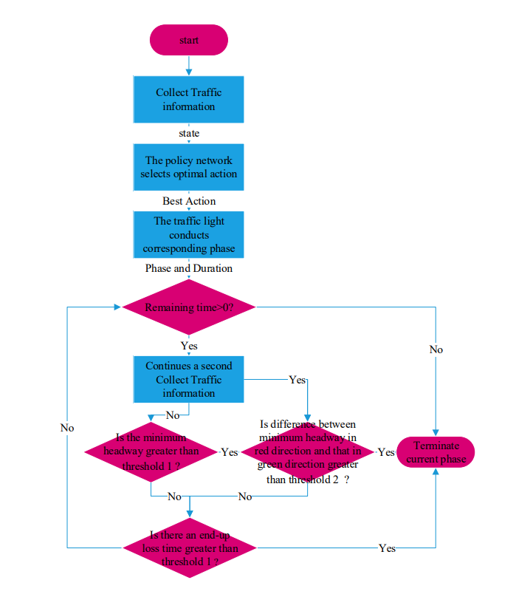
Figure 8: the specific procedure of adaptive timing algorithm

VI Experiment
In this section, we begin with introducing the simulator and baseline methods, as well as the parameter settings used in this paper. Then, we evaluate the performance of the proposed method.

A. Experiment Setting & Parameter Setting
（1）Experiment Setting
The experiments are conducted on an open source and microcosmic traffic simulator SUMO (Simulation of Urban Mobility) [57]. SUMO supports Custom road network and route data of vehicles. In the meanwhile, it provides precise and flexible traffic control, and a large number of real-time statistical data for analysis via TraCI interface. Hence it is very suitable for the development of traffic control model.
The simulation is performed in a single intersection scenario. Specifically, the intersection links to four perpendicular roads with length of 500 meters. And each road has four lanes: a rightmost lane, two through lanes in the middle and a left inner one that allows only left turns. The rightmost one allows both straight and right turn. All lanes’ design speed is 13.89 m/s, i.e., 50 km/s. however, the actual speed of vehicles can reach 60 km/s. What’s more, the maximum acceleration and minimum deceleration of each vehicle are 1 m/s² and 4.5 m/s², respectively.
This intersection environment simulates the main urban intersections. Compared with the real-world scene, it is simplified, but it can effectively verify the effect of the proposed method. In addition, more intersection types and more phase control can be further conducted based on it.
（2）Parameter Setting for Adaptive Timing algorithm
There are several parameters of the adaptive timing algorithm should be set before experiment. The values of them are listed in Table 3.
Table 3: parameters of the adaptive timing algorithm
parameters | value
$$T_{detect}$$ | 1 seconds
$$T_{max}$$ | 30 seconds
$${threshold}_{1}$$ | 3 seconds
$${threshold}_{2}$$ | 3 seconds
$$D_{g}$$ | 15 meters

B. Evaluation Metric
（1）cumulative reward
It represents the sum of all immediate rewards. This index measures the convergence of the optimization objective in reinforcement model learning, which is only used at training stage.
（2）average delay
Vehicle delay is calculated when the vehicle speed is below 0.1m/s. The average delay refers to the average waiting time of all vehicles passing through the intersection. In addition, it is the main indicator we use in the training and testing phase.
（3）average stop
Vehicle stop refers to the number of times vehicle speed is less than 0.1m/s. hence this indicator represents mean stop of all vehicles.
（4）average time loss
Time loss is incurred due to driving below the ideal speed. It contains slowdowns due to passing by intersections or congestion. It is worth mentioning that scheduled stops do not count. If a car accomplishes its route at ideal speed without stopping or slowdown, its time loss will be zero. Therefore, this indicator represents mean time loss of all vehicles during the whole simulation time.
（5）average speed
Speed refers to the average speed of the vehicle to complete the route. This indicator represents the average value of all vehicle speeds.
（6）average phase duration
The indicator refers to mean green phase duration in the whole simulation time.
（7）the number of phases
This index represents the number of phase transitions in the whole simulation time. The larger the value is, the more frequent the phase transition is.
For all indicators above, （3）-（7）are only used to measure the performance of all methods at testing stage.

C. Training with Different Phase Duration Settings
In the training phase, we generate traffic flow data to imitate the actual traffic scene. The arrival time of vehicles in the front and back sections of the whole simulation period is Weibull distribution, and that in the middle section is uniform distribution. In this way, all kinds of situations in the actual traffic scene can be included as far as possible. The composition of traffic flow data for training is shown in Table 4.
Table 4: the distribution of vehicle generation time and quantity
Time | Sum of cars | Disturbution
0~3600 | 1800 | weibull
2600~4600 | 500 | uniform
3600~7200 | 900 | weibull
7200~7500 | 0 | --
In addition, the vehicle trajectory is generated randomly, thus the traffic flow in each direction may be a bit different, but the gap would not be too big. Moreover, different random seeds are set for each episode, which makes the trajectory and arrival time distribution of vehicles change constantly. The purpose of this design is to make the learning experience of reinforcement learning model more comprehensive and improve its generalization ability.
Figure 9 depicts the fluctuation of traffic flow in an episode. It can be seen from the figure that the traffic flow rate per minute is constantly changing. The peak and trough are very obvious, and the traffic flow rate in each direction is also different. More precisely, the traffic flow rate in the east-west direction is greater than that in the north-south direction. In other episodes, however, the situation may be reversed.
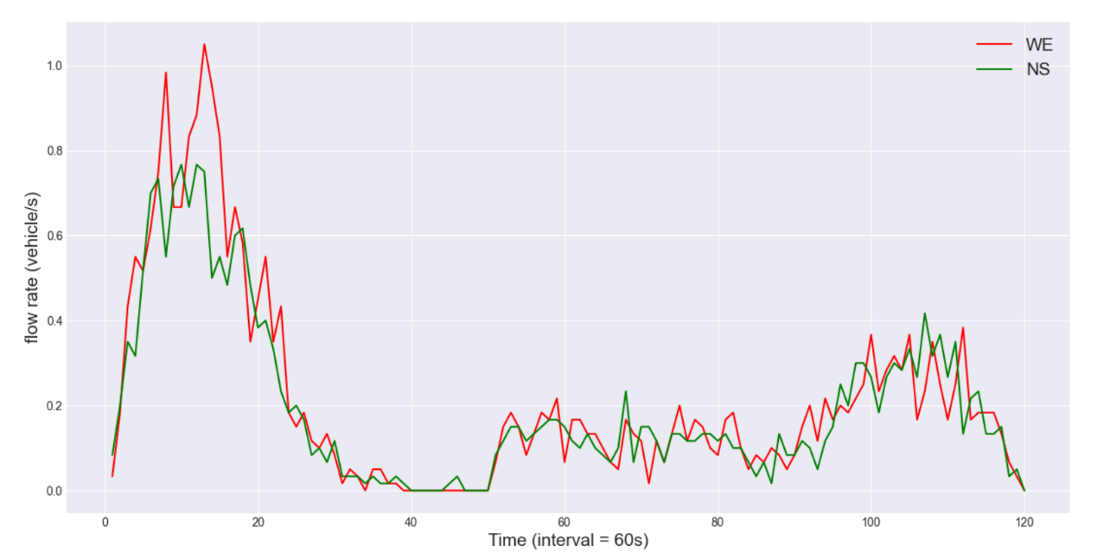
Firstly, we respectively train the same reinforcement learning model under different phase duration settings to understand the effect of phase duration on the performance of the model. We select PPO model to carry out this experiment and set the general parameters of the model as shown in Table 5.
Figure 9: the fluctuation of traffic flow in an episode

Table 5: the setting for PPO model
Model Parameter | Value
actor learning rate | 0.001
critic learning rate | 0.005
$$λ$$ | 0.8
Training episode | 100
Max steps | 7500

We set six phase lengths: 5 seconds, 10 seconds, 15 seconds, 20 seconds, 25 seconds and 30 seconds. Note that we train 100 episodes due to the fast convergence of model. It is difficult to continue to converge after just dozens of episodes.
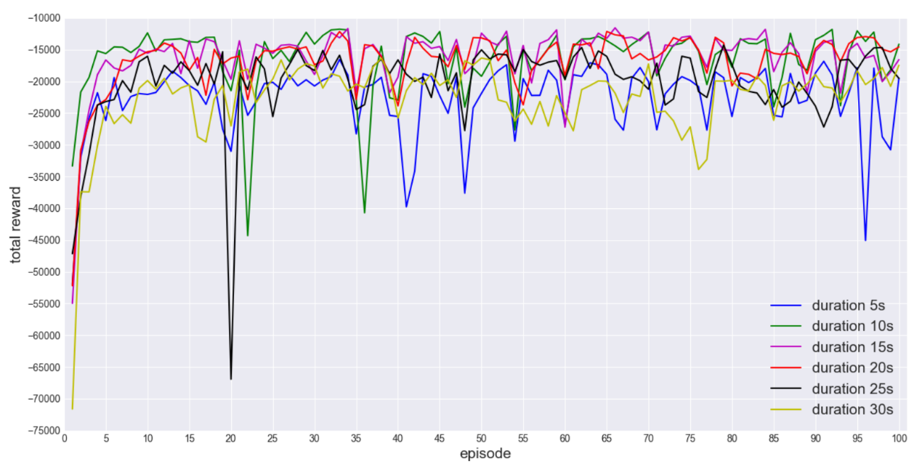
The specific training results are described as follows in aspects of total reward and average delay per episode. In figure 10, the performance of PPO model is not good when the phase duration is too large or too small. Specifically, small duration like 5 seconds is not of benefit to the optimization of target. It seems to result harder training of the model. Additionally, big duration up to 25 seconds incur the same problem for PPO model.
Figure 10: total reward per episode for PPO models with different durations

Compared with duration settings mentioned above, we can observe that total reward of the model fluctuates in a small range near a larger value when the duration is preset as 15 or 20 seconds. In these duration settings, the model has better performance with higher sustainability.
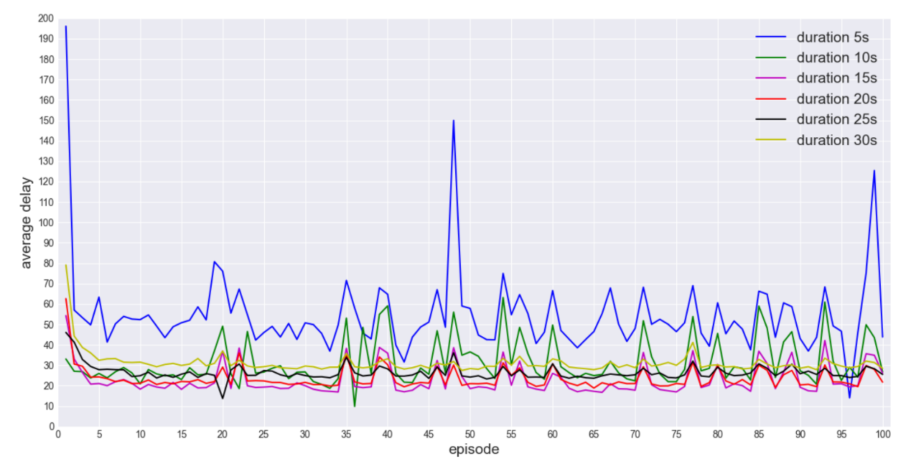
In the light of average delay, the model training differences among all duration settings are more obvious, as depicted in Figure 11. When phase duration is preset as 5 seconds, the average delay is above 40 seconds, and its fluctuation is very large. When phase duration is preset as 5 seconds, the average delay is significantly reduced, but its fluctuation is still obvious. Therefore, if the duration is set too small, the learning effect of reinforcement learning model is relatively poor. However, when duration is too large, such as 25 or 30 seconds, it is easy to converge, but its performance is not good enough. Among all the duration settings, the model with setting of 15 second is the best and enough stable in performance. Consequently, this model will be adopted in the next part of the experiment.
Figure 11: average delay per episode for PPO models with different durations

According to the analysis above, even if the same reinforcement learning model is set with different phase duration, its training effect is also very different, and its convergence difficulty and training effect are different. Furthermore, Although the average delay of most episodes is the smallest for the model with 15-second duration, its average delay is inferior to other models in some episodes, which means that there is still room for improvement.

D. Compared Methods
（1）Fixed-time Control (FT)
This method sets the phase sequence and phase duration in advance, so the phase of traffic signal changes periodically. Here, each straight phase is set for 25 seconds, and each left turn phases is set for 20 seconds.
（2）Self-Organizing Traffic Light Control (SOTL)
This adaptive traffic light control method has no fixed phase length. It decides whether to change to the next phase according to real-time traffic information, including the number of vehicles in the green direction and the number of waiting vehicles in the red direction.
（3）Deep Reinforcement Learning for Traffic Light Control (DRL)
It is also known as DQN, which is a kind of Q-learning method to fit the action value through deep neural network. For DQN, the action with biggest action value will be chosen in the testing stage.
（4）Adaptive Timing (AT)
Here, adaptive timing is used to dynamically adjust phase duration for a fixed phase sequence that cannot be changed.
（5）PPO for Traffic Light Control
PPO model here is applied to make phase decision. However, each phase duration is preset as the same value and cannot be dynamically adjusted.
Our proposed method achieves the entire dynamic control of traffic lights via the combination of (4) and (5). Hence, we want to verify whether their combination is better than their respective performance.

E. Performance on Synthetic Data
In order to evaluate the performance and stability of each method under different traffic flow, we generated 12 synthetic route data to simulate the situation of sparse and dense traffic flow. Their traffic depart rates vary from 0.2 veh/s to 1.3 veh/s, with the interval of 0.1 veh/s. Differing from the route data in the training stage, the traffic flow of these data fluctuates very slightly. This is because their vehicles are generated by uniform distribution.
Figure 12.a-d shows the traffic light control performance of each method under different traffic flow rates. With the increase of vehicle flow rate, the efficiency of traffic control is decreasing for each method. Obviously, with the increase of incoming vehicles, their average delay and time loss get inevitably larger. Additionally, the average speed of vehicles decreases correspondingly. However, our method has good performance under all traffic flow rates, especially when the traffic flow rate is less than 1.0 veh/s. Besides, our method makes the traffic efficiency decrease very slowly, and AT method has similar performance. It can be seen that the effect of adaptive timing is quite obvious. which gives more reasonable phase duration to reduce much time loss, and adapt to the change of traffic flow rate. In addition, since our method also controls the phase dynamically based on PPO model compared with AT, its average delay and average time loss are further reduced.
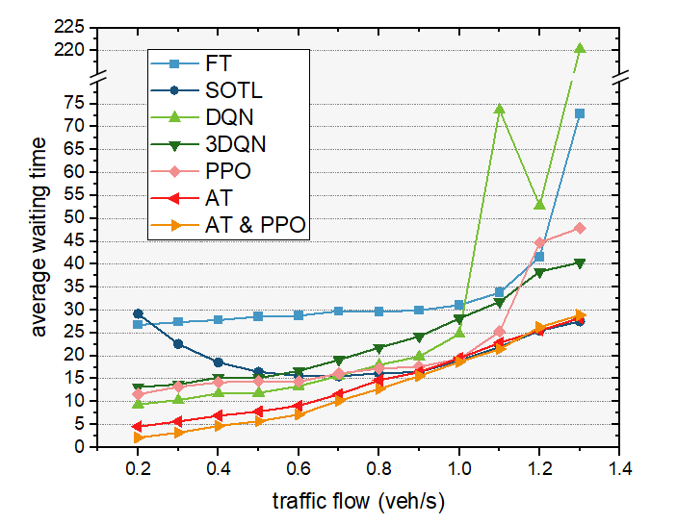
However, when the vehicle flow rate is relatively large, SOFT method is slightly better than AT method in terms of delay and time loss, and our method is not as good as the above two methods even if the difference is very small. The reason may be that the difference of traffic density in each direction is small due to uniformly generation of arriving vehicles, which render slight effect of phase selection. But in term of average stops and average speed of vehicles, our method is still the best.
(a) average delay for all methods under different traffic flows
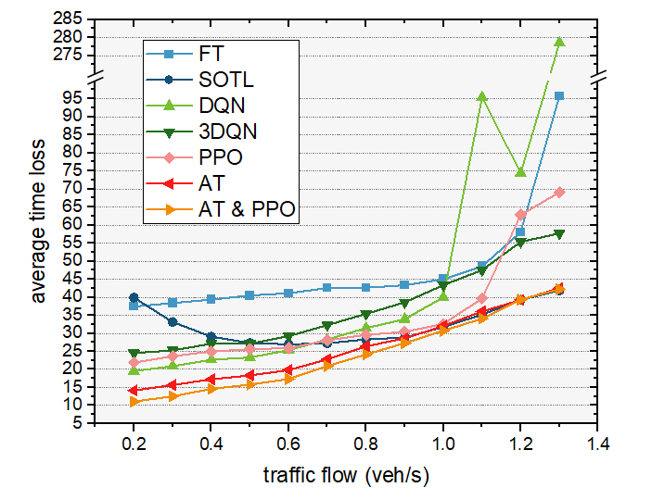
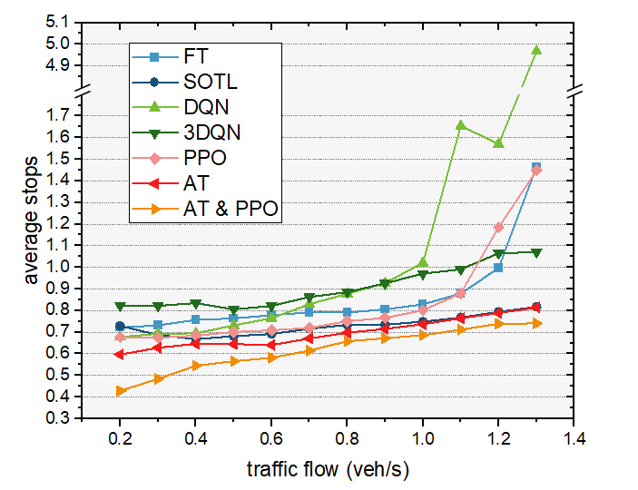
(b) average stops for all methods under different traffic flows

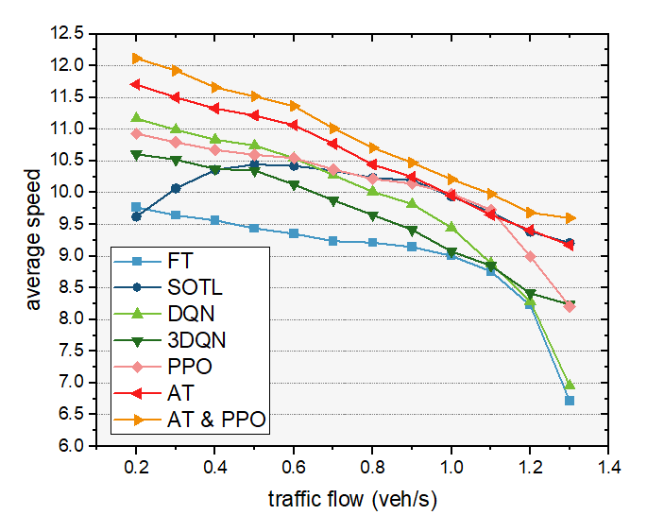
(c) average time loss for all methods under different traffic flows
(d) average speed for all methods under different traffic flows
Figure 12: experiment results for all methods under different traffic flows
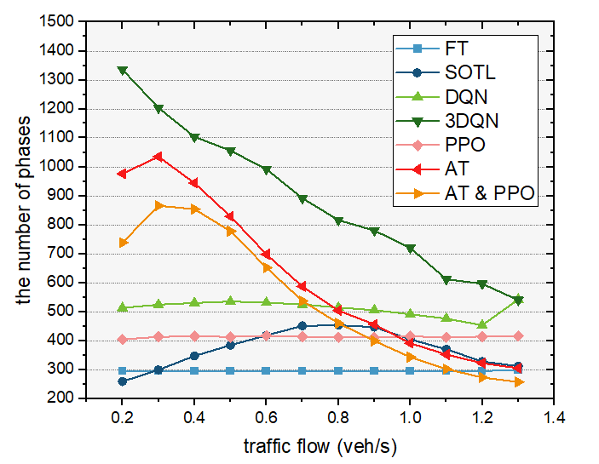
Figure 13.a-b shows the number of phase adjustments and average phase duration of each method under different traffic flow rates. It can be seen that the number of phase adjustment of our method and AT method decreases gradually. Accordingly, their average phase duration becomes longer. It also shows that the larger the traffic flow rate is, the longer the optimal phase duration is, which is in a dynamic changing process.
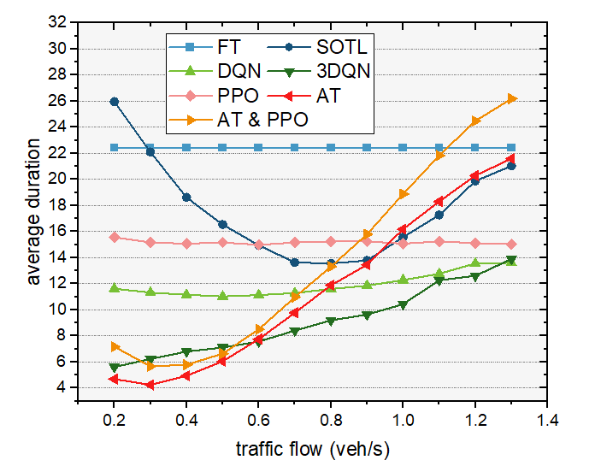
- total number of phases for all methods under different traffic flows
(b) average phase duration for all methods under different traffic flows
Figure 13: phase and duration adjustment of each method under different traffic flows

F. Performance of a Whole Day
In this subsection, the real traffic flow is used for the experiment, and the traffic flow data is from Luxemburg sumo traffic (LuST), which contains the complete data of one day [58].
In the real world, the situation of intersection is complex, and the width of intersection, the length of road, the number of lanes, the number of phases, and even the traffic flow rate of each road are very different. Here, only one intersection of main road is selected to verify the experimental results. The selected intersection is a typical 4-arm one the traffic flow data is gathered by counting the number of vehicles that pass by the intersection in certain area.
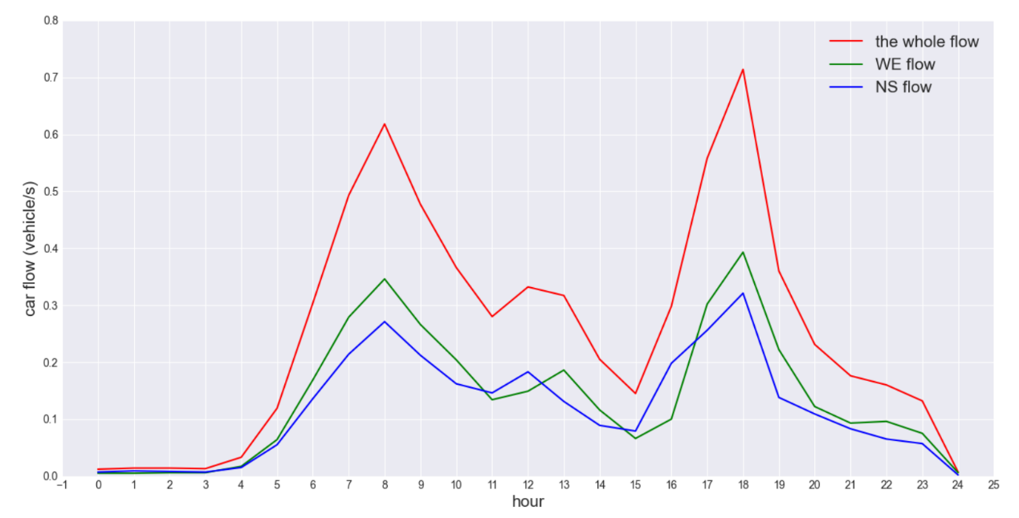
In the actual traffic data, the average vehicle flow rate is 0.266 vehicle per second, which is relatively sparse. Specifically, the overall traffic flow rate is high from 7-9 AM and 17-18 PM, and low in early morning and late night. In other periods, the traffic flow rate fluctuates from 0.2 to 0.4 vehicle per second, as shown in Figure 14. Moreover, the north-south and east-west traffic flow rates of the intersection are basically the same as the overall traffic flow rate, but the north-south traffic flow is slightly lower than the east-west one. Thus, the traffic is relatively balanced.
Figure 14: the traffic flow in a whole day

We compare the performance of several methods by delay, stops, time loss and speed of vehicle. Our proposed method gets the best result in all indicators
According to Table 6-9, our proposed method, i.e. AT & PPO, is apparently superior to other baselines. Not only the average waiting time is greatly reduced, but also the standard deviation is very small, which means that the average waiting time gap of vehicles passing through the intersection is very small. Of all the vehicles, 25% do not need to wait at all, 50% only need to wait within one second, and 75% only need to wait within six seconds. The only disadvantage is that the maximum delay is not as good as AT and SOFT methods.
In addition, we can see from the table that FT method is the worst, with the average delay reaching 29.72 seconds. The average delay of each vehicle varies greatly. One quarter of the vehicles only need to wait less than 2 seconds, but the other quarter needs to wait more than 52 seconds.
The reinforcement learning method, no matter PPO or DQN, is obviously better than traditional FT method. In terms of average delay, DQN is 55% of FT, PPO is 52.3% of FT, and their standard deviations also decrease to a certain extent. The disadvantage is that a few vehicles wait too long, up to 400 seconds.
Furthermore, the performance of AT is even better than that of reinforcement learning, which shows the superiority of our adaptive timing method. By PPO model selecting the optimal phase, AT & PPO can reduce the average waiting time to the minimum, which is only 16.2% of traditional FT method, 21.2% of SOFT method, 29.4% of DQN method, and 70.8% of pure AT method.
Table 6: detailed experiment result about delay
Method | Mean | Std | Min | 25% | 50% | 75% | Max
FT | 29.721 | 25.855 | 0 | 2 | 27 | 52 | 153
SOFT | 22.617 | 24.965 | 0 | 1 | 15 | 37 | 130
DQN | 16.364 | 25.459 | 0 | 1 | 9 | 22 | 444
PPO | 15.554 | 20.52 | 0 | 1 | 9 | 24 | 478
AT | 6.786 | 8.147 | 0 | 0 | 4 | 11 | 63
AT&PPO | 4.807 | 8.534 | 0 | 0 | 1 | 6 | 150

In terms of the number of stops, our method makes the average stops the least, only 0.658, which is far better than PPO and AT. Moreover, over 25% of vehicles do not need to stop and wait at the intersection. More precisely, the actual value is 43%, which means that a considerable number of vehicles do not need to stop and wait, far superior to other methods. (PPO is 24.4%, DQN is 23.5%, FT is 19.6%, SOFT is 24.86%, and AT is 30.4%)
Table 7: detailed experiment result about stops
Method | mean | std | min | 25% | 50% | 75% | max
FT | 0.976 | 0.618 | 0 | 1 | 1 | 1 | 4
SOFT | 0.896 | 0.625 | 0 | 1 | 1 | 1 | 4
DQN | 0.958 | 0.71 | 0 | 1 | 1 | 1 | 9
PPO | 0.905 | 0.627 | 0 | 1 | 1 | 1 | 4
AT | 0.812 | 0.622 | 0 | 0 | 1 | 1 | 3
AT&PPO | 0.658 | 0.634 | 0 | 0 | 1 | 1 | 3
Recall that time loss includes the waiting time and the lost time of not reaching the ideal speed. In term of time loss, we can also observe similar comparison results from Table Y.
Table 8: detailed experiment result about time loss
Method | mean | std | min | 25% | 50% | 75% | max
FT | 41.436 | 27.661 | 3.06 | 15.27 | 39.98 | 64.1 | 187.17
SOFT | 33.502 | 26.025 | 2.75 | 10.17 | 28.27 | 48.7 | 141.87
DQN | 27.841 | 28.481 | 2.9 | 11.23 | 20.56 | 34.15 | 463.62
PPO | 26.509 | 21.638 | 2.63 | 11.02 | 21.78 | 36.21 | 490.83
AT | 17.103 | 9.678 | 2.74 | 8.91 | 15.96 | 22.59 | 76.88
AT&PPO | 14.614 | 9.92 | 2.92 | 7.62 | 12.01 | 18.35 | 161.7
According to Table 9, our proposed method also maximizes the average speed of vehicles, which means greater traffic throughput and higher traffic efficiency at intersections. It can be seen that both phase selection and duration adjustment are of great significance to improve traffic efficiency, and our method is very effective in the combination of the two.
Table 9: detailed experiment result about speed
Method | mean | std | min | 25% | 50% | 75% | max
FT | 8.56 | 2.62 | 2.41 | 6.40 | 8.02 | 10.66 | 16.26
SOFT | 9.24 | 2.54 | 3.06 | 7.24 | 9.12 | 11.32 | 16.32
DQN | 9.79 | 2.30 | 1.28 | 8.34 | 9.96 | 11.44 | 16.79
PPO | 9.79 | 2.18 | 1.52 | 8.25 | 9.81 | 11.38 | 16.79
AT | 10.70 | 1.64 | 4.98 | 9.56 | 10.67 | 11.83 | 17.08
AT&PPO | 11.08 | 1.63 | 2.83 | 10.05 | 11.14 | 12.20 | 16.90

According to the above analysis, the adjustment of phase based on reinforcement learning method alone or the phase duration based on adaptive timing method can greatly improve traffic efficiency. By combining PPO method with AT, our system can adjust phase and duration to further improve traffic efficiency. Moreover, the adaptive timing scheme based on the concept of effective green light time can reduce the number of vehicles with long delay, which makes the influence of traffic lights on vehicles balanced without too extreme situation.
Since the traffic flow rate fluctuates all day with obvious peaks and troughs, we count the average phase duration per hour and its corresponding average delay to observe the adaptability of each method to traffic flow changes.
As can be seen from the Figure 15.a-b, the traffic flow is quite small at 0-4am, and the average phase duration of all methods is large, but their average delay is very different. Among them, our proposed method, i.e. AT & PPO, makes the average delay near zero, which is far superior to other methods.
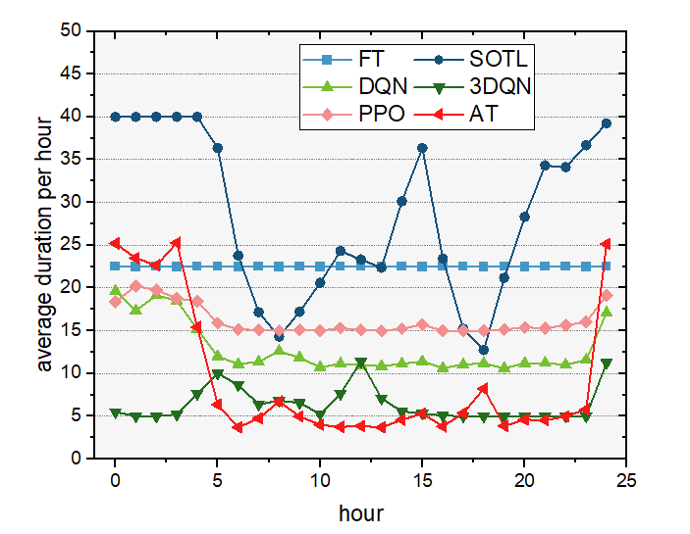
In other time periods, the average green time of DQN and PPO changed slightly while that of FT did not change at all. The average phase duration of our method is similar to the change of vehicle flow rate, so that its average delay of each hour is minimum with slight fluctuation. AT method with fixed phase sequence also shows this similarity. It is worth noting that compared with AT & PPO, AT method has less average green time and more phase transitions, but its performance is reactive poor. We can infer the effect of phase selection, that is, to choose a more reasonable phase every time step, which reduces the frequent phase conversion.
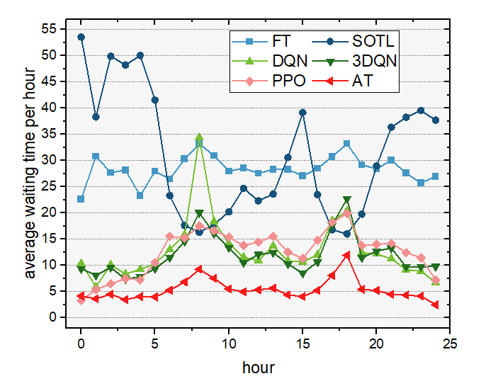
(a) average duration per hour for all methods in a whole day flow
(b) average delay per hour for all methods in a whole day flow
Figure 15: duration adjustment per hour of each method in a whole day flow

VII Conclusion
In this paper, we propose a traffic light signal system based on reinforcement learning and Self-Adaptive Timing based on the idea of dynamically adjusting both phase and duration. In our system, the most suitable phase was judged by PPO model and the most effective green duration by self-adaptive timing. We conduct extensive experiments using both synthetic and real world traffic data and demonstrate the superior performance of our proposed method over other methods. Besides, we discuss the relationship between optimal phase and traffic flow that the best duration would rise at least with the increase of traffic flow.
We are also aware of the limitations of the current approach. First of all, PPO is only a relatively good reinforcement learning method that a better reinforcement learning model can reduce the wrong phase decision. Secondly, our experiments can be carried out at different kinds of intersections and multiple intersections to further verify the performance of our proposed method. In addition, we also hope to extend the method to more complex intersection conditions, such as pedestrians and bicycles, so as to be closer to the real scene. We would like to study further in these future directions to make our method more applicable to real traffic scenarios.

References
[1] Khattak Z H, Fontaine M D, Boateng R A. Evaluating the impact of adaptive signal control technology on driver stress and behavior using real-world experimental data[J]. Transportation research part F: traffic psychology and behaviour, 2018, 58: 133-144.
[2] Jin J, Ma X, Kosonen I. An intelligent control system for traffic lights with simulation-based evaluation[J]. Control engineering practice, 2017, 58: 24-33.
[3] Xiong Z, Sheng H, Rong W G, et al. Intelligent transportation systems for smart cities: a progress review[J]. Science China Information Sciences, 2012, 55(12): 2908-2914.
[4] Miller A J. Settings for fixed-cycle traffic signals[J]. Journal of the Operational Research Society, 1963, 14(4): 373-386.
[5] Koonce P, Rodegerdts L. Traffic signal timing manual[R]. United States. Federal Highway Administration, 2008.
[6] Cools S B, Gershenson C, D’Hooghe B. Self-organizing traffic lights: A realistic simulation[M]//Advances in applied self-organizing systems. Springer, London, 2013: 45-55.
[7] Pandit K, Ghosal D, Zhang H M, et al. Adaptive traffic signal control with vehicular ad hoc networks[J]. IEEE Transactions on Vehicular Technology, 2013, 62(4): 1459-1471.
[8] Wu, C., Kreidieh, A., Parvate, K., et al. (2017). Flow: Architecture and Benchmarking for Reinforcement Learning in Traffic Control. CoRR, abs/1710.05465.
[9] Li L, Lv Y, Wang F Y. Traffic signal timing via deep reinforcement learning[J]. IEEE/CAA Journal of Automatica Sinica, 2016, 3(3): 247-254.
[10] Wei H, Zheng G, Yao H, et al. Intellilight: A reinforcement learning approach for intelligent traffic light control[C]//Proceedings of the 24th ACM SIGKDD International Conference on Knowledge Discovery & Data Mining. 2018: 2496-2505.
[11] Wei H, Xu N, Zhang H, et al. Colight: Learning network-level cooperation for traffic signal control[C]//Proceedings of the 28th ACM International Conference on Information and Knowledge Management. 2019: 1913-1922.
[12] Zhao Dongbin, Shao Kun, Zhu Yuanheng, et al. Overview of Deep Reinforcement Learning: also on the development of computer go [J]. Control Theory and Application, 2016, 33(6)：701-717.
[13] Tesauro G. TD-Gammon: A Self-Teaching Backgammon Program[J]. Neural Computation, 1944, 6(2): 215-219.
[14] Sutton R S, Barto A G. Reinforcement Learning: An Introduction[J]. IEEE Transactions on Neural Networks, 1998, 9(5): 1054-1054.
[15] Kearns M, Singh S. Near-Optimal Reinforcement Learning in Polynomial Time[J]. Machine Learning, 2002.
[16] Kocsis L, Csaba Szepesvári. Bandit Based Monte-Carlo Planning[J]. Lecture Notes in Computer Science, 2006, 4212: 282-293.
[17] SILVER D, SCHRITTWIESERH J, SIMONYAN K, et al. Mastering the game of Go without human
[18] Riedmiller M. Neural fitted q iteration – first experiences with a data efficient neural reinforcement learning method[C]// European Conference on Machine Learning. 2005.
[19] Lange S, Riedmiller M. Deep auto-encoder neural networks in reinforcement learning[C]// International Joint Conference on Neural Networks. 2010.
[20] Abtahi, Fasel I. Deep belief nets as function approximators for reinforcement learning[C]// Aaai Conference on Lifelong Learning. 2011.
[21] Lange S, Riedmiller M, Voigtlander A. Autonomous reinforcement learning on raw visual input data in a real world application[C]// International Joint Conference on Neural Networks. 2012.
[22] Koutník J., Schmidhuber J., Gomez F. (2014) Online Evolution of Deep Convolutional Network for Vision-Based Reinforcement Learning. In: del Pobil A.P., Chinellato E., Martinez-Martin E., Hallam J., Cervera E., Morales A. (eds) From Animals to Animats 13. SAB 2014. Lecture Notes in Computer Science, vol 8575.
Springer, Cham.
[23] Zhao, Dongbin & Shao, Kun & Zhu, et al. (2016). Review of deep reinforcement learning and discussions on the development of computer Go. 33. 701-717. 10.7641/CTA.2016.60173.
[24] Konda V. Actor-critic algorithms[J]. Siam Journal on Control & Optimization, 2003, 42(4): 1143-1166.
[25] SCHULMAN J, WOLSKI F, DHARIWAL P, et al. Proximal policy optimization algorithms [EB/OL]. arXiv: 1707.06347, 2017.
[26] HEESS N, WAYNE G, SILVER D, et al. Learning continuous control policies by stochastic value gradients [C] //Advances in Neural Information Processing Systems (NIPS). Montréal: [s.n.], 2015: 2944 –2952.
[27] SCHULMAN J, LEVINE S, ABBEEL P, et al. Trust region policy optimization [C] //Proceedings of the 32nd International Conference on Machine Learning (ICML). Lille: [s.n.], 2015: 1889 – 1897.
[28] Human-level control through deep reinforcement learning[J]. Nature, 2015, 518(7540): 529-533.
[29] Zhao D, Wang H, Shao K, et al. Deep reinforcement learning with experience replay based on SARSA[C]// Computational Intelligence. IEEE, 2017.
[30] Anschel, Oron et al. “Averaged-DQN: Variance Reduction and Stabilization for Deep Reinforcement Learning.” ICML (2017).
[31] He, F.S., Liu, Y., Schwing, A.G., & Peng, J. (2017). Learning to Play in a Day: Faster Deep Reinforcement Learning by Optimality Tightening. CoRR, abs/1611.01606.
[32] Bellemare, Marc G. et al. “A Distributional Perspective on Reinforcement Learning.” ICML (2017).
[33] Fortunato, M., Azar, M.G., Piot, B., Menick, J., Hessel, M., Osband, I., Graves, A., Mnih, V., Munos, R., Hassabis, D., Pietquin, O., Blundell, C., & Legg, S. (2018). Noisy Networks For Exploration. CoRR, abs/1706.10295.
[34] Hessel, Matteo et al. “Rainbow: Combining Improvements in Deep Reinforcement Learning.” AAAI (2018).
[35] Watkins C.,Dayan P. Technical note Q-learning[J].Journal of Machine Learning, 1992,8:279-292
[36] Wiering M., Vreeken J., Veenen J. ,et al. Simulation and optimization of traffic in a city[C]. In IEEE Intelligent Vehicles Symposium(IV’04), Parma, Italy, IEEE,2004: 453–458
[37] Abdulhai B., Pringle P. Autonomous Multiagent Reinforcement Learning - 5gc urban Traffic Control[C]//Annual Transportation Research Board Meeting .TRB,2003
[38] Cheng Xiangjun, Chang Xinzhi, Yang Zhaoxia. Traffic signal control method based on Q-Learning [J]. System engineering theory and practice, 2006, 28 (8): 136-140
[39] Chen Yangzhou, Zhang Hui, Yang Yuzhen. Application of agent based on Q-Learning in single intersection traffic control [J]. Highway traffic technology, 2007,24 (5): 117-120
[40] Lu Shoufeng, Liu Ximin, Dai Shiqiang. Q-learning for adaptive traffic signal control based on delay minimization strategy[C]. USA: The International Conference on Networking, Sensing and Control. Institute of Electrical and Electronics Engineers, 2008:687-691
[41] he Zhaocheng, she Xiwei, Yang Wenchen. Traffic signal self-learning control method for single intersection combining Q-learning and fuzzy logic [J]. Computer application research, 2011, 28 (1): 200‐202
[42] Liang X, Du X, Wang G, et al. A deep reinforcement learning network for traffic light cycle control[J]. IEEE Transactions on Vehicular Technology, 2019, 68(2): 1243-1253.
[43] Hsieh P C, Chen Y R, Wu W H, et al. Timing optimization and control for smart traffic[C]//2014 IEEE international conference on internet of things (iThings), and IEEE green computing and communications (GreenCom) and IEEE cyber, physical and social computing (CPSCom). IEEE, 2014: 9-16.
[44] Tang C, Xia S, Zhu C, et al. Phase timing optimization for smart traffic control based on fog computing[J]. IEEE Access, 2019, 7: 84217-84228.
[45] Shen G, Zhu X, Xu W, et al. Research on Phase Combination and Signal Timing Based on Improved K-Medoids Algorithm for Intersection Signal Control[J]. Wireless Communications and Mobile Computing, 2020, 2020.
[46] Vogel A, Oremović I, Šimić R, et al. Fuzzy traffic light control based on phase urgency[C]//2019 International Symposium ELMAR. IEEE, 2019: 9-14.
[47] Yi-Fei W, Zheng G. Research on polling based traffic signal control strategy with fuzzy control[C]//2018 IEEE 4th International Conference on Computer and Communications (ICCC). IEEE, 2018: 500-504.
[48] Abbas M K, Karsiti M N, Napiah M, et al. High accuracy traffic light controller for increasing the given green time utilization[J]. Computers & Electrical Engineering, 2015, 41: 40-51.
[49] Zhao C, Hu X, Wang G. PDLight: A Deep Reinforcement Learning Traffic Light Control Algorithm with Pressure and Dynamic Light Duration[J]. arXiv preprint arXiv:2009.13711, 2020.
[50] Manual H C. HCM2010[J]. Transportation Research Board, National Research Council, Washington, DC, 2010: 1207.
[51] W. Wei. Study on effective green light time calculation methods of signalized intersection [J]. Shanxi Architecture, 2015,41(04):125-126.
[52] Wang Y, Rong J, Zhou C, et al. Dynamic estimation of saturation flow rate at information-rich signalized intersections[J]. Information, 2020, 11(4): 178.
[53] Zhang R, Leteurtre R, Striner B, et al. Partially detected intelligent traffic signal control: Environmental adaptation[C]//2019 18th IEEE International Conference On Machine Learning And Applications (ICMLA). IEEE, 2019: 1956-1960.
[54] Sutton R S, McAllester D A, Singh S P, et al. Policy gradient methods for reinforcement learning with function approximation[C]//NIPs. 1999, 99: 1057-1063.
[55] Mnih V, Badia A P, Mirza M, et al. Asynchronous methods for deep reinforcement learning[C]//International conference on machine learning. PMLR, 2016: 1928-1937.
[56] Guler S I, Menendez M, Meier L. Using connected vehicle technology to improve the efficiency of intersections[J]. Transportation Research Part C: Emerging Technologies, 2014, 46: 121-131.
[57] Lopez P A, Behrisch M, Bieker-Walz L, et al. Microscopic traffic simulation using sumo[C]//2018 21st International Conference on Intelligent Transportation Systems (ITSC). IEEE, 2018: 2575-2582.
[58] Codecá L, Frank R, Faye S, et al. Luxembourg sumo traffic (lust) scenario: Traffic demand evaluation[J]. IEEE Intelligent Transportation Systems Magazine, 2017, 9(2): 52-63.

