Title: Planning for innovative customer service
——Li Ning Group

Course：Marketing management
Name：Mingyue.Li
ID number：2006426

content
1. Summary 3
2. 7P Theory 3
3. STP theory 6
4. Implementation strategy 7
5. Recommendations 8
6. Conclusion 9
7. Organization Appendix and reference 9

- Summary
According to Li Ning's 2020 annual report, the company's primary online sales channels include third-party platforms such as Taobao, Tmall and JD.com.（Li Ning report 2020）
Also has the company's online mall, WeChat mall and so on. However, the offline stores of Li Ning's brick-and-mortar retail have been slow to develop. Li Ning will turn its development strategy to the Internet for breakthroughs. （Ayibonu,2020）But the online retail industry is growing faster, and consumer maintenance costs are rising compared with traditional retail stores. Experiential marketing can examine marketing issues more from consumers' perspective, give full consideration to consumers' preferences and consumption habits, constantly analyze and understand consumers' needs according to industry experience, and create a consumption experience beyond expectations for target customers.（ Wang.Yexiang,2019）

- 7P Theory
Product
Li Ning Company was founded at the beginning of sports shoes, sportswear and other products. Because at the end of the last century, the Chinese market was in a state of short supply, and many enterprises in sports products manufacturing were in a profitable state（Tan Xiaofang.2019）. So the breadth of Li Ning's product portfolio has been laid down since the company's beginning, which is caused by the market environment. Product positioning has long been a problem: the core consumer group ageing. The positioning of the product is more casual and lacks professional sports attributes. The affinity of the product does not meet the needs of young consumers.
That is to say, Li Ning's products remain unchanged for a long time, and it did not launch products to meet the market demand in time.(Lu.Z，2020)
This problem appeared at the beginning of the 21st century, but China's market economic system has begun to take shape, people's living standards have been greatly improved, and the material requirements have changed with the progress of society. And Li Ning on the market's change of reaction slightly slow, Li Ning needs to begin to adjust changes and seek to embark on the path of specialization（Cao Yulu.2018）. For example, the introduction of professional management personnel, expanding the research and development work, introducing professional football shoes, basketball shoes, running shoes, and clothing.

Price
The target consumer groups of Li Ning can be divided into two parts: the first part is over 30 years old middle-income consumer groups; The second section is for students aged between 15 and 24.(Jin Xin. 2019)
Li Ning sells at a discount to Nike and Adidas but is about 50 per cent higher than other Chinese sportswear brands because it positions itself at the mid-to-high end of the domestic market. Therefore, avoid the high-end route, avoid direct competition with the world's two major sports brand giants Nike, Adidas, and the price is relatively widespread, suitable for the Chinese market, conducive to the company's development.(Mao Ge hui &Wu, H. F. 2021) From this point of view, the choice of price route of Li Ning Company is the most beneficial to itself at present, but with the development of internationalization and the expansion of the company's brand, the company is bound to turn to the high price route gradually.

Promotion
Sponsorship of sporting events can enhance consumers' perception of the brand. Implicit marketing is used in the marketing model. Li Ning needs to emphasize the combination of the uncertainty of competitive sports with the energy and fighting spirit of athletes, and translate that into its brand philosophy (Liu Qing.2020). At the same time, Li Ning needs to attach great importance to the innovation of marketing mode, search for sports stars through competitions, and enhance their social effects. For example, it invites NBA star Shaquille O 'Neal to visit China. It is precise because Li Ning has become the real winner of the whole sports brand because of this kind of form. The second, the extension strategy. (Cui W N. 2021.)
The primary strategy is to save the old samples through acquisitions, agency, merging and so on the way to brand extension and operation, although, in the whole market, Li Ning will still own brands as the dominant of the whole market, but also adopted specific defensive measures to better protect the Li Ning brand market share for all types of the mature brand guarantee its original brand image For example, in 2009, Li Ning bought all the shares of Kaisheng Sports Hong Kong Ltd. and began to accelerate its development in badminton. (Zhang Bosen.2021)Third, Li Ning is different from some domestic sports products enterprises in terms of international marketing strategy. Li Ning has never followed the principle of OEM production and has its standard process from design to production. By basing itself on the local market, it gradually improves the international strategy of its brand.
In the international market, Li Ning began to learn the experience of supplying enterprises in the domestic and international markets in this way. Secondly, the Li Ning brand is in the critical stage of Li Ning brand image promotion. (Zhao Yani & Qiao Lijuan.2019) Company needs to find something in line with the current sports star brand, and only in this way can an influential brand be formed.

Place
In the development stage of Internet information technology, the market development direction of the clothing industry has gradually shifted from the traditional offline order transaction to online transaction, and consumers' understanding of the network e-commerce platform has been increasing year by year. Under this market background, Li Ning's sales channel no longer needs to rely on the traditional offline order transaction mode. (Li Junbin.2020.)Therefore, the company's management should realize the importance of the network for enterprise marketing and carry out O2O collaborative marketing activities, which can expand the original marketing channels of the company and improve the company's overall profit.
To further improve the competitiveness of Li Ning in the market, to overcome the current Li Ning facing a single channel problem.(Gong Jiayi, Xue Peng.2020) Li Ning should actively promote the construction of offline experience stores. Under the current new economic situation, Chinese enterprises are faced with the possibility of transformation at all times, and all industries are faced with changes and upgrades at all times. Therefore, Li Ning should promote the construction of offline experience stores to provide consumers with a more direct way to understand the company's products.

Physical evidence
Good service in physical stores makes consumers want to spend impulsively. Consumers are more willing to buy goods under the persuasion of salespeople. Communicate with customers, explore different needs of customers, explore potential target market. To maintain the relationship between the brand and customers and ensure the relationship between customers, physical stores adopt product promotion and incentive activities to make it easier for customers to buy. For example, merchants offer discounts to member-consumers to increase customer engagement and spending time.
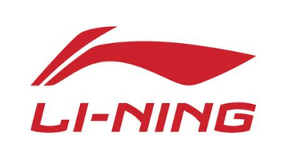

People
According to the 7P Theory, the company must pay attention to employee training, achieve high-quality service, provide good service for customers, and do an excellent job in pre-sale, in-sale and after-sale service. Let customers more conveniently and comfortably buy products and enjoy the related services.（ZHANG Li,2020） Providing good service is an integral part of customer value. Service and sales personnel are the front-line personnel who communicate directly with consumers. Their professional attitude, personal quality, information accumulation degree, language expression ability and so on will affect customers' purchasing decisions.

Process
The garment industry belongs to high contact service, so Li Ning must clearly define the service operation process and customer interaction order, emphasize the "consumer-centered" marketing concept, and redesign various business processes according to the needs of consumers and the idea of providing customers with the most convenient and the best quality service.（Chen Xiuwen.2020）As a result, reduce administrative costs and administrative costs, reduce the push between departments and unnecessary labour, improve their market competitiveness, improve customer satisfaction, improve service efficiency.

- STP theory
3.1 Market Segmentation
In 2010, Li Ning announced that Li Ning company only take a young line and give up the middle-aged and elderly market segments. Li Ning company to do so through market segmentation, blue ocean strategy to avoid with Adidas, Nike and other international well-known brands in the high-end white-collar market for the fight.（LIU Xin，2020）
But Li Ning excessive market segmentation and too narrow product positioning so that the product terminal sales become passive overall.
After the Li Ning subdivision market, operating income appeared to shrink substantially. So obviously, Li Ning's market segmentation did not occupy the target market consumers. So to capture this segment of the young market, Li Ning needs to be close to them and give them products, brands and cultural experiences.

3.2 Market Targeting
Aftermarket segmentation, Li Ning chose "90's people "as the target market. This kind of young people is students and young workers in large and medium-sized cities who love sports and advocate new trends. When selecting the target market, three conditions need to be met: the appropriate market size and growth potential, enough market attraction, in line with the enterprise's goals and resource advantages.（Huang, M. H.2021）However, the survey found that the actual consumer groups in Lining are mainly aged between 24 and 35 (not the "post-90s"), and they are concentrated in the second and third-tier cities with middle income. So Li Ning's target consumer groups and the actual consumer groups have a severe mismatch.

3.3 Market Positioning
Brand positioning is too high, too low or chaotic; that is, the target consumer group's perception of the enterprise brand is very different from the enterprise's brand positioning, easy to make the enterprise can not attract the target market consumer groups, and lose the original consumer groups.（Xi, W. 2021, 3）
In the brand Logo and advertising language, to cooperate with the new image of Li Ning brand positioning, Li Ning company in 2010 launched a new Logo, and the new Logo lack the old Logo elegant, and no longer have the original Logo initials, become meaningless geometric graphics, by many consumers think is Li Ning copycat version.
Li Ning's move failed to impress the target market and alienated the distance from the original consumer groups, destroying the consistency of the brand appeal.（Zhao Yani, Qiao Lijuan. 2019）In terms of price positioning, with the selection of the new target market and the positioning of the young brand, Li Ning has significantly increased the price of its products. However, this price deviates from consumers' understanding of the value of their products, so the products appear unmarketable. In addition, while high prices are usually associated with good design and quality, Li Ning's price increases aren't based on improved design or quality.

- Implementation strategy
（1）Differentiated experiential marketing
Before beginning experiential marketing activities, Li Ning needs to locate target groups and find specific audience groups. Then, take differentiated experiential marketing design according to the survey results. According to the preferences of different ages to consider, understand the buyer's will and mood, the product's appearance to do delicate design, fully mobilize the desire to buy. Improve the environment for experiential marketing. The impulsive purchasing behaviour of consumers is seriously affected by the environment. In addition, a good environment and atmosphere can help people's desire to buy. （Merrilees,B. 2016.）Therefore, the store design for experiential marketing should be simple, beautiful and generous. It can also rely on the power of the Internet to conduct online advertising, use technology, the Internet and other media for communication, increase the stackability of fans, and enhance the influence of experiential marketing through multi-channel publicity.
On the other hand, companies need to focus not only on one scene but also on the coherence and relevance between the scenes. （Hu You & Li Y. 2021）For example, Li Ning, besides leading clothing, still can increase the leisure area of tea and coffee, which is a combination of a single scenario that can enhance consumer desire and increase consumer opportunity. These scenes can stimulate each other's consumption feelings and enhance consumption stickiness. In addition, more and more shopping centres, department stores and retail stores are introducing experiential elements. Retailers are using Internet technology to offer lifelike experiences and products and even using the latest virtual reality technology to attract consumers. Strive to create a combination of entertainment and retail social space to provide consumers with a richer experience.

（2）Expression of emotional experience.
When products and services become more and more homogeneous, consumers no longer consider product quality, function and other factors but pay more attention to emotional communication and emotional drive. Emotional experience is situation-based and creates emotional preferences for customers that are different from competitors.(JiangC.X,2016) For example, through the research and refinement of consumers' own characteristics, flagship stores build marketing situations in line with users' temperament and theme.
Li Ning's experience marketing is an essential part of offline sales, is the spiritual support of consumers, can achieve a huge market demand. Consumers will get psychological satisfaction through brand value-added experience and then generate corresponding purchase desire. (Zhang Rui, Zheng Kang. 2019). The shopping environment and product experience of Li Ning stores will affect consumers' offline impulse purchase intention. In-store promotions, interactions between salespeople and customers, and the store environment's design all impact the positive emotions of customers, which will increase impulse spending.

(3) New media promote accurate communication
In the current digital social environment, precision marketing no longer requires large areas of advertising, but through digital analysis, processing store data to make consumer portraits, to judge consumer preferences, to achieve precise advertising. In addition, through hot events, consumers can transfer from offline to online, and organization can realize the integration and innovation of new media and traditional media to create a new customer experience that is more precise, personalized and interactive.（Blázquez, M. 2014.）
Make full use of social media and new media to spread emotions and experience information. Enterprises can stimulate the emotional resonance of consumers through the design of scenes or stories and seize the hearts of consumers. (Hu Yingjia & Lu Yangfan.2020).For example, product promotion messages, consumer information is collected digitally through stores, and consumer portraits are generated through backstage computing. Based on consumer portraits, Li Ning can promote products to customers in a targeted way so that the product promotion page is more in line with consumers' preferences. In addition, by creating an atmosphere of exclusive VIP services, Li Ning can achieve an excellent emotional experience and lay a foundation for repeated purchases by consumers in the future.

- Recommendations
Computer science can test marketing results. For example, companies need to track consumer feedback in real-time and closely link marketing results to sales results according to user feedback, daily word-of-mouth, ample data supervision and in-store evaluation; organizations kept following up the marketing effect of Li Ning clothing and helped the company verify the marketing effect in real-time.
Li Ning will establish a clothing evaluation platform to strengthen the whole process and the whole-scene service effect.
Evaluation, The integrated information platform of the supply chain based on blockchain technology incorporates experiential marketing in the alliance chain and creates a multi-centre and efficient, comprehensive marketing evaluation system through a consensus mechanism. Blockchain technology promotes information collection of clothing manufacturers and after-sales service, encourages consumers to upload comments and feelings, and encourages consumers to make comments to form an accurate and tamper-free service evaluation platform. The service evaluation will be displayed on all nodes in the network. Due to the immutability and authenticity of blockchain, the company is promoted to improve the service level.
Should also be through the customer service evaluation platform to establish a "see products, choose and buy products, with the whole process of the use of the product, realize the whole scene of intelligent marketing to the customer, the evaluation process but also attaches great importance to the marketing activities, marketing activities before and after the marketing activities of continuity, with particular emphasis on monitoring and tracking effect and marketing activities in the marketing activity effect evaluation and optimization Suggestions, after then Improve the overall marketing effect.

- Conclusion
Based on the theories of 7P, STP and experiential marketing, combined with the case of Li Ning, this paper puts forward the implementation methods to improve consumer satisfaction. Through the research, aiming at the current development state of Li Ning, The following conclusions are drawn: Li Ning should grasp the current opportunity, adhere to the offline store transformation, to create an experiential marketing blueprint. Integration of online and offline and logistics, through the application of strategic experience module, to create a consumption scenario to meet consumer needs. Return to product design. Accurate consumer demand, strengthen communication with consumers, establish consumer database, and strengthen customer loyalty to the brand. And through blockchain and digital technology, and other technologies to track and test the results of marketing.

- Organization Appendix and reference

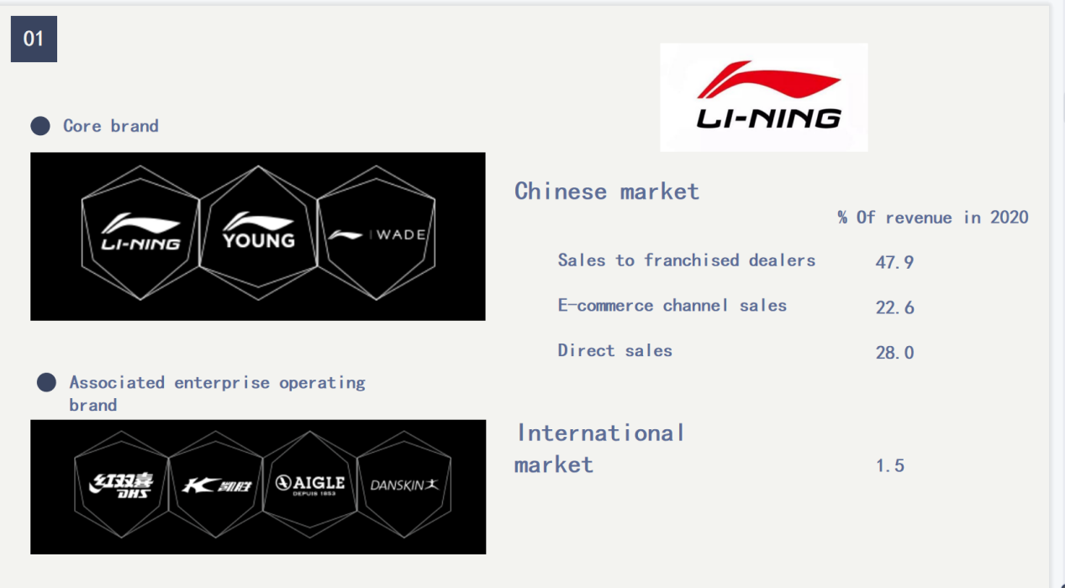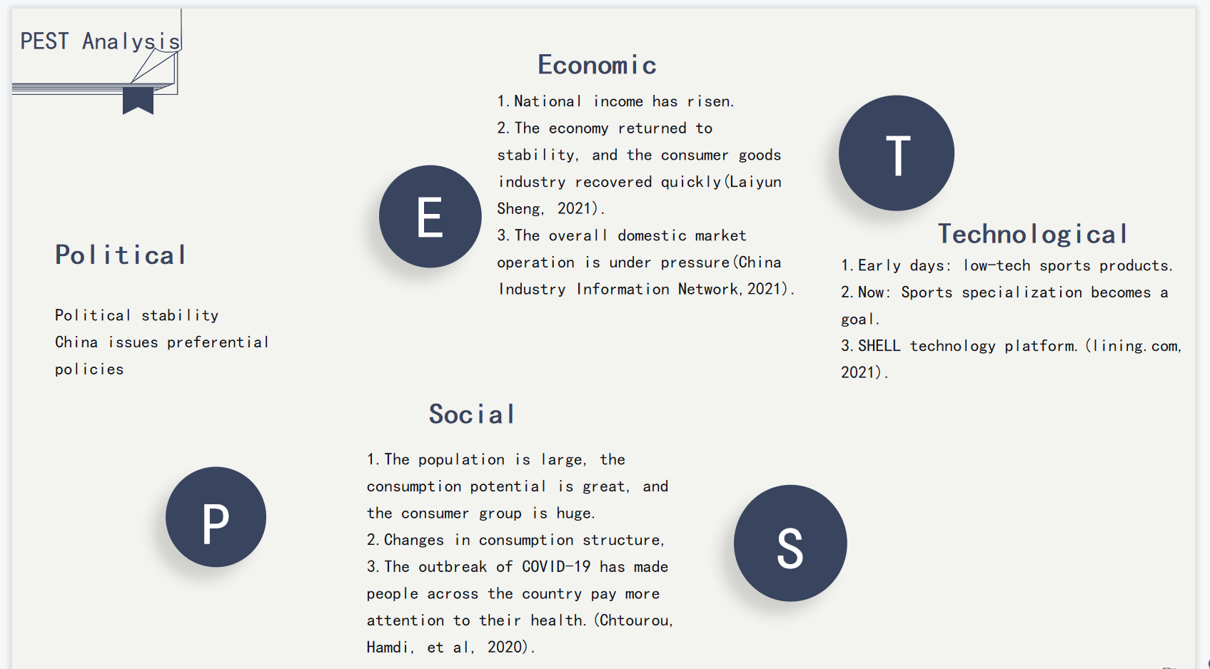

- Ayibonu (2020). Research on the brand communication strategy of Li Ning
- Blázquez, M. (2014). Fashion shopping in multichannel retail: The role of technology in enhancing the customer experience. International Journal of Electronic Commerce, 18(4), 97-116.
- Cao Yulu.(2018). Analysis on the Internationalization Mode of Chinese Local Brands -- Taking Li Ning as an example. Western Leather (13),35.
- Cui W N. (2021). Research on the development characteristics of sporting goods industry under the background of the new era: Li Ning and Nike as examples. Static and Sports Articles and Technology (06),134-135.
- Chen Xiuwen.(2020). Experiential Marketing Strategy for Retail Enterprises in Physical Stores. Business Culture (13),76-77.
- Jin Xin. 2019(08). Li Ning Chaoqian Walk [J]. Chinese Clothing.
- Jiang Chuanxin (2016-05-19). Emotional resonance in store sales. Xinhua Bibliography News,005.
- Hultén, B. (2011). Sensory marketing: the multi‐sensory brand‐experience concept. European Business Review.
- Hu Yingjia & Lu Yangfan.(2020). Research on Precision Marketing Strategy Based on Social Media. Science and Technology Intelligence (12),12-18.
- Huang, M. H., & Rust, R. T. (2021). A strategic framework for artificial intelligence in marketing. Journal of the Academy of Marketing Science, 49(1), 30-50.
- Hu You & amp; Li Y. (2021). The application of blue ocean strategy in H enterprise. Guangxi Quality Supervision Guide (04),138-139
- LIU Xin, LIU Lixi & AMP; Peng, Yuling.(2020). Analysis on the Synergistic Development of Customer Satisfaction and Internet + Entity Industry. Modern Enterprise (01),105-106.
- Lu, Z. (2020). Inventory management optimization of Li Ning Company
Lang, C., & Armstrong, C. M. J. (2018). Fashion leadership and intention toward clothing product-service retail models. Journal of Fashion Marketing and Management: An International Journal.
- Li Junbin.(2020). Li Ning brand: the trendsetter of domestic goods. Corporate Civilization (04),111-112.
- Mao Ge hui & amp; Wu, H. F. (2021). Influence of explosive thinking on creative design of clothing brands and suggestions: A case study of Li Ning brand. China Packaging (04),47-50.
- Wang Yexiang. (2019). Expansion of female consumer market based on experiential marketing. Journal of Business Economics (10),63-66.
- Zhang Rui, Zheng Cancan. 2019(05) Discussion on Impulsive Buying Behavior of Consumers [J]. Modern Business Industry.
- Zhang Bosen.(2021). Research on the Brand Remolding of Local Enterprises in the Context of Traditional Cultural Identity: A Case Study of Lining Brand. Journalism and Communication (02),23-25.
- Tan Xiaofang.(2019). Research on the Marketing Strategy of Chinese Sporting Goods Enterprises Listed in Hong Kong
- Liu Qing.2020.Production City.[J].
- Xi, W. (2021, 3). Analysis of Huawei's International Marketing Strategy Based on the SWOT Analysis. In 2021 2nd International Conference on E-Commerce and Internet Technology (ECIT) (pp. 151-154). IEEE.
- Zhao Yani &Qiao Lijuan.(2019). A Study on Brand Marketing Strategy of Li Ning -- A Case Study of Students in Hangzhou University. Fortune Today (21),49-50
- Gong Jiayi, Xue Peng.2020 Review of New Retail Development [J]. Commercial Economy.
- Merrilees,B. (2016). Interactive brand experience pathways to customer-brand engagement and value co-creation. Journal of Product & Brand Management.
- ZHANG Li, ZHAO Shouxiang & Zhang Duo.(2020). A Review of Research on the Site Selection of Fresh E-commerce Physical Stores under O2O Mode from the Perspective of Consumers. Light Industry Science and Technology (03),113-114.
- Zhao Yani, Qiao Lijuan. 2019(21) Fortune Today.Research on Ning Brand Marketing Strategy Taking Students in Hangzhou University as an Example [J].

