Student Name: Mohammed Rahman

Student Number: 1702587

Word Count: 1550

BA Course Title: Ways of Perceiving

On behalf of this project, I have planned an exhibition focusing on many multiple topics that can relate to as one and starting with that is focusing on black stereotypes. For many years Europe, Especially America have been linking black men with stereotypes that associate them with violence, all because of their appearance, they have been violent towards blacks when it comes to white police officers. There have been many deaths among young black men because of police brutality; they should change how they recognise these African Americans in order to prevent causing more harm and death towards them. The way society recognises black stereotypes is that they are more aggressive and dangerous than white Americans who present similar or even more aggressive behaviours than them. African American pull much more threats than other races make such as being in the news and in music such as rap and hip hop but music is what keeps them out of trouble in the streets than to cause more danger, same with art you express your feelings in to a sheet than to use those feelings in the streets and be endangered.

Secondly, ill be starting to talk about ‘respect’ and why that should be a serious topic to talk about. Respect is showing someone that you value their feeling and a thought, proving someone that you take appreciation and thoughts earns respect, but there’s not respect in different people race or culture because of their skin colour or not understanding someone else’s belief in their specific clothing, language or god, so they would much prefer to throw in wars, bomb, guns in to the fight, instead of understanding each other and have respect and peace.

Thirdly, emotions can affect everything we do, thought and action, they are part of our lives. Emotions can put you in a great mood and it can put you in a terrible mood, it can make you feel lost when something is not going right in your head and it could make you upsetting if not depressing from just what you are feeling such as no one cares about you or that your lonely or you get abused by bully’s and that could cause the depression to rise up to be suicide. Emotion can make you feel all of that but if you could control it or want to make something out of it, that’s where the power comes from by using what you feel and put it to good use such as music and art.

Last but not least I am working on judgemental, we live in a judgemental society. The amount of people judges by the way they look or be fake friends with them until they left the room to judge about them or how much u hate that specific person. Don't judge a book by its cover and Id like to link all of the four categories that I have chosen: Stereotypes, respect, emotions, judgemental all of these are important to comprehend and fix one another to understand the true culture of one another and understanding that we are all equal and we are part of one.

I have chosen to perform my exhibition in the National Museum Cardiff, as I wanted my explanation of the work to be at a place where I grew up and the layout offers a great range of area to discover all the different sections I have included. The exhibition is based on the equality of society and where it is taking us to the future.

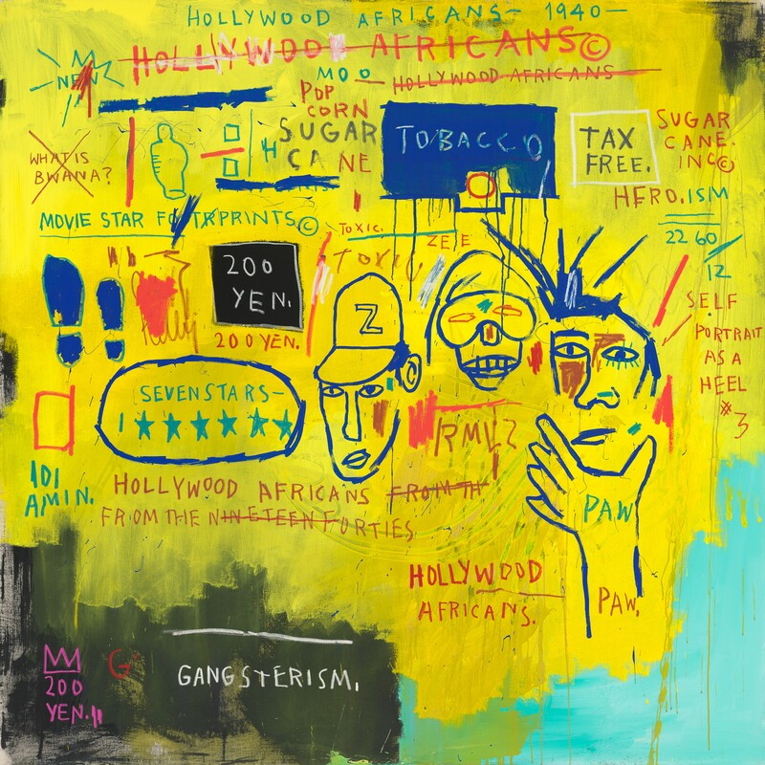

This artwork was made in the time when Hollywood Africans were one of the progressions of Basquiat's paintings. It’s about black stereotypes in Hollywood. It was painted while Basquiat was on a long visit to Los Angeles, in 1983.

His artwork contains notes that are “Sugar cane.” “Tobacco.” “Gangsterism.” and “What is bwana.” These refer to the partial parts available to black performers in old Hollywood movies. The thought of rejection is strengthened in the way that Basquiat crossed out words or expressions in his works. He did this to attract thoughtfulness regarding the crossed out words. The technique, he explained, was actually meant to direct attention to them “I cross out words so you will see them more; the fact that they are obscured makes you want to read them.”

Basquiat's artistic creation reflects huge numbers of the issues African Americans manage ordinary. In some case being in media outlets, politically as well as socially, prejudice and separation have dependably been available. He relates these issues through a large number of his works of art, and one particularly was Hollywood Africans. In spite of the fact that the artists achieve many issues, he has constantly observed African American culture through his artworks, regularly making non-white individuals the heroes of his works of art. Basquiat is one of the famous artists that has been black stereotyped in his age and made something that didn't affect him into doing harmful things back.

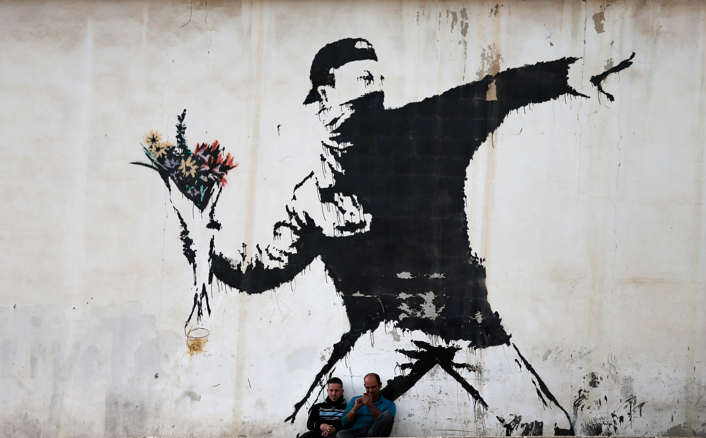

Many people experience life and still don’t know how to use or know the meaning of the word ‘respect’ towards different cultures or themselves. Respect is the affection for a feeling of the importance or smartness of an individual. There are things in life you have to hold in respect, such as respecting for yourself, respecting for other people, and respecting someone’s personal items. Respect is taught to individuals everywhere and it is even educated to them in other people’s religions and culture. Respect is the very viewpoint that keeps everything in your life.

Respecting for yourself is critical to someone because it is very well maybe they look up to you for a great example in life. On the other hand, if individuals have no respect for themselves, they will be in all probability go into depression. Respecting yourself is just as meaningful for your confidence. Having high confidence implies that people

respecting your companions implies not mocking them, not fighting, and helping them when they are agitated by something. Finally respecting someone’s personal items implies not destroying or taking something that isn't yours. It makes sense if you respect someone’s items because its just right to do, most people don't consider how the other person would feel if it exactly happened to you. Don't destroy it respect it just like how Banksy artwork is giving an example to not throw war or damage something, treat it well.

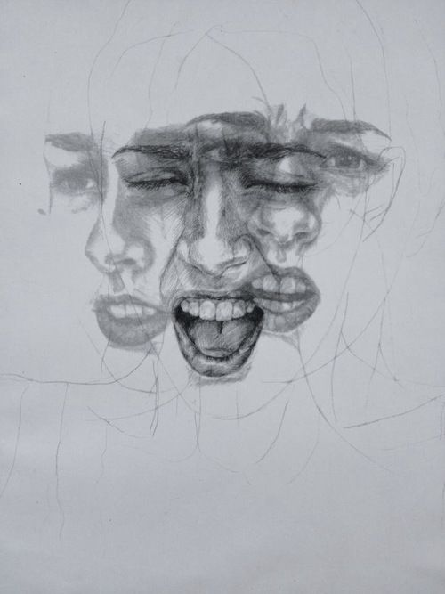

People usually don't understand each other properly, they would usually keep on mess around with other peoples emotions even though they know its hurting them directly or to pretend that they didn't know it was hurting their feelings, as in this piece above shows the innocent being mind or possibly actual face reaction when being attacked from someone's roughness as she's expressing multiple emotions and pain through what she is getting that is happening all at once. Emotions aren't something to be careful to talk about, no one would usually care about one person's emotions, and that emotions could lead them to darkness in being far alone, trapped and then fall into depression, as this piece is slowly starting to show. But then emotions are a typical part of our lives, everyone's emotion describes their own individualities, our independence demonstrates our identity and our identity that we genuinely are and what we need to be. Our emotions are an important part of our lives without emotions would be technically nothing and boring as in you can't express your feelings of different emotions in art, express your feelings in love and sadness of music or express the thrill in sport, emotions is a powerful mind in us to express.

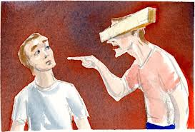
In this piece, it shows a male judging another being while having a plank of wood covering his eyes, which illustrates that he is judging someone by its cover. But he’s not looking at anything just a black screen from the cover of the wood. The person who is being accused randomly seemed shocked or surprised by the stupidity of this aggressive judgemental person.

People today do not need the negativity of the judgemental person because it can cause damage to another person even if they’re not showing it in front of you but definitely afterwards when they’re alone. People or society does not or can't handle judgemental people as they can lower their self-esteem. Furthermore, negative people put others down so they can make themselves feel better about their own anxieties or doing it for the attention of others just to show off. Negative judgements of people could lead the innocents to be depressed or even I a worse matter of hand thinking or actually committing suicide.

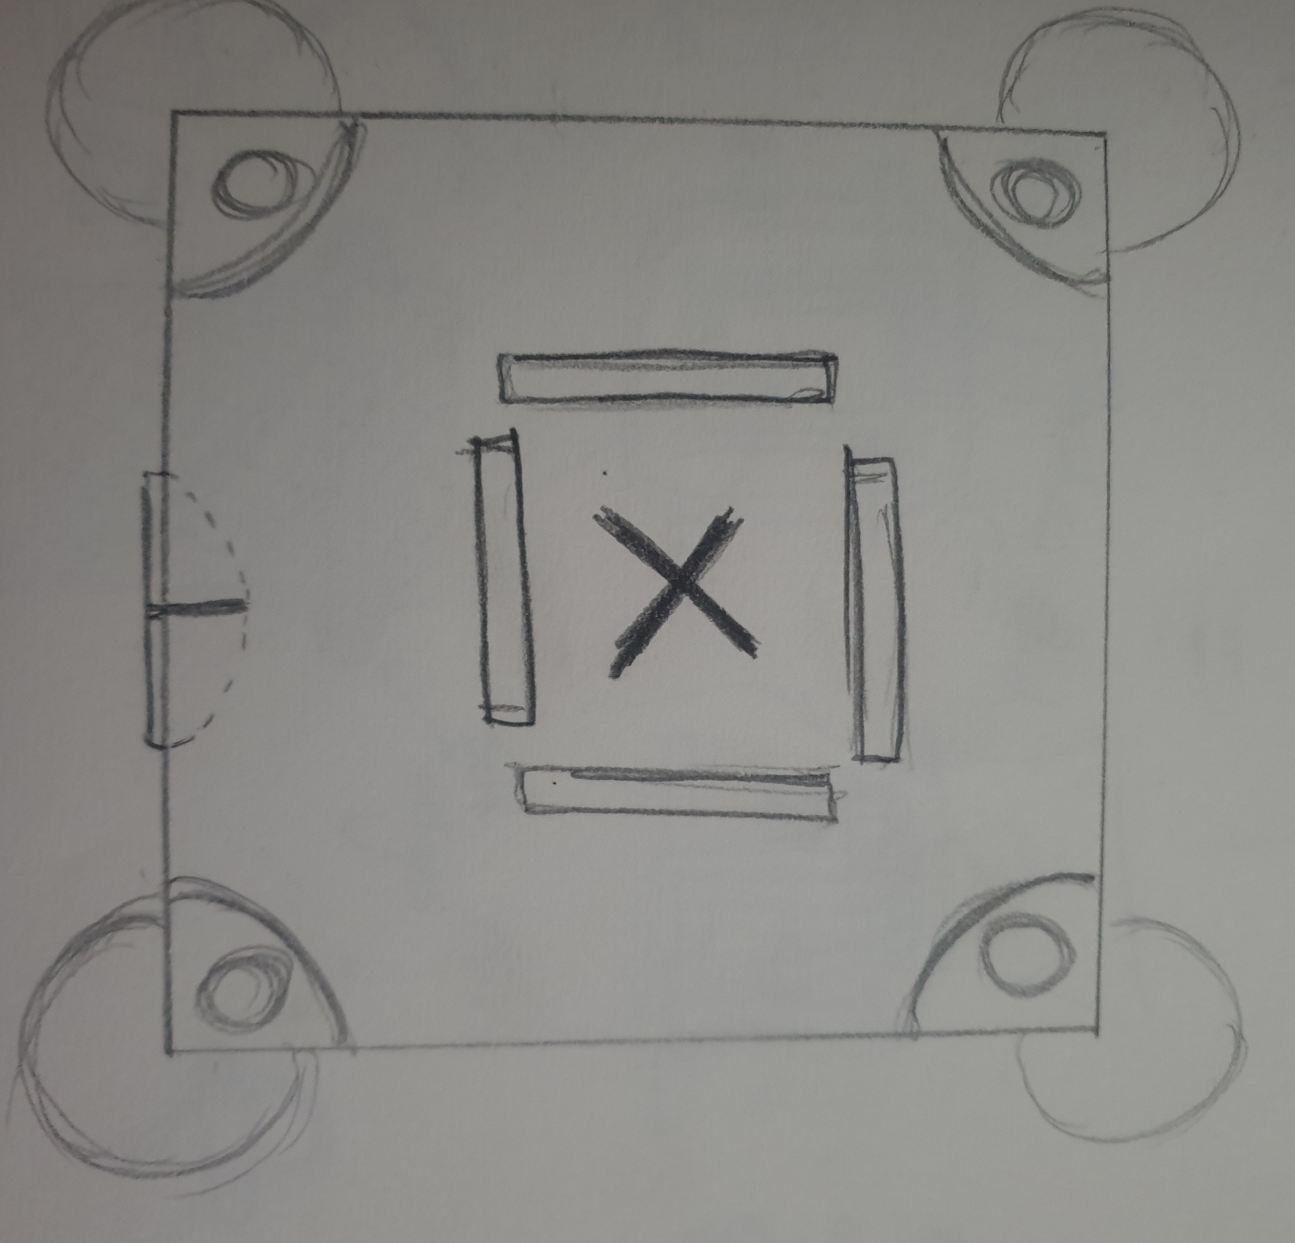

This is the map of the exhibition and the four rectangles are the artworks that are placed up in the wall. The corner of the walls has a circle and it represents as a stage lights that are surrounded in each corner, all four of the stage light are pointing directly on the "X" mark that has been spray painted onto the ground. It represents that X marks the spot in for which each of the art pieces is separated from because it hasn't been fixed as one or be resolved yet, so all the art pieces are finding its way to the spotlight.

Bibliography/ Reference

“Sugar cane.” “Tobacco.” “Gangsterism.” and “What is bwana.”
http://collection.whitney.org/object/453

“I cross out words so you will see them more; the fact that they are obscured makes you want to read them.”
http://collection.whitney.org/object/453

http://atucker98.blogspot.co.uk/2016/01/hollywood-africans.html

http://www.theartstory.org/artist-basquiat-jean-michel.htm
https://nmaahc.si.edu/blog-post/popular-and-pervasive-stereotypes-african-americans

https://en.wikipedia.org/wiki/Respect

https://www.mentalhelp.net/blogs/depression-and-positive-vs-negative-emotional-states/

https://www.time-to-change.org.uk/about-us/our-campaigns/challenging-stigma-young-people/impact-judgement

