

University of Wales Trinity of St David:
Ordnance Munitions and Explosives

Academic Year 2025 - 2026

Thomas Lumsden (2427105)

To what degree did the design of tanks change warfare from the first to the second world war?
Supervisor: Gareth Collet

Contents
Contents 2
List of Figures 3
Introduction 4
Tanks of WWI 4
Design 4
Impact 6
Limitations 6
Interwar Developments 7
Tanks of WWII 8
Designs 8
Impact 9
Analysis 9
Conclusions 9
References 10

List of Figures

Figure 1: Little Willie Tank………………………………………………………………………………………………5
Figure 2: Mark I Tank (Mother)…………………………………………………………………………………………6

Introduction
The tank was one of the most important military inventions of the twentieth century as it changed how armies broke through enemy defences and fought battles. In the First World War, tanks were introduced to solve the problem of trench warfare on the Western Front, which was a 400-plus mile, mostly static, combat zone stretching from the Swiss border to the North Sea. Soldiers would reside in trenches for weeks at a time dealing with mud, rats and trench foot, all while under fire from enemy snipers. This meant neither side could advance easily without heavy casualties. Traditional infantry tactics were no longer effective, so there was a need for a new technology which would introduce unseen forms of physics and OME on the battlefield, alongside new tactics that could break the defensive lines of the opposition.
Tanks were developed as a direct response to this problem, but early models were slow, unreliable, and often mechanically weak. By the Second World War, tank design had improved and tanks had become faster, better armed, better protected, and far more effective when used alongside other forces like infantry, artillery & aircraft support. The use of all these forces together is called a Blitzkrieg, where a surprise attack using quick, overwhelming forces is utilised to break through enemy lines. Using blitzkrieg tactics was the norm for Germany in early World War 2, in which tanks were the key component when it came to executing these tactics. The changing design of tanks between the First and Second World War will be examined to analyse the impact and summarise to what degree the improvements made influenced modern warfare.

Tanks of WWI
Trench warfare tactics made traditional infantry attacks extremely costly and often unsuccessful. Tanks were designed to cross difficult ground, protect crews from enemy fire and support infantry advances, with the hope that their armour and mobility would allow troops to finally break through enemy lines. However, the earliest tanks very heavy, slow, and prone to breaking down which limited their effectiveness on the battlefield but paved the way for more efficient and effective tank designs. The introduction of the tank and its earliest designs also completely changed how warfare would be fought throughout wars, which also influenced nations across the globe to adopt the same foundation for armoured machines.

Design
The first working tank design was a prototype made in the autumn of 1915, named ‘Little Willie’. This followed a failed design attempt of the ‘No. 1 Lincoln Machine’, which failed due to the tank tracks being too flat and poorly balanced, which resulted in slipping and jamming during turning and trench crossing. Little Willie was first ready for trials in December 1915, however while it proved that a tracked armoured vehicle was mechanically viable, it had a major flaw: its low track profile meant it struggled to climb the steep, muddy banks of German trenches [1]. Despite ‘Little Willie’ never seeing combat, it was still produced to feature all the foundational components of the armoured vehicles of that time, consisting of thick steel, gun turrets, all while being mobile.

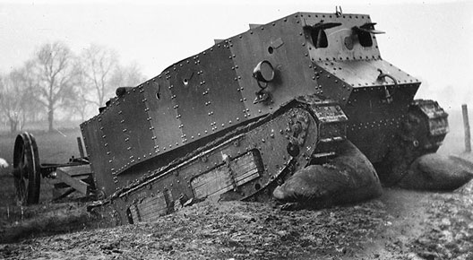
Figure 1: Little Willie Tank [2]

‘Little Willie’ was quickly replaced with a larger model with a new track design which circled the entire tank, this track design proved to be successful in conquering the previous issues Little Willie had encountered: The Mark I Tank (Big Willie) set the basis of all the early tanks which were used in battle, and was renamed Mother—'as it was the first of all tanks' [3].
The Mark I Tank consisted of a rhomboidal (diamond) shaped body which was manufactured with the use of riveted steel plates ranging from 6mm to 12mm thick [1]. This armour was initially effective against enemy fire, as German infantry bullets were unable to penetrate this armour. Despite this, the Germans then introduced the ‘K Bullet’ which was an armour piercing round with 7.92 × 57mm casing, which was made of steel with a hardness of at least 64 HRC (Rockwell Hardness Scale) designed specifically to penetrate the Mark I Tank [4]. These tanks also contained a 105-horsepower Foster-Daimler petrol engine [5], and a pair of large hydraulic wheels. The Mark I Tank differentiated between the male and female designs: The male was armed with two 6-pounder (57mm) naval guns to blast enemy pillboxes and artillery, plus three Hotchkiss machine guns, which were used as its primary close-defence and secondary armament [6]. The "Female" Tank was armed with five Vickers machine guns [7], with the purpose of them being designed to protect the Male tanks from being swarmed by enemy infantry.
The Mark I Tank required an incredible amount of coordination, as it took four crew members to steer the tank and an additional four to serve as gunners operating the armament. One primary driver who sat at the front, controlling the engine throttle, primary gearbox, and the steering tail wheels. The commander sat next to the driver and operated the main brakes, and two gearsmen were stationed at the back of the tank, one next to each track's secondary gearbox.

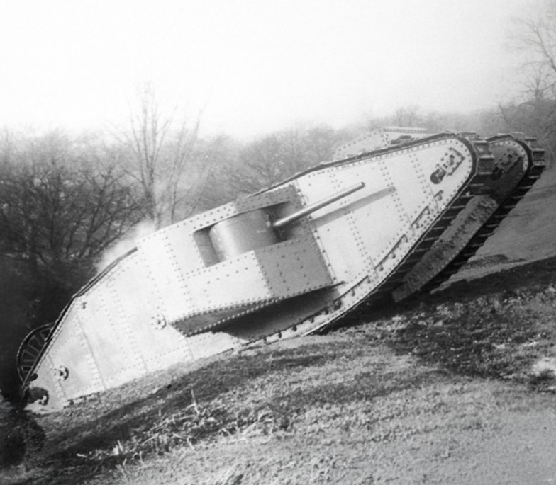
Figure 2: Mark I Tank (Mother) [8]

Impact
The tank proved that it was a vital psychological weapon and a tool for the initial tactical breakthrough of the stalemate on the Western Front and paved the way for a new age of battlefield warfare.
Their arrival on the battlefield shocked troops as they had no training or equipment to counter this new technology, and the rumour of their presence alone forced the enemy to completely rethink their defensive strategy. This showed that trench warfare could be challenged by new technology, which lead to the development of tanks for many different militaries. Tanks helped infantry in attacks by crushing wire and suppressing defenders, but they were not yet developed enough to be used as a key tool that would ultimately advance through open enemy territory and result in victory, as they came with many limitations. At this point in their development, their main value was as a supporting weapon to break through the enemies’ front lines, not as the centre of military strategy which would eventually win the war.

Limitations
Although the tanks of WW1 proved to be effective in breaking through the front lines and breaking the trench stalemate of the Western Front, and also showed that it was a clear technological advancement that they held over the opposition, they were heavily limited and this prevented them from becoming the decisive weapon military planners had hoped for.
Mechanical failure showed that the current Mark I design had developmental problems. Of the 49 original Mark I tanks deployed on the Western Front, 36 set off from the British line of departure, and only 27 made it as far as German forward positions, and six travelled as far as the secondary and tertiary objectives [9].
They were also extremely slow, with a maximum speed of 2mph [5]. The 105hp engine was located in the centre of the crew compartment. It was unshielded, creating a burn hazard and filled the space with deafening noise, intense heat, and carbon monoxide [10]. Temperatures inside could reach upwards of 50 °C, with men sometimes losing consciousness inside the tank but more often collapsing when getting out into fresh air.
Crews were forced to work in extremely difficult conditions. The ‘K Bullets’ that the Germans developed struck the hard steel of the tank, which resulted the hardened steel bullet perforating the body of the tank, causing frequent fragmentation of metal or molten lead to flake off the inside of the hull (spalling) which flew into the eyes and faces of the crew [11]. To counter this danger, crews were issued with leather and chainmail masks, which also helped to protect their heads against projections inside the tank [12].
Tanks also had poor visibility, as the crew relied on either slits or steel periscopes for vision, which meant they were unable to operate the tank without a clear understanding of the external environment. This meant the crew operating the tank had very limited situational awareness on the battlefield, which could have resulted in possible friendly fire, getting stranded in ditches, or getting lost. This paired with the fact that the Mark I Tanks lacked radios made it even harder communicate with friendly forces, which made cohesive attacks nearly impossible to coordinate.
Because of these problems, tanks could not move quickly or respond flexibly to changing battlefield conditions.

Interwar Developments
During the interwar period between WW1 and WW2, tank design improved significantly as engineers and military leaders learned from the initial experience during World War 1.
New designs were made and tested extensively through smaller regional wars in order to test and evaluate tank designs and change them accordingly to their regional effectiveness. One example of this was during the Spanish Civil War, where Spain was used as a proving ground for Germany's untested tank designs [13]. Although the number of tanks in action was comparatively small and they saw limited service, several conclusions were reached that aided the development of Blitzkrieg. Tanks became more reliable, faster, and more practical for real battlefield use [13]. Suspensions improved, engines became significantly more reliable and fuel efficient, tank armour utilised new designs which consisted of thicker steel and used welding over riveting, which gave better protection to both the crew and the tank itself without making them impossibly heavy. One of the most important developments was the introduction of radios, which would allow commanders to communicate more effectively and coordinate attacks. At the same time, military thinkers began to see tanks not just as support weapons, but as tools for rapid movement and breakthrough operations.

Tanks of WWII
By the time of the Second World War, tanks had become more advanced and central to military operations. Vehicles such as the German Panzer series and the Soviet T-34 were much more effective than WW1 tanks because they combined speed, firepower, and protection. They could move across rough terrain more easily, fire more accurately, and survive longer in combat [14]. Tanks were no longer simply experimental machines; they were essential battlefield weapons used in large numbers and in coordinated offensives.

Designs
WW2 tank design showed major improvements in almost every area. Tanks had better engines, improved suspension systems, stronger armour, and more powerful guns.
The design improvement that proved the most effective and influential was the introduction of sloped armour. Angled metal was used in the armour design, which increased the chance of an incoming shell deflecting off rather than penetrating into the steel. Tanks like the T-34 utilised this, making their protection more effective without greatly increasing weight [7]. The overall thickness of the steel of WW2 tanks was increased to about 50mm-100mm. For comparison, a 50mm plate angled at 60 degrees has the same effectiveness as a 100mm vertical plate. Panzer III tanks were designed to have an extremely hard outer layer of steel armour which would shatter incoming shells, which was backed by a softer layer of steel to absorb the kinetic energy without cracking, which allowed tanks to advance even under enemy fire.
WW1 tanks were held together by rivets whereas WW2 tanks consisted of welded hulls. This eliminated “rivet popping” which is when one of the pins would fire out of the inside of the hull and posed a deadly threat to the crew.
The tanks were fitted with longer barrelled, high velocity guns. These used massive high-velocity tank barrels paired with a chemical propellant to fire solid steel kinetic penetrators (projectiles that utilise speed and mass over explosive power to destroy armour) at over 3000 feet/s. They were designed to penetrate through 4-6 inches of steel from as far as a mile away. The guns were fitted with telescopic sights with 2-5 times magnification, and stadiametric reticles and crosshairs which helped calculate distance. The use of these reticles helped gunners improve shot accuracy, letting them know the exact distance of their target, allowing for an easier determination of how far their bullet would drop in order to hit the target.
WW2 also introduces tanks with a fitted 3-man turret which consisted of a commander, gunner and loader. This allowed for some tanks to fire 15-20 rounds per minute in short bursts. The range of the guns also increased massively, hitting targets up to 2000 yards away, allowing for armour piercing rounds to travel the intended distance without losing kinetic energy needed to penetrate the targets armour. These advances made tanks faster, more dependable, and more deadly than their WW1 predecessors.

Impact
The impact of improved tank design on WW2 warfare was significant. Tanks could now be used for to quickly infiltrate enemy lines while also being able to continue for deep attacks, modern tanks also took advantage of weaknesses in enemy lines. This made Blitzkrieg tactics possible; where tanks, infantry, artillery and aircraft worked together to overwhelm opponents quickly. Instead of slowly grinding through trenches, armies could now move through openings, surround enemy forces, and disrupt supply lines. Tank warfare had become a major part of modern mobile warfare.

Analysis
The degree to how tanks design has evolved and proved effective is clear and significant. The impact of evolving tank design has influenced many warfare outcomes and plays a major role as to how warfare is fought in the modern day. For example, the use of tanks in the recent Russia-Ukraine war that is ongoing has been a significant and essential component to break initial deadlocks and push through enemy front lines. Although this use of tanks proves effective, their use beyond that isn’t worth the risk, as the recent use of drones in modern warfare has shown that tanks aren’t needed past being hidden, indirect artillery or mobile snipers.
The use of drones in the conflicts of today is becoming increasingly more common and effective, allowing for cost effective and precise targeting, all while keeping human operators out of combat. Some inexpensive, mass-produced drones can accurately destroy or disable multi-million-valued military assets.

Conclusion
In conclusion, the key developments in tank design between the two world wars was significant but gradual, as tank design slowly developed from early WW1 until WW2, where different designs were constantly being tested and utilised. Tank design only kept improving over time, eventually proving to be the defining factor in early wars until modern day. With these developments came improved speed, reliability, armour, firepower, suspension, and communication. These changes made tanks far more effective and allowed military planners to use them in new ways. As a result, tanks became a key part of Blitzkrieg and other forms of modern warfare. Their development helped transform military strategy from static trench fighting to fast, coordinated operations.
Overall, the evolution of tanks changed how warfare has been fought throughout history to a significant degree, and it was the ever-developing design of tanks that allowed them to be used as a significant supporting role in the outcome of many past conflicts, and has pioneered how warfare of the modern day is fought, proving to be a defining piece of technology that shaped the world we live in till this day.
References
[1] C. Ellis, P. Chamberlain, “Tanks Marks I to V”, Profile Publishing, Vol 3, 1969
[2] D. Fletcher, “Little Willie”, The Tank Museum, Accessed: 31/05/2026, [Online], Available: https://tankmuseum.org/little-willie/
[3] T. Tate, “From little Willie to mother: The tank and the First World War”, Women: A Cultural Review, 8:1, 48-64, 1997
[4] A. G. Kolmakov, I. O. Bannykh, V. I. Antipov, L. V. Vinogradov, M. Sevostyanov, “Materials for bullet core”, Deformation and Fracture of Materials, 2020
[5] D. Fletcher, “British Mark I Tank 1916”, New Vanguard 100: Osprey Publishing, 2004
[6] J. Glanfield , “The Devil's Chariots: The Birth and Secret Battles of the First Tanks”, Sutton Publishing, 2001
[7] D. Brown (2020). ““NEVER MIND THE HEAT, NEVER MIND THE NOISE”: UNDERSTANDING THE WORKING CONDITIONS OF TANK CREWS DURING THE FIRST WORLD WAR”, Journal of the Society for Army Historical Research, 98(393), 175–194, 2020
[8] Sgt. A Cherrett, “The Hunt for Mother”, The Tank Museum, Accessed: 31/05/2026, [Online], Available: https://tankmuseum.org/article/the-hunt-for-mother
[9] “The Dawn of the Armored Fighting Vehicle”, Worldview Stratfor, Sep 2016. Accessed 26 May 2026, [Online]. Available: https://worldview.stratfor.com/article/dawn-armored-fighting-vehicle
[10] Major-General Sir W. G Macpherson, Major-General Sir W. P. Herringham, Colonel T.R. Elliott, Lieutenant-Colonel A. Balfour, “Medical Services: Diseases of the War”, History of the Great War. Vol. II, p. 527-529, 1923
[11] H, Chisholm, "Armour Plate", Encyclopædia Britannica, London & New York: The Encyclopædia Britannica Company, Vol. 30 (12th ed.). pp. 204–205, 1922
[12] "Collections: Helmet, leather tank helmet", Imperial War Museum, Accessed: 26 May 2026. [Online] Available: https://www.iwm.org.uk/collections/item/object/30015952
[13] I. Westwell, “Condor Legion: The Wehrmacht’s Training Ground”, Spearhead Series No.15, Compendium Publishing, pp. 89, 2004
[14] “The Red Army’s T-34 Tank: The Eastern Front and Beyond” , Accessed: 22 May 2026. [Online]. Available: https://warfarehistorynetwork.com/article/the-red-armys-t-34-tank-the-eastern-front-and-beyond/

