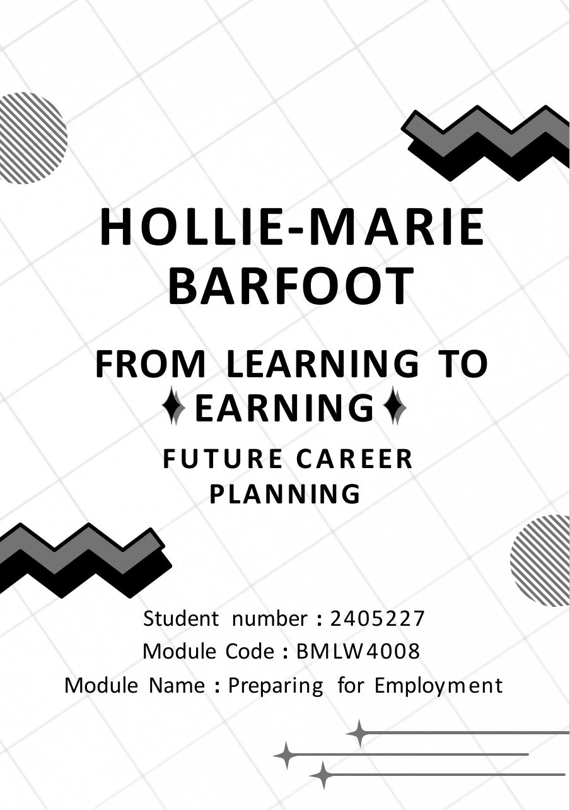

Table of Contents
Success in the Workplace 3
CV – 5
Covering Letter – 6
LinkedIn Profile – 7
Reference List – 8

Success in the Workplace

A mix of reaching professional goals, keeping a good outlook, and cultivating solid relationships are necessary for success in the job. It all comes down to continuously producing excellent work, working well with others, and aggressively looking for chances to advance (Ennaglobal, 2023). Some tips for becoming successful in the workplace include meeting deadlines, being a team player and understanding your employer’s expectations. Be sure you are aware of the culture of your organisation. Influential factors include your working relationship with your manager or supervisor and your cultural fit with the company itself. Meet deadlines every time, understanding the potential consequences of missing goals. Communicate with your supervisor well in advance of a deadline if you think you will not be able to finish a task on time. You should also always offer at least one solution to show that you can solve problems. Companies value those who are prepared to sacrifice their own goals for the departments or company’s overall aims. There are others who can address problems for a certain work or project, and you should be self-aware enough to involve the team when necessary. Being a team player gets you noticed, and it is one of the most valuable talents an employee can have (Hays AU, 2025). Continuing, here is a more in-depth investigation into skills needed to become successful in the workplace, supplying the potential employer with an experienced CV and covering letter is essential to enhancing your chances of being selected for that role. A cover letter and a CV is your chance to provide the recruiter a strong first impression of you as an employee prior to an interview. It is your opportunity to show an employer why you are a good fit for the position by summarising your background, skills, and values. By outlining your motivation for applying for that specific position, it also gives an employer more information about your existing circumstances. For instance, you can be an entry-level worker hoping to obtain experience in a formal workplace. Alternatively, you might be leaving your current employer to pursue a completely different career path or a higher-level position at a different company. Regardless of your motivations for applying, a strong CV and cover letter allow prospective employer to learn more about you and your potential contributions to the business (Indeed, 2025). According to Carnahan (2023), based on the report Carnahan released on for Harvard Business School, she implied that the ‘first 90 days mattered’. Within this report, she dives into each step as to why the first 90 days matter. According to research, an employee's success, longevity, and contribution to the firm are mostly decided by their first ninety days on the job. Therefore, it is essential that the organisation create and implement a successful onboarding program in addition to the employee creating and implementing a deliberate plan. In the end, this collaborative strategy reduces risk and maximises success while fostering and enhancing connections and communicating transparency. Introducing new hires to important stakeholders, preparing staff for success by creating an internal interview guide for discussions, and developing a 90-day plan divided into three 30-day increments to meet important aims and goals are all crucial components of a successful onboarding process for the employer. Something that is repeatedly mentioned throughout being successful in the workplace is to keep asking questions, you can predict having questions about your role and duties when you first start a job. On the other hand, you might cease asking questions over a prolonged period, such as years, in a position. Find out what your peers are working on or about other aspects of the company. You will prove your involvement with your coworkers and your awareness of business-wide developments by doing this. Although it might not have an impact on your everyday tasks, having a more comprehensive understanding of the business could be useful in meetings or group projects (Page, 2023). Professional abilities and personal qualities combine to create success in the job. Emotional intelligence, flexibility, explicit communication, and a dedication to lifelong learning are important components. People with a growth mentality and resilience are more likely to succeed in dynamic situations Dweck (2006). When personal values and corporate goals are in line, motivation and job satisfaction are increased. According to Goleman (1998), employee achievement is further supported by strong leadership and a positive workplace culture that values feedback and appreciation. A competitive edge is supported in the fast-paced, digital economy of today by those who make upscaling investments and keep an open mind. Success in the job is decided by fulfilment, growth, and significant contributions to the aims of a company rather than just by promotions or pay.

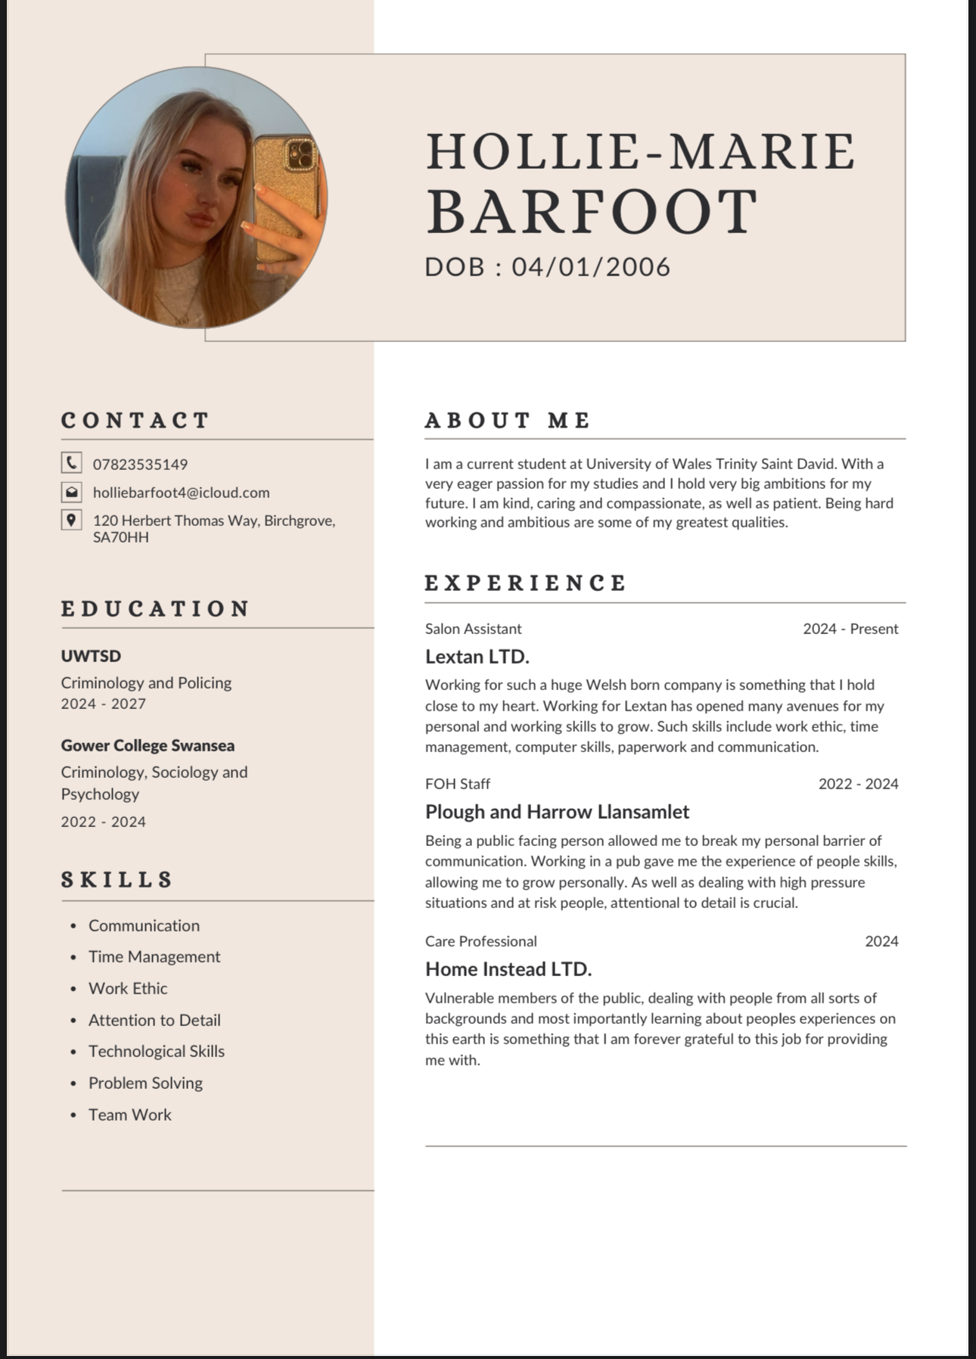
CV

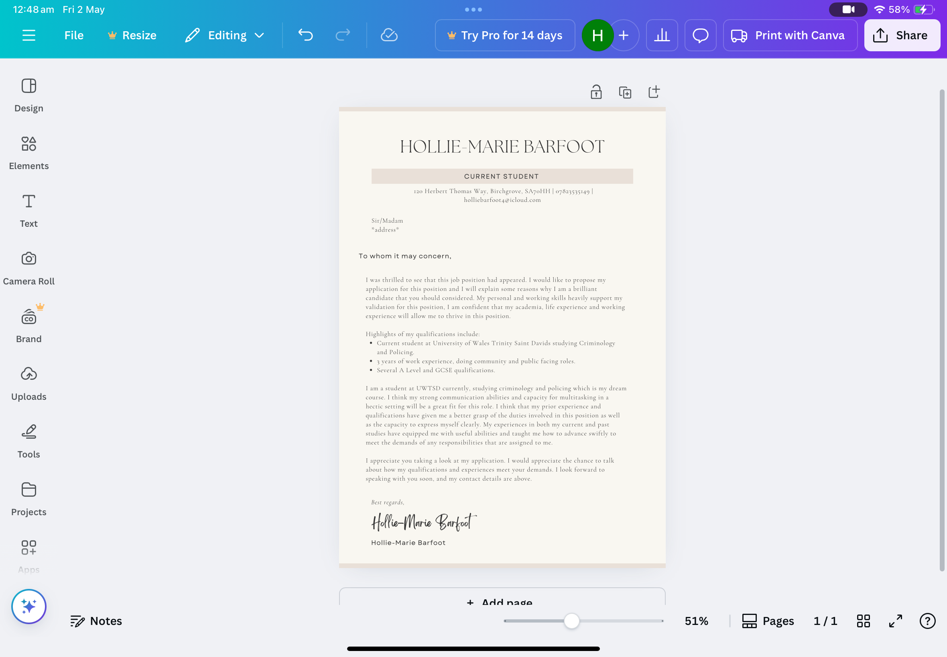
Covering Letter

LinkedIn Profile

https://www.linkedin.com/in/hollie-marie-barfoot-0681ba363?utm_source=share&utm_campaign=share_via&utm_content=profile&utm_medium=ios_app

Reference List

Carnahan, R. (2023) Tackle the first 90 days of your next role: a 5-step process for success on the job - Alumni - Harvard Business School. Available at: https://www.alumni.hbs.edu/careers/blog/post/tackle-the-first-90-days-of-your-next-role-a-5-step-process-for-success-on-the-job (Accessed: 15 April 2025).

Dweck, C.S.(2006) Mindset: The new psychology of success. New York: Random House. (Accessed: 16 April 2025).

Ennaglobal (2023) How to answer the ‘What does success look like to you?’ job interview question. Available at: https://enna.org/how-to-answer-the-what-does-success-look-like-to-you-job-interview-question/#:\~:text=In%20a%20professional%20setting%2C%20it's,and%20seeking%20opportunities%20to%20grow (Accessed: 14 April 2025).

Goleman, D. (1998) Working with emotional intelligence. New York: Bantam Books. (Accessed: 16 April 2025).

Hays (2025) Tips on how to be successful at work. Available at: https://www.hays.com.au/career-advice/career-development/tips-to-be-more-successful-at-work (Accessed: 14 April 2025).

Indeed (2025) How important is a cover letter. Available at: https://uk.indeed.com/career-advice/cvs-cover-letters/how-important-is-a-cover-letter (Accessed: 15 April 2025).

Page, M. (2023) Six top tips on how to succeed at work. Available at: https://www.michaelpage.co.uk/advice/career-advice/growing-your-career/six-top-tips-how-succeed-work (Accessed: 16 April 2025).

