Murray Bruce - Creative Diary.
2 March - Spoke to Matt for the first time. Read him the notes I have for my "Guilty" story and suggested that I could develop it for the 5,000 word submission. As I read it aloud I realised that the story I write now will not be the story I had imagined I was outlining back in October. Matt suggested I bullet point what I was setting out to do, or something like that. Based on the notes I added in preparation for today's meeting, that would be.
- Inspired by Richard Brautigan's "Sombrero Fallout", explore using interventions by an omniscient narrator to describe the life/problems/quirks of a fictional writer of the "Guilty" story, which is a first person narrative by a heartbroken alien from another galaxy, who awaits trial for having failed to commit suicide, and who is obsessed with observing the quirks/lives of the people of the UK. Sounds clunky, put like that, but I'm hopeful.
- Themes of prejudice, sectarianism/racism, gender fluid sexuality, and guilt. Realities, non-judgemental observations.
- Mistakes, mistaken identities, misunderstanding, elements of farce.
- Magic Realism/folk tales - explore the way Mariana Enriques tells a story, without the need for set-ups and happy endings, or resolution.
- Masking/disguises/shape-shifting/absurdity.
Ordered Slaughterhouse 5 and 5 other Kurt Vonnegut books, arriving tomorrow.
3 March - On waking, I had an idea for how to present/approach this piece. 5,000 words might not be not enough to use chapters to differentiate narration of the writer's experiences and the yarn/story, and I wanted to not slavishly follow the Sombrero Fallout template. I also want to play around with the passage of time in the piece. So; I'm going to try to make Eisor's story a single dream, narrated by them, woken from and re-entered on the dreamer falling back asleep, and italicise the omniscient present-moment-narration of the dreamer's life/thoughts to visually separate it. This allows the compression of real-time, the passage of dream-time and narration time to separate and, possibly, solves the problem of multiple narrators. Fingers crossed emoji.
Wrote for an hour, a cat and a flea have joined the story as characters and I have had an idea for the ending = ambiguous waking from a dream. Needs developing but handy to have something notional to work toward at this early stage. Word count is 750. Incorporates a trimmed down version of original story concept/intro.
4 March - Further thoughts/notes = CAT is deejay (my first cat) - sweep/little undertaker story happened yesterday and still peeved (my memory of a Polish chimney sweep called ???),
FLEA is named Rosie (Eisor is Rosie spelt backwards. Rosie was my maternal grandmother's maiden name.) Pregnant (research!?). Flea speaks in poetics. Cat is a joker.

Researched spacetime continuum, life cycle of the flea and the East Ham chimney sweep Andre Du Pre (once I'd remembered his name, as I last saw him in 1994).

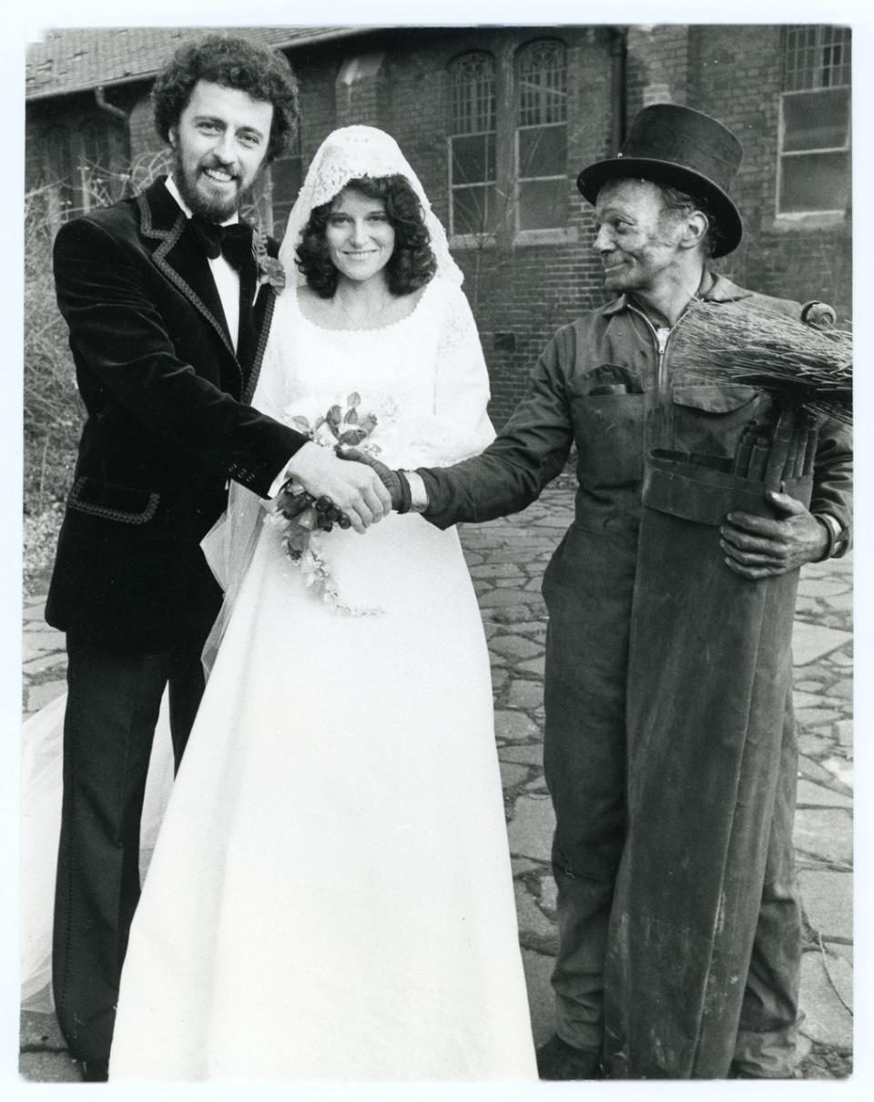

Andre's the guy on the right, doing his best to bring luck to newlyweds in 1978.

5 March - I didn't write very much yesterday. The new characters, the research rabbit holes and how I'm going to present and resolve whatever the fuck I'm trying to do here kept pinballing around my head. Seems to be heading towards a dream-within-a-dream-within-a... but I also want to keep it simple. The song I'm currently working on is the very first song I ever recorded, 1982 revisited in 2024 and getting down to an essence in 2026. So that is feeding in - trying to avoid the writing going off into some baroque nightmare. I'm good with pattern and structure, wanting to keep it simple, but also fuck about with the passage of time and get as experimental as I can with the dream-spilling-into-dream, is the whole thing a dream (well, d'uh) but still get a few laughs in there.

Tried to read the academic paper on humour. Fuck. Horrorshow. I didn't really give it a chance, because I kept hearing Ken Dodd's voice.

"Freud's theory was that when a joke opens a window and all those bats and bogeymen fly out, you get a marvellous feeling of relief and elation. The trouble with Freud is that he never had to play the old Glasgow Empire on a Saturday night after Rangers and Celtic had both lost."

All I want to do today is write as much as I can, without too much attention to structure/logic/quality and all that shit, in the hope that I can see where it might be going.

Got an Oblique Strategies prompt. "Be Dirty". OK. Got past the 1,000 words count on only one coffee.

6 March - Friday. Slow start to the day. Word count 1,200. Planning to emphasise Eisor's story (the dream) in this morning's writing. Oh, and try to expand on my idea that the flea should express herself through poetry. And maybe see if a more chaptered approach might work after all, initially/simply as an aid to writing the piece, contradicting my first thoughts.

But first, another coffee. Oh, and also been thinking about Mariana Enriques and her way of story-telling.

OK. Changed the layout to use chapter/page breaks and given the parts a title. Might be making more sense but seem to be getting further away from what I wanted to say, in the beginning. Not that that's a bad thing, but I'm feeling a bit of overwhelm and drained of ideas today.

Other things happening today, that are going to take my time. Good things.

7 March - day off.

8 March - eye trouble. Has both cataracts done in January, so kinda freaked when I woke with a throbbing, bloodshot, painful left eye. As I'd gone private, I called the hospital, for advice. They said they'd call the surgeon and he'd call me back. Yeah, right. Within an hour he called, from his skiing holiday in Finland! Sent him photos and he called back, reassured me (probably conjunctivitis or a scratch) and I'm trying colloidal silver, which seems to be helping. Took until mid-afternoon for me to feel up to trying to write because I'm now worried that I don't have much story and all my effort's gone into structuring the thing.

Cut a bit of stuff and then felt better about it. Word count over 1400 now. Leave it at that until I've had some feedback.

9 March - encouraged by Matt's feedback. Had to head to Lampeter after mmeeting.

Jude and I are guinea pigs for the guided tour of the old Lampeter building by Nicky Hammond. Brilliant. Really helpful for the Lampeter story I'm working on.

Started feeling anxious when I got back. Had an aspergian anxious meltdown, wrote a very melancholy tune on an acoustic guitar, went to bed late and slept badly.

10 March - Feeling better but devoid of creative energy, so I read The Vampyre novella by John Polidori from 1819. Had the idea that it would help with creating Rosie the poetic blood-sucking flea character. Not sure how, yet, but glad that I read it. Also read a half dozen of the Lampeter archivist pamphlets.

Scribbled some plot notes and intentions for the Guilty story.

Reworked the melancholy tune for the electric guitar and started thinking about writing a poem to sit over it. Calling it Buddy.

11 March - on the way home from shopping in the morning I started the poem. Finished it by 3pm and dubbed a rough version over last night's phone recording.

A strong squeeze to my shoulder stops me.
I turn to a grinning face.
"Hey Buddy!"

Bald, bespectacled, bearded, and bubbling.
Hiya. Yeah...

My snapped smile says what, who-the-fuck?
I hope not.
"We were just talking about you yesterday, we were."

My first and only thought was why?
"When was it?"
Wondering that myself.

But I don't know who,
and I don't know where.
When is the least of my worries.
Buddy. Buddy. Buddy.

"We always wondered what happened to you."
Why? Thanks, I think.

"When are you going to come and see us again, buddy?"
Whenever suits.
"She misses you, you know?"
Aye? Yeah. I. I...

Does she?
"Soon, huh?"
Soon.

But I don't know you
so, I don't know her.
When is the least of my worries.
Buddy.

Another coffee then back to writing the Guilty story.
Got back into it, made the changes Matt suggested and tightened the text. Reduced redundancy and repetition.
Wrote Rosie the flea's first poem. Been worrying about that, but I hear her voice now.
Added more of the alien's story.
Can see where I'll be writing tomorrow.

12 March - Writing an instrumental in DADGAD tuning in the early hours - I came out to the studio to collect my phone at midnight and was still there at two - calling it You Chose Me, as there is a lyric idea forming around those words.

Thursday morning, blowing a gale - retuned my wee acoustic tenor guitar to CGDG (higher pitched version of the Irish Bouzouki tuning) and wrote an instrumental called Cwmtydu.

Back to the Guilty story, after lunch. More of Eisor's story. Expanding - sketch out/plan the development with chapter headings and a brief outline/thoughts. Word count over 1,800.

Friday 13 March - I've had a rushing flood of ideas that are about the shape and purpose of this story. It's got to have some of that, I think. Used my phone to record them before they flow away downstream. Try to incorporate and expand them in the text. Before going to the gym to continue rehab' on my hip replacement.

Went well. Now over 2,500 words. Flowed and I have a clear idea where I will go next. Daoism and Brigadoon.

Gym time.

Had a lot of ideas for fragments, new chapters, and even an indication of how it's going to end. All of which I've made voice notes of and will incorporate into the story on Sunday.

14 March - Day off, sort of. More voice notes of dialogue, tangents and dirty jokes. Will go through all of the voice notes tomorrow, before sending what I have to Matt.

15 March - Sunday. Breakfast, take coffee, my voice notes and various scribbled scraps to the studio. Write, meditate, eat some more, coffee, write some more.

Stopped writing a half past four. Word count is north of 4,200. Will print it off to read. It flowed. Poured out of me. May only make sense to me. If at all. Need to start thinking about how to use the remaining 800 words to, eh...

Read through before sending to Matt, made a few clarifying changes and added page numbers.

Title? "Guilty" turns out to be the name of the first chapter. OK to stick with it?

16 March - Online with Matt.
Had some DIY to do in my studio.
Started feeling unwell, later (unconnected to DIY).
Wrote a lyric for a new song. Made a rough recording.

17 March - Saw a GP. Infection = antibiotics. Felt shite.
Made a few voice notes for the story.
Worked on lyric and tried another version.

18 March - Still feeling shite. Podiatrist in the morning and Trauma & Orthopaedics follow up at Glangwili Hospital in afternoon on hip replacement.
Finished the lyric, probably.

You’re still a punk at heart

Did you judge me neighbour? You were pissed yourself.
Would you walk a country mile in my shoes?
Hold a stolen stop sign high above your head.
Answer on a postcard, or please yourself.

Daoist in retirement. Hoping for abandonment.
Frozen in a dream time. You’re still a punk at heart.

You got far away from home to live the life you wanted.
Had to be a rebel. While everyone got old.
Left life in a city with parks that have pagodas.
Moved on to a village that doesn’t have a shop.

Daoist in retirement. Faking up enlightenment.
Frozen in a dream time. You’re still a punk at heart.

Daoist in retirement. Ventriloquism paid the rent.
Frozen in a dream time. You’re still a punk at heart.

Sexy times and laughing forever.
Not giving a fuck in all kinds of weather.
Be honest and trusted.
Not caught out and busted.

Sleepy time’s gone North

Any time was party time - Now party time is borderline.
It was what it is - now, only more so.
The groove under your nation? Survival. Exploitation.
Party time and sleepy time went North.

Daoist in retirement. A sobering experiment.
Frozen in a dream time. You’re still a punk at heart.

Daoist in retirement. A pessimistic sacrament.
Frozen in a dream time. You’re still a punk at heart.

More thoughts and made more notes for Guilty story. Tried three different tunings on one of my guitars. Couldn't work with any of them, all sounded horrible. Back in standard tuning, guitar sounds good again.

19 March - Bad night. Nightmares/obsessing loops.
Sat down at 9am to work through notes and, hopefully, write.
Two and a half hours later and I'm getting near a first draft. 4,936 words. Tried to make it a bit clearer who The Dreamer is. Solve that mystery, possibly.

Printed it off to try reading aloud.

Remembered that I dreamt of a guitar tuning last night, tried it, sounds fantastic, wrote two new pieces. FACFCD, turns out to be Open F Major Sixth. Nice.

20 March - Gym in the morning. Has some more ideas for story - WD-40 & Pluriverse.

21 March - Day off.

22 March - working up a first draft to send Matt. Reading aloud. Making changes, as I get a feel for the story, in my mouth.

Sticking with the word "naught" in Rosie's first poem. Feels right, in her voice. That would be her inner voice.

I do not have the space, time (see what I did there?) or knowledge to even begin introducing the idea of The Pluriverse, at this late stage, so just a quick mention. Save for another yarn.
The WD-40 idea should be insertable (sniggers).

OK, now north of 5,100 words and I think I am happy enough with it to call First Draft. Gonnie do a bit o' gairdenin', and have a wee think, before sending it to Matt for discussion tomorrow.

23 March - first draft well received. Couple of interesting things to ponder before submitting.
- Is it "this life" or "this story" etc?
- What the hell am I talking about when Eisor predicts a supernova - love or a literal supernova...

Hoping to get it in by the due date without needing a DD.

24 March - Happy Birthday to me.

25 March - Gardened in the morning. Sat down to write after lunch.

Point 1 - I decided it was too early in the story to be considering what "this" is. Even to raise the possibility of a "this". Just tell the story, so initially tried

The Dreamer is startled awake. Like every morning this year, they are on the wrong side of the bed. The side reserved for the person...

but changed the punctuation and went for new paragraphs to convey that the dreamer is having frequent crazy dreams and better establish the sense of loss/incompleteness.

The Dreamer is startled awake. Like every morning this year.

They are on the wrong side of the bed. The side reserved for the person who will one day complete them for the first time in a long and troubled life.
The dim light...

With a view, however, to hinting at what "this" is, I also changed the beginning of the next section from

The pod hadn't been tested. No need...

to

Ah, you're back. See, the thing is, the pod hadn't been tested. No need...

Eisor addressing The Dreamer directly, back in the dream. I'm hoping that's not too clumsy.

Point 2 - The Supernova thing. I want to convey that The Dreamer has survived some kind of bad love scenario and a true love is on the way, foretold by Eisor, in a dream, foretold/hoped for/willed by the dreamers subconscious.

Changed

What did you call love, child of Tam? The universal faither. Surely you're gled that you escaped, alive and alone?

to

What did you call love, child of Tam? The universal faither. Surely you're gled that you escaped that love, alive and alone?
and, finally

Save yourself, Tam's bairn. Like me, you loved at the limits of your strength. But you know, and I know you know, that there is a light that approaches.
You've felt the tingle of the first few particles from thon supernova and soon the light from its explosion will engulf you.

becomes

Save yourself, Tam's bairn.
Like me, you have loved at the limits of your strength. But you know, and I know you know, that there's a never-before-and-forever-after blast of love approaching. Like your very own supernova.
You've felt the tingle of the first few particles passing through, haven't you? Soon the light will engulf you.
I think that work's better and is an improved link to the rest of this section.
Print it off, to read aloud again.
26 Mar - Going to submit today. Reading aloud resulted in more trimming of repetition, tidying/clarifying expression, and tightening up/expanding the use of Scots.
But you know, and I know you know, that there's a never-before-and-forever-after blast of love approaching. Like your very own supernova.
became
Don't you know that there's a never-before-and-forever-after blast of love approaching? Your very own supernova.
I think it's as good as it's going to get, for now. As close to what I'd hoped to express. 5,149 words. Going to hit submit.
I'm also not going to re-read this diary before I submit it. It was written in real-time, reflects whatever was going on, and I see no point in now attempting to edit it. Can't be ersed.
I've enjoyed this module. The writing. A lot. I write something - music, song lyrics, poetry, story ideas and research - every day and it's been good to get a feel for expanding my creativity into a larger work. I've got a couple of large projects I'm researching and will be expanding one of them (I have the first few chapters, sketchy plot outline, and an ending), as well as getting down to recording a new batch of music to put online.

