Construction Materials - ACBA4016:
Assignment 1:
Case Study of a Steel Frame Structure and a Concrete Frame Structure: The Empire State Building, New York, USA, compared to The Hatsuse Mita Apartments, Minato City, Japan

Prepared by: Morgan Owens
For Review by: Alan Nantel
Contents
Introduction 2
Part A: Using your own research, select two existing habitable buildings from around the world, one of Concrete frame, one of Steel frame and report briefly on their original design and method of construction. 2
Part B: The case studies should then analyse the framing material of each building in the following specific areas. 4
Part C). Produce your own summative comparison of the advantages and dis-advantages of the two framing materials, in tabular format. 9
References 10

Introduction
Construction materials are fundamental to the design, performance, intended use, and sustainability of buildings. This assignment examines two types of framing material structures: a concrete frame structure and a steel frame structure. In this report, the aim is to analyse the Hatsuse Mita Apartments in Japan, which has been selected as the concrete frame structure, and the Empire State Building in New York City, which has been selected as the steel frame example. By comparing these two structures, the aim is to first understand the design and the method of construction for both structures and then investigate the strengths, durability, environmental impact, and adaptability of the materials used to construct each of them.

Part A: Using your own research, select two existing habitable buildings from around the world, one of Concrete frame, one of Steel frame and report briefly on their original design and method of construction.

Hatsuse Mita Apartments
The Design: The Hatsuse Mita Apartments, my chosen Concrete Frame structure, designed by the architectural firm ihrmk, was completed in 2019 in Minato City, Japan. The design concept revolves around the belief of flexibility and adaptability, allowing the owner's family to move between units as and/or when their needs change. Each unit has a unique floor plan, and the building features a mix of private residential and communal spaces organized in a non-hierarchical manner.
(Daily, 2021).
(architectures.jidipi.com, 2021)

The Construction: The structure is built with 310mm square columns placed 1350mm apart, creating an intermediate structural scale that blends with the surrounding environment. The central feature is called the "Meguri-doma," it is a covered stairwell and common-use corridor that connects all levels and allows for natural light and ventilation for the inhabitants. The design incorporates open and inner terraces to create a fluid indoor-outdoor living experience.
(Daily, 2021).
(architectures.jidipi.com, 2021)

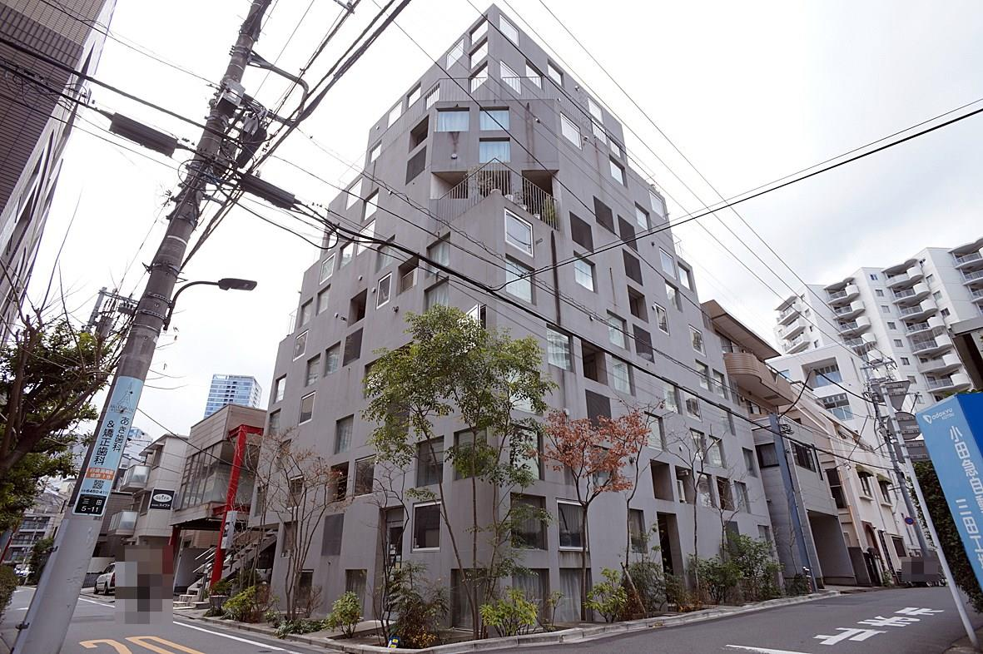
(Homes, n.d.)

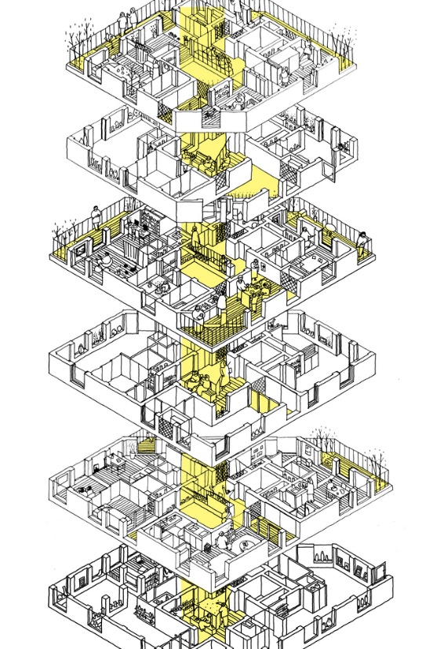

(Abdel, 2021)

Empire State Building
The Design: The Empire State Building, designed by the architectural firm Shreve, Lamb & Harmon, was completed in 1931 in New York City, USA. The design is influenced by the Art Deco style, characterized by its sleek, symmetrical lines and ornamental elements. The building is 1,454 feet (443.2 meters) tall, with its antenna spire, making it one of the most iconic skyscrapers in the world.

The building's design utilizes setbacks at various levels, which not only enhance its aesthetic appeal but also provide a functional purpose by reducing wind pressure on the structure. The facade is composed of limestone, granite, and aluminium, giving it a distinctive appearance that has become synonymous with New York City's skyline.

The Construction: Construction of the Empire State Building began on March 17, 1930, and was completed in just over a year, opening on May 1, 1931. The building's structural system is a steel frame, which was revolutionary at the time. This steel frame enabled rapid construction and provided the necessary strength to support the building's height. The steel columns and beams were prefabricated and assembled on-site, creating a robust skeleton that supports the entire structure.

The construction process was incredibly fast, with an average of 4.5 floors completed per week. This speed was achieved through meticulous planning and coordination, as well as the use of advanced construction techniques. The building's foundation was excavated to a height of fifty-five feet, and the steel frame was constructed using cranes and derricks.

The exterior of the building was clad in limestone and granite, with spandrels between the windows. The lobby has an Art Deco design with marble walls and floors, and a mural depicting the building as the center of the universe. The construction was managed by Starrett Brothers and Eken, who ensured that the project was completed on time and within budget.

(Website, n.d.)
(Website, n.d.)
(Website, n.d.)

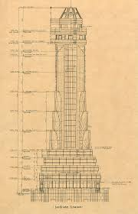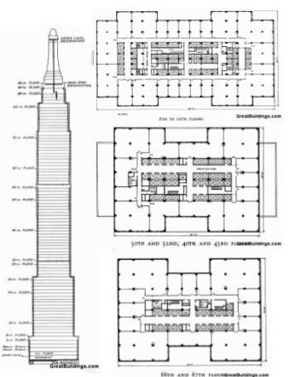
(old.skyscraper.org, n.d.)
(Pinterest, n.d.)

Part B: The case studies should then analyse the framing material of each building in the following specific areas.

  - The framing material choice, in relation to strength, durability and climatic resistance, given the environmental conditions it is exposed to at the site.

Concrete Frame Structure
- The Framing Material Choice: The Hatsuse Mita Apartments utilize a frame built with 310mm square columns placed 1350mm apart to optimise structural strength. This choice of framing material ensures maximum strength and durability, which are crucial for the building's stability and longevity.

- The 310mm thickness, concrete, square columns provide exceptional strength, allowing the building to maintain its weight and resist multiple forces. The intermediate structural scale of the frame helps the building blend with its surroundings while providing the necessary support.

- Durability: The columns are designed to withstand the environmental conditions of Minato City, Japan, which include seismic activity and varying weather patterns such as hot summers and typhoon seasons. The use of high-quality materials ensures the building's durability and ability to maintain structural integrity over the years.

- Climatic Resistance: The framing material is chosen to resist climatic factors, ensuring the building's safety and stability. The design focuses on the seismic activity of Japan, as well as the various weather patterns, providing resistance to both earthquakes and extreme weather conditions.

- The Hatsuse Mita Apartments' structural design and selection of materials reflect a thoughtful approach to ensuring the building's strength, durability, and climatic resistance, making it a reliable and sustainable building in Minato City.

(Daily, 2021).
(architectures.jidipi.com, 2021)

Steel Frame Structure:
- The Framing Material Choice: The Empire State Building utilizes a steel frame for its structural system. This choice was made due to steel's exceptional strength, durability, and ability to withstand various climatic conditions. Steel provides the necessary support for the building's height and ensures its stability and safety.

- Strength: Steel is known for its high tensile strength, which allows it to support the weight of the building and resist forces such as wind and seismic activity. The steel frame of the Empire State Building consists of columns and beams that create a robust skeleton, capable of bearing the load of the entire structure.

- Durability: Steel is durable and resistant to wear and tear, making it an ideal material for long-lasting structures. The Empire State Building's steel frame has proven its durability over the decades, maintaining its integrity and strength despite exposure to various environmental conditions.

- Climatic Resistance: The steel frame of the Empire State Building is designed to withstand the climatic conditions of New York City, including temperature fluctuations, humidity, and wind forces. Steel's resistance to corrosion and its ability to maintain structural integrity under different weather conditions ensure the building's durability and safety.

- The use of steel in the Empire State Building's construction was revolutionary at the time and set new standards for skyscraper design and construction. The steel frame allowed for rapid construction and provided the necessary strength to support the building's height, making it one of the most iconic structures in the world.
(Pegus, 2013)
(Website, n.d.)
(Website, n.d.)
(Website, n.d.)

  - The impact of the framing material's original production process, to community and to the environment.

Hatsuse Mita Apartments - Impact on the Local Community

- The production of framing materials often involved local suppliers and manufacturers, which can boost the local economy by generating jobs and supporting local businesses. For the Hatsuse Mita Apartments, manufacturers such as ABC Trading, Aica, and Nippon Paint were involved.

- Social Impact: The construction of the apartments provided housing solutions for the local community, especially for those displaced by redevelopment projects. The design promotes a sense of community with shared spaces like the "Meguri-doma" (a covered stairwell/common corridor) that connects all levels and allows for social interaction with one another.

Hatsuse Mita Apartments - Impact on the Surrounding Environment
- Resource Mining: The production of framing materials usually involves the mining of raw materials, which can cause deforestation, habitat destruction, and soil erosion. The environmental impact depends on the sustainability practices of the suppliers involved.

- Energy Consumption and Emissions: The manufacturing process of the framing materials is energy-intensive and can result in significant greenhouse gas emissions. The choice of materials and the efficiency of the production process play a crucial role in determining the overall environmental footprint of the structure.

- Waste Generation: The production process produces waste, including offcuts and by-products of the production process, which must be managed properly to minimize environmental impact. Sustainable practices such as recycling and waste reduction can help to mitigate this impact as much as possible.

- The transportation of the Concrete from the production site to the construction site contributes to carbon emissions and traffic congestion.

- The use of Local suppliers can reduce the distance to site and its environmental impact.

(Lexicon, 2019)
(Daily, 2021).
(architectures.jidipi.com, 2021)

Empire State Building Impact on the Local Community:
- The construction of the Empire State Building significantly boosted the local economy by creating thousands of jobs and promoting numerous businesses. The project involved over 3,400 workers, many of whom were immigrants, contributing to the economic vitality of New York City.

- Social Impact: The Empire State Building has become a symbol of New York City's ambition and resilience, attracting millions of tourists annually and contributing to the city's global recognition. It offers office spaces and observation decks, enhancing the quality of life for its visitors and tenants.

Empire State Building - Impact on the Surrounding Environment:
- Resource Mining: The production of steel involves the production of raw materials, which can lead to environmental degradation, such as habitat destruction and pollution. The environmental impact depends on the sustainability practices of the suppliers involved.

- Energy Consumption and Emissions: The manufacturing process of steel is energy-intensive and results in significant greenhouse gas emissions. The construction of the Empire State Building required a substantial amount of energy, contributing to its overall carbon footprint.

- Waste Generation: The production and construction processes generate waste, including offcuts and by-products. Proper waste management practices are essential to minimize the environmental impact.

- Transportation: The transportation of materials to the construction site contributes to carbon emissions and congestion. Given the scale of the Empire State Building, the coordination involved was extensive, adding to the environmental impact.

- Sustainability Initiatives: Despite the environmental challenges, the Empire State Building has undergone several sustainability retrofits to mitigate its impact.

- Energy Efficiency: The building's retrofit included upgrading the chiller plant, adding an additional pane of coated film to its windows, installing insulation behind radiators, and upgrading the elevator system with regenerative braking. These upgrades have significantly reduced the building's energy usage by about 40%.

(Website, n.d.)
(Website, n.d.)
(Website, n.d.)
(Ahlfeldt, 2020)

  - The frames ease of assembly and the potential ease of its adaptation to different building shape and building use, within the life cycle of the building.

The Hatsuse Mita Apartments
- Ease of Assembly: The Hatsuse Mita Apartments utilize a concrete frame structure with 310mm square columns placed 1350mm apart. This design allows for efficient assembly, as the columns and beams can be prefabricated and easily installed on-site. The regular spacing of the columns simplifies the construction process, ensuring that the frame can be erected quickly and accurately.

- Potential Ease of Adaptation: The concrete frame structure of the Hatsuse Mita Apartments offers considerable flexibility for adaptation to different building shapes and uses throughout the building's life cycle. The intermediate structural scale of the frame allows for modifications and expansions without compromising the building's integrity. This adaptability is crucial for meeting changing needs and functions over time.

- The Hatsuse Mita Apartments' design includes a "Meguri-doma," an open stairwell and common corridor that connects all levels. This feature, along with the flexible column placement, allows for various configurations of living spaces and terraces. The building can be reconfigured to accommodate different shapes and layouts, making it versatile for future changes.

- The design of the Hatsuse Mita Apartments is designed to be non-hierarchical, allowing each unit to be offered as a rental unit or treated as an "individual room" of the family's residence. This flexibility enables the building to adapt to different uses, such as residential, commercial, or mixed-use spaces. The ability to modify the interior layout ensures that the building can meet diverse needs over time.

- The concrete frame structure of the Hatsuse Mita Apartments provides both ease of assembly and potential for adaptation, making it a sustainable and versatile choice for long-term use in Minato City, Japan.
(Lexicon, 2019)
(Daily, 2021).
(architectures.jidipi.com, 2021)

Empire State Building
- Ease of Assembly: The Empire State Building utilizes a steel frame structure, which was revolutionary at the time of its construction. The steel columns and beams were prefabricated and assembled to the site, where they were bolted and riveted into place efficiently. This method allowed for rapid vertical construction, with the framework rising at an impressive pace of 4.5 stories per week. The tiered workflow, where multiple teams worked simultaneously on different aspects of the building, ensured that the assembly process was streamlined and efficiency.

- Potential Ease of Adaptation: The steel frame structure of the Empire State Building offers significant flexibility for adaptation to different building shapes and uses throughout the building's life cycle. The modular nature of the steel frame allows for modifications and expansions without compromising the building's integrity. This adaptability is crucial for meeting changing needs and functions over time.

- Adaptation to Different Building Shapes: The design of the Empire State Building includes setbacks at various levels, which not only enhance its aesthetic appeal but also serve a functional purpose by reducing wind pressure on the structure. The steel frame allows for various configurations and extensions, making it versatile for future changes in building shape and layout.

- Adaptation to Different Building Uses: The spatial organization of the Empire State Building is designed to be flexible, allowing for different uses such as office spaces, observation decks, and commercial areas. The steel frame structure enables the building to adapt to diverse needs, ensuring that it can accommodate changes in use over time. The ability to modify the interior layout and add new features ensures that the building remains relevant and functional throughout its life cycle.

- The steel frame structure of the Empire State Building provides both ease of assembly and potential for adaptation, making it a sustainable and versatile choice for long-term use in New York City.
(Constructions, NA)
(Website, n.d.)
(Website, n.d.)
(Website, n.d.)

Part C). Produce your own summative comparison of the advantages and dis-advantages of the two framing materials, in tabular format.

Criteria | Concrete Frame | Steel Frame
Advantages | - Strong under heavy loads | - Strong for tall structures
 | - Fire and pest resistant | - Wear and tear resistant
 | - Good for earthquakes and weather | - Good for wind and temperature changes
 | - Boosts local economy | - Creates jobs and supports businesses
 | - Promotes community interaction | - Attracts tourists, symbol of resilience
Disadvantages | - High energy use and emissions | - High energy use and emissions
 | - Resource mining impacts environment | - Resource mining impacts environment
 | - Limited sustainability initiatives | - Requires maintenance to prevent corrosion

References
Abdel, H., 2021. Arch Daily. [Online]
Available at: https://www.archdaily.com/963346/hatsuse-mita-ihrmk/60c791f2f91c81324e000097-hatsuse-mita-ihrmk-axonometric-sketch
[Accessed 02 March 2025].
Ahlfeldt, J. M. B. a. G., 2020. Building The Skyline - The Birthd and Growth of Manhattans skyscrapers. [Online]
Available at: https://buildingtheskyline.org/empire-state-building-economics/
[Accessed 25 February 2025].
Anon., 2021. https://architectures.jidipi.com/j00052610/en/hatsuse-mita-apartments. [Online]
Available at: https://architectures.jidipi.com/j00052610/en/hatsuse-mita-apartments
Anon., 2021. https://www.archdaily.com/963346/hatsuse-mita-ihrmk. [Online]
Available at: https://www.archdaily.com/963346/hatsuse-mita-ihrmk
Anon., n.d. [Online]
Available at: https://www.archdaily.com/963346/hatsuse-mita-ihrmk
architectures.jidipi.com, 2021. architectures.jidipi.com. [Online]
Available at: https://architectures.jidipi.com/j00052610/en/hatsuse-mita-apartments
[Accessed 26 February 2025].
Constructions, R., NA. Rezovate Constructions. [Online]
Available at: https://www.rezovate.com/blogs-for-industries/the-art-of-construction-empire-state-building
[Accessed 26 February 2025].
Daily, A., 2021. Arch Daily. [Online]
Available at: https://www.archdaily.com/963346/hatsuse-mita-ihrmk
[Accessed 26 February 2025].
Homes, P., n.d. Plaza Homes. [Online]
Available at: https://www.realestate-tokyo.com/rent/B0022056/hatsuse-mita/#lg=1&slide=0
[Accessed 02 March 2025].
Lexicon, u., 2019. urbanNext Lexicon. [Online]
Available at: https://urbannext.net/hatsuse-mita/
[Accessed 26 February 2025].
old.skyscraper.org, n.d. old.skyscraper.org. [Online]
Available at: https://old.skyscraper.org/EXHIBITIONS/TEN_TOPS/esbmooringmast.php
[Accessed 27 February 2025].
Pegus, L., 2013. ESB_DESIGN_GUIDLINES.pdf, https://www.empirestatebuildingny.info/pdf/ESB_DESIGN_GUIDLINES.pdf: Lydia Pegus.
Pinterest, n.d. Pinterest. [Online]
Available at: https://uk.pinterest.com/pin/empire-state-building--253468285260201665/
[Accessed 27 February 2025].
Website, E. S. B. O., n.d. [Online]
Available at: https://www.esbnyc.com/about/history
[Accessed 01 March 2025].
Website, E. S. B. O., n.d. Empire State Building Official Website. [Online]
Available at: https://www.esbnyc.com/about/facts-figures?_gl=1*6uhiol*_up*MQ..*_ga*MTMyNjMyNDUzMS4xNzQzMDE2Mzcz*_ga_9S692RFY6S*MTc0MzAxNjM3Mi4xLjAuMTc0MzAxNjM3Mi4wLjAuMTMxNjYwMDUzNQ..
[Accessed 01 March 2025].
Website, E. S. B. O., n.d. Empire State Building Official Website. [Online]
Available at: https://www.esbnyc.com/about/architecture-design?_gl=1*ohr08d*_up*MQ..*_ga*MTMyNjMyNDUzMS4xNzQzMDE2Mzcz*_ga_9S692RFY6S*MTc0MzAxNjM3Mi4xLjEuMTc0MzAxNjUwNS4wLjAuMTMxNjYwMDUzNQ..
[Accessed 01 March 2025].

