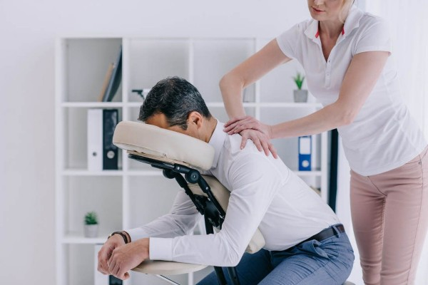
Tatiana Pirvu
1906799
Purple Soul Therapy
Mobile massage therapy
and
pampering


Business Plan

Tatiana Pirvu |Managing Enterprises| 16/06/2020
Contents
Introduction 4
Name and Identity 5
Aims and Objectives 5
Business Aims 5
Business Objectives 5
Legal Identity 5
Services description 5
Marketing and PR Plan 6
Target market 6
How are we going to sell/promote our service? 6
Marketing and Digital Marketing Plan 7
Media plan 7
Forester’s 5 I’s 7
Pricing Strategy 8
Why? 8
Cost Leadership Price description 8
Differentiation price 9
Other elements of marketing 9
HRM 9
Who we need to help us to start-up and run our business? 9
Organisation chart 9
Physical Location 10
Where will we run our business? 10
Market research 12
Cash flow forecast 15
Cash Flow in 16
Expenses 16
Contingency plan 19
Gantt chart 20
Three years Gantt Chart 20
References 20
Annexe 1 21
Questionnaire analysis 21
Annexe 2 26
Annexe 3 28
Print screens about our collaboration with freelancers to complete our aims and objectives 28
Negotiations and collaborations/joint ventures research 30
Annexe 4 31

Introduction

Purple Soul Therapy is a new entity created for business purposes in Cardiff and surrounding areas.
The services PS Therapy has to offer are mobile massage therapy and pampering.
In this business plan, we conducted internet research about competition and prices, and we followed marketing models, performed marketing research and questionnaire analysis.
A lot of fun creating promotional materials: business cards; stand-up banners etc.
A website with the same theme and colours has been designed as well.
www.purplesoultherapy.com

‘The path towards knowledge and wisdom begins with raw data.’
Christian Felice

Following Ackoff DIKW (i-scoop, ?)model (Data, Information, Knowledge and Wisdom) helped us to extract information and to take valuable and more precise decisions in our management role.

The questionnaire was focused on narrowing the demographic and finding out people’s preferences regarding price, personal comfort, and relaxation preferences.

Competition discovered on our research, challenged us to create a business model that stands out.

Research shows that the Cardiff massage market is saturated with the same model of business. See Annexe 4

Most of the critical competitors in Cardiff are united, and they support each other.
They created a small community (with commercial purposes) with a good reputation (Trip advisor; Google; Yell; Facebook. Etc.) E.g. www.yurtinthecity.com

Studying some other competitors business models, we find out a couple of direct and indirect competitors operating in the area: Jessica Sainsbury’s-Thomas; Cardiff Met Sport-massage Clinic; Royal Thai massage etc.
Elaborating the cash flow forecast helped us reveal our pre-vision and anticipated annual sales that ended up with a positive financial exercise.
The Contingency Plan was the most revelatory one. Exercising eventual/unexpected threats helped us to adapt the operational strategy and create new opportunities for income. This raised awareness about our vulnerable position if we are not planning extreme situations.
Running a SWOT analysis makes us see what the future and current opportunities are and what are the threats, helping us to make contingency actions even more precise and accurate.

My kindly thanks and my eternal gratitude, to my teacher and mentor Mel Squire, you helped me get a vision of my world beyond seeing the rest of the world.
Millions of thanks to Christian Felices to teach me so many digital 'tricks ' in such a short time. (they make my life easier)
Thank you for your patience and care, Paul, my beloved husband, and partner.
Special thanks for the support and friendship to my colleagues Ben, Samina and Violeta, for being there when I needed them.

Name and Identity

PS Therapy – Company name
- PURPLE Soul Therapy -Mobile Massage Therapy and Pampering
- Mission statement
The Advocates of health and wellbeing!

Aims and Objectives

Business Aims
- To promote a high quality of life and to provide the best massage therapy for people at work or wherever they are.

Business Objectives
- To provide mobile massage therapy in Cardiff and Newport's area, promoting our mission and values.
- To recruit therapists and specialists that will comply; promote and share our values and mission.
- To work together with corporate to promote wellbeing at work and to maintain the quality of people’s life.
- To use just organic and clinically tested, environmentally friendly products.
- To teach people how to manage pain and to have a better life.
- To create a premium product that elevates the wellbeing for people and positioning PSTherapy as the leader on the market.

Legal Identity
Partnership (Trinity Of ST David University, 2020)
The partnership legal form is the best match as I will work together with my sister, and after one year, we can recruit other partners.
The partnership has a convenient legal form as it has simple accountancy and shared responsibility-we are sharing the income and the losses, and each of us is paying their taxes.

Services description
​Mobile massage therapy for corporate has two options: desk massage or chair massage (both the same, but we are adapting our services to the client needs of space.
Desk massage: we are giving the massage therapy on its chair or
Chair massage: we bring our massage chair.
Minimum of equipment or no equipment at all, desk massage it is cost- efficiency and an excellent choice for any kind of workplace setup.
Whole-body massage: massage with oil on the massage couch (at client home; rented space or office for massage therapy.)
Pampering: facial beauty massage and deep cleaning; face, feet and hands masks and massage; individual eyelashes application; peeling.

Marketing and PR Plan

Target market
We have researched three main categories/demographics so we can run along the year three specific marketing campaigns, seasonal ones. (Trinity Of St David University, 2020)
- People at work age between 20 to 55-60 (see Annex 1 -Questionnaire analysis)
People that work seating mainly in front of the computer or desk in general.
An agency must run the marketing campaign, or we can collaborate with other massage companies that are willing to take us like specialists in their team.
- Sports lovers that are tired after sport or have contractures etc. age 20-35 We will create vouchers and flyers to share and promote among the sports centres that require massage collaborators or contacting the sportive directly offering vouchers. To be recommended by our friends and choosing a specific day of the week dedicated to this group.
- Females that are looking for pampering in groups or separately age 28 to 45 or over. When we are working with collaborators, or we are contracting ourselves a Corporate that is looking to reward their employees, we want to offer an array of services like:
- face beauty massage and legs or hands masks
-neck, head, and shoulders therapeutic massages.
-body massage

How are we going to sell/promote our service?
- PS Therapy is using social networking online (Facebook; Instagram; YouTube).
- PS Therapy is participating in demonstrations events like social networking or renting a spot/pitch in a central shopping centre offering 5-10 minutes demo; participating in the company’s fairs etc. Check here email
- Print out business cards and flyers and encouraging referrals (See promotional materials Here)
- Offering loyalty prices
- Writing articles and video tutorials; classes for beginners and self-help for our customers etc.
- Having 2-3 campaigns per year with a specific theme (looking to find the first that matching PSTherapy Objectives maybe-BRG-that stands for Brake Relax and Go -for people at work that can replace coffee break or cigarette with 10 minutes revigorated head/shoulders massage therapy (or group stretching session )
- Participating in other partnership/joint ventures or collaborations like promoting quality of life together with organisations that are creating shows or festivals -see Body Mind And Spirit (mind body spirit, 2020)
- Sell vouchers on the website or adding as referrals with collaborators such gym classes Yoga etc.
- PS Therapy are advertising with posters magnets on our car/cars
- Using endorsements from our collaborators and our happy clients
- PS Therapy can use direct mail with a specific campaign -we need have this late after 1-2 years and to research if feasible. To take an Agency as a collaborator to be sure of success.

Marketing and Digital Marketing Plan

Media plan

No  Of activity | Marketing and Digital Marketing activities | Measurables | Calendar of activities
1 | Create social media accounts | Google business lounge, Facebook, YouTube, and Instagram accounts | May 2020
2 | Posting 3 times a week on social media channels | Posters and campaigns promo + relevant articles | May 2020-April 2021
3 | Creating and sourcing all relevant promotional materials | Three weekly Online Posters, 1 stand up banner; 6 T-shirts; 200 business cards; 1 Logo; 1 website; 20 mugs; 50 pens; 2 car and 30 fridge magnets; 5 articles in our blog and 1 Spa leisure and massage therapy created e-magazine. | May 2020-October 2020
4 | ‘Engaging with key influencers and people within the local area and community’ (People Per Hour offer) | 2 Bloggers, two networkers,
5 | We are building up the email list. | 100 subscribers | July-November 2020
6 | Responding to any questions and queries | Emails/client monitoring files | July -April 2020
7 | Arranging competitions and promotions | Three promotional corporate service packages and three subscribers prises/monthly | August-December 2020
8 | Monthly optimised blog with keywords | Five articles optimised with keywords | May-October 2020
9 | SEO updating monitoring | Ranking on the first page on Google and Bing over relevant keywords | May 2020-April 2021
- The cost for this campaign would be £180.00 plus VAT/month
- E-magazine layout link
https://fliphtml5.com/learning-center/top-8-e-magazine-software-for-publishing-online-magazines/

Forester’s 5 I’s
To structure online marketing that is the most approachable for us at the level start-up, we are considering the 5 Forrester I’s (Forrester is a marketing agency that creates a functional online marketing model). The five I’s elements are INVOLVEMENT; INTERACTION; INTIMACY; INFLUENCE; INDIVIDUAL (Hanlon, 2020)
We are insuring Involvement by inviting customers to:
- Read new articles about self-help.
- Participate in competitions or bloggers and networkers’ campaigns.
- Questioning and send feedback about our services
- Recommend and refer our services
We can measure the level of Involvement by monitoring the analytics of our website and posters (how long people remain engaged when they are reading; are people following a link or article/video posted in social media? Etc.)
Interaction
We can monitor how many people that are getting involved are interacting with our offers/buying our services or ask questions about prices etc.
Intimacy
We can observe and monitor the quality of the peoples that interact by looking at their comments; brand awareness; considering their feelings etc.
Influence
The number of reviews, referrals and shares and comments in our blogs we will be monitoring. How likely our clients will recommend our services? Surveys and questionnaires can give us a metric about a specific number (qualitative and quantitative) of people that are aware of and loyal to our brand.
Individual
We will focus on individuals that can influence a group (a manager that can influence others with the results of personal wellbeing for our corporate addressed services or a blogger etc.)

Pricing Strategy

Why?
- PS Therapy is choosing the Cost leadership (Trinity od St Davids, 2020) prices to penetrate the market, and that is our position on the market.
- After PS Therapy is proceeding to research their competitor’s prices and services and making the analysis, the costs can change.
- PS Therapy wants to grow their pieces organically once their customer perceives the quality of their services and feel the benefits of the therapies taken. Comparison with the market prices will be Not too high not to low! For an hour of treatment, PSTherapy envisages an estimated rate of £ 40-45/h. (results from specialist cost plus consumables plus costs with rent; transport etc. also must be considered 20% taxes.

Cost Leadership Price description
- 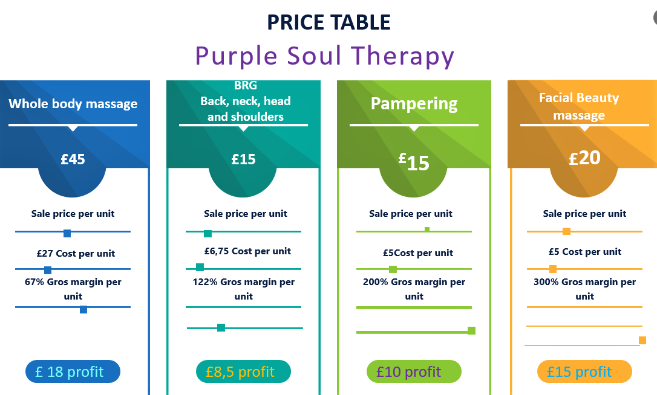

Differentiation price
PS Therapy partners (the joint venture ones) will apply differentiation prices as they are offering premium services, and we are part of it. One of the goals is to looking forward to creating a premium product and apply a differentiation price. PS Therapy is considering that in the future.

Other elements of marketing (Trinity Of St David University, 2020)

HRM

Who we need to help us to start-up and run our business?
- One consultant/specialist in marketing for advice to plan end follow the campaigns Annex 3
- Host company for our website (already rent it to Weebly)
- Web design and analytic/ SEO specialist to promote online image/presence (already done it)
- One service secretary/receptionist for bookings
- One cleaning company or an hourly collaborator self-employed regime
- 1-2 therapists to work and encourage self-employed regime

How will we recruit them?
- To promote and advertise our jobs is better to use the Federation of Holistic Therapies to have a more straightforward and direct approach in regard with DBS and certifications and insurances that a specialist must have them before starting the collaboration with PS Therapy. Is possible to promote the recruitment on other Websites: People per hour; Yell; Indeed; referrals; etc.

How will we train and induct them into the business?
- Training in house by the manager/administrative director in the organisational matters and mission; values and objectives-3-4 hours induction course and two weeks shadowing.
- All recruited partners and collaborators must be already specialists in their speciality and to belong to a specialist’s body such Associations or other recognised institutions, mandatory insurance and DBS updated.

How will you pay them and what will their salaries be?
- We are paying the therapist for each project with the agreed fee against the invoice for deductions, a self-employed regime with a contract for back up.

Who will they report to and what will their duties be?
- The relationship will have a written contract with specifications for each of the collaborators with deadlines and specific, measurable results for each project also with a job description with health and safety rules included and specification in regards with payments and other terms.

Organisation chart
- Organigram 1 and 2 when we are developing in an extensive partnership

Physical Location

Where will we run our business?
PS Therapy design is a Mobile one. Making people feel as comfortable as they want by us getting to their work or home, attend events locations or in a rented space or the registered Partnership address if possible. See emails& negotiations about rented space

What equipment do we need to run our business?

For the beginning of PS Therapy needs:
- 2 Massage couches.
- Two massage chares.
- Two desk massage support
- Two carriers for couches
- Two bottle warmers
- Face oil like almond, apricot or coconut oil; body oils like grape seeds oil
- Body cream
- Body powder
- Towels warmer and UV sanitiser
- Spirit and sanitisers.
- Cotton.
- Couch Paper and face towels/paper towels
- Ten towels; 2 blankets
- Two couch electric blankets/wormers
- 2 iPad for music and communication
- Two laptops
- Six purple or white T-shirts and six black work trousers
- One car
- Face and feet masks
- 2 Magnifiers
- Two mirrors
- Three mobile phones

Logo from Free logo services and
Promotional material

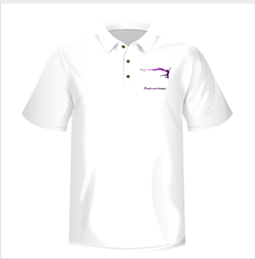

on everyday wearing

Market research
PS Therapy market and competition

We researched to understand your market, including our industry, regions, customers, competitors

- Questionnaire-attached in Annexe 1
- Online research-pictures in annexe 4
- Personal experience-visited in 2017 two of the competitors
- Social media research-pictures in Annexe 4
- Family and friends- 3 family members participated in our research as clients and gave feedback without their name
Competitor 1
Location | Name | Website | Average prices | Strengths | Weaknesses
Cardiff | Wildwood therapies  (Yurt in the city) | https://wildwoodtherapies.com/  http://yurtinthecity.co.uk/ | 30 min £30  60 min £45 90 min £65  2 hrs £85 | He’s Old on the market since 2002-as he declares in his bio and works with experienced therapists too | The website is not secured, and the functionality of the business is confusing. To understand how is operating, new clients need to read all the content
Cardiff | Wildwood therapies  (Yurt in the city) | https://wildwoodtherapies.com/  http://yurtinthecity.co.uk/ |  | Good SEO on Google, the top first page | The SEO on the second page shows confusing messages in regards to ‘Yurt in the city’ that is present in other people’s promotional without explaining what that means
Cardiff | Wildwood therapies  (Yurt in the city) | https://wildwoodtherapies.com/  http://yurtinthecity.co.uk/ |  | Has his own central, well-established location in Central Cardiff positioning the business well geographically | Works well for people that are referred but not for new genuine clients
Cardiff | Wildwood therapies  (Yurt in the city) | https://wildwoodtherapies.com/  http://yurtinthecity.co.uk/ |  | Trained in many therapies or styles covering up a large area of needs for customers | We were present at the opening in 2017 September in The Boneyard Pontcanna, an event that took place with another story.
Cardiff | Wildwood therapies  (Yurt in the city) | https://wildwoodtherapies.com/  http://yurtinthecity.co.uk/ |  | Individual businesses and works in collaboration when necessary | Not all clients love the wild, and yurt atmosphere-the the first experience was not a relaxing one.
Cardiff | Wildwood therapies  (Yurt in the city) | https://wildwoodtherapies.com/  http://yurtinthecity.co.uk/ |  | Organising events and that gives a second income stream | No legal partners just individual collaborations
Competitor 2
Location | Name | Website | Average prices | Strengths | Weaknesses
Cardiff | Royal Orchid Thai Massage | https://www.royalorchidthaimassage.co.uk/ | £45/h  £32/h for a package of 5 sessions | Well established location on main street visible positioned in the people traffic area | The website is confusing regarding the main menu that it is below all information. Can be missed on mobile phone screens.
Cardiff | Royal Orchid Thai Massage | https://www.royalorchidthaimassage.co.uk/ |  | Modern and clean premises
Competitor 3
Jessica Sainsbury’s-Thomas, self- employed regime; promote herself just on social media with an expired space website. Highly rated on google map. Same prices as other competitors.
PS Therapy
What we believe that is the difference between our competitors and us is that we are working mainly with corporate customers under direct contracts and we are paid directly by the company to maintain the wellbeing of it employers
Location | Name | Strengths | Weaknesses | Current or future opportunities | Current or future threats
Cardiff | www.purplesoultherapy.com | Working in Partnership as specialists with experience over 15 years between us  We have planned our business to have a proper start, and we are building up a backup plan.  We have Versatility Adaptability and Mobility these are responding to clients’ needs  We can integrate ourselves easily and connect with our field community sharing knowledge and responsibility. | New on the market, and we need to gain the trust and support of our customers very quickly | After studying our competitors, we considering collaborating with each one and help them with their projects and invite them to enjoy our projects. | Exclusive contracts can bring the risk of losing many bookings at once
Cardiff | www.purplesoultherapy.com |  | We have other projects to run this year | To work with professional and marketing agencies to be promoted appropriately right from the beginning. E.g. Developing our Video channel with tutorials for self-help and become known and trustful; | One of us to seek or missing for other reason and to lose opportunities or to honour our contracts
Cardiff | www.purplesoultherapy.com |  |  | To build up a contingency plan to ensure our business continuity | A pandemic and lockdown can be happening at any time, and we can risk losing our incomes
Cardiff | www.purplesoultherapy.com |  |  | To build up relationships with professional communities and become known
Cardiff | www.purplesoultherapy.com |  |  | To engage other partners in our project and to show them the opportunity/benefits of working together

Operational strategy
All our studies and research can result in an operational/working strategy and design of maxim of short (15’) four massages/ hour for 5-6 hours/ day per therapist for three days a week.

We can configure a schedule for working on Monday and Tuesday
whole day; Wednesday break for resting our hands
Thursday and Friday one of us is working, and one takes a day off alternate days between us.

Sunday and Saturday different design and another configuration if necessary.
We will prepare two events per month on weekends and take three to a maximum of four whole-body massage therapies each in a rented location.

Also, in alternate weekends, occasionally, we will enjoy courses or participate in training to maintain our Professional Continuous Development

How we ensure our incomes?

By taking into consideration our business model and schedule, a simple calculation can reveal the following:

- Three days per week from 12-18:00, each therapist can work six hours with 10 minutes break after every hour. (5 hours working each).

Multiply with four clients per hour results in 20 customers each

20 x £15/ person = £300 each per working day
£300 x three days/week = £900 each therapist (we estimate an average working capacity-the cash flow forecast is calculated at minimum capacity)

- For the weekends when we are booking events, we will negotiate a package and evaluate each event separately. That will be an extra income.

- For two weekends per month we will be booking our permanent clients for whole-body massage in the intervals of 9-12:00 and 13-17:00
We are anticipating a minimum of five clients per therapist each of the two days Saturday and Sunday.
If we are charging each minimum £45/hour results in £225 each therapist.

5 x £45/person = £225/therapist /one of the weekend days
£225 x 2 days= 450/therapist x 2 therapists =£900 total sales/weekend

Our permanent clients are the ones that can influence other people with the results of their therapies. They are becoming our services advocates if they are happy with the outcome of each personalised experience.
We envisage that the scenarios are changing with the messages of our marketing campaigns and becomes each time more effective. With a proper procedure put it in place for monitoring activities and control the outcomes, we can install routines and create efficiency for our work.

- At any time, we can re-configure our schedule to work on Saturday and Sunday morning and afternoon. A brake is necessary between two therapy sessions.

Anticipated working Schedule plus contingency parallel schedule

Contingency plan schedule* | Operational schedule for two therapist’s year 1
Therapist 3 | Therapist 1 | Therapist 2 | Day of the week
12-18:00 | 12-18:00 | 12:18:00 | Monday
12-18:00 | 12-18:00 | 12-18:00 | Tuesday
Day off/replace T1 or T2 | Day off | Day off | Wednesday
Replace T1 or T2 | 12-18:00 | Day off | Thursday
12:18:00 | Day off | 12:18:00 | Friday
9-12:00  13-17:00 | 9-12:00  13-17:00 | 9-12:00  13:17:00 | Saturday
9-12:00  13-17:00 | 9-12:00  13-17:00 | 9–12:00  13-17:00 | Sunday
9-17:00 | 9-17:00 | 9-17:00 | Events calendar

Cash flow forecast
Demonstrating how efficient can be our best sale product, BRG-short massage therapy- The Cash flow forecast is calculated at the minimum working capacity.
Following the scenario previously described, the next pictures illustrate in number tables of our financial pre-vision.
Sales assumption -started with month April 2021 March 2022
- Table Product breakdown
- Table Number of sales/months
- Table Average value sales per day based on 30 days /month
- Table Average Cost of transactions per day based on 30 days/month
- Table Cash inflows for incomes prediction of 12 months
- Table Cash inflows for expenses prediction of 12 months

- Our start-up capital is £2000
After we create the Contingency Plan, we envisage other sources of income, to reduce the impact of zero income in case of necessity.
An online course for self-help brings us a minimum monthly income of £30 to 60 - money that is for contingency situations.

Cash Flow in
- For April (first month) the total income is £5780 resulted from all services sales and online course
- All rest of the months' forecast is favourable with sales over £5000 except December when sales are exceeding 6600 because of seasonal sales.

Expenses
- Existing assets /online course £500 onetime payment for the template and hosting for one year
- Rent or premises costs £100 per calendar month -13 months expenses with the starting point
- Business rates for business premises £25 per calendar month
- Utilities (gas, electricity, water) £59-13 months expenses with the starting point
- Insurance £55 -13 payments with a starting point
- Telephone and internet £20-13 expenses with the starting point
- Marketing and advertising expenses £180 per calendar month-13 payments with the starting point
- Vehicle running costs £10 per calendar month (MOT/service/ cleaning. Etc.)
- Equipment purchase or leasing £100 /month for April and May
- Postage, printing, stationery £20/month-13 expenses with the starting point
- Transport and delivery clean towels etc. £60-13 expenses with the starting point
- Professional fees (accounting) £300 paid in December
- Staff costs automated receptionist £10 -13 expenses with the starting point
- Withdraws each therapist £800 x 2 =£1,600 -monthly
- Promo and Publicity one time only in November £ 200
We were close monthly and annual balance on positive results, as shown in our tables below.
In the first financial year, we have not taken any loan or grants
We trust that our positive balance after the first year will convince investors or future partners to enjoy our enterprise.
*Apologies to having the tables as pictures I will send them on email too
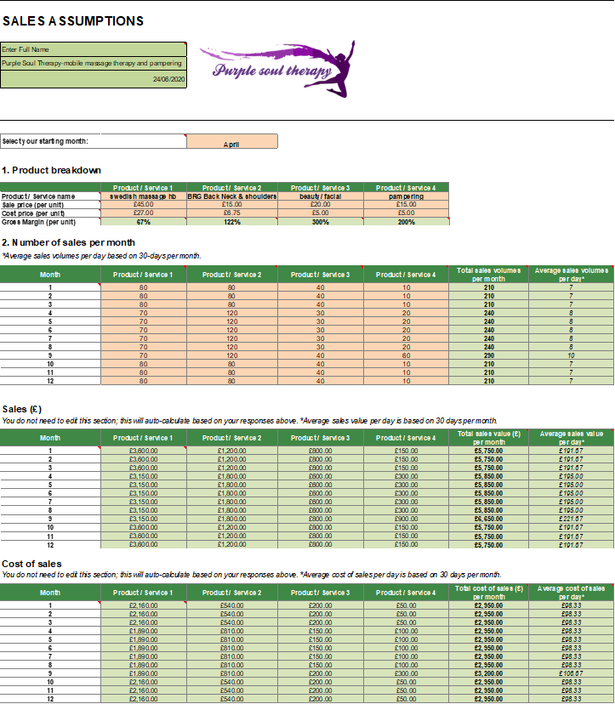

Contingency plan
In the eventuality of one of the threats happening
Threat | Solution | Concrete actions
Exclusive contracts can bring the risk of losing many bookings at once and losing money/income if cancelled or closed. | - We are ensuring the business for temporary losing income.  - Developing relationships that are being used in case of necessity  - Contracting an agency to ensure work against a commission  - Second stream income  - Third stream income | - We are paying monthly insurance for a temporary loss of income.  - We maintain a close relationship with our insurance agent  - In the case of loss of income, we are redeeming our temporary income insurance, and we are contacting the agency for work placement  - Open-up an online shop with self-help-based products related to massage therapy  - Affiliate services and referrals that can bring the commission, E.g. Pamper Company from London that we already have a relationship.  - Create an online course for self-help and having subscribers with minimum fee/calendar month that can become our online shop clients
One of us is seeking, and we risk missing opportunities or to honour our contracts | - Employ or contracting another therapist for backing up our holidays or seek holidays  - Both must have insurance individually for losing income because of illness | - We have a signed agreement with therapists that accepts our terms and conditions and comply with emergencies calls  - We are posting a notice in our therapist's communities and ask help
A pandemic and lockdown can be happening at any time, and we can risk losing our incomes | - Insurance for losing income.  - We are using our abilities and qualifications to work another job, e.g. health care assistants  - We are using/ taking a loan at the minimum rate  - We create savings for contingency situations | - Redeem insurance  - Employing in health and social care industry  - Keep up with National news  - Keep up a relationship with the community to be informed about any changes in our field  - Etc.
Each of us is responsible for putting in place the contingency plan. In case of necessity, both can deal with the situation. We are preserving a date on month, e.g. The third Saturday monthly for informing, awareness and training about how to apply the contingency plan, controlling and monitoring each activity for preventing extreme situation to occur.

Gantt chart

Three years Gantt Chart
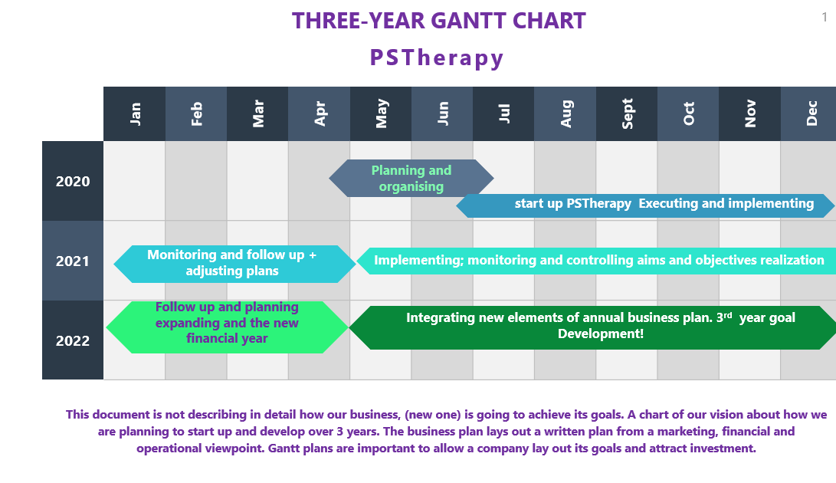

References
- Boulanger, K. T., 2012. Factors related to satisfaction, pain and affect the outcome in massage therapy clients. [Online]
Available at: https://ir.uiowa.edu/etd/1551/
[Accessed 18 June, 2020].
- Doetsch, M., 2014. Pampering vs self care how to tell the difference. [Online]
Available at: https://newyewhealing.com/pampering-vs-self-care-how-to-tell-the-difference/
[Accessed 18 June, 2020].
- Hanlon, A., 2020. Are you exploiting the 5 I's of Digital Marketing?. [Online]
Available at: https://www.smartinsights.com/marketing-planning/marketing-models/forresters-5is/
[Accessed 28 June, 2020].
- i-scoop, ?. DIKW model. [Online]
Available at: https://www.i-scoop.eu/big-data-action-value-context/dikw-model/
[Accessed 29 June, 2020].
- Mind-body spirit, 2020. Upcoming Events. [Online]
Available at: https://www.mindbodyspirit.co.uk/whats-on
- Sunberg, T., Cramer, H. & Sibbritt, D., 2017. Musculoskeletal Science and Practice. [Online]
Available at: https://www.mskscienceandpractice.com/article/S2468-7812%2817%2930115-7/fulltext
[Accessed 16 June, 2020].
- Treat well, 2020. Treat well-prices. [Online]
Available at: https://www.treatwell.co.uk/places/treatment-back-neck/offer-type-local/in-cardiff-uk/
[Accessed 18 June, 2020].
- Trinity od St Davids, 2020. Introduction in marketing, Cardiff: UWTSD.
- Trinity Of ST David University, 2020. Business Identity, Swansea: s.n.
- Trinity Of St David University, 2020. Marketing Segmentation Factsheet, Cardiff: s.n.

Annexe 1

Questionnaire analysis

Marketing research
Purple Soul Therapy is a mobile massage therapy partnership organization, established in Cardiff Wales UK.
In this short report, we will exercise how to analyse a Questionnaire that we created to research the market and to find what is the demographic for massage therapy preferences within Cardiff and surrounding areas.
In this questionnaire are no personal data were required. The information is used strictly for the purpose mentioned above—the survey completed by 11 participants with different ages and preoccupations.
We create 12 questions focused on demographics and people’s preferences and expectations, e.g. in regards to the prices, personal comfort, and quality of the services.
Analysing 5 of the main questions alone we can prove the effectiveness of this kind of services in Cardiff and surroundings.
Our subjects answered first some demographics related questions (age; gender; location, and professional status).
Other questions where formulated to show up people interests, preferences and expectations (preferred length of a therapy session and if other services like stretching and pampering are appreciated and are equally important)
We also considered analysing the preference/expectations of people in price and how critical are for them some other former customer’s reviews and therapist’s experience.
After discovering the demographics of the market (predominantly females with ages between 20-55, living in Cardiff; more than half of them full time employed), we find out that a vast majority of people prefer a more extended massage therapy (30-60 minutes) within the comfort of their own home if possible.
An equal number of people prefers massage therapy at club/salon, and just a few of them at work. A majority has no specific schedule in mind, but over 25% prefers to have massage therapies twice a week.
100% of subjects Strongly Agree or Agree that other customers high rating reviews are essential for them to
Studies show that a large percentage of the adult population are attending massage therapy with the purpose of sickness prevention and wellness, but also a large number of people choose massage for therapeutically reasons (Sunberg, et al., 2017) .
Our subjects confirm that most of them prefer back neck/shoulders therapy and whole-body massage.
In conclusion:
- PS Therapy can create a versatile mobile service if conditions for the quality massage therapy are met or stationary when the client can attend our premises.
- Our demographic is versatile too and can relax when conditions are proper conditions. The quality of our services is mandatory as customer’s reviews are especially important for people.
- Equally important for our customers is the experience of our therapists.
PS Therapy prices policy will be cost leadership, answering customers’ expectations. When convenient to do so, PS Therapy will organically grow their pieces once their customer perceives the quality of their services. Will apply differentiation prices, offering premium services.
- Awareness about massage therapy benefits and compliance will be increased in our customers. Knowledge about the benefits of massage therapy can be done mainly by informing and educating them throughout appropriate direct interviews, awareness campaigns, referrals, articles, etc.
- Questionnaires and interviews will be taken as often as possible to keep contact with the trend and to update and invigorate the business at the expected standards.
5 QUESTIONS INTERPRETATION:
Question 1
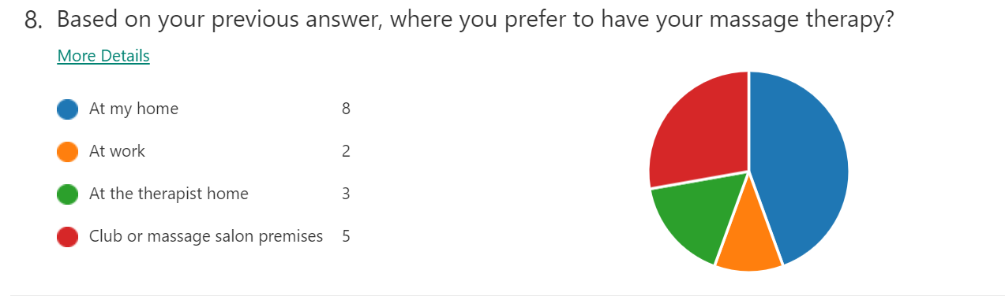
After question 7 (which refers to the frequency of massage therapies), in this graphic for the eight the item, we can conclude that a vast majority (nearly half of the subjects) prefers their own home when is about pampering or massage therapy. Almost half of the responders prefer other premises, including therapist home and just 2 of the subjects, consider having a massage at work.
As a start-up, we can design a marketing strategy to promote our services, considering people’s preferences expressed in this graphic. To accomplish one of our goal focused on prevention of specific postural conditions (to help people at work with short massage sessions), we need to create a particular strategy of marketing that answer people needs and preferences.
Question 2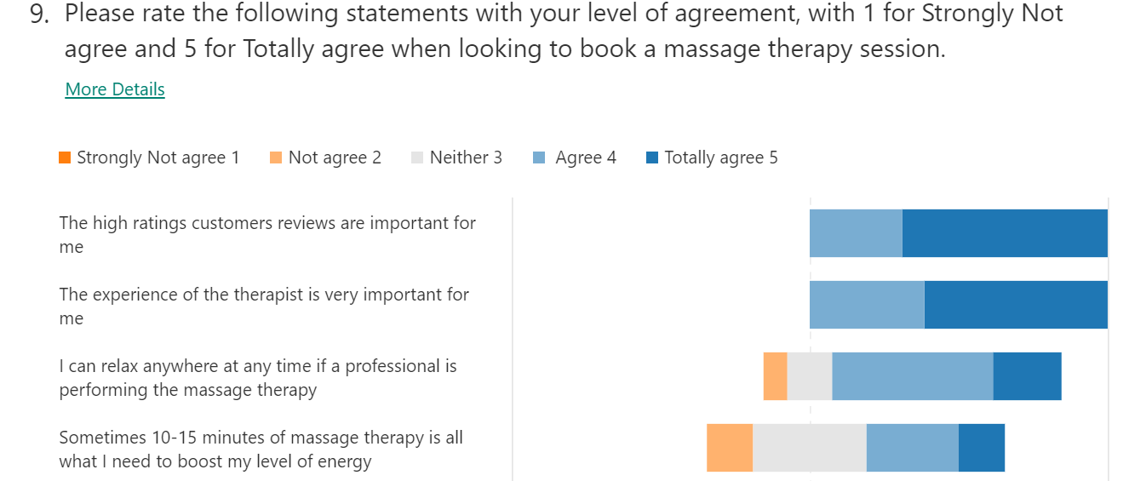
We create a Likert question to find out people’s attitude and opinion about how important the quality of services and personal comfort is for them.
(considering that our business design is a mobile massage therapy and maybe sometimes noise or space can constrict our client's satisfaction and pleasure).
An overwhelming majority ‘Agree’ and ‘Totally Agree’ that other people high rate reviews and the experience of the therapist are essential.
Particularly useful information when promoting our small enterprise. PS therapy should pay attention to encourage people to leave us their reviews at the end of our service and to underline and promote them when they make future promotions properly
For the third statement, our subject’s answers encourage us to believe that mobile massage therapy should carefully consider the environment when booking a therapy session.
One of the main conditions for quality massage therapy is that the customer not to be disrupted or disconnected during the session.
When customers choose their premises for the therapy, it’s necessary to make sure that their home is fit for high-quality treatment and all conditions are kept offering full quality services
For the fourth statement, we intended to find out people’s opinion regarding short massage sessions.
Half of the subjects agreed that these kinds of sessions could be a choice when they need a rapid boost of energy.
A window of opportunity is with undecided/neutral people. Some of them have never had massage therapy, so we can create a strategy that promotes our services to inform people and to lead them in that direction. Others prefer different ways of energizing themselves, and we need to think different approaches also, to answer their expectations correctly.

Question 3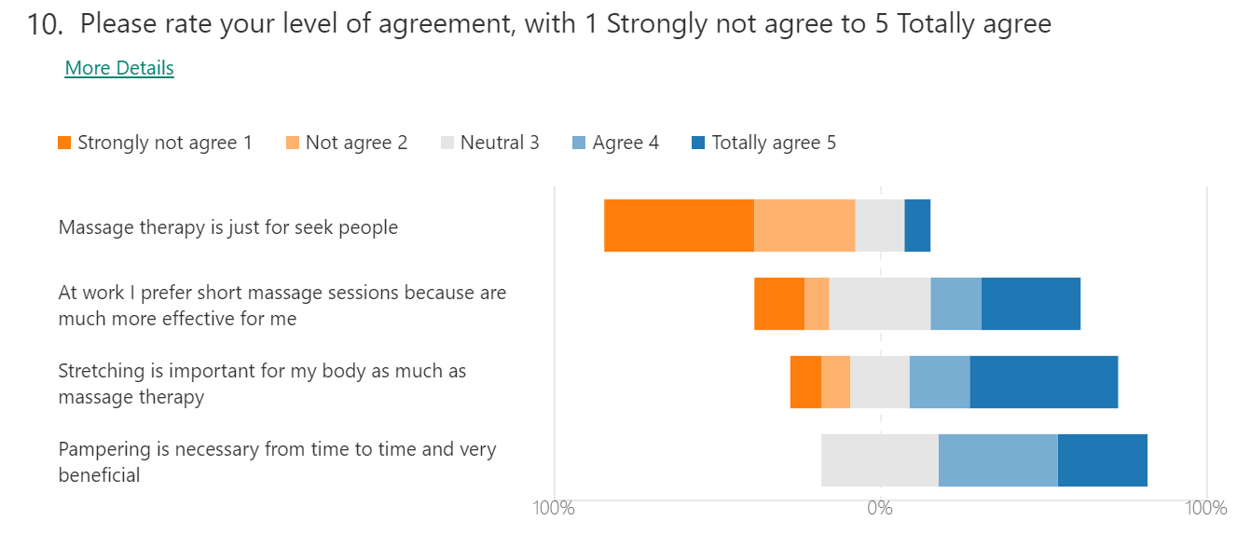
Next analysed question is also a Liken one. Our subjects agreed with a vast majority that massage therapy is not just for people having medical conditions. We tested how strongly people believe that massage is a necessity in life, or it is just something recreational.
The next two questions tested our subject opinion about two possible services that we are intending to launch: stretching and pampering. We had the confirmation that both could be not just accepted but even welcomed services. The Neutral position is relevant, too, for our marketing strategy.
A very well designed educational and informative campaign can change the misconception of luxurious thing that means ‘pampering’ for some people, with self-care that means pampering in another concept.
We can work out a marketing campaign that will suggest to our clients that ‘Pampering can be luxurious but also accessible and necessary by all of us’. (Doetsch, 2014)
Question 4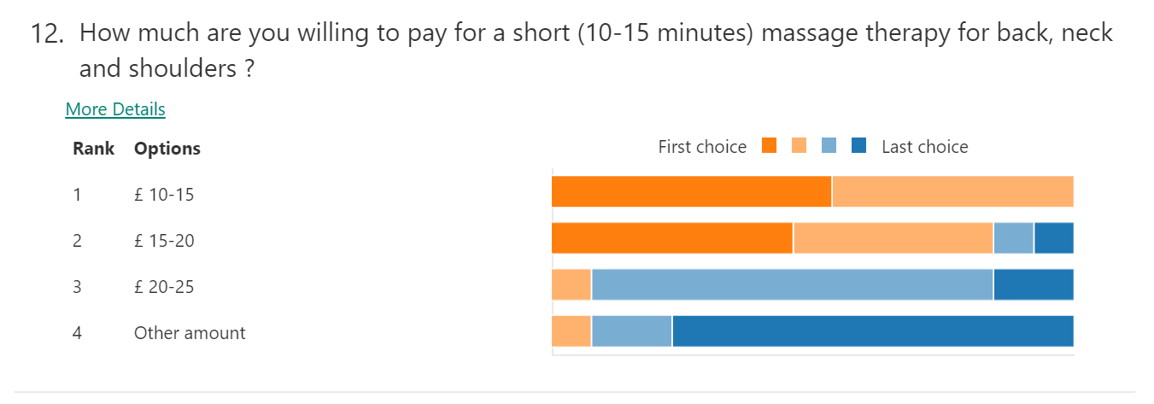
For question 12, we tested the subject’s preferences prices. We asked them to rank several price options, and answers reveal that price between £10-25 can be one of our products addressed, especially to people at work.
We have had a confirmation that people can appreciate an excellent short and revigorated massage session with price between £10-20.
By analysing first two options it comes, that is ideal for creating a price of £15 per person for 15 minutes session on back neck and shoulders massage
We need to design and promote our service to answer the majority opinion appropriately
When properly advertised, more people (maxim 4 per hour) can benefit from the therapist services. This situation will have the maximum efficiency for the therapist as well.
The research shows that other therapists in the Cardiff area charging £30 for 30 minutes of massage therapy (back-neck and shoulders). (Treat well, 2020).

Question 5 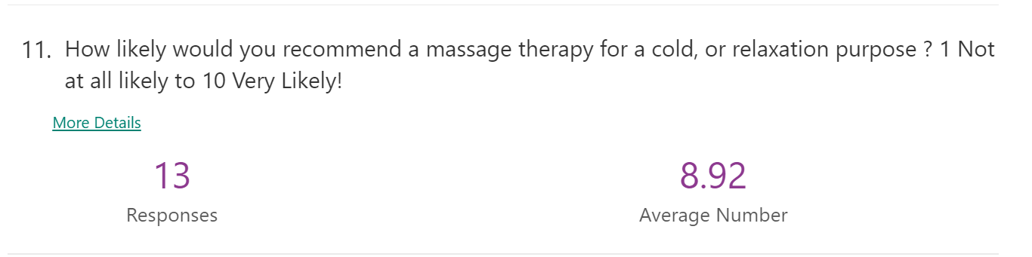
In our research, we included a question that can reveal how likely a person is to recommend massage therapy. Even a majority of people will most likely recommend massage therapy for relaxation or adjuvant in healing there are still some of our subjects which will hesitate or will consider the message will not be their first option in the matter.
It is our mission to inform and educate people about the main benefits of massage therapy and to encourage our client to recommend massage therapies or to pamper as relaxation or helping in healing methods.
To be referred by a client, we need to create an incredibly pleasant experience to increase awareness about the benefits a therapy session can have.
Studies show that often the therapists are not communicating enough with their customers and not interviewing them regarding their experience. Some clients sometimes are booking a massage session without knowing what to expect from it. The outcome in this situation is that they might consider their expectations have not achieved. (Bulanger, 2012)



Annexe 2

Five promotional materials: business cards, poster, magnets and stand up banners
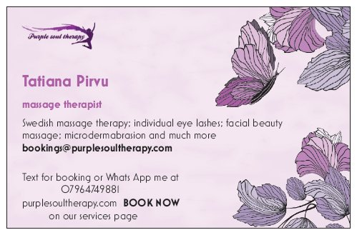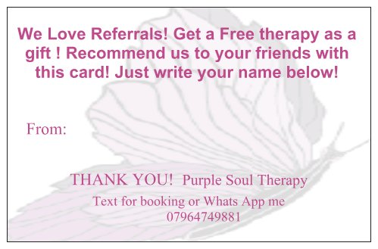Business card two faces
Instagram Poster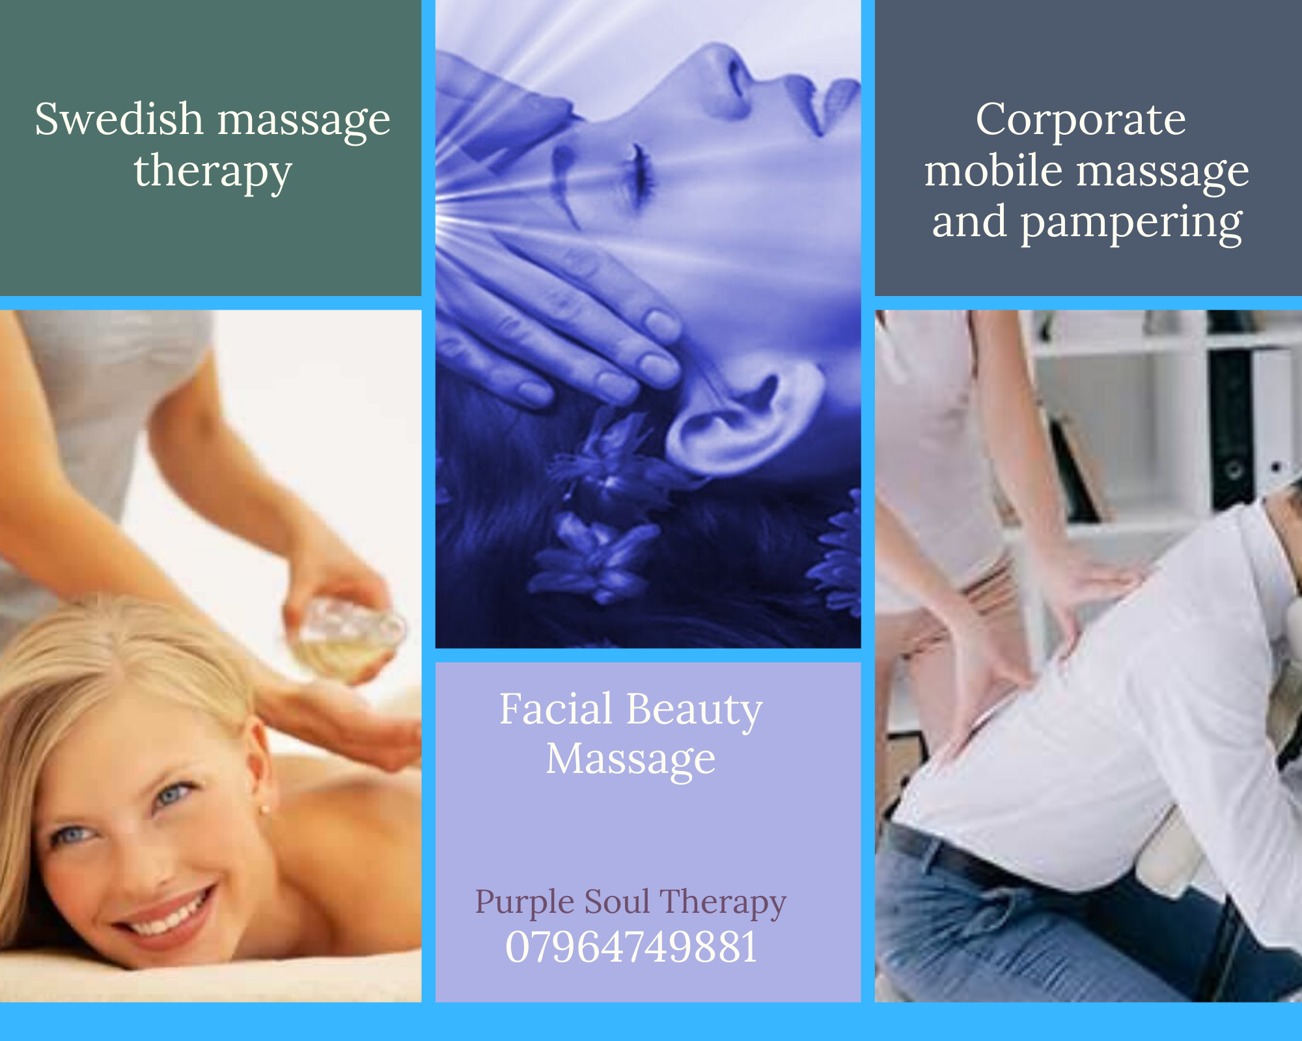

Car or fridge magnets (large for our car or 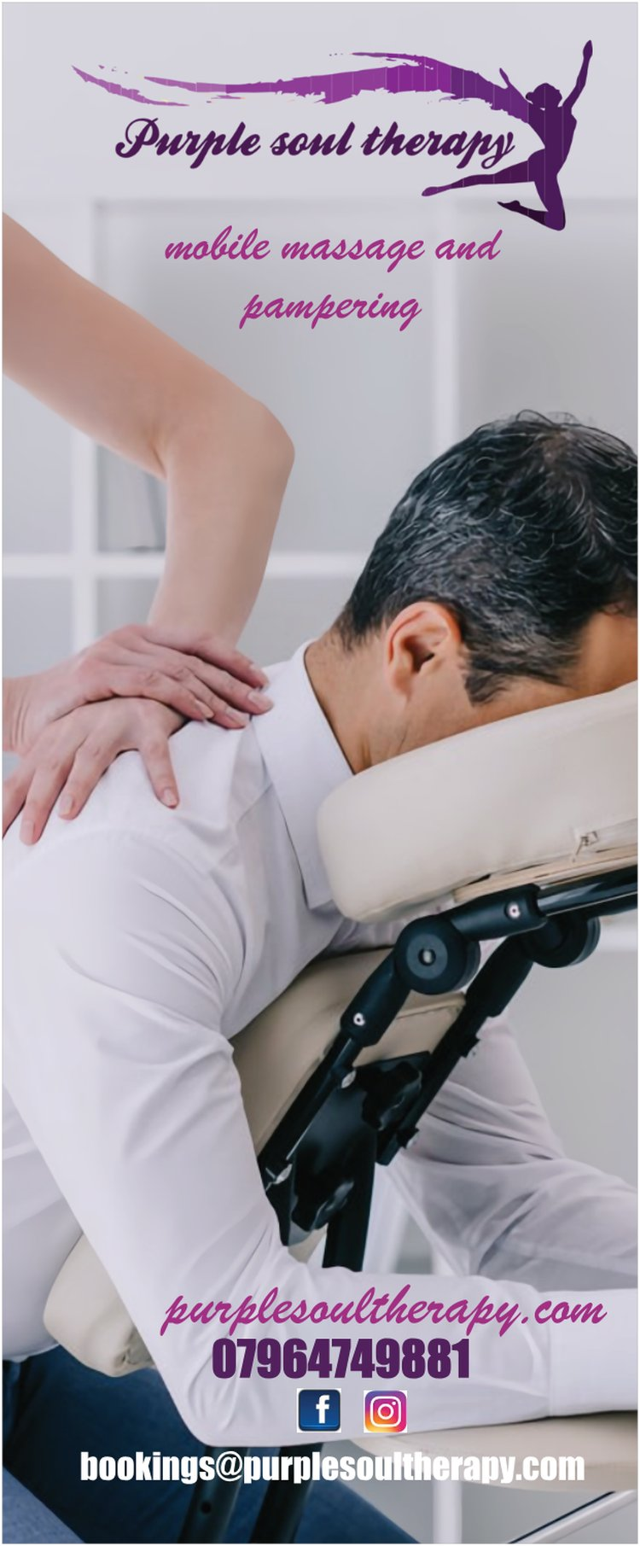STAND up BANNER a people stopper

Annexe 3

Print screens about our collaboration with freelancers to complete our aims and objectives
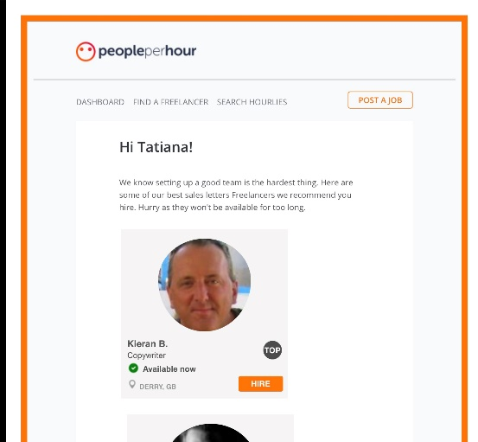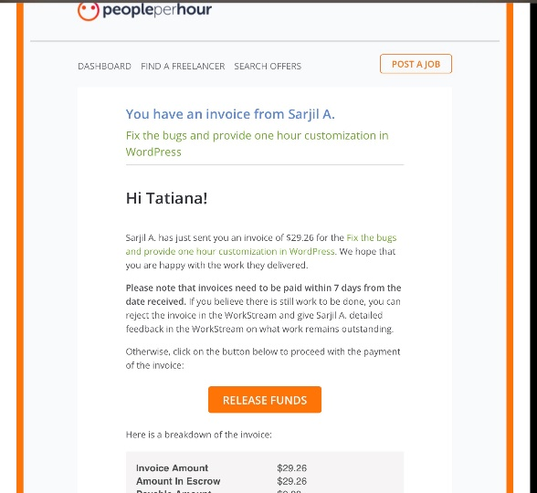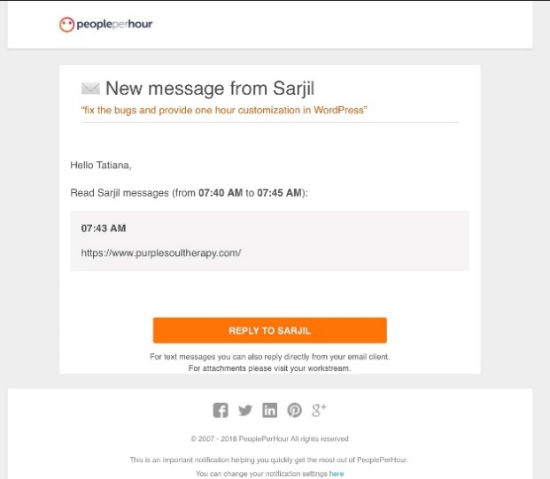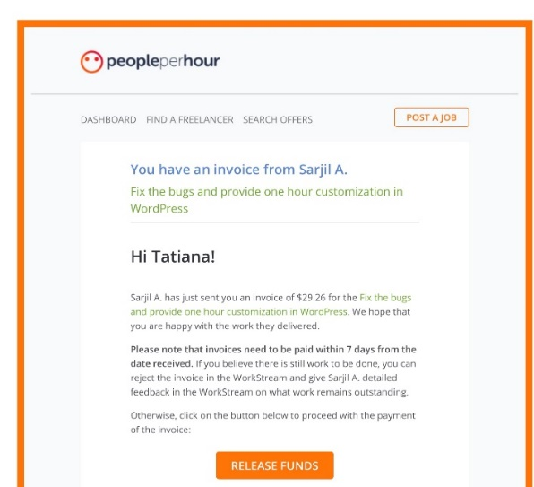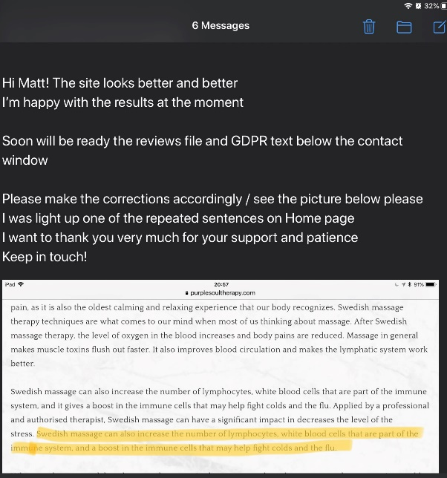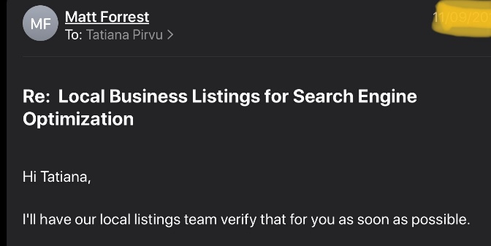

Snapshots with our website www.purplesoultherapy.com

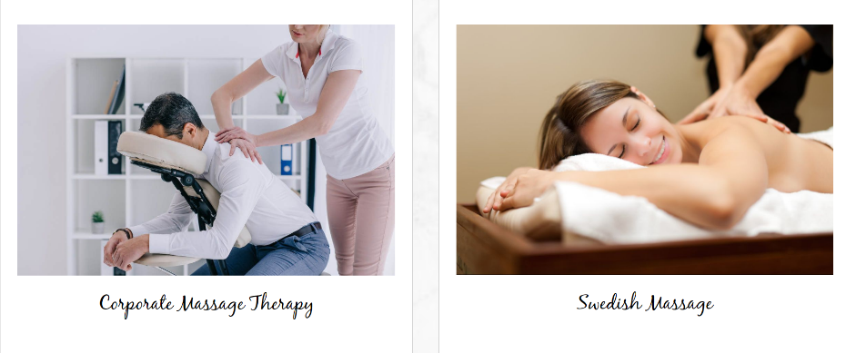

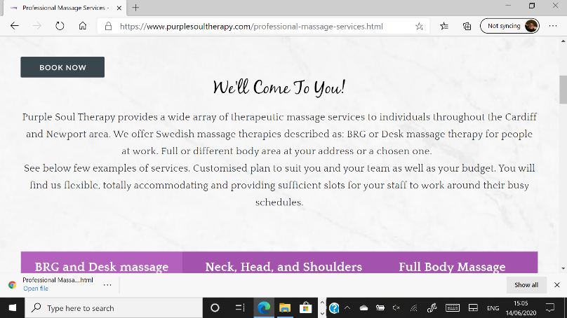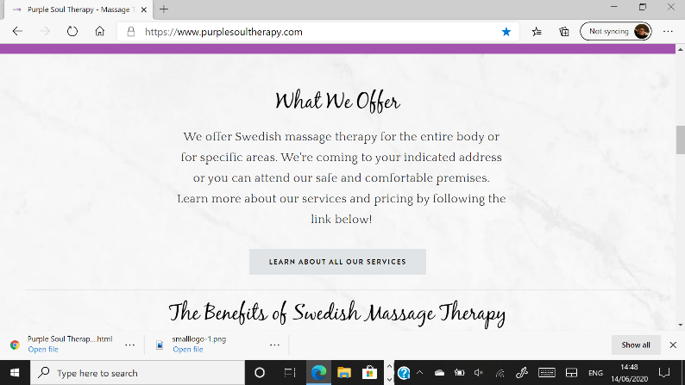

Negotiations and collaborations/joint ventures research -temporary/occasionally rented space for our customer's comfort
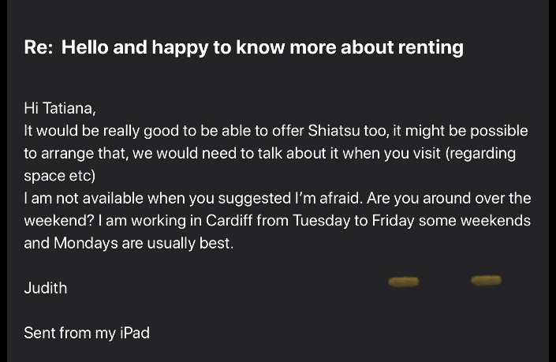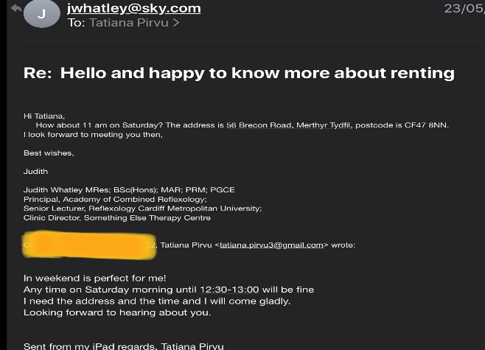
Collaboration with companies in case of emergency for a contingency action plan
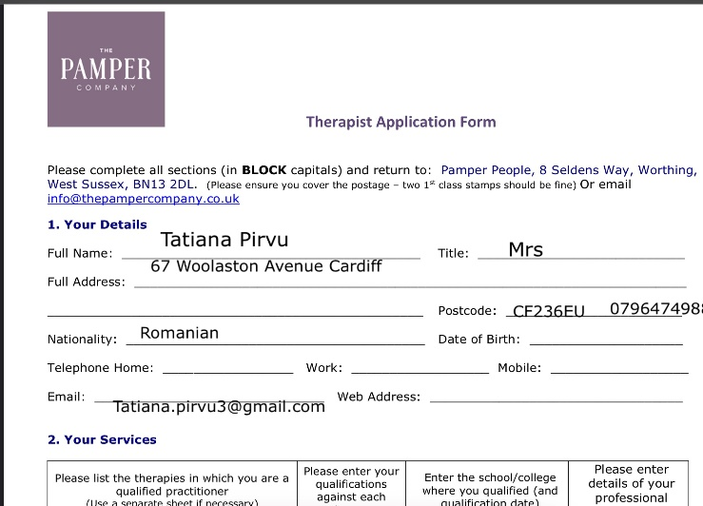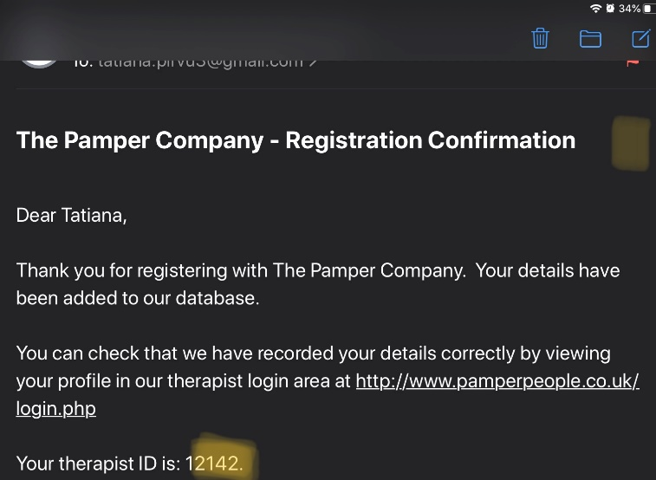

Annexe 4


