Title Page

Student Name: Sonam Akhtar
Student Number: 2439007
Module Number: LCLM4001_BIRM
Title: Academic Skills
Lecturer's Name: Reza Taghizadeh
Assignment Title: Reflective Writing

Table of Contents

Title Page 1
Table of Contents 2
Introduction 3
Description of Experiences 3
Analysis and Personal Reflection 3
Conclusion 4
Reference List: 5
Appendix A 6

  - Introduction
At the start of this module, I did not realise how much I would grow not only academically but also in the way I think, reflect, and learn. This reflective report will investigate and analyse my learning experience throughout the academic skills module. Reflection is a crucial step in any practice as it allows us to look back and grow. I will critically analyse specific activities, topics, and experiences; for instance, paraphrasing, the in-class quiz, and the application of academic skills exercises. I will identify my strengths and areas for improvement. I will use Gibbs’ reflective model (1988) to assist me in reflecting on my journey. Bassot (2024) believes that the Gibbs model (1988) is a more thorough reflection model in contrast to others, as it has a greater level of reflection due to the prominence of feelings (see Appendix A for Gibbs' reflective cycle (1988). Furthermore, I will develop a clear action plan and employ my academic skills along with the theories I have learnt to advance my education.
  - Description of Experiences
At the beginning of my academic journey, we learnt many important academic skills, including time management. Throughout the academic module, I engaged in various activities, such as creating a mind map and completing a crossword puzzle. A key activity that occurred, which significantly impacted my learning, was completing information skills through Moodle. Initially, I felt anxious and overwhelmed by the amount of information I was expected to learn, especially after discovering that we could be assessed on topics related to information skills in our quiz. However, after making short notes to help me remember key details, I felt more confident. Completing the information skills helped me gain a better understanding of the academic module and learn at my own pace; however, I was unable to finish the information skills during class time and had to set aside time at home to complete them. I faced this difficulty because I took the time to take notes to assist with revision. According to Nachiappan (2022), in certain situations, our handwritten notes prove to be invaluable. This makes revision easier and more effective. Overall, I learnt the importance of notetaking in this module. Moving forward, I will ensure that I take notes in a diagrammatic format to avoid wasting time writing full sentences; this will also help me during revision.

Analysis and Personal Reflection
There were several significant experiences during the academic module, including preparing for the skills quiz and completing an in-class assignment within a specified time limit, which involved paraphrasing and creating a mind map. Additionally, the library session, which introduced us to a website called ‘Cite Them Right’ (2025), played a vital role in helping me reference correctly.
Initially, I felt overwhelmed by the skills quiz because of the amount of information I was expected to learn. I also constantly feared that I would be unable to complete the in-class assignment within the set time limit. I was anxious about paraphrasing correctly because I did not want to accidentally commit plagiarism. However, when a member from the library explained the use of a website called ‘cite them right’ (2025), it boosted my confidence and made me feel more comfortable referencing. I also appreciated the support from my lecturer, as he was available to help with any questions.
I faced numerous successes and challenges throughout my academic journey. A positive aspect was that making short notes helped me to revise and prepare for the skills quiz; however, I had to allocate time from home every morning and evening to ensure I could go through my notes in time. Additionally, we were given time just before the quiz to help refresh our minds. While completing the in-class assignment, which I managed to finish within the allotted time, I had to decide which task to start with first. I began by writing a paragraph and spent a little too long re-writing sentences, which left me less time to complete the mind map, which I saved for last. The library session was successful as it helped me finish my first assignment for another module by allowing me to reference correctly and apply what I had learnt about paraphrasing.
These experiences emphasised the importance of time management, as I had to allocate time from home, leaving less time to spend with family. Bast (2016) believes that individuals who do not manage their time well will scarcely have time for leisure, as students are constantly overwhelmed with assignments, quizzes, and in-class tests. I faced these challenges because I did not create a study plan to help manage my revision time and to highlight which topics to prioritise. During the in-class assignment, I also struggled with time. I spent most of my time writing a paragraph, which increased the pressure to finish the other tasks more quickly. When a library member visited us in class, I was unsure how to reference correctly, as I had never needed to use Harvard referencing and was unsure of what was required.
Overall, the academic module has been an essential part of my educational journey as it has taught me a great deal, such as the importance of time management and how to reference correctly. I now understand what is needed to paraphrase successfully and the significance of paraphrasing throughout my academic learning. While there is still room for improvement, my initial anxiety has transformed into motivation to learn.
In the future, I plan to use the time management strategies I have learnt and implement them to better organise my time, ensuring I do not feel stressed or overwhelmed. Additionally, I will create a study plan to guide me throughout the rest of my academic journey so I can avoid falling behind. I also intend to use the website ‘cite them right’ (2025) to ensure I can reference correctly in my assignments.

Conclusion
In conclusion, this report showed that the academic skills module has been valuable through activities such as paraphrasing, information skills, and in-class assignments. I now have a clearer understanding of academic writing. Using Gibbs’ reflective model (1988) helped me reflect on and identify my strengths and weaknesses, and it also enabled me to analyse how I felt and responded to different academic challenges. As a result, I now recognise the importance of reflection. Trimasse (2025) believes that to develop both professionally and personally, reflective skills are essential. I aim to become a better student through regular reflection and plan to incorporate this practice into future modules.

  - Reference List:
Bassot, B. (2024) The reflective journal. 4th edition. London: Bloomsbury.
Bast, F. (2016) ‘Crux of time management for students’, Resonance, 21(1), pp. 71–88.
Bitesize Learning. (2024). Gibbs’ Reflective Cycle explained: Diagram & examples. Available at: https://www.bitesizelearning.co.uk/resources/gibbs-reflective-cycle-explained-diagram-examples (Accessed: 3rd July 2025)
Bloomsbury Academic (2025) Cite them right. Available at: https://www-citethemrightonline-com.ezproxy.uwtsd.ac.uk/home (Accessed on 5th July 2025)
Gibbs, G. (1988) Learning by doing: A guide to teaching and learning methods, Further. London: Education Unit.
Nachiappan, S. (2022) ‘Note-taking and note-making: The ever-cherished art’, Indian journal of Ophthalmology. 2nd Edition, 70(12), pp. 4438–4444.
Trimasse, N. (2025) ‘The use of reflective reports in higher education’, Reflective practice, 26(1), pp. 154–171.

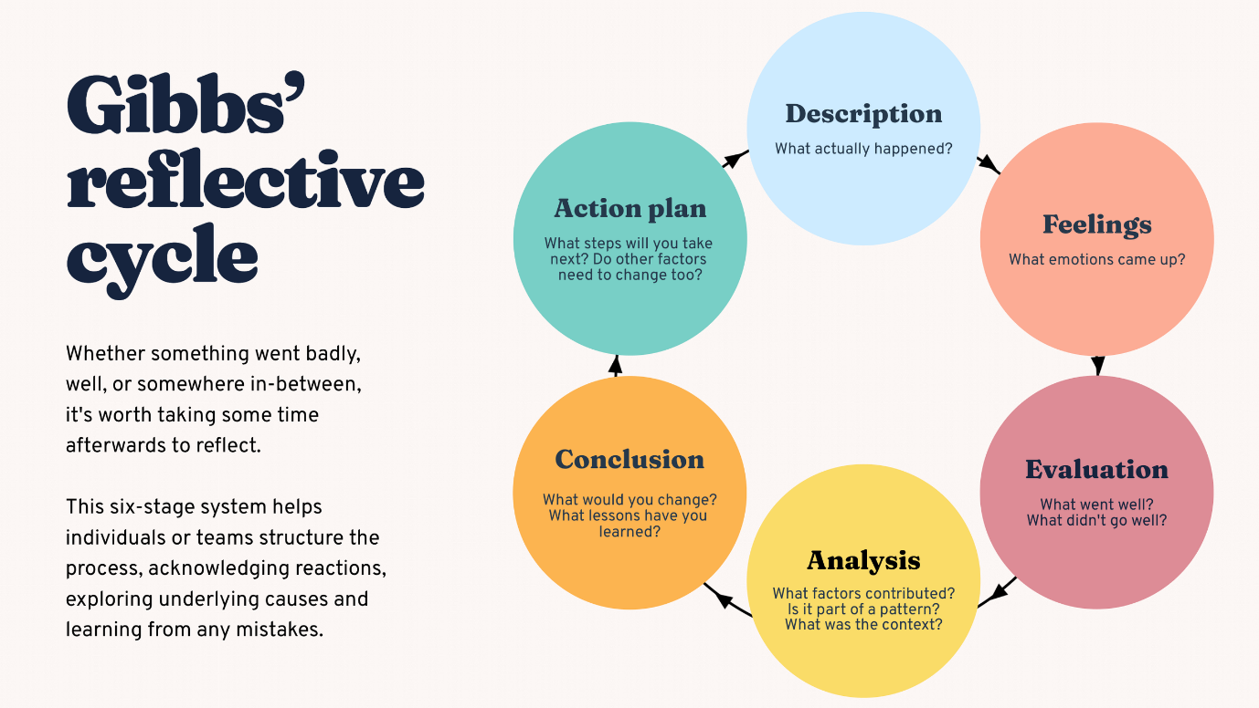
Appendix A:
Figure A: Shows Gibbs' Reflective Cycle

