Research In Practice
Identity, survival and motherhood

Student Name:
Chloe Lloyd

Student number:
1906286

Course:
BA (hons) Photography in The Arts

Module:
Research in Practice (ADAD5004/C)

Lecturer:
Paul Duerinckx

Word Count: 2444
(Before reference and citation)

In this research document, I will be investigating the meaning of three keywords, identity, survival and motherhood. During the research I will discuss each topic and reflect how each keyword can affect not only parents but most individuals. I am going to research deeper into how the three keywords affect and can change the psychological thinking, behaviour and emotions of women who become mothers. I will include artists and theorists who have included the discussion topics within their own work. I chose the three words as they represent aspects of my life, as individuals we all struggle to survive, every person has felt as though their identity changes over time, or due to certain events in their lives and lastly as a woman we are consumed with so many changes in our lives, but we are especially impacted physically and emotionally when we become mothers.

Identity

Identity is the distinguishing personality of an individual. As individuals we are all unique, we each have characteristics, qualities, experiences and interests that differ from other individuals, making us distinct from anyone else. Identity is who we are, activities we enjoy, foods we love to eat, books we read, movies we like to watch. Our identity is also our sexual orientation, religious, cultural, social and political beliefs. Our identity is also based on the way we look. Physical identity defines us by gender, race, height, weight, eye colour and even our hair colour. (Personal identity)
Erik Homburger Erikson was a German developmental psychologist and psychoanalyst, he was known for his theory on psychological development of human beings. (“Erik Erikson Biography - American German-born psychoanalyst & essayist ...”) Erikson coined the phrase “identity crisis”. The development of identity had been one of Erikson’s biggest concerns in his own life, which he referred to in his theories. Erikson’s interest in identity began during his childhood as he always felt like an outsider. Erikson’s mother Karla Abrahamsen was from a prominent Jewish family in Denmark, Karla married a Jewish stockbroker named Valdemar Salomonsen. Karla had become pregnant when she was estranged from her husband, and little is known of Erikson’s biological father. When Karla discovered she was pregnant she fled to Germany, Erik was born 15 June 1902 and she gave him the surname Salomonsen. In 1905 Karla married Jewish paediatrician Theodor Homburger, Erikson was officially adopted by his stepfather and became Erik Homburger. Karla and Theodor brought Erik up to believe Theodor Homburger was his biological father.
Growing up, Erikson felt he did not belong, he was unsure of his identity, he was tall, blonde, blue eyed and was being raised in the Jewish faith, at his Jewish temple school he was teased for being Nordic looking which made him stand out from his peers. At Grammar school he was teased for being a Jew. Erikson left school without any academic distinctions and did not know what career to pursue, his stepfather had wanted him to go to medical school, instead Erikson went to art school but only for a short time before deciding to drop out and go travelling to contemplate his own identity. (Cherry, 2022)
Raphael Segarra aka “Finok” is a Brazilian contemporary artist, he has become one of the most prolific names on the streets of Sao Paulo. Finok addresses lost identity, loss of individuality and loss of cultures and traditions in contemporary society. Finok’s solo exhibition “Identity Loss” examines identity in different cultures and looks how they are placed and varied into our lives.

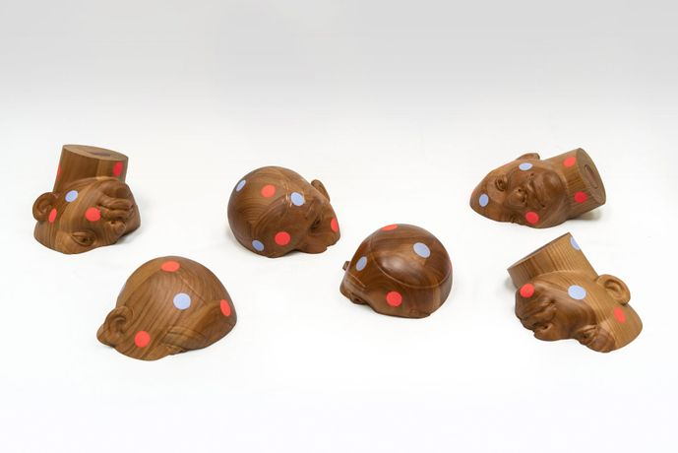
Figure 1 (2021) Finok, identity loss (accessed: 19 May 2023)

Finok visually explores many traditions, he uses his own identity and roots in Brazil to show the relationship of Carnival and its identity that has been forgotten and re-interpretated for our existing globalised world. Finok frequently uses faded or obstructed faces in his work to address temporality of identity, each erased painting on a wall is like a deleted story from the page of a book. Finok furthers his representation with his use of tiles in his exhibitions, he shows how a tile placed on a wall, then covered by another tile, changes the story, identity and history of the previous tile, proving how identity can be lost, changed, forgotten or erased. (Finok)
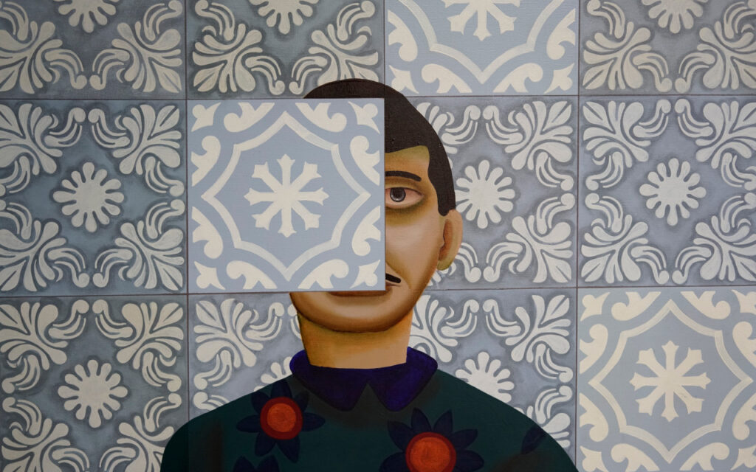
Figure 2 (2021) Finok, Identity Loss (accessed: 19 May 2023)

Finok’s work is also inspired by geometric patterns and contrasting colours of Senhor do Bonfirm ribbons. Senhor do Bonfirm is a municipality in the Northeast region of Brazil, in the state of Bahia. During ancient times the ribbons had been made from strips of saints clothing, they had typically been worn around the wrists or ankles of individuals and made into medallions to provide them with protection and luck. Churches in Brazil would also display the ribbons on their gates in honour of the Saints and in the belief the ribbons would keep them healthy and strong and as reminder of their faith. Nowadays the use of the ribbons has been lost and even mischaracterised, as they are now used as decorations on hats, bags, scarfs, wallets and even home décor. Tourists who visit Brazil, usually buy the ribbons as a souvenir of their stay or even T-shirts, towels, and key chains displaying the print of the ribbons. Tourism has been one of the biggest contributors to the emergence of the current ribbons, modifying and broadcasting the ribbons as a prop with the power to perform miracles, assisting in the ribbons losing their identity.

Survival
The meaning of survival is to continue to live or exist despite difficult circumstances, ordeal or accident. Survival is accepting your current circumstances, trying to improve them, while sustaining your life until you can get out of the situation. Survival depends on an individual’s ability to withstand stress, especially in emergency situations. (Survival definition & meaning) Our brains are our most powerful tool, as mental skills are more important than physical skills in survival and emergency situations. We do not have to be physically strong but mentally strong to react effectively and use available resources to enable us to survive. Psychological state and attitude are the most important ingredient of survival, with the correct attitude anything is possible. To make it through the worst of situations, determination, strong will and a powerful desire to live is a must. Surviving wilderness emergencies, will alone is a major factor, without will to live survival is impossible. Commitment to live, refusal to give up and a positive mental attitude greatly increase our chances of survival.
Larry Towell is a Canadian photojournalist, photographer, poet and historian, he is well known for his images of conflict and natural disasters. Towell was born in 1953, he became interested in photography while he was studying visual arts at York University in Toronto. In 1984 Towell became a freelance photographer, his early works include projects on the Contra war in Nicaragua, the civil war in El Salvador and Vietnam veterans. Towell’s images of natural disasters include Hurricane Katrina and the Exxon Valdez oil spill. Hurricane Katrina was a category five hurricane which struck the US Gulf coast. The hurricane caused widespread devastation from central Florida to Texas. Greater New Orleans suffered flooding in eighty percent of the city. New Orleans was flooded for weeks, the flooding from the hurricane destroyed most of New Orleans transportation and communication facilities, tens of thousands of people were left to survive without little to no access to food, shelter and necessities. Rescue operations were set up to evacuate the people who had survived and had now found themselves displaced. Larry Towell travelled along the coast of Alabama, Louisiana and Mississippi, documenting the dramatic aftermath. Towell was accompanied by novelist Ace Atkins. Towell’s images were published in his book “In the Wake of Katrina”. The images depict the devastation of the hurricanes impact and is also a tribute to human endurance. Towell had photographed the World Trade Centre attack in September 2001, which lead him to want to investigate for himself what had happened in Afghanistan since then. Towell arrived in Afghanistan in 2008, (Larry Towell - Biography) by that time most news channels no longer had regular coverage of the ongoing conflict, as news outlets found it was extremely dangerous to place themselves in the middle of a war zone. Towell catalogued in his book “Afghanistan” improvised explosive devices and the landmines that litter the country, along with the survivors who had been maimed by them.
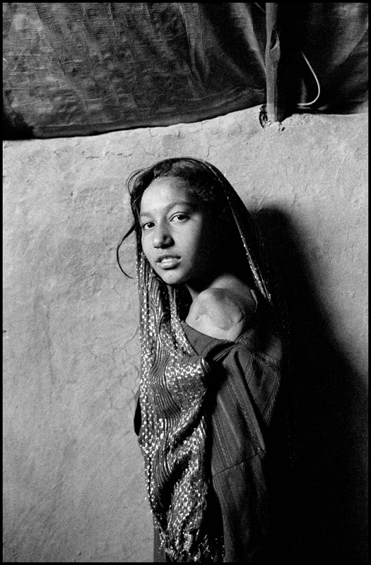
Figure 3 (2011) Juma Gul, Charahi Qambar Refugee camp Kabul, Afghanistan (accessed: 19 May 2023)
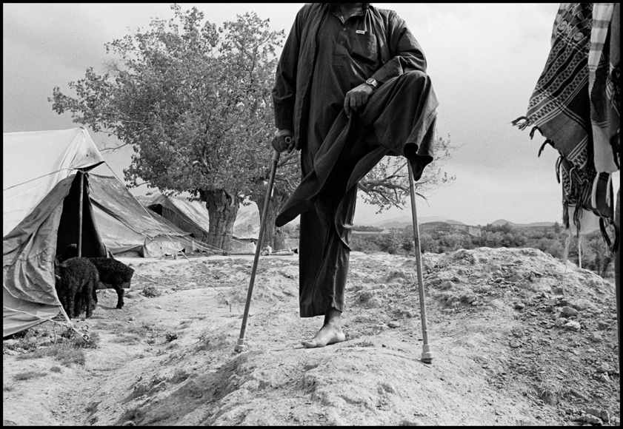
Figure 4 (2009) Kochi (nomad) landmine victim with tents for sheep and family members Shomoli Plain, Afghanistan (accessed: 19 May 2023)

Herbert Spencer was an English philosopher, psychologist, biologist, sociologist and anthropologist. (“Herbert Spencer Explained”) Spencer introduced the expression “survival of the fittest”, which he used in his work “Principles of Biology” in 1864. Spencer believed only species which can adapt themselves within their changing climate and conditions could survive on earth. Spencer believed when there was competition among individuals, he believed it would cause a rise of only strong successful individuals within society. Spencer considered survival of the fittest was also down to natural selection, not only in humans but animals and organisms, creating a gradual improvement with human society and all species, believing only the weak would become extinct. (Herbert Spencer 2023)

Motherhood
Motherhood is the state of being a mother. Motherhood is a gender specific term for parenthood. A person enters motherhood when they become a mother, this usually happens when their first child is born. Some women become mothers by adoption or by marrying/ becoming a partner to someone who already has children. (motherhood/concepts 2023)
Elinor Carucci is an Israeli American fine art photographer, who has published four monographs to date. Carucci’s third monograph “Mother” was published in 2013. Mother examines the world of her own motherhood, it began during her pregnancy of her twins and ended when the twins turned eight years of age. Carucci’s journey of motherhood began in 2004 when she became mother to daughter Emmanuelle and son Eden. Motherhood did not begin smoothly for Carucci, at the end of her pregnancy she had to be induced and go through labour, only to have an emergency caesarean that left her weak and in pain. A few days later she was sent home to begin her new life as a mother of twins. Carucci wanted to explore and display the realities of motherhood in her images, the complex moments, the joys the pain, the beautiful and the ugly, the love and the dysfunctions. In her photographs Carucci captures the connection and bond between mother and child, with a range of photographs reflecting the honest highs and lows, bliss to the raw and less attractive moments. Carucci stated “As I was getting to know my babies, I was also getting to know myself better. Motherhood revealed the best and worst in me. (Jansen, 2020) I was filled with so many emotions, joy and wonder, love and happiness coexisted with sadness, anger, exhaustion and anxiety, as well as a sense of mourning for the body I would never have again, the woman I would never be again.”
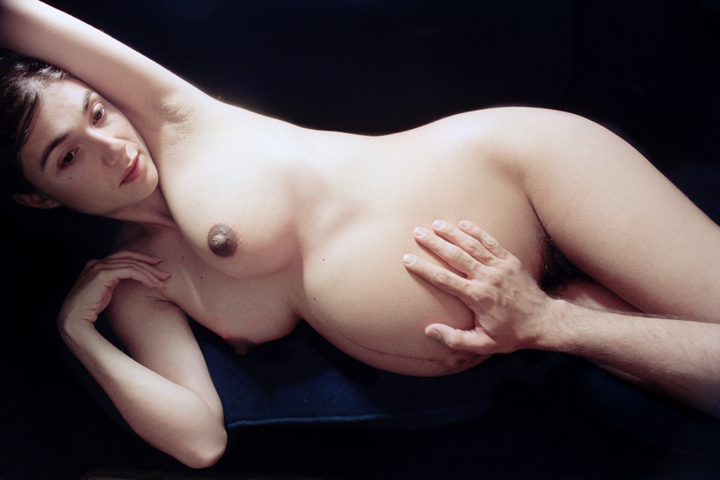
Figure 5 (2004) feeling me (accessed: 19 May 2023)

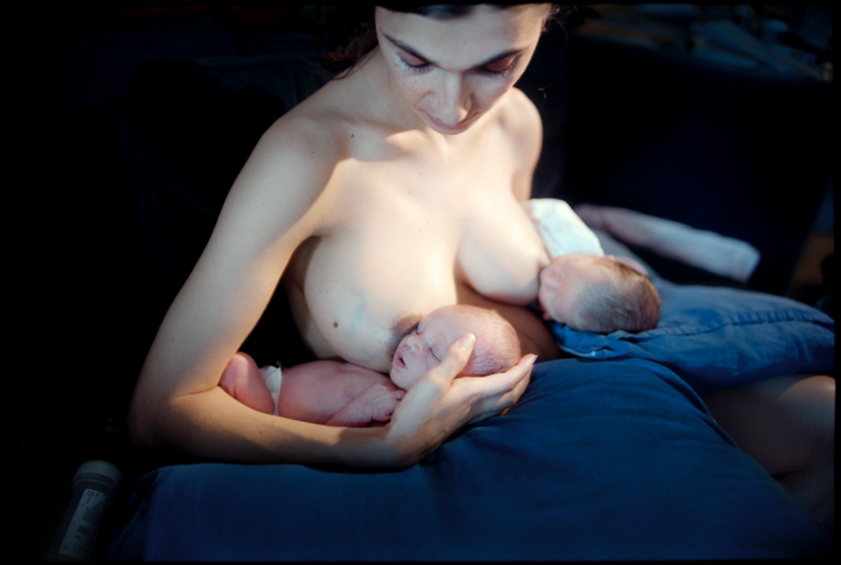
Figure 6 (2004) the first week (accessed: 19 May 2023)

Kate Babetin is a registered psychotherapist whose writing, “The birth of a mother” was published in the Journal of prenatal and perinatal psychology and Health. Babetin has written how there is no experience in a woman’s life that is more impactful and life altering than becoming a mother. (The birth of a mother a psych) Babetin’s article explores the psychological birth of a mother by exploring the topics; the various stages of transformation; factors that influence the transformation; and the ways how a woman’s identity, career and relationships change. Motherhood changes a woman because it alters the brain structurally and functionally. Transformation from woman to mother is something most women are not fully prepared for. Becoming a mother has not been medically explored as much as how the baby turns out. The transformation is more apparent for mothers rather than fathers as they have grown and carried the child in their body and started to form a bond with their unborn baby. The birth of a baby creates physical pain in labour, the birth of a mother has its own labour, but it is not physical it is emotional. Moments after delivery of a baby are vital for mothers and baby to bond, with a good bond, mothers are more attentive and supportive, when a baby is separated from its mother, typically with premature births, it can have a devastating psychological effect on the mother. Within a few weeks after birth, most women have fully accepted their new role and feel like a mother. Mothers are very adaptable, becoming a mother can change their feelings for their future, it may also depict which path they next travel. Mothers who are experiencing the transformation between woman to motherhood, may want or must change their careers, form new relationships with new friends, who have more in common with them and adjust to their relationships with their spouse postpartum. Their everyday life changes, they are usually the ones who have to consider childcare, days out with a new baby, whilst trying to be all they were before the birth of their baby. Despite all the challenges and sleepless nights and all the responsibilities that mothers may have, most mothers would not change their lives after motherhood, they have pure love for their children and are grateful for the transformation within their lives, they see their children as a blessing.

Survival, identity and motherhood are all entwined and immerge, disappear and re-immerge in our lives numerous times. As a woman we use our basic survival skills to gain careers, work our way up career ladders in a male dominant society, we have to adapt, become fierce and change our attitude towards our receptors, either by acting feminine, ladylike and submissive, or by being headstrong, independent, forceful and fierce as our male counterparts and colleagues. We have to keep changing our identity throughout our lives, we sometimes can become lost along the way as so much of life impacts our behaviour and thought process. We go from being sexually seductive, strong independent women, career obsessed, to being submissive spouse, domesticated goddess’ and mothers who try to become all the above. We have to keep a positive mental attitude to survive each ongoing change and transformation in our lives. When women become first time mothers, it can cause women to have a negative reaction, not only about their body changes, their relationships with friends, partners and husbands, it can impact on their identity, they no longer know who they are, they may not feel like a good mother, they may feel like they no longer exist to a particular group of friends or work colleagues. Usually, a woman is adaptable and finds a way to deal with all that life throws at her, including having to juggle childcare, work, keeping their relationship happy and sensual, all while being immersed within different roles, she feels are expected of her, by society, spouse and other mothers.

Which poses the question, how do women use survival skills to adapt, keep and renew their identity while being submerged in motherhood?

Figure list

Figure 1
Identity loss - exhibition at STOLENSPACE Gallery in London (no date) ArtRabbit. Available at: https://www.artrabbit.com/events/identity-loss (Accessed: 19 May 2023).
Figure 2
Finok : Identity loss (2023) StolenSpace Gallery. Available at: https://www.stolenspace.uk/portfolio_page/finok-identity-loss/ (Accessed: 19 May 2023).
Figure 3
Larry Towell - Afghanistan (no date) Stephen Bulger Gallery. Available at: https://www.bulgergallery.com/artists/110-larry-towell/series/afghanistan/#/image_popup/artwork19873/ (Accessed: 19 May 2023).
Figure 4
Larry Towell’s Afghanistan • Magnum Photos Magnum Photos (no date) Magnum Photos. Available at: https://www.magnumphotos.com/arts-culture/larry-towell-afghanistan/ (Accessed: 19 May 2023).

Figure 5
Jansen, W. by C. (2020) Elinor Carucci: Motherhood revealed the best and Worst in me, ELEPHANT. Available at: https://elephant.art/motherhood-revealed-best-worst/ (Accessed: 19 May 2023).
Figure 6
(No date) The first week. Available at: https://www.28vignonstreet.com/en/artworks/elinor-carucci/the-first-week (Accessed: 19 May 2023).

Bibliography
Jansen, W. by C. (2020) Elinor Carucci: Motherhood revealed the best and Worst in me, ELEPHANT. Available at: https://elephant.art/motherhood-revealed-best-worst/ (Accessed: 19 May 2023).
The birth of a mother a psych (no date) Scribd. Available at: https://www.scribd.com/document/558532562/The-Birth-of-a-Mother-A-Psych# (Accessed: 19 May 2023).
." encyclopedia of european social history. . encyclopedia.com. 4 may. 2023 . (2023) Encyclopedia.com. Available at: https://www.encyclopedia.com/social-sciences-and-law/sociology-and-social-reform/sociology-general-terms-and-concepts/motherhood (Accessed: 19 May 2023).
Herbert Spencer (2023) Encyclopædia Britannica. Available at: https://www.britannica.com/biography/Herbert-Spencer (Accessed: 19 May 2023).
Larry Towell - Biography (no date) Stephen Bulger Gallery. Available at: https://www.bulgergallery.com/artists/110-larry-towell/biography/ (Accessed: 19 May 2023).
Survival definition & meaning (no date) Dictionary.com. Available at: https://www.dictionary.com/browse/survival (Accessed: 19 May 2023).
Finok (no date) Widewalls. Available at: https://www.widewalls.ch/artists/finok (Accessed: 19 May 2023).
Cherry, K. (2022) How people develop an identity or cope with role confusion, Verywell Mind. Available at: https://www.verywellmind.com/identity-versus-confusion-2795735 (Accessed: 19 May 2023).
Erik Erikson Biography - American German-born psychoanalyst & essayist ..., https://pantheon.world/profile/person/Erik_Erikson/.
Personal identity (no date) Oxford Reference. Available at: https://www.oxfordreference.com/display/10.1093/oi/authority.20110803100319176;jsessionid=954E014CDFC4A754C0B7754F896B23A1#:~:text=(identity)%20A%20phenomenological%20sense%20of,over%20time%3B%20a%20self%20image. (Accessed: 19 May 2023).

