Submission #2-5 – Interim submissions, 500 words each
Name: Greg Thompson
Number: 1705753
Module: work-based project

What new skills did you learn in the period?

Within this time period I have learnt various key skills, the main being how to work under pressure and being able to manage various sub-contractors at the same time has been an aspect of this job that has being very challenging.

How have you been able to adapt / use the new skills learnt within the work environment?
e.g. time management / technical / soft skills

Having various sub – contractors on site at once has been difficult to keep track of their work and the budgets. I have adapted the way I keep track of the budget as I used to log costs as I go along and then review at the end of the project, whereas now I keep a running total against their quotation to ensure it does not exceed it. I do this with an excel spread sheet.

What was the highlight and why?

This question is for the end of the project.

What part of the task / activity were most challenging and least challenging?

The most challenging part of this project is ensuring the work is done inline with the programme of works. We have had a lot of direct labour on site last week, we are currently ahead of schedule based on the programme of works.
The problem I was faced with was I had to get the solar panels removed from both roofs at the same time. This created an issue as both sets were disconnected at the same time creating no power being generated. After various discussions, this was resolved, and we are now trying our best to get both roofs completed as soon as possible.

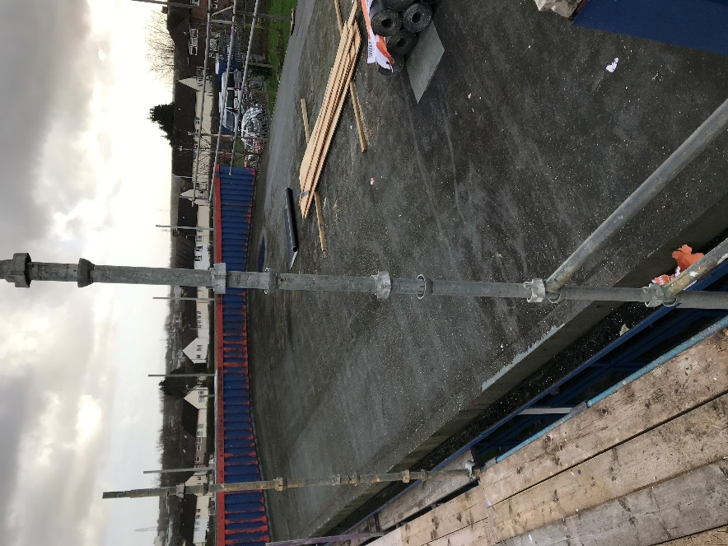
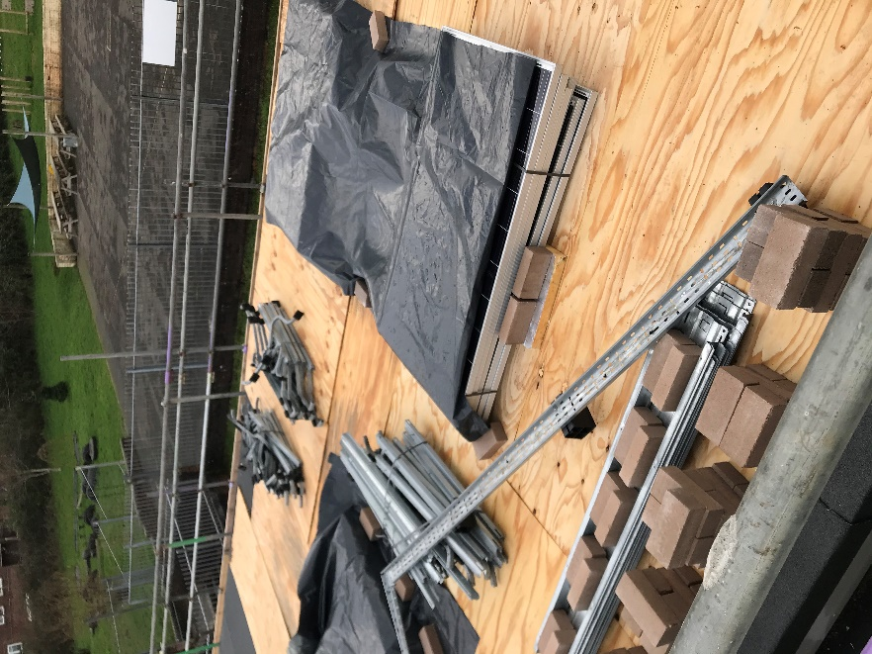

Another issue that is apparent is the waste coming off the roofs, we are not allowed a skip on site due to the small site compound. This creates a low of waste on the roofs, which is often hard to control. As show in images below. This can create poor working conditions and have a knock-on effect on the time scales that we have set ourselves.

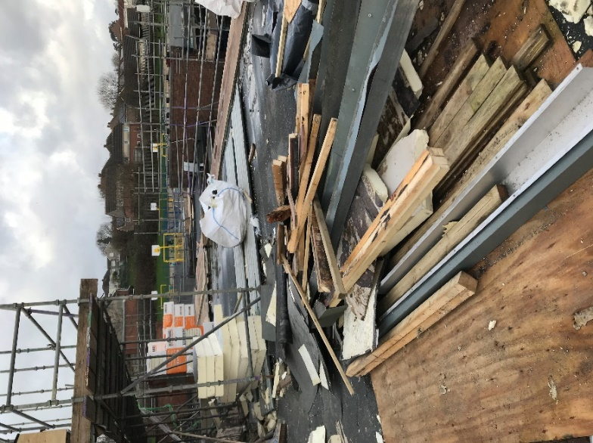
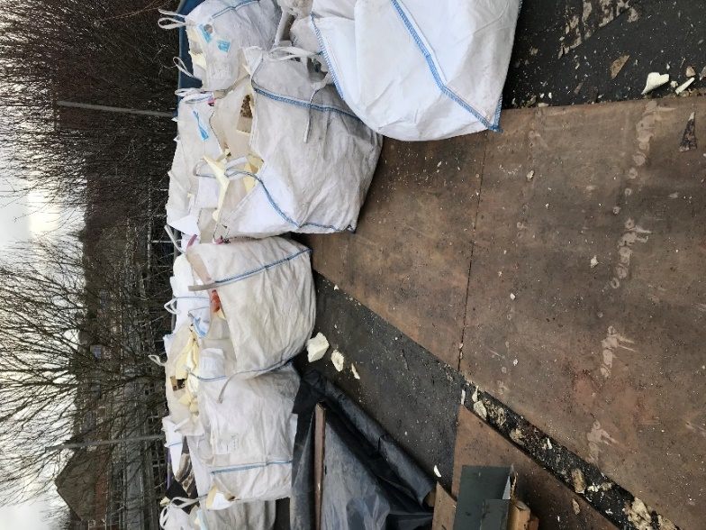

The least challenging part of this project is the day to day organising, I have a great contracts manager and site manager that help ensure material orders are always sent over with two days in advance to allow me to order them in time. Making sure the men are all in the correct PPE, all health and safety forms are filled in. This has been a huge help with the project.

How are you progressing according to your objectives (learning contract)?

I have completed various site audits and meetings with the site manager meetings to ensure works are going ahead according to plan and have been carried out in the highest order, leaving no defects. With so many members of staff on site, house keeping has been an issue. So, I do a site walk around every couple of days ensuring no rubbish has built up.

