SOFTWARE DEVELOPMENT

Table of Contents
Section 2 3
Introduction 3
PART A (UNDERSTANDING) 3
1. Introduction to array and its importance 3
2. Concept of Inheritance 4
PART B (TESTING) 10
PART C (IMPLEMENTATION) 11
Conclusion 15

Section 2

Introduction
OOPS concepts are mostly used for providing a clear modular structure for the programs that hence defines abstract datatypes that hides the details of implementation. By taking the help of OOPSs, it is easier to modify and maintain the existing codes as here the new objects are created by allowing a smaller difference to the ones that already exist in the system. Four basic concepts that are provided by this terminology are inheritance, abstraction, polymorphism as well as encapsulation. Encapsulation concept is often used for bundling the data along with the methods that are operating on that particular data. Polymorphism is describing various classes used by taking the help of a similar interface. The concept of inheritance tells that a child class in inheriting the features from the parent class. On the other hand, abstraction is used for hiding the details of internal implementation within a system.

PART A (UNDERSTANDING)

1. Introduction to array and its importance
An array is termed as the group of variables having the same type and can be referred by a common name. In an array, each of the data items is considered to be the element of the array. The data types of the elements can be of the valid type of data such as int, float, char, etc. and also, the elements are stored in a contagious location (Beller et al2017, p.356). Also, the length of the array is specifying the number of elements available in the array. In the case of C#, memory allocation is done dynamically and mostly, the kind of array is an object. For such reason, finding the size of the array with the help of predefined functions is very easy (Cservenka, 2018, p.805). In this case, it is also observed that. The variables present in the array are in an ordered manner and each of them is having an index that begins with 0 (Panda, 2020, p.,352). Array in the case of C# works differently from C or C++. Thus, for the arrays in C#, there are some points that must be considered:
- By taking the help of member lengths, the length of the arrays can be easily found as the arrays in C# are considered as objects.
- Array variable in the case of C# can be declared like other variables by putting [] after the mentioned data type.
- Here, the elements of the jagged array are often initialized to null and are of reference types (Homann and Laenen, 2018, p.325).
In any programming language, the array can represent multiple items of data having the same type with the help of a single name. Apart from that, this also helps in accessing the elements randomly by simply using the index number.
Example
string[] cars = {"Volvo", "BMW", "Ford", "Mazda"};
Console.WriteLine(cars[0]);
From the above example, it can be observed that all types of car are represented by a single name car. So, this is an array of data type “string”. Here, cars [0] shows the first element of the array i.e. Volvo.

2. Concept of Inheritance
Inheritance is the most important concept used in OOPs. This helps in defining a class in terms of another class that makes the creation and maintenance of the application easier. This hence provides an opportunity for reusing the functionality of code and thus speeds up the time taken for implementation (Chakravathi, 2016, p.208). At the time of creating a class, without writing new data members and member functions, the programmer is able to designate the new class inherited by the existing class known as a base class and the new class is said to be the derived class. Inheritance mostly applies the idea of the IS-A relationship (Solanki, 2017., p.68).
Example of Inheritance in C#
using System;

namespace InheritanceApplication {
class Shape {
public void setWidth(int w) {
width = w;
}
public void setHeight(int h) {
height = h;
}
protected int width;
protected int height;
}

// Derived class
class Rectangle: Shape {
public int getArea() {
return (width * height);
}
}
class RectangleTester {
static void Main(string[] args) {
Rectangle Rect = new Rectangle();

Rect.setWidth(5);
Rect.setHeight(7);

// Print the area of the object.
Console.WriteLine("Total area: {0}", Rect.getArea());
Console.ReadKey();
}
}
}
From the above example, it can be observed that shape is the base class whereas Rectangle is the derived class that means all the properties of shapes are inherited by the rectangle.
The given below example demonstrates the program for multiple inheritances:
using System;

namespace InheritanceApplication {
class Shape {
public void setWidth(int w) {
width = w;
}
public void setHeight(int h) {
height = h;
}
protected int width;
protected int height;
}

// Base class PaintCost
public interface PaintCost {
int getCost(int area);
}

// Derived class
class Rectangle : Shape, PaintCost {
public int getArea() {
return (width * height);
}
public int getCost(int area) {
return area * 70;
}
}
class RectangleTester {
static void Main(string[] args) {
Rectangle Rect = new Rectangle();
int area;

Rect.setWidth(5);
Rect.setHeight(7);
area = Rect.getArea();

// Print the area of the object.
Console.WriteLine("Total area: {0}", Rect.getArea());
Console.WriteLine("Total paint cost: ${0}" ,Rect.getCost(area));
Console.ReadKey();
}
}
}
Following types of inheritance are supported by C#:
- In the case of single inheritance, derived classes can inherit the features of a single base class. From the image illustrated below, it can be seen that A is the base class whereas B is the derived class.
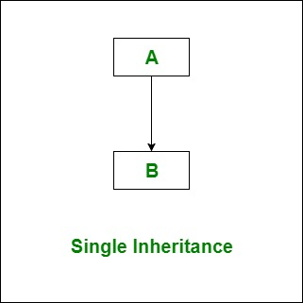
Figure 7: Single Inheritance
- Multilevel inheritance shows that a derived class can inherit a base class and also the derived class can act as the base class for any other class (Jones et al2016, p.232). From the figure, it can be observed that A is acting as the base class for B and then B is acting as a base class for C (Owe, 2016, p.210).
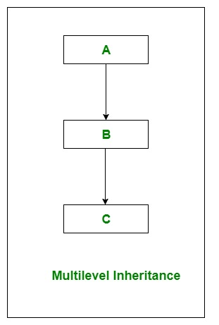
Figure 8: Multilevel Inheritance
- In the case of hierarchical inheritance, one class is serving as the base class (superclass) for more than a single derived class. The below figure shows that A is the base class for derived classes B, C and D (Baumgartner et al2019, p.12).
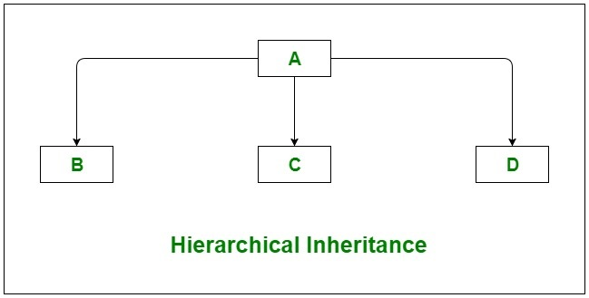
Figure 9: Hierarchical Inheritance
- In the case of C#, multiple inheritances are not supported. In order to implement such inheritance, there is a need to use interfaces. Here, class C is derived from both A and B interfaces (Maheswaran. and Aloysius, 2018, p.297).
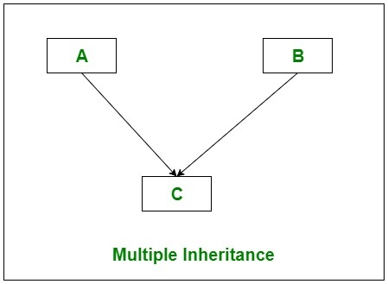
Figure 10: Multiple Inheritance
- As C# does not supports multiple inheritances, thus, here hybrid inheritance is also not possible. Thus, this is also done through interfaces. Hybrid inheritance is a mixture of two or more types of inheritance. From the below figure, it can be noticed that Class D is derived from the interfaces B and C and again both B and C are derived from A (Mukherjee, 2016, p.1).
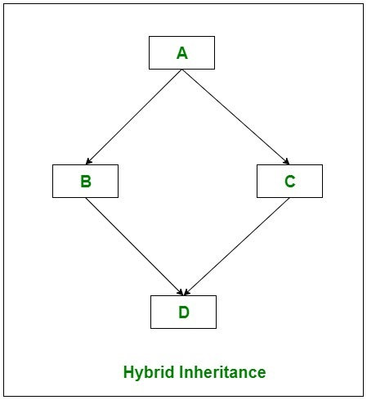
Figure 11: Hybrid Inheritance

PART B (TESTING)

 | Unit testing | Integration testing | Functional testing
Definition | In the case of unit testing, a single component from the entire system is tested. | Such testing is important for testing the components of the system that works together, i.e. multiple units can be tested for collaboration. | This testing is applied for testing the behaviour of the application according to the requirement.
Technique of testing | Here, white box technique is mostly applied (Drave et al2018, p.146). | In this testing, three types of techniques are applied such as white box, black box as well as a grey box. | Here, the black box technique is mostly preferred.
Level of Complexity | This is not much complex as the smallest codes are available here. | Slightly complex than the unit testing (Garousi et al2018, p.62) | As compared to the unit as well as integration testing, functional testing is the most complex one.
Errors | Unit testing often finds the issues that are occurring frequently in the modules. | At the time of integrating various modules, such testing finds difficulties. | This testing finds the issues that hinder the applications for performing its functionality (Lin et al2018, p.1). Along with that, it also includes some issues based on the scenarios.
Table 1: Comparing three types of testing
(Source:MEHTRE, and NIGAM, 2019, p.62)

PART C (IMPLEMENTATION)
For creating the classes, OOPs concept has been used in this section. Here, different methods have been utilized for storing the data like manufacturer, VRN, Model, number of seats, type, power, etc. The methods are created in such a manner that can hence set the speed for the vehicle, get information about forwards and backwards and so on.
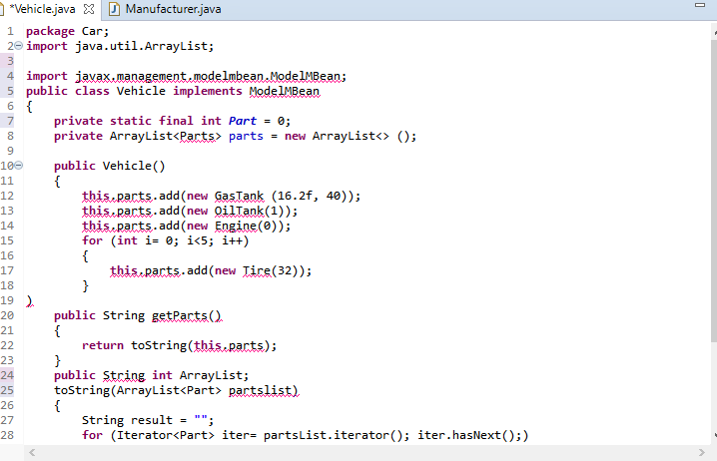
Figure 12: Showing the classes and methods in Vehicle
The given below source code has been implemented for running the program:
package Car;
import java.util.ArrayList;

import javax.management.modelmbean.ModelMBean;
public class Vehicle implements ModelMBean
{
private static final int Part = 0;
private ArrayList<Parts> parts = new ArrayList<> ();

public Vehicle()
{
this.parts.add(new Manufacturer Audi(20.1f, 45));
this.parts.add(new Model -Sportback(1));

this.parts.add(new GasTank (16.2f, 40));
this.parts.add(new OilTank(1));
this.parts.add(new Engine 1800cc(0));
for (int i= 0; i<5; i++)
{
this.parts.add(new Tire(32));
}
)
public String getParts()
{
return toString(this.parts);
}
public String int ArrayList;
toString(ArrayList<Part>partslist)
{
String result = "";
for (Iterator<Part>iter= partsList.iterator(); iter.hasNext();)
{
result += ((Part) iter.next().partName)= "\n";

}
return result;
}
}
}

In order to develop the code for the vehicle, at first, it is important to make a package for Vehicle. Then, for importing all the methods and functions related to the Array, the command: import java.utill.ArrayList is typed. As per the requirements, a public class Vehicle has been created. import javax.management.modelmbean.ModelMBean, is then used for implementing the ModelMBeans. Then, the array declaration is done. From this, it can be seen that Audi has been added as the manufacturer, name of the model for Audi is added as Sportsback and the new engine capacity is kept as 1800 cc. Then, the number of oil tank for Audi has been kept as 1. The next part of the program is used for getting the parts that further returns string value in order to measure the output. The ArrayList has been converted into a string by using the method toString(). This method has returned the string representation of the object. The next part is an iterator, that is used here for enabling a programmer for traversing the container particularly the array list. As here, the collection that is the list of the array cannot be modified, so here, the iterator is used for modifying the list.

package Car;
Public void run() {
try {
do {
float mileage = getFloat("How much mileage your vehicle is giving at present?");
OilTankoTank = null;
Engine engine = null;
for (int r = 0; r<parts.size(); r++) {
parts.get(r).function(mileage);
if (parts.get(r).partName == "oil tank") { oTank = (OilTank) parts.get(r); }
if (parts.get(r).partName == "engine") { engine = (Engine) parts.get(r); }
}
oTank.setEngineAgeModifier(1 + (engine.getLifeInMinutes() / engine.getBestCondition()));
} while (getBoolean("Going to Service Centre?"));
this.status();
} catch (CarCrashException e) {
System.out.println(e.getMessage());
System.out.println("Your car is not performing well, so buy a new one.");
} finally {
System.out.println("Thank you for driving responsibly.");
}
}
}
The above-mentioned source code shows the void run function that is used here for the generation of values in float and hence gives result about the mileage of the vehicle. This is also giving the boolean function that can be acted as a modifier thus, there is a need for using Boolean function here.

Conclusion
Section 2 represents the entire detail of the array. Several codes have been provided in this section for showing the working of inheritance concepts in OOPs. Along with that, the section also discussed the testing techniques. For testing, the researcher in this section chose unit testing, integration as well as functionality testing. A brief comparison has been made regarding the three types of testing. Lastly, a program has been delivered for representing a car. The program has demonstrated the declaration of methods as well as class. The last part also showed the programming for the modules such as speed of the vehicle, forwards and backwards, etc. The section also provided screenshots for java platform demonstrating the methods as well as classes of vehicle.

References
Beller, M., Gousios, G. and Zaidman, A., 2017, May. Oops, my tests broke the build: An explorative analysis of Travis CI with GitHub. In 2017 IEEE/ACM 14th International Conference on Mining Software Repositories (MSR) (pp. 356-367). IEEE.
Cservenka, M.H., 2018. Design and implementation of dynamic memory management in a reversible object-oriented programming language. arXiv preprint arXiv:1804.05097.
Panda, I., 2020. Object Oriented Programming.
Homann, H. and Laenen, F., 2018. SoAx: A generic C++ Structure of Arrays for handling particles in HPC codes. Computer Physics Communications, 224, pp.325-332.
Chakravathi, M.R., 2016. Study on Function Ambiguity in Inheritance Using Object Oriented Programming with C++, Java and C. International Journal of Computer Science and Software Engineering (IJCSSE), 5(9), pp.208-212.
Solanki, A.V., 2017. Virtual Base Class, Overloading and Overriding Design Pattern in Object Oriented Programming With C++. Asian Journal of Computer Science And Information Technology, pp.68-71.
Jones, T., Homer, M., Noble, J. and Bruce, K., 2016. Object inheritance without classes. In 30th European Conference on Object-Oriented Programming (ECOOP 2016). Schloss Dagstuhl-Leibniz-ZentrumfuerInformatik.
Owe, O., 2016, June. Reasoning about inheritance and unrestricted reuse in object-oriented concurrent systems. In International Conference on Integrated Formal Methods (pp. 210-225). Berlin: Springer, Cham.
Baumgartner, G., Läufer, K. and Russo, V.F., 2019. On the interaction of object-oriented design patterns and programming languages. arXiv preprint arXiv:1905.13674.
Maheswaran, K. and Aloysius, A., 2018. Cognitive weighted inherited class complexity metric. Procedia Computer Science, 125, pp.297-304.
Mukherjee, M., 2016. Object-Oriented Analysis and Design. International Journal of Advanced Engineering and Management, 1(1), pp.1-11.
Drave, I., Hillemacher, S., Greifenberg, T., Rumpe, B., Wortmann, A., Markthaler, M. and Kriebel, S., 2018, August. Model-Based Testing of Software-Based System Functions. In 2018 44th Euromicro Conference on Software Engineering and Advanced Applications (SEAA) (pp. 146-153). IEEE.
Garousi, V., Felderer, M., Karapıçak, Ç.M. and Yılmaz, U., 2018. What we know about testing embedded software. IEEE Software, 35(4), pp.62-69.
MEHTRE, V.V. and NIGAM, Y., 2019. Review on Concepts Related to Object Oriented Programming System.

