POLIOMYELITIS
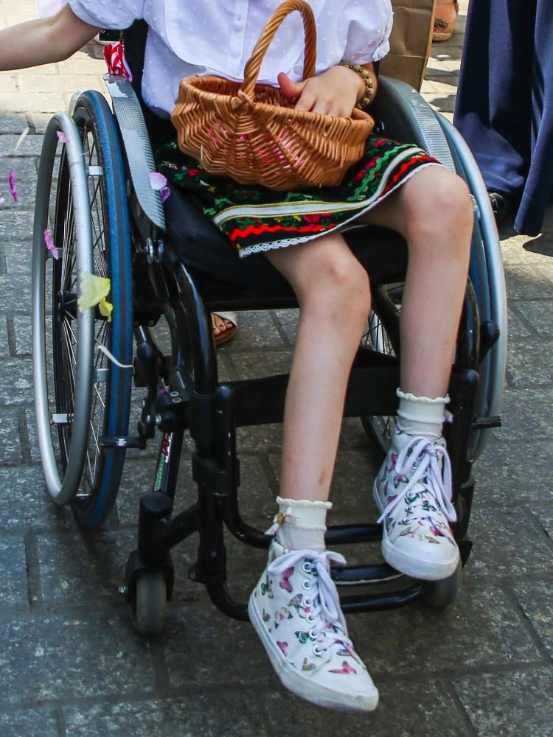

Student Name: Danielli Souza
Student Number: 2211925
Module code and title: LCHS4004
Introduction to Public Health
Lecturer’s name: Laila Surani

Table of Contents

Introduction 3
Approaches to Measuring the Incidence of Polio in the UK and Critical Evaluation 3
Approaches to Monitoring the Incidence of Polio in the UK and Critical Evaluation………………4
Polio Incidence in the UK.……………………………………………………………………………….5
Conclusion…………………………………………………………………………………………………6
Reference List…………………………………………………………………………………………….7

Introduction

Viral polio, or poliomyelitis, primarily affects young children and can cause severe paralysis or even death (WHO, 2021a). The incidence of polio has been measured, monitored, and controlled by the UK using a variety of successful tactics. This report is based on the group presentation, which is majorly focusing on the particular disease: POLIOMYELITIS. This disease may be caused by a virus. Along with this, the disease may affect the nerves in terms of the spinal cord or brain stem. Poliovirus is the most crucial cause for spreading the disease from person to person by affecting the spinal cord of a human body. The purpose of this study is to identify the root causes of polio disease. Along with this, it also focuses on the measurement, monitoring as well as the controlling strategies within the UK. This group presentation was based on the Polio in the UK.

Approaches to Measuring the Incidence of Polio in the UK and Critical Evaluation
The UK has implemented several polio incidence measurement tools, including laboratory-based and clinical surveillance systems. Acute flaccid paralysis (AFP), a polio-related clinical symptom, is tested for in the laboratory-based monitoring system (Public Health England, 2021). On the other hand, the clinical surveillance system involves keeping track of patients with AFP and other neurological conditions that might be brought on by polio (World Health Organization, 2020).
These methods have successfully located polio cases and pinpointed outbreaks, although they have certain drawbacks. For efficient monitoring, healthcare practitioners must report instances promptly, but this is not only sometimes due to various issues, including a lack of resources and competing priorities (World Health Organization, 2020). Additionally, in regions with inadequate laboratory capacity, laboratory-based surveillance may fail to detect polio cases (Public Health England, 2021).
The UK also takes part in international polio surveillance projects, like the Global Polio Eradication Initiative, to get around these restrictions (World Health Organization, 2020). Thanks to this program, the UK now has access to the most recent information on polio cases and outbreaks from around the globe.
The UK uses cutting-edge methods in addition to surveillance systems to track the prevalence of polio, like testing sewage for poliovirus. Even in the absence of clinical cases, this environmental surveillance method aids in detecting poliovirus transmission in communities (Public Health England, 2021).

Approaches to Monitoring the Incidence of Polio in the UK and Critical Evaluation
The UK has used many polio surveillance tactics, including active and passive surveillance systems. In the passive surveillance method, medical professionals alert authorities to suspected cases of polio. In contrast, the goal of active surveillance is to proactively look for polio cases by analyzing samples from patients exhibiting neurological symptoms.
No native wild poliovirus transmission has occurred in the UK since the inactivated polio vaccine (IPV) was introduced in 2004 (Public Health England, 2021). However, there is still a significant danger of imported cases, particularly where vaccination rates are low. As a result, the UK has implemented some procedures to monitor and assess the risk of polio importation, including screening travelers from countries where the disease is widespread and performing risk assessments for populations with low vaccination rates.
Serological surveillance is another method used in the UK to check on the efficiency of the polio vaccine. Testing blood samples from vaccine recipients to gauge their level of polio immunity is required. In order to identify communities or groups with low vaccination coverage and to direct vaccination efforts, serological surveillance is used (Public Health England, 2021).
Despite the effectiveness of these monitoring methods, polio surveillance in the UK still needs help. For instance, the efficiency of passive surveillance may need to be improved by healthcare practitioners who underreport cases (World Health Organization, 2020). Additionally, due to the lengthy polio incubation period, the surveillance systems run the danger of missing imported cases in regions with low vaccination coverage and polio case detection rates.
The UK's monitoring and assessment procedures for tracking polio incidence have successfully kept polio-free since 2004. To add, however, continued efforts are required to toss the obstacles associated with polio surveillance and response.

Polio Incidence in the UK
Poliomyelitis, or polio, is a highly contagious viral disease that can cause paralysis and, in severe cases, death. The last case of indigenous wild poliovirus transmission in the United Kingdom was recorded in 1984. Since then, the country has taken various measures to reduce the spread of the disease.
Vaccination is the most effective technique for polio prevention. The United Kingdom's effective vaccination program includes the inactivated polio vaccine (IPV) in the standard immunization schedule for all children under 18 months (Public Health England, 2021). IPV is highly effective and has helped to reduce the prevalence of polio in the country. However, vaccine coverage remains poor in some communities, raising the danger of polio outbreaks.
The UK government has developed many vaccine uptake strategies to combat poor vaccination coverage, including public awareness campaigns targeting hard-to-reach populations and collaborating with healthcare providers to ensure timely and complete immunization coverage. In addition, because of the COVID-19 pandemic, the country has implemented a "catch-up" program for children who missed their normal vaccinations (Public Health England, 2021). The program ensures that all children, including those with IPV, are immunized.
Outbreak response planning is another method for reducing polio incidence. The United Kingdom has an effective outbreak response strategy that details the procedures to be done in the case of a polio outbreak, such as increased surveillance, targeted vaccination programs, and contact tracing. The strategy also involves precautionary measures such as vaccine stockpiling and developing specialized treatment centers.
In addition to vaccination and outbreak response planning, the UK takes steps to prevent polio from being imported from other nations. Screening passengers from polio-endemic countries, enforcing vaccination requirements for travelers, and conducting risk assessments for populations with low vaccine coverage are all part of this effort. These procedures contribute to lowering the risk of polio importation and ensuring early detection and reaction in the event of an imported case.
Despite the success of these efforts, there are still issues related to polio control in the UK. Because polio is still widespread in some countries, one of the most difficult concerns is the risk of imported cases. Because of the virus's extended incubation period, imported cases may not be diagnosed until several weeks after arrival in the UK, increasing the risk of transmission to others.
Another issue is vaccine reluctance, which can lead to low vaccination coverage and raise the risk of polio outbreaks. Various circumstances, including misinformation and lacking trust in vaccines, can trigger vaccine apprehension. The UK government has initiated public awareness programs to promote the benefits of vaccination and counteract vaccine misinformation to overcome vaccine reluctance.
Furthermore, the United Kingdom engages in polio eradication initiatives such as the Worldwide Polio Eradication Initiative (GPEI). GPEI is a collaboration between the WHO, UNICEF, the US Centers for Disease Control and Prevention (CDC), and Rotary International. The project seeks to eradicate polio globally by giving technical assistance and resources to nations, including the United Kingdom, in order to improve their polio surveillance and response capabilities (WHO, 2021).
Finally, the United Kingdom has established various effective polio control measures, including immunization, outbreak response preparation, and importation prevention. However, there are still issues with disease control, including the possibility of imported cases and vaccination reluctance. Ongoing efforts are required to solve these issues and keep the country polio-free.
Conclusion
The United Kingdom's attempts to reduce the prevalence of polio have generated significant results through various strategies. The surveillance and monitoring systems in the United Kingdom have shown to be effective in discovering and tracking the disease, while control tactics have efficiently stopped its spread. The immunization program, with outbreak response planning and importation prevention measures, has significantly reduced the country's polio incidence.
Nonetheless, it is critical to recognize that these tactics have limitations that could jeopardize the gains gained in polio control thus far. Imported cases from places where polio is still prevalent pose a serious concern. The virus's long incubation period enhances the possibility of transmission before diagnosis, posing a substantial hazard to public health. Furthermore, vaccine apprehension might impede vaccination coverage in some populations, leading to the re-emergence of polio epidemics.
The United Kingdom's attempts to reduce the prevalence of polio have proven successful. The country has established various efficient polio detection, tracking, and prevention techniques. However, the hurdles of imported cases and vaccine hesitancy continue to jeopardize progress. To maintain its polio-free status, the UK government should continue to invest in effective polio control initiatives and collaborate with international organizations.

Reference List

- Public Health England. (2021). Poliomyelitis: the green book, chapter 24. Retrieved from https://www.gov.uk/government/publications/polio-the-green-book-chapter-24
- World Health Organization. (2020). Poliomyelitis. Retrieved from https://www.who.int/news-room/q-a-detail/poliomyelitis
- Public Health England. (2021). Poliomyelitis: the green book, chapter 24. Retrieved from https://www.gov.uk/government/publications/polio-the-green-book-chapter-24
- Public Health England. (2020a). Poliomyelitis. Retrieved from https://www.gov.uk/guidance/poliomyelitis
- Public Health England. (2020b). Poliomyelitis (polio) – the green book, chapter 28a. Retrieved from https://www.gov.uk/government/publications/polio-the-green-book-chapter-28a
- Public Health England. (2020c). Immunisation against infectious disease – the green book. Retrieved from https://www.gov.uk/government/collections/immunisation-against-infectious

