MindBridge
Closing the Gap in Youth Mental Health Care
A Supervised Digital Support Platform for Young People Awaiting NHS Mental Health Treatment

Student Name: Isiorono Marvelous Ewharekuko
Student ID: 2410703
Module: BMHP5014 — Changemakers: Creativity and Value Creation
Lecturer: G1 Laila Surani / G2 Caroline Salami
Assignment Title: Component 2: Assignment (Report)
Submission Deadline: 1st May 2026

PART ONE: POSTER

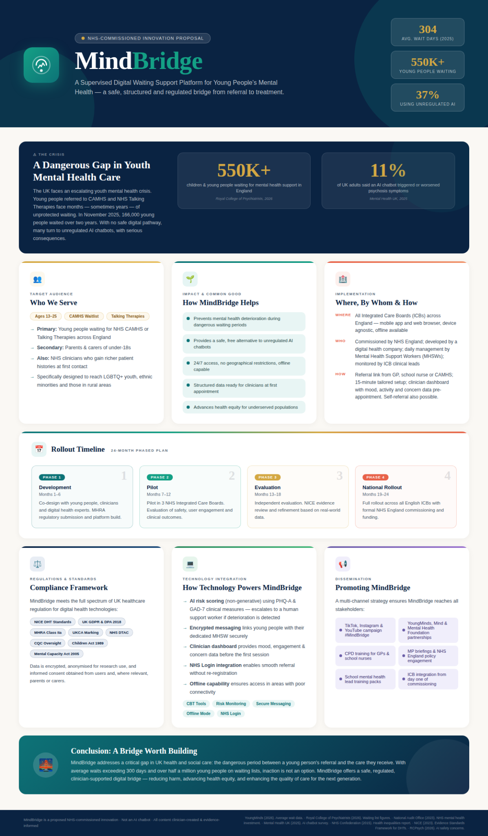

PART TWO: WRITTEN PITCH

MindBridge: Bridging the Gap in Youth Mental Health Care

Introduction
Young people's mental health is in crisis in the UK. The average length of time young people had to wait for an appointment with mental health services between September and November 2015 was 304 days, the longest recorded average wait (YoungMinds, 2016). This is not a short-lived disruption: this is a systemic breakdown of a crisis with alarming consequences. When YoungMinds surveyed nearly 14,000 young people in 2022, 26% reported they had attempted to take their own lives because of having to wait for urgent help, and over 50% said their mental health had deteriorated while waiting for help (YoungMinds, 2022).

MindBridge is a proposed digital platform to be commissioned by the NHS offering safe and structured support to 13-25 year olds between the time they are referred by the NHS and receive treatment. It's not an alternative to therapy. It's an evidence-informed, clinician-supervised bridge - to stop the deterioration, to keep young people out of harm's way and to improve the care they receive once they get help.

The People This Innovation Affects
The intended user base is young people (13-25 years) on waiting lists for CAMHS or the NHS "Talking Therapies" in England. As of November 2025, in England 550,610 children and young people are waiting for mental health services and 30% have been waiting for over two years (RCPsych, 2026). They remain at risk: waiting times in the teenage years negatively affect academic performance, family relationships and are associated with the greater incidence of chronic and treatment-resistant mental illness in adulthood.

The platform also helps overcome equity in the system. Shamed and complex needs are under-represented in the NHS (NHS Confederation, 2015) A free, 24/7 accessible online platform provides an opportunity for these groups to access mental health support without many of the barriers of stigma, cost, transportation and distance associated with timely access to mental health care.

Policy, Legislation, and Professional Services
Mindbridge's settings are well supported with proper policy frameworks. The NHS Long Term Plan (2019) is designed to deliver more mental health services and mental health being accorded a level of esteem equal to physical health. The Children Act 1989 and Mental Capacity Act 2005 place legislative obligations for safeguarding with users under 18 years of age that MindBridge will comply with through a risk assessment of users and mandated escalation. The regulatory oversight for its service will be the Care Quality Commission (CQC) and NICE's Evidence Standards Framework for Digital Health Technologies (2023) is the standard process for validating them for use in the National Health Service (NHS).

Perhaps more important, prudent use of digitally enabled therapies should be complementary and not replace current services as per the NHS Confederation (2015) and successful NICE-approved digital therapies should save thousands of hours in NHS therapists' time, as well as being cost beneficial. MindBridge is being designed with this in mind, as a supplement but not a substitute for existing provision.

Why Innovation Matters Here — and Why Now
The problem is of great significance, so it requires an entrepreneurial solution. Joseph Schumpeter's process of creative destruction proposes innovation involving breaking down outdated and flawed systems and adding value (Schumpeter, 1942). MindBridge uses this theory in the NHS environment: it doesn't set out to solve the mental health staffing crisis, but what it does do is it adds a new value proposition to the existing system by using technology to better manage scarce clinical resources and keep young people safe in the meantime.

The need is imperative given what is occupying the space left by UK waiting lists. More than one in three UK adults (37%) have already sought out an AI chatbot to support their mental health; 11% reported chatbot use led to or exacerbated symptoms of psychosis and 9% reported it led to self-harm or suicidal thoughts (Mental Health UK, 2025). In a survey of 11,363 13-17-year-olds by UK youth charity, the Youth Endowment Fund, one quarter reported using an AI chatbot for mental health in the last 12 months, due to high waiting lists and barriers to accessing professional help (Youth Endowment Fund, 2025). Young people are not waiting around, they are seeking out potentially harmful options. MindBridge is a safe and regulated option.

The examples of current tools show this is possible. On the Limbic chatbot - part of the NHS Talking Therapies program - referrals from minority communities improved, and the amount of clinician time taken for initial assessment decreased, without delays to treatment (MIT Technology Review, 2024). A peer-reviewed systematic review and meta-analysis showed that chatbots based interventions successfully reduced psychological distress among young people (Worldviews on Evidence-Based Nursing, 2025). MindBridge builds on such research and evidence in the specific and undervalued context of the NHS waiting period.

Calling on the Public: Why Your Involvement Matters
The public must play a role . The MindBridge program will not be successful as an NHS initiative unless it has the backing of the public. It is dependent on young people, parents and carers, teachers and schools and communities to want to know about it, to trust it, support it and use it.
The public can support MindBridge: by discussing it with their GP and the school-based mental health team; by fund raising with the charities YoungMinds, Mind and the Mental Health Foundation who are already urging the government to invest in digital, regulated-by-the-NHS mental health solutions; and by contacting their MPs to urge acceptance of digital waiting-period support for young people with evidence-based programs. Whenever support for mental health is discussed, openly and without judgement, with compassion, it will help a young person to seek support - with MindBridge or otherwise.
Community engagement also leads to a better online system. Grant McPheeters will use a co-consultation process with young people, parents and carers, community groups and organisations to ensure the website will be culturally sensitive, accessible and relevant. Value creation for the common good (one of the principles of this module) needs to include the community in the creation of innovation, not just create innovation for the community.

Limitations and Critical Considerations
It's crucial to recognise this innovation's limitations. Online tools cannot substitute for the therapeutic relationship, and MindBridge is not a replacement for urgent clinical care for those young people in distress. There are also legitimate concerns about the digital divide - not all young people have access to the internet or smartphones. MindBridge would need to be complemented with offline options and outreach to ensure it did not exacerbate inequalities. And while people's engagement with digital health interventions can differ, ongoing engagement relies on thoughtful user experience design and clinical monitoring.

Conclusion
MindBridge is an innovative, evidence-based and practical idea in the spirit of value creation for the good. It is not a silver bullet for mental health care - but it is a challenge to question what can be done - as quickly as possible - with the resources currently available (technology and clinical approaches), to ease young people's distress while they wait for treatment? The answer - a safe, supported and integrated with the NHS online bridge - is possible.

References
Mental Health UK (2025) Over one in three using AI chatbots for mental health support, as charity calls for urgent safeguards. Available at: https://mentalhealth-uk.org (Accessed: 29 April 2026).

MIT Technology Review (2024) A chatbot helped more people access mental-health services. Available at: https://www.technologyreview.com (Accessed: 29 April 2026).

National Audit Office / Committee of Public Accounts (2023) Progress in improving NHS mental health services. Available at: https://publications.parliament.uk (Accessed: 29 April 2026).

NHS Confederation (2025) Investment priorities for mental health 2025. Available at: https://www.nhsconfed.org (Accessed: 29 April 2026).

NHS England (2019) The NHS Long Term Plan. Available at: https://www.longtermplan.nhs.uk (Accessed: 29 April 2026).

NICE (2023) Evidence Standards Framework for Digital Health Technologies. Available at: https://www.nice.org.uk (Accessed: 29 April 2026).

Royal College of Psychiatrists (RCPsych) (2026) Half a million children on mental health waiting lists in England risk turning to AI chatbots for support. Available at: https://www.rcpsych.ac.uk (Accessed: 29 April 2026).

Schumpeter, J.A. (1942) Capitalism, Socialism and Democracy. New York: Harper & Brothers.

Health Innovation Network (2025) The Scale Gap: Why the NHS must scale its digital mental health ambition. Available at: https://healthinnovationnetwork.com (Accessed: 29 April 2026).

Worldviews on Evidence-Based Nursing (2025) Chatbot-Delivered Interventions for Improving Mental Health Among Young People: A Systematic Review and Meta-Analysis. Available at: https://pmc.ncbi.nlm.nih.gov (Accessed: 29 April 2026).

YoungMinds (2022) Survey of young people on mental health waiting lists. Available at: https://www.youngminds.org.uk (Accessed: 29 April 2026).

YoungMinds (2024) Increase in youth waiting over a year for mental health support. Available at: https://www.youngminds.org.uk (Accessed: 29 April 2026).

YoungMinds (2026) Young people wait 304 days for mental health support. Available at: https://www.youngminds.org.uk (Accessed: 29 April 2026).

Youth Endowment Fund (2025) Children, Violence and Vulnerability Report. Available at: https://youthendowmentfund.org.uk (Accessed: 29 April 2026).

