Nathan J Morris

The following essay will be split into two parts, part one will discuss surveying and its different types, outlining and discussing in detail one of these factors. Part two of the essay will describe the application of digital surveying technologies in surveying listed buildings and give an example of the appropriate tools to be used and also of the information to be collected
Essay
Digital surveying and its different types, focussing on the technologies in surveying listed buildings.

Contents
Introduction 2
What is surveying 2
Why we survey things 2
Types of surveying classifications 2
Plane and geodetic surveying 3
Surveying by method 3
(Technologies,2021) 3
Surveying by equipment 3
Surveying based on purpose 4
Topographic survey 4
Mining survey 4
Cadastral survey 5
Hydrographic survey 5
Listed Buildings 6
What is a building survey 6
Building surveying equipment 6
Building surveying process for a listed building 7
Report 8
Initial assessment 8
Technical survey report 8
References 10

Word count - 2141

Introduction

The following essay will aim to discuss what is digital surveying, the history of surveying, the classification and different types of surveying and then moving on to focus on digital surveying and looking at how surveying can be used in surveying of listed buildings.

What is surveying

Surveying can be defined as the “technique of determining the relative position of different features on, above or beneath the surface of the earth by means of direct or indirect measurements and finally representing them on a sheet of paper known as plan or map” (RICS.org,2021)
The general consensus is that surveying had its origins in ancient Egypt, with a recorded land register of boundaries dating back as far as 3000BC and more notably with the construction of the pyramid Khufu at approximately 2700BCE. (Civiltoday,2021)

Why we survey things

We undertake surveys to gain a greater understanding of what it is we are interested in, whether this is for preparing maps or constructing roads or buildings. For example, if we are constructing a new building on a piece of land, we need to set out the area we plan to build on, working out the footprint of the proposed building, the area of the development, the angle of the ground it is proposed to be built on etc. All this information is vital in determining what is needed (raw materials, foundation types etc) before we even begin construction. It sets out the blueprint of the design and enables a more accurate costings, drawings, and planning for a development (RICS.org,2021)

Types of surveying classifications

There are several types of surveying classifications and these can be broken down into the following:
- Plane and geodetic
- Surveying by purpose
- Surveying by method
- Surveying by equipment
I will explore each of these classifications briefly and then focus in depth on surveying by purpose

Plane and geodetic surveying

Plane surveying is for smaller surveying projects of approximately 250sq.km or less as this discounts the curvature of the earth. Equipment used in this type of surveying method can be measuring tapes or theodolite surveying devices any other device that captures 2D (2 dimensional) values only. Accuracy in these types of surveys are considered low (civilengineer.com,2018).
Geodetic surveying is for larger projects generally over 250sq.km, and this type of surveying accounts for the curvature of the earth. These surveys can be used to provide points at which smaller plane surveys can connect to. They are of a high degree of accuracy and are very popular, they use a more precise surveying equipment such as GPS (civilengineer.com,2018).

Surveying by method

There are three main types of surveying under this classification, and these are Triangulation, Trilateration and traversing.
Triangulation involves the measurement of angles within surveying and establishing a network of control points through the use of triangles.
Trilateration is similar to triangulation but instead uses distance which is measured and the angles are then calculated.
Traversing is where a number of connected lines are measured with the assistance of an angle measuring device and the lengths between these points measured. There are two types open and closed traverse (Civiltoday,2021).
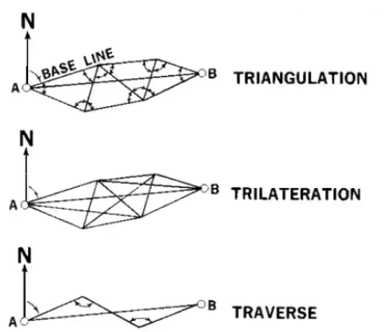

(Technologies,2021)

Surveying by equipment

There are many types of surveying equipment, and these can be broken down into two main types, Traditional and modern / Digital.
Traditional surveying equipment used techniques like pacing and surveying chains, measuring tape etc where the modern digital surveying equipment include devices such as total stations, GPS, laser scanners and digital laser levels. There are many different types of equipment used for surveying and as a general rule the modern equipment will provide a faster more accurate result than traditional methods mentioned above (RGS.org,2021).

Surveying based on purpose
This type of survey is for a specific purpose such as a Cadastral survey, a Construction survey, hydrographic survey, mining survey, topographic survey etc. These survey types are used to enable a certain desired outcome. A brief overview of a few of these surveying types will be discussed below :

Topographic survey
A topographic survey is a survey of an area of land undertaken gather data about the topography and elevation of the land which will also capture all significant features within the desired boundaries, such as trees, buildings etc.
These surveys are generally for larger sites, these can include large housing developments, new road construction, site boundary determination for easements / planning etc
This type of survey is usually undertaken using lasers and marking out the area using steel pins which are fixed to a solid base on the ground that does not move easily. The total stations and gps units are then used to mark out the points one step at a time until the whole site has successfully been surveyed (RGS.org,2021).
Recently Drone surveying has become popular which enables a laser on the drone to scan an area and produce millions of points of co-ordinates which in turn enable the line and level data to be captured, this blanket approach enables the whole area to be surveyed in a very short period of time (topographical.co.uk,2021)
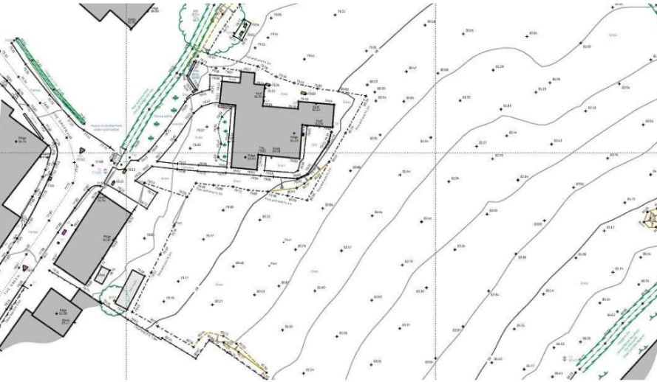

Figure 1 – Topographical survey (topographical.co.uk,2021)

Mining survey

Mining surveys are used to help identify or help find potential mining sites, these surveys also help provide information on existing mining shafts / tunnel dimensions etc. These are essential to the planning, design, and safety of underground mining activities (dmp.au,2021). Standard measuring equipment like tapes and theodolites can be used for the standard mine shaft measurements with ultrasonic luch stations and sonar can be used for the mapping of underground shafts. All of these measurement will then be collated and a suitable map of the area constructed.

Cadastral survey

A cadastral survey or also known as a land survey / property survey is a survey conducted to define property boundaries, re establish or identify newly adjusted land boundaries, and is used primarily from a legal perspective when facilitating property sales (omnisci.com,2021).
These surveys can be undertaken using many different methods of surveying where distance and co-ordinates are marked. This survey type generally does not require complex angle and elevations to be calculated as simple lines to denote boundary changes is all that’s required.

Hydrographic survey

A hydrographic survey is the surveying of underwater features, these include measuring of the sea / river bed using sonar or echo sounders. These types of technology are usually attached to a boat which will pass over a certain body of water and the sonar / echosounding equipment will send out acoustic sound waves that bounce off an object underwater and report back to the unit of how long this signal takes to come back. This returning signal delay enables the production of hydrographic maps based on this. These surveys are used to assist with many varying maritime projects, such as planning for offshore oil drilling, any form of marine construction (new harbours / bridge construction), reservoir depths and dredging planning (Hammond,2021)
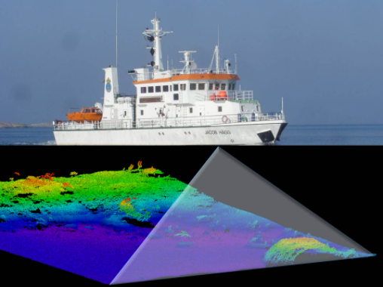
Figure 2 – Hydrographic survey (famosproject.eu,2021)

Listed Buildings

A listed building is a building and in some cases its garden / outbuildings that can be defined as “Buildings of special architectural or historic interest” (IPOC.co.uk,2021).
It is a recognition of the buildings unique appearance / historical importance and as a result the listing status brings a whole host of limitations over what can be changed / modified on or in this building.
There are many reasons why a building can be chosen to be listed but one of the most common reason being its age. All buildings built before 1700 which are similar to their original condition are listed. Most buildings that date pre 1840 are also listed while many buildings that pre date 1914 are listed if they have a special feature or are the work of certain architects etc.
A listed building will be graded based their importance, listed gradings for these buildings in England and Wales fall into one of three categories (we will ignore Scotland as this slightly different).
“Grade 1 - Buildings are of exceptional interest; only 2.5% of listed buildings are Grade I
Grade 2* - Buildings are particularly important, being of more than special interest; 5.5% of listed buildings are Grade II*
Grade 2 - Buildings of special architectural or historic interest; 92% of listed buildings are Grade II”
(IPOC.co.uk,2021).

What is a building survey

A building survey is a comprehensive and in depth report which provides a detailed examination of a property’s condition and also its construction. The survey will look at walls, flooring, roofs, chimneys, doors and windows and also provide recommendations on how to resolve any problems that this survey identifies (sdlsurveying.co.uk,2021). A building survey will be conducted by a chartered surveyor who should also be regulated by a professional body such as the royal institute of chartered surveyors (RICS).
The main reason for a building survey is when purchasing a property, although the report does not provide a valuation it is a great way of getting a professional report on the condition of the property prior to purchasing it, to see if there could be any unforeseen issues prior to completing the purchase. (RICS.org,2021)

Building surveying equipment

There are many tools which can be used in surveying, below is a small list of common tools in a surveyors arsenal.
Telescopic camera – this type of camera would be ideal for looking in loft spaces, gutters and for viewing roofs where using a ladder or other method would eliminate a potential dangerous situation.
High quality digital camera – this is essential so small details are not missed whilst compiling a report and high quality images can detail and potential issues
Drone – these can enable a detailed video of roofs, gutters and windows from ground level and capture the building from many different angles from a safe platform.
Optical distance measurement / measuring tape – if using a tape measure is not possible, these forms of digital measuring are ideal as they enable accurate plans to be produced despite limited access
Protimeter – These enable surveyors to measure damp in walls without intrusively drilling samples.
Torch – this will enable the surveyor to inspect any poor lighting areas more thoroughly
Ladder – this will assist the surveyor to gain access to lofts etc

Building surveying process for a listed building

The process for a building survey or for any building will be very similar, the reason for undertaking a survey on a listed building could be to facilitate a sale, understand its condition or simply understand the history of the building. The main components for undertaking a survey of a listed building are as follows.
Planning – the surveyor will need to research the building prior to his visit, this can include online research or local planning portal information etc, this analysis will provide the surveyor with an idea about the property before he arrives and help with any decision making on what he may need to look for i.e expecting asbestos / has the property been extended etc.
Field work – Whilst on site the surveyor will undertake various data acquisition tasks using some of the above mentioned tools, take site measurements and also undertake visual observations whilst making notes throughout. These tasks help determine whether the building is suffering from any damp, structural problems such as subsidence, timber decay etc and will help identify any substantial concerns from the surveyor which may impact a potential sale.
Data processing – the next stage of the process is where the information obtained from the planning and also field work will be collated and analysed, this will help the surveyor produce the final report and also any drawings that may be produced.
Mapping – The next step for the surveyor is data representation, this includes the creation of helpful sketches and drawings which can easily identify any issues and represent them easier than pure text descriptions. These can include annotated photos / historical plans.
Report – The report will have two parts, an Initial assessment and also a technical report.

Report

Initial assessment

The initial assessment will enable a brief rating on elements of the building such as its walls, roof, windows, stairs etc and be based under each of the following categories. External, Internal,Ground and Services. These will each then be rated good,fair,poor,very bad or not inspected (some surveyors use a numbering convention instead). And example of this can be found in the table below (RICS.org,2021)

External | Good | Fair | Poor | Very bad | Not inspected
Windows | x
Roof |  |  | x
Internal
Walls | x
Stairs |  | x
Ceiling | x

Technical survey report

Following on from this initial assessment a more detailed technical report will be produced. This technical report will go into a much greater detail of each element and provide photographs, a description of the risk and an action to take based on the risk identified. An example can be found below
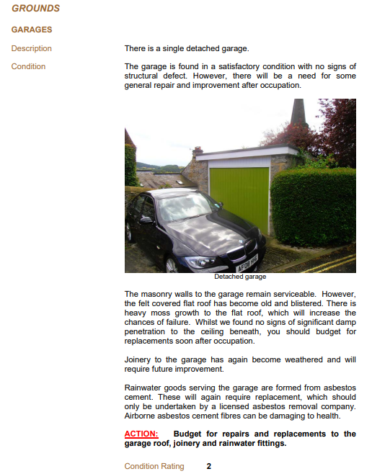

(building-survey-report-sample.pdf (wilkins-vardy.co.uk))

The building survey is the most comprehensive survey for any home especially older properties and listed buildings. These reports are in depth and essential for anyone looking for expert advice on any defects or issues with a potential property purchase.

References

Civil today 2021. [online] Available at: <https://civiltoday.com/surveying/13-definition-and-importance-of-surveying> [Accessed 21 December 2021].

Department of Mines, Industry Regulation and Safety. 2021. What are the duties of the mine surveyor?. [online] Available at: <https://www.dmp.wa.gov.au/Safety/What-are-the-duties-of-the-mine-9510.aspx> [Accessed 21 December 2021].

Famous project.eu. 2021. [online] Available at: <https:// http://www.famosproject.eu/activities/hydrographic-surveying/> [Accessed 21 December 2021].

Fao.org. 2021. Cadastral surveys and records of rights in land. [online] Available at: <https://www.fao.org/3/v4860e/v4860e03.htm> [Accessed 21 December 2021].

Hammond, A., 2021. How About Hydrographic Surveying?. [online] Imarest.org. Available at: <https://www.imarest.org/membership/education-careers/careers-in-the-marine-profession/how-about-hydrographic-surveying> [Accessed 21 December 2021].

Omnisci.com. 2021. What is Cadastral? Definition and FAQs | OmniSci. [online] Available at: <https://www.omnisci.com/technical-glossary/cadastral> [Accessed 21 December 2021].

Rgs.org. 2021. [online] Available at: <https://www.rgs.org/CMSPages/GetFile.aspx?nodeguid=2a1e4a85-0187-4394-892a-eca75b203115&lang=en-GB> [Accessed 21 December 2021].

Rics.org. 2021. [online] Available at: <https://www.rics.org/uk/upholding-professional-standards/sector-standards/building-surveying/> [Accessed 21 December 2021].

SDL Surveying. 2021. What Is A RICS Building Survey? | RICS Building Surveyors | SDL Surveying. [online] Available at: <https://sdlsurveying.co.uk/our-products/rics-building-survey/> [Accessed 21 December 2021].

Technologies, E., 2021. Triangulation and Trilateration, Surveying and Geomatics (CE-PC-403), 4th Semester, B.Tech. CE, MAKAUT | Erudition Paper. [online] Paper.erudition.co.in. Available at: <https://paper.erudition.co.in/makaut/btech-in-civil-engineering/4/surveying-and-geomatics/chapter/triangulation-and-trilateration/group-1/page-8> [Accessed 21 December 2021].

The Constructor. 2021. Modern Surveying Instruments and Their Uses in Civil Engineering Survey. [online] Available at: <https://theconstructor.org/surveying/modern-surveying-instruments-uses/16/> [Accessed 21 December 2021].

Topographical.co.uk. 2021. What is a Topographical Survey?. [online] Available at: <https://www.topographical.co.uk/blog/what-is-a-topographical-land-survey> [Accessed 21 December 2021].

Wilkins-vardy.co.uk. 2021. [online] Available at: <https://wilkins-vardy.co.uk/assets/pdf/building-survey-report-sample.pdf> [Accessed 21 December 2021].

