

Hotel Handbook for Intercultural Competence

Foreign Languages and Cultural Awareness

BMIH5003

Student’s Name: Cristina Mutu
Student’s ID: 2012841
Lecturer’s name: Mike Davies

Table of Contents
Executive Summary 2
Introduction 2
Country A - England 3
Country B - China 3
Country Analysis 4
Conclusion 5
References 5

Foreign Languages and Cultural Awareness

Executive Summary
The following report is willing to underpin as main subject the cultural awareness within the hospitality industry. In a more specific point, the main focus will be on the cultural intelligence and sensitivity importance for the hotel personnel in order to be able to deliver the expected customer services. Further will be analyzed the hotel location and the guests home country along with details regarding the culture. The Country analysis will be done with Hofstede Insights tool in order to generate the handbook for the hotel’s personnel. Last but not least, there will be a table with do’s and don’t in order to aid the personnel to better underpin the main outcomes of the report.

Introduction
According to (Farrell, 2021), the cultural intelligence and sensitivity is a skill that every employee in the hospitality field should have as it is highlighted by the capability to handle any kind of cultural differences. Moreover, the personnel should be able to work under any kind if cultural circumstances both positive and negative. As cultural concepts vary, the employees are those who need to immediately adapt to the contexts as guests require excellent services.
Hofstede’s cultural dimensions is a theory generated by Greet Hofstede at the end of the 70’s after the author was doing research of a decade while analyzing and getting improvements to develop the theory for the better understanding of the cultural differences (Mind Tools, 2020).
The main aim of Hofstede was to highlight how a culture may be different by another and how their specific dimensions may vary. (CFI, 2021)
This report will focus on how Hofstede sees both England, the hosting country and the country from where the guest is coming, China in order to highlight the cultural resemblance and differences.

Country A- England
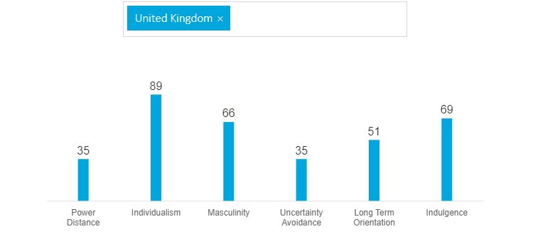
After analyzing Hofstede’s theory, below is a table representing the indices from Hofstede’s theory
England is a country part of the United Kingdom situated in the north-western part of Europe. In the country people are speaking English language and the country is lead by the Queen as it is a Monarchy. For this reason, there are cross-differences between social groups as there are the low, middle and upper class but also, the nobility class that is formed by the people that are entitled and also, the members of the royal family. (David, 1999)
As the Power Distance Index in England is marked as 35 which is considered low, the employees in the hospitality industry work in flatter organizations, so the employees and leaders are considered almost equal, so delegation is the most fitting method in order the hotel to survive.
As Individualism is ranked high, there is highlighted those employees will act and expect to be rewarded individually as they are not team oriented.
As Masculinity is also highly ranked in United Kingdom, there is highlighted that the employees and people’s egos are strong so, money and status is important, as well as proving different things according to the gender.
Uncertainty Avoidance in UK is low, which means people are oriented to discover new things, open to innovation and they do not need to be very structured but contributions in maintaining them focused is needed.
Long Term orientation is high which means that English people are modest and educated without focusing on expressing how good they are but rather do their job well.
The level of indulgence is high so optimism is something notable for people from England while there exists the freedom of speaking and manifesting their own thoughts.

Country B – China
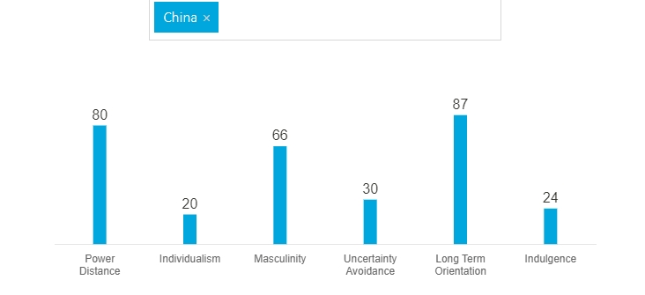
In China, the Power Index is high which states that people from the country are agreeing with the existence of inequity and. The differences of power. Moreover, the Chinese people are paying attention to the rank and social position.
Individualism in China is low which highlights that people are more team-oriented and ready to help others in order to achieve a common goal.
The level of masculinity is high for Chinese people and they are concerned to make a difference regarding the gender as well as aiming to have a high income in order to seek more respect from others.
Uncertainty Avoidance is low for people in China which means that people like to take risks and rules are easily accepted and followed. Further, Long term orientation is high so we can state the fact that Chinese people are perseverant and persistent due to the fact that for them, long-term goals are more likely satisfying than the short-term ones. Low indulgence is highlighting the fact that the social norms are diminishing the opportunities of Chinese people to behave as they want.

Country Analysis
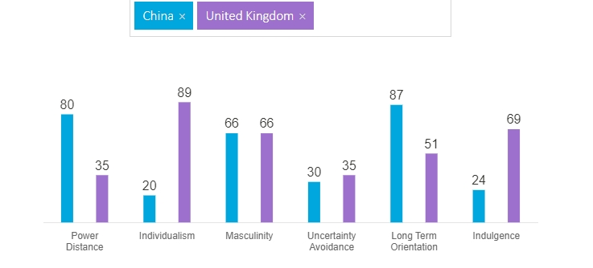
Shangri La in the center of London is a hotel that offers their guests breathtaking views as it is situated in the Renzo Piano building at 34th to 52th floor. (Shangri- La, 2022)
As the discussed hotel is originally from China, there are many Chinese guests booking rooms within the hotel. For this reason, the staff from England should be able to adapt easily to the guest’s culture. Further will be a comparison between the English and Chinese culture in order to help the Shangri-La’s personnel to cope with the cultural differences.
Due to the data above, we can see differences between English and Chinese people in matter of Power Distance, which relates to the fact that while in England people tend to be considered equal? The hotel staff should address to Chinese people in matter of their social status. Individualism is quite different also, which means that the Chinese people tend to travel in groups and they are l needed to be treated equal while coming to the hotel as guests. Last but not least, the hotel staff should be aware that Chinese people are different from the indulgence point of view which means that they expect all the norms to be followed and a more formal attitude to be adopted by the staff.

Hotel Handbook
Do | Don’t
Greet according the status | Do not disrespect the guest
Act professional always | Do not try to change the guests’ beliefs
Always be polite | Do not adopt a friendly attitude but stay professional
Follow the rules regarding the norms that should be followed

Offer respect for all the group members

Treat everyone regarding their social status

Conclusion
The differences between the cultures are those aspects that make the job of the hotel employees more interesting and at the same time challenging. For this reason, they should be prepared and trained to face all the differences between cultures and deliver excellent services.

References
- CFI, (2021), Hofstede’s Cultural Dimensions Theory, Accessed on March 9th 2022
- David C., (1999), British Culture: An Introduction, Accessed on March 9th 2022
- Farrell J., (2021), What is Cultural Intelligence?, Hebburn, England, Accessed on March 9th 2022
- Mind Tools, (2020), Hofstede's Cultural Dimensions, Accessed on March 9th 2022
- Shangri-La, (2022), Escape the city, London, UK, Accessed on March 9th 2022
- Manktelow D., (2021), Equal Opportunities in the Workplace, Published on May 26th, Accessed on March 9th 2022
- Pew, (2008), Chinese Views of Their Lives, Accessed on March 9th 2022.
- Management Training Institute, (2019), The Importance of Setting Long-Term and Short-Term Goals, Published on March 28th, Accessed on March 9th 2022
- Cox C., (2015), Teamwork In China, Published on February 25th, Accessed on March 9th 2022.
- Robson D., (2016), How important is social class in Britain Today?, Published on April 7th, Accessed on March 9th 2022.

