Entrepreneurship
Assessment 2

Mihail Cristian

Student ID: 2112321

Module: Entrepreneurship

Module Code: LCBB5001

Table of Contents
Introduction 1
Business description 1
Industry Analysis 1
Operations and management team plan 3
Marketing Plan 4
Financial plan 6
Market research 7
Conclusion 8
References 9

Introduction
The report focuses on creating a business plan that takes into account all of an organization's functions. The "Oxyfresh air purifier" has inspired the business. It includes an analysis of the industry. It also emphasizes the product's marketing strategy and financial stability. It also manages the management team and the company's operations. Additionally, market research is done on the product. The analysis provides a comprehensive overview of the industry, including its strengths and weaknesses. This information can be used to make informed decisions about the company's future growth and development strategies.

Business description
An air purifier with a distinctive design is called "Oxyfresh." In addition to giving its tenants clean air, it also maintains a balance between CO2 and oxygen in the atmosphere. The company's mission is to "provide customers with quality air purifiers at reasonable prices." The air purifier will make the product more affordable for consumers with middle-class incomes. Furthermore, Oxyfresh uses advanced technology to filter out pollutants and allergens, making it an ideal choice for people with respiratory issues. With its sleek design and efficient performance, Oxyfresh is a great investment for anyone looking to improve the air quality in their home or office.
The product's market analysis, information about the company's management, and details about business operations are all included in the business plan. The financial plan with a six-month sales forecast is also included. It aids in comprehending the company's financial stability. It also includes the product's marketing research as well as the marketing strategy that will be employed to raise consumer awareness of the product (Zhao, 2020). Furthermore, the business plan outlines the target market and identifies potential competitors.
The product takes into account all intellectual property rights, including trademarks, copyrights, and industrial design rights. It complies with all legal requirements, such as the sources of the law, consumer protection laws like safety regulations, and prohibitions against faulty products, among others. In addition, the company also offers a warranty for their air purifiers to ensure customer satisfaction and peace of mind (Zhao, 2020). They strive to continuously improve their product and customer service to maintain their reputation as a reliable and trustworthy brand.

Industry Analysis
VRIO Analysis
Resource and capabilities | V | R | I | O
Corporate support | ✓ | ✓ | ✓ | ✓ | Sustained competitive advantage
Research and design | ✓ |  | ✓ | ✓ | Competitive advantage
Financial stability in the market | ✓ | ✓ |  | ✓ | competitive advantage
Market proximity | ✓ |  |  | ✓ | Sustainable competitive advantage
Product range | ✓ | ✓ | ✓ | ✓ | Sustainable competitive advantage
Product Quality | ✓ | ✓ | ✓ | ✓ | Sustainable competitive advantage
The demand of the product | ✓ |  |  | ✓ | Competitive parity
Growth in market | ✓ |  | ✓ | ✓ | Competitive advantage

Porter five forces
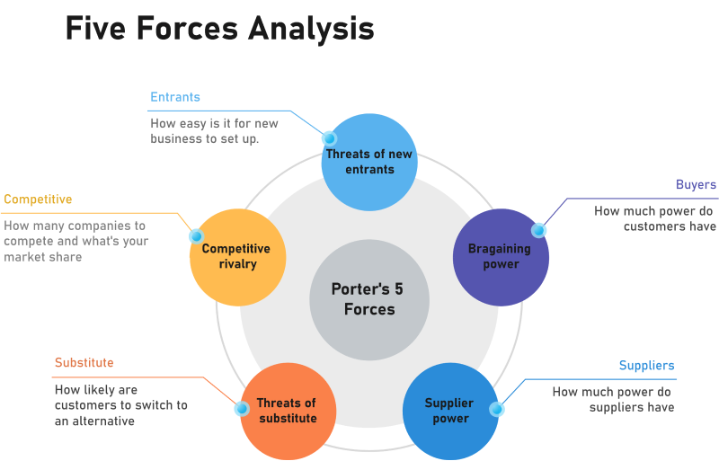
Figure.1. Porter’s five forces
Source: (Stocchi et al., 2019).
Competitive rivalry
The market for air purifiers is growing, especially in the wake of the COVID-19 pandemic. Customers are more concerned with leading healthy lives. Air purifier is in high demand. Consequently, the competition is growing (Zhao, 2020). The competition for "Oxyfresh" will be fierce from companies like Philips, Aier, and others. The air purifier market is flourishing and aggressive.
Threat of substitutes
Every day, the electronic industry changes. The constant advancement of technology creates a significant threat from substitutes. As a result, there is a growing threat of substitutes in the air purifier industry.
Threat of new entrants
It is greatly preferred by newcomers due to the lower capital requirements and higher profit margins (Curtius, 2021). It is suitable for newcomers because of the enormous number of consumers in developing nations.
The bargaining power of the buyers
In the air purifier market, the buyer has significant negotiating power. The buyer incurs a little switching expense. Due to the abundance of options on the market, consumers are in charge (Curtius, 2021). In the case of "Oxyfresh," the idea behind the product is distinct and singular, making it difficult for customers to easily locate an alternative.
Bargaining power of the suppliers
The suppliers of raw materials and the suppliers of human resources can be divided into two categories. Because there are so many manufacturers in the market for air purifiers, the supplier has a lot of negotiating power.
The market for air purifiers has a lot of potentials. With numerous opportunities in the consumer, transportation, industrial, and utility industries, the future of the global purifier market is positive (Curtius, 2021). By 2023, the market for purifiers is projected to grow to a value of $21.5 billion. From 2018 to 2023, it is expected to expand at a CAGR of 5.4%. The market has valuable growth potential and financial stability, which makes it appropriate for "Oxyfresh," according to the VRIO analysis. According to Peter’s five forces, the market is perfect for investment and has a high-profit margin. Furthermore, the increasing awareness among people about the importance of clean air and water is also contributing to the growth of the purifier market (Chakim et al., 2022). The technological advancements in the purifier industry are also expected to boost the market growth in the coming years.

Operations and management team plan
The business model of the Oxyfresh air purifier will be both a disintermediation model and a standard retail model. Disintermediation is the mode in which the customer directly deals with the producer or manufacturer of the products. It removes all the middlemen from the supply chain. Buyers can directly buy the products from the retail store and the official website of Oxyfresh. It allows the customer to buy the product at a low cost and increases the profit margin of the company in the long run (Chakim et al., 2022). The standard retail model will help the company sell its product on popular e-commerce sites such as Amazon, eBay, and others. By eliminating the intermediaries, Oxyfresh can have better control over the quality of its products and ensure that they reach customers in a timely manner. This also enables the company to establish a direct relationship with its customers, which can lead to better customer satisfaction and loyalty.
The legal structure of the business includes the fact that Oxyfresh will be a limited liability company. It is a mixture of a co-partnership, general partnership, and sole proprietorship. An LLC shields its members from personal liability; only the company's assets are in danger. The members share in the company's gains and losses, and they are each subject to individual taxation (Chakim et al., 2022). There is no limit to the number of members. Corporate, sole proprietorship and other options are among the many others. The decision to use an LLC was made because it offers limited liability and because of the way, the business is set up, which means that its operations will be more expansive than those of a sole proprietorship or partnership (Haralayya, 2021). In addition, LLCs also offer flexibility in management structure and can choose to be taxed as a partnership or corporation. This allows for more control over the tax implications and distribution of profits among members.
Management team
Management team | Qualifications | Job profiles
Members | Founders of the company | Taking top executive decisions.  Approving policies and strategies.
Senior manager | MBA in management  More than 7 years of experience | Observing the progress of the team.  Providing feedback on policies.  Approving team activities
Assistant Manager | MBA  More than 5 years of experience | Formulation of the strategies.  Managing administration of the team.
Team leads | Post Graduation  More than 2 years of experience | Managing the activities of the team  Managing the progress of the tasks.  Reviewing the efficiency of the team members
Staff | Graduate  Freshers or less than 1 year of experience | Managing sales  Marketing responsibilities  Responsibilities of internal department

Marketing Plan
The marketing plan aims to make the "Oxyfresh" air purifier accessible to middle-class consumers so that they can create healthy environments in their homes.
Segmentation
The products' geographic segmentations include the UK's most polluted cities, including London and others. Although all age groups will be able to purchase the products, upper-middle and upper-class consumers will be the target market.
Targeting
The target customers of the air purifier are smokers whose families are at greater risk of exposure to the chemicals due to smoking (Haralayya, 2021). Families living in polluted cities or the members of those families suffering from respiratory diseases or asthma in small children People with allergies due to dust, smoke particles, and pollen.
Positioning
The products will be positioned depending on the quality and effectiveness of the products in cleaning the air. The focus will be on the equivalency of the filter compared to its competitors and others.
4Ps of marketing
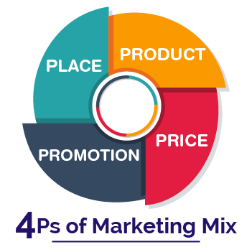
Figure.2. 4P’s of marketing
Source: (Stocchi et al., 2021)
Product
The company's product strategy is to offer high-quality goods at competitive prices. It will give the business a competitive edge, build brand recognition, and also boost customer retention rates (Haralayya, 2021). The product will come with a batch number, a manufacturing date, and general instructions.
Price
The product will use both penetration pricing and skimming pricing as pricing strategies. Penetrating pricing refers to setting the product's price low at first in order to enter the market quickly and boost sales (Rajath, 2020). The Oxyfresh air purifier will cost between 60 and 300 pounds. Prices will vary depending on the product's model.
Place
The product will be sold at retail establishments, which will initially be in London and eventually will spread out across the nation. The products will also be offered online and on Oxyfresh's official website. The pricing strategy for the online and offline channels will be consistent to avoid any confusion among customers.
Promotion
The marketing plan combines public relations, advertising, sales promotions, and personal selling (Rajath, 2020). Oxyfresh will also collaborate with influencers and social media platforms to further promote its products.

Financial plan
Sources of cash |  | Uses of cash
Self-financing | £10000 | Operations and management | £8000
Crowdfunding | £12000 | Software and manufacturing | £5000
Financial institutions | £23000 | Inventory | £14000
 |  | Marketing expenses | £3000
 |  | Office spaces | £7000
 |  | Other miscellaneous expenses | £8000
Total | £45000 |  | £45000
The financial plan includes raising money through self-financing, crowdfunding, and financial institutions such as loans. The structure of debts includes a balance between debt and equity finances so that the business will not be burdened in the future. Additionally, the financial plan also outlines a strategy for managing cash flow effectively to ensure that the business can meet its financial obligations and maintain sufficient liquidity (Rajath, 2020). This will involve monitoring expenses closely and implementing measures to reduce costs where necessary.
Sales forecast
Oxyfresh predicts that it will capture 5% of the market in the first years of its operations. It is predicted that there will be a constant increase in sales by 10% as time goes which help the business obtain financial stability (Deepak, 2019). The above-mentioned graph and tables show the sales forecast for the next 6 months.
Month | Sales
January | 500
February | 550
March | 605
April | 665
May | 731
June | 804
Total | 3,855 units

The sales forecast products that the in the next three months there will be a total of around 3,855 units of products will be sold. Thus, the estimated revenue of revenue will be 231,300 pounds. This is higher than the capital invested in the startup. The business will be able to cover the loans and operating expenses from the revenue.

Market research
Air purifier sales are anticipated to increase by 100%. Hospitals, restaurants, and other businesses and establishments account for 60% of the demand for air purifiers. 40% of the remainder comes from private households (Deepak, 2019). Although most people in the UK are unwilling to spend the necessary money, they have realized the value of air purifiers. The trends suggest that there will be an increase in demand for air purifiers in the future (Goyal, 2021). Air purifiers are currently in demand from the upper class and those with respiratory conditions.
The demographic environment is part of the macroenvironment. Different respiratory conditions, like asthma and acute respiratory diseases, affect a wide range of people. Therefore, the Oxyfresh air purifier operates best in a favourable demographic environment. The air purifier benefits from the economic climate because it targets the upper middle class and upper class, and because of its low prices, it is easily accessible. The natural environment benefits as well because air purifiers pose no environmental hazards (Goyal, 2021). The air purifiers' advanced and distinctive technology makes the technological environment favourable.

Conclusion
The report concentrates on developing a business plan that considers every aspect of a company. The company was motivated by the "Oxyfresh air filter." Analyses of the business are included. Additionally, it highlights the security of the product's finances and marketing plan. Additionally, it oversees the executive group and business activities. Additionally, the merchandise is the subject of a market study. It includes various models such as VRIO analysis and Porter’s five forces in order to provide a comprehensive review of the industry.

References
Chakim, N.R., Indradewa, R. and Tantri Yanuar Rahmat Syah, D.F., 2022. FINANCIAL PLANNING: APPLICATIONS TO BUSINESS STARTUPS JAMU PARTNERSHIP IN INDONESIA. FINANCIAL PLANNING: APPLICATIONS TO BUSINESS STARTUPS JAMU PARTNERSHIP IN INDONESIA.
Curtius, J., Granzin, M. and Schrod, J., 2021. Testing mobile air purifiers in a school classroom: Reducing the airborne transmission risk for SARS-CoV-2. Aerosol Science and Technology, 55(5), pp.586-599.
Deepak, R.K.A. and Jeyakumar, S., 2019. Marketing management. Educreation Publishing.
Goyal, K. and Kumar, S., 2021. Financial literacy: A systematic review and bibliometric analysis. International Journal of Consumer Studies, 45(1), pp.80-105.
Haralayya, B., 2021. Working capital management at TVS motors, Bidar. Iconic Research And Engineering Journals, 4(12), pp.255-265.
Rajath, K. and Santhoshkumar, N., 2020. Effectiveness of marketing strategy of ‘neera health drink’with reference to the 4P’s of marketing. IJ360MR, 7(4), pp.2320-7132.
Stocchi, L., Pourazad, N., Michaelidou, N., Tanusondjaja, A. and Harrigan, P., 2021. Marketing research on Mobile apps: Past, present and future. Journal of the Academy of Marketing Science, pp.1-31.
Zhao, B., Liu, Y. and Chen, C., 2020. Air purifiers: A supplementary measure to remove airborne SARS-CoV-2. Building and Environment, 177, p.106918.

