

Programme Name: Master of Business Administration
Module Name & Code: Strategic Management LCMB7003
Lecturer’s Name: Hoang Nguyen
Student Name & ID: Naitiksinh Pareshbhai Parmar (2525945)
Word Count: 5045
Submission Date: 12-AUG-2026

Table of Contents
Section 1 6
1. Organisational Context and Industry Overview 6
1.1 Company Background 6
1.2 Industry and Market Context 7
2. Strategic Analysis of the Business Environment 8
2.1 External Environment Analysis Using PESTEL 8
2.1.1 Political Factors 8
2.1.2 Economic Factors 9
2.1.3 Social Factors 10
2.1.4 Technological Factors 11
2.1.5 Environmental Factors 12
2.1.6 Legal Factors 13
2.1.7 Critical Evaluation of External Opportunities and Threats 14
2.2 Internal Environment Analysis Using VRIO 14
2.2.1 Internal Environment Analysis 14
2.2.2 Critical Assessment of Strengths and Weaknesses 18
2.3 SWOT Strategic Synthesis 19
3. Comprehensive Strategic Evaluation 20
3.1 Evaluation of Starbucks' CSR Strategy 20
3.2 Balanced Scorecard Analysis 24
4. Strategic Choices and Implementation 26
4.1 Evaluation of Strategic Options 26
4.2 Evaluation Using Strategic Frameworks 27
4.3 Recommended Strategy 30
4.4 Implementation Challenges and Mitigation 30
Section 2 33
5. Reflection on the Consultancy Process (Gibbs Reflective Cycle) 33
5.1 Description 33
5.2 Feelings 34
5.3 Evaluation 34
5.4 Analysis 34
5.5 Conclusion 35
5.6 Action Plan 36
6. Conclusion 37
References 39

List of Figures
Figure 1: Global Distribution of Starbucks Stores 6
Figure 2: Starbucks' Core Corporate Values 7
Figure 3: China Coffee Market Size Forecast (2021–2033) 8
Figure 4: 2025 US–China Tariff Timeline 9
Figure 5: China's Consumer Spending and Retail Sales Performance in 2025 10
Figure 6: Starbucks Now Mobile Order & Pay Service in China 11
Figure 7: Starbucks Coffee and Farmer Equity (C.A.F.E.) Practices Framework 12
Figure 8: Key Components of China's Personal Information Protection Law 13
Figure 9: World's Top 10 Most Valuable Restaurant Brands (2024) 15
Figure 10: Starbucks Rewards Ecosystem and Customer Loyalty Network 16
Figure 11: Starbucks Mobile Application and Digital Rewards Platform 17
Figure 12: Starbucks' Employee Training and Career Development Pathways 18
Figure 13: Starbucks' Climate and Nature Commitments 21
Figure 14: Starbucks' Ethical Coffee Sourcing 22
Figure 15: The Starbucks Foundation's Community Development Initiatives 22
Figure 16: Starbucks' Investment in Youth Education 23
Figure 17: Strategic Positioning Map of Major Coffeehouse Competitors 26
Figure 18: Porter's Five Forces Model for Industry Competitive Analysis 27
Figure 19: Ansoff Matrix for Strategic Growth Options 28
Figure 20: SAFe Framework for Evaluating Strategic Options 29
Figure 21: Gibbs' Reflective Cycle for Structured Reflective Practice 33

List of Tables
Table 1: VRIO Analysis of Starbucks in the Chinese Market 15
Table 2: SWOT Analysis of Starbucks in the Chinese Coffee Market 19
Table 3: Balanced Scorecard for Starbucks China 25
Table 4: Implementation Challenges and Mitigation Strategies for Starbucks China 32
Table 5: Personal Action Plan for Future Strategic Consultancy Development 37

Section 1

1. Organisational Context and Industry Overview

1.1 Company Background
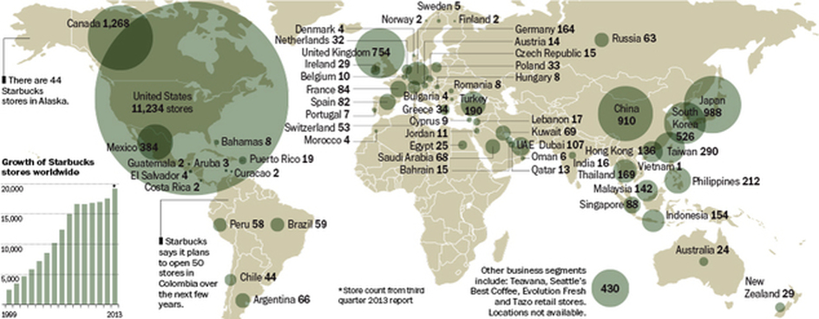
Figure 1: Global Distribution of Starbucks Stores
Source: Starbucks Corporation (2025)
Starbucks, founded in 1971 in Seattle, has grown to become the world's largest specialty coffeehouse chain by 2025, with 40,000 stores in 80+ markets (Starbucks Corporation, 2025). The company's mission is ‘to inspire and nurture the human spirit – one person, one cup, and one neighbourhood at a time', and its vision is to make ‘designing amazing customer experiences through high quality coffee, innovation and sustainable business practices' (Starbucks Corporation, 2025). The core values of Starbucks focus on a sense of belonging, courage, excellence and positive impact to people and the environment. It is a combination of company-operated and licensed stores, with the use of digital platforms, customer loyalty programmes, premium product differentiation and the ethical sourcing of its coffee through its Coffee and Farmer Equity (C.A.F.E.) Practices, which enables long-term value creation (Raj, 2021; Starbucks Corporation, 2025).
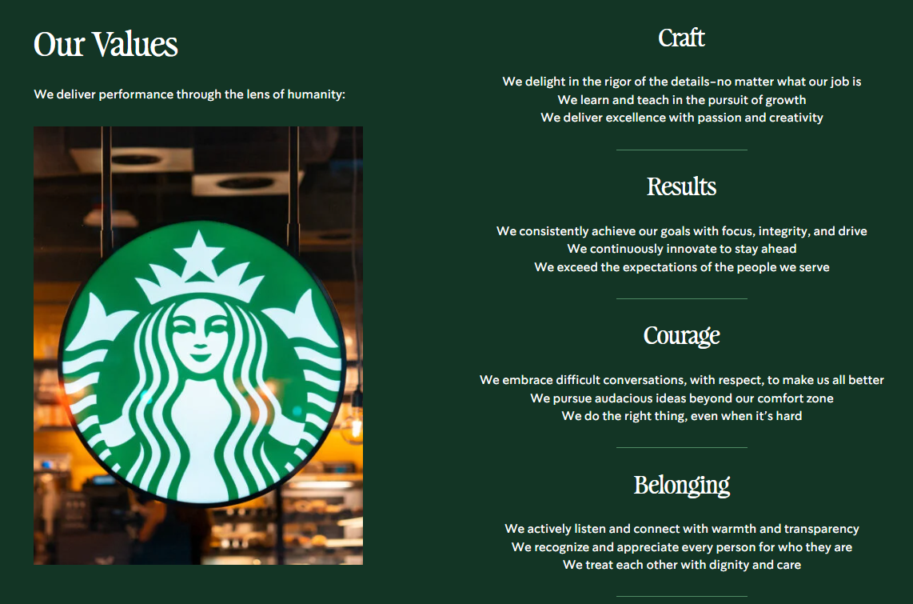
Figure 2: Starbucks' Core Corporate Values
Source: Starbucks Corporation (2025)

1.2 Industry and Market Context
This report examines Starbucks China, the second largest international market for the firm, where the country's rapid urbanisation, growing disposable income and changing consumer lifestyle continue to drive demand for high-quality coffee. Coffee consumption in China is projected to grow beyond key cities and the younger generation has been increasingly drawn to specialty coffee and digital ordering platforms, which will drive robust long-term growth in the country's coffee market (Grand View Research, 2025; Buttha et al., 2024).
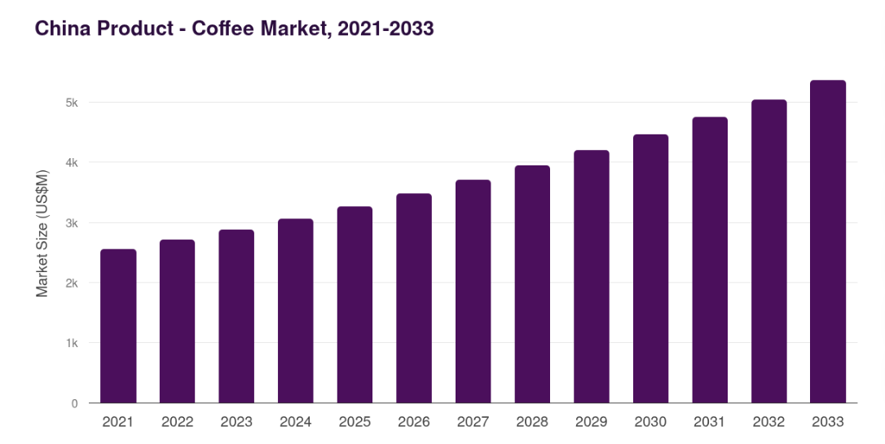
Figure 3: China Coffee Market Size Forecast (2021–2033)
Source: Grand View Research (2025)
However, the market has become extremely competitive – not only with domestic brands like Luckin Coffee, but also with international brands such as Costa Coffee and Tim Hortons China. Luckin's technology-driven, value-oriented approach has fueled heightened price competition and rapid digital innovation in the industry (Zhao et al., 2025). Despite these obstacles, Starbucks's strong brand equity, unique customer experience, wide-ranging store infrastructure, and digital integration create a strong competitive advantage for the brand, enabling it to compete on quality, customer loyalty, and experience, as opposed to low-cost alone (Ren et al., 2023; Zhang, 2025).

2. Strategic Analysis of the Business Environment

2.1 External Environment Analysis Using PESTEL

2.1.1 Political Factors
Starbucks has both challenges and opportunities in the political environment of China. Retail and food service sectors have grown as a result of government policies to support domestic consumption and urban economic development, and promote quality. But rising geopolitical tensions, changing trade policies and more government favoring local businesses could spur indirect competition with multinational businesses. In addition, the government's preference for domestic brands has bolstered the local market, necessitating Starbucks to keep adjusting its localisation approach, but it remains committed to its global brand identity (Starbucks Corporation, 2025; Tang et al., 2025).
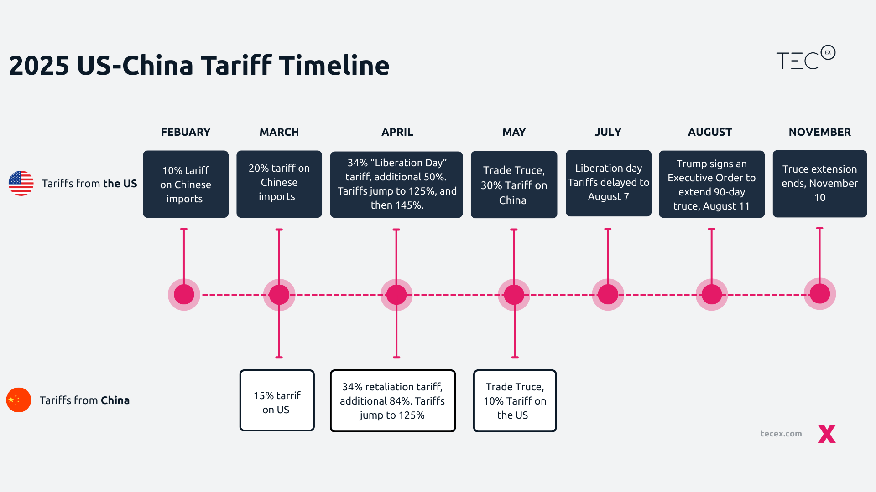
Figure 4: 2025 US–China Tariff Timeline
2025 US–China Tariff Timeline

2.1.2 Economic Factors
The economic conditions greatly impact Starbucks' performance in China. China's economy has been growing, but the growth has been accompanied by reticence to spend, inflation and heightened customer sensitivity to price. In the meantime, the Chinese coffee market is still expected to grow fast in the long run as their disposable income continues to rise and the population is set to become more urban, and middle-income consumers will emerge (Grand View Research, 2025).
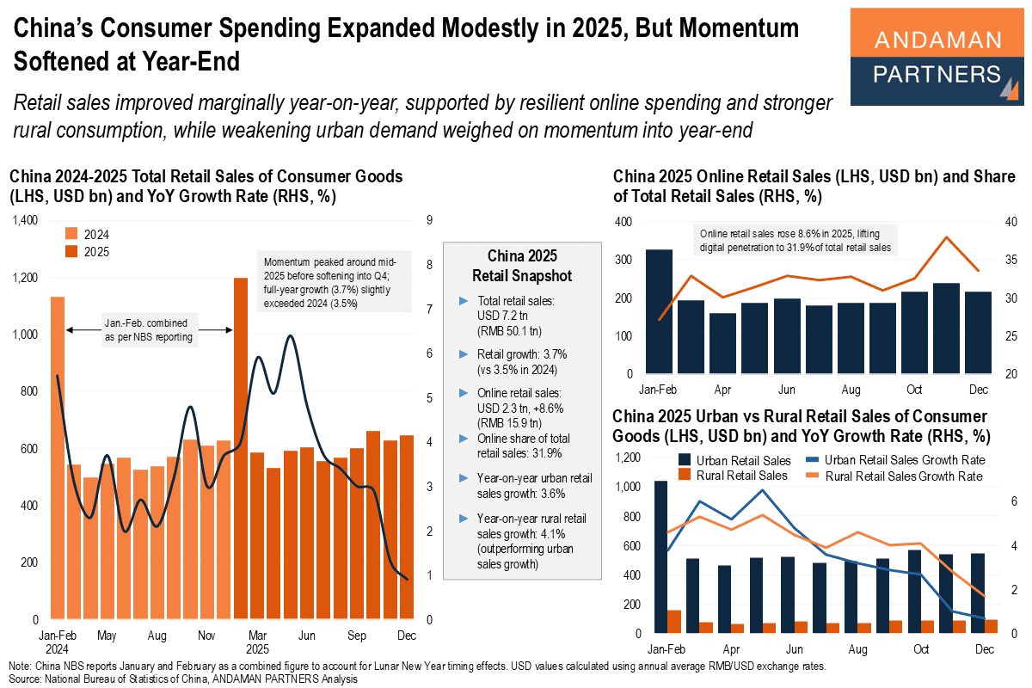
Figure 5: China's Consumer Spending and Retail Sales Performance in 2025
Source: Andaman Partners (2026)
However, the aggressive price competitions by local brands, especially Luckin Coffee, with its lower cost-of-service strategy by using a digital-first business model (Zhao et al., 2025) have challenged Starbucks premium pricing strategy. Starbucks will therefore need to maintain the premium positioning while supporting actions to increase value in order to maintain profitability.

2.1.3 Social Factors
One of the biggest factors affecting Starbucks is the shift in consumer preferences. The younger Chinese consumer is now strongly linked to coffee with Modern lifestyle, social activities, and personal identity. There is a demand for higher quality drinks, bespoke experience, healthier food and beverage items, and quick digital services (Buttha et al., 2024). In response, Starbucks has introduced locally inspired beverages, improved customer experience, and bolstered the Rewards programme. However, consumers are increasingly demanding both affordability and high quality, which puts pressure on Starbucks to be both affordable and high quality to keep customers loyal without compromising on their brand value (Ren et al., 2023).

2.1.4 Technological Factors
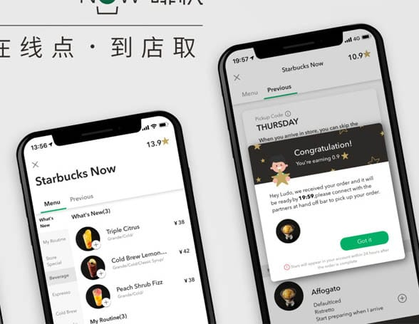
Figure 6: Starbucks Now Mobile Order & Pay Service in China
Source: NFCW (2019)
In China today, technology is an important competitive factor of the coffee industry. Mobile ordering, digital payments, artificial intelligence, personalised promotions and delivery platforms all serve as a lifeline for consumers. Starbucks has prioritized its digital strategies by leveraging Starbucks Rewards, mobile apps, and partnerships to ensure a more engaging customer experience and operational efficiency (Starbucks Corporation, 2025). Technology-driven competitors like Luckin Coffee, however, are driven by very data-oriented business models and lower operating costs, and are able to quickly win customers over with this (Zhao et al., 2025). Thus, ongoing investments in digital marketing skills, customer data analysis, and service development are crucial to sustain competitive advantage (Figueiredo et al., 2026).

2.1.5 Environmental Factors
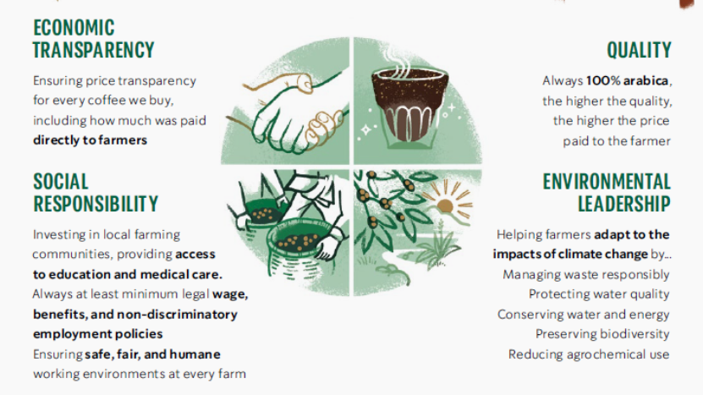
Figure 7: Starbucks Coffee and Farmer Equity (C.A.F.E.) Practices Framework
Source: Starbucks Stories (2020)
The importance of environmental sustainability has grown for both regulators and consumers. Starbucks's environmental initiatives have been reinforced by the responsible sourcing of its coffee, the company's carbon reduction goals, waste management and recyclable packaging programmes under the C.A.F.E. Practices and the company's global ESG strategy (Raj, 2021; Starbucks Corporation, 2025). These efforts boost corporate image and trust in the company, and contribute to sustainable competitiveness. However, the impacts of climate change remain an ongoing threat to global coffee production, particularly through increased risks in the coffee supply chain, raw material costs, and uncertainty of sourcing (Bager et al., 2020; Abate et al., 2026).

2.1.6 Legal Factors
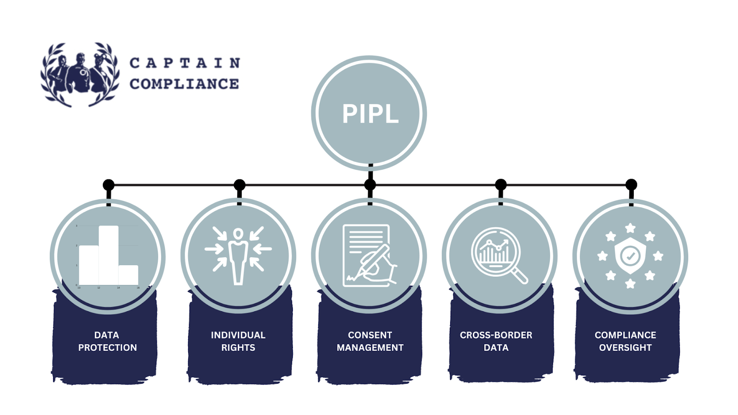
Figure 8: Key Components of China's Personal Information Protection Law
Source: Captain Compliance (2025)
As China's legal landscape continues to shift, Starbucks needs to meet more and more rigorous standards for food safety, employment rights, minimum consumer rights, and environmental measures. Improving food safety governance boosts consumer confidence and adds to the compliance burden of operations (Tang et al., 2025). Furthermore, compliance with provisions regarding data privacy, digital transactions, and environmental reporting demands ongoing investment in compliance systems. Non-compliance with regulatory requirements could impact Starbucks' reputation and erode stakeholder trust in a more regulated landscape (Starbucks Corporation, 2025).

2.1.7 Critical Evaluation of External Opportunities and Threats
The PESTEL has shown that Starbucks China's external environment is an attractive and very dynamic environment. The greatest potential lies in the continued expansion of the specialty coffee market in China, growing interest in specialty coffee among younger generations, technology breakthroughs, and the demands for sustainable premium coffee products (Grand View Research, 2025; Buttha et al., 2024). On the other hand, the most significant challenges are severe competition with domestic brands now that they are digitally enabled, high consumer price sensitivity, supply chain disruptions due to climate issues, and rising regulatory requirements (Bager et al., 2020; Zhao et al., 2025). All of these reinforce the need for Starbucks to continue its strategy of focus on differentiation as opposed to competing on price, and to continue to innovate, adopt digital capabilities, be leaders in sustainability, and provide a great customer experience.

2.2 Internal Environment Analysis Using VRIO

2.2.1 Internal Environment Analysis
The VRIO framework evaluates whether Starbucks' internal resources and capabilities generate sustained competitive advantage within the Chinese coffee market.
Resource / Capability | Valuable | Rare | Difficult to Imitate | Organised to Capture Value | Competitive Implication
Brand equity | ✓ | ✓ | ✓ | ✓ | Sustained competitive advantage
Customer loyalty ecosystem (Starbucks Rewards) | ✓ | ✓ | Moderate | ✓ | Temporary to sustained advantage
Digital capabilities | ✓ | Moderate | Moderate | ✓ | Temporary competitive advantage
Ethical supply chain and C.A.F.E. Practices | ✓ | Moderate | ✓ | ✓ | Sustained competitive advantage
Human capital and organisational culture | ✓ | Moderate | ✓ | ✓ | Sustained competitive advantage
Table 1: VRIO Analysis of Starbucks in the Chinese Market
Source: Author (2026)
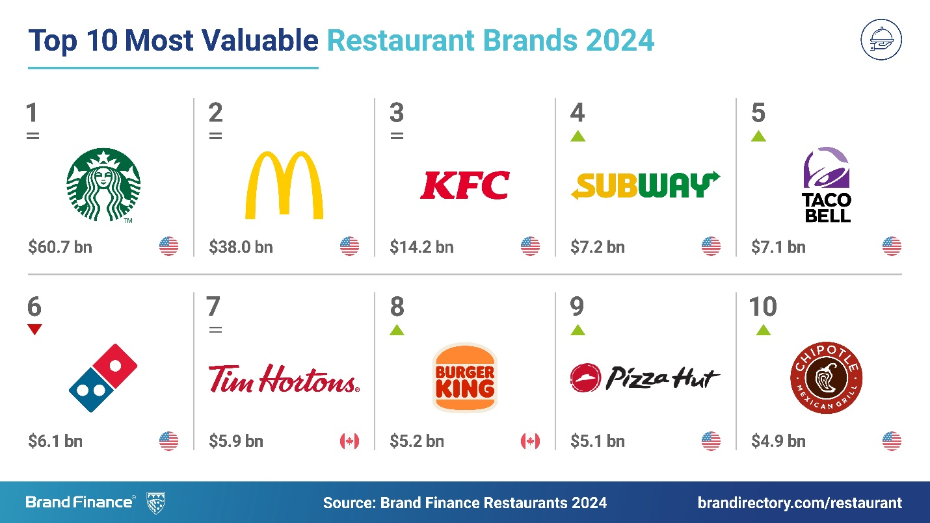
Figure 9: World's Top 10 Most Valuable Restaurant Brands (2024)
Source: Brand Finance (2024)
Brand Equity: Starbucks has one of the most highly trusted premium coffee brands in the world, and can command premium prices without compromising customer confidence and loyalty. In China, its reputation extends beyond coffee to lifestyle, quality, and social experience, differentiating it from lower-priced competitors. Building brand equity can lead customers to pay higher, and help to create a firm position in the market, thus it is an important strategic asset which is difficult to imitate (Ren et al., 2023; Zhang, 2025).
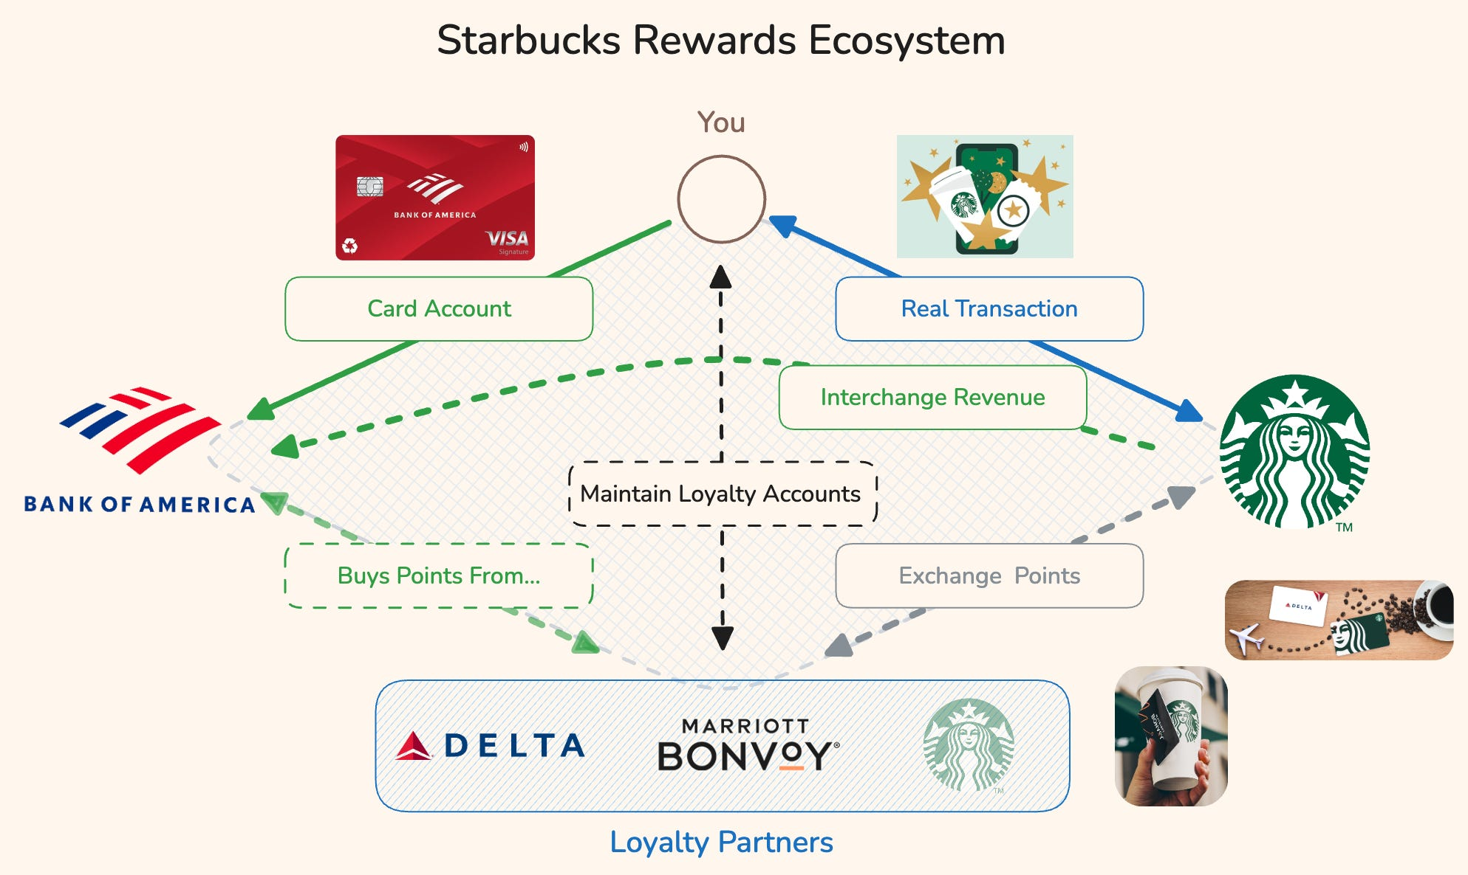
Figure 10: Starbucks Rewards Ecosystem and Customer Loyalty Network
Source: Harvard Business School Digital Initiative (2022)
Customer Loyalty Ecosystem: With mobile ordering and customised promotions, the Starbucks Rewards programme enhances customer retention by engaging them with data-driven initiatives. This ecosystem can help to encourage repeat purchases and increase customer lifetime value, but other digital loyalty programmes, like those used by rivals Luckin Coffee, have also been embraced by competitors. Thus, though valuable and relatively rare, continuous innovation is essential to maintain its competitive advantage (Pereira et al., 2025; Starbucks Corporation, 2025).
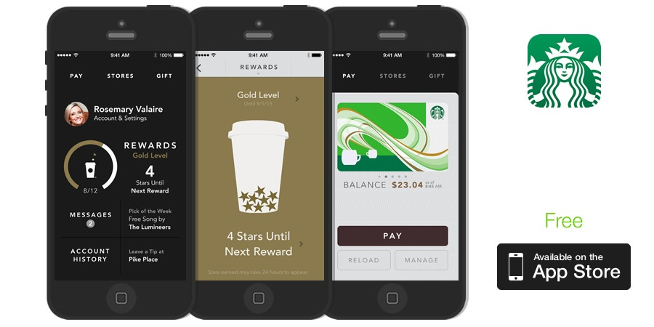
Figure 11: Starbucks Mobile Application and Digital Rewards Platform
Source: Harvard Business School Digital Initiative (2017)
Digital Capabilities: Some of the key investments Starbucks has made are in digital platforms, mobile apps, AI-powered personalisation, and omnichannel customer engagement. These features increase efficiency and convenience in operations, as well as facilitate data-driven decision making. China's digital coffee industry, however, is rapidly changing, and ongoing technological investment is essential to stay competitive with digital-native competitors (Figueiredo et al., 2026; Starbucks Corporation, 2025).
Supply Chain: Starbucks' C.A.F.E. Practices, responsible sourcing standards, supplier relationships, and quality assurance systems enhance its global supply chain. These capabilities improve product consistency, ethical sourcing and sustainability, and lower the reputational risk. This kind of integrated supply chain management is hard to replicate by competitors, thus providing them with long-term competitive advantages (Raj, 2021; Bager and Lambin, 2020).
Human Capital: Starbucks' high-quality customer service is facilitated by employee training, inclusive organizational culture, leadership development, and customer service excellence. The company's focus on employee engagement ensures a steady brand and service. However, with the rise in labor expenses and competition for skilled workers, ongoing investments in workforce development are essential (Starbucks Corporation, 2025).
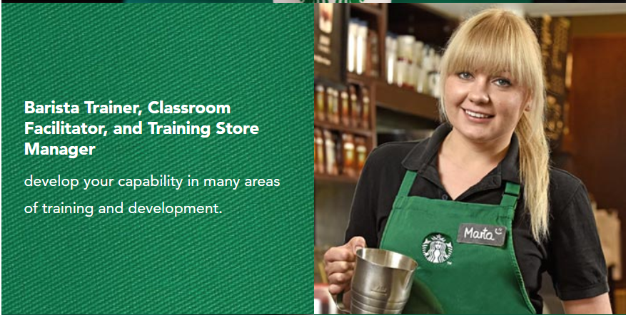
Figure 12: Starbucks' Employee Training and Career Development Pathways
Source: Starbucks EMEA Careers (2025)

2.2.2 Critical Assessment of Strengths and Weaknesses
Starbucks's main strengths are its worldwide recognized brand, high quality customer experience, ethical supply chain, digital ecosystem and organizational culture. Together these resources contribute to the differentiation and long-term competitiveness of China. Weaknesses, however, include premium pricing in a more price-sensitive market, reliance on ongoing digital innovation and vulnerability to intense local competition with lower operating costs. Starbucks must therefore continue to play on its strengths and be flexible to customer expectations and technology to maintain its competitive advantage (Ebrahimzadeh et al., 2026).

2.3 SWOT Strategic Synthesis
Strengths | Weaknesses
Globally recognised premium brand | Premium pricing strategy
Strong customer loyalty ecosystem | Higher operating costs
Advanced digital platform | Slower adaptation than digital-native competitors
Ethical sourcing and sustainability leadership | Dependence on premium market segment
Extensive retail network and customer experience | Exposure to changing consumer spending
Opportunities | Threats
Rapid growth of China's coffee market | Intense competition from Luckin Coffee
Expanding middle-income consumers | Increasing price sensitivity
Digital innovation and AI | Climate-related supply chain risks
Rising demand for sustainable products | Regulatory and compliance pressures
Expansion into lower-tier cities | Market saturation in major cities
Table 2: SWOT Analysis of Starbucks in the Chinese Coffee Market
Source: Author (2026)
Overall, the SWOT analysis reveals that Starbucks needs to adopt SO strategies, take advantage of the country's growing specialty coffee market, and the rising demand for premium experiences, while capitalising on its own strengths such as the premium brand, digital ecosystem, and sustainability leadership. ST strategies involve strengthening the product innovation, customer engagement and service differentiation to fight the strong competition and price rivalry, and to retain the premium position (Zhao et al., 2025; Zhang, 2025).
WO strategies should focus on the weaknesses to increase operational efficiency, localization of the product and increase value offerings when not taking out the brand equity. Investment in AI-powered personalisation and digitalisation would improve the competitiveness against technology-based competitors. WT strategies focus on managing risks, such as diversifying supply chains, enhancing regulatory requirements, and better controlling costs to lessen susceptibility to market volatility and climate shocks (Bager et al., 2020; Zhao et al., 2025).
In general, the SWOT synthesis postulates that Starbucks needs to maintain its premium differentiation strategy with the digital innovation and sustainability; it is not advisable for Starbucks to pursue price competition. The internal strengths can be combined with external market opportunities to be the most suitable strategic path that can be used to maintain the competitive advantage and long-term growth of the Chinese coffee market.

3. Comprehensive Strategic Evaluation

3.1 Evaluation of Starbucks' CSR Strategy
At Starbucks, corporate social responsibility (CSR) is integrated into the corporate strategy and serves as a means to achieve its mission of inspiring and nurturing the human spirit, and creating long-term value for shareholders. CSR is not just a philanthropic program, it is part of the operational resilience, brand and sustainable competitive advantage (Kang et al., 2022).
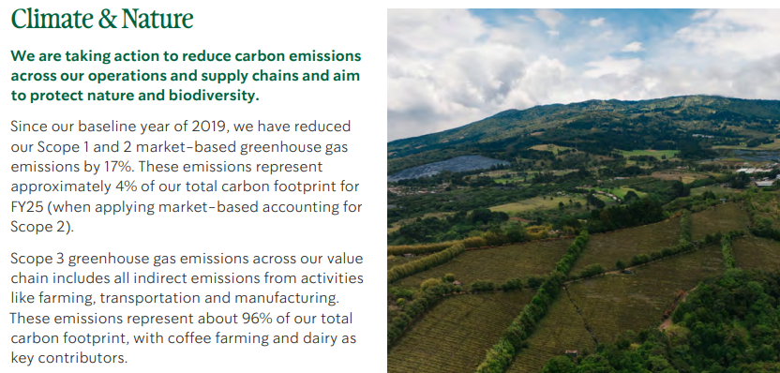
Figure 13: Starbucks' Climate and Nature Commitments
Source: Starbucks Corporation (2026)
Starbucks has pledged to decrease carbon emissions, decrease waste, encourage reusable packaging and enhance water stewardship. The company also focuses on designing stores that are more efficient in terms of energy and waste, as well as on implementing circular economy initiatives to minimize its environmental footprint (Starbucks Corporation, 2025). The latter serve to enhance the ESG profile of Starbucks and cater to the increasing consumer demands for sustainable businesses. Nevertheless, operating in an environmental manner is difficult because coffee is a resource-consuming crop and the number of outlets is increasing (Bager et al., 2020).
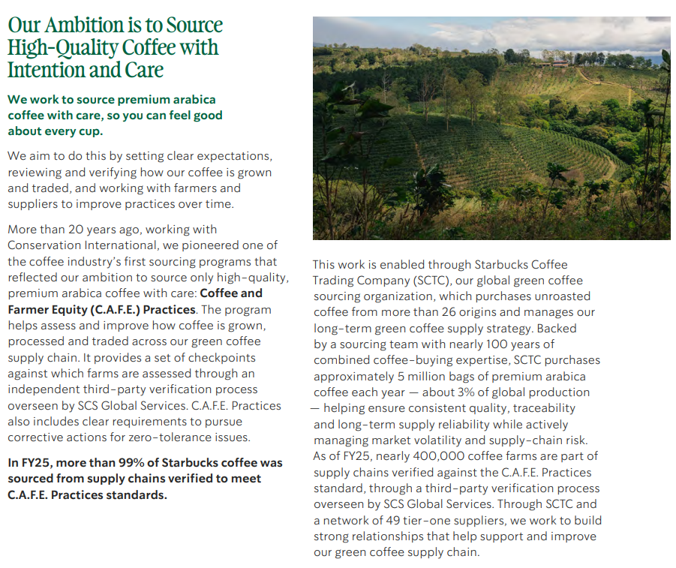
Figure 14: Starbucks' Ethical Coffee Sourcing
Source: Starbucks Corporation (2026)
One of the best CSRs that Starbucks has is ethical sourcing. Starbucks advocates for responsible sourcing, supplier audits, farmer support and sustainable farming through its Coffee and Farmer Equity (C.A.F.E.) Practices. These efforts enhance coffee quality, build supplier relationships, and minimize long-term risks in the supply chain arising from climate change and market volatility (Raj, 2021; Abat et al., 2026). Ethical sourcing therefore is not just a brand builder, but a part of the operation that helps to make it sustainable.
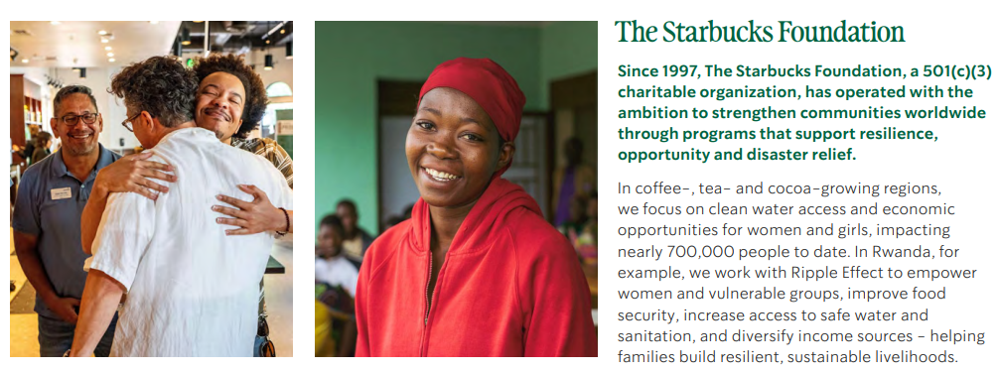
Figure 15: The Starbucks Foundation's Community Development Initiatives
Source: Starbucks Corporation (2026)
Starbucks also shows community engagement with youth development initiatives and partnership programmes helping to connect with local communities and make them stronger in terms of social inclusion and engagement. At the local level, community activities boost stakeholder confidence and strengthen customer ties, supporting the company's luxurious brand image (Starbucks Corporation, 2025).

Figure 16: Starbucks' Investment in Youth Education
Source: Starbucks Corporation (2026)
Employee welfare continues to be a strategic pillar. Starbucks fosters employee development, leadership, diversity, and inclusivity to enhance customer service and employee satisfaction. This investment enhances client experience, fosters organisational performance and innovation (Obeng et al., 2026).
In conclusion, Starbucks' CSR strategy is consistent with its mission, focusing on multiple aspects such as sustainability efforts via the environment, ethical business operations and employee training, and engagement with stakeholders. However, CSR is no longer a cost, but it can help enhance brand equity, customer trust, supply chain resilience, and competitiveness (Ren et al., 2023). However, as consumers become more demanding and the hype surrounding ESG is growing more intense, Starbucks needs to be more concrete in outlining sustainability impacts while keeping its reporting process transparent and open.

3.2 Balanced Scorecard Analysis
Transforming Starbucks China's strategic aims into quantifiable monetary and non-monetary performance measures that aid in its execution is done through the Balanced Scorecard (Madsen, 2025).
Perspective | Objectives | KPIs | Targets | Strategic Initiatives
Financial | Increase sustainable revenue growth and profitability | Revenue growth, operating margin, same-store sales growth | Annual revenue growth >8%; positive same-store sales growth | Expand premium beverages, optimise store portfolio, improve operational efficiency
Customer | Strengthen customer loyalty and premium brand experience | Starbucks Rewards membership, customer satisfaction, repeat purchase rate, Net Promoter Score | Growth in Rewards members; customer satisfaction above 90% | AI-driven personalisation, localised products, digital engagement, premium customer experience
Internal Business Processes | Improve operational excellence and supply chain sustainability | Order fulfilment time, inventory efficiency, ethically sourced coffee percentage, waste reduction | 100% ethical sourcing maintained; reduced operational waste | Strengthen C.A.F.E. Practices, digital operations, supply chain optimisation, process automation
Learning and Growth | Develop employee capabilities and innovation | Employee engagement, training hours, staff retention, digital innovation projects | Higher employee retention; continuous leadership development | Leadership training, digital capability development, diversity initiatives, innovation culture
Table 3: Balanced Scorecard for Starbucks China
Source: Author (2026)
The proposed Balanced Scorecard is based on the differentiation strategy used by Starbucks China, which incorporates financial performance, customer satisfaction, operational excellence, sustainability and organisational learning. Financial indicators guarantee profitability while customer measurements increase customer loyalty in an increasingly competitive market (Liu, 2025). Operating measures like internal process indicators enhance operational efficiency and ethical sourcing practices, while learning and growth measures foster innovation, skill development, and sustainable adaptability. Overall, the Balanced Scorecard offers a holistic framework for measuring strategic performance in Starbucks' international expansion, connecting these four views to ensure that the company tracks strategic progress beyond just financial results, thereby boosting strategic alignment and maintaining its competitive advantage in the dynamic coffee market of China (Madsen, 2025; Subačienė et al., 2026).

4. Strategic Choices and Implementation

4.1 Evaluation of Strategic Options
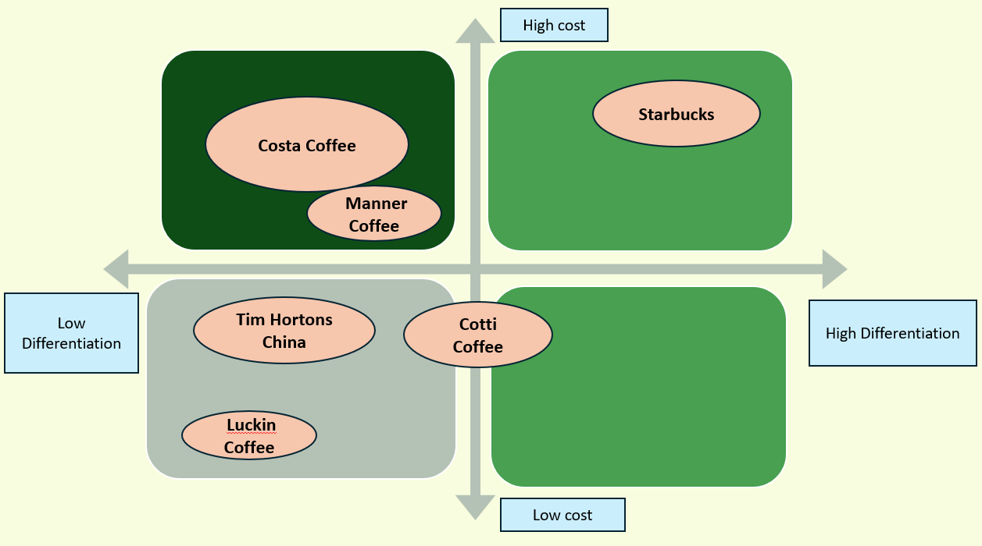
Figure 17: Strategic Positioning Map of Major Coffeehouse Competitors
Source: Author (2026)
Starbucks China has three strategic options at the business level: cost leadership, differentiation, or focus. Cost leadership is not the most appropriate of the options as Starbucks' premium positioning is more associated with their superior quality product, ambience of stores, their ethical sourcing and customer experience than low prices. Such direct competition with value-oriented players like Luckin Coffee could lead to a decline in brand value and a drop-in profitability, but not to long-term sustainable competitive advantage (Ren et al., 2023; Zhang, 2025).
Differentiation is a current strategic asset of Starbucks. It will distinguish itself with high quality coffee, individual customer experiences, a digital approach, product innovation and sustainability initiatives. These skills warrant high prices and contribute to the high degree of customer loyalty, which is hard to mirror by rivals (Raj, 2021; Starbucks Corporation, 2025).
Starbucks' success is also based on the focus strategy it has adopted, that is, focusing on niche markets like premium urban consumers. However, niche markets alone could restrict future expansion in terms of consumption as it continues to spread to lower tier cities and wider consumer groups. As a result, Starbucks should be looking to expand its customer base while maintaining its luxury brand (Puyt et al., 2025).
In general, differentiation is the most suitable strategic alternative as it corresponds to Starbucks' internal capabilities, their CSR commitment and their long-term positioning. Instead of playing a game of price, Starbucks should focus on increasing value creation through innovation, digital transformation and localised customer experience.

4.2 Evaluation Using Strategic Frameworks
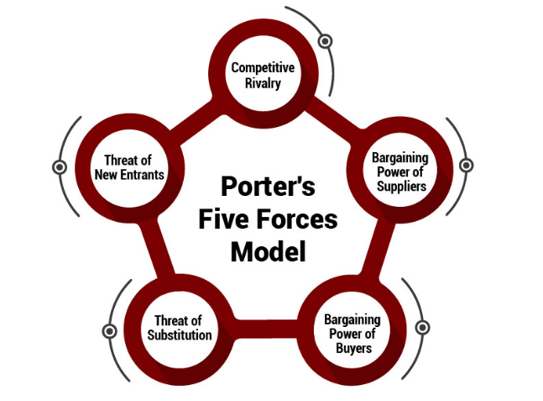
Figure 18: Porter's Five Forces Model for Industry Competitive Analysis
Source: The Strategy Institute (2025)
Using Porter's Five Forces, it can be seen that the level of competition in the coffee industry in China is very high as there is high rivalry between local and foreign brands. Buyer power has risen since buyers are able to easily move to other coffee retailers, and the threat of substitutes is moderate since there are many alternative beverages available. While Starbucks has a relatively controlled supply chain with its worldwide sourcing network, new market players are making inroads with digital business models. These conditions make it crucial to maintain competitive differentiation instead of cost competition (Gunawan Warja et. al 2025).
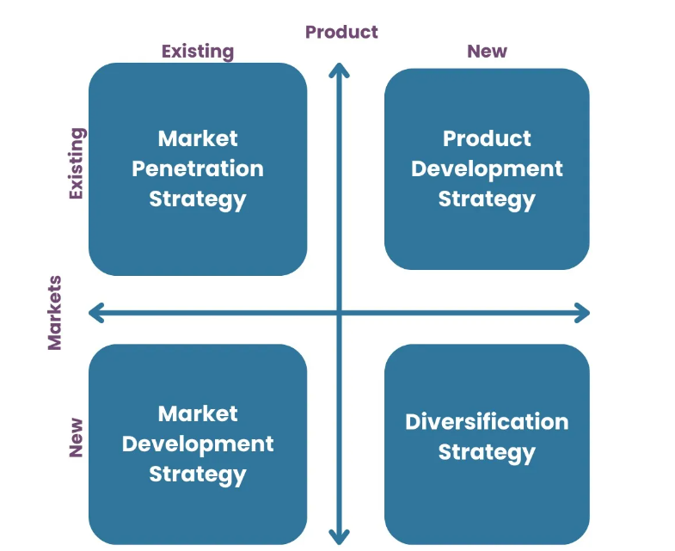
Figure 19: Ansoff Matrix for Strategic Growth Options
Source: Oxford College of Marketing (2023)
Based on Ansoff Matrix, product development is the most appropriate growth strategy. By offering locally-inspired drinks, healthier food and beverage options, AI-driven personalisation, and enhanced experiences, Starbucks can adapt to shifting consumer demands and reinforce its market presence. This is a less risky approach than diversification and creates more value for the customer than market penetration alone (Maris, 2019).
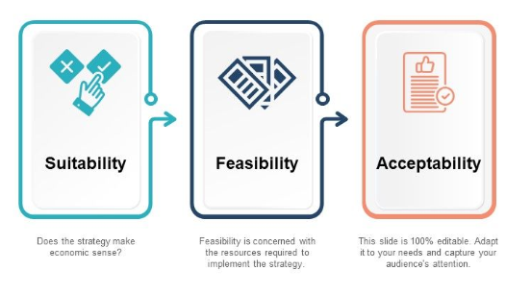
Figure 20: SAFe Framework for Evaluating Strategic Options
Source: SlideGeeks (2025)
Further, the preferred strategy is supported with the SAFe framework. In terms of Suitability, digital premium differentiation is a very good answer to market demand, new technologies and competition. In terms of Acceptability, the strategy aligns with the goals of shareholder value, customer satisfaction, employee development and sustainability goals while maintaining Starbucks' premium brand. Regarding Feasibility, Starbucks has access to the finances, digital capabilities, global brand value, and organisational expertise required to successfully implement this strategy (Wei, 2025; Sepasi, Tabatabaei Rafiei et al., 2024).

4.3 Recommended Strategy
A strategic direction that can be recommended for Starbucks China is Digital Premium Differentiation via Localised Customer Experience. Overall, it enhances Starbucks' core competitive strengths, and integrates high-end coffee, technological innovation, sustainability, and China-driven product development.
The plan focuses on the growth of AI-powered personalization for the customer, Starbucks Rewards, new beverages and food offerings based on local tastes and preferences, better engagement through omnichannel customer communications and efforts, and increased environmental, social and governance (ESG) initiatives. These are the steps that make sure Starbucks is able to offer greater value to the customers, but can continue to charge them high prices because of the growing market competition (Starbucks Corporation, 2025).
The benefits are expected to be increased customer retention, customer loyalty, operational efficiencies with digital technologies and sustainable revenue growth. Additionally, product innovation at the local level helps Starbucks to be more responsive to the increase and decrease of consumers' tastes and preferences, and minimize the competition of the local coffee chains (Weber et al., 2026).
Most significantly, this approach forms sustainable competitive edge by using important and hard-to-replicate resources, such as brand equity, digital capabilities, ethical sourcing and customer experience (Shavina Alifia et al., 2025). In the context of coffee market competition in China, Starbucks uses innovation, service excellence, and sustainability to differentiate and enhance long-term growth and sustainability.

4.4 Implementation Challenges and Mitigation
Implementation Challenge | Potential Impact | Mitigation Strategy | Responsible Function
Intense competition from domestic brands (e.g., Luckin Coffee) | Reduced market share and customer loyalty | Accelerate product innovation, strengthen premium customer experience, and expand localised offerings | Marketing & Strategy
Rapid technological change | Digital capability gaps and declining customer engagement | Invest continuously in AI, data analytics, digital platforms, and cybersecurity | Digital Transformation & IT
Rising operational and sourcing costs | Lower profitability and margin pressure | Optimise supply chain efficiency, strengthen supplier partnerships, and implement cost management initiatives | Operations & Procurement
Climate change affecting coffee production | Supply disruptions and increased raw material costs | Diversify sourcing regions, invest in climate-resilient farming, and strengthen C.A.F.E. Practices | Supply Chain & Sustainability
Increasing ESG and regulatory requirements | Compliance costs, reputational damage, and legal risks | Enhance ESG reporting, strengthen compliance systems, and conduct regular regulatory audits | Sustainability & Compliance
Changing consumer preferences | Reduced demand for existing products | Increase market research, introduce localised products, and expand healthier menu options | Marketing & Product Development
Talent attraction and employee retention | Higher staff turnover and inconsistent service quality | Enhance employee benefits, leadership development, and continuous training programmes | Human Resources
Economic uncertainty and price sensitivity | Declining sales and reduced premium purchases | Introduce value bundles, personalised promotions, and targeted loyalty rewards while maintaining premium positioning | Finance & Marketing
Table 4: Implementation Challenges and Mitigation Strategies for Starbucks China
Source: Author (2026)

Section 2

5. Reflection on the Consultancy Process (Gibbs Reflective Cycle)
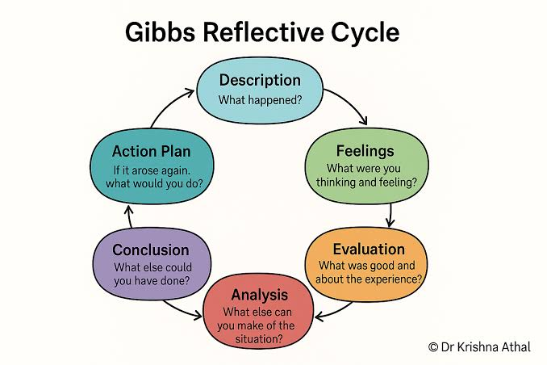
Figure 21: Gibbs' Reflective Cycle for Structured Reflective Practice
Source: Dr Krishna Athal (2025)

5.1 Description
The consultancy task was to analyze the strategic position of Starbucks in the Chinese coffee market and develop recommendations to enhance its competitive advantage. The report needed to include integration of strategic management frameworks (such as PESTEL, VRIO, SWOT, Porter's Five Forces, Ansoff Matrix, SAFe and the Balanced Scorecard) with real organisational evidence. This also included examining Starbucks' CSR strategy, analysing the internal and external environment of the company, and making suggestions that can be implemented grounded on empirical research from the academic world and the company reports.

5.2 Feelings
This was a challenge in the beginning as it involved a combination of academic theory, business analysis and consultancy mindset. There was a need to make informed choices on selecting appropriate strategic frameworks and to collate information from various sources. Gradually as I was learning more about Starbucks' strategic environment and the coffee market in China, my confidence grew and was able to critically analyze evidence instead of just describing business activities.

5.3 Evaluation
The use of strategic management frameworks to consider Starbucks from various perspectives was one of the best parts of the assignment. Using company data in addition to academic literature made the recommendations more credible, and helped me better support strategic decisions. The analysis of CSR in relation to the competitive strategy also revealed the link between sustainability and long-term business performance.
However, I was too dependent on descriptive information at first and did not notice the significance of critical evaluation. Another difficulty was being able to select the most important problems from the vast amount of information. This meant that it was not possible to try to include all the evidence available and there was a need to prioritize the evidence according to its relevance for Starbucks's competitive position.

5.4 Analysis
This assignment helped me a great deal to understand strategic management as a holistic decision-making process and not a number of analytical tools that are independent in nature. Combining PESTEL and VRIO was a great way of showing the interaction between the external environment and organisational capabilities to determine its competitive advantage. Similarly, when SWOT was used along with Porter's Five Forces and SAFe framework, it was clearly seen that strategic recommendations should not only be derived from one model but there are several additional complementary perspectives.
Also, working with evidence improved my critical thinking skills. Instead of accepting company reports at face value, I compared corporate information with academic literature and industry evidence to identify both strengths and potential limitations. This method in turn pointed out the value of evidence triangulation in the preparation of consultancy reports.
Moreover, using theory in a real multinational firm helped me to link theory and practice in the form of practical business recommendations. Instead of having to present the theory models on their own, I was able to apply the models as decision support tools offering a strategic insight.
Lastly, the consultancy approach was a catalyst for objective and solution-oriented thinking. However, I focussed not just on organisational issues but also on realistic evidence-based recommendations that met stakeholder expectations, organizational capacity and long-term strategic goals. This experience deepened my understanding of what makes a consultant valuable; combining analytical rigour and practical implementation considerations.

5.5 Conclusion
It was a great consultancy experience completing this report as it really helped me to increase my knowledge of strategic management and use recognised frameworks in an organisational setting. During the journey, I grew in confidence at critically analysing external and internal business environments, interpreting company and industry evidence and applying academic theories and ideas into practical strategic decision making.
I also gained an understanding of the significance of applying a range of analytical tools to come up with well-rounded, evidence-informed recommendations. This experience proved that while a good strategic consultant can certainly provide their business with a list of business problems, they can also help them present realistic, attainable solutions that fit their capability, the stakeholders' expectations, and market conditions. In general, the assignment offered me valuable experience in analysis, critical thinking and consulting that will help me in my academic studies and future career in strategic management.

5.6 Action Plan
Development Goal | Activities | Timeline | Success Measure
Strengthen strategic analysis skills | - Practise applying PESTEL, VRIO, SWOT, and Porter's Five Forces to real organisations.  - Analyse annual reports and strategic case studies. | Next 6 months | Ability to produce more comprehensive, critical, and evidence-based strategic evaluations.
Improve evidence evaluation | - Read recent peer-reviewed journals monthly.  - Review industry reports and company annual reports.  - Compare academic evidence with practical business data. | Ongoing | Stronger integration of high-quality, credible evidence in academic and consultancy reports.
Enhance consultancy thinking | - Complete strategic business case studies.  - Develop practical recommendations using recognised frameworks.  - Evaluate implementation risks and mitigation strategies. | Within 6 months | Recommendations become more realistic, actionable, and aligned with organisational objectives.
Develop professional communication | - Practise consultancy report writing.  - Improve presentation and data visualisation skills.  - Seek feedback from lecturers and peers to refine communication. | Ongoing | Clearer, more persuasive, and professionally structured consultancy reports and presentations.
Table 5: Personal Action Plan for Future Strategic Consultancy Development
Source: Author (2026)

6. Conclusion
From a strategic point of view, it can be seen that the Chinese market for coffee is highly competitive and is booming quickly, with the changing preferences of coffee drinkers, digital transformation, sustainability concerns and strong rivalry from Chinese competitors like Luckin Coffee. In spite of these external threats, Starbucks is in a solid strategic position, and it is evident that these factors would contribute to its sustainable competitive advantage in the future: its well-known brand, the quality of its customer service, its digital economy, its ethical sourcing and the quality of its organization.
It is concluded that differentiation is still the most suitable business level strategy. In particular, the Digital Premium Differentiation through Localised Customer Experience approach will help Starbucks meet changing customer demands without compromising on its premium market. It is noted that this strategy is supported by the company's internal strengths and is in line with the market opportunities, while also being suitable, acceptable and feasible to be successfully implemented.
If the recommended approach is implemented successfully, it is expected that this will increase customer loyalty, as well as enhancing the efficiency of the operations and sustainability performance and contributing to long-term revenue growth. Finally, as Starbucks continues to innovate, enhance its digital capabilities and create locally relevant customer experiences, it can continue to strengthen its competitive advantage and maintain market leadership in China's dynamic coffee industry while providing long-term value to its customers, employees, shareholders and other stakeholders.

References
Abate, T., Raj, S. and Chawla, G. (2026) 'Sustainable supply chain management in the global coffee industry: Bibliometric analysis and research agenda', Humanities and Social Sciences Communications. Available at: https://doi.org/10.1057/s41599-026-08216-6.
Bager, S.L. and Lambin, E.F. (2020) 'Sustainability strategies by companies in the global coffee sector', Business Strategy and the Environment, 29(8), pp. 3555–3570. Available at: https://doi.org/10.1002/bse.2596.
Buttha, S., Khamsroy, A. and Lhapeerakul, P. (2024) 'Factors affecting coffee consumption culture in China during the year 2012–2021', Journal of Sinology, 18(2), pp. 67–87. Available at: https://journals.mfu.ac.th/jsino/article/view/137.
Ebrahimzadeh, S.M., Labafi, S., Khajeheian, D., Roshandel Arbatani, T. and Sepasgozar, S. (2026) 'Sustainable development and innovation as drivers of brand equity enhancement in knowledge-based enterprises: Empirical evidence from science parks', Sustainability, 18(6), 3115. Available at: https://doi.org/10.3390/su18063115.
Figueiredo, R., Agag, G., Yousaf, A. and Soliman, M. (2026) 'Digital marketing capability: Its impact on marketing agility and service innovation in the hospitality industry', International Journal of Hospitality Management, 135, 104607. Available at: https://doi.org/10.1016/j.ijhm.2026.104607.
Grand View Research (2025) China coffee market size, share and trends analysis report. Available at: https://www.grandviewresearch.com/horizon/outlook/coffee-market/china.
Gunawan Warja, A.A., Abdurahman and Purnamasari, P. (2025) 'Business strategy analysis of Kopi Kenangan using Porter's Five Forces', Jurnal Minfo Polgan, 13(2). Available at: https://doi.org/10.33395/jmp.v13i2.14443.
Kang, L. and Bi, C. (2022) 'Research on Starbucks brand value marketing in China's coffee industry', Technium Social Sciences Journal, 37, pp. 230–234. Available at: https://doi.org/10.47577/tssj.v37i1.7622.
Liu, Z. (2025) 'Evaluating Starbucks’ ESG performance: Environmental, social, and governance insights', in Proceedings of the 2025 5th International Conference on Business Administration and Data Science (BADS 2025). Advances in Computer Science Research. Available at: https://doi.org/10.2991/978-94-6463-980-3_15.
Madsen, D.Ø. (2025) 'Balanced Scorecard: History, implementation, and impact', Encyclopedia, 5(1), p. 39. Available at: https://doi.org/10.3390/encyclopedia5010039.
Maris, S.S.C. (2019) 'A study on Ansoff matrix technique: As a growth strategy and an adaptive learning technique adopted in the leading brand of products', JAC: A Journal of Composition Theory, 12, pp. 1494–1506.
Obeng, H., Sarwar, A., Arhinful, R. and Mensah, L. (2026) 'Corporate social responsibility as a driver of sustainable competitive advantage through green human resource management and technological adaptability', Discover Sustainability. Available at: https://doi.org/10.1007/s43621-026-03493-2.
Pereira, M.d.S., de Castro, B.S., Cordeiro, B.A., de Castro, B.S., Peixoto, M.G.M., da Silva, E.C.M. and Gonçalves, M.C. (2025) 'Factors of customer loyalty and retention in the digital environment', Journal of Theoretical and Applied Electronic Commerce Research, 20(2), p. 71. Available at: https://doi.org/10.3390/jtaer20020071.
Puyt, R.W., Lie, F.B. and Madsen, D.Ø. (2025) 'From SOFT approach to SWOT analysis: A historical reconstruction', Journal of Management History, 31(2), pp. 333–373. Available at: https://doi.org/10.1108/JMH-05-2023-0047.
Raj, D. (2021) Starbucks: C.A.F.E. Practice. Available at: https://doi.org/10.13140/RG.2.2.34095.46249.
Ren, Y., Choe, Y. and Song, H. (2023) 'Antecedents and consequences of brand equity: Evidence from Starbucks coffee brand', International Journal of Hospitality Management, 108, 103351. Available at: https://doi.org/10.1016/j.ijhm.2022.103351.
Sepasi, S., Tabatabaei Rafiei, S.H. and Madandar, B. (2024) 'Optimizing business processes through SAF: A new frontier in performance management', Research Annals of Industrial and Systems Engineering, 1(1), pp. 21–33. Available at: https://doi.org/10.22105/raise.v1i1.32.
Shavina Alifia and Dalimunthe, G.P. (2025) 'Operationalisation of internal analysis using the VRIO framework: Assessing resource and capability management in a Bandung-based coffee business (Case study: Kopi Anjis)', International Journal of Economics and Management Research, 3(3). Available at: https://doi.org/10.55606/ijemr.v3i3.419.
Starbucks Corporation (2025) Annual Report 2025. Available at: https://s203.q4cdn.com/326826266/files/doc_financials/2025/ar/Starbucks-Corporation_2025-Annual-Report-Web-Ready.pdf.
Subačienė, R., Arbidane, I., Mietule, I., Kotane, I., Auzina-Emsina, A. and Lace, N. (2026) 'System of non-financial performance indicators in the manufacturing sector', Administrative Sciences, 16(1), p. 17. Available at: https://doi.org/10.3390/admsci16010017.
Tang, S., Yang, Y. and Li, Z. (2025) 'Governance of food safety in China's pre-made dishes industry: Legal reforms, policy strategies, and international perspectives', Frontiers in Nutrition, 12, 1702278. Available at: https://doi.org/10.3389/fnut.2025.1702278.
Wei, Y.-M. (2025) 'A hybrid multi-criteria decision-making framework for the strategic evaluation of business development models', Information, 16(6), p. 454. Available at: https://doi.org/10.3390/info16060454.
Weber, J.J., Coronado, A.E. and Baumann, L. (2026) 'Digital transformation strategy alignment and implementation in industrial SMEs: A taxonomy and systematic literature review', Strategic Business Research, 2(1), 100183. Available at: https://doi.org/10.1016/j.sbr.2026.100183.
Zhang, J. (2025) 'Analysis of Starbucks' differentiated marketing strategy', Advances in Economics, Management and Political Sciences, 218, pp. 222–226. Available at: https://doi.org/10.54254/2754-1169/2025.CAU27575.
Zhao, Z., Chen, G., Duan, J. and Xu, Y. (2025) 'Site selection analysis and prediction of new retail stores from an urban commercial space perspective: A case study of Luckin Coffee and Starbucks in Shanghai', ISPRS International Journal of Geo-Information, 14(6), p. 217. Available at: https://doi.org/10.3390/ijgi14060217.

