Name: Nadine Gayle
Student Number: 1816824
Module Code: BMHP5001_BIRM
Title: Supporting Paper.
Lecturer’s Name: DR Mark Gallagher- Read

Introduction
Acupuncture is the oldest healing method in the world. Acupuncture is a traditional Chinese medicine. Acupuncture is a therapy that aims to help restore the self-healing chemicals within the body, Acupuncture is looked at as part of a complementary alternative medicine (CAM) (SAGE Journals, n.d.)
Some of the key points that will be discussed in this paper are:
- Acupuncture has been Practiced in china for thousands of years.
- A lot of research has been done around acupuncture.
- How acupuncture used.
- Benefits of having Acupuncture.
What is acupuncture ?
Acupuncture therapy is one of the different sorts of conventional therapy and elective meds. The conventional treatment measure is the inclusion of needles at explicit focuses into the skin of a patient’s body. The traditional treatment of acupuncture is a process that is insertion of Tiny needles in so points of the body of the person who is receiving acupuncture (Brazier, 2017)
Acupuncture is not like traditional methods of using needles this method, includer’s placing the needles into certain points into the body that stimulates, self-healing also known as the qi (which is the vital energy that always circulates through the body) Chinese medication experts accept qi disturbances make uneven balances around the body’s energy that can lead to other health problems (Johnson, 2018)
Qi is considering the energy that moves through the body. A few types of needle therapy intend to rebalance qi with needles that touch needle therapy focuses (acupoints) all through the body. There are many acupoints in the body along 14 significant meridians, likewise, called energy-conveying channels in the body. (Friedlander, 2019)
When it comes to acupuncture, there are Thirteen types of which ten of them are traditional, and three of them are western, which all aim to improve health issues. Traditional types of acupuncture all aim to regulate the blood flow to promote a self-healing within the body. Where western acupuncture is used by health professional's that use this method in a more textbook way (Dr (TCM) Attilio D’Alberto, n.d.)
The practice of acupuncture therapy started in China. It was first referenced and recorded in quite a while dating two or three hundred years before the Common Era. Prior rather than needles honed stones and long sharp bones were utilized around 6000 BCE for needle therapy treatment. These instruments could likewise have been utilized for basic surgeries like spearing an ulcer and so forth (Li et al., 2020)
How is it used?
Acupuncture is where 10 – 20 tiny needles are inserted into the main pressure points of the body. Also known as Acupuncture needles by the acupuncturist. that Stimulate the points of the body. This method of acupuncture encourages the body to promote natural healing and to improve bodily functions. for needle therapy treatment. (White, 2004)
Many studies show that There is no logical evidence that the acupuncture needle therapy focuses exist, and it is difficult to demonstrate that they either do or don't, however various examinations propose that needle therapy works for certain conditions (www.medicalnewstoday.com, 2017)
Research behind Acupuncture
Acupuncture is one the most searched and documented alternative medicines around. Acupuncture is needle therapy that is broadly used in the UK, with an expected 3.8 million needle therapy medicines conveyed in 2009.1 A new meta-examination dependent on singular patient information from almost 18,000 patients exhibited needle therapy is viable for a scope of excruciating conditions (Greville-Harris et al., 2016)
Much research that was carried out has been observed into to the positive and negatives of acupuncture.
Since logical examinations have not completely clarified how acupuncture therapy functions inside the system of Western medication, needle therapy stays a wellspring of contention. It is critical to play it safe when choosing about needle therapy.

Benefits of having acupuncture.
There are so many benefits to having acupuncture. But before having acupuncture, its recommended, to speak to your doctor beforehand. Most people decided to have acupuncture, as and different method of pain relief, having this method of CAM can be reinsuring as this can help with mild health conditions as well as much more some of the benefits acupuncture.
Acupuncture, however, has expanded uses in other parts of the world. Before considering acupuncture, talk to your doctor. Conditions that may benefit from acupuncture include the following:
- Pain relief
- Pregnancy
- Pain from caused by dental.
- Anxiety
According to research some results can be seen after the first treatment of acupuncture, are having acupuncture, your body starts to show signs, such as sleeping better, one may feel less stress, and may even feel like they have more energy and some maybe be more emotional (Calabro, 2013)
But just like any procedure, there are also risk to having acupuncture according to many research the most common side effects to having acupuncture, is Bleeding some bruising from where the needles have been inserted, some of the other side effects to be aware of is feeling light headed, and in some case even fainting there is also come more complex but rare side effects such as Nerve damage and some damage to the organs, But this does not stop thousands of people receiving acupuncture a year (Publishing, 2017)
Acupuncture Needle therapy was first recorded during the ancient Chinese time by clinical text by Huang Di Nel Jing, The Yellow Emperor's Classic of Internal Medicine (White, 2004)

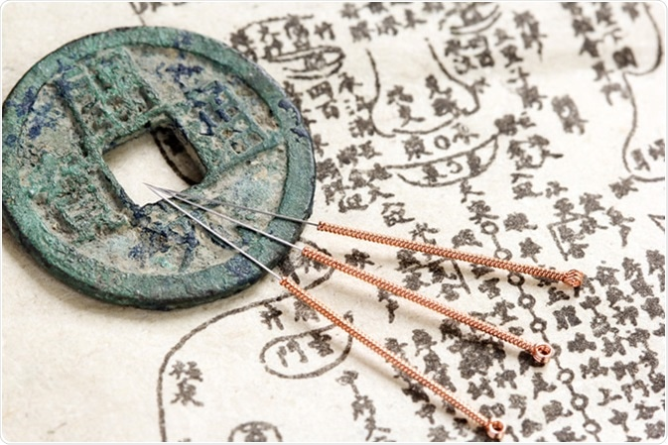

(Mandal, 2018)

Conclusion
Acupuncture is one of the most searched medicine in the uk with Millions of people, a year having acupuncture to help, with pains and other problems that that they are facing. Some facts to acupuncture still are unknown, but there are many benefits, to having the tiny needles inserted, but the research that has been done, shows that more still needs to be done on the clinic side of the side effects of what the outcomes could be, acupuncture with other medicine could be very helpful as well as a good procedure for patients that believe in alterative treatment.

Reference list
Brazier, Y. (2017). Acupuncture: How it works, uses, benefits, and risks. [online] www.medicalnewstoday.com. Available at: https://www.medicalnewstoday.com/articles/156488#:~:text=Acupuncture%20is%20a%20form%20of [Accessed 27 Feb. 2021].
Calabro, S. (2013). How to Know When Acupuncture Is Working. [online] HuffPost. Available at: https://www.huffpost.com/entry/acupuncture-treatment_b_3188605#:~:text=When%20acupuncture%20starts%20working%2C%20it [Accessed 1 Mar. 2021].
Dorfer, L., Moser, M., Bahr, F., Spindler, K., Egarter-Vigl, E., Giullén, S., Dohr, G. and Kenner, T. (1999). A medical report from the stone age? The Lancet, [online] 354(9183), pp.1023–1025. Available at: https://www.thelancet.com/journals/lancet/article/PIIS0140673698122420/fulltext.
Dr (TCM) Attilio D’Alberto. (n.d.). Dr (TCM) Attilio D’Alberto. [online] Available at: https://www.attiliodalberto.com/acupuncture/types-of-acupuncture.php [Accessed 1 Mar. 2021].
Friedlander, J. (2019). What Exactly Is “Qi”? Plus, 6 Ways to Boost It for Better Health. [online] Healthline. Available at: https://www.healthline.com/health/ways-to-balance-qi-for-health [Accessed 26 Feb. 2021].
Johnson, J. (2018). Qi deficiency: What is it and can you treat it? [online] www.medicalnewstoday.com. Available at: https://www.medicalnewstoday.com/articles/321841 [Accessed 1 Mar. 2021].
Li, Y., Liu, X., Guo, L., Li, J., Zhong, D., Zhang, Y., Clarke, M. and Jin, R. (2020). Traditional Chinese herbal medicine for treating novel coronavirus (COVID-19) pneumonia: protocol for a systematic review and meta-analysis. Systematic Reviews, [online] 9(1), p.75. Available at: https://www.ncbi.nlm.nih.gov/pubmed/32268923.
Mandal, A. (2018a). Acupuncture History. [online] News-Medical.net. Available at: https://www.news-medical.net/health/Acupuncture-History.aspx [Accessed 25 Feb. 2021].
Mandal, A. (2018b). Acupuncture History. News-Medical.net. Available at: https://www.news-medical.net/health/Acupuncture-History.aspx [Accessed 25 Feb. 2021].
Publishing, H.H. (2017). Acupuncture. [online] Harvard Health. Available at: https://www.health.harvard.edu/medical-tests-and-procedures/acupuncture-a-to-z#:~:text=The%20most%20common%20side%20effects [Accessed 1 Mar. 2021].
SAGE Journals. (n.d.). Acupuncture in Medicine. [online] Available at: https://journals.sagepub.com/home/aim [Accessed 9 Mar. 2021].
White, A. (2004). A brief history of acupuncture. Rheumatology, [online] 43(5), pp.662–663. Available at: https://academic.oup.com/rheumatology/article/43/5/662/1788282 [Accessed 27 Feb. 2021].
www.medicalnewstoday.com. (2017). Acupuncture: How it works, uses, benefits, and risks. [online] Available at: https://www.medicalnewstoday.com/articles/156488#how_does_it_work [Accessed 20 Feb. 2021].

