
Executive Summary
This project focuses on evaluating the effectiveness of Vitasoy business model under the existing business environment and provide suggestions in adopting the market change. This report states the analytical views on the external and internal factors impacting the company’s business and evaluates the commercial prospects of Vitasoy. To sustain market growth in the Hong Kong market, it is recommended that Vitasoy should adjust the product portfolio by increasing the proportion of plant-based food commodities through the development of new items to satisfy the future market demand.

Table of Contents
1. Introduction 1
1.1 Company background 1
1.2 Problems definition 1
1.3 Project aims and objectives 2
2. Project scope 2
3. Information source and research method 3
4. Analysis and discussion 3
4.1 External factors affecting Vitasoy current business model 3
4.1.1 Economic aspects 4
4.1.2 Social aspects 7
4.2 Internal factors impacting Vitasoy current business model 12
4.2.1 Business advantages of Vitasoy 13
4.2.2 Reducing competitiveness as compared to Mainland China 13
4.2.3 Locate the existing strategic position of Vitasoy 15
5. Recommendation 16
5.1 Development in the varieties of tofu products 17
5.2 Product expansion to plant-based meat 17
5.3. The possibility in plant-based pet food 18
6. Conclusion 19
Reference 20

1. Introduction

1.1 Company background

Vitasoy was founded in 1940 in Hong Kong by Dr. Kwee-seong Lo to promote sustainable nutrition through varies food and beverages products. The company launched its iconic soymilk during its establishment to introduce a protein-rich nutritious drink in wartime for the Hong Kong citizens (Vitasoy, 2021). Its product portfolio has further expended to other food and beverage items but still maintained over 90% produces as plant-based beverage offering (Vitasoy, 2020(a)). Vitasoy produces are now available in more than 40 markets worldwide and has operations in Hong Kong, Mainland China, Australia, Singapore and the United States (Vitasoy, 2020(a)).

1.2 Problems definition

Vitasoy soymilk was once an affordable source of nutrition during wartime in the 1940s which marked the company successful establishment in Hong Kong. Since then, Vitasoy has heavily focused on the expansion of beverage products and currently setting key performance indicators (KPI) to sustain plant-based beverage offering at more than 90% till the fiscal year 2025/26 (Vitasoy, 2020(a)). However, with the significant change in economy and standard of living after the company's formation, alongside permanent customer behavior shifts on nutrition focus and healthier dining habit after the Covid-19 crisis (Swiss Re Institution, 2020), can Vitasoy business model, which highly concentrated in plant-based beverage products, satisfy consumers’ desire for nutrition in the 2020s come to question.

1.3 Project aims and objectives

In response to the problem, this project performs a review on Vitasoy business model and provides recommendation to align with the change in consumers’ consuming practices. Thus, the following project objectives are defined to achieve the project purpose:
i) To identify the potential plant-based product markets
ii) To innovate and develop new plant-based products
iii) To recognize possible business models for future development

2. Project scope

With the success of Vitasoy, the sales of the company have developed with various ready-to-drink and nutritious products under different brands and make available in the global market. To align with Vitasoy’s business vision which is to provide sustainable nutritious plant-based food and beverages (Vitasoy, 2020(a)), this project will specify on the plant-based product line ‘Vitasoy’ and focuses on the Hong Kong market, a core operation region that facilitates local sales and exporting with self-owned manufacturing plants. All protein in-takers will be targeted as potential customers in this project to identify the capacity in the plant-based product market.

3. Information source and research method

The source of information in this project relies on published information related to Vitasoy and its business, i.e. company websites, annual reports and sustainability reports; market research reports; published articles; digital media; and market data from official organizations such as Census and Statistics Department (C&SD) and International Monetary Fund (IMF). The information is secondary data obtained mainly through websites, books, articles, etc.

4. Analysis and discussion

To determine the effectiveness of the business model of Vitasoy, it is necessary to analyze whether such model aligned with the change in the business environment and consumers behavior. Such analytical review helps to evaluate the business prospect of the company for identifying possible market capacity for future development.

4.1 External factors affecting Vitasoy current business model
PESTEL analysis (Aguilar, 1967) is a tool to analyze the macro-environmental factors that influence a company’s performances. In this section the critical external factors affecting the company’s business model are identified with reference to PESTEL analysis. These factors are further breakdown by using the MECE principle (Rasiel, 1999), for the purpose to apply mutually exclusive and collectively exhaustive thinking to the identified issues for building the cause and consequences relationship that impacts the current business model.
External factors | Change drivers | Cause | Consequence
Economic | Improvement in living standard | Upward trend in GDP per capita and median monthly household income | Increase customers' willingness to purchase quality products
Economic | The capacity in the beverage market | Reaching bottleneck in average beverage volume consumption | Limit the opportunity to achieve market growth
Social | Covid-19 | Increase concern in healthy lifestyle after the health crisis | Boost the demand for nutritious food and beverage
Social | Change in Hong Kong household structure | A consistent decrease in birth rate and household size | Gradually reduce in customer base in the future
Table 1 External factors influencing Vitasoy business model

4.1.1 Economic aspects
As being a large consumer goods organization in Hong Kong, the economic conditions in the region have direct influence on the business performances of Vitasoy. The following graph illustrates some of the economic aspects that can be the indicators of the future development of the company.

Graph 1 Historical trend in Hong Kong economic aspects

Source : C&SD, 2021; Statista, 2020(a)
i) Improvement in living standard
Customers’ ability to consume is one of the most impactful factors that affect the standard of living in the region. Such ability can be observed by the local economic development in recent years. Graph 1 illustrates that the real Gross Domestic Product (GDP) per capita and median monthly household income in Hong Kong, which are the indicators of individual’s consumption ability, see a consistent growth on a year-on-year basis (YoY) in the past ten years except for the recent two years as the economy was suffering from the impact of social unrest and the Covid-19 outbreak. Despite the sudden economic downturn, according to the forecast of IMF (2021), the real GDP of Hong Kong is expected to maintain a growth between 2% - 4% in the forthcoming five years, whereas the estimated average monthly salaries performed by Trading Economics (2021) projected an upward trend that reaches HK$18,500 in 2022. Thus, these formulate a gradually growing economy that enhance individual spending ability and encourage consumption activities.
The consistent growth in the individual’s consumption ability provides a positive condition for improving the general standard of living in Hong Kong, in which local customers are more prepared and willing to spend on higher quality products for better living. Vitasoy has been supplying the local food and beverage market with non-genetically modified soyabean products at an affordable price. However, since there are gradually upward shifting in customers’ spending capability and demanding for quality living, the company can align with such trend by expanding its product portfolio through innovating upgrade health products at a higher selling price, to capture the consumers who desire for products that are better than average.
ii) The capacity in the beverage market
Meanwhile, the development in the Hong Kong beverage market is critical for Vitasoy performances as the company has maintained more than 90% of its products as plant-based beverage offerings (Vitasoy, 2020(a)), which falls into the non-carbonated soft drinks category that represents non-alcoholic liquid refreshment beverages that are not artificially carbonated. In the past eight years, the consumption in average volume in non-carbonated soft drinks per capita reflects a feeble growth in which growth rate was kept below 1% over the years as shown in Graph 1, and according to Statista (2020(a)), the forecasted growth rate will maintain at a similar level till 2025. Also, a comparison is made between the Chinese communities which share a more similar beverage consumption habit, the estimated average per capita consumption in Hong Kong in 2021 stands at 26.4 liters, which is more than double of the China market, i.e., 11.1 liters, that is expected to be consumed (Statista, 2020(a)(b)). These illustrate that Hong Kong customers are already positioning at a higher beverage consumption level, together with the weak growing trend in the market, indicates that Hong Kong is currently experiencing a relatively maturing beverage market with little capacity to expand.
Thus, Vitasoy current KPI target to sustain 90% beverage offering till 2026 (Vitasoy, 2020(a)) may not be favorable to the company’s business in Hong Kong as a maturing regional beverage market provides little capacity for further development. The heavily beverage focused business strategy would confine future revenue growth due to such market condition. This would require the management to reconsider and might need modification on regional KPI to sustain a more balanced proportion in its food and beverage products.
To sum up, in response to the existing economic aspects that affect Vitasoy business model, the company should adjust its product portfolio by innovating new health products and increase the proportion in plant-based food products to capture the economic benefit from the market trend.

4.1.2 Social aspects
Since Vitasoy target customers are individuals, any change in social behavior and daily practices could directly impact the level of consumption of its products.
i) Covid-19
Soya-based products have always been recognized as a healthy substitute for animal protein. Back before the Covid-19 outbreak in 2020, there were rising awareness on meat-free products replacing by vegan or plant-based meat for a healthy lifestyle (Vegconomist, 2019). The pandemic has even accelerated this trend where survey shows that plant-based protein becomes mainstream in some of the developed countries (Anderson, 2020), and is believed that this will increase the market demand for soyabean product such as tofu, soyabean-based dairy substitutes and processed meant. The permanent customer behavior change on healthy eating in the post-Covid 19 era (Swiss Re Institution, 2020) can further create and secure the market capacity for plant-based products. Since Vitasoy has been long promoting its nutritious plant-based food and beverage from the establishment of the company, the shift of such dining practice opens up business opportunities for its brand products to be more integrated into customers’ eating habit.
Graph 2 Change in spending behavior of Hong Kong consumers under Covid-19
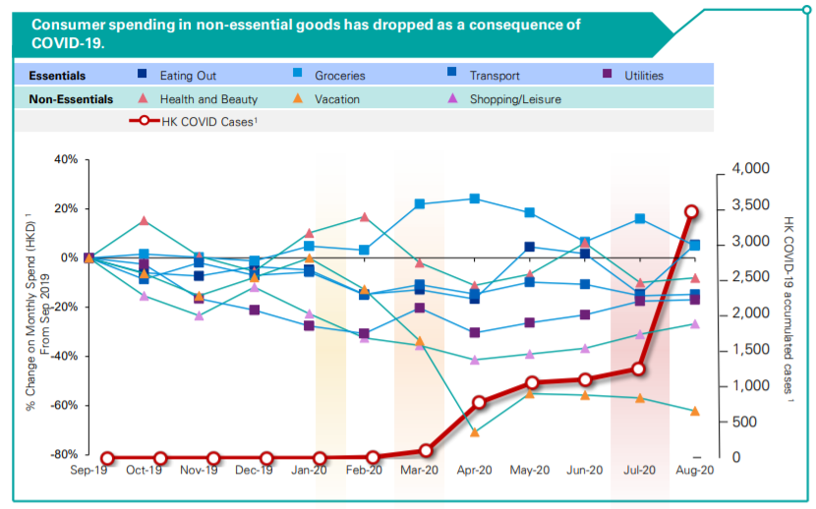
Source: KPMG & Gini, 2020

In Hong Kong, local customers are adjusted to new normal under the Covid-19 outbreak who prioritized eating at home instead of dining out and is believed that such practice will continue after the epidemic (Nielsen, 2020). As illustrated in Graph 2, the spending on essential products such as groceries have been outperformed all other consumption categories due to the formation of stay-in-home economy in the health crisis, and the developing home cooking trend is expected to continuously favorable to the sales of certain fast-moving consumer goods such as packaged food even after the pandemic. Together with the growing attention to plant-based protein as mentioned above, the aftermath of Covid-19 has expanded the market capacity in the sales of plant-based food products for home consumption in Hong Kong. Vitasoy plant-based food items such as tofu are likely to gain advantages from the new form of dining habit, but the company might not be able to fully capture the economic benefit from the trend due to the limitation on the variety of its food products. Thus, currently will be a proper timing for Vitasoy to develop other possible plant-based food products to cater for the upcoming market demand.
ii) Change in Hong Kong household structure
Vitasoy current target customers are the citizens in Hong Kong and the change in household structure will influence the customer base which has a direct impact on the company’s source of revenue.

Graph 3 Historical trend in Hong Kong household structure

Source : C&SD, 2021
Graph 3 has illustrated the changes in the formation of Hong Kong household in the past two decades. There has been a consistently dropped in the crude birth rate after it reached its peak in 2011 and at the same time, the average domestic household size has gradually reduced to 2.8 as compared to 3.3 twenty years ago. However, the number of domestic households recorded a slight but steady increase during the same period. This indicates that the population trend of Hong Kong will be structured by a larger number but a smaller size of households, and this will eventually lead to a reduction in population due to the decline in the willingness to give birth within a family. This assumption can be further supported by the projected household and population of Hong Kong as shown below.

Table 2 Hong Kong population and household projections
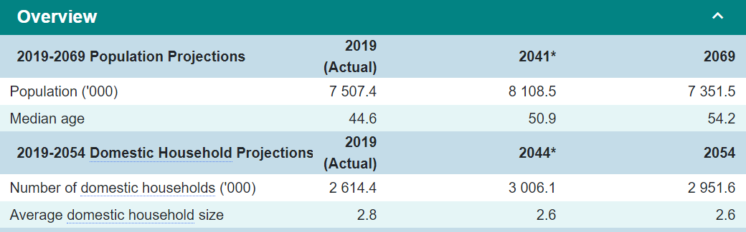
Source : C&SD, 2021
The Hong Kong population and the number of households will reach the peak in the 2040s and the population in 2069 will reduce to a level that is less than the compared actual figure in 2019. Meanwhile, the average domestic household size will drop to 2.6 and maintain at the same level till 2054. Thus, the average consumption for food and beverage in domestic households within the future 30-40 years can foresee a decline due to the reduction in household size and population, which will affect Vitasoy source of revenue in the long term.
Yet, the demographic change in Hong Kong households has also created another phenomenon, where young families tend to adopt pets as part of their family instead of having children, which stimulate the growth in the pet industry including pet food (Chung, 2018). The latest survey conducted by the C&SD (2019) demonstrated that more than 200,000 households owned dogs or cats, representing 9.4% of the total households in Hong Kong. The same as human, dogs and cats need to consume protein for nutrition balance and meatless diets for pets can be a possible development in the future. As being an experienced plant-based protein processor, Vitasoy could investigate the possibility to extend its target customers from human to pets, to offset the reduction in customer base due to the change in household and population structure in the long term.
By considering the social aspects as mentioned above, to incorporate the business model with the change in social behavior and household structure, Vitasoy can modify the product portfolio by increasing the varieties of plant-based food products and research on the likelihood to extend its target customers on food products from human to pets.

4.2 Internal factors impacting Vitasoy current business model
To identify internal factors affecting Vitasoy business model, the SWOT analysis (Humphrey, 2005), which is an analytical tool to evaluate strengths, weaknesses, opportunities and threats of a strategic planning, is used to locate the elements that impacting the company’s performances. Since Section 4.1 has mentioned the opportunities and threats to the existing business model, the following will focus on the strengths and weaknesses of the company to illustrate the effectiveness of its current business strategy. Strategic Drift (Johnson, Scholoes & Whittington, 2005) is used for reference to determine the sensitivity of Vitasoy to the business environment after considering all the evaluated factors and helps to provide a solution to sustain Vitasoy business.
Elements | Performances | Business Status
Strengths | Well established brand name | Phase 2 - Strategic Drift
Strengths | Provide quality products | Phase 2 - Strategic Drift
Weakness | Declining competitiveness among its business regions | Phase 2 - Strategic Drift
Table 3 Existing position of Vitasoy business model

4.2.1 Business advantages of Vitasoy
With Vitasoy long establishment in the Hong Kong market, its brand name has been an icon that forms part of the history of Hong Kong. The company has been staying focus on its long-term vision, to provide plant-based nutrition products, and its success in launching the iconic soymilk has marked a strong foundation for its brand name to develop. Together with continuously providing quality products, such as the use of non-genetically modified ingredients and maintaining low sodium content (Vitasoy, 2020(a)), the customers' confidence level in the brand has been deep-rooted that can be outperforming other competitors. Thus, it is easier for the company to gain consumers’ confidence when launching different products with such a superior foundation in the Hong Kong market.
The outstanding brand status and product credibility have given Vitasoy extra flexibility in changing its product portfolio to adjust to the market. Based on its previous success in soymilk, the Company has extended the variety of plant-based beverage offerings, i.e., adopting product development strategies, to enhance its market capacity in the beverage market. Similarly, when the company has the necessity to launch a diversification strategy to incorporate the new market trend, its accomplished branding and product quality could provide a better startup platform for the company to introduce its new product to the public.

4.2.2 Reducing competitiveness as compared to Mainland China
Vitasoy Hong Kong market was once the key revenue and profit driver of the organization, but the rapid development in the Mainland China market has overtaken its position and became the company’s dominant market.

Graph 4 Vitasoy segment revenue trend

Source: Vitasoy 2020(b); 2019; 2018; 2017; 2016
As shown in Graph 4, the revenue gap between the Hong Kong market and the Mainland China market has been expanding since the FY 2015/16. Except for the recent year impacted by the Covid-19 outbreak, the Mainland China revenue managed to achieve 11% - 39% YoY growth during the five years period, while at the same time the Hong Kong market can only maintain 5% or below YoY growth.
Graph 5 Vitasoy segment profit trend

Source: Vitasoy 2020(b); 2019; 2018; 2017; 2016
Similar to the revenue trend, Graph 5 has illustrated that the dominant profit generating position of the Hong Kong market was replaced by Mainland China in FY2017/18 and since then the Hong Kong profit started to suffer from the negative growth rate. These figures demonstrated that the Hong Kong market performance has been stuck at a similar level as compared to five years ago, or even weakening since its profit is struggled from maintaining YoY growth. Such performance has indicated the reducing competitiveness within the organization as compared to the speedy development of Mainland China.
The weakening competitiveness among internal segments is an early alarm for the management to review the Hong Kong business model. A timely adjustment on the business model to react to the market trend and the change of business environment can prevent further decline of performances.

4.2.3 Locate the existing strategic position of Vitasoy
By reference to the four stages of strategic drift, the current status of Vitasoy can be positioned at phase 2. Due to its early successful business model, the company has been focusing on the development of plant-based beverage offerings, but as mentioned in Section 4.1, the change in economic and social aspects has led to a shift in customers eating habit and consuming practices, in which the continuity of the same model might not be able to fulfil the upcoming customer demand. The reduction in the effectiveness of the model can be supported by the recent performances of the Hong Kong market, during the past five FY, the company has found it difficult to sustain business growth in the region. These characteristics of the Hong Kong market can be matched with the phenomenon under strategic drift.
Therefore, to prevent from entering into phase 3, where the gap between customers expectation and the company’s products is so large that the company needs to make an immediate change, it is currently the right timing for Vitasoy to further understand what consumers’ needs and stay aligned with the change in the business environment.
To summarize, after evaluating the external and internal factors as mentioned in this section, there is a necessity for Vitasoy to modify its business model by adjusting its product portfolio, particularly to increase the plant-based food products, in response to the upcoming market demand.

5. Recommendation
It is suggested that a modification of the product portfolio is required for Vitasoy to face the forthcoming business environment. Ansoff matrix (Ansoff, 1957) is a management tool to analyze suitable strategies for the company to consider its growth capacity using existing or new products in the existing or new markets. Since there is a foreseeable increase in demand for plant-based food products, to expand the market capacity in Hong Kong, it is recommended that Vitasoy should increase the proportion of food commodities and innovate in new products to fulfil future customers’ needs.
Graph 6 Vitasoy growth plan
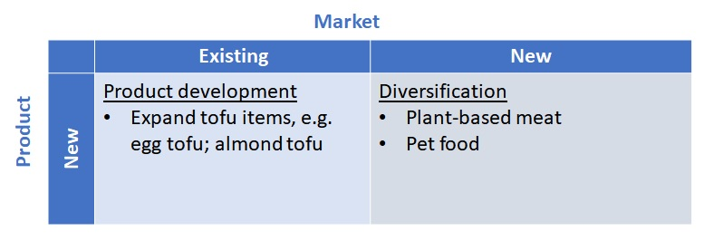

5.1 Development in the varieties of tofu products
Vitasoy existing food products mainly consist of four types of tofu items (Vitasoy, 2021), therefore there is still capacity to expand its related products, including almond tofu and egg tofu, etc. in the existing market. The currently well-known tofu products can build product credibility to the upcoming new products, and the increase in the variety of products can sustain product attractiveness to the target customers. Moreover, the company’s previous experience in similar food processing can incorporate in the new product development, not only may shorten the innovation time for the latest products, but also stimulate improvement in food processing technology to enhance the quality of the existing plant-based food items.
Since Vitasoy has already had the basic techniques to manufacture tofu commodities, such product development can be determined as a prompt response to meet the increase in plant-based food demand in the post-pandemic era and is expected to be ready for launch within one year.

5.2 Product expansion to plant-based meat
With the rising attention to healthy living, there is a visible change in demand for plant-based meat, in which within a year, the supply of the meat substitutes has been broadly expanding from selling at the supermarket (Ancheta, 2020) to serving at the fast-food restaurant (Hall, 2020). The home cooking trend in progress as mentioned in Section 4.1.2 is expected to boost the demand for packaged plant-based meat which will enhance the market capacity for plant-based food products. Even though the market price for plant-based meat might be higher than ordinary meat, the increase in living standard as mentioned in Section 4.1.1 has encouraged more customers to consume high-quality protein for daily intake. As being an experienced plant-based food processor, Vitasoy has high potential in developing plant-based meat to capture such market trend and expand the company’s growth capacity.
However, the production of plant-based meat will involve new recipes and techniques in which Vitasoy might not be able to launch the product quickly. Therefore, the development of the product will be considered as a mid to long term strategic plan that will only be made available in the market within 3-5 years.

5.3. The possibility in plant-based pet food
By considering the future change in household structure as mentioned in Section 4.1.2, an early investigation on expanding the target customer group, i.e. from human to pet, might create an opportunity to enhance the source of revenue. Even though plant-based diet for pets might not be as popular as human at the current stage, there is also a trend in shifting pet diet to get closer to owners’ eating habit (Wethal, 2020). A beforehand research in the pet market allows Vitasoy to better understand the potential capacity in this business and the possibility to expand its production to cover pet retail.
Yet, the pet food market is a completely new business to Vitasoy and plenty of preparatory research is required before the company can get involved in the production and launching. Such product diversification plan is determined as a long-term strategic plan to get prepared for the change in business environment in the upcoming 30 - 40 years.

6. Conclusion
After analyzing the external and internal factors affecting Vitasoy business environment, indicators are illustrating that the effectiveness of the existing business model is reducing and might not be able to satisfy upcoming customer demand. Therefore, there is a need for Vitasoy to take timely review on its business model, especially to adjust its product portfolio, to align with the market trend. It is recommended that the company should adopt strategic plans focusing on new plant-based product development to enhance the market capacity for future growth.

Reference
Aguilar, F. J. (1967). Scanning the Business Environment. Macmillan

Ancheta, T. (2020). ‘Hongkongers can now buy Impossible Meat in ParknShop outlets in the city’, TimeOut. Available at : https://www.timeout.com/hong-kong/news/hongkongers-can-now-buy-impossible-meat-in-parknshop-outlets-in-the-city-102020 (Assessed: 30 March 2021)

Anderson, J. (2020). Emerging Consumer Behavior Shifts: Six Ways Food & Beverage Innovation Is Evolving in the Face of COVID-19. ADM. Available at : https://www.adm.com/news/news-releases/emerging-consumer-behavior-shifts-six-ways-food-beverage-innovation-is-evolving-in-the-face-of-covid-19-2 (Accessed: 30 March 2021)

Ansoff, H. I. (1957). ‘Strategies for diversification’, Harvard Business Review, 35(5), pp.113-124

C&SD (2019). Thematic Household Survey Report - Report No. 66. Available at: https://www.censtatd.gov.hk/en/data/stat_report/product/C0000034/att/B11302662019XXXXB0100.pdf (Accessed: 2 April 2021)

C&SD (2021). Statistics. Available at: https://www.censtatd.gov.hk/en/page_1226.html (Accessed: 2 April 2021)

Chung, C. (2018). ‘Pet theory: rising ownership in Hong Kong opens up a host of retail opportunities’, South China Morning Post, 27th February.

Hall, A. (2020). ‘McDonald’s to launch meat-free burger, McPlant, to offer plant-based alternative to Big Mac’, South China Morning Post, 11th February.

Humphrey, A. (2005). ‘SWOT Analysis for Management Consulting’, SRI Alunmi Newsletter

IMF (2021). People’s Republic of China Hong Kong Special Administrative Region. Available at: https://www.imf.org/en/Countries/HKG#whatsnew (Accessed: 29 March 2021)

Johnson, G., Scholes, K. and Whittington, R. (2005). Exploring Corporate Strategy 7th Ed. Harlow, UK: Pearson Education

KPMG and Gini (2020). Impact of Covid-19 on Hong Kong Consumers’ Behaviours.

Nielsen (2020). Nielsen: Eating at Home Will Remain the New Reality for Asian Consumers, Especially Hong Kong, Post COVID-19. Available at : https://en.prnasia.com/releases/apac/nielsen-eating-at-home-will-remain-the-new-reality-for-asian-consumers-especially-hong-kong-post-covid-19-278643.shtml (Assessed: 30 March 2021)

Rasiel, E. (1999). The McKinsey Way. McGraw-Hill Education

Statista (2020(a)). Non Carbonated Soft Drinks Hong Kong. Available at: https://www.statista.com/outlook/cmo/non-alcoholic-drinks/soft-drinks/non-carbonated-soft-drinks/hong-kong (Assessed: 2 March 2021)

Statista (2020(a)). Non Carbonated Soft Drinks China. Available at: https://www.statista.com/outlook/cmo/non-alcoholic-drinks/soft-drinks/non-carbonated-soft-drinks/china (Assessed: 29 March 2021)

Swiss Re Institution (2020). All change: how COVID-19 is transforming consumer behaviour. Available at: https://www.swissre.com/institute/research/topics-and-risk-dialogues/health-and-longevity/covid-19-and-consumer-behaviour.html (Accessed: 28 February 2021)

Trading Economics (2021). Hong Kong Average Monthly Salaries. Available at: https://tradingeconomics.com/hong-kong/wages (Accessed: 29 March 2021)

Vegconomist (2019). Growing consumer preferences toward vegetarian and flexitarian foods to drive the demand for vegetarian and vegan products. Available at: https://vegconomist.com/market-and-trends/growing-consumer-preferences-toward-vegetarian-and-flexitarian-foods-to-drive-the-demand-for-vegetarian-and-vegan-products/ (Accessed: 30 March 2021)

Vitasoy International Holdings Limited (2021). Vitasoy. Available at: https://www.vitasoy.com/ (Assessed: 2 March 2021)

Vitasoy International Holdings Limited. (2020(a)). Sustainability report 2019/20, pp. 10, 18.

Vitasoy International Holdings Limited. (2020(b)). Annual report 2019/20

Vitasoy International Holdings Limited. (2019). Annual report 2018/19

Vitasoy International Holdings Limited. (2018)). Annual report 2017/18

Vitasoy International Holdings Limited. (2017). Annual report 2016/17

Vitasoy International Holdings Limited. (2016). Annual report 2015/16

Wethal, C. (2020). ‘A Plant-based Pet Food Frenzy is on the Horizon’, Kerry, Available at : https://www.kerry.com/applications/pet-nutrition/plant-based-pet-food (Assessed : 30 March 2021)

