
UNIVERSITY OF WALES: TRINITY SAINT DAVID
PRIFYSGOL CYMRU: Y DRINDOD DEWI SANT

School of Business

Managing in Complex environments: Strategies, Insights and Solutions

HKBM7016

Professor: Peter Fong

Business Report (Individual Assignment)

Title of Paper:
A business report on Facebook’s business strategy and competitive advantage to develop the Asia market

Lee Wai Yip, Harry
University Student Number: 2031149
Programme: Doctor of Business Administration
Date: Apr 18, 2022
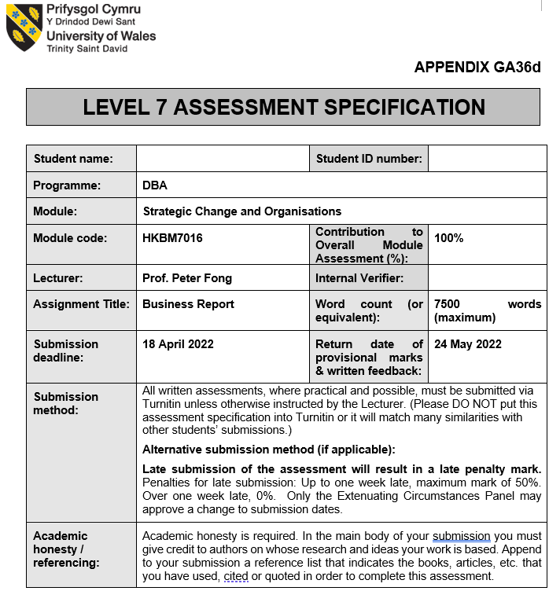

Table of Contents
1. Introduction 4
2. Internal Audit – RBV view of Facebook 5
3. External Audit of Facebook 14
4. Financial and ethical analysis of Facebook 26
5. Facebook’s decision of M&A 27
6. Strategies generation and recommendation 30
7. Strategies barriers for Facebook in development Asia market and strategic choice 32
8. Conclusion 34
9. Reference 36

- Introduction
Meta, the parent company of Facebook, a social network company in the United States to provide community service, was set up on February 4, 2004, the main founder is Mark Zuckerberg. Headquartered in Menlo Park, California, USA, it is one of the most valuable companies in the world and is considered one of the top five technology companies along with Microsoft, Amazon, Apple and Alphabet.
Facebook’s founder is Mark Zuckerberg, who is a Harvard student who previously graduated from High School of Ardsley. At very first beginning, registration for the virtual community was just for Harvard College students. Two months later, enrollment linked to other high schools in the Boston area, Boston College, Boston University, MIT, Tufts University, as well as the University of Rochester, Stanford, NYU, Northwestern University and all the Ivy League schools. The following year, many other schools were added. Finally, anyone who has a colleges postfix email address such as .edu, .uk, etc. worldwide can sign up. Afterwards, social networks for high schools and companies can also be established in Facebook. The site's name, Facebook, comes from the traditional paper "roster". Usually colleges in the United States distribute this "roster" of all members of the school community to new students and staff to help them get to know each others in the school.
According to July 2007 data, Facebook has the most users of any website that mainly serves college students: 34M active users, including users on non-college networks. From 2006 to 2007, the site's ranking in the US site rose from 60th to 7th. At the same time, Facebook is the number one photo sharing site in the United States, with 8.5M photos uploaded daily. Top 500 World Brands in 2010 showed that, Facebook took the position of Microsoft and to rank first.
It subsequently received an investment of 12.7 million US dollars and was listed on the Nasdaq Stock Exchange on May 18, 2012. On October 28, 2021, CEO Zuckerberg announced at Connect 2021 that he will focus on the development, expansion and application of the Metaverse, and change the company name from "Facebook" to "Meta".
In April 2022, Time magazine selected the 100 most influential companies in the world in 2022, and Meta was listed.
- Internal Audit – RBV view of Facebook
Resource Based View (RBV) is a management tool and strategic framework used by companies and enterprises to locate and utilize strategically available assets/resources and to give organizations a long-term, sustainable competitive advantage. It is a work. The foundation of the RBV framework is to evaluate, identify, and strategically target resources that can make an organization more competitive. From RBV, all organizations and businesses have access to own, and control their resources, giving them a competitive advantage in the industry. Also, they are the subset of these resources can achieve excellent long-term performance. Owning and managing valuable resources apart from these resources can lead to long-term, sustainable competitive advantage. RBV broadly categorizes the resources available to a company as either tangible or intangible components.
Tangible components:
Tangible components include resources that are tangible and easily identifiable from the organization or competitors. In addition, these are readily available on the market or can be developed over the long term. Competitors would acquire the same or similar resources in their growth, giving the company an almost negligible competitive advantage.
Examples of physical resources provided by Facebook Inc are:
Office assets
The office assets are physical resources of Facebook which includes all company-owned and leased space for hosting production units and warehousing. In addition, all settings owned or leased by the company for services deliveries are also under the tangible resources within their land properties.
Equipment
For Facebook, available equipment is also count as tangible resource, including all equipment owned by the company for services deliveries and other operational purposes. Hence, all technological assets and technological related integrations used to improve processes and operations can also be viewed as extensions of the equipment which is used to enhance their product lines and integrate economies of scale.
Material
This material contains other materials that all raw materials, semi-finished materials and other service products used by Facebook Inc and other products are successfully manufactured and packed. These materials are tangible in nature and are easily available for their own manufacturing processes and other uses.
Daily operation supplies
Facebook’s daily operation supplies are also a tangible component, including all materials and product services used and required to support the company's production and delivery functions. Supplies in operations also include all service products and support materials required by other Facebook functions which is used to achieve business goals and its metrics.
Facilities
A facility is also a tangible resource that can be clearly identified by Facebook Inc.'s competitors. These include all of the company's service production units, distribution centers, offices and supporting business units and functions and help the company streamline processes and operations, as well as lead to successful performance. The facility also includes Facebook Inc.'s interior design and building interior - designed to optimize performance and maintain brand identity.
Technology Infrastructure
These includes all assets related to technology, office equipment and maintenance, and electrical resources, for example power allocation to Facebook's factories. Building infrastructure is an important resource for businesses to ensure high performance and drive business operations. However, like any other tangible asset, it is available to competitors also. Competitors can set up something similar to what Facebook owed.
Intangible components:
Intangible components are resources that do not hvae physical shape but are owned Facebook Inc. Competing players, usually, it is hard to copy which means, they cannot acquire intangible resources that is currently available to Facebook due to related factors and aspects. The uniqueness of the story, the blur setting of causation, and the complexity of society. Intangible assets are almost unique which they would be stayed in the organization for long periods of time, forming the basis for Facebook Inc.'s competitive advantage. Facebook Inc.'s intangible resources are also considered nine sources of business success because they cannot be easily replicated by competitors in the factor market. For example, for Facebook Inc, intangible resources include:
Brand reputation
The reputation of the Facebook Inc brand is built on its historic uniqueness, which has been working hard for decades to deliver high quality products and earn the trust of consumers. A company's brand, culture and reputation, based on its unique company vision and mission, and customer relationships, is unique to its competitors and can be a order winner in term of competitive advantage.
Intellectual property
Facebook’s manufacturing process with the uniqueness of its products are protected by intellectual property rights. These prevent other competitors from simulate them or accessing their own product portfolio, ingredients, and inputs. This guarantees the novelty of Facebook Inc. and makes its products impossible for competitors to imitate.
Goodwill
Again, Facebook Inc's goodwill has grown through its historic uniqueness, and brand awareness and customer experience have helped increase the company's long-term goodwill. This has improved Facebook Inc's overall brand equity. The company's credit, built on the long-term efforts of the Facebook Inc. brand, cannot be duplicated by competitors.
Product name
Facebook as a brand name is also an intangible asset for a company because no other competitors can adopt or imitate Facebook’s brand name. The product name is identified by the customer over the years. This allows customers to instantly identify Facebook across national business borders. The product name also conveys Facebook’s promises and values delivering ​​to customers around the world which is one of the company's competitive advantages also.
Customer Experience
Facebook offers its own customer’s purchasing journey and experience to its customers through its brand campaign, product, marketing activities. Competitors' marketing campaigns, strategic orientations, intentions, customer experience, brand campaigns can be reproduced and cannot be provided, but Facebook Inc. is a source of unique competitive advantage it is equipped.
Proprietary technology, computer software, database and business secret
Facebook has succeeded in activities and transactions, has many faithful customers, repeating itself for its enterprise secret, and includes business secret for product competition. Facebook also develops and integrates state-of-the-art, internally developed technology. This includes hardware and software used to improve a company's operational processes, thereby giving it a market advantage.
Video and audiovisual materials (movies, TV shows, etc.)
All marketing content, no matter video or the audiovisual works designed, deployed, published by Facebook also constitutes as an intangible component. Although this marketing tool do not have physical value, it helps build the Facebook brand and helps raise brand awareness and business value and overall brand value. Because this material is driven by larger business and marketing strategies, Facebook develops marketing content that factor market players cannot imitate.
Customer list
Facebook offers a variety of different product lines and services for different audiences and targeted consumer segments. In addition, Facebook operates in the worldwide and has consumer markets in over a hundred of countries. It is no exaggeration to say that Facebook has developed its own customer markets with similar characteristics in different countries. In addition, these customer segments include consumers from different groups and categories. As a result, Facebook has its own list of clients from different countries that cannot be widely imitated due to the added social ambiguity.
License, license fee, and standstill agreements
As time passes, Facebook has developed its own license, royalty, and standstill agreements in a variety of consumer markets that it works in. This is strategic result over time by its consistent and successful business result and brand development, from operational, down to emotional and then to natural lifestyle. With such breakthrough and the brand`s identity, as well as founders’ strategic leadership and vision, Facebook has developed unprecedented license, royalty and standstill agreements that confer a competitive marketing role in the internal market.
Import quota
Facebook has a strategic contract with lots of countries for import rates. These quotas not only applied at the final package product, but also include their own raw materials and imports into various countries to support business processes. Therefore, the specified import quota cannot be copied by other competitors easily as it is based on the unique rank and strategic direction of Facebook.
Franchise contract
Facebook has its own franchise contract with a trusted partner from various companies for service production. This allows businesses to enter a variety of markets while culturally and financially protecting them from potential risks. Franchise contracts are also intangible which are based on the unique bond of trust fostered by Facebook Inc.
Relationships with customers and suppliers (including customer lists)
Facebook maintains unique relationships with its customers and suppliers. Relationships with both customers and suppliers altogether, which are evolve over time through consistent behavior, trust-building, and transparency of operations. With such strong cohesion between customer and supplier relationships, it supports Facebook to be a well-managed, well-functioning global network that, for the foreseeable future, be largely impossible for competitors to imitate.
Marketing rights
The marketing rights Facebook developed in different countries are based on their unique strategic direction from the top management, as well as legal compliance and company track record. It's something that other player can't imitate or achieve. Indeed, Facebook has developed them over time through rigorous business processes and it simply means - giving them a unique market position in the market compared to other players.

Heterogeneity and immobility of resources
A firm's RBV holds that all resources an organization owns, controls, and possesses share two fundamental characteristics: heterogeneity and fixity.
Heterogeneity
Under heterogeneity, RBV assumes that skills and skill-based resources, such as, in different practices of HR activities, staff-training and talent building, vary from one another. Such change is important to avoid establishing perfectly competitive features. Therefore, due to heterogeneity, RBV enables each organization has different amounts and combinations of resources under similar external pressures and conditions, leading to different strategic directions and strategic choices.
This also means that the strategic decisions and choices made by Facebook will be significantly different from its competitors facing the same or similar environmental pressures externally, based on different combinations of the company's available resources. This RBV-based assumption of heterogeneity allows Facebook to complement products and outperform competitors in the de facto market and gain competitive advantage by using unique bundles and resource combinations.
Immobility
Under assumption, RBV assumes that the associated resources to the firm are immobile and cannot be moved from one entity to another, at least under a short-term scenario. Based on this characteristic of being fixed in the short term, RBV stated that competitors cannot imitate and replicate the resources that are currently available in Facebook or develop and implement strategies and decisions similar to Facebook. Resources intangibles are largely fixed in the nature.
All intangible components and resources available to Facebook are heterogeneous and immobile in nature. For Facebook Inc, tangible components and related resources are also inherently immobile in the short-term and can be homogenized with players in the markets, depending on the progress and development of competing companies in the market.
VRIO Analysis
Just based on the features of heterogeneity and fixity, they are not enough for Facebook as the only resources to develop of their order winners - competitive advantage. To determine if such resources can be functioned and improved to develop a long-term competitive advantage, it is important to identify the resources that enable companies to meet VRIO standards.
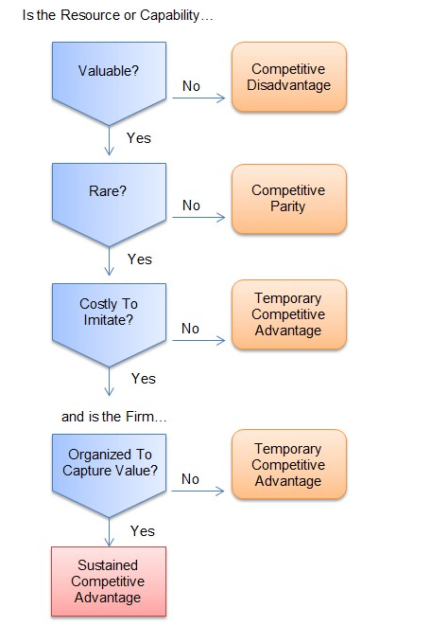

The VRIO framework evaluates tools based on valuable, rare, unique, and curated criteria. For Facebook, VRIO strategy tools are used to find out that if those resources are implemented under long-term competitive advantage. For Facebook, this is considered:
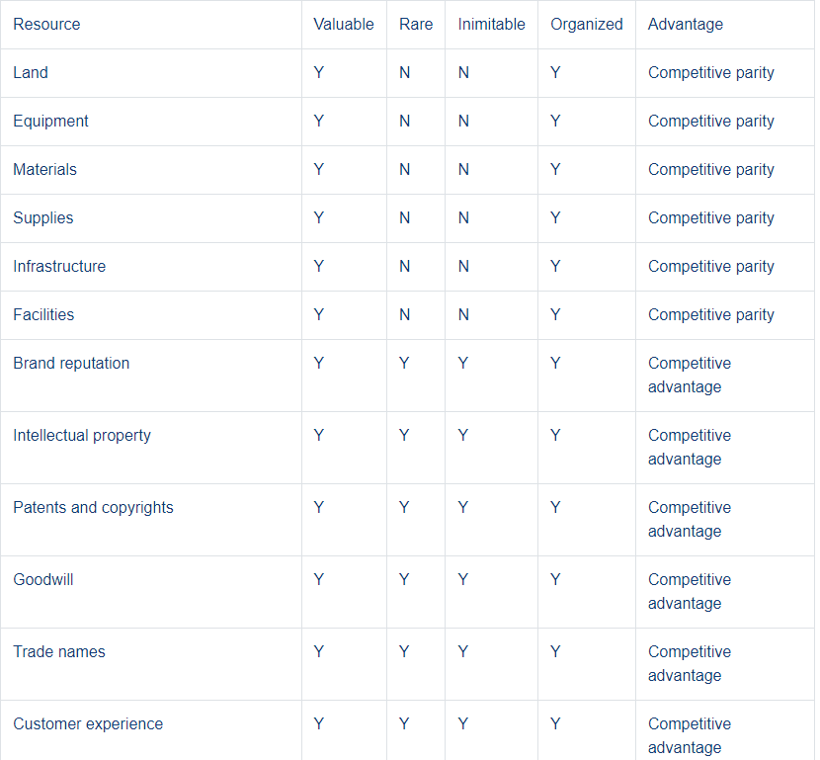
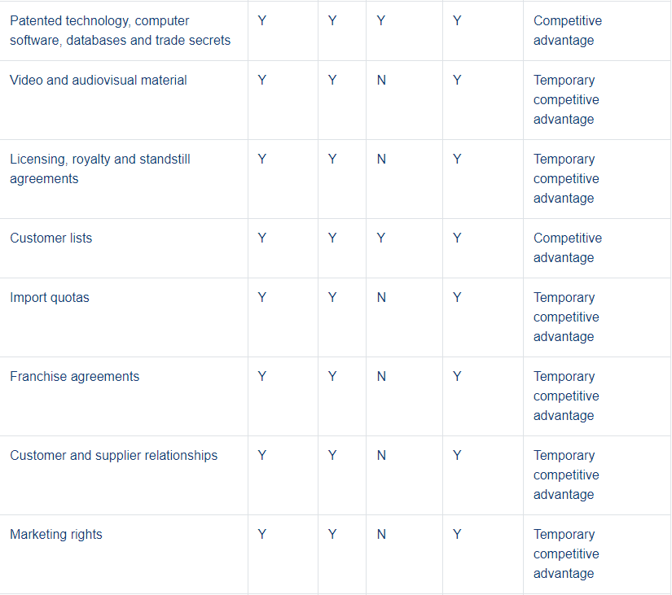
Competitive advantage
The definition of competitive advantage is that as the environment or ownership and control of resources that gives Facebook a favorable business advantage and marketing position. These resources and environments enable Facebook to outperform the competitors in virtual community markets in different countries and cities, and also be a good fit to create a unique customer base with marketing demand for its unique and quality services. Competitive advantage, should be a long-term one and often sustainable because the company owns, controls, or possesses resources that is able to meet all VRIO elements successfully.

When the resources available to Facebook Inc are heterogeneous and fixed in nature, but can only successfully meet certain VRIO criteria, the company develops other forms of benefits. This includes:
Competitive Disadvantage
Facebook Inc's competitive disadvantage is having resources that are fundamentally worthless and can cause the company to underperform the competition and potentially cause the company to underperform.
Competitive parity
Resources that bring a level of competition to Facebook are those that allow to achieve the threshold result and performance in an industry.
Short-term Competitive Advantage
It means the superior business advantages and profits taken by Facebook. However, it is short-term which may be copied by competition and participants in a long trun. Over time, they can also be set up or acquired by competitors and new entrants. So while they provide Facebook with strong competitive advantages, it is only temporary and not sustainable.
Competitive Advantage
The advantage that Facebook Inc has developed based on its resources is sustainable and will remain so for the long term. This is often inimitable by the competitors and developed with added value from the first beginning. Facebook is able to use such resources sustainably to strengthen its position of competitive advantage.
- External Audit of Facebook
SWOT Analysis of Facebook
Products & Services:
Social Media Platform / News Feed / Watch / Marketplace / Stories / Messenger / Lasso / Instagram / WhatsApp / Oculus – Virtual Reality Device / Workplace – Business Tool / Portal – Video Calling Device / Calibra – Electronic Payment System / Facebook Dating
Competitors:
- Social Media: Tencent, Twitter, Snapchat, LinkedIn etc
- Advertising: Google and Amazon
- Business Communication – Microsoft teams and Zoom
- Video – Youtube and TikTok
- Online Dating –Hinge and Bumble
- Electronic payment – ​​PayPal
- P2P marketplace – Letgo and E-bay
Strength of Facebook
- Strong brand - 5th on Forbes (2019) with a market cap of $88.9 billion
- Diversified Portfolio - Comes with WhatsApp, Instagram, Messenger, Oculus, Workplace (business communication), Portal (video calling device) and Calibra (electronic payment system).
- Market Dominance - Facebook and its home products (Instagram, WhatsApp, Messenger) are the world's leading social networks with a monthly-active-person (MAP) value at around 2.89 billion, by year end of 2019
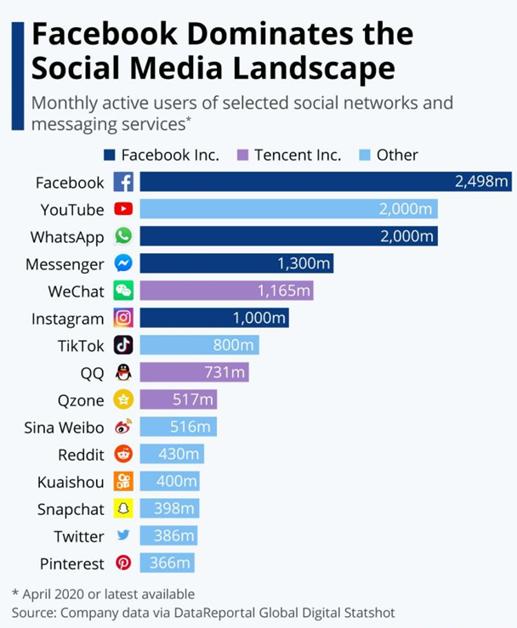

- Solid customer base – around 40% of the world's total population uses Facebook and its home products (For example, Instagram, WhatsApp, Messenger)
- Good company benefits - Forbes Ranking: 2020 Best Diversity Employers Ranking 147; 2019 Global Best Employers Ranking 144, 2019 America's Best Employers Ranking 71.
- Good leadership & company culture
- Focus on R&D innovation - 2015-2019 R&D investment increased from $4.8 billion to $13.6 billion, accounting for 19% from its annual revenue.
- Strong business in ads - 98.5% from its annual revenue, came from ads. in 2019
- Effective Marketing Strategies - Over 2 Billion of People Use Its Marketing Tools Every Day
Weakness of Facebook
- User Privacy Issues - Neglecting to protect the privacy of users, if the company cannot effectively solve this problem, its brand awareness will be seriously affected.
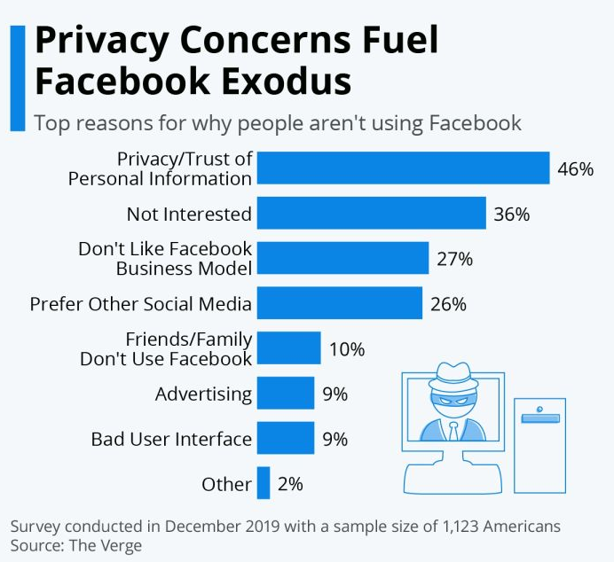
- Over-reliance on advertising for revenue
- Spreading false news - Facebook has received a lot of criticism in delivering false and misleading news and information in the public. Misleading information that Fakebook has no control over can be very bad for society as a whole.
- Management Friction - Since the company's inception, successive scandals have been disrupting the harmony among top executives.
- Strategies to expand the business operations
Opportunity of Facebook
- Diversified Portfolio - Additional paid services for developing business models: online dating, hardware devices, e-wallets, news subscriptions, etc.
- Extend Existing Platforms - Extend existing services based on a large user base
- Integrate other applications
- Adapt to different audiences - introduce new features to get into target markets, such as advanced business cooperation platforms, e.g. LinkedIn
- New Acquisitions Expand Scale
- Improve mobile advertising according to advertising trends.
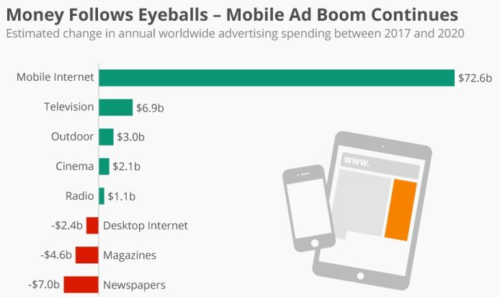

Threat of Facebook
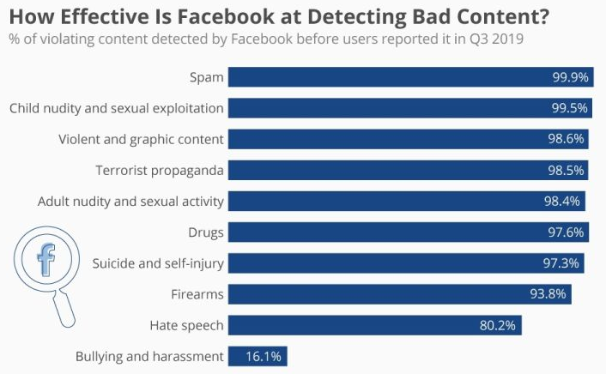
- The market is competitive - Facebook's future is looking increasingly bleak as new entrants like TikTok offer platforms tailored to the younger generation.
- Unfavorable New Laws - By recent scandals from the Cambridge Analytica, amount of unfavorable regulations against Facebook is being passed and adopted. Additionally, concerns about data security, insensitive content, and intellectual property infringement have prompted multiple regulators at the Commerce Department to create regulations that force Facebook to comply with new and much more transparency and accountability regulations and requirements
- FB is banned in several countries
- Data Breach - Facebook has experienced many cases that its data has been compromised and affecting a huge number of users. For example, in a data breach in December 2019, the personal information (names, user IDs, cell-phone number) of over two hundred millions of users was exposed.
- New digital tax policy - Recently, both UK and EU have introduced a new digital tax that require digital community company including Facebook, to pay higher taxes which is a burden to its falling profits. If there are more countries adopt digital taxation, most of the profits of Facebook will go directly to paying digital taxation.
- Damaged reputation - From horror live broadcasts in New Zealand to the Cambridge Analytica data scandal, fake news, hacked accounts and more, just to name a few, Facebook's spectacular image and reputation are eroding at an alarming rate. This is a major threat.
- Fake accounts are abundant - Facebook estimates that of its over two billions of monthly-active-users (MAUs) globally, over 10% may under duplicate accounts and 5% represent are fake accounts. Most of the these accounts come from countries such as Indonesia, Philippines, Vietnam and China.
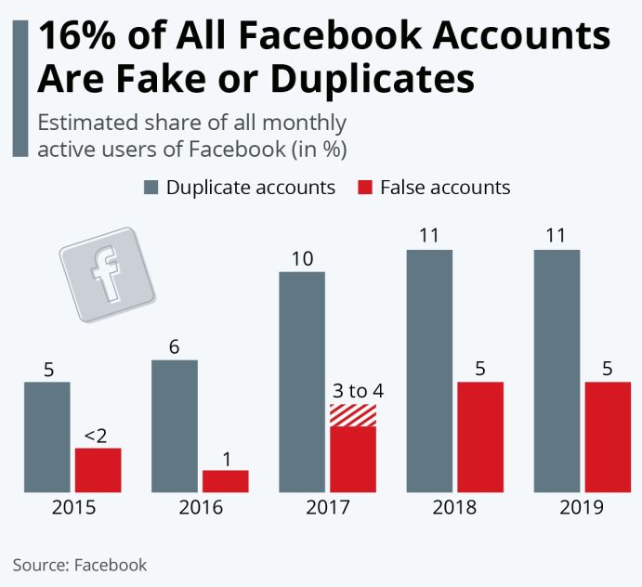

Five Force Analysis of Facebook
Through the following five steps that Michael E. Porter pointed out in his 1979 HBR article "How Competitive Forces Shape Strategy" that analysts can better understand a company's position relative to its industry.
In Facebook, the company has different platforms, from the very beginning social network to the other faimly products, such as Messenger, Instagram and WhatsApp. Some competitors, including Alphabet's Google Plus network and Yahoo's Tumblr, have tried to break into Facebook's market, but so far, none has really impacted user numbers and usage of Facebook. However, that doesn't mean Facebook isn't vulnerable, indeed, Porter's framework of five forces analysis helps clarify these threats.

Current competitors
Whether it's keeping in touch with family and friends, making money as an influencer, or sharing their thoughts, almost everyone has at least one social media statement these days. Social media is a technology that helps people, thoughts, and ideas connect in a virtual world and build communities and networks. Facebook is arguably the largest and most popular social network in the world. Founded in 2004, the company has 2.5 billion monthly active users as of September 2019. The company reported revenue of $ 70.7 billion in 2019. However, some sites are trying to take Facebook's market share. Below are some highlights from Facebook and its competitors.
- Facebook is the largest social media platform in the world.
- Instagram and Facebook are vying for users, although Facebook owns the Instagram.
- Snapchat supports users to share photos and videos that last as little as 10 seconds.
- LinkedIn, a social networking site for professional employees, employers and recruiters, was acquired by Microsoft.
- Twitter allows users to share their thoughts in 280 characters.

Instagram
Instagram is Facebook's biggest competitor, since it's also Facebook's biggest rival belonging to the social networking giant. Facebook bought the Instagram site for $1 billion in 2012. It is estimated to be worth more than $100 billion, which is more than a hundred times when Facebook originally paid for the site.
Instagram was launched in 2010 by two founders - Kevin Systrom and Mike Krieger. As of January 25, 2020, the app had over 1 billion total active users and over 500 million daily users of the site. As of that date, the site had shared as many as 50 billion photos.
While Facebook doesn't compete with Instagram for profits after the M&A, it does compete with it on users and the time users spend on the social media platform. Here's a breakdown of the Apps demographics:
- More women than men use the app - 56% vs 44%
- 6 in 10 adults have an Instagram account
- Over 120 million users in the US
- 28 minutes a day: Instagram users' time on the app
- 63% of Americans use the app daily
- Instagram is more popular with teens because it's simple, higher privacy setting and very intuitive. 72% of teens are regular Instagram users. Teens appreciate that their audience isn't necessarily because of Facebook, they value the ease with which they can express themselves under Instagram platform.

Snapchat
Snapchat is one of the newest Apps on social media. The photo and video sharing app was developed by Evan Spiegel, Bobby Murphy and Reggie Brown and released in 2011. As of the fourth quarter of 2019, Snapchat boasted 218 million daily users.

This app is very popular with children under the age of 16. It was originally designed to share short-lived photos and videos that disappear within seconds. Another welcome feature is that it allows users to reach a friend segment, rather than all of their friends at once.

Users send pictures that recipients can view for a short period of time, usually 10 seconds. After this time, the photo disappears. This allows teens and people to have or feel a higher level of privacy.

Snapchat went public in March 2017, but it hasn't yet had any impact on profits. But in the 12-month period ended 2019, the company made $1.7 million in revenue.
LinkedIn
LinkedIn is a professional site. This site was founded in 2002 and launched in 2003. It is the primary platform for career profiling and recruitment that connects recruiters and job hunters. Companies use LinkedIn to locate potential job seekers in the same city or internationally, and job seekers use LinkedIn to find new jobs. The site has been extended to allow people to post and comment on career related topics, achievements and news. Like Facebook’s traditional function, people can like/share posts created by other people. Basic function of LinkedIn is free of charge, but there is an annual fee if users would like to get premium and advanced services . LinkedIn reflects the future of the recruiting market and process. Having a LinkedIn profile is a necessity for future job seekers. Microsoft bought LinkedIn in 2016. The acquisition cost Microsoft $26.2 billion, which is the the largest and most expensive loss for Microsoft at the time. LinkedIn`s annual revenue was around $6.8 billion at the end of 2019.

Twitter
Twitter also competes with Facebook in terms of user engagement, but due to Twitter's overall nature, it's not a direct competitor to other major social networking companies. The company initially assigned 140 characters for each tweet, but in 2017 that number doubled to 240 characters.

The company was founded in 2006 by Jack Dorsey Noah Glass, Biz Stone and Evan Williams. The site has over 3 million active users and the daily “tweets flow” is over 5 million every day. About 153 million people view and send tweets every day. Twitter’s main revenue is from ads., with the company reporting revenue of $ 3.45 billion, up 13.7% year-on-year.

Porter's Five Forces model
The Porter's Five Forces model first looks at the current competition. Facebook competes as a social network with all types of businesses, from full-featured Google Plus and Tumblr to niche sites such as Twitter and LinkedIn.

Facebook has several different platforms, which help it compete more directly with these competitors, but they don't appeal to all demographics as well. For example, many younger users prefer Facebook's WhatsApp or its rival Snapchat, while professional users may prefer LinkedIn, Twitter or Facebook pages. In this sense, Facebook faces a moderately high risk.

Facebook customer bargaining power
In addition, many people account for some different social media platforms. The more the user is engaged in Facebook family, the shorter the time spends on Facebook and other platforms.

This gives Facebook customers a major bargaining power. Finally, because Facebook is free, the user does nothing to change the platform network, and the social media platform is not exclusive. Even Facebook request the user to login at least once, when Facebook wants to earn money on the ads. or website, the user must actively use the site for market research rising from all data Facebook collected. In other words, Facebook needs to go one step further in order for users to actively use Facebook's services. This also means spending money on ad research and development (R & D) to limit the number of ads and create more powerful features, and work to build integrations with Facebook and other websites or services.

The threat of new entrants
The cost of getting started with smartphone apps and platforms is relatively low, so the threat of new entrants is definitely there. All we need is a good programmer and a secure server. The secret is to get enough food brand support to attract users, inspire enough trust to allow users to share personal information securely on the platform, and effectively compete with big companies like Facebook is to create an economy large enough to do.

Facebook has been the leader so far, but all it needs is to win new entrants. What's more, this doesn't mean all users need to give up Facebook. In fact, it only takes a single population, such as teenagers. That's why Facebook's stock price has dropped almost every time there are new reports of teens being inactive online. If an app is really popular among teens, that's enough to blow Facebook down. For now, the risk is at a moderately low level.

The Bargaining Power of Suppliers
Facebook suppliers also have bargaining power. In this sense, providers include everything from server construction and maintenance to run Facebook's various social media platforms.
Obviously, Facebook is big enough and powerful enough to have less problems with supplier bargaining power than small businesses, but that doesn't mean the problem is completely. In that sense, vendors can also make Facebook work as it does today, like the Internet.
For example, if internet usage is restricted or very expensive after reaching the set limit, users will be forced to spend less time on social media, even if Facebook is set correctly. There is a possibility. The cost and availability of high-speed Internet access can affect the time Facebook users spend on their site.
Another factor could be the websites and services that provide your Facebook login ID. This helps keep Facebook up-to-date every time a user logs in to an external site this way, but if the technology becomes unpopular or is replaced by a more secure identifier such as a fingerprint reader, Facebook may lose this integration.

The threat of facebook
Facebook has a huge user base, but as a whole, the social network is very vulnerable to new technologies and changing trends. If the social network becomes unpopular, Facebook will lose many of its existing players.

Likewise, most of Facebook's competition comes from niche sites. What might happen is that instead of choosing a more direct competitor, the user chooses an alternative. New parents might choose to share photos of their kids on parenting sites rather than Facebook, or cooking enthusiasts might want more of an interface on recipe sites than on Facebook.

Also, with companies like Apple developing services that allow families and groups to share photos and information easily (and securely), some close-knit groups may be less likely to use Facebook, opting instead for this type of family-to-family information.

- Financial and ethics analysis of Facebook
Facebook primarily makes money by selling ad space on various social media platforms. These platforms include websites and mobile applications that allow users to connect and communicate with family and friends. The company's websites and apps include social networking site Facebook, photo and video sharing app Instagram, and messaging apps Messenger and WhatsApp. Facebook also offers an ecosystem that allows users to connect through Oculus virtual reality products.
Facebook competes with other companies that sell ads to marketers and companies that provide a platform for users' various social networks to communicate and share content. Major competitors include Apple, Alphabet Google and YouTube, Tencent Music Entertainment Group, Amazon.com , and Twitter. Below shows the highlights of Facebook’s financial areas:
- Facebook sells ads on social media sites and mobile apps.
- Ad sales are Facebook's main source of revenue.
- Facebook is accelerating its shift to online commerce, spurred by the COVID-19 pandemic, and ad demand is growing.
- On December 9, 2020, the FTC and 48 attorneys general filed an antitrust lawsuit against Facebook over its acquisition strategy.

Facebook finance
Facebook reported net income of $29.1 billion and a net profit of $86 billion with a profit margin of 33.9% in fiscal 2020, which ended on December 31, 2020. 2 Up to 45% or $38.4 billion of revenue came from the U.S. and Canada. Another 55% came from the rest of the world.

Annual revenue growth in fiscal 2020 was 21.6%, a slowdown from the 26.6% revenue growth in fiscal 2019. 2Despite the slowdown, Facebook noted that while the second quarter was a low point for ad revenue growth, growth improved in subsequent quarters, a development the company believes is in line with the shift in commerce during the COVID-19 pandemic. It is related to the acceleration of offline to online development. 4﻿ FY 2020 Net Income Up 57.7%.

Ethics issues of Facebook
On October 6, 2020, after a 16-month investigation into the business practices of tech giants Apple, Amazon, Facebook and Alphabet, the House Antitrust Judiciary Subcommittee released a report on how to reform the law to avoid the continued emergence of digital monopolies. 's suggestion. The Democratic-majority staff submitted a nearly 450-page report, concluding that the way the four big tech companies dominate the industry has affected the U.S. economy and democracy, recommending that Congress implement changes to antitrust laws that could result in some businesses being banned. separation.

On December 9, 2020, the Federal Trade Commission (FTC) attorneys general from 46 states, Washington, D.C., and Guam filed an antitrust lawsuit against Facebook, the culmination of a year-long investigation. The lawsuits allege that Facebook's acquisition strategy was designed to eliminate competition, specifically accusing Facebook's acquisition of Instagram and WhatsApp of being illegal. The lawsuit also asks the court to block Facebook from acquiring anything worth more than $10 million while the case is pending. Another Federal Trade Commission (FTC) lawsuit seeks to force Facebook to spin off WhatsApp and Instagram.

Facebook is one of several other social media companies that have locked the account of former US President Donald Trump on the Facebook platform. This move was facilitated by the January 6, 2021, attack on the U.S. Capitol by Trump supporters who wanted to overturn the results of the 2020 presidential election, which many believe was stolen from Trump come. Five people were killed in the attack. Facebook and other social media companies have defended the decision to silence Trump, citing a ban on incitement to violence. Social media companies have received increasing attention in recent years for their outsized influence over online discourse.

- Facebook’s decision of M & A
The future mobile social platform is indispensable for Facebook. With the development of the mobile Internet, more and more people's social behaviors take place in mobile platform. To grasp the mobile market is to grasp the future of social networking.
Facebook itself is underperforming on mobile platforms. Although Facebook is the world's largest social platform, it has not shown its dominance on the mobile side, and it is constantly challenged by new mobile social applications such as WhatsApp and Snapchat.
The power of WhatsApp is in the mobile social space. WhatsApp has 450 million monthly active users, 70% of which are daily active users, and currently has 1 million new users per day. The number of messages sent by WhatsApp is already close to the amount of text messages sent globally.
Facebook has a history of successful acquisitions of mobile platform applications. Facebook's previous biggest acquisition on a mobile platform was the $1 billion acquisition of Instagram, a photo-social app, but Instagram's value was far more than $1.2 billion. The acquisition of WhatsApp has the potential to achieve the same effect.
The acquisition of WhatsApp is in line with Facebook's internationalization strategy. Now that Facebook's users have exceeded one billion, it needs to continue to explore emerging markets to maintain user growth. At present, WhatsApp is the most international mobile social application and has performed well in many emerging markets. Facebook can use WhatsApp to enter these emerging markets.
"A problem that can be solved with money is not a problem" - this sentence is very apt to explain the pressure Facebook faces on the mobile side. Even if Facebook can spend a lot of money to acquire one or two social companies that are doing very well on the mobile side, there are still a lot of strong enemies in this market, including LINE, Kakao Talk and WeChat from Asia.
The biggest problem Facebook faces is that people's social behavior has changed from traditional PC Internet to mobile platforms. WhatsApp, Snapchat, WeChat, etc. are all products designed for mobile platforms, so these products show much more vitality than Facebook.
After acquiring WhatsApp, Facebook has strengthened its mobile social strength, but the challenges from other competitors have not eased.
Compared with WhatsApp's focus on communication tools, mobile social applications from Asia such as LINE and WeChat have been platformed early and have formed a more direct threat to Facebook. In terms of product structure, LINE and WeChat are like WhatsApp+Facebook.
Facebook's other competitor, Snapchat, has created a new social field, and the "delete after reading" social method has subverted Facebook's social timeline model. Facebook's business model relies entirely on user information and user-contributed content, and when faced with a social application like Snapchat that "destroys content", Facebook will be helpless.
Reorganization / restructuring of Facebook Inc
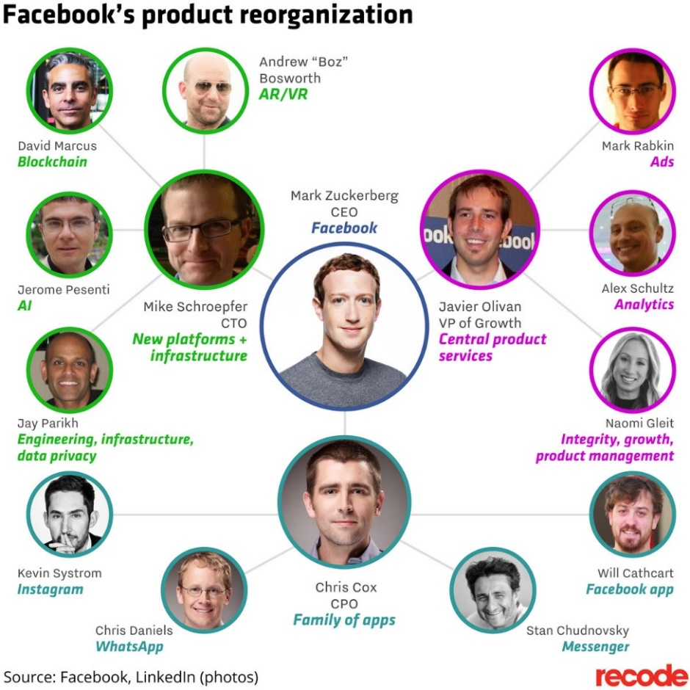
Source: https://innovation-village.com/facebooks-new-product-reorganization/
After such a big exercise of mergers and acquisitions, Facebook undertook one of the largest restructurings in its history, appointing new leaders not only for WhatsApp, Messenger and Facebook's core apps, but also new responsibilities for other people in power, including blockchain Technology provides new solutions.
Restructuring can be a useful management tool in the search for new value and is often part of an M&A integration. Getting this type of reorganization right allows for smooth consolidation of business units in the merging company, standardization and streamlining of corporate activities, alignment of people with expected results, and rapid realization of integration synergies.

- Strategy generation and recommendation
Quick response strategies at Internet world
Develop new business models around existing value is critical for every business, but existence value alone is not enough. People love Facebook's services, but if Facebook can't generate revenue, it can't have the energy to continuously supply people's needs. In other words, the tide of people should be turned into a tide of money, and the traffic should be turned into sales.
People may feel that Facebook has successfully created a community game industry with small games such as Happy Farm since 2007; but in fact, shortly after Facebook’s IPO in 2011, it encountered a fever in community games and growth momentum. Meanwhile, Wall Street and the media began to question Facebook's mobile monetization strategy. So starting in 2012, Facebook entered the battle of mobile online advertising, and after a year of trying to become the preferred promotion channel for mobile game publishers, it has since eaten Google's profit pie. Advertising revenue in the final quarter of 2015 was $5.64 billion, with mobile advertising accounting for 80% of the total.
It now appears that Facebook is primarily monetizing mobile advertising. But if we pay attention to the development of Facebook for a long time, we will find that there are things that can be done on the Internet. Facebook has tried more or less: blogging, developing Facebook-specific applications, cooperating with HTC, and launching videos, communities, and e-commerce. , media, until the recent human resources recruitment and other functions. In short, Facebook's current success is the result of constant tweaking and experimentation and to start with the existence of value surrounding and find a profitable business model. If new development can create new core value, then look for new possibilities in the surrounding area. If development encounters a bottleneck, Facebook need to adjust it.
Even now competing with Google, Facebook's leaders clearly know that the real enemy is not on the Internet but themselves. In the age of science and technology, it is not difficult to make a fortune, but if companies are blindly satisfied with the status quo and do not seek innovation and change, as soon as new competition emerges, it will collapse faster. eBay was surpassed by Amazon, Yahoo was defeated by Google, and Twitter was up and down in a decade. All these show Facebook needs to adapt a quick response strategy in the fast-changing world.
In the future, Facebook is bound to continue to adjust the direction of its efforts and to make sure to keep adding users while monetizing the new traffic. Just too much focus on short-term profits will cause users to leave; but if there is no active profit, it will not be sustainable. Merge and Acquisition is a correct direction for Facebook to diversify their product ranges and act quickly to the market and make a more substantiable profit. The success of Microsoft in the decade is somehow related to effective M&A is the market.
Looking back at the history of Facebook’s establishment, the way to establish a firm foundation is no different from other technological innovations, that is, it requires good ideas, good technology, good capital, good timing and good luck.
Facebook founder Mark Zuckerberg is technically capable. In other words, the ideas in your head can be made by yourself, without the help of others. If Facebook can control the goods and services by themselves, you will not worry about the external environment. A good product made by a good idea and good technology needs to meet a good time, Facebook’s internal resources and infrastructure should be good enough to support all these.
Just under the pandemic situation, the social media store’s turnover in 2020 increased by about 25% compared to last year, and the market is estimated to reach $2 trillion in transaction value within four years1. More research points out that more than 30% of users have started to use social media as their main shopping platform. Coupled with the impact of the epidemic this year, about 30% of physical stores of small and medium-sized enterprises in the United States have begun to switch to online sales and actively seize social media e-commerce in the face of operational difficulties. market.
Facebook launched a new function, Facebook Shops, in May this year, in order to develop its e-commerce business, and also hope to help small and medium-sized enterprises continue to operate during the pandemic. Facebook provides a variety of Facebook and Instagram store layouts. Stores can choose an interface similar to their brand style, and freely classify products through custom categories to increase product exposure opportunities. Quick response with strong technology capabilities and huge customers bases took a comparable market share at different economic stages.

Employees empowerment and building innovative culture
As far as soft skills are concerned, the ability to handle disagreements and lead to appropriate conclusions is crucial. If the company is looking for a manual or a clear reference, it probably won't find it, because these conditions are new and constantly changing. Companies need to have some independence of the employees, the ability to think, and the ability to adapt quickly to change.
The ability to work together as a team is another criterion. During the pandemic, many companies have turned to full-time remote work, giving employees the option of returning to the office or working from home, or a hybrid approach, this ability that is especially important when you don't have the opportunity to meet, communicate, and collaborate with team members in person.
Top management need to focus about team synergy as a team, and it's also about Facebook’s mission and how it interacts with its community and customers. They need to have a same mind set to bring the people closer all around the world which is the mission of Facebook.
When it comes to hard skills, whether technical or non-technical, a strong analytical mindset is important. For example, in addition to the current job and the next business marketing campaign, Facebook must also consider the expansion of data-driven proposals to the market. It need insight into cross-border business, promotion strategies and issues related to digital transformation.
Another hard skill is strategic planning and execution discipline. Facebook needs to look for employees who can develop strong strategies, but strategy is useless if you can't break it down into what needs to be done today and what needs to be done in the long term, which these are needed to build in company’s culture. Good culture is that we can judge the other person's next behavior without communication.

- Strategies barriers for Facebook in development Asia market and strategic choice
China is the core part of Asia market. However, in China, markets such as search engines, online shopping, social media, video, and image sharing have long been monopolized by different large Chinese companies. Among them, social media has been monopolized by Tencent’s WeChat and Sina Weibo. Facebook’s only selling point is that it can "Going out of China" and reaching out to people outside China, but at present, it is too early to say whether Facebook can bring social media back to China. Even if it does return to China, there is a good chance of cooperating with the Chinese government and implementing a certain degree of censorship. The outside world is also worried Facebook provides user data to the Chinese government, a practice that could irritate users outside of China.

However, there are also foreign social media that can penetrate the Chinese market, and a relatively successful example is LinkedIn, a social media platform for businesses and professionals.

When LinkedIn entered the Chinese market a few years ago, it was publicly known that it would use people and software to censor content deemed politically sensitive. Users of the Chinese version cannot create groups or post long-form articles on LinkedIn.

When LinkedIn initially implemented censorship, it was accused by some non-Chinese users, such as some European and American users, who received information that their speech violated Chinese regulations. They accused LinkedIn of eroding freedom of speech, and there were no clear rules for censorship. But these criticisms were short-lived and did not have a major impact on LinkedIn.

A LinkedIn spokesperson said before that they are very supportive of free speech, but they understand that if they want to operate in China, they need to follow the Chinese government's requirements, and they make this decision after careful consideration. The example of LinkedIn shows that even if China's rules are accepted, the overseas markets of these companies will not be greatly affected.

Another example is Apple. In order to enter the Chinese market, in accordance with the requirements of the regulatory authorities, Apple has removed several programs from the Chinese app store. Most of these apps are VPN programs that provide customers with “over-the-wall services” and the programs of some Western media in the past also suffered the same fate. Likewise, this public opinion did not deal a heavy blow to Apple's performance.

At present, Facebook's development direction in China is similar to that of Google (Google). It is also sensitive to things that cannot be done and is looking for other ways to enter the market.

Google, which has been banned since 2010, has been trying to enter the Chinese market in different ways. Google now has hundreds of employees in China, with offices in Shanghai, Shenzhen, and Beijing. It has also recently established an artificial intelligence laboratory to research different artificial intelligence technologies with different organizations and enterprises. Recently, Google has cooperated with other companies to launch different applications, such as the file management program Files Go, Google Translate, and the WeChat applet.

If Facebook starts business in China is a start, an opportunity, let Facebook experiment with doing business in China. China has some different views on privacy from Western countries. How Facebook will deal with it and what type of business and business it will focus on is worth paying attention to.

However, it is worth mentioning that Facebook itself has come under fire for privacy issues and control over the permissions users can read posts. The just-published second-quarter results, both in terms of earnings growth and user growth, were lower than expected. Facebook shares fell sharply on the unfavorable news that revenue growth was expected to slow in the second half of the year and expenses to grow faster than revenue next year. This reflects that Facebook is not only encountering a bottleneck in China, but also needs to seek breakthroughs in its original business development.

- Conclusion
When Zuckerberg started Facebook in 2004, he wasn't the only one building the social networking platform. Before him, there were dozens of social networking platforms with millions of users, many of which had raised millions of dollars, but Facebook managed to break into the market and build the largest community in the world website platform.

The social network is one of the largest digital advertisers in the world, rivaled only by Google. Unlike its competitors, Facebook's ads are consumer-driven — using personal information from Facebook profiles to tailor ads to each user.

Facebook has shown its determination to grow and adapt -- far beyond its original function of connecting Harvard students, it is now a global social network, news site, and photo storage facility. While Facebook has managed to maintain its lead so far, it will be a challenge to keep pace with its competitors and maintain rapid growth.

How does Facebook outrun its earlier, larger, better-funded rivals? The answer is that Facebook wins by strategy, not by its original founding vision or inherent unfair competitive advantage.

- Reference
- A 5-Step Process for Reorganizing After a Merger [online]
Available at:< https://hbr.org/2016/12/a-5-step-process-for-reorganizing-after-a-merger#:~:text=But%2C%20according%20to%20McKinsey%20research,harms%20the%20newly%2Dformed%20organization.>
[Accessed 2 Apr 2022]
- Barrett, F.J. 1995. Creating appreciative learning cultures. Organizational Dynamics, 24(1): 36-49.
- Bass, B.M., & Avolio, B.J. 1993. Transformational leadership and organizational culture. Public Administration Quarterly, 17(1): 112-121.
- Bluedorn, A.C., & Lundgren, E.E. 1993. A culture-match perspective for strategic change. Research in Organizational Change and Development, 7: 137-179
- Facebook Is Buying Huge Messaging App WhatsApp For $19 Billion! [online]
Available at:< https://www.businessinsider.com/facebook-is-buying-whatsapp-2014-2>
[Accessed 2 Feb 2022]
- Facebook’s New Product Reorganization [online]
Available at:< https://innovation-village.com/facebooks-new-product-reorganization/>
[Accessed 2 Feb 2022]
- Facebook Closes $19 Billion WhatsApp Deal [online]
Available at:< https://www.forbes.com/sites/parmyolson/2014/10/06/facebook-closes-19-billion-whatsapp-deal/?sh=182fe965c66c>
[Accessed 2 Feb 2022]
- Gelfand, M. J., Leslie, L. M., Keller, K., & de Dreu, C. (2012). Conflict cultures in organizations: How leaders shape conflict cultures and their organizational-level consequences. Journal of Applied Psychology, 97(6), 1131–1147.
- Hersey, P., Blanchard, K., & Johnson, D. (2000) Management of organizational behavior: leading human resources. Upper Saddle River, NY: Prentice-Hall.
- Jelenc, L., & Pisapia, J. (2015). Individual Entrepreneurial Behavior in Croatian IT Firms: The Contribution of Strategic Thinking Skills. Journal of Information and Organizational Sciences, 39(2), 163-182.
- Johnson, J.R. 1998. Embracing change: a leadership model for the learning organization. International Journal of Training and Development, 2(2): 141-150.
- Johnson, J.R. 2002. Leading the learning organization: portrait of four leaders. Leadership and Organization Development Journal, 23(5): 241-249.
- Johnson, J. D., Donohue, W. A., Atkin, C. K., & Johnson, S. (1994). Differences Between Formal and Informal Communication Channels. The Journal of Business Communication (1973), 31(2), 111–122. https://doi.org/10.1177/002194369403100202
- Judge, T. A., Bono, J. E., Ilies, R., & Gerhardt, M. W. (2002). Personality and leadership: A qualitative and quantitative review. Journal of Applied Psychology, 87, 765−780.
- Kor, Y. and Leblebici, H. (2005), “How do interdependencies among human-capital deployment, development, and diversification strategies affect firms’ financial performance?”, Strategic Management Journal, Vol. 26 No. 10, pp. 967-998.
- Kotter, J. P. (1996). Leading change. Boston, MA: HBS Press.
- Lee, J., & Miller, D. (1999). People matter: Commitment to employees, strategy and performance in Korean firms. Strategic Management Journal, 20, 579−593.
- Lieberson, S., & O'Connor, J. F. (1972). Leadership and organizational performance: A study of large corporations. American Sociological Review, 37, 117−130.
- Lok, P. and Crawford, J. (2004), "The effect of organisational culture and leadership style on job satisfaction and organisational commitment: A cross‐national comparison", Journal of Management Development, Vol. 23 No. 4, pp. 321-338.
- Prewitt, V. 2003. Leadership development for learning organizations. Leadership and Organization Development Journal, 24(2): 58-61.
- Sadler, P., 2003. Leadership. London: Kogan-Page.
- Schein, E.H. 1983. The role of the founder in creating organizational culture. Organizational Dynamics, 12(1): 13-28.
- Schien, E.H. 1996. Three cultures of management: the key to organizational learning. Sloan Management Review, 38(1): 9-20.
- Senge, P. 1994. The fifth discipline: the art and practice of the learning organization. New York: Currency Doubleday.
- Waldman, D.A., Ramirez, G.G., House, R.J., & Puranam, P. 2001. Does leadership matter? CEO leadership attributes and profitability under conditions of perceived environmental uncertainty. Academy of Management Journal, 44(1): 134-143.
- Waldman, D. A., & Yammarino, F. J. (1999). CEO charismatic leadership: Levels-of-management and levels-of-analysis effects. Academy of Management Review, 24, 266−285
- WhatsApp, WeChat and Facebook Messenger Apps – Global useage of Messaging Apps, Penetration and Statistics [online]
Available at:< https://www.messengerpeople.com/global-messenger-usage-statistics/#:~:text=Facebook%20is%20leading%20when%20it,close%20to%201%20billion%20users> [Accessed 2 Feb 2022]

