

Raj Bhatia
Cyber Security and Digital Forensic
Student ID: 2522682

Lecturer: Dr. Ayman Al Hajjar

Data Security, Governance and Compliance
Module code: ACCA7028
Academic Year 2026 – 2027
Submission date - 29th April 2026
Case Study: FinSure Bank (FSB)

Index
Sr. No |  | Topic | Page No.
 |  | Abstract |  | 06
1 |  | Introduction |  | 07
2 |  | Literature Review: Frameworks and Models for Information Security |  | 08
 | 2.1 | Information Security Frameworks Overview |  | 08
 | 2.2 | Information Security Management System ISO/IEC 27001 |  | 08
 | 2.3 | Infrastructure Library for Information Technology |  | 09
 | 2.4 | NIST Framework for Cybersecurity |  | 09
 | 2.5 | Ethical Dilemmas in Information Security |  | 10
3 |  | FinSure Bank's Security Issues |  | 11
 | 3.1 | Risks to Cloud Infrastructure Security |  | 11
 | 3.2 | Security Issues with BYOD |  | 11
 | 3.3 | Risks to Mobile Banking Security |  | 11
 | 3.4 | Insufficient Security Governance and Compliance Structure |  | 11
 | 3.5 | Risk Assessment Methodology |  | 12
4 |  | FinSure Bank's suggested security governance and compliance strategy |  | 13
 | 4.1 | Developing a Security Governance Structured Design |  | 13
 | 4.2 | The framework of integrated security should be established |  | 13
 | 4.3 | GDPR Data Protection and Compliance |  | 14
 | 4.4 | Unchanging Security Surveillance and Risk Management |  | 14
 | 4.5 | Information Security Policy and Contingency Planning |  | 14
 | 4.6 | Network and Perimeter Security |  | 15
5 |  | The Significance of Reviving Information Security Rules and Standards |  | 17
 | 5.1 | Taking Action Against New Cybersecurity Risks |  | 17
 | 5.2 | Ensuring Adherence to Legal and Regulatory Conditions |  | 17
 | 5.3 | Enhancing Governance for Organizational Security |  | 17
6 |  | Conclusion |  | 18
7 |  | References |  | 19

Table Content
Sr. No | Topic | Page No.
1 | Comparison of Major Information Security Frameworks | 08
2 | Risk Assessment for FinSure Bank | 11
3 | Security Governance Roles Proposed | 13
4 | Integrated Security Framework Strategy | 13
5 | Recommended Data Protection Controls | 14

Figure Content
Sr. No | Topic | Page No.
1 | Key Components of ISO/IEC 27001 ISMS | 09
2 | The Cybersecurity Framework of NIST | 10
3 | Risk Assessment and Mitigation Lifecycle | 12
4 | Layered Network Security Architecture | 15
5 | Zero Trust architectures | 16

Overview Course Work Task
The present coursework develops a strong Governance, Risk, and Compliance (GRC) model that the FinSure Bank can adopt to ensure its digital-first operations. It considers such industry standards as ISO/IEC 27001, NIST CSF, ITIL, and COBIT to deal with vulnerabilities of cloud infrastructure, BYOD, and mobile banking. To alleviate fraud and insider threats, the report outlines an integrated security framework, such as a well-designed hierarchy of governance, Zero Trust networking, and data controls in line with GDPR, as solutions. Lastly it critiques the need to constantly develop higher regulatory standards to ensure organizational resilience in the face of a more complex cyber-threat environment.

Abstract
The finance sector is witnessing the revolution of cloud-based technologies enabling online banking to be scaled and efficient. Nonetheless, they also present additional cyber vulnerabilities to sensitive financial, transactional and PII data. To counteract this, good governance, enterprise risk management, and compliance models are needed on the financial side to make sure that their critical information is secured by the confidentiality, integrity, and availability (CIA triad) model.
This paper applies the case of the FinSure Bank to investigate the ways in which the risks in online banking can be mitigated by having well-structured cybersecurity governance. It considers well-known frameworks like COBIT, ISO/IEC 27001, NIST Cybersecurity Framework and ITIL that facilitate risk analysis, compliance requirements, and the adoption of Information Security Management Systems (ISMS).
The analysis shows that the environment in FinSure Bank has major threats such as cloud service threats, BYOD policies, mobile banking threats, and absence of governance structure. To mitigate such problems, this research suggests a combined Governance, Risk, Compliance (GRC) framework to provide resilience of cyber activities, regulatory adherence, and security to the contemporary digital banking.

Introduction
It has transformed financial institutions because of the rapid growth of digital technologies and services with internet usage. Digital banking, though efficient, becomes accessible and offers better delivery of services, is also a characteristic of high rates of cyber and data security threats. This means that the threat of data leakage and unauthorized access to sensitive financial and personal information increases as more and more people are using cloud networks, mobile technology, and making their systems interdependent increasing the attack surface [1].
Risk management is essential in corporate governance through the incorporation of the information security. Cybersecurity plans need to assure CIA (Confidentiality, Integrity, Availability) of information assets, backed by well-established governance plans [2].
To minimize such risks and encourage continuous enhancement of Information Security Management Systems (ISMS), organizations employ such standards as ISO/IEC 27001, ITIL, and COBIT [3]. The case with FinSure Bank reveals the complexity of cybersecurity concerns in BYOD, cloud computing, and work-at-home environments, as they lead to such threats as fraud, identity theft, and insider threats [4].

Literature Review: Frameworks and Models for Information Security
The quick development of digital infrastructures and the appearance of regulation demands that organizations have structured information protection structures and governance processes. These frameworks offer formal ways to identify, analyze, and track cybersecurity risks and establish technological and governing controls. It has been found out that firms having formal security governance are more resistant to cyberattacks and their risk management is greater especially in highly regulated industries such as financial services [5].

2.1 Information Security Frameworks Overview
An organizational governance structure designed to protect organizational information systems is called an information security framework. They manage the use of technological and administrative controls, best practices, regulations, and standards. Research shows that these frameworks can assist organizations in defining areas of weakness, implementing risk-based controls, and performing security operations at a steady level in dynamic environments [6].
Framework | Main Focus | Characteristic Features | Organisational Benefits
ISO/IEC 27001 | Information security management | Security controls, risk assessment, and implementation of ISMS. | Secures and safeguards information resources and maintains regulatory control.
ITIL | IT service management | Lifecycle management and process optimization of services. | Enhances reliability of service and adopts security as an operations concern.
COBIT | IT governance | Alignment of IT with business objectives | Strengthens governance and accountability
NIST Cybersecurity Framework | Cybersecurity risk management | Identify, Protect, Detect, Respond, Recover functions | Provides structured cybersecurity risk management
Table 1: Comparison of Major Information Security Frameworks

2.2 ISO/IEC 27001 Standard
The rapid evolution of infrastructures and distant facilities and increasing regulation strain require organisations to transition to the methodized information protection system, governance models. These frameworks provide procedural orientation towards cybersecurity risk first identification, analysis and management and provide governance and technical guardianship establishment. Literature also evidences increased resilience of properly functioning organisations with formal security governance to cyberattacks and more resilience to manage the risk particularly in highly regulated industries like the financial services [7].

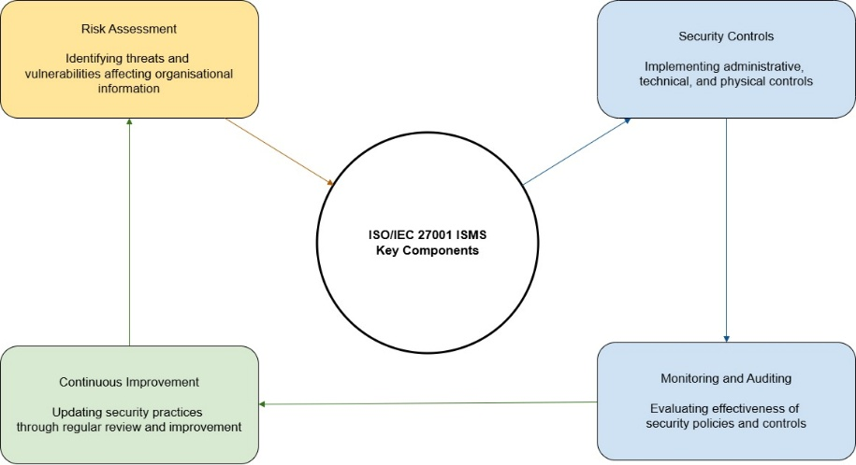
Figure 1: Key Components of ISO/IEC 27001 ISMS

2.3 Infrastructure Library for Information Technology
ITIL is a time related framework of managing and delivering IT services. Although it mainly deals with information technology service management (ITSM), it is significant to incorporate information security into organisational processes. ITIL enhances the reliability, efficiency and risk management of its services because it organizes the process of service and governance practices. Research indicates that organisations that implement ITIL have superior incident reactance, enhanced service execution as well as control in IT risks [8]. ITIL Service Lifecycle model (strategy, design, transition, operation and continual improvement) guarantees the controlled and efficient delivery of the services. It also instills security measures like data security, accessibility and risk management throughout the process and information security becomes a reality of IT governance and operation.

2.4 NIST Framework for Cybersecurity
The National Institute of Standards and Technology developed the NIST Cybersecurity Framework (CSF), a risk-based framework that is widely used to address cybersecurity threats. Its five main functions—Identify Protect Detect Respond Recover—help organizations improve their risk awareness, asset protection, incident detection, response, recovery, and system resilience [9], [10].

Figure 2: The Cybersecurity Framework of NIST

2.5 Ethical Dilemmas in Information Security
Financial institutions must protect sensitive data and operate in regulated environments, yet a strong cybersecurity plan may create conflicts between privacy and security. Customers' and employees' rights should be balanced with monitoring, especially in BYOD settings. It is crucial to use open policies and handle data responsibly. Data are managed securely by following the General Data Protection Regulation (GDPR) because of accountability, encryption, and access limits, maintaining confidence [11], [12].

FinSure Bank's Security Issues
The speed of digital expansion of FinSure Bank has augmented cybersecurity and governance-related issues. Over dependence on cloud solution, BYOD and mobile banking leaves the organisation vulnerable to data breach, fraud and lack of regulatory compliance.

3.1 Cloud Infrastructure Risks
More than 90% of FSB systems make use of third-party cloud services. Although it can be scaled, threats like maladjustments, lax access controls, and poor monitoring may result in data breaches and losses [13].

3.2 BYOD Security Risks

BYOD increases flexibility, but creates certain vulnerabilities, with personal devices not as high-quality as those offered by enterprise vendors. Lack of these controls MDM, encryption and strong authentication increases a threat of malware and data leakage [14].

3.3 Mobile Banking Risks

The use of mobile platforms increases the attack surface, putting systems at risk of phishing, malware, and identity theft. Strong authentication (MFA) and secure development, as well as real-time monitoring, should be used to reduce the risks [15].

3.4 Governance and Compliance Gaps
Lack of a systematic governance structure undermines risk management and implementation of policies exposing them to cyber-attacks and regulatory fines [16].
Threat Category | Description | Potential Impact | Risk Level
Cloud Security Breaches | Misconfigured cloud systems or weak access control | Exposure of financial data | High
BYOD Vulnerabilities | Unsecured personal devices accessing corporate systems | Data leakage or malware infection | High
Mobile Banking Attacks | Phishing, malware, and fraudulent mobile applications | Customer account compromise | High
Insider Threats | Workers or partners abusing access to the system | Financial fraud or data theft | Medium–High
Lack of Governance | Lack of audits and organized security policies | Regulatory non-compliance | High
Table 2: Risk Assessment for FinSure Bank

3.5 Risk Assessment Methodology
Any financial institutions harnessed in sophisticated online settings need to take a formalized method to cybersecurity danger evaluation. Since FinSure Bank operates in large volumes of sensitive information, in cloud systems, mobile banking, and distributed systems, it is highly prone to risks of loss of information, fraud and breach of regulations. Documents such as formal standards such as ISO/IEC 27005 and NIST Risk Management Frameworks give detailed instructions on how to identify, analyse and manage these risks [17]. Risk assessment is initiated by recognising critical assets and threats, then examines the vulnerabilities, phishing, malware, misconfigurations, and inadequate authentication systems [18].
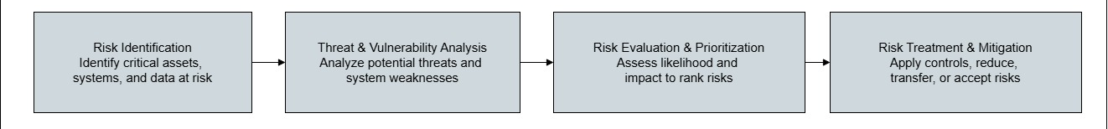
Figure 3: Risk Lifecycle of Assessment and Mitigation.

The proposed security governance and compliance plan of FinSure Bank.
To reduce cybersecurity risks, FinSure Bank needs to put in place a thorough structure for information security governance and compliance. Formal governance structures help to continuously improve and regulate risks and guarantee that security policies, organizational objectives, and legal requirements are all consistent [19].

4.1 Design of structure of security governance.
Through incorporating security into decision-making processes and clearly defining roles, responsibilities, and accountability, an organized governance architecture would improve cybersecurity [20].
Role | Responsibility
Board of Directors | Controls information security governance strategically.
CISO, or chief information security officer | Develops and manages security regulations and policies.
Committee on Security Governance | Verifies regulatory compliance and evaluates security procedures.
Team for IT Security | Monitoring threats and puts security procedures in place.
Team for Compliance and Risk | Task Force Audits and regulates.
Table 3: Security Governance Roles Proposed.
This approach improves accountability and control by distributing security responsibilities among organizational levels.

4.2 Framework for Integrated Security
FinSure Bank must adopt a cohesive approach using on frameworks such as ISO/IEC 27001, NIST, ITIL, and COBIT, with ISO 27001 serving as the foundation for the ISMS [21].
Framework | Role in Security Strategy
ISO/IEC 27001 | Creates a system for managing information security
NIST Cybersecurity Framework | Strengthens cybersecurity risk management
ITIL | Integrates security within IT service lifecycle
COBIT | Provides governance and alignment with business objectives
Table 4: Integrated Security Framework Strategy
As a result, these frameworks can be unified to allow FinSure Bank to build a unified and scalable security architecture that can support the operational and strategic security challenges.

4.3 GDPR Data Protection and Compliance
To keep sensitive data, the General Data Protection Regulation (GDPR) requires strict adherence to regulations. The primary measures to reduce the risk of breaches and raise the degree of data security include RBAC, data classification, encryption, MFA, monitoring, and recurring audits [22].
Security Control | Purpose
Data Encryption | Secures the financial and personal data.
Multi-Factor Authentication (MFA) | Prevents unauthorised access of the system.
Data Classification | Organizes data based on sensitivity levels
Security Monitoring systems. | Identifies the suspicious activities on the fly.
Periodic Compliance Audit | Oversight that they are compliant with the rules.
Security Control | Purpose
Table 5: Recommended Data Protection Controls
These measures should enable FinSure Bank to keep client’s information safe and at the same time incur data-protection regulations in the global sphere.

4.4 Ongoing Security supervision and Risk management.
Automated vulnerability tests, regular audits, and continuous monitoring are helpful in identifying threats early on so that the incident response can be improved [23].

4.5 Security guidelines and backup plans.
RBAC, MFA, encryption, BYOD, and cloud management are examples of best practices. Regulation compliance and operational continuity are ensured by response contingency, disaster recovery, and secure backups [24] [25].

4.6 Network and Perimeter Security
In digital banking, networks progressively expose their systems to cyber threats. In order to secure internal networks and maintain operations security, effective network and perimeter security measures are required [26]. Firewalls and Next-Generation Firewalls (NGFWs) offer more sophisticated filtering traffic and threat detection [27]. IDS/IPS is used to detect and prevent malicious activity [28], and network segmentation prevents the lateral attacks. Virtual Privacy Networks (VPNs) are used to secure remote communication with encryptions [29].
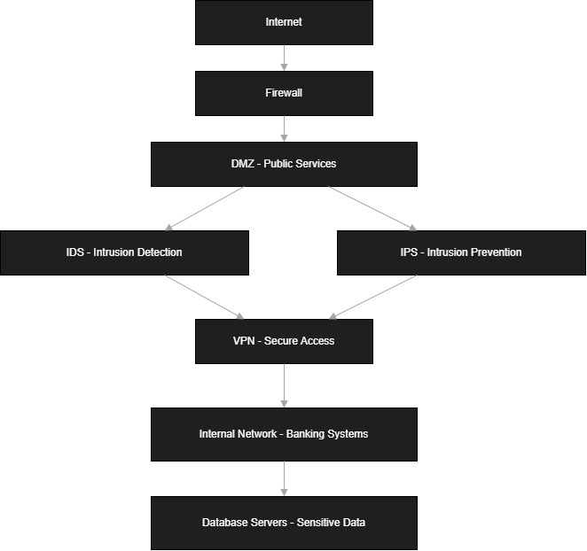
Figure 4: Layered Network Security Architecture

Additionally, contextual access control and continuous authentication are enforced by Zero Trust architectures, which significantly reduce insider threats and unauthorized access [30].
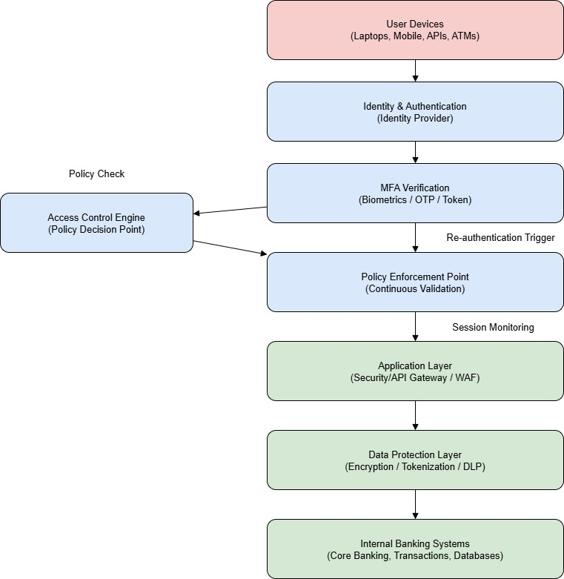
Figure 5: Zero Trust architectures

The Resurgence of Information Security Rules and Standards Implication.
The rushed digitalisation and changing cyber threats demand the dynamic changes in the security regulations and standards. Armed with powerful risk management measures, the use of contemporary controls and compliance are essential because of the sensitivity of the information undertaken by the financial institutions and operational safety.

5.1 Discussion of New Cybersecurity Threats.
Phishing is at scale, AI-driven attacks, malware, and other advanced threats are examples that create organisational risk. Old systems are still susceptible and frequent upgrades of security systems and technologies are needed to avoid data breaches and identity thieves [31].

5.2 Ensuring Legal and Regulatory Compliance
The rules like the General Data Protection Regulation (GDPR) enhance data protection and reporting of breaches. The non-compliance can lead to financial fines and reputational losses and it is imperative to ensure that it is constantly done [32].

5.3 Legal/Regulatory Compliance.
The adaptable governance of security and active risk management also enhance the resilience of organisations and promote safe digital activities.

Conclusion
To mitigate such a challenge, a robust Governance, Risk, and Compliance (GRC) framework should be embraced at FinSure Bank to tackle the emerging cybersecurity challenges. The introduction of structured security governance with the aid of risk management and continuous monitoring greatly improves the resilience of organisations. Access management, data protection and incident response are the key controls that guarantee the security of vital financial systems. Implementing the security practices according to the regulatory requirements, the bank is able to secure sensitive data and safeguard the trust of customers as well as the long-term operational stability of the bank in a fast-evolving digital landscape.

7. References
[1] M. E. Whitman and H. J. Mattord, Principles of Information Security, 7th ed. Boston, MA, USA: Cengage Learning, 2021.
[2] B. von Solms and J. van Niekerk, "From information security to cyber security," Computers & Security, vol. 38, pp. 97–102, 2013.
[3] AXELOS, ITIL Foundation: ITIL 4 Edition. London, UK: TSO (The Stationery Office), 2019.
[4] T. Grance and W. Jansen, "Guidelines on Security and Privacy in Public Cloud Computing," NIST Special Publication 800-144, National Institute of Standards and Technology, Gaithersburg, MD, USA, 2011.
[5] R. von Solms, "Information security governance: COBIT or ISO 17799 or both?," Computers & Security, vol. 24, no. 2, pp. 99–104, 2005.
[6] P. Bowen, J. Hash, and M. Wilson, "Information Security Handbook: A Guide for Managers," NIST Special Publication 800-100, Gaithersburg, MD, USA, 2006.
[7] A. Calder and S. Watkins, IT Governance: An International Guide to Data Security and ISO27001/ISO27002, London, UK: Kogan Page, 2015.
[8] E. Humphreys, "Information security management standards: Compliance, governance and risk management," Information Security Technical Report, vol. 13, no. 4, pp. 247–255, 2008.
[9] M. Marrone and M. Kolbe, "Uncovering ITIL claims: IT executives’ perception on benefits and business impact," Information Systems and e-Business Management, vol. 9, no. 3, pp. 363–380, 2011.
[10] National Institute of Standards and Technology, "Framework for Improving Critical Infrastructure Cybersecurity," NIST, Gaithersburg, MD, USA, 2018.
[11] K. Stine, S. Quinn, D. Witte, and M. Gardner, "Guide for Cybersecurity Event Recovery," NIST Special Publication 800-184, 2016.
[12] K. Siponen and A. Vance, "Neutralization: New insights into the problem of employee information systems security policy violations," MIS Quarterly, vol. 34, no. 3, pp. 487–502, 2010.
[13] S. Subashini and V. Kavitha, "A survey on security issues in service delivery models of cloud computing," Journal of Network and Computer Applications, vol. 34, no. 1, pp. 1–11, 2011.
[14] M. Morrow, "BYOD security challenges: Control and protect your most sensitive data," Network Security, vol. 2012, no. 12, pp. 5–8, 2012.
[15] A. A. Alqahtani and H. H. Alqahtani, "Cybersecurity risks in mobile banking applications: Threats and countermeasures," Int. Journal of Advanced Computer Science and Applications, vol. 11, no. 6, pp. 455–462, 2020.
[16] Information security, cybersecurity and privacy protection — Guidance on managing information security risks, ISO/IEC 27005:2022, 2022.
[17] H. A. Shey, J. M. Corman, and J. P. Nunes, "Managing enterprise information security risk," IEEE Security & Privacy, vol. 8, no. 4, pp. 30–36, 2010.
[18] National Institute of Standards and Technology, "Risk Management Framework for Information Systems and Organizations," NIST Special Publication 800-37, 2018.
[19] A. Da Veiga and J. H. P. Eloff, "A framework and assessment instrument for information security culture," Computers & Security, vol. 29, no. 2, pp. 196–207, 2010.
[20] S. De Haes and W. Van Grembergen, Enterprise Governance of Information Technology. New York, NY, USA: Springer, 2015.
[21] S. AlHogail, "Improving IoT Readiness of Organizations Based on the Information Security Culture," IEEE Access, vol. 6, pp. 22259–22269, 2018.
[22] D. Bhalavat, A. Doshi, N. Keni, and P. R. Shah, "Automated Compliance: A Privacy-Focused Solution for GDPR and DPDPA Adherence," in 2024 13th Int. Conf. on System Modeling & Advancement in Research Trends (SMART), 2024, pp. 831–837.
[23] S. Noel, E. Harley, K. Tam, M. Limiero, and D. Sharevski, "Measuring and visualizing the quality of cyber security risk management," IEEE Security & Privacy, vol. 15, no. 5, pp. 68–75, 2017.
[24] R. Sandhu, E. Coyne, H. Feinstein, and C. Youman, "Role-based access control models," IEEE Computer, vol. 29, no. 2, pp. 38–47, 1996.
[25] K. Killcrece et al., "Computer Security Incident Handling Guide," NIST Special Publication 800-61, 2012.
[26] W. Stallings, Network Security Essentials: Applications and Standards, 6th ed. Boston, MA, USA: Pearson, 2017.
[27] S. Northcutt and J. Novak, Network Intrusion Detection, 3rd ed. Indianapolis, IN, USA: New Riders, 2003.
[28] K. Scarfone and P. Mell, "Guide to Intrusion Detection and Prevention Systems (IDPS)," NIST Special Publication 800-94, 2007.
[29] S. Kent and K. Seo, "Security architecture for the Internet Protocol," IETF RFC 4301, 2005.
[30] S. Rose, O. Borchert, S. Mitchell, and S. Connelly, "Zero Trust Architecture," NIST Special Publication 800-207, 2020.
[31] S. Romanosky, "Examining the costs and causes of cyber incidents," Journal of Cybersecurity, vol. 2, no. 2, pp. 121–135, 2016.
[32] R. Renaud and K. Goucher, "The curious incidence of security breaches by knowledgeable employees and the pivotal role a good security culture can play," Information Management & Computer Security, vol. 20, no. 2, pp. 92–101, 2012.

