Gareth Weeks (P150081)

Global Financial Markets Report - Norway
Contents Page
Executive Summary ……………………………………………………………………………………………………………2 Recommendations ……………………………………………………………………………………………………………..2
Introduction ……………………………………………………………………………………………………………………….3
International Trade Theory…………………………………………………………………………………………………4
Absolute Advantage ………………………………………………………………………………………………4
Assumptions ………………………………………………………………………………………………………….4
Comparative Advantage…………………………………………………………………………………………4 - 5
International trade – Norway……………………………………………………………………………………………. 5
Trading Partners……………………………………………………………………………………………………………….…5
Credit rating……………………………………………………………………………………………………………………..…6
Current debt of the country……………………………………………………………………………………………..…6
Main Economic Service……………………………………………………………………………………………………….6
Exports…………………………………………………………………………………………………………………...6
Imports…………………………………………………………………………………………………………………..6
Norwegian National Bank………………………………………………………………………………………………..…6-7
History……………………………………………………………………………………………………………………6-7
Role……………………………………………………………………………………………………………………..…7
Monetary Policy……………………………………………………………………………………………………7-8
Accounting standards…………………………………………………………………………………………………………8
Norwegian Currency……………………………………………………………………………………………………………8
Exchange Rates……………………………………………………………………………………………………….8
Inflation Rates………………………………………………………………………………………………………..8
SWOT………………………………………………………………………………………………………………………………….8-10
Developing Sustainability……………………………………………………………………………………………………10
Conclusion ………………………………………………………………………………………………………………………….10-11
References …………………………………………………………………………………………………………………………11-12
Appendices…………………………………………………………………………………………………………………………13-19

Executive Summary
The research in this report was conducted to evaluate the economic benefits, specialisation of production, and the exchange of commodities that international trade brings to Norway; and the benefits international trade has brought to the country. The research from this report will cover aspects such as the financial markets, international trade, current plans for sustainability and in-depth analysis of the central bank’ and currency’ History.
From the below research we have found that Norway has a stable and successful economy, their currency is currently strong, the country has a strong partnership with other nations and has a good credit rating. We also found that the the current state of trade and production is thriving; monetary system has been in play for many years, and the central bank is responsible for the creation, execution and enforcement of monetary policy.
Recommendations
I recommend that Norway should do the following:
- Continue its progress in accounting standards and; aims in aligning them and other sectors with their roadmap.
- Aim to lower the fragmented market and push to create solid markets to provide for.
- Push for more development in the health industry with an aim to reduce the cost so future development can be cheaper.
- Find a sector that will give the country absolute advantage in the market to sustain production.

Introduction
This report will discuss in depth about International Trade, Norway and international trade and further information of the Norwegian economy. It will look at the export and import, exchange and inflation rates and how they have been influenced. This report will also assess the current economic state and gather the latest trend of imports and exports made by Norway. Furthermore, this report will delve into the central banking system and how their monetary policy works, is regulated and implemented efficiently, capital market and a SWOT analysis that covers various areas of the economy.

International Trade Theory
International trade theory is a group of several theories that try to explain international trade. Trade in its simplest form is the exchange of goods or services between two parties. International trade is the same basic concept of trade; however, it would be between two or more countries. One reason people trade is to gain goods or services that they cannot produce themselves, this also is able to be applied as a simplified form of what international trade is, on the surface international trade is countries supplying goods and services to each other in return for other goods and services that they cannot produce or cannot produce it cheaper. At times instead of a service or supply of goods there is a monetary equivalent exchanged. (SaylorAcadamy, 2019)
Absolute Advantage
Absolute advantage in economic terms is a reference to an individual or group of people that produce a large quantity of produce compared to its competitors. This was introduced in the book “An inquiry into the Nature and Causes of the Wealth of Nations” by Adam Smith in 1776. Mr. Smith explains absolute advantage as a certain country’s intrinsic capability to produce a higher volume of a commodity than its global competition. (Institute, 2019)
Smith was the pioneer of the absolute advantage concept. Smith pointed out through opportunity cost that the regulations favouring one industry is depleting the growth of other industries as it reduces the resources available to them. Thus, taking away from an area that would thrive from more employment. Smith then applied the principle to society, specifically using a shoe maker as an example. He used the example of a shoemaker not using the shoes he had produced himself because of it being a waste of his productive resources and instead buying the shoes that were made efficiently by another producer. Pointing at each individual in society has their specialisations in the production of goods and services which said individual has an advantage. Finally, Smith applies the opportunity cost principles, specialization in international economic policy, and the international trade principles. Smith simply explains that it is more beneficial to import goods from other nations where the production can be done more efficiently as this allows the country to apply its resources in its most efficient and productive industries. Smith emphasizes that a nations advancement in technology compared to its competitors is the primary determinant of international trade and its flow around the globe. (Institute, 2019)
Assumptions
While Smith pioneered the theory of absolute advantage there were a few assumptions, smith assumed that the cost of commodities were equated to the amount of labour required in the respective production process; that labour was mobile within a country but not between said countries; considered a two country and two commodity framework for the analysis and implicitly assumed that trade between two countries would be considered if each of the two countries had an absolute reduced cost in production of one of the commodities being traded. (Institute, 2019)
Comparative Advantage
Comparative advantage is the instance a country produces good or services at a lower rate than other countries in the market. A nation with a comparative advantage would ensure the trade is benefits them, the nation ensures that the benefits from buying the good or services outweigh the disadvantages there may be by importing said service or good. The product may not be of a high standard but there is a lower opportunity cost than the other countries to import. (Amadeo, 2018)
Comparative advantage theory was created in the eighteenth century by the economist David Ricardo. His argument was that a country boosts its economic growth by focusing on the industry that has the most substantial comparative advantage. An example is that at the time England had the ability to produce cloth at a cheap cost and Portugal had the perfect conditions to make wine at a reduced cost. Ricardo’s prediction was that England would reduce its production of wine and start sourcing it from Portugal and Portugal would reduce its production of cloth and source it from England. He was right in his assumptions as they stopped producing these products since there was a comparative advantage which made it cheaper to trade these commodities instead of solely producing it at a higher rate. Therefore, both benefited from trading what they produced more efficiently. (Amadeo, 2018)
Ricardo developed his approach to combat the restrictions on wheat importation in England at the time. His argument was that the restrictions were nonsensical as restricting the low-cost and high-quality wheat from countries that have the ideal conditions to produce said product. It would be ideal if England exported production that needed skilled labour or machinery to increase their value as it could acquire more wheat in trade deals than by growing its own. (Amadeo, 2018)
The comparative advantage theory explains why the trade protectionism isn’t efficient in the long run. Most political leader have a pressure from the public to ensure the safety of local jobs and lively hoods which ends up in increased tariffs on trade; however, this is not a fix for the better but a fix that is only temporary and not guaranteed to work. In the end it is more likely to cause issues with a country’s competitiveness in the market. It also not only creates a waste in resources and time spent on inefficient industries but also pushes the public to pay higher prices for domestic products. (Amadeo, 2018)
International trade – Norway
Norway’s economy is a fairly open one with 68.5% of their GDP being represented as trade in 2018. The usual exports and imports for Norway are energy-intensive products and high-technology items. Norway is in the top twenty countries that export oil and the second largest seafood and natural gas exporter in the world currently. Norway is in the bracket of the 25 biggest exporters which is excluding inter-EU trading. Around 10% of Norway’s exports are industrial products such as ships and oil platforms and Norway’s main import is manufacturing items such as transportation and information technology, this accounts for 40% of all imports. (Nordea, 2019)

Trading Partners
Norway’s main trade partners are members of the EU. As seen in appendix 1 and 2 the United Kingdom was the most exported to in 2017, followed by Germany, Netherlands and Sweden. Sweden was the country Norway imported from the most in 2017, followed by Germany, china and the United States. Norway has a considerable trade surplus; however, this is linked to global oil and gas prices and wasn’t as fruitful between 2015-2017 compared to the previous years. After a 17 year low in 2016, the Norwegian trade surplus expanded considerably in 2018 from NOK 140.4billions to NOK 288 billion. Exports of oil and gas accounted for more than half of the country’s exports and imports rose by 4% at the time. (Nordea, 2019)
Credit Rating
Currently Norway’s credit rating overall is triple A. From the charts available (See appendix 5) we can see the general outlook on Norway is a stable credit rating with no real shift in a bad direction so far. The last recorded rating under triple A (see appendix 6) was in 1958 and from then has kept a good standard. (economics, 2019)
Current debt of the country
Norway had a recorded debt equivalent of 36.20% of the country’s GDP in 2017 and has averaged 38.01% from 1980 to 2017. Unfortunately, Norway reached a high of 53.70% in 1993; however, recorded a record low of 27.30% in 2014. As seen by the charts provided (see appendix 7) Norway had a serious debt increase over the years. (Economics, 2019)
Main Economic service/s:
Exports:
Norway’s exportation of goods and services annually range from Crude oil, petroleum gas and refined petroleum to raw aluminium and fresh fish. These exports go to countries such as the UK, Germany and Sweden. (Pariona, 2017)
Imports:
Norway Imports around 149 billion dollars’ worth of produce each year. The country’s main imports include products such as cars, computers and passenger/cargo ships. Norway’s largest import partners include countries such as Sweden, China and Denmark. (Pariona, 2017)
Norway gets its cash flow through many industries, one of the largest industries that accounts for a big portion of the Norwegian governments revenue is the petroleum industry.
The petroleum industry plays a vital role in Norway’s economy. The oil and gas sectors are Norway’s biggest in terms of value added, government revenue, investment and export value. The long-term goal of the governments petroleum industry is to ensure that it benefits society as a whole while also maintaining it for future generations to gain from the country’s petroleum wealth. This has been a key point in the development of financial and legal frameworks for the sector. Since Norway started production in these sectors, they have added more than NOK 14 000 Billion in current NOK into the Norwegian GDP. From the graph (see appendix 8) you can see the cash flow and how the industry influenced its growth.(Directorate, 2019)
Norwegian National Bank
Brief History
Norges Bank was established in 1816; however, Norway’s numismatic history dates to roughly the year 1000. In C.1000 Norway’s first known coin was produced, it was a penny attributed to Olav Tryggvason. For a long while no coins were minted but through importation of foreign coins the monetary needs were satisfied.1628 Norway established a mint in Olso, formerly known as Christiania. The coins were made from silver which was derived from the mines and works in Kongsberg. As a symbol of remembrance for this key point in Norway’s history they named a street mint street or Myntagaten in Norwegian, this is located 100 meters from the site of the original mint. (Bank, 2019)
Later in the years Norway separated from Denmark and the union with Sweden. From this Norges bank was established by the Act of Storting meaning the Norwegian Parliament. This was put in place 14th June 1816 and the monetary unit was speciedaler (rixdollar), which was divided into 120 skillings or 5 ort (“rigsort”) where they were valued at 24 skillings each. (Bank, 2019)
On June 4th, 1873 the Money Act was established to shift Norway onto the gold standard, and to use the terms Krone and øre in parallel to the other terms daler and skilling as one rixdollar is the equivalent to for Korner. Norway replaced the gold standard with silver from the 1st of January 1874. (Bank, 2019)
In 1987 the Norges Bank seat is moved to Oslo, and in 1906 a new building is built to accommodate the influx of people that would be the workforce for the printing plant. (see appendices 3 and 4). Shortly after, on March 29th, 2001 new regulations on monetary policy were established by the council state. Norges Bank set the key rate with their view of maintaining a low and stable inflation, this target was set at 2.5%. From the help of other banks Norges bank established Norsk Kontantservice AS (NOKAS). This company would be responsible for handling on money for the banks of Norway while also taking on some of Norges Banks statutory responsibilities in the area of cash handling. (Bank, 2019)
Today Norges Bank has the exclusive ability of being able to issue coins and banknotes. The bank is a provider of loans for the Norwegian commercial and savings bank but also receives deposits from it also. Norges Bank also has an important role in the payment system by dealing with settlements between other banks. (Finance, 2019)
Role
Norges Bank has the responsibility to execute the monetary and exchange policy. These monetary policy guidelines were established by Royal Decree on March 29th, 2001. The policy is orientated towards maintaining a low and stable inflation rate over time. The Bank must analyse current trends in the economy while ensuring to pay attention to the financial markets. From this they advise the governing bodies of Norway on matter relating to economic policy and compile data in relation to balance of payments. (Finance, 2019)
Monetary policy
Norges Bank objective on monetary policy is to maintain a low and stable inflation rate, the bank states that the operational target for their monetary policy is annual consumer price inflation of near 2% over time. The bank also aims to maintain a flexible and forward-thinking approach when looking at targeting inflation so that it contributes to high output and employment to ensure a lower build-up of financial imbalance. (Bank, 2018)
To achieve these goals Norges Bank has monetary policy instruments. The main instrument is the policy rate which the interest rate on banks’ deposits up to an agreed quota in Norges Bank. This policy influences the short-term money market rates, while having its expectations being the decisive point on to which banks’ deposit and lending and bond rates yield. (Bank, 2018)
While also having the ability to influence the key policy rate, Norges Bank is able to buy and Sell NOK or simply intervene in the foreign exchange market in order to have an influence on the Krone exchange rate; however, they normally do not intervene and has not intervened in the foreign exchange market since January 1999. (Finance, 2019)
Accounting standards
All final standards set by the Norwegian Accounting Standards Board (NASB) are mandatory. The standards set must follow the Norwegian Act of 1998. There is an exception to Small companies which can apply separate standards to SME’s, all companies must comply to the set standards; however, organisation such as charities and non-profits also have a separate set of standards they can adhere too. ((NRS), 2019)
Norwegian Currency
The currency of Norway is the Kroner. This was introduced in 1875 to replace the Norwegian speciedaler and kept at a fixed rate of 4 Kroner is the equivalent to 1 speciedaler. This forced Norway to join the Scandinavian monetary Union which was established 2 years earlier. However, the Scandinavian Monetary Union stopped in 1941 and the countries adopted their new currencies. In 1992 the Norges Bank discarded its fixed rate due to the speculation against the new currency. This led to a shortfall of around 2 billion Kroner for foreign coin reserves of the Norwegian Central Bank. (OANDA, 2019)
Exchange Rates:
Currently in 2019 the Norwegian NOK has hit a minimum of Kr8.404, maximum of Kr8.783 and averaged at Kr8.579. The current state of the Norwegian currency shows it is not in the best of shape currently being valued at 11.27 NOK to 0.0887 GBP, 8.557 NOK to 0.117 USD; however, the NOK is staying strong against currencies such as the Russian Ruble which is currently valued at 7.63 RR to 0.1311 NOK. (FX-Rate, 2019)
Inflation Rates:
The annual inflation rate had eased for a seven-month low of 3% in February 2019 but had beaten the market consensus of 2.8%. Cost slowed from 5.9% to 4.15 for housing and utilities; transport from 3.4% to 2.7%, and restaurants and hotels from 3.3% to 3.1% compared to the previous month. However, there was a price rise for things such as recreation and culture which rose from 3.6% to 4.3%; miscellaneous goods and services from 1.3% to 1.4%, and food and non-alcoholic beverages from 1.2% to 2.0%. The annual core inflation increased to 2.6% and consumer prices rose 0.8% per month. Norway averaged an inflation rate of 4.60% from 1950 to 2019 reaching a high of 18.90% in June of 1951 and a record low of -1.80% in January of 2004. (Economics, 2019)
SWOT:
Using a SWOT analysis, we can see the strengths and weaknesses of Norway’s economic state. Using a SWOT analysis that covers a range of areas in Norway’s economy I have condensed the information (see appendix 9 – 11) into the following breakdown of the data into three per category.
Strengths
Health – Currently Norway’s Public administration covers overall systems; there are no separate ICT business sector and, short communication lines between other Nordic countries. (Kristiansen, 2019)
Economy – Norway is known as a country that has early adaptations of new services and tests different ideas of technological progression; Norway also has advanced users and customers and, has successfully readjusted their national institutions. (Kristiansen, 2019)
ICT –The country has stable manpower; a high degree of automation, Short distance and a good knowledge of their home market. (Kristiansen, 2019)
Weaknesses
Health – Norway as a country is too small of a home market and resources available to develop advancement in health equipment is sparse. Unfortunately, the health authorities are focusing solely on cost and not progression in business which is stagnating the market and halting any further development currently. (Kristiansen, 2019)
Economy – The Norwegian culture of development in technology and not business progression is causing a slow growth, small enterprises in a fragmented cluster is causing a possible low in effectiveness with the current mass marketing techniques which could lead to erosion of brand loyalty. Also, with the current state of the countries size there is difficulty in creating niche markets. (Kristiansen, 2019)
ICT – As Norway is a small country there are fewer people in the market and because of the market being so small it has some difficulty in handling large changes.(Kristiansen, 2019)
Opportunities
Health – Nordic countries have a product that is respected around Europe which gives them an advantage in the market. As the products from these Nordic countries is respected as high standard there is possibility for less risk of bring sued in Nordic countries. (Kristiansen, 2019)
Economy – As there is growth in consumption there will be more demand for production in the market opening more opportunities. The development of new standards; both de facto and official globalisation gives way for progressive countries to thrive in the market. (Kristiansen, 2019)
ICT – Currently production must satisfy environment requirements, at this time Norway has a big stance in the petroleum industry and is satisfying the market. Norway’s position as a wealthy country gives it the ability to test new developments and markets. (Kristiansen, 2019)
Threats
Health – As the rate of development that is slowed by liability of damage there is high risk in certain markets and governmental regulations i.e. ICT security, Expensive development in medical equipment for small nations causes issues for countries like Norway as they make it more expensive or harder to venture into different types of development. (Kristiansen, 2019)
Economy –The growing threat of creation of monopolies that slow down development in other sectors causes stagnation in the markets and little movement for new development and DAB discussions also puts pressures on countries to better their data analysis and shows the competition that’s out there currently with big data analysis. (Kristiansen, 2019)
ICT – Increased research and development (R&D) makes it easier for countries to progress and create new development; however, as this is an expensive thing not all countries can improve their R & D immediately. The competence and production in Asia pose a threat to the European market, flooding it with cheap products and labour. Also, with the current lack of qualified workers and limited effort in maximising the use of state aid rules creates a demand for increased workforce that is not able to be satisfied at this time. (Kristiansen, 2019)
Developing Sustainability in Norway
Climate change will eventually drastically affect Norway’s businesses economically, through regulation and physically. The finance sector is at risk through the risks in finance, effects on investments and changing environments for insurance risk. Norway needs to adapt their business structures and strategies to combat the current and future changes that will affect how the country continues to trade. Finance Norway being a company that deals with risk assessment has stepped forward to assist not just the Norwegian business sector but the Paris agreement on climate change, the organisation has developed and agenda to go alongside the plan to combat climate change. CEO of Finance Norway Idar Kreutzer explained that the company’s task is to support the transition to a low-carbon and sustainable economy. (Norge, 2018)
Finance Norway is aiming to unite the Norwegian financial sector through their roadmap ambitions, this will involve collaborations within the sector; the authorities and stakeholder, engaging with the European Union and monitoring the progress of the roadmap. (Norge, 2018)
Idar Kreutzer says “through guidance, requirements and expectations, we can contribute to reducing climate risk while creating new business opportunities. This creates value for the financial sector, for our client and other stakeholders, and for society as a whole. The roadmap represents a targeted increase in climate efforts by the financial sectors and its stakeholders until 2030. (Kreutzer, 2018)
Conclusion
To conclude, from the above analysis we can see that Norway is prospering in international trade and exporting more than they import while also having an advantage in their market currently. The country has developed trade partnership around the world inside and outside the EU which is driving growth. With the accounting standards, policies and current control of their market in place Norway is one of the wealthiest in the Nordic region; the current efforts to maintain a low inflation rate and the strength of their currency Norway is at this time there is no doubt that they will maintain a good position in the market. Overall from their efforts and current progress in creating a sustainable and low-carbon economy there is exciting advancements to come; however, I do think there will be subtle improvements over the coming years instead of large bursts of progress in their roadmap.

References
(NRS), N. R., 2019. The Norwegian Accounting Standards Borad (NASB). [Online]
Available at: http://www.regnskapsstiftelsen.no/globalmeny/english/
[Accessed 04 03 2019].
Amadeo, K., 2018. Comparative Advantage Theoy and Examples. [Online]
Available at: https://www.thebalance.com/comparative-advantage-3305915
[Accessed 21 03 2019].
Bank, N., 2018. Monetary Policy. [Online]
Available at: https://www.norges-bank.no/en/about/Mandate-and-core-responsibilities/Monetary-policy-in-Norway/
[Accessed 21 03 2019].
Bank, N., 2019. Brief History of Norges Bank. [Online]
Available at: https://www.norges-bank.no/en/about/History/Norges-Banks-history/
[Accessed 21 03 2019].
Directorate, N. P., 2019. The Government Revenues. [Online]
Available at: https://www.norskpetroleum.no/en/economy/governments-revenues/
[Accessed 21 03 2019].
economics, T., 2019. Norway - Credit Rating. [Online]
Available at: https://tradingeconomics.com/norway/rating
[Accessed 21 03 2019].
Economics, T., 2019. Norway Government Debt to GDP. [Online]
Available at: https://tradingeconomics.com/norway/government-debt-to-gdp
[Accessed 21 03 2019].
Economics, T., 2019. Norway Inflation Rate. [Online]
Available at: https://tradingeconomics.com/norway/inflation-cpi
[Accessed 21 03 2019].
Finance, M. o., 2019. The Central Bank of Norway (Norges Bank). [Online]
Available at: https://www.regjeringen.no/en/dep/fin/about-the-ministry/etater-og-virksomheter-under-finansdepartementet/Related-Institutions/Central-Bank-of-Norway/id213276/
[Accessed 21 03 2019].
FX-Rate, 2019. Norwegian Krone. [Online]
Available at: https://fx-rate.net/NOK/
[Accessed 28 03 2019].
Institute, C. F., 2019. Absolute advantage. [Online]
Available at: https://corporatefinanceinstitute.com/resources/knowledge/economics/what-is-absolute-advantage/
[Accessed 20 03 2019].
Kreutzer, I., 2018. Norway's financial sectos produces 2030 roadmap to support a low-carbon, sustainable economy. [Online]
Available at: https://www.finansnorge.no/en/aktuelt/nyheter/2018/06/a-profitable-and-sustainable-norwegian-financial-sector/
[Accessed 05 03 2019].
Kristiansen, E. H., 2019. Norwegian Swot. [Online]
Available at: http://nordic-ictfore.vtt.fi/materiaali/kristiansen_norwegian_swot.pdf
[Accessed 01 04 2019].
Nordea, 2019. Foreign trade figures Norway. [Online]
Available at: https://www.nordeatrade.com/en/explore-new-market/norway/trade-profile#classification_by_products
[Accessed 20 03 2019].
Norge, F., 2018. Norway's financial sector produces 2030 roadmap to support a low-cabon, sustainable economy. [Online]
Available at: https://www.finansnorge.no/en/aktuelt/nyheter/2018/06/a-profitable-and-sustainable-norwegian-financial-sector/
[Accessed 04 03 2019].
OANDA, 2019. Norwegian Kroner. [Online]
Available at: https://www.oanda.com/currency/iso-currency-codes/NOK
[Accessed 21 03 2019].
Pariona, A., 2017. The Economy Of Norway. [Online]
Available at: https://www.worldatlas.com/articles/the-economy-of-norway.html
[Accessed 28 03 2019].
SaylorAcadamy, 2019. International Trade Theory. [Online]
Available at: https://saylordotorg.github.io/text_international-business/s06-01-what-is-international-trade-th.html
[Accessed 13 03 2019].

Appendices:
- Source: https://www.nordeatrade.com/en/explore-new-market/norway/trade-profile#classification_by_products
Main Suppliers  (% of Imports) | 2017
Sweden | 11.5%
Germany | 11.1%
China | 9.8%
United States | 6.8%
South Korea | 6.8%
Denmark | 5.4%
United Kingdom | 4.8%
Netherlands | 3.9%
Poland | 3.4%
Italy | 3.1%
2. source: https://www.nordeatrade.com/en/explore-new-market/norway/trade-profile#classification_by_products
Main Customers  (% of Exports) | 2017
United Kingdom | 21.1%
Germany | 15.5%
Netherlands | 9.9%
Sweden | 6.6%
France | 6.4%
Belgium | 4.8%
Denmark | 4.7%
United States | 4.6%
Spain | 2.3%
Poland | 2.2%


Bankplassen 4, Norges Bank's offices 1906-1986.
3: Source: https://www.norges-bank.no/en/about/History/Norges-Banks-history/


Bankplassen 2, Norges Bank's
offices since 1986
4. Source: https://www.norges-bank.no/en/about/History/Norges-Banks-history/

Rating Moody's Norway
Long term Rating |  |  |  | Short term Rating
Foreign currency |  | Local currency |  | Foreign currency |  | Local currency
Date | Rating(Outlook) | Date | Rating | Date | Rating | Date | Rating
2018-06-15 | Aaa (Stable)
2016-03-04 | Aaa (Stable)
2003-11-15 | (Stable) | 2018-06-15 | Aaa
1997-09-30 | Aaa | 2016-03-04 | Aaa
1987-07-13 | Aa1 | 1995-08-11 | Aaa
1978-01-12 | Aaa
5. Source: https://countryeconomy.com/ratings/norway
Agency | Rating | Outlook | Date
DBRS | AAA | stable | Mar 21 2012
Fitch | AAA | stable | Sep 21 2000
Moody's | Aaa | stable | Sep 30 1997
Fitch | AAA | n/a | Mar 13 1995
S&P | AAA | stable | Nov 08 1990
S&P | AAA | negative | Jun 26 1989
Moody's | Aa1 | stable | Jul 13 1987
Moody's | Aaa | stable | Jan 12 1978
S&P | AAA | n/a | Jul 09 1975
S&P | BBB | n/a | Sep 09 1958

6. Source: https://tradingeconomics.com/norway/rating

7. Source: https://tradingeconomics.com/norway/government-debt-to-gdp
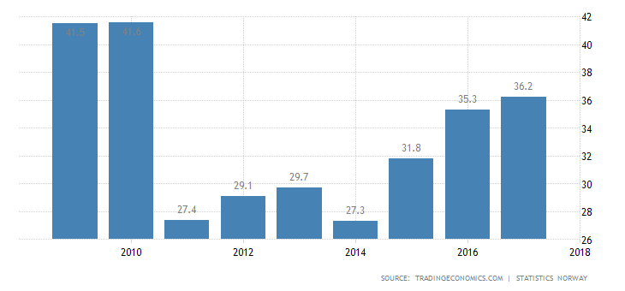
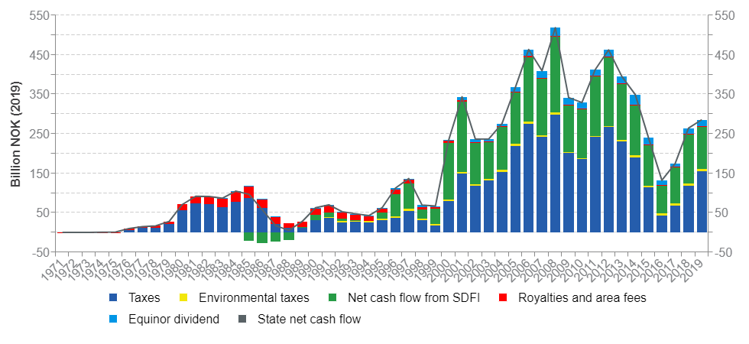
8. Source: https://www.norskpetroleum.no/en/economy/governments-revenues/

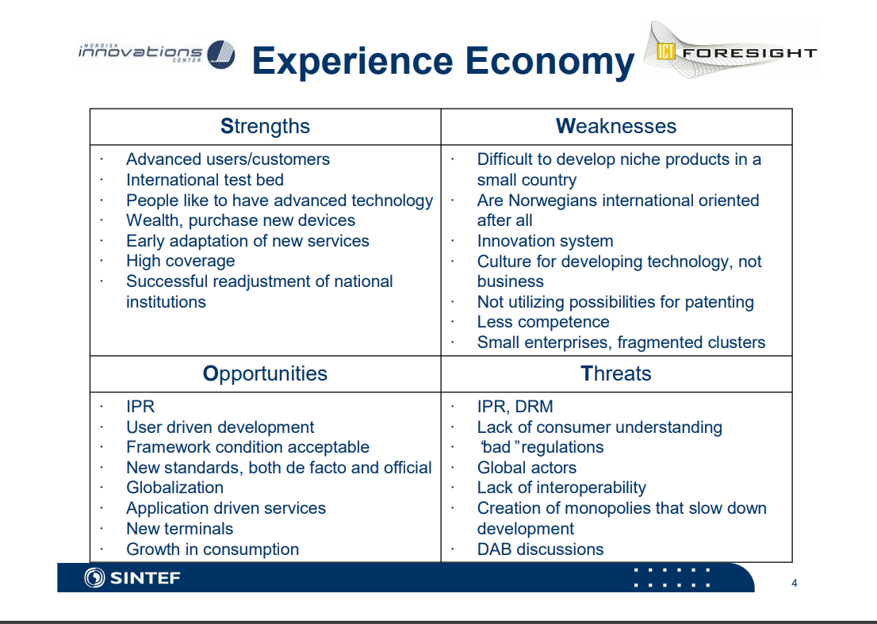
9. Source: http://nordic-ictfore.vtt.fi/materiaali/kristiansen_norwegian_swot.pdf
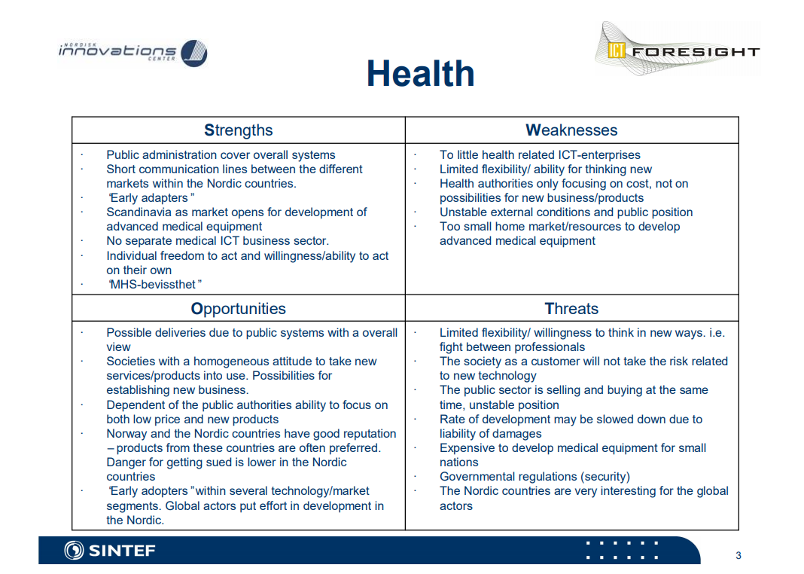

10. Source: http://nordic-ictfore.vtt.fi/materiaali/kristiansen_norwegian_swot.pdf
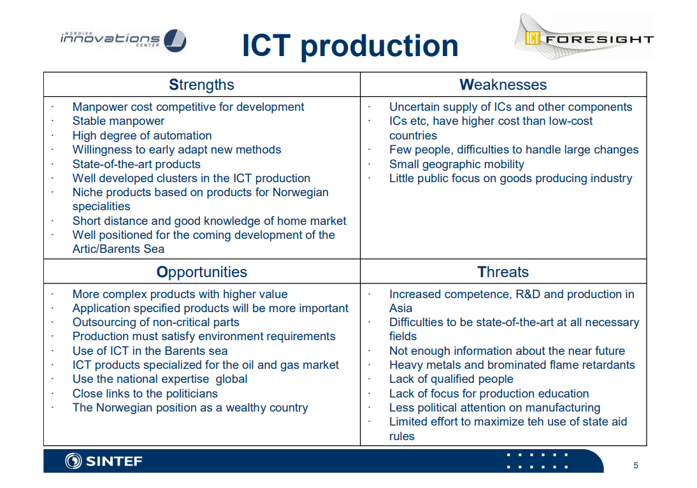
11. Source: http://nordic-ictfore.vtt.fi/materiaali/kristiansen_norwegian_swot.pdf

