Manufacturing processes and defects

ACAM4000

Megan Cain
2518443
04.02.2026

Abstract
This report reviews the manufacturing processes related to three objects made of different materials. The analysis, covers the comparison of manufacturing methods, material selection and product quality and highlights the importance of material selection for an improved product.

Contents
Abstract 1
Introduction 2
Research and discussion 2
Material 1 2
Material 2 3
Material 3 4
Manufacturing methods comparison 5
Material 1 5
Material 2 6
Material 3 6
Comparison 7
Mechanical and Thermal Properties Comparison 7
Material 1 7
Material 2 8
Material 3 9
Lifespan and Cost Analysis 10
Material Selection and Alternative Choices 13
Material 1 13
Material 2 13
Material 3 14
Conclusion 14
References 14

Introduction

This study is focused on three items of different materials and their manufacturing processes. Beginning, with a stainless-steel fork. Secondly, a thermoplastic straw, and finally, a ceramic mug.

Research and discussion

This report examines three everyday objects made from different materials. Each object is investigated in terms of material properties, manufacturing processes and demonstrates how different materials affect suitability, cost and production efficiency

Material 1

Fork
A utensil used for eating, a simple everyday item, with-an immense global market. Its material, Stainless steel offers excellent mechanical properties. A hard, durable and tough material that provides strong corrosion protection. All desirable qualities for a fork. (John, 2024)
The British Stainless-Steel Association says “Stainless steel is 100% recyclable and its long-term life makes it an ideal environmental performer” (BSSA, 2026)
Applications of stainless-steel:
- Architecture
- Food industry
- Medical field
- Household

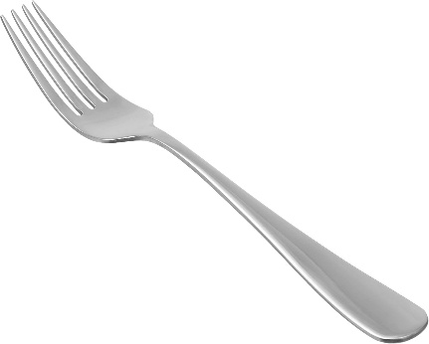

Material 2

Straw
A thin hollow tube used for drinking. BBC news claims “We use 8.5 billion plastic straws a year in the UK” (News, 2018) Made from a thermoplastic called polypropylene. This material is highly versatile and possesses favourable properties including flexibility, light weight, durability, chemical resistance, and relatively high thermal resistance. However, while polypropylene is recyclable, it is onetime use and many straws still end up in landfill and oceans. Due to it being a non-biodegradable material it presents a negative environmental impact. (Iere, 2025)

Applications of thermoplastics (polypropylene):
- Packaging
- Automotive
- Medical
- Textiles

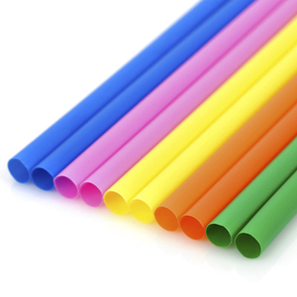

Material 3

Mug
A drinking vessel, an everyday object used on a large scale globally. Made from ceramic, the properties supply a hard wearing, strong and heat/corrosion resistant product. (Works, 2017) On the other hand, raw material extraction and energy consumptions and emissions contribute to the industries ecological footprint. But, using recycled waste instead of raw materials can help toward this factor. (Lee, 2025)

Applications of ceramics include:
- Glasses
- Refractories
- Construction

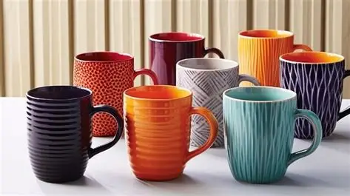

Manufacturing methods comparison

Most manufacturing methods use a mold to form the desired product. For example, to produce a fork here are the common processes used

Material 1

Manufacturing of stainless-steel forks
- Forging molds – Used in the original forming of the cutlery. The stainless steel is heated then shaped in the mold through compressive forces resulting in the basic shape of the desired product.
- Stamping molds - After forging, stamping molds are applied to refine the shape of the product. These molds are engineered to endure high forces and repeated use. This process is favoured for its uniformity, precision and quality in the final product. (Wu, 2025)

Each type of mold is crafted from high-grade materials capable of withstanding high temperatures and pressures, ensuring durability and precision.
Raw material
Heating

Stamping
Forging

Material 2

Manufacturing of plastic straws
- Raw material preparation- Plastic pellets are heated until a viscous liquid is formed
- Extrusion- The melted plastic is forced through a specialised die at high pressure, forming it into a long tube
- Cooling- The extruded straw is rapidly cooled to solidify its form
- Cutting- The long tube now can be cut into its preferred lengths.
(INNOMEC, 2023)
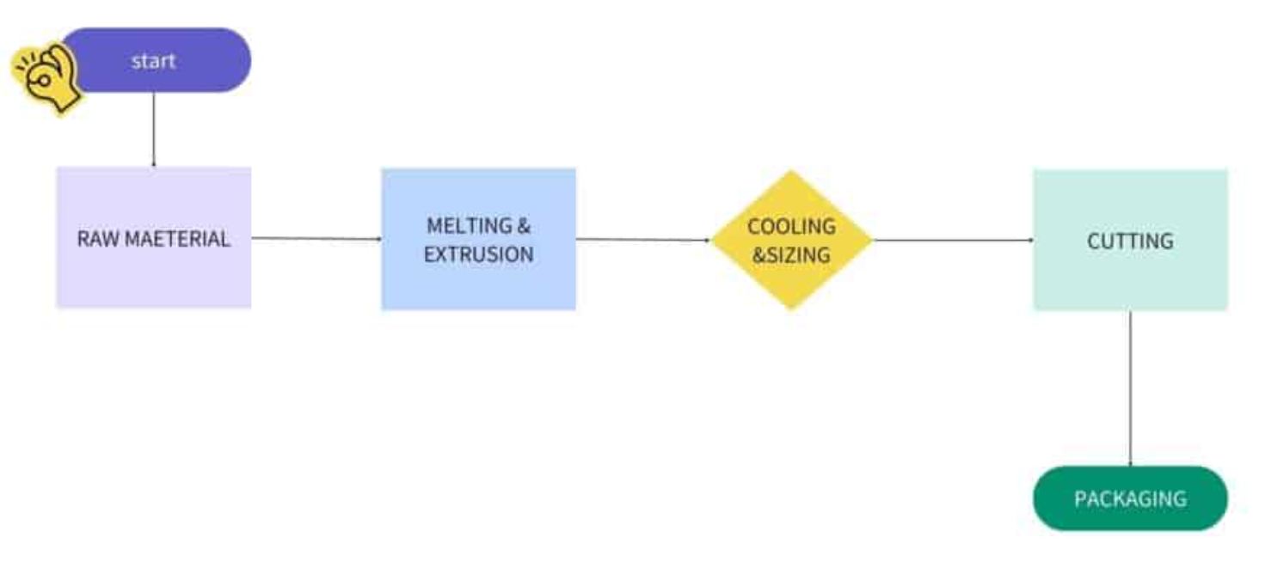

Material 3

Manufacturing of Ceramic mugs
- Clay preparation- Ensure the clay mixture is correct, a suitable consistency and void-free is critical for the mug’s integrity and durability
- Molding- The clay mixture is injected into mold and hydraulically pressed to form the mug shape
- Drying- Excess moisture must be removed from the mug to avoid cracking during the firing process
- Glazing- Once dry the mug is coated to provide a smooth and waterproof surface
- Firing- Fired in a high-temperature kiln this transforms the clay into a dense body providing strength and hardness (Mugmee, 2025)

Comparison

Forging is a process that uses heat and high-pressure to create components, it delivers high strength durable objects with refined grain structures. (Fractory, 2025). Alternatively, extrusion uses a die to create a continuous uniformed shape. Unlike forging, extrusion is best used for simplistic shapes with consistent cross-sections (Plastikcity, 2024). Injection moulding, similar to forging can create complex shapes with high surface quality. All three manufacturing processes support high-volume production. (ScienceDirect, n.d.)

Mechanical and Thermal Properties Comparison

Material 1

Stainless-steel offers excellent properties that make it suitable for forming a fork these include:
- Durability
- Corrosion and rust resistance
- Hygienic and easy to clean
- Attractive finish
- Cost effective and eco friendly
(Liam, 2024)
In comparison other materials do not offer these desired purposes. Silver, for example requires more maintenance to avoid tarnishing and is less cost effective. Furthermore, titanium is brittle in comparison to stainless-steel and more expensive to source.

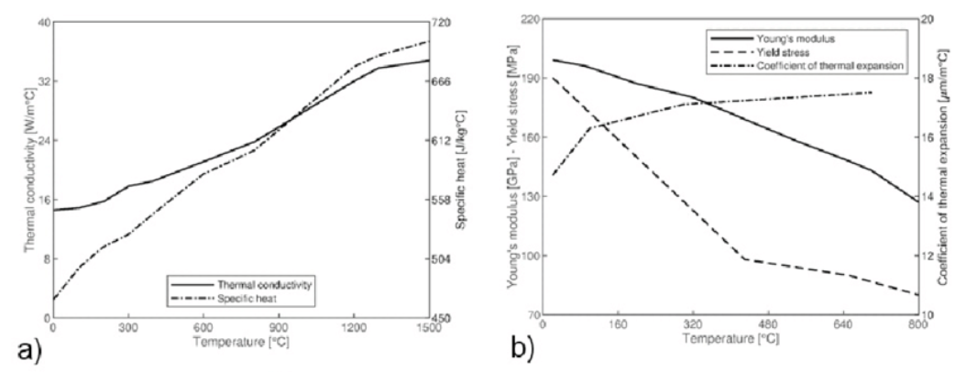
(Luca, 2019)

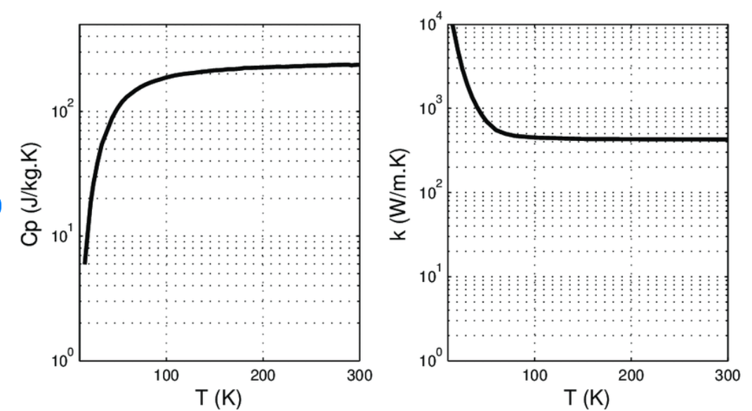

(Roy, 2010)

Material 2

Plastic (polypropylene) straws provide many desirable properties:
- Durability
- Easy to form/mass produced
- Cost effective
- Malleability
However, even though recyclable, plastic straws have proven to be detrimental to the environment. In comparison different materials provide unique advantages and disadvantages. For example, a paper straw is biodegradable, therefore has a strengthened environmental impact. However, less robust. Moreover, metal straws supply durability and sustainability is reusable and recyclable yet less cost effective. Metal also is a conductor which can prove a disadvantage for suitability in hot beverages.
(Caldwell, 2025)

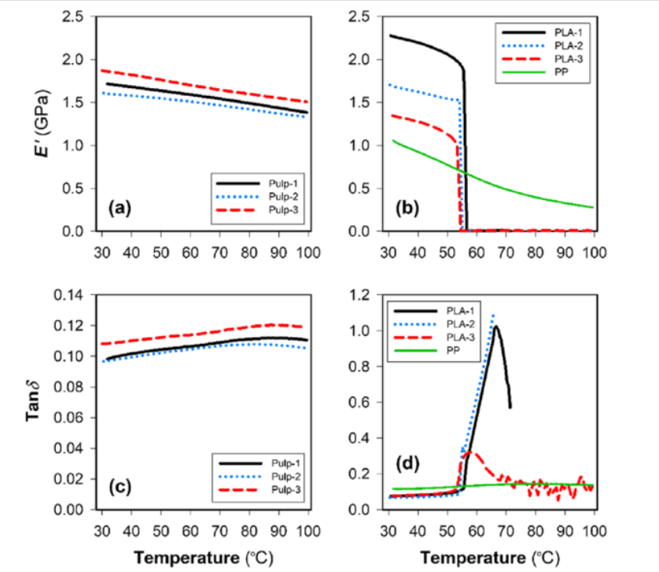
(Liang, 2023)

Material 3

Ceramic is beneficial for use in mugs with its properties being:
- Thermal conductivity
- Strength
- Hardness
- Non-porous/hygienic
(Washington, n.d.)

Nevertheless, ceramic is brittle. In comparison, mugs can be made from stainless steel which is more durable, tough and has a higher insulating capability. Ideal for a travel mug but is more expensive. In addition, plastic mugs are lightweight and cost effective. However, plastic is less durable and has a lower heat resistance in relation to ceramic/stainless steel. Plastic can become discoloured and cracked over time.
(Ismar, 2023)
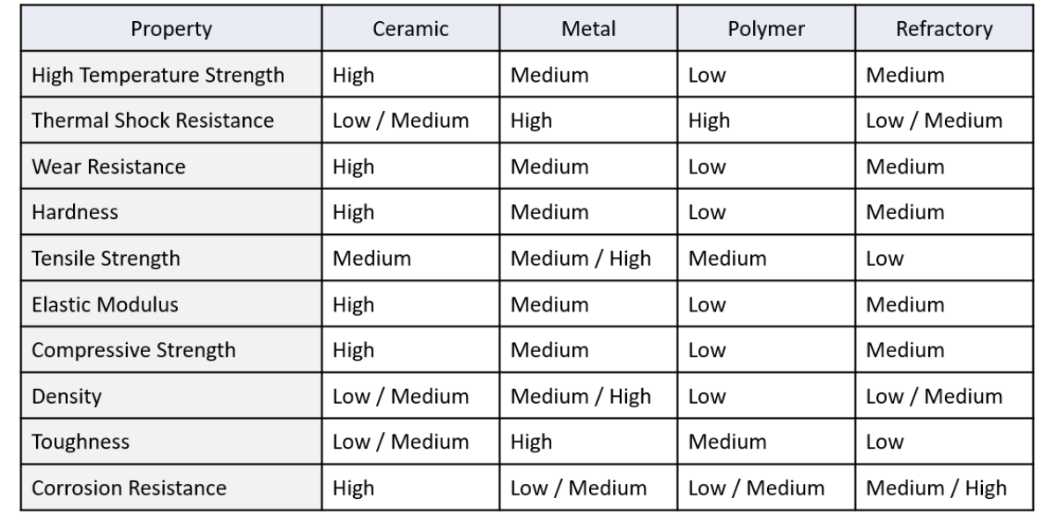
(Denton, 2019)

Lifespan and Cost Analysis

Stainless steel forks demonstrate to be longer lasting compared to silver-plated forks. As the silver is only plated its surface begins to erode with continued use eventually uncovering its vulnerable base metal and accelerating degradation.
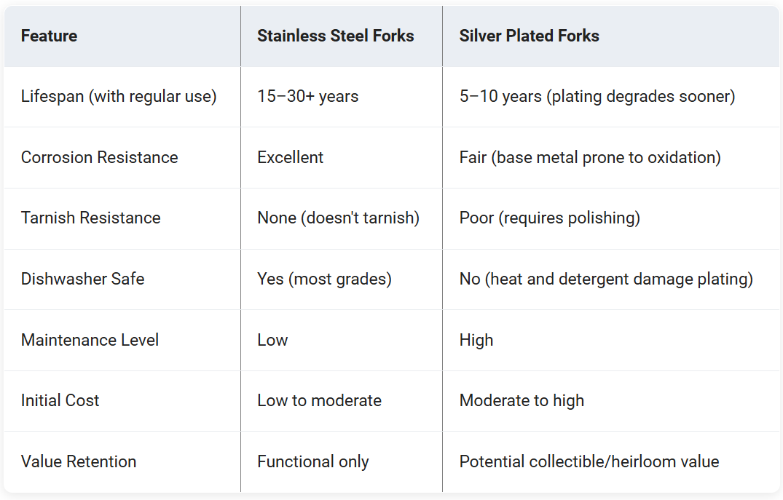
(Cole, 2026)
While titanium has an improved strength to weight ratio and has excellent resistance against fatigue. It is more costly and less impact resistant. All materials are recyclable.
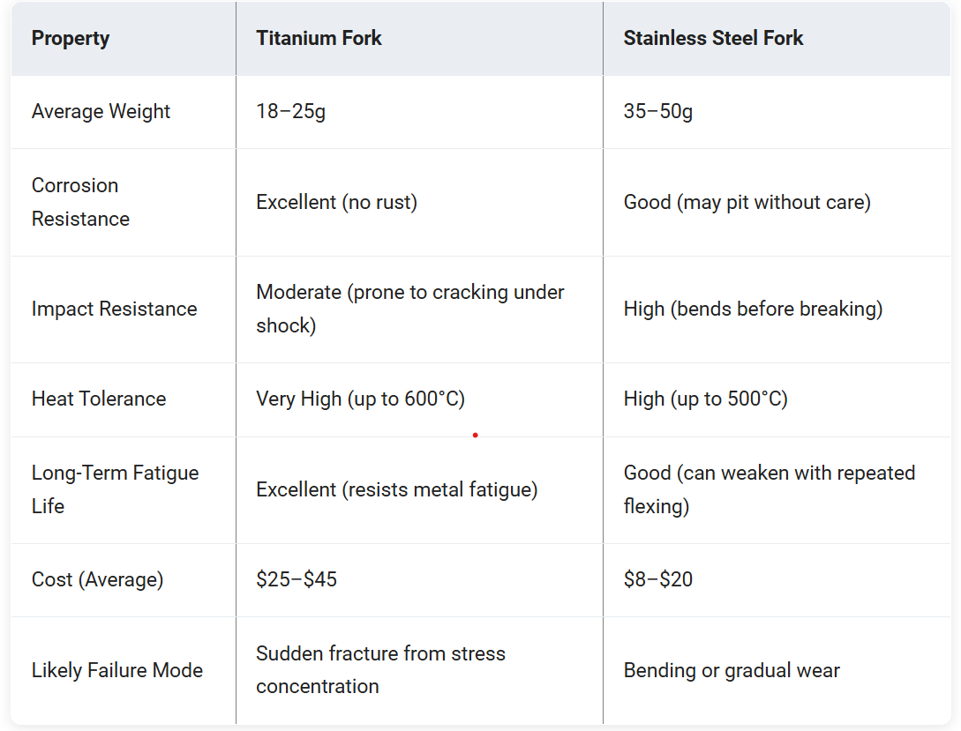
(Cole, 2026)
Plastic and stainless steel provide a long-life span. Whereas, paper is very short. Plastic Is the cheapest to manufacture and mass produce but has the greatest environmental impact.
Plastic straws are usually not recyclable due to their small size and take a long time to degrade.
Paper straws are biodegradable and are a one-time use.
Stainless steel straws are recyclable and reusable.

- Ceramic mug- 1-5 years. Moderate cost
- Stainless steel mug- 1-10 years. High cost
- Plastic mug- 6 months-1year. Low cost
Ceramic mugs can experience change and degradation over their lifespan this could be as staining, chipping or cracking. Without, regular maintenance and cleaning stainless steel mugs can encounter stains, odours and corrosion. With exposure, plastic mugs can undergo discolouration and cracking. All materials are recyclable but ceramic can be difficult to dispose of.
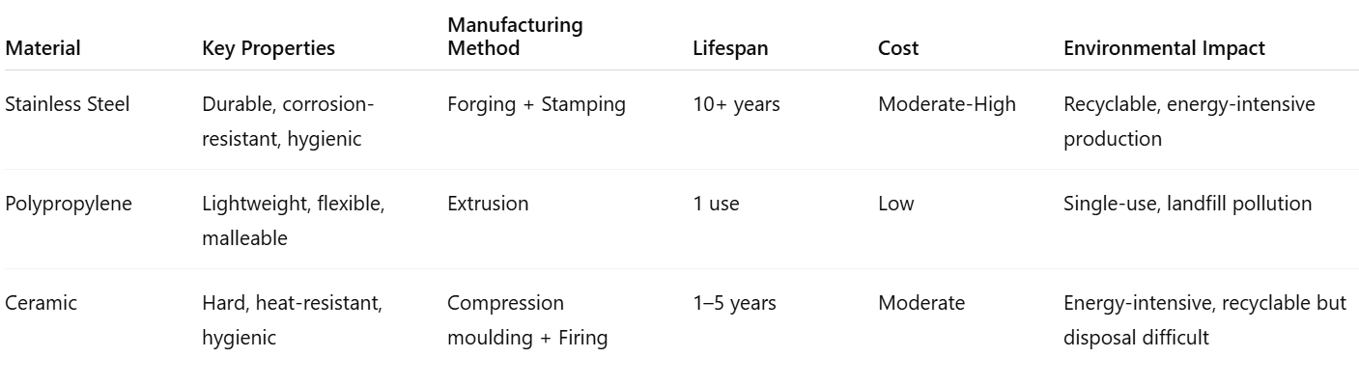

Material Selection and Alternative Choices

Material 1
Stainless steel is widely used because of its high strength, durability, and corrosion resistance. Manufacturing it through forging moulds improves mechanical properties by refining the grain structure and producing strong, reliable components. This makes the process well suited. However, forging stainless steel requires high temperatures and forces, which increases energy consumption and causes faster mould wear.
Overall, forging stainless steel is an effective but resource demanding process. Improvements in mould materials and process control in forging could help reduce costs and increase efficiency.
- A preferred material could be an aluminium alloy manufactured by die casting or stamping this process could be a practical alternative to stainless steel, especially where lightweight and cost efficiency are priorities.

Material 2
Plastic straws are lightweight, and low-cost. Extrusion is an efficient and suitable manufacturing process because it produces long, hollow shapes with consistent dimensions and minimal waste. However, extruded plastic straws contribute to environmental pollution due to their single-use nature. The process also limits design variation.
Overall, extrusion is an effective method for plastic straws, but using biodegradable materials or reusable designs would improve sustainability and performance.
- A preferred material could be, paper a sustainable alternative, especially for disposable use.

Material 3
A ceramic mug made by compression moulding is consistent, smooth, and material-efficient, making it ideal for mass production. Its drawbacks include potential cracking in thicker areas and a limited fine detail. The process is fast and reproducible. But molds wear over time and air traps can cause defects. Improvements could include better mold design and finishing touches to enhance the mug’s appearance.
- A durable alternative to ceramic is stainless steel, which resists cracking and chipping. Stainless steel mugs are best made using deep drawing, which shapes metal sheets into uniform, strong mugs suitable for mass production.

Conclusion

In conclusion, this report has highlighted how material selection and manufacturing methods directly influence a products durability and efficiency. While understanding, cost implications and defects that can be facilitated depending on the chosen process. Overall, material and method are both fundamental for optimal manufacturing results.

References

BSSA, 2026. BSSA. [Online]
Available at: https://bssa.org.uk/bssa_articles/environmental-aspects-of-stainless-steel/
[Accessed 01 January 2026].
Caldwell, E., 2025. The Flavour Experts. [Online]
Available at: https://theflavorexperts.com/what-material-are-metal-straws-made-of/
[Accessed 25 January 2026].
Cole, N., 2026. Alibaba. [Online]
Available at: https://www.alibaba.com/product-insights/stainless-steel-vs-silver-plated-forks-which-one-actually-lasts-longer.html
[Accessed 2 February 2026].
Cole, N., 2026. Alibaba. [Online]
Available at: https://www.alibaba.com/product-insights/are-titanium-forks-really-worth-the-extra-money-compared-to-stainless-steel-what-breaks-first.html
[Accessed 2 February 2026].
Denton, I., 2019. International Syalons. [Online]
Available at: https://www.syalons.com/2019/10/29/guide-to-technical-ceramics/
[Accessed 25 January 2026].
Fractory, 2025. [Online]
Available at: https://fractory.com/forging-process-explained/
Iere, 2025. Iere. [Online]
Available at: https://iere.org/why-are-plastic-straws-bad-for-the-environment/#H3_FAQ_12_What_organizations_are_working_to_address_plastic_pollution
[Accessed 05 Jauary 2026].
INNOMEC, 2023. Flex Machine. [Online]
Available at: https://flexstrawmachine.com/plastic-straw-manufacturing-process-explained-key-equipment-and-steps/
[Accessed 20 January 2026].
Ismar, 2023. Coffee Mug Collection. [Online]
Available at: https://coffeemugcollection.com/12-best-materials-for-coffee-mug-and-7-worst/
[Accessed 25 January 2026].
John, 2024. SteelPro Group. [Online]
Available at: https://steelprogroup.com/stainless-steel/properties/
[Accessed 01 January 2026].
Lee, S., 2025. Number Analytics. [Online]
Available at: https://www.numberanalytics.com/blog/ceramic-environmental-impact
[Accessed 05 January 2026].
Liam, 2024. Nice Flat Ware. [Online]
Available at: https://www.niceflatware.com/why-stainless-steel-is-ideal-for-cutlery-5-reasons-explained/
[Accessed 15 January 2026].
Liang, Y., 2023. Research Gate. [Online]
Available at: https://www.researchgate.net/figure/Dynamic-mechanical-properties-of-straw-samples-Storage-modulus-E-as-a-function-of_fig3_372696604
[Accessed 25 January 2026].
Luca, A. D., 2019. Research Gate. [Online]
Available at: https://www.researchgate.net/figure/AISI-304-stainless-steel-material-properties-a-thermal-properties-b-mechanical_fig2_339480011
[Accessed 25 January 2026].
Mugmee, 2025. Mugmee. [Online]
Available at: https://www.mugmee.com/how-ceramic-mugs-are-made/
[Accessed 20 January 2026].
News, B., 2018. BBC News. [Online]
Available at: https://www.bbc.co.uk/news/science-environment-43825197
[Accessed 5 January 2026].
Plastikcity, 2024. Plastikcity. [Online]
Available at: https://www.plastikcity.co.uk/blog/what-is-plastic-extrusion/#aioseo-the-plastic-extrusion-process
Roy, F., 2010. Research Gate. [Online]
Available at: https://www.researchgate.net/figure/Figure-A-2-Specific-heat-and-thermal-conductivity-of-silver-as-a-function-of-temperature_fig29_43128970
[Accessed 25 January 2026].
ScienceDirect, n.d. ScienceDirect. [Online]
Available at: https://www.sciencedirect.com/topics/engineering/ceramic-injection-moulding
Washington, n.d. [Online]
Available at: https://courses.washington.edu/mse170/powerpoint/Adjorlolo/Chapter_12%20Ceramics.pdf
Works, H. E., 2017. How Enginering Works. [Online]
Available at: https://www.howengineeringworks.com/questions/what-are-the-advantages-and-disadvantages-of-ceramics/
[Accessed 05 January 2026].
Wu, M., 2025. JEC. [Online]
Available at: https://jeccutlery.com/the-role-of-molds-in-stainless-steel-cutlery-production-line/
[Accessed 20 January 2026].

