Interpretative Phenomenological Analysis Write-up
The three super-ordinate themes found in this study are displayed in Table 1. The themes emerged whilst undertaking interpretative phenomenological analysis of one interview transcript which explored the lived experience of caring, coping and well-being. The pseudonym Jasmine was given to the participant to anonymise and protect her identity. Due to the limitations of this essay, only the first two themes will be discussed. The researcher recognises that their own biases may have affected the findings in this study. It must also be noted that the relationship between Jasmine and the researcher may have influenced the answers given.
Table 1
Master Table of Super-Ordinate Themes and Themes.
Emergent themes | Page/line | Key words
1. Caring for others
- Identifies as a carer for dad | 2.2 | look after my Dad
- Breakdown due to stress from caring for parents | 2.23 | Breakdown through stress
- Caring for self to care for others | 3.16 | If you don’t look after the carer
2. Caring for own well-being
- Aware of importance of caring for own well-being | 3.17 | I finally realised
- Gained knowledge from training courses | 3.3 | Bring it forth that I had to
- Coping strategies | 4.4 | I have to keep an established routine
3. Lack of confidence in personal views and opinions
- Hesitates when answering questions | 2.9 | Um, I think in my opinion
- Questioning her answer when explaining | 5.10 | Does that make sense?
- Looking to interviewer for guidance | 2.16 | Um, three?
- Changing between 1st and 2nd person pronouns | 4.11 | So you go and enjoy your walk

Caring for Others
The super-ordinate theme ‘caring for others’ is clear throughout, it initially presents itself at the beginning of the transcript when Jasmine identifies as her father’s carer in the statement, “help to care for look after my Dad as well, with my mum” (2.2). This role has implications for Jasmine’s well-being, as she later disclosed “I had a bit of a breakdown through stress of looking after both my parents” (2. 23). Despite the negative effect caring for others has had on Jasmine’s well-being, she appears to feel it is necessary and is happy to help. Jasmine does not attach any negative connotations to caring for others and she values the well-being of others highly. This is evident in her attitude on society’s well-being that “everyone should be kind to each other” (8.18).
Jasmine lets her role as a carer take priority in her life, to the extent of it being the reason she now looks after her own well-being. This is observed in the interview when Jasmine justifies looking after herself by saying, “once the carer falls, who is going to look after the other people?” (3.16) and “if you don’t look after yourself how are you going to look after everyone else around you?” (3.24). She appears to use these notions as motivation to look after her own well-being, this might be to maintain the context of her narrative of identifying as a carer. Jasmine’s comments regarding caring for herself in order to care for others are frequent through the interview emphasising the importance of this perspective to her. Her use of different pronouns in these comments invite the researcher to consider that Jasmine may be reiterating quotes from her training courses. However, it may be easier for her to speak from another perspective to detach herself from the personal implications of looking after herself as she has struggled with this before. As demonstrated in this quote, “you end up looking after everyone else other than yourself” (3.15).
There are also cultural considerations when looking at Jasmine’s experiences, as she is a female and women tend to take on a nurturing role across society. Additionally, Jasmine’s role within her family is important as her parents rely on her for support as indicated by the reason for her breakdown. Thus, it is reasonable that Jasmine finds herself in a carer role. The main concern is that prior to her breakdown she was not looking after her own well-being as shown above.
Caring for own well-being
Jasmine understands that her definition of well-being has evolved. When defining well-being she said, “now as I’ve got older” (2.15), indicating a change due to age. Though, this can also be attributed to her breakdown and subsequent training courses as Jasmine acknowledged the impact by saying, “bring it forth that I had to actually look after myself” (3.3). Nonetheless, she hesitates and is incoherent when talking about her breakdown, “um… I’ll start again” (2.25), implying that she may not have reflected on the event and the impact of the event effectively. Even so, her views on her own well-being have changed. Since her breakdown she understands the importance of looking after her well-being. However, only in relation to caring for others, as she stated, “so I finally realised that the carer has to come first” (3.17).
The temporal change that Jasmine experienced created opportunity for her to develop her own well-being. With a new outlook on well-being, and additional educational knowledge through various courses attended, she understands that it is necessary for her to look after her well-being and has ideas of how to do so. For example, “I do practise the mindfulness mediation bit” (4.7), nevertheless, she still struggles to see every aspect of her well-being holistically. Jasmine does not associate depression and anxiety with her mental and emotional well-being as she refers to this as “the physical side” (2. 27) and states that it is treated through medication. From a holistic viewpoint she links having an “established routine” (4.4) and “walking her dogs” (4.6) with not needing medication anymore, but she uses the word “luckily” (4.6) and the phrase, “at the moment” (4.4), suggesting she does not trust herself to improve her well-being without medication.
It is interesting that she does not mention others supporting her. She reveals her husband in relation to where she lives when she says, “I live with my husband” (2. 1), with no further reference to him. This suggests that she does not view her husband as someone who influences her well-being, indicating that her well-being is something that she must address alone. Comments such as, “I can – not so much avert it – but try and go another way” (4.18) made during the interview reflect Jasmine’s need to be in control of her own well-being, furthermore, many of her coping strategies are independent activities such as, “walk around some woods” (4.13) or “exercise” (4.16). This supports the idea that she views her well-being as a personal battle, without the support of others. This may be due to Jasmine seeing herself a carer and not wanting to burden others with supporting her as she prioritises caring for others above caring for herself. Opposingly, social relations may not have been discussed due to the researcher’s questions and the context of the interview.
In summary the results suggest that Jasmine understands the need to prioritise her own well-being and she likes to be in control of this. Her motivation to improve her well-being lies in her wanting to support others. Jasmine understands her breakdown has had an impact on her view of well-being and has introduced successful coping strategies to her life. Jasmine has the foundations to care for her own well-being with the knowledge gained from her training courses, and consequently continue caring for others. She still needs time to reflect and develop her understanding of holistic well-being to build her confidence in improving her well-being and to overcome any related hesitations.

Appendix
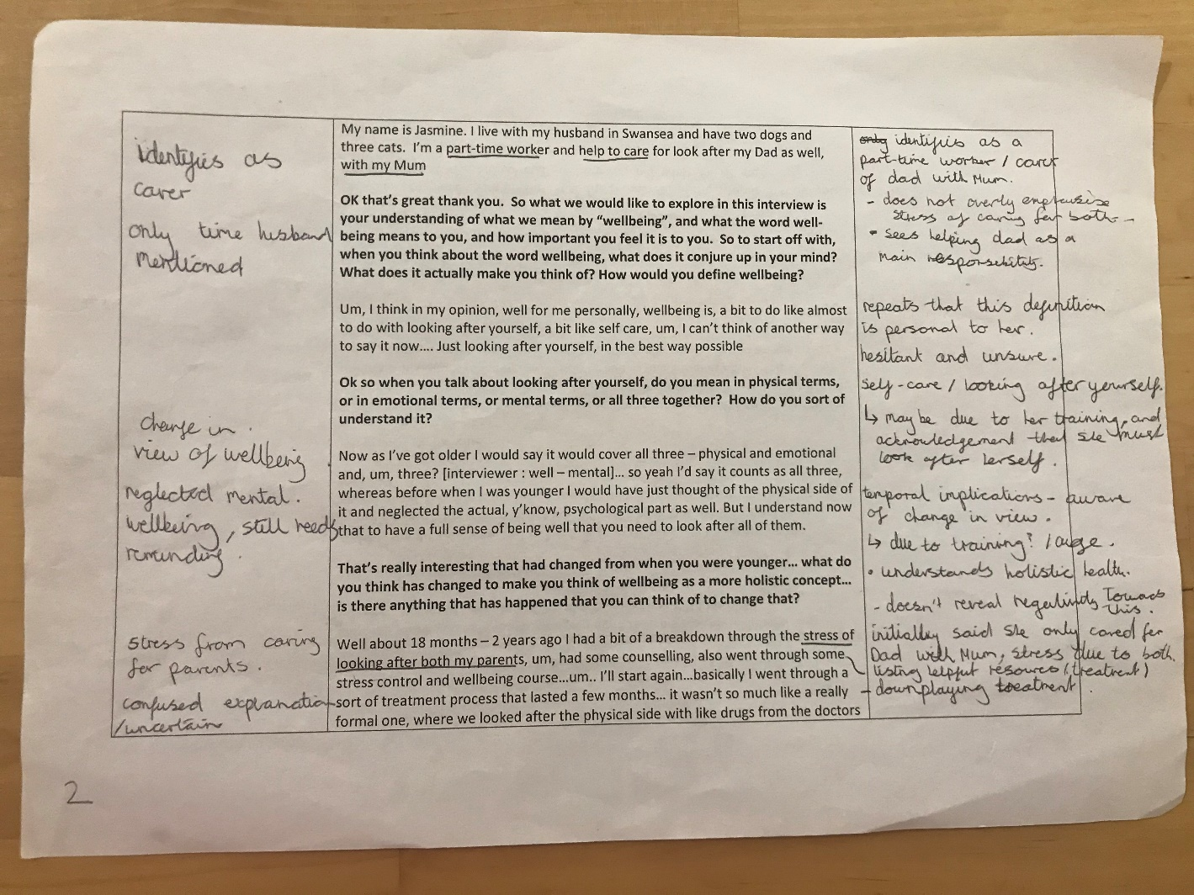
Step 2: initial noting and Step 3: developing emergent themes
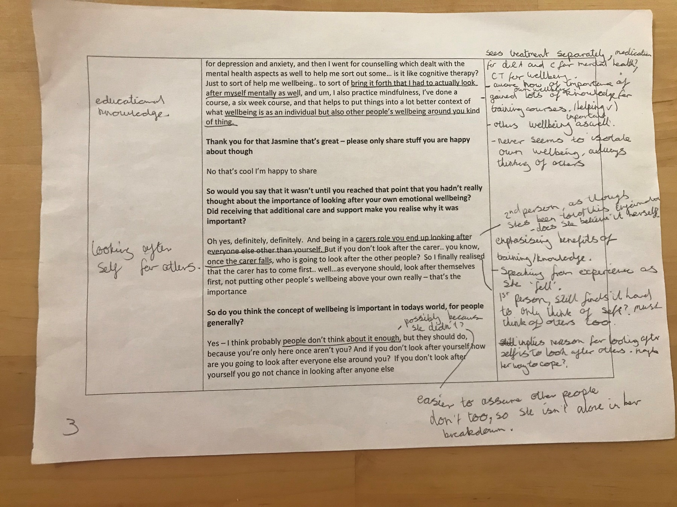
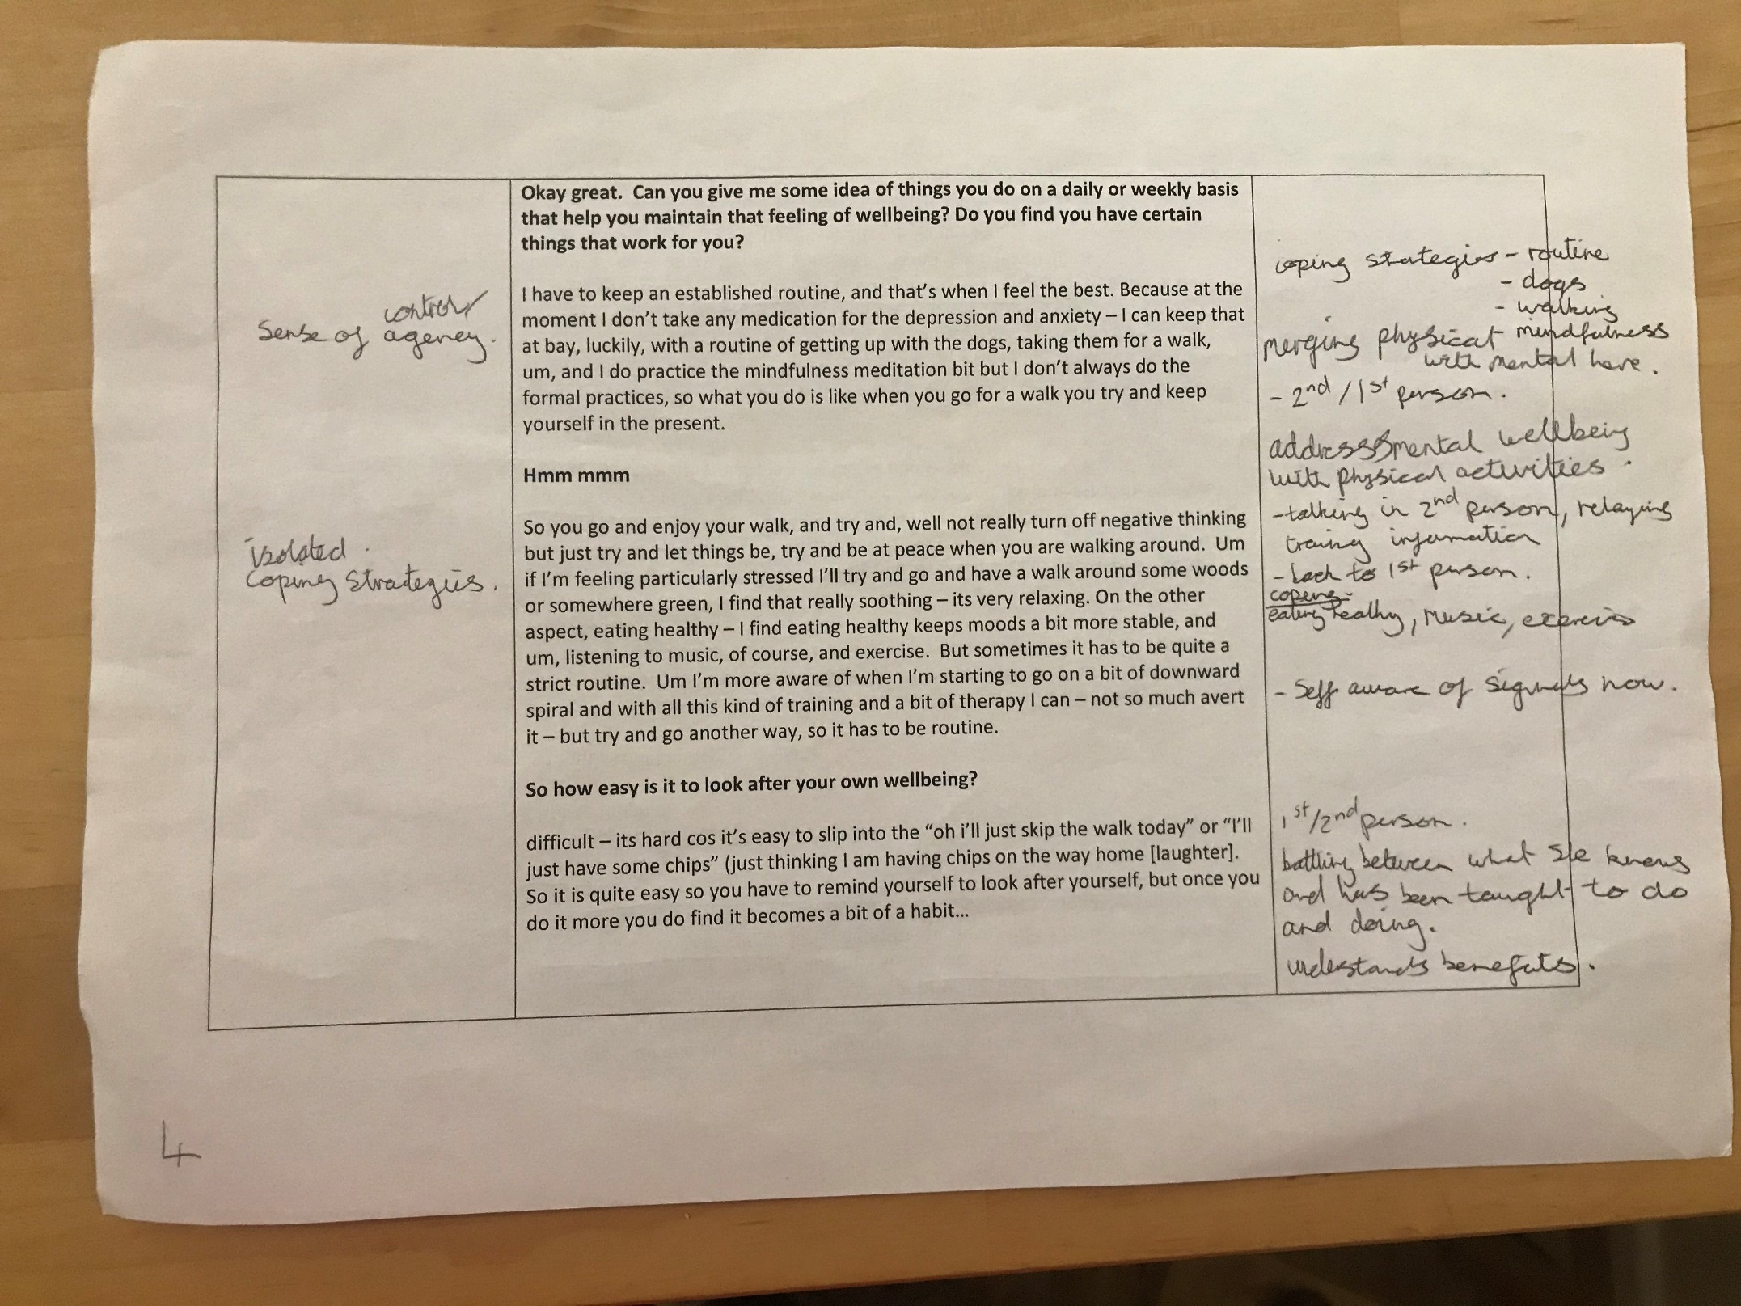
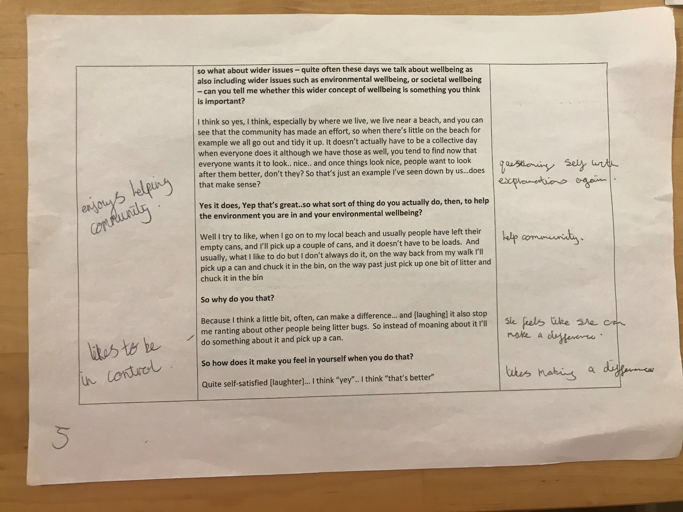

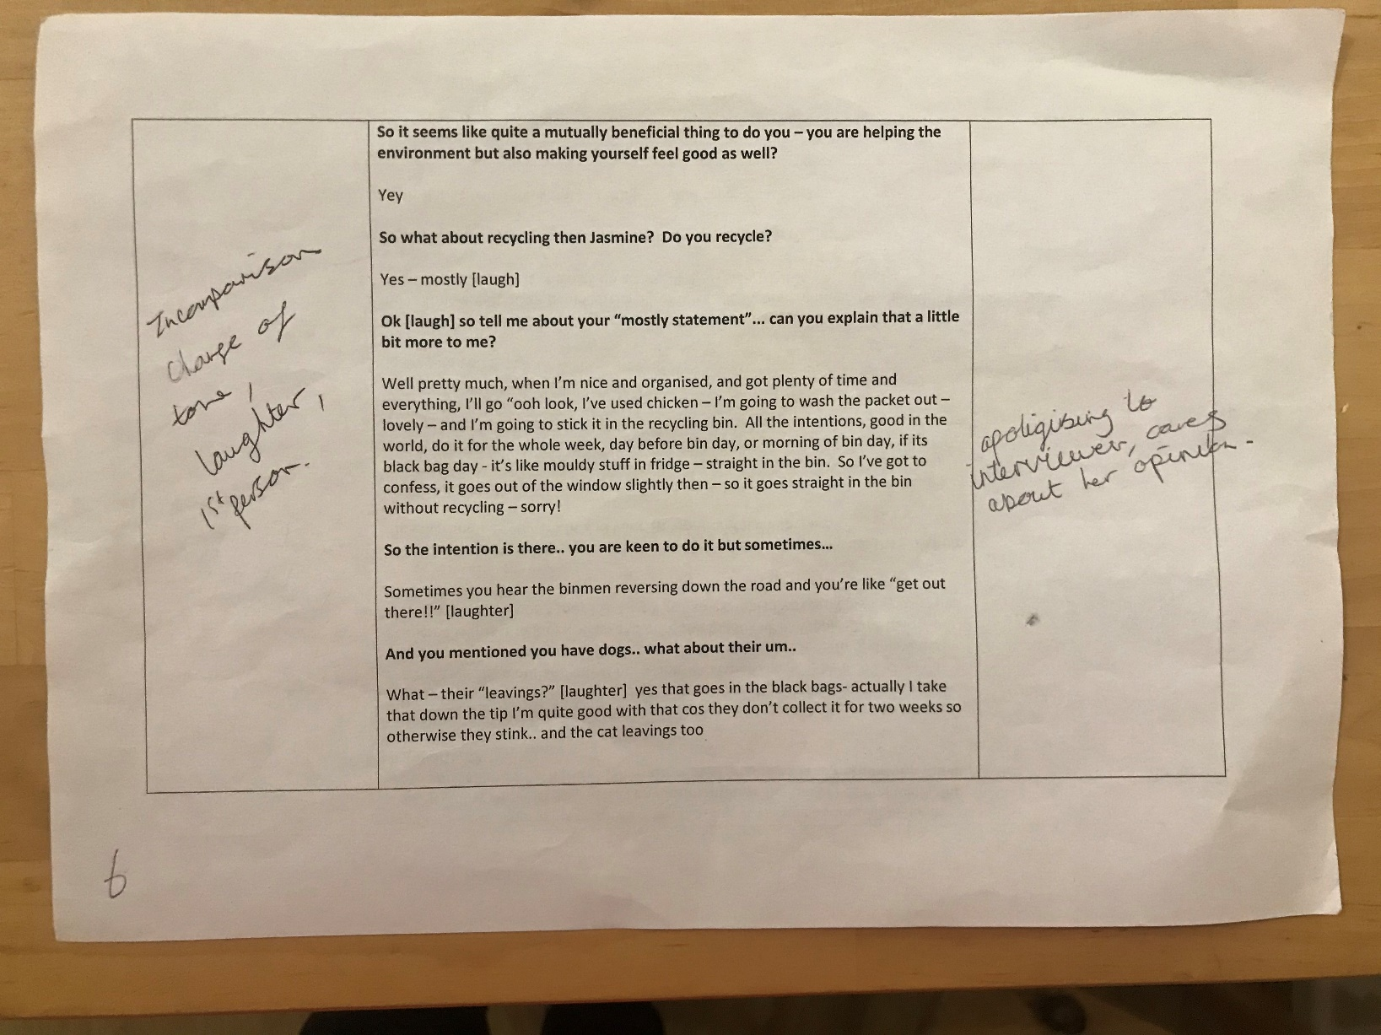
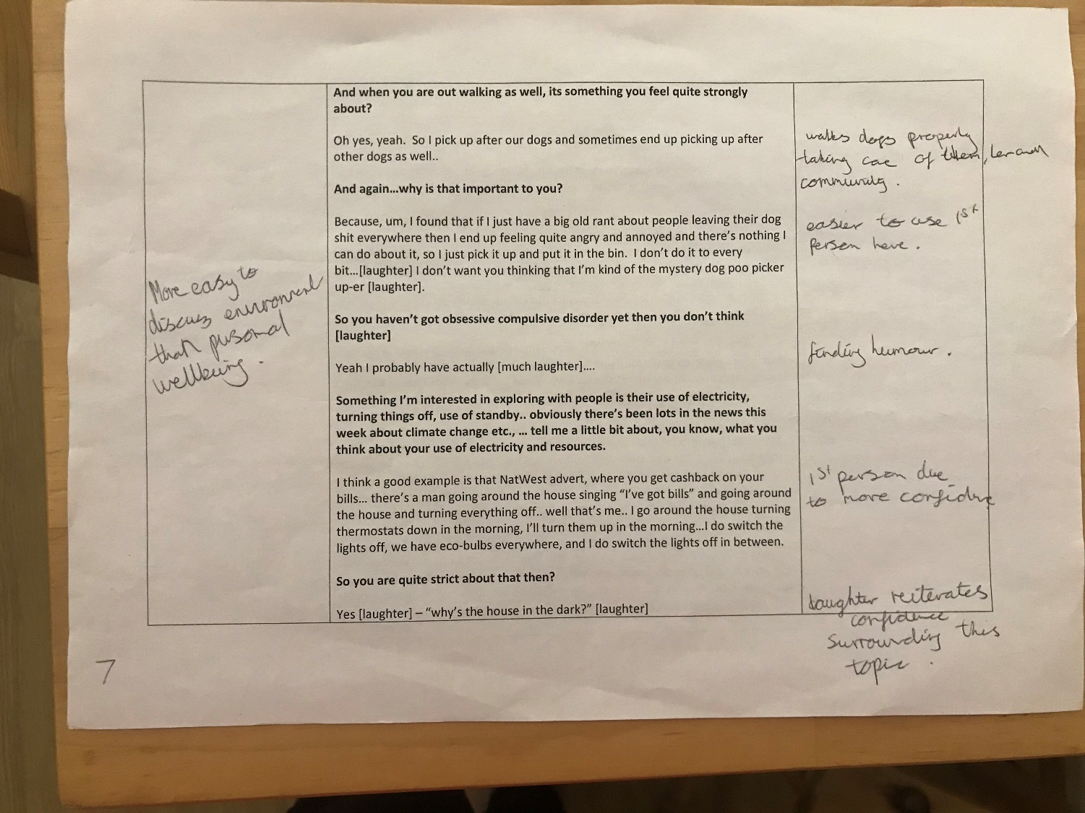

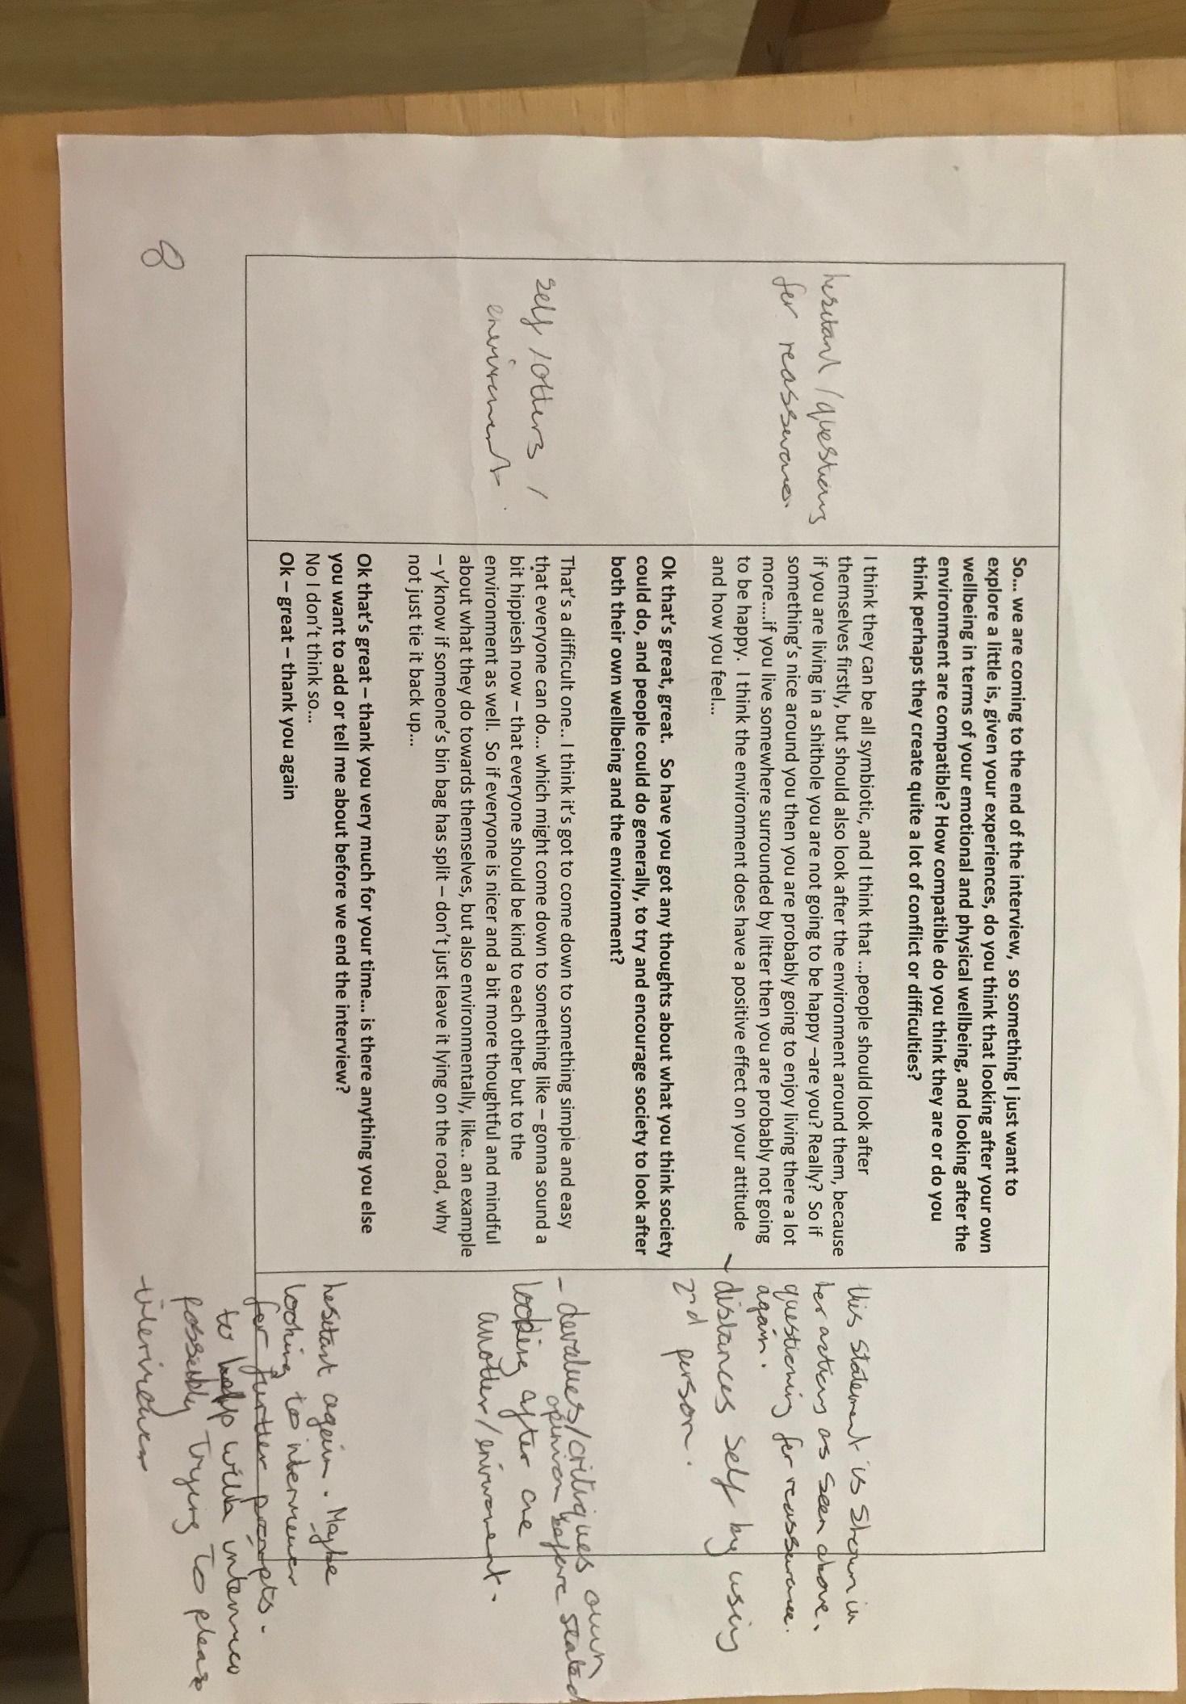
Step 4: searching for connections across emergent themes
Themes
Lacks confidence in own opinions
- Looks to interviewer for guidance
- Hesitates
- Specifies that it is her own opinion repeatedly
- Self-aware of signals now. Post training.
- Questioning self when explaining.
- Humour when talking about OCD
- Looks for reassurance many times.
- Finds it easier to use 1st person and be more confident with answers when discussing environment compared to when discussing own wellbeing.

Caring for her own wellbeing
- Change in view of what wellbeing is (due to age, breakdown, training)
- Uncertainty when discussing treatment following breakdown, possible that more reflection is needed.
- Does not appear to be negative about the treatment process following breakdown.
- Aware of importance of own wellbeing
- Gained knowledge from training course
- Routine, dogs, walking, mindfulness, eating healthily, music, exercise.
- Changes between 1st and 2nd person a lot.
- Battling with what she knows and has been taught to do and actually doing it.
- Understands benefits.
- Likes to be in control of this and possibly sees this as a personal battle without support from others.
- Finds it easier to address her mental wellbeing through physical activities.
- Could be implied that she likes tangible coping strategies, this may be why she has not reflected on the mental processes involved with her breakdown to be able to talk about it coherently straight away
- Does not seek help from others as her role is to care for others not have them help her.
- Laughter in 2nd half of interview when her personal wellbeing is not being discussed, no laughter in 1st part.

Sense of agency/ autonomy? (links to own well-being) – throughout.
- She feels like she can make a difference.
- Likes making a difference.
- Doesn’t look to others to support her until she had to due to breakdown.
- Coping strategies do not involve relying on others.
- Likes to improve community herself.

Social relations and support (links to coping with own wellbeing)
- After initially mentioning husband, no further mention of husband or anyone supporting her.
- Educational knowledge : sees treatment as separate for each aspect of wellbeing so does not fully understand wellbeing from a holistic point of view.

Caring for others
- Identifies as a carer for her dad.
- Stress from caring for parents.
- Does not seem to isolate own wellbeing, always thinking of others
- 2nd person “being in a carers role you end up looking after everyone else other than yourself… once the carer falls, who is going to look after the other people?” as though shes reiterating things taught on course as she follows this with.
- “so I finally realised that the carer has to come first” – jasmine appears to be trying her best to do this though it is not clear whether this is to help herself or others.
- Enjoys helping community
- Relationship with interviewer - Trying to please interviewer, apologises, laughs

