

Master of Business Administration
International Business Concepts-LCMB7034
Report
Student Name: Jeel Bhratbhai Anghan
Student ID: 2522449
Submission Date: 31/07/2026
Table of Contents
Section 1: International Market Entry Analysis 3
1. Introduction 3
2. Organisation and Global Approach 4
2.1 Company Overview 4
2.2 Bartlett and Ghoshal's International Strategy 4
2.3 Global Configuration and Competitive Advantage 6
3. Macro-Environmental Appraisal And Market Attractiveness 6
3.1 Introduction to the Indian Market 6
3.2 Political Environment 7
3.3 Economic Environment 8
3.4 Legal Environment 10
3.5 Cultural Environment 11
3.6 Industry and Market Attractiveness 13
3.7 Dunning's Eclectic (OLI) Paradigm 16
4. Entry Mode Strategy and Strategic Synthesis 18
4.1 Historical International Expansion Pattern 18
4.2 Evaluation of Alternative Entry Modes 19
4.3 Recommended Entry Mode for India 20
5. Conclusion and Recommendations 21
Section 2: Reflective Account 22
5.1 Introduction 22
5.2 Description 23
5.3 Feelings 23
5.4 Evaluation 24
5.5 Analysis 25
5.6 Conclusion 26
5.7 Action Plan 26
Reference list 27

Section 1: International Market Entry Analysis

1. Introduction
Five Guys is a privately owned American burger restaurant that has gained an international name for its high-quality buns, the use of fresh ingredients and the high service level given to the diners. In subsequent years, the company has also been primarily driven by the franchise method. Because the company is not intent on sacrificing quality or brand uniformity, it has entered foreign markets based on the franchising method, gaining a strong foothold in the international market. Sun (2022) argued that Five Guys has enhanced their mark from traditional quick-service restaurant (QSR) operators by sticking to a premium pricing tag that's powered by multiple premium attributes, including high product quality and streamlined operations, instead of diversifying the menu range. This approach has worked in developed countries, but has not been proven in other emerging countries, as consumer purchasing power as well as the culture and regulatory environment could differ significantly.
This report aims to provide a critical assessment regarding the possibility of Five Guys moving into India; the company has had minimal operational presence. The outstanding attraction of the country for investments is the significant middle-class population, urbanisation and demand for luxury food services. Prakash and Singhai (2024) pointed out that India's economic expansion and positive changes to the investment climate have made India more appealing to multinational corporations, while other scholars warn that numerous regulatory issues and the strong competition faced by companies, as well as a wide client preference, remain significant constraints on entry.

2. Organisation and Global Approach

2.1 Company Overview
Five Guys opened in Arlington, Virginia, in 1986 as a family-run burger joint but has grown to become one of the world's fastest-growing premium quick-service restaurant chains. It is a burger, hot dog, fries and milkshake-to-order business with a focus on the freshness of its ingredients and the simplicity of its operations. Sun (2022), Five Guys' competitive positioning is best driven by pricey quality compared to big international chains like McDonald's, Burger King and Wendy's. Five Guys now has stores throughout North America and Europe, the Middle East and Asia, mostly by way of master franchise agreements, and they haven't settled into India just yet.

2.2 Bartlett and Ghoshal's International Strategy
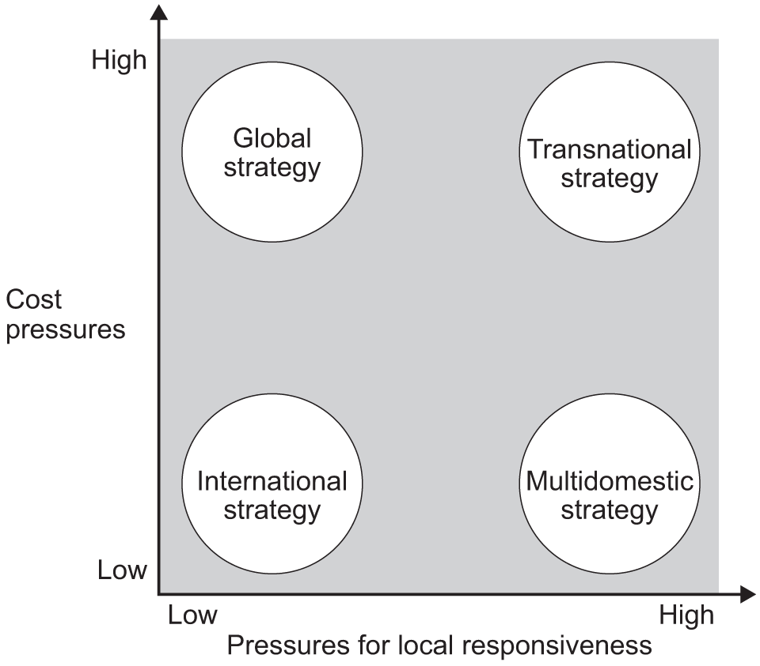
Figure 2.2: Bartlett and Ghoshal's International Strategy Matrix
(Source: Singhai, 2024)
Five Guys best fits the international strategy framework of Bartlett and Ghoshal as a transnational strategy. The company also drives for global efficiency through the same brand standards, supplier specifications and operating methods while ensuring there is adequate country responsiveness to meet country-specific consumer preferences. According to Li et al. (2024), companies which are implementing transnational strategies are making better use of different aspects of this strategic mix of global integration and cultural adaptation to attain better long-term competitiveness, especially in culturally diverse markets.

2.3 Global Configuration and Competitive Advantage
Five Guys' competitive advantage has emerged out of an operating model of integration across the world while at the same time being decentralised in a selected manner. Kayed et al. (2025) hold that institutionalisation through the franchisee business model highlights the possibility of firms expanding quickly via going international with minimal capital investment and gaining local market knowledge from their franchise partners. The method has enabled Five Guys to expand overseas without taking on the hefty risks and financial losses that come with having a 100% subsidiary company in another country.
The company's value chain is focused on sourcing high-quality ingredients, executing an optimised operation, proven quality management and its preferred customer experience, all of whom strengthens its premium brand appeal. Five Guys is not like many of its competitors in the global fast-food sector, which either run on price competition or create food chains based on substitutions. This differentiation has helped to build customer loyalty in developed markets.

3. Macro-Environmental Appraisal And Market Attractiveness

3.1 Introduction to the Indian Market
The growing population, increasing urbanisation and long-term positive economic outlook give India one of the most attractive markets for multinational companies. The fast food sector in the country has significantly grown due to changes in the lifestyle of the people, the rise in disposable income among them, and the higher convenience aspect for younger people to opt for quick-service restaurants (QSR) over conventional restaurants. Prakash and Singhai (2024) stated that the favourable investment environment and the growing middle class in India have created the opportunity for sustainable long-term growth for foreign food-service brands. Fortunately, although this has been a positive situation, the success of a market will depend on tackling the complex nature of regulation, cultural diversity and the competitive environment posed by international and domestic QSR operators. Therefore, the company must understand the political, economic, and legal context of India to decide on an apt market entry strategy for them.

3.2 Political Environment
Government Stability and Business Environment
In the last ten years, the current democratic wave in India, led by a stable democratic regime and pro-business reforms, has been strengthening the attraction of the country for foreign investors. The Ministry of Commerce and Industry (2024) has stated that the progress and development made in the Ease of Doing Business programmes, and in digital governance and infrastructure, have bolstered investor confidence in various areas including food services. Stable politics allows outside companies to make more long-term investments than in many emerging markets, with a relatively low institutional risk.
Foreign Direct Investment (FDI) and Trade Policies
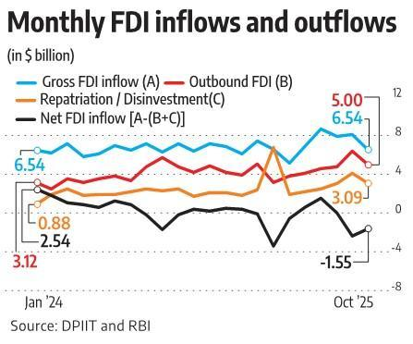
Figure 3.2: Monthly FDI Inflows and Outflows into India
(Source: Li et al., 2024)
Many food-service and food processing activities allow 100% Foreign Direct Investment (FDI) in the government's automatic route in India, promoting foreign chains by expanding their operations through wholly owned subsidiaries or going through the franchise model. The government's 'Make in India' and 'Digital India' campaigns have further enhanced India's investment potential with a push towards local procurement and technological advancements. The policies may prove useful for Five Guys to allow them to buy from nearby suppliers and cut down on having to use imported ingredients for their dishes.
Food Regulations, Taxation and Investment Incentives
The introduction of Goods and Services Tax (GST) in India has enabled the country to overcome the issues related to multiplicity of indirect taxes currently applied in various states, paving the way for greater efficiencies in business. The Food Safety and Standards Authority of India (FSSAI) (2024) regulations also set out clear standards around food quality and hygiene, which help build trust among consumers and ensure that there are proper standards of competition in the restaurant sector.

3.3 Economic Environment
Macroeconomic Performance
Despite intermittent fluctuations, India's growth rate in GDP has been positive, and its domestic demand is robust, while foreign investment is on the rise, maintaining its growth as one of the fastest-growing major economies. As stated by the International Monetary Fund (2025), India's economic fundamentals remain strong, with strong domestic demand conditions, making it a very attractive prospect for foreign Multinational Companies to invest in India. The positive macroeconomic outlook could offer great opportunities for premium restaurant brands that are looking to expand in the longer term.
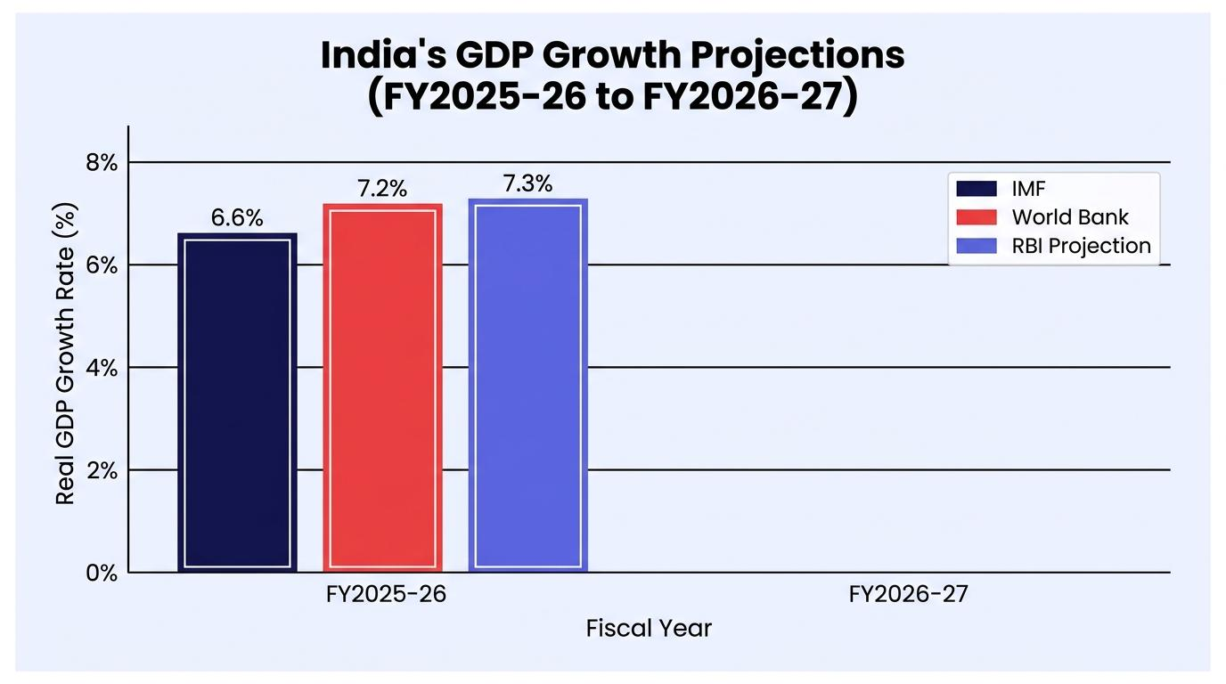
Figure 3.3: India’s GDP Growth Projection
(Source: International Monetary Fund, 2025)
Li et al. (2024), however, suggest that GDP growth is not enough to make international expansion a success; companies should also take into account differences in income in the target areas and the consumption power of the target consumers. Though some metros, including Mumbai, Delhi, and Bengaluru, have a high purchasing power, there exists nationwide income inequality which may restrain Five Guys in cities other than metros.
Consumer Income, Urbanisation and Middle-Class Growth
In a rapidly urbanising and growing middle-consumer society, a lot has changed in terms of consumer spending habits and preferences. International brands and convenient food-service experiences are becoming increasingly in demand, as are premium dining experiences by a growing number of young professionals. This demographic change correlates closely to Five Guys' high-end nature.
Inflation, Exchange Rates and QSR Market Growth
Continuous inflation and exchange-rate fluctuations are other potential dangers for foreign restaurants. However, volatile food commodity prices and exchange rates could result in higher costs of importing, as well as lower margins and challenging pricing decisions. However, the QSR segment remains healthy in India with the help of digital food platforms, rising female participation and evolving food habits among the people.
According to research firm Research and Markets (2023), it is estimated that international premium restaurant brands will continue to see strong demand across India in the long term, as the QSR industry is projected to grow at a compound annual rate of 14.2% in the coming years, reaching $3.63 billion by 2023. India's economy is robust, contributing to a large consumer market, and, even though it faces short-term strains due to inflation, the prospects for further expansion for Five Guys are positive with effective pricing strategies and local food sources.

3.4 Legal Environment
Compliance and Safety for food
The Food Safety and Standards Authority of India (FSSAI) regulates the legal framework in India for food businesses with a view to bringing out complete standards for food quality, hygiene aspects, packaging and labelling. As per FSSAI (2024), conforming to these regulations improves consumer protection and provides uniformity amongst the food-service operators.
Strict food safety regulations provide some protection to the public and still raise food safety costs because of compliance requirements, including mandatory inspection, staff training and food safety systems. If Five Guys uses the same rigorous quality testing as it does in the U.S. they would need to invest in supplier auditing and operational monitoring to ensure quality is recognised on a global level.
Labour Laws and Franchising
India has adopted several new Labour Codes, modernising the existing labour laws and making them easier to understand, which also provides more protection to the workers. They are reforms that benefit multinational employers by providing clarity and promoting formalisation of the labour force. Moreover, notwithstanding the lack of a specific franchise law, franchising is a much preferred method of expansion and provides flexibility for franchise relations between franchisor and local partner.
But experts say that the lack of specific franchise laws could cause a legal grey zone for the ways disputes are resolved, contracts enforced, or intellectual property rights claims dealt with. This means that Five Guys would have to have well-constructed franchise contracts with trained and experienced legal counsel.
Intellectual Property and Environmental Regulations
The trademarks, patents and copyrights are legally protected in India, which may allow multinational companies to protect their brands and business assets. Five Guys' brand reputation is an asset for them, and the importance of strong trademark protection is especially important in their market.

3.5 Cultural Environment
Hofstede's Cultural Dimensions
One of the major factors that affect the success of any international business is culture because it directly affects the products the consumer likes, his/her buying habits and his/her acceptance of the product. In their study, Li et al. (2024) found that multinational corporations that find the right balance between cultural adaptation and global standardisation have higher acceptance and long-term competitive performance than those that global standardise alone. When implementing Hofstede's Cultural Dimensions, several differences in the cultures of the United States and India become apparent in the lives of the five guys that must be taken care of before entering the Indian market.
India has a high Power Distance that means more acceptance of hierarchical relationships and authority than the U.S. As such, any existing organisational structures, employee management and practices of leadership should be customised so they align with local workplace norms. Moreover, India's comparatively collectivist culture further emphasises the importance of the family, community, as well as group dining experiences. Five Guys could improve customer engagement by providing family meals or offering the option for customers to order from multiple locations in one meal, since Indian consumers tend to dine as a family or with friends.
Consumer Behaviour and Dietary Preferences
With the rise of disposable income, rising rates of urbanisation and knowledge of foreign food brands in India, consumer behaviour has radically changed. But as younger consumers become more discerning buyers, they are looking for upscale meals at reasonable prices. However, religion and family customs are still significant influences on buying, as are many health concerns.
The main hurdle for Five Guys to overcome in India is the country's rich and varied food culture. Vegetarianism and religious and cultural taboos are a significant part of the Indian consumer market, notably in the form of vegetarian cuisine as well as a ban on eating beef, based on religious beliefs, and pork, stemming from religious/cultural beliefs. This would mean that Five Guys' classic beef menu wouldn't cater to a big portion of its customers. Prakash and Singhai (2024) said that when the products are localised extensively instead of simply localised and translated to markets in India, multinational restaurant chains find it easy to succeed in selling their products in the Indian state market.
Individual, Community and Eating Habits
Five Guys would have to revamp the product range and uphold the status quo of its product's premiumness in order to succeed in India. There may be some inspiration to start with: When it comes to burgers, what could come up as a novel new menu addition are grilled paneer burgers, spicy vegetable burgers, premium burgers featuring chicken and locally inspired toppings based on taste preferences. Moreover, the company must provide separate space for the preparation of vegetarian and non-vegetarian foods to take care of religious sensibilities, which will also increase consumers' trust in the company.

3.6 Industry and Market Attractiveness
Porter's Five Forces Analysis
India's quick-service restaurant (QSR) market is providing significant growth prospects, and the competition levels are very fierce, says Porter's Five Forces framework. as per the Research and Markets' report (2023), the QSR segment will remain robust with the rapidly growing urbanisation, digital food delivery platforms and agility to boost expenditure on convenience foods. However, the important thing is for competitors to be managed and leveraged along with customers' requirements and suppliers to achieve a sustainable competitive advantage.
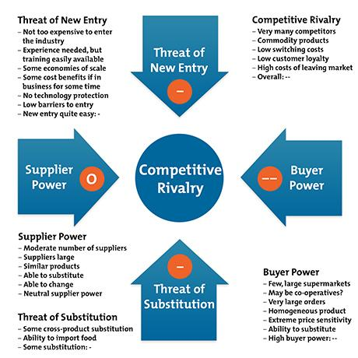
Figure 3.6: Porter’s Five Forces
(Source: Prakash, 2024)
Threat of New Entrants: Moderate
The Indian restaurant sector is still a growth sector, as the entry level is pretty reasonable, especially through franchising. Foreign investment is also encouraged by the support of the government. Building a premium international brand, however, does demand, to a large degree, the investment of capital, being effective in supply chain management and having a good name. Therefore, although it is possible to gain entry, it can be difficult to establish a long-term market position.
Bargaining Power of Suppliers: Low to moderate
The quality and uniformity of ingredients and product is crucial at Five Guys. While local sourcing can help minimise transportation costs and strengthen supply chain resilience, finding suppliers willing and able to provide a consistently high-quality, global standard may be difficult. The reliance on suppliers is thus a moderate operational risk.
Bargaining Power of Customers: High
Indian consumers have a powerful negotiating voice, considering that there are comparable levels of restaurants offering alternate choices, and when it comes to price sensitivity, it's rather strong. Li et al. (2024) proposed that while premium products are often bought on both price and perceived value in emerging markets, consumers typically worry more about the value they are getting than the price itself. Therefore, it is necessary that Five Guys make sure that consumers know exactly how Five Guys is different from other burger joints to justify the high price.
Competitive Rivalry and Substitute Products
The rivalry among the various players in the QSR industry in India is quite intense. Many international chains have already developed large restaurant chains and gained high consumer recognition with them, including McDonald's, Burger King, KFC and Wendy's. In addition, there are some domestic brands available: domestic ones like Jumbo King or Wow! Momo and Haldiram's offer tremendous benefits to the local community because of their local menu knowledge, low prices and wide regional distribution.
Meanwhile, there is a high risk of having substitutes, as customers can move at any time to a café, a street food stall, a "cloud kitchen" and even a full-service restaurant. With India's food culture being extremely diverse, there are plenty of value-based options: this adds to the competition with luxury restaurant chains.
Market demand and growth prospects
However, India's market attraction is extremely good even in the face of all these competitors. Feeling the pulse of the market, the rise in disposable incomes of the middle classes, the surge of women's participation in the workforce, the growth of food delivery services and a lifestyle change still continue to spur the demand for premium dining experiences, says IMARC Group (2025). Moreover, digital ordering apps like Zomato and Swiggy have helped to a great extent increase the market access of international restaurant chains.

3.7 Dunning's Eclectic (OLI) Paradigm
Based on the Owning stages (Ownership: O), Location (L), and Internalisation (I) advantages, Dunning's Eclectic Paradigm (OLI) is a holistic framework to determine whether a multinational enterprise (MNE) should go abroad. If all three advantages are strong enough for firms to justify entering foreign markets, they will succeed in the international arena and become sustainable. (Li et al., 2024) By using the OLI framework, it can be seen that India is a possible strategic location for Five Guys, as it needs to be adapted appropriately.
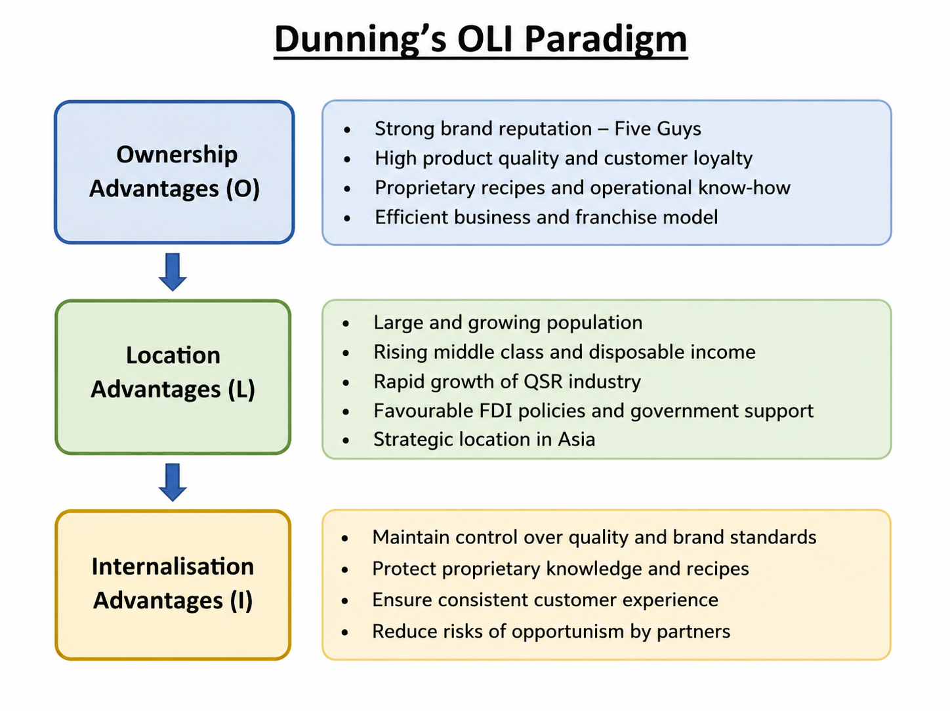
Figure 3.7: Dunning’s OLI Paradigm
(Source: Self-developed)
Ownership Advantages (O)
Some of the things Five Guys has that the rest of the chain doesn't necessarily possess are what makes 5 Guys unique. It's a globally recognised brand, known for high quality, optimised systems, high franchise management skills and a loyal customer base. Five Guys differentiates itself from many other fast food establishments, which focus their marketing strategies on low prices, by focusing on the premium market through its product customisation, fresh menu, and excellent customer service. Sun (2022) also suggests that this differentiation strategy has helped build the firm's international competitiveness because the firm has developed a differentiation strategy that couldn't easily be matched by its rivals.
Location Advantages (L)
India has a high rise in the middle-class population, urbanisation, favourable demographics and one of the fastest-growing QSR markets in the world against the backdrop of location-specific benefits. India's conducive investment conditions and the growth of consumer demand, along with favourable government regulations on foreign direct investment (FDI), remain strong reasons for attracting multinational companies for long-term investment prospects (Prakash, 2024). In addition, India's advanced digital food delivery infrastructure further bolsters ease of access to the market and access for consumers.
However, there are also downfalls to being located there. Competitive business environment, regulatory environment, cultural diversity and income differences between various regions can create operational risks. For this reason, it is vital to properly evaluate cities and slowly expand.
Internalisation Advantages (I)
The internalisation benefits that are observed in the data justify the strategic control of important business activities over licensing of the knowledge. Internal control is especially critical to Five Guys due to its focus on product quality, consistency of operations and brand reputation. A solid master franchise strategy will empower the franchise to meet quality standards while providing local specialists. In some overseas markets, this is the approach that has proven to work well.

4. Entry Mode Strategy and Strategic Synthesis

4.1 Historical International Expansion Pattern
Five Guys has traditionally developed globally using master franchising and franchise relationships to help fast-track its expansion overseas while limiting its financial risk. The company has worked with established local franchise partners who have restaurant development expertise to market owners in charge of restaurant operations and expansion. Kayed et al. (2025) also suggested that one of the best strategies for multinational food-service companies to conduct their business operation in other countries by reducing capital investment and uncertainty of operating a food-service store is through franchising.
This has enabled Five Guys to grow its revolutionary-fast service in Europe, the Middle East and Asia while keeping its standards and processes relatively comparable across the globe. Local franchise partners bring much-needed expertise on consumer behavior and networks of suppliers, as well as regulatory expertise, which lowers the company's learning curve in strange markets.

4.2 Evaluation of Alternative Entry Modes
Choosing the right entry mode is one of the most significant strategic decisions that will have the biggest impact on the success of international business. Prakash and Singhai (2024) suggested that the option of an FDI entry mode should depend on the degree of investment commitment, operational control, flexibility and risk in terms of the host country conditions.
Franchising
For Five Guys, the most appropriate type of expansion is going on to become a franchise, considering that this demands only a moderate capital outlay compared to opening additional stores on their own and includes a fast expansion process with the help of local partners. Franchisees bring valuable knowledge of local consumers, local regulations and supply networks, which decreases uncertainty with regard to market entry. Some issues with the quality of the service and of customer experience may happen, however, due to less managerial control.
Licensing
Minimal financial investment and, e.g. authorization of another company to use IP is valid for licensing. However, licensing offers the least degree of operating control and of the misuse of IP and the risk of dilution of your brand. This would have a reputational risk for Five Guys, which is branded as high-end.
Joint Venture
Joint ventures involve experts in each respective market, collating them with management expertise from abroad. This approach to entry helps ensure compliance with regulations, sharing of resources and distribution of risks, as well as better cultural adaptation. Artefacts from conflict issues between partners, however, are commonplace in joint venture settings in Li et al. (2024), as slow decision-making and strategic disputes between joint partners are frequent. Local partners can be used successfully to enable an international expansion, as shown in the early partnership between the Starbucks brand and Tata Consumer Products with localised brands of coffee and tea that continue to have compatible goals.
Wholly Owned Subsidiary
It offers full management authority, better protection of intellectual property rights and full control over operational decisions, as it is a wholly owned subsidiary. The necessity to invest significantly in the business, on the other hand, increases the company's political, financial and operational risks. Having a previous entry into the Indian market, if any, would play a huge factor in reducing the uncertainty involved with entering the Indian market, especially when it comes to Five Guys' experience.
Strategic Alliance
Unlike an equity partnership, a strategic alliance can be formed to address a variety of issues, including adoption of new technology, supply chain or marketing, and does not establish a distinct entity. An alliance will decrease the investment risk and will ease the learning-by-doing process in markets; however, it is noted that it will have less strategic control and less long-term commitment than franchising or joint ventures.

4.3 Recommended Entry Mode for India
Given the above analysis, it can be inferred that master franchising is the entry mode most suited to Five Guys' expansion to India as it provides maximum efficiency of the investment and provides control and responsiveness to the local market. Kayed et al. (2025) suggested that "franchising allows the multinational restaurant brands to grow quickly while taking advantage of the expertise of the franchisee in relation to the market. This approach meshes very well with Five Guys' historical international strategy, and helps to maintain Dunning's advantage of keeping our products, procedures and brand standards in-house.
Some researchers point out, however, that franchising may diminish managerial control, as well as reputational risk, if franchisees are unable to provide consistent customer service worldwide. In emerging markets, Prakash and Singhai (2024) argued that multinational corporations must become more attuned to the cultural and institutional challenges by partnering more closely with local actors.

5. Conclusion and Recommendations
The analysis indicates that with India's expanding middle class population and favourable global market conditions, as well as a rapidly growing quick-service restaurant industry, India is a market of interest for the long-term future for Five Guys.
Bartlett and Ghoshal, as well as Dunning's OLI paradigm, have argued that the conditions and capabilities of companies in foreign markets can be successfully met by aligning business capabilities with the countries where it is entering. There is, however, issues around cultural differences, regulation and the high competition within the territory that call for proper market entry strategy planning. Hence, some of the strategies that should be used to give Five Guys an edge in the Indian market include the establishment of phased open-up in the major cities of the Indian market, engaging experienced partner franchisees locally, strict controls on the quality of operations and services, and some selective menu localisation, as a whole.

Section 2: Reflective Account

5.1 Introduction
This reflective account critically reviews the steps taken whilst conducting research, analysing and preparing the international business report for Five Guys' expansion to India. The reflection is based on Gibbs' Reflective Cycle as it offers a structured approach to reviewing what has happened, strengths and weaknesses and continuous professional development. The reflection addresses the research process, information sources, analytical process used, problems that arose, and the learning that was achieved during the process of Task fulfillment.
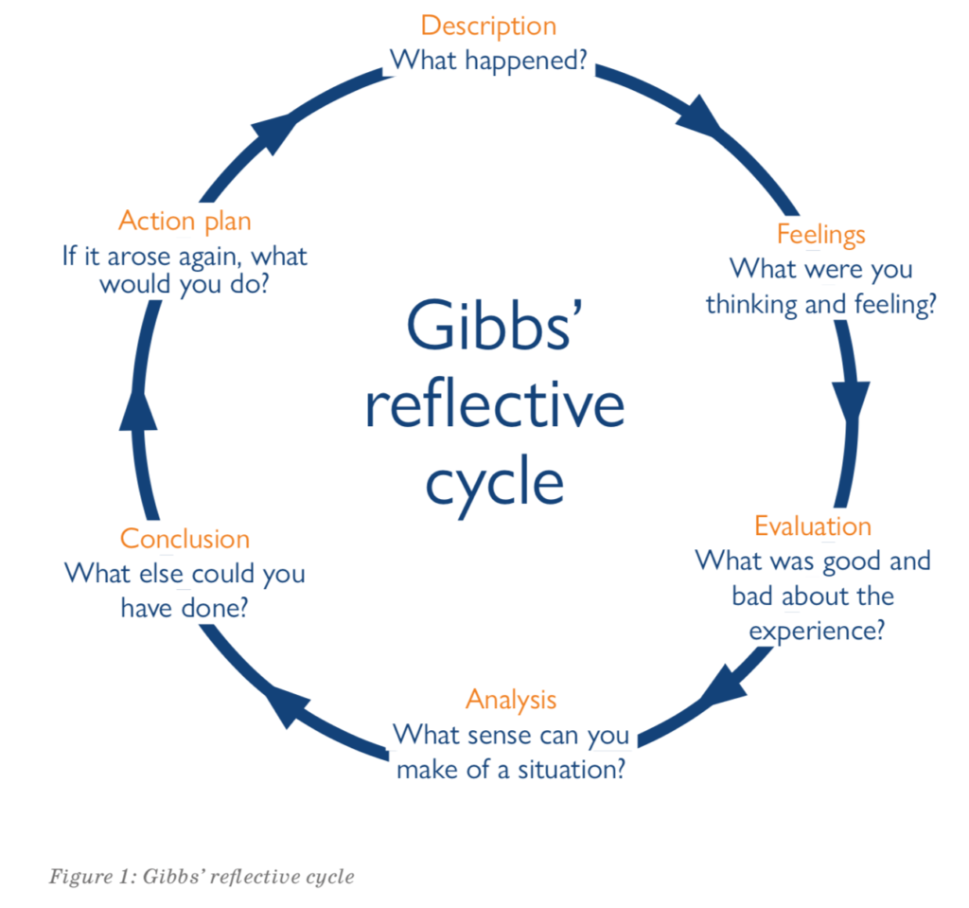
Figure 5.1: Gibb’s Reflective Cycle
(Source: Sun, 2022)

5.2 Description
The main aim of this evaluation was the critical analysis of the feasibility of getting Five Guys into the Indian market, employing the known theories of International business history and the evidence from up-to-date sources. The first step in the research process was to identify the multinational firm which did not have a significant presence in India till 2026. Companies' reports, government publications, industry reports, and the latest research published in academic journals were used to confirm Five Guys' presence in other countries, with the decision to pursue India, the target country, being justified by reviewing such reports.
Prakash and Singhai (2024) suggested that the analysis of the international market needs to be a combined analysis of macro-environment and strategic management theory. Therefore, some of the existing strategy models were used, such as Bartlett and Ghoshal's International Strategy Model, the cultural dimension model of Hofstede and Dunning's 'Eclectic (OLI)' Paradigm. These models served as a framework to study India's political, economic, legal and cultural landscape and their evaluation of other options for market entry.
During the research process, information was sorted into thematic sections to create a logical progression of environmental analysis and recommendations for the Projects.

5.3 Feelings
At first, I felt confident and had some past knowledge of other countries' business concepts, which I read from lectures and previous studies. I had to provide extensive proof, from several good sources, of the suitability of the right multinational company to operate in India, but before I did that, I needed to determine what that company was, to get rid of obviously unfriendly companies in my mind, etc. This proved to be more difficult than it seemed, as many multinationals were already in India by making use of subsidiaries, licensing or franchise contracts.
Li et al. (2024) stressed the important role of incomplete information and sometimes conflicts in the context of international business decisions. While contrasting various reports, government publications and academic articles on the Indian investment scenario, I found one throwing out conflicting opinions on India's investment attractiveness, and then another on the regulatory environment.
But while there were many challenges I grew more and more confident as I went along. The use of theory allowed me to relate theory to actual business decisions and not just remember the factors that impact the external environment. I believe that strengthened my belief in the ability to investigate alternative expansion strategies across the world with facts and evidence and not opinions.

5.4 Evaluation
An important facet of my research process was using a variety of credible sources of information. Theory was generated from academic journal articles, and contemporary market evidence was obtained from reports published by various organisations like the International Monetary Fund, Invest India, FSSAI and Research and Markets. This, plus various other sources, further helped to enhance the reliability and applicability of the analysis.
In addition, multiple international business frameworks were incorporated to improve the quality of this report. Instead of using only one analytical model, Bartlett and Ghoshal's model was used to explain Five Guys' international strategy, while Hofstede's model was used to draw attention to young people to the cultural challenges and Porter's Five Forces was used to assess the current level of competition of the retail sector in the country and the rationale for the proposed entry strategy justified by Dunning's OLI Paradigm. This was done for integration to create a more holistic strategic appraisal.
There were, however, several potential weaknesses as part of the research process. Sun (2022) believed that a private firm will provide less such information than a publicly listed firm because that information is not subject to public scrutiny. This restriction was revealed due to Five Guys being a relatively small company, giving somewhat limited financial and strategic information compared with a larger, multinational company, like McDonald's. This meant that there was a greater emphasis on the use of secondary academic literature and industry reports.

5.5 Analysis
I'm very glad that I got to use this assessment as it helped me improve my understanding of International Business vs theory to real-life application of strategic business decisions. This research came before nationalisation; I thought of it first as a selection of "attractive" markets. It was highlighted, however, that organisational capacities, institutional contexts, and strategic orientations are equally crucial for internationalisation to be successful.
Kayed et al. (2025) suggested that international franchising is successful when they strike a balance between global consistency of the brand and its adaptation to the local market. The idea gained significance when considering the expansion of 5' Ratna.The idea stood true especially when considering the expansion of 5' Ratna into India. While it was found that financial risk is mitigated through franchising, it is important for sustainable competitive advantage through cultural adaptation. The importance of balancing between standardisation and adaptation was highlighted by the real examples from McDonald's and Burger King; the significance of menu localisation to their success within India was explained.

5.6 Conclusion
Overall, this assessment was a useful theoretical and practical learning experience. I faced some difficulties in the research process due to the scarcity of information and controversy in the evidence, but ended up with recommendations that were balanced and evidence-based, provided with the use of recognised strategic frameworks. The experience gained reinforced my School of Business research abilities, critical thinking towards environments in international business contexts and the use of academic theories to help inform real-life decisions within an organisation.

5.7 Action Plan
Future International business projects will aim to further develop research abilities by having the ability to access more peer-reviewed journal articles and international market databases in the earliest stages of the research process. In addition, I will further develop skills in comparing and contrasting the theories and models, and I will include more quantitative market information to drive strategic recommendations. The improvements will help fine-tune all of my academic and professional work in the future in terms of quality, credibility and practical relevance.

Reference list
Bain and Company (2024) India Consumer Market Report. Available at: https://www.bain.com/ (Assessed: 28th July, 2026)
Deloitte India (2024) Global Powers of Retailing. Available at: https://www2.deloitte.com/in/en.html (Assessed: 28th July, 2026)
Department for Promotion of Industry and Internal Trade (2025) FDI Statistics. Available at: https://dpiit.gov.in/ (Assessed: 28th July, 2026)
Euromonitor International (2024) Consumer Foodservice in India. Available at: https://www.euromonitor.com/ (Assessed: 28th July, 2026)
EY India (2024) Future Consumer Index India. Available at: https://www.ey.com/en_in (Assessed: 28th July, 2026)
Fischer, D. and Roy, K. (2025) 'Market Entry in India: The Curious Case of Starbucks', Rutgers Business Review. Available at: https://rbr.business.rutgers.edu/article/market-entry-india-curious-case-starbucks
Food Safety and Standards Authority of India (2024) Food Safety Regulations. Available at: https://www.fssai.gov.in/ (Assessed: 28th July, 2026)
ICRA (2023) 'Indian Quick-Service Restaurant Industry to Witness Strong Growth in Near to Medium Term'. Available at: https://www.scribd.com/document/747844143/icra-qsr-report
IMARC Group (2025) India Food Service Market Report. Available at: https://www.imarcgroup.com/india-food-service-market
International Journal of Multidisciplinary Research Review (2025) 'The Franchise Model in India: A Catalyst for Sustained Economic Development'. Available at: https://www.researchgate.net/publication/394641998_THE_FRANCHISE_MODEL_IN_INDIA_A_CATALYST_FOR_SUSTAINED_ECONOMIC_DEVELOPMENT
International Journal of Science and Research Archive (2024) 'Flipping Burgers and Financials: QSRs COVID-19 Journey'. Available at: https://www.researchgate.net/publication/378239841_Flipping_burgers_and_financials_QSRs_COVID-19_Journey
International Monetary Fund (2025) India: Article IV Consultation. Available at: https://www.imf.org/en/Countries/IND (Assessed: 28th July, 2026)
Invest India (2025) Food Processing Sector. Available at: https://www.investindia.gov.in/sector/food-processing (Assessed: 28th July, 2026)
Invest India (2025) Retail and E-commerce. Available at: https://www.investindia.gov.in/ (Assessed: 28th July, 2026)
Kayed, M., Kacker, M., Wu, R. and Sadeh, F. (2025) 'The Impact of Brand Equity on Vertical Integration in Franchise Systems'. Available at: https://arxiv.org/abs/2508.06824
KPMG India (2024) Retail Trends in India. Available at: https://kpmg.com/in/en/home.html (Assessed: 28th July, 2026)
Li, Y., Fan, D., Kumar, V. and Ananthram, S. (2024) 'Configuring International Growth of Emerging Market Multinational Enterprises: A Compositional Springboarding View in the Context of India', Journal of Management Studies, 61(6). Available at: https://onlinelibrary.wiley.com/doi/full/10.1111/joms.12981
McKinsey and Company (2024) The State of the Indian Consumer. Available at: https://www.mckinsey.com/ (Assessed: 28th July, 2026)
Ministry of Commerce and Industry, Government of India (2024) FDI Policy Circular. Available at: https://dpiit.gov.in/ (Assessed: 28th July, 2026)
Mordor Intelligence (2025) India Quick Service Restaurant Market. Available at: https://www.mordorintelligence.com/industry-reports/india-quick-service-restaurant-market (Assessed: 28th July, 2026)
OECD (2025) Economic Survey of India. Available at: https://www.oecd.org/india/ (Assessed: 28th July, 2026)
Pearson, S. and Malthouse, E. (2024) 'Fifth Generation IMC: Expanding the Scope to Profit, People, and the Planet', Journal of Advertising. Available at: https://arxiv.org/abs/2404.04740
Prakash, K. and Singhai, M. (2024) 'Analysis of Market Entry Strategies for Foreign Multinational Corporations in India: A Market Research Study', International Journal For Multidisciplinary Research, 6(3). Available at: https://www.ijfmr.com/research-paper.php?id=19810
PwC India (2024) Consumer Markets in India. Available at: https://www.pwc.in/ (Assessed: 28th July, 2026)
QSR Magazine (2025) QSR 50 Report. Available at: https://www.qsrmagazine.com/wp-content/uploads/2025/07/QSR_QSR50_AUGUST2025.pdf (Assessed: 28th July, 2026)
Research and Markets (2023) India Quick Service Restaurant (QSR) Market Report 2023. Available at: https://www.globenewswire.com/news-release/2023/03/22/2632521/0/en/India-Quick-Service-Restaurant-QSR-Market-Report-2023-Market-to-Reach-INR-431-27-Bn-5-221-Billion-in-FY-2027-with-International-Brands-Dominating.html
Research and Markets (2023) Quick Service Restaurant Market in India 2023. Available at: https://www.researchandmarkets.com/report/india-fast-food-market
ResearchGate (2024) 'Critical Evaluation of Strategic Management in the Indian Fast-Food Chain Business'. Available at: https://www.researchgate.net/publication/378126243_Critical_Evaluation_of_Strategic_Management_in_the_Indian_Fast-Food_Chain_Business
Statista (2025) Quick Service Restaurant Market in India. Available at: https://www.statista.com/ (Assessed: 28th July, 2026)
Sun, C. (2022) 'Market Analysis of Five Guys', Proceedings of the 2022 7th International Conference on Financial Innovation and Economic Development. Available at: https://www.researchgate.net/publication/363360058_Market_Analysis_of_Five_Guys
World Bank (2025) India Overview. Available at: https://www.worldbank.org/en/country/india (Assessed: 28th July, 2026)
World Economic Forum (2024) Future of Consumption in India. Available at: https://www.weforum.org/ (Assessed: 28th July, 2026)

