


MSc Industry 4.0 Advanced Manufacturing

Advanced Industry 4.0

Module Code: ACPA7000

Assignment 2 - Advanced Industry 4.0 Essay

Lecturer: Mahesh Kannath

Industry 4.0 Technology
Evaluating the strategic benefit of Industry 4.0 for Manufacturing Systems

12th January 2023
Student: Gareth Gooding (2125561)
E-mail: 2125561@student.uwtsd.ac.uk

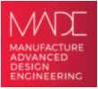


Evaluating the strategic benefit of Industry 4.0 for Manufacturing Systems

Contents

Introduction 3

Current UKWDG Industry 4.0 technology Case Studies 4

Opportunities for Industry 4.0 benefits at UKWDG 5

Industry 4.0 technology 1 – Robotics – Techniglass 8

Industry 4.0 technology 2 – Augmented Reality (AR) - Customer Experience 12

Industry 4.0 technology 3 – Augmented reality (AR) - Health and safety training 14

Conclusions 16

References 17

Introduction

With recent global issues, such as the Covid-19 pandemic, Brexit and the Russia-Ukraine War businesses have been impacted in a variety of ways. Manufacturing have been negatively affected, from supply chain to personnel availability, to energy costs and sale of products. Stability and sustainability must be keys focusses to recover and thrive in the current economy. There are key factors that need to be focussed on to ensure a stable business:

Financial stability
Cash, operating profit, EBITDA etc, all contribute to financial stability. If this is not sustained, then a business will not develop. Most improvements gained by Industry 4.0 technology will be measured by the financial benefits produced by its introduction.

Environmental impact
Environmental policies and requirements are directing business to reduce its carbon footprint. Carbon footprint and Energy usage are key areas which must be managed to control costs.

Assets and Infrastructure
The asset value and infrastructure directly affect the value of the product and the business. These areas must be maintained to improve sustainability of the business and its financial stability.

Human Capital
A good workforce must be sustained to ensure the efficiency and profitability of a business. Training, engagement, employee benefits and a safe working environment are factors which must be managed to ensure a sustainable workforce.

Social Capital
The interaction with the customer, community, company reputation and culture of a business. Key factors to ensure a sustainable business

These factors need to be addressed when exploring innovative technologies, to ensure all are considered.

UKWDG manufacturing systems will be used as a case study to provide examples of the manufacturing systems that will benefit from Industry 4.0.

UKWDG

UK Windows and Doors Group (UKWDG) manufactures and sells uPVC windows, doors, and other fenestration products, employing over nine hundred personnel across the UK, consisting of the following divisions:
- Duraflex (Tewkesbury)– uPVC Extrusion site – extruding uPVC into lengths of profile from which windows and doors are manufactured.
  - Duraflex System House is based in this facility, which designs and develops new products.
- Techniglass (South Wales) – IGU manufacturer – processes glass into Double-glazed Insulated Glass Units (IGUs).
- Evolution Windows (Bedfordshire) – Manufactures premium windows and doors.
- Griffin Windows (2 sites in South Wales) – Manufactures windows and doors using uPVC profile from Duraflex and IGUs from Techniglass.
- Distribution Hub (South Wales) – central hub for South Wales distribution.
- Sevenday (UK Wide) – 24 trade counters selling to local trade installers of windows and doors across the UK

UKWDG develop customer tailored products and provide customer support as part of a Customer Experience. With UKWDG being one of 4500 window and door fabricators in the UK (Insight Data Ltd, 2022) it is driving Customer Experience as its differentiator from competitors. As per below statement from the UKWDG website:

"We pride ourselves on our customer first approach. From ordering through to delivery, our aim is to provide you with the service & support tools to make your life easier." (UKWDG, 2022)

A strategic look on how to make the business more sustainable is key for UKWDG. Financial stability needs to be improved to enable investment in manufacturing processes. Industry 4.0 technology can improve efficiencies and provide cost savings in many areas. The Customer Experience proposition is key to the current good performance of the business, which can also gain benefits from implementing Industry 4.0 technology.

Investment in new technologies has been inhibited by financial stability, and culture. To change the culture towards innovation and trust in emergent technology the benefits of implementation must be realised and understood by the business.

Quoting Klaus Schwab, “Still valid today is the lesson from the first industrial revolution – that the extent of which society embraces technological innovation is a major determinant of progress.” (Schwab, 2017)

Current UKWDG Industry 4.0 technology Case Studies

The manufacturing processes in UKWDG have opportunities to improve performance and efficiency. More modern equipment is faster, more reliable and uses less labour. The investment required to upgrade to new equipment is not available, so other opportunities must be explored to deliver benefits to the business. Industry 4.0 technology can provide solutions. At a strategic level, low-cost projects have been launched across the business to gain improvements.

Additive Manufacturing – 3D Printers

3D printers are used in the Duraflex Technical department to facilitate customer tailored product enquiries. The tailoring of products can be designed, and prototypes produced instantly to implement a finished design.

Previously, prototypes for new products required a metal die-tool to be fabricated in Austria for an extruded prototype. Timescales were 2 months, at costs of approximately £10k each. If the prototype was not right, a new tool was manufactured.

Cost - Low
- £10k - existing 3D printers
Benefits – Medium (3)
- Financial - 3D printers have financial benefits, eliminating prototype tooling costs.
- Customer Engagement - Rapid design and prototyping allow the customer to introduce new products swiftly to market.

Internet of Things (IoT) – LPWAN Smart Energy metering

Techniglass is a high energy consumer. Smart Metering via LPWAN devices using the LoRaWAN protocol is on trial to determine areas of higher energy usage. High energy areas can be highlighted, and improvements projects implemented and tracked by the Smart Metering.

Cost - Low
- £5k – existing LPWAN Smart Metering devices.
Benefit – High (5)
- Economic – Tracking of energy at circuit level can identify opportunities. Energy reduction result in cost savings.
- Environmental – Reduction of energy usage reduces the company’s Carbon footprint.

Internet of Things / Internet of Software – Track-pod

Track-pod is on trial at the Distribution Hub. Track-pod is used to manage the delivery fleet from a central system. Mobile devices are used to ensure Point of Delivery scanning and optimise delivery routes via the delivery plan and GPS.

Cost – Medium
- £50k – software and devices
Benefit – Medium (3)
- Financial – Point of delivery confirmed, product transition to the customer in a good condition – reducing warranty claims. Optimised travel reduces fuel use.
- Environmental – reduction of travel distance reduces Carbon Footprint

Internet of things (IoT) / Big data – Backtrack

Backtrack was trialled in 2022 to monitor Manual handling movements of employees. The Smart Gyroscope device is fitted to an operator and tracks movements. The gathered data is available to inform the user of the Manual Handling practices. The data can indicate how to improve Manual Handling behaviours.

Cost – Low
- £5K - subscription service
Benefit – Medium (2)
- Health and Safety - Improved Manual Handling will reduce injuries at work, leading to less lost time/sickness, and improved morale.
- Financial gains achieved by reducing loss time due to injury.

Opportunities for Industry 4.0 benefits at UKWDG

IoT / IoS – RFID Product tracking – Griffin Windows

There is a large variety of product types in Griffin Windows. The variation requires manual product changes regularly throughout the production cycle. A technology which can automate product changes is RFID tracking. The sizes can be loaded onto an RFID tag, placed on the product. As it moves through the production process the tag is scanned by an RFID Reader and the machine uses the data to automatically re-size to the product size required.

This would increase the speed of production cycle and reduce in manual errors. RFID implementation would be a high cost, due to the specification of the manufacturing system. Control systems are based on DOS-based PCs, which are not compatible with RFID systems. To enable adoption new control systems would be required, which would cost over £100k.

Cost – High
- £100k
Benefit – Low (2)
- Financial gains due to a more efficient process – less delays caused by manual product changes. Less scrap from manual error.

Cloud Manufacturing - Duraflex

Duraflex contains thirty similar extrusion lines. Each line is standalone, requiring manual changes and manual recording of data, such as temperatures, speeds, runtime, and throughput. A SCADA system will allow equipment alterations remotely, whilst providing historical and real-time performance data to improve the production process. A Cloud- based SCADA system allows the process to be controlled, managed, and sourced via a Cloud based platform provider. A cloud-based platform eliminates the requirement for investment in local servers and software.

Cost – Low
- £25K - license plus subscription.
Benefit – Low (2)
- Financial - the benefits come from improved control and reduced manual data gathering. The enhanced data will improve decision making and allow better control of the process improving efficiency.

Robotics - Griffin Windows

All sites are semi-automatic, but the most manual handling movements are performed in the Treorchy manufacturing site. This site produces windows and doors of assorted sizes, up to 1000 per day. The process involves uPVC profile length to be cut into set batch sizes. These batches sizes form a specific window, which is welded by automated welders. They are manually lifted from the machine and moved into another section where hardware, such as handles, and locks are fitted. The frames are then manually moved to a despatch area. From the despatch area they are then moved manually to trucks for loading. To summarise, up to one thousand complete frames are moved manually three times each manually.

Solution – Automated robotic product movement, to sort, stack and batch to despatch is a solution offered by the OEM manufacturer of the window production line, reducing the manual handling of 1000 frames, reduced opportunity for damage, and consistent batch sorting for improved delivery accuracy.

Cost – High
- >£250K – OEM produced options would be preferred for compatibility, and support. Complexity of the automated product moving systems would cause extended downtime to move and adapt current systems.
Benefits – High (5)
- Financial – reduction in personnel required to move frames within the factory.
- Health and Safety – reduce risk of injury caused by manual movement of 1000 frames
- Social – a large investment in modern equipment would improve employee confidence for the company’s future.
Robotics Techniglass – IGU production

Techniglass processes glass into Insulated Glass Units (IGUs). IGUs consists of two or more panes of glass that are spaced apart by a bar and sealed with sealant to become a single unit. This involves cutting large sheets into smaller sheets which are manually moved to an edge polishing station, then manually moved to a toughening furnace. From the furnace the glass pieces are manually moved to an IGU line, where the glass pieces are paired and bonded with a Spacer bar to form a double-glazed unit. Each workstation is loaded and unloaded by hand.

There are numerous manual interactions with the glass, which causes damage, potential for harm from sharp edges and a requires labour to move the glass.

Solution – automated robotic product movement, to load, unload glass at different workstations. Manual handling and laceration risks can be reduced with less manual interaction with the sharp-edged glass pieces.

Cost – medium
- £100k.
Benefits – High (5)
- Financial – reduction in personnel.
- Financial – swifter process and reduces costs from damaged product
- Health and safety – reduce manual handling and laceration injuries.
- Social – a large investment in modern equipment would improve employee confidence.

Augmented Reality - Health and Safety training

UKWDG is made up of six facilities and twenty-four trade branches, supported by 4 Health and Safety personnel, who deliver inductions, safety training and audits. With a total of thirty locations to visit and nine hundred personnel a lot of travel is required for 4 Health and safety personnel.

AR opportunities can facilitate remote training, and auditing. Mobile devices such as mobile computers, smartphones, AR glasses can be used to allow full visual access from one site to another, allowing adequate instruction to be given without attending site. This would aid training requiring physical objects, which can be overlayed via AR into areas for training. These options would reduce the need for travelling and train more personnel.

Cost – Low
- £10k for AR/VR services
Benefit – High (4)
- Financial – reduce travel costs
- Environmental – reduce Carbon footprint by reducing vehicle movements
- Health and safety – increase access to training and instruction – increasing the number of personnel trained.
- Health and Safety – accidents and incidents – instant visual access of incident with AR, to give real time diagnosis of issue.

Augmented Reality (AR) – Customer Experience

Customer Experience are responsible for customer interactions – sales, aftersales, warranty, and service. There are warranty claims that are registered, often without access to evidence – a window may be installed one hundred miles away, which is too far to visit for inspection. AR allows instant access to the warranty claim, by viewing the evidence remotely and allowing a swift decision to uphold or reject the claim. This will reduce rogue warranty claims, which are not always inspected.

Service Engineering is another opportunity. There are six service engineers who attend customer sites for warranty repairs, issue resolution, installer queries and installer training. AR can allow a portion of this work to be completed remotely. Remote training can be achieved, reducing the need to travel.

Cost – Low
- £20k Subscriptions
Benefit – High (5)
- Financial – reduce travel costs / improved customer loyalty
- Environmental – reduce Carbon footprint by reducing vehicle movements
- Social – customers have increased access to assistance.

There are ten Case Studies within UKWDG either in development or are future opportunities. Recent global issues have constrained the business’s ability to invest in medium or high-cost areas. To help prioritise the opportunities that Industry 4.0 technologies can deliver Cost and Benefit will be the criteria to score them.

Cost/Benefit Analysis

The chart classifies technologies in three ways:
- Not to adopt
- Viable to continue
- To adopt

Four technologies will not be adopted
- IoT/IoS – Low Benefit
- Cloud Manufacturing – Low Benefit
- IoT/IoS RFID – High Cost / Low Benefit
- Robotics Upvc Treorchy – High Cost

Three technologies are on trial and will be continued
- Additive Manufacturing – Low cost / Medium Benefit
- IoT/IoS Track-pod – Medium Cost / Medium Benefit
- LPWAN Energy Metering – Low Cost / High Benefit

Three technologies to adopt
- Robotics Techniglass – Medium Cost / High Benefit
- AR/VR CEx – Low Cost / High Benefit
- AR/VR H&S – Low Cost / High Benefit

Industry 4.0 technology 1 – Robotics – Techniglass

Recent global issues have reduced labour availability, making it difficult to retain or attract staff. Energy and other costs rising across the UK has increased employee costs, resulting in wage rises of 10% in the last 2 years, with more wage rises expected. The higher cost of labour alters the priorities of the business - to reduce labour costs to ensure a sustainable future.

Industry 4.0 technology has been available for several years, with the opportunity to reduce the headcount required for the manufacturing process. With labour costs increasing the return on investment for this technology is more favourable.

IGU Manufacturing process

The various machines used in the process of making insulated glass are washing unit, drying unit, spacer conveyor, butyl extruder, and pressing unit, which is vertical. The insulated glass is constructed in the following ways: A hollow aluminium spacer bar is bent into the desired shape. Holes are drilled in the spacer bar, which is filled with a desiccant such as silica gel or zeolite that helps in absorbing water vapour. The drilled holes are sealed with a primary sealant such as butyl. Primary sealant is also applied to the sides of the spacer bar. Two glass panes are placed along the side of the spacer bar and pressed with an automatic presser. A secondary sealant such as polysulphide or silicon is applied along the sides of the whole unit. The insulating glass unit is ready. (Saint Gobain Glass, 2023)

The process involves separate workstations, with manual movements of glass consisting of unloading glass from one workstation into trolleys or harp racks, moving the trolley then unloading the glass into the next station. In Techniglass 2000 units are produced per day.

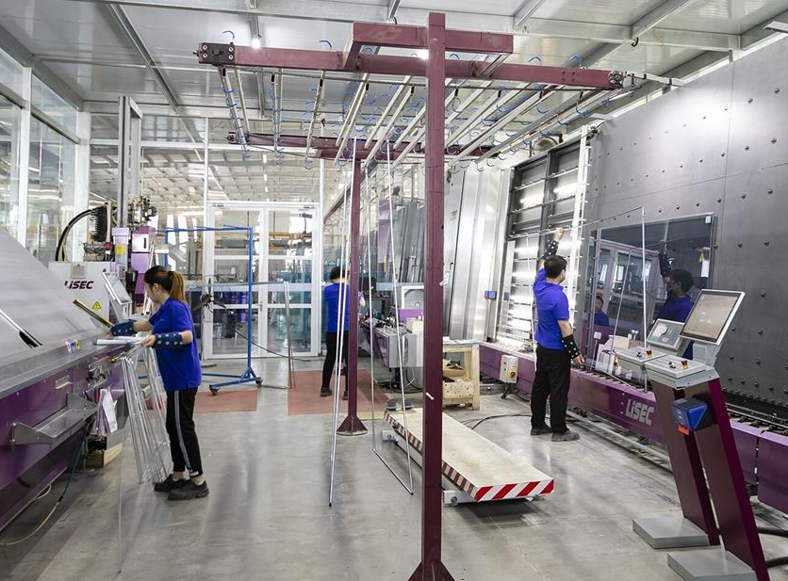
(Qingdao Morn Building Materials Co.,Ltd , 2021)

The glass industry in the UK has been affected by rising costs of labour and are adopting Industry 4.0 technology. Glass Systems are a direct competitor to UKWDG and recently implemented an Industry 4.0 technology, a Robotic Loading system in collaboration with GS-MR in 2022.

Glass Systems + GR-MR Robotic Loading System

“LEADING THE WAY WITH INVESTMENTS IN ADVANCED PROCESSING TECHNOLOGY PURCHASING THE FIRST IG-L ROBOTIC LOADING SYSTEM DESIGNED & MANUFACTURED IN THE UK BY GS-MR” (Glass Systems Ltd, 2022)

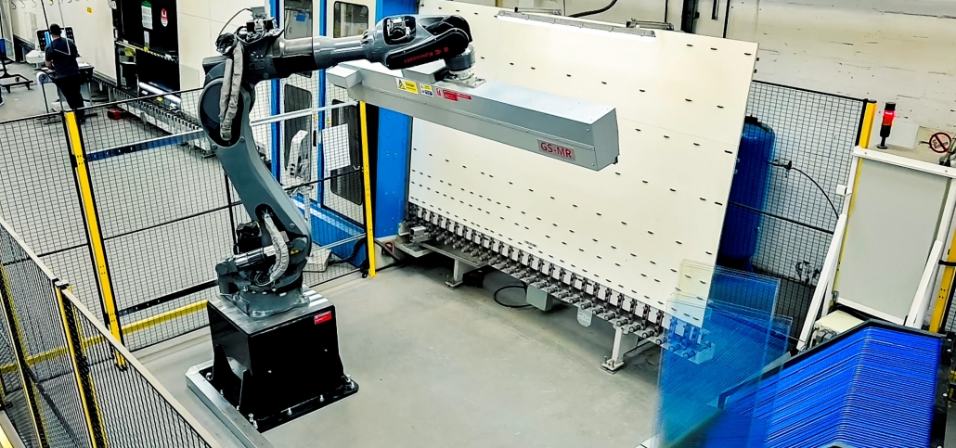
(Glass Systems Ltd, 2022)

The IG-L Robotic Loading System was designed and manufactured in the UK by GS-MR Glass and Stone (Machinery & Robotics) UK & Ireland Ltd. A robotic system which automatically unloads glass from harp racks or vertical storage systems and then loads onto an IG line. The glass pane is moved on its edge, rather than the traditional suction system, which could damage coatings.

Robert Owen, GS-MR said, “GS-MR were privileged to design and manufacture the IG-L Robotic Loading System for Glass Systems, who continually demonstrate to lead the glass processing industry within the UK.

With my extensive engineering background, I always pushed for improvements in functionality, promoting much needed industry automation, especially due to manual loading being such a potentially unsafe and uninspiring employee environment. Designing a solution which affiliated Industry 4.0 principles, further evaluating, and improving safety, alongside enabling improved quality and production was an absolute must. Without question, automation must be able to contribute to future proofing the global glass industry.” (GS-MR, 2022)

The benefits of the robotic system are financial with regards to labour costs and reduced scrap, but also improving the safety of employees.

Khaled Elleboudy – Glass Systems Managing Director said:
“Our IG-L at Glass Systems has quickly developed into a standard processing feature – put simply, we would not want to operate without it. The IG-L is a glass industry game changer. To be a part of this exciting automation at the very start gives Glass Systems a significant leading edge.

The glass industry knowledge and integrity repeatedly demonstrated by GS-MR throughout the automation development has resulted in establishing GS-MR’s IG-L Robotic Loading System as the clear industry success it is, leading Glass Systems to invest in further automation with GS-MR. Glass Systems are harnessing the undisputed benefits advanced automation technology is bringing to our industry.

Growth and development are key areas for Glass Systems, and we were able to increase sales volume by approximately 15-20% in 2021 compared to previous years. With the global challenges experienced more recently, it is more important than ever to focus on customer service and the consistent quality of deliverables. The business relationship we have developed with GS-MR is key not only to our business strategy of implementing improved automation processes, but also contributes to Glass Systems maintaining their UK premier industry status.” (Glass Systems Ltd, 2022)

Glass Systems have developed a Collaborative Innovation with GS-MR to improve performance in terms of sales and customer service with the implementation of automation. This venture has been financially beneficial, a benefit in terms of the Health and Safety of their staff, but also Socially. Reports of this venture were posted on both company websites, and LinkedIn, which would give customers confidence that Glass Systems is the market leader.

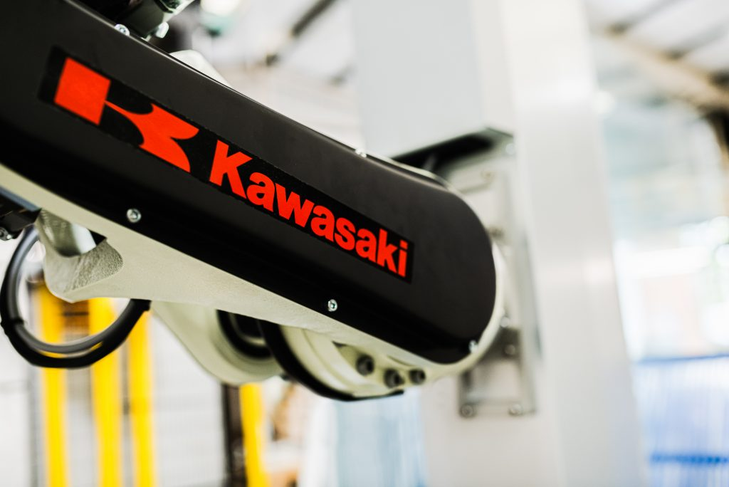
(GS-MR, 2022)
GS-MR developed this solution with Kawasaki, utilising the BX system for the IG-L robotic system. GS-MR are part of the Kawasaki Robots UK preferred Integrator Scheme 2021, forming a collaborative technology partnership.

Erdman Automation IGU line automation

Another example of Industry 4.0 technology is from Erdman Automation Corp. Based in the USA.

Erdman robotics have developed an unloading robot from IG Line to rack using the suction cup end effector to grip the glass.

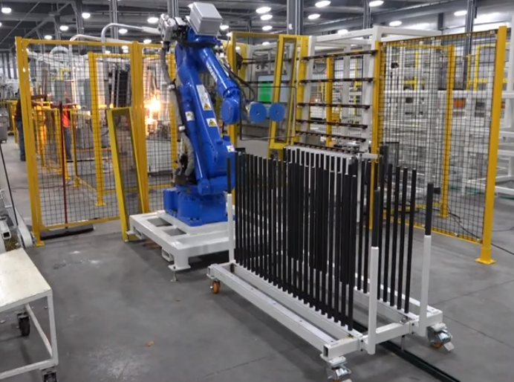
(Erdman, 2023)

Like the IG-L Robotic loading system the Erdman robot reduces the manual handling required by conventional IGU lines.

Erdman also developed the Erdman® Unmanned Robotic IG Work Cell, using three robots. One for loading, one for positional holding of the glass while the flexible spacer is applied and gas filled, and one for sealing and offloading.

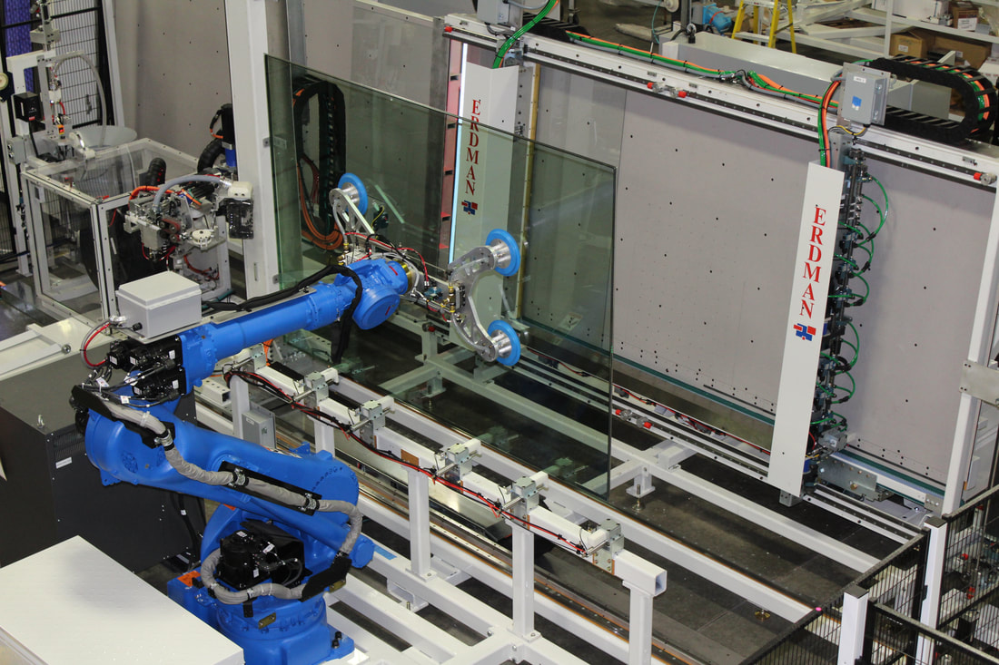
Spacer Applicator and Gas fill (Erdmanautomation, 2023)

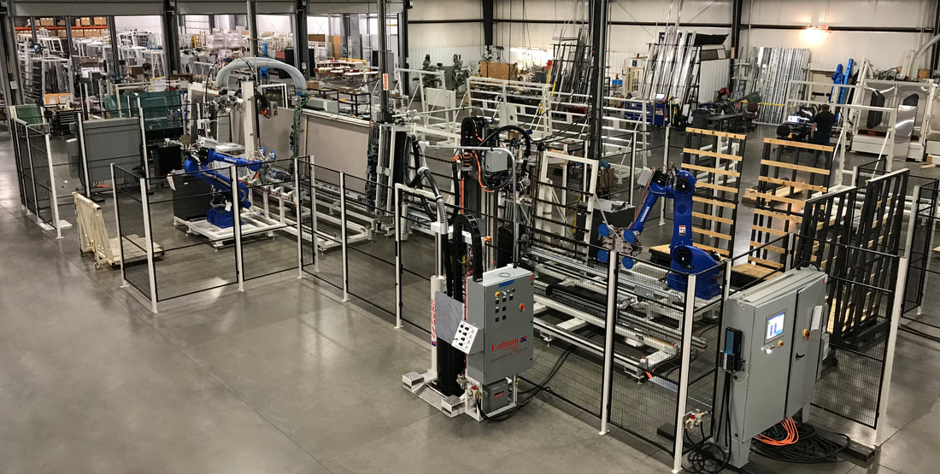
(Erdmanautomation, 2023)

Erdman claim the following benefits
- Reduce labour from 4-6 operators down to less than 1 and shift your labour into areas of more critical thinking
- Produce 1, 5’x10’ IG Unit per minute (90 seconds with gas fill)
- Run your robotic work cell around the clock and produce 1440 units (non-gas filled) per 24 hours at 100% efficiency
- Save one half of the required floor space of a traditional box-spacer line (approximately 20 ’x 75’)
- No direct labour means safety because all heavy lifting is performed by robots
- Produce cleaner IG because of reduced conveying
(Erdmanautomation, 2023)

Erdman Automation, and GS-MR both develop Industry 4.0 technology to enable financial, humanistic, and social benefits to Glass Industry companies.

The financial, humanistic, and social benefits give clear justification for UKWDG to investigate Robotics further, but this is also enhanced by a competitor already implementing an automated robotic system. Glass Systems being an earlier adopter than Techniglass creates an opportunity for benchmarking, the next step in developing a business case for investment.

Industry 4.0 technology 2 – Augmented Reality (AR) - Customer Experience

The UKWDG Customer Experience department manage sales, customer service, warranty, and field service engineers. The growing demand for UKWDG products across the UK is increasing the workload of the Customer Experience department. Historically, increases in workload meant increase in headcount, incurring more costs for the business. Warranty claims are difficult to dispute, with low value claims accepted without challenge.

There are six field service engineers that are booked for issues and site support weeks in advance, requiring constant travelling and a van stocked for any eventuality as they do not know the issue until on site.

A solution is required to reduce warranty claims and reduce the burden for the service engineers. Augmented Reality technology can achieve both. UKWDG have engaged with ‘Sightcall’ to evaluate the benefits of digitising the customer service process, and what technology can enable a more efficient service engineer function.

Sightcall

“SightCall is an enterprise-grade video cloud platform helping service leaders improve outcomes without deploying unnecessary support to the field. We blend the digital and physical worlds into a real-time collaborative environment that empowers technicians, reduces spend and improves the customer experience.” (Sightcall, 2023)

Sightcall is a Cloud Native service with global coverage using high bandwidth connections. It is controlled and managed by Sightcall and offers reliable remote video connection. The platform structure and independent network allows reliable video, high availability and is optimised for Visual Assistance. It is built on an Application Programming Interface (API) layer, which enables integration with other software, such as the UKWDG Customer Service applications.

The platform is the basis for Visual assistance using an Omnichannel approach – SMS, E-mail, chat, web, or Application. The application or web browser can utilise Augmented Reality technology on a live video screen to provide assistance. Customers, and field service engineers can connect using a desktop PC, mobile/tablet, and wearable devices.

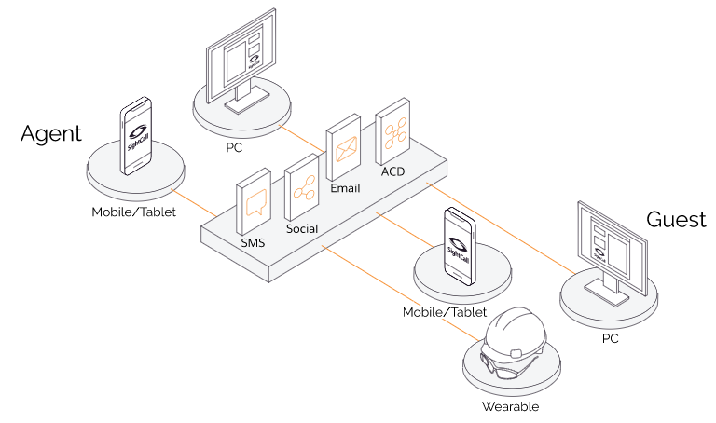
(Sightcall, 2023)

For customers, an invitation via SMS or e-mail will trigger a visual assistance session, or an Application can be installed on the remote device (mobile/tablet etc) for direct video link and AR opportunities.

Customer Service

Using Sightcall customers can show issues, or warranty claims in real time, allowing the customer service team to remotely resolve the issues, or confirm the warranty claim is valid. Issues should be resolved swifter, reducing the time spent on them.

Customer satisfaction will improve due to the speed of resolution, and costs will reduce by accurately assessing and potentially rejecting warranty claims.

Customer engagement is another benefit with real time visual support sessions.

Field Service engineers

Similar benefits can be gained for field service engineers.

Remote assistance - Service engineers can use remote Visual assistance to help customers resolve installation problems, or issues. A key benefit would be reducing travel, by reducing unnecessary onsite visits - cost saving, and an environmental benefit, reducing the company’s Carbon Footprint

Pre-Visit Assessment - If a site visit is required a Pre visit Assessment can remotely assess a site, determining the time, tools, and equipment necessary for the task. Better preparation would improve the first fix rate of service calls, as the correct tools, parts and information would be available.

AR guided repairs - Whilst on site the service engineer can use Sightcall for AR guided repairs, using step by step work instructions overlayed onto the area of work, reducing time to repair.

Remote support – Service engineers can receive on the job training from a remote expert using AR Visual assistance, reducing training time for inexperienced engineers.

Sightcall highlight features of AR as below:

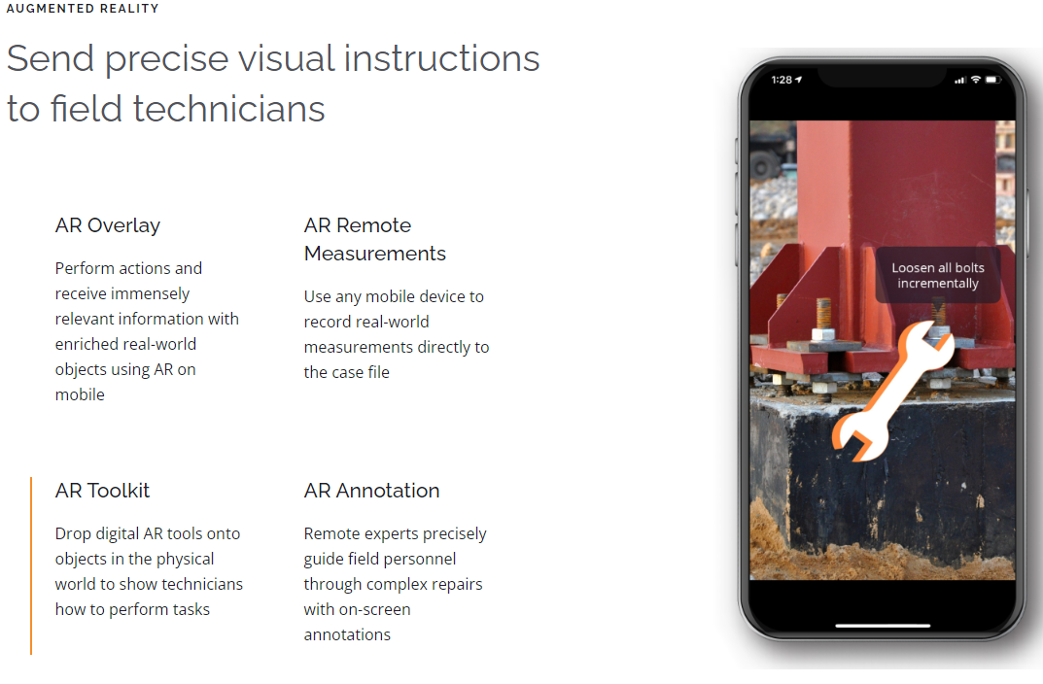
(Sightcall, 2023)

Wearables – Sightcall can integrate with wearable devices such as the M300XL Smart Glasses, manufactured by Vuzix. (Vuzix corporation, 2019). The wearable device, or Smart Glasses add a hands-free benefit to the Visual assistance, enabling safer operations, especially when handling dangerous equipment or working alone. The Augmented Reality benefits are enhanced by overlaying on the smart glasses, rather than through a mobile device held in hand.
Vuzix most recent model M400 is below:
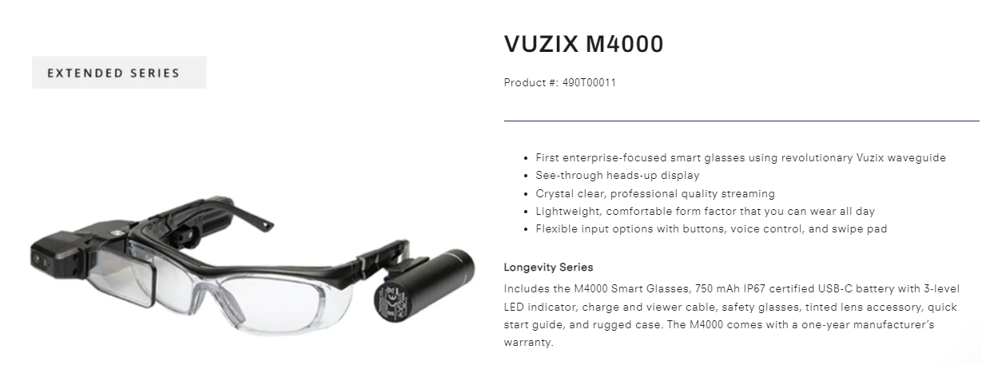
(Vuzix, 2023)

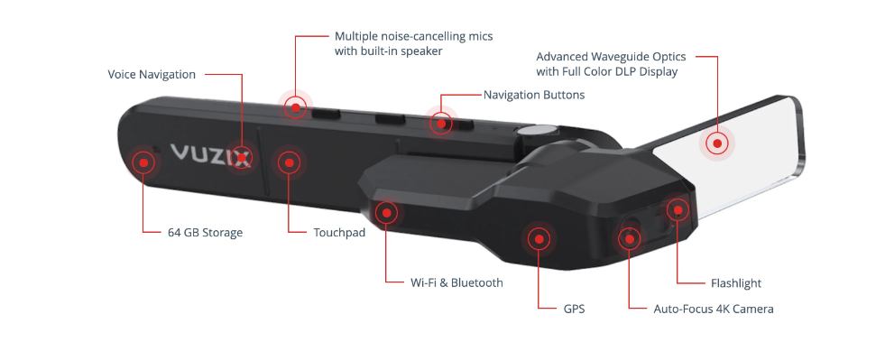
(Vuzix, 2023)

Industry 4.0 technology 3 – Augmented reality (AR) - Health and safety training

UKWDG has 30 sites (6 manufacturing sites + 24 trade counters). There are personnel on all sites, who UKWDG have a duty of care to keep safe. The personnel also have a duty to keep themselves and others safe.

The company must educate its employees with health and safety training to ensure they have the knowledge and competence to work safely. To conduct this training for nine hundred employees over thirty sites is challenging, involving co-ordination, excessive travelling and commitment from the Health and Safety department.

A solution is required to reduce the travelling and co-ordination, to simplify the process and the training. This can be achieved by adopting Industry 4.0 technology - Augmented reality (AR) to train employees remotely. The expected benefits for adopting AR would be:

- Environmental – reduced travelling reduces the Carbon footprint.
- Financial – reduced travelling reduces costs. Less personnel are required to deliver the training.
- Human – more health and safety training delivered.
- Social – simplified training, new technology would increase engagement of the employees, and show a positive step to Health and Safety auditors, customers and the community.

An example technology is ‘Sightcall,’ explored for the Customer Experience enabling technology. Sightcall could be used for Health and Safety Audits – using the visual assistance application to view and remotely highlight audit factors in real time. A more specific application is ‘Senar.’

Senar Training Application

Senar is a mobile application developed by GuidiGO. It is an Augmented Reality training platform which distributes simulators on mobile devices. Trainees can conduct real time immersive training, directly from their phones, in situations that would be too hazardous, costly, or impossible to replicate.

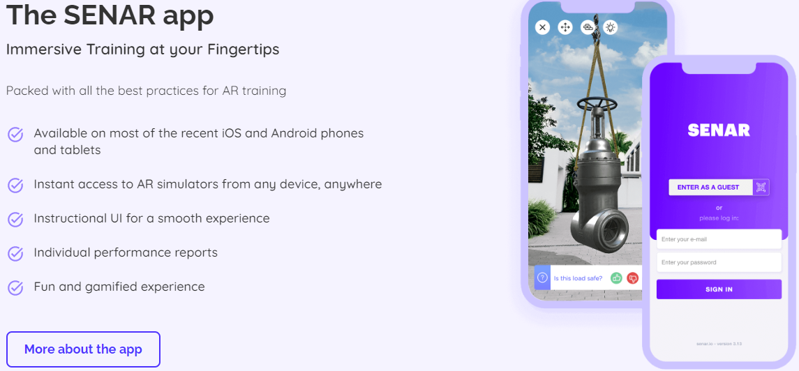
(GuidiGO Inc, 2022)

For example, there is a Fire Safety Training section, containing an Augmented Reality fire safety simulator, allowing trainees to learn about fire safety in an immersive environment without any risk to themselves.

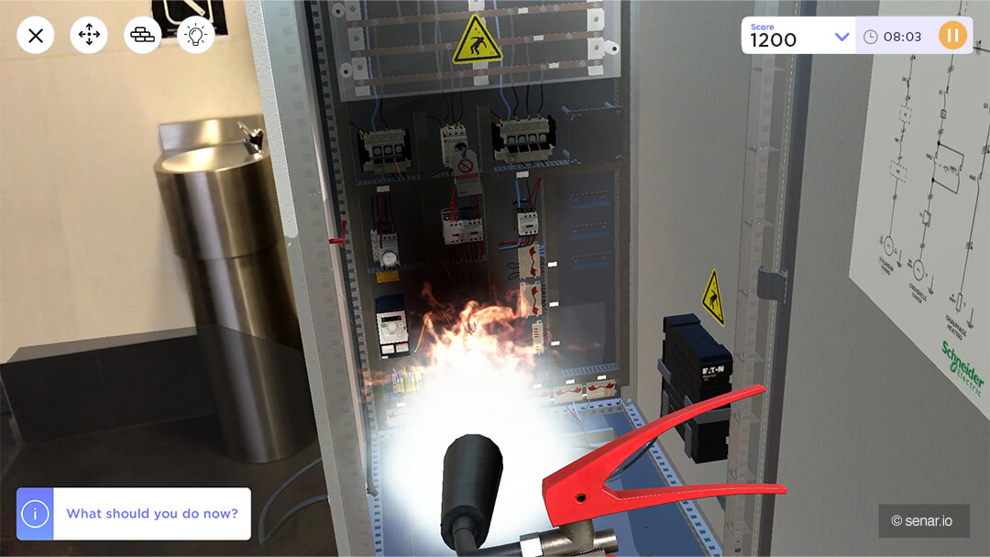
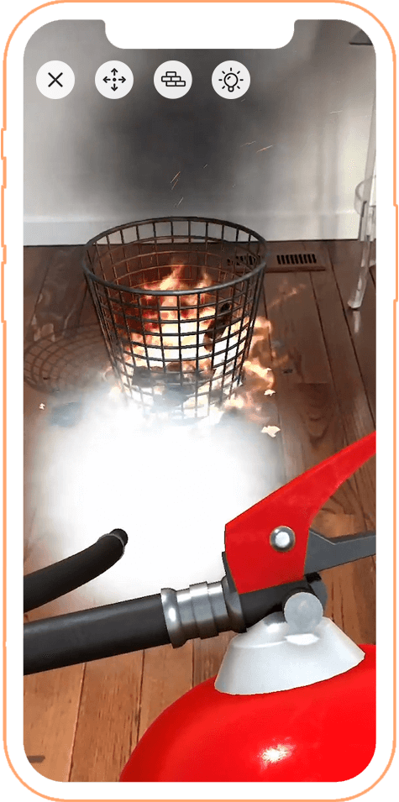
(GuidiGO Inc, 2022)

Several training scenarios presenting different situations are available, expecting the trainee to learn and react to these scenarios during the training. A score and report are available to show knowledge and competency gained from the training.
Benefits for UKWDG would include
- Increased engagement due to the method of training
- Instant training availability – distribute the scenario and all staff on all sites can complete the training
- Reduced travel burden – cost saving and environmental benefit – reduced carbon footprint

Conclusion

Businesses are aware of high-cost Industry 4.0 technology, and companies are criticised for not investing in Industry 4.0, however there are benefits that can be gained by low-cost Industry 4.0.

UKWDG have already adopted and trialling Industry 4.0 technologies, which are low cost, with instant benefits. The current financial position of the business prevents the adoption of large-scale Industry 4.0 technology such as the Griffin Windows process automation.

The 3 Innovations chosen to progress are based on costs, benefits, and scalability. If the technology is scalable, then investment can be spread, and the project can be phased to ensure its adoption.

- Robotics – Techniglass.
Benefits include Labour Cost savings and improvements in the safety of employees.

The implementation would not impact the production process due its cellular structure. The robotic solution would be like that of Glass Systems installation, an already proven project, and would not require major modifications to the process. Collaborative partners such as GS-MR are accessible to provide the solution. The project would be scaled proportionally with costs, for example one robotic unit per year.

- Customer Service – Augmented reality.
Benefits include cost savings in warranty claims and travel. Reduced travel also delivers an environmental benefit. Other benefits include improved Customer service and customer engagement, with the instant visual access to support.

The implementation would be through a collaborative partner, such as Sightcall, with a phased approach. The scalability of this Industry 4.0 technology is a key benefit.

- Health and safety training – Augmented Reality.
Benefits include cost savings due to reduced travel, which also delivers an environmental benefit. Training efficiency is vastly improved, with instant access to training in the normal place of work.

These Industry 4.0 technology innovations are key strategies for UKWDG to reduce costs, improve safety and reduce the Carbon Footprint of the business. All of which are key sustainability strategies – Financial Stability, Human Capital, and Environmental Impact. Social Impact and Assets and Infrastructure are also areas of benefit, with improved customer engagement and investment in technology and equipment to improve manufacturing processes.

If UKWDG succeed with these projects and prove the Financial and other benefits, further Industry 4.0 technologies can be a focus for UKWDG.

(Word Count – 4854)

References
- Erdman, 2023. Robotic IG to Sash Placement & Offload. [Online]
Available at: https://www.erdmanautomation.com/robotic-offload.html
- Erdmanautomation, 2023. UNMANNED ROBOTIC IG WORK CELL. [Online]
Available at: https://www.erdmanautomation.com/unmanned-robotic-ig-work-cell.html
- Glass Systems Ltd, 2022. LEADING THE WAY WITH INVESTMENT IN ADVANCED PROCESSING TECHNOLOGY. [Online]
Available at: https://www.glasssystems.co.uk/leading-the-way-with-investment-in-advanced-processing-technology/
[Accessed 2023].
- GS-MR, 2022. Press Releases. [Online]
Available at: https://gs-mr.com/press-releases/
[Accessed 2023].
- GuidiGO Inc, 2022. Fire Safety Training in Augmented Reality (AR). [Online]
Available at: https://www.senar.io/ar-training/fire-safety
[Accessed 2023].
- GuidiGO Inc, 2022. SENAR. [Online]
Available at: https://www.senar.io/
[Accessed 2023].
- Insight Data Ltd, 2022. Fenestration and Glazing database. [Online]
Available at: https://www.insightdata.co.uk/marketing-data/fenestration-and-glazing-database/
[Accessed September 2022].
- Qingdao Morn Building Materials Co.,Ltd , 2021. Argon filled insulating glass VS warm edge spacer insulating glass. [Online]
Available at: https://www.mornglass.com/argon-filled-insulating-glass-vs-warm-edge-spacer-insulating-glass.html
- Saint Gobain Glass, 2023. INSULATED GLASS UNIT. [Online]
Available at: https://in.saint-gobain-glass.com/insulated-glass-unit
[Accessed 2023].
- Schwab, K., 2017. The Fourth Industrial Revolution. Great Britain: Portfolio Penguin.
- Sightcall, 2023. Augmented reality for the modern workforce. [Online]
Available at: https://sightcall.com/technology/augmented-reality
- Sightcall, 2023. Sightcall. [Online]
Available at: https://sightcall.com/
- Sightcall, 2023. WebRTC Visual Support. [Online]
Available at: https://sightcall.com/technology/webrtc
- UKWDG, 2022. UKWDG. [Online]
Available at: https://www.ukwg.co.uk/
- Vuzix corporation, 2019. Vuzix Partners with SightCall to Deliver a See-What-I-See Field Service Solution on Vuzix' M300XL Smart Glasses. [Online]
Available at: https://www.prnewswire.com/news-releases/vuzix-partners-with-sightcall-to-deliver-a-see-what-i-see-field-service-solution-on-vuzix-m300xl-smart-glasses-300838480.html
- Vuzix, 2023. VUZIX M4000. [Online]
Available at: https://vuzix.uk/products/m4000-smart-glasses
[Accessed 2023].

