Student Name: Chantelle Simmonds
Student Number: 1914402
Module Code: BMSW 4005
Module Title: Professional and Career Development
Lecturer: Chrisford Chogugudza
Assignment Title: Portfolio of Work

CONTENTS

- Introduction
- Personal Development Plan
- Swot Analysis
- Desired Career
- Learning Development and Training
- Kolb
- Honey and Munford
- DISC
- Reflection

Introduction
This is a reflective report to assess my current skills and competencies, and to evaluate how they measure up against the requirements needed for my career of choice. I will be using a personal development plan and swot analysis to identify and analyse the skills I have and the ones I need to gain to full-fill the requirements. We will explain and evaluate the different learning and development training methods, which can be used to assess the capabilities of prospective employees.

Personal Development Plan
A personal Development plan is a continuous process of self-improvement and self-awareness. Having a Personal Development Plan will help you to self- reflect on your current skills and what skills you need to improve on to enhance the qualities you already hold to enable you to fulfil your personal, educational and career goals and achievements (Cottrell 2015). Taking steps to evolve who you are and where/who you want to be. PDP is effective in providing clarity so you can focus on precisely what you want to accomplish, forcing you out of your comfort zone which expands your perspective in your personal development. This makes you more confident and stronger allowing you to make realistic goals, highlighting the obstacles and challenges you may come across in advance (Morgan, 2017). The downfall of having a personal development plan is the constant updating if u miss/late in reaching a milestone, this will have an impact on the schedule you have set. Although some may look at this as reaching their milestones and changing circumstances to be able to see how far they have reached their achievements and in what time scale. Other disadvantages of a PDP when ‘not taking your self-development seriously when seeking success’ is:
- Lack of understanding may influence your thoughts and actions.
- Not able to find better and productive ways to achieve goals.
- Make unrealistic goals to attain.
- Not discover their real strengths or weaknesses.
- May start to have a negative outlook.
- I have developed my own personal development plan which is over a four-year time span.

Below is my personal development plan to achieve over the next four years.
 | Short-Term Time Frame | Mid-Term Time Frame | Long-Term Time Frame
My Goals | First year of university  Be more confident in lectures and assignments | Finish higher education- gain degree  Be more confident within learning in my own capabilities | Successfully finish degree to gain employability  Have a job that I enjoy and I’m passionate about
Skills and Knowledge to be Learnt | Better communication Problem Solving Critical Thinking | Public Speaking  Seek paid or voluntary work to gain experience | Employability Skills  Leadership Skills  Professional development
Next Steps | Continue Higher Education | Continue Higher Education  Seek Placement/voluntary work | Continue education and learning  Seek Employability

Swot Analysis
A swot analysis is beneficial to someone who wants to attain personal goals, highlighting and focusing on four criteria’s: your strengths, weaknesses, threats, and opportunities. Once someone has recognised the positive and negative characteristics in the swot analysis this should enable you to understand and diminish the negative that has been recognised by finding solutions in understanding what you’re lacking and in eliminating them to enhance the positive and reach the opportunities on a personal and professional level. Reducing your chances of failure (Mindtools, 2020).
Desired Career
THREATS
- Demand of my children
- Fear of failure
- Lack of Knowledge
- Other people looking for job with more experience
- Lack of confidence may lead to missed opportunities
- Failure in education
- Potential failure in interviews due to nervousness

OPPOURTUNITIES
- Finishing degree
- Still in a learning environment
- Can seek guidance from university support
- Gain experience in desired job
- Earn Money
- Continue professional training and learning to enhance development within domestic violence.

WEAKNESSES
- Need to attain more skills and finish degree
- Self-doubt and confidence in my own abilities
- Lack of voluntary work
- Lack of relevant work experience in my desired job
- Can take on too many responsibilities
- Maintaining balance with home life, studies, and work

STRENGTHS

Currently doing bachelor’s in health and social care
- NVQ level 2 in health & Social Care
- Experience in social care & vulnerable people
- Empathetic, patient & Caring
- Good Listener and understanding
- Passionate, honest & reliable
- Experienced 1st hand
- Good time keeping
- Attention to detail
- Great-team player
- Good communication and written skills
- Can work under pressure

My desired career would be to work as a domestic violence family support. As someone who has experienced domestic violence first-hand, I understand and recognise the impact it has on women and the consequences it has especially if children are involved. According to the Committee on the Elimination of Discrimination against Women (CEDAW,1992). Domestic abuse is largely a male perpetrated crime that has its roots in the inequalities between men and women in our society. As a family support worker looking to work with men and women who have/and are going through domestic violence, I would expect to offer advice and support to anyone who finds themselves in such a situation. As well as referring them to the necessary services such as counselling, I will also help them deal with and overcome any difficulties that may have manifested as a result of experiencing such traumas, such as depression, mental health issues and substance misuse.
To work with victims of domestic violence, employers usually seek someone with experience of working in social care, it is essential to not be judgemental and show compassion. Patience and sensitivity to individual needs are important as a lot of the people you will be helping won’t automatically want your help. Above all good communication skills are essential, as a lot of time will be spent speaking one to one with victims, so being able to reason and assess the situation is vital.

Some employers prefer their employees to obtain a degree in a mental-health sectors other accept a degree in mental health or social work-related areas. Within these areas, you can gain other qualifications that may give you an advantage when applying do jobs as a family support worker, such as:

Domestic abuse awareness Certificate or Diploma

BTEC National Certificate or Diploma in Children’s care Learning Development
- CACHE Certificate or Diploma in Childcare Education
The skills that are required to become a domestic violence support worker are important to be able to successfully help the people that need the services. for me to achieve the required skills for the position I will need to work on my professional development I was able to identify the skills I have for the position by my SWOT analysis. I've been able to identify I what skills I currently hold for the position such as I am already currently in higher education working towards my degree in health and social care, in my degree I will cover modules and attain knowledge related to psychology, child care policies, children young people and families. I already have the skills of communication, patience, empathy and understanding. I still need to obtain work experience, so I need to look for a voluntary placement. Further develop my knowledge by finding courses for other skills and knowledge needed such as-
Domestic abuse awareness, training on how to deal with responding to victims of sexual violence (Safelives, 2020). I need to investigate further training like distant learning, part time or short-term courses to acquire a certificate or diploma for the skills needed to fulfil my ambition.

Learning, Development and Training Methods
I have been assigned as an Assistant Manager to determine the methods of learning and growth preparation for new recruits that are expected to start at the organisation.
Learning Theories describe how an individual receives, processes, and retains information during learning. Emotional, cognitive and I’m environmental influences all have a position in how we understand, view, and retain knowledge that has been changed and acquired. Through the learning theories one will be able to develop and learn through, training courses, online courses, interactive learning, development activities and programmes. Dewey (1933) believes that an individual learns better through having a hands-on approach (interactive learning) and reflection, he states that ‘reflective is thought as active’.
As individuals we all have different learning styles, as an organisation recruiting the right candidates for the positions we hold, it is essential to see how an individual can perform. Having an induction within the company for new recruits to be able to bring them onboard is a process that is used for the recruits to learn ‘knowledge, information, skills, behaviours, organisation norms and values’(Neugebauer, J. & Evans-Brain, J. 2016) needed for the individuals’ to effectively become a member of the team. Onboarding strategy may incorporate a series of informal and formal activities. Socialisation theorist Felman (1981) suggests that to be able to adjust within a new working environment, ‘role clarity, task mastery and social integration’ are the three fundamentals that reflect how an individual will settle in the new workplace.
Training methods that were used to assess how the candidates worked well within a team was Interactive, visual, aural, critical and decision making training, this was done by ice breakers, team games, role play, re-enacting scenarios and case studies that they may be faced with on a day to day basis within the work environment. By rehearsing the scenarios given to them, receive and reflect on the feedback given to them on the outcomes that occurred. This technique should engage the recruits and help them retain the information.
By identifying how a person can learn effectively in their preferred learning style can strengthen them through the exercise of the experimental cycle.
Some of the method used were linked to the Kolb (1984) learning cycle which has four learning stages as it showed how a person learns through discovery and experience. Kolb’s model suggests that an individual cannot learn by just watching or reading, to understand and learn effectively you need to do.

Kolb four stages of the learning cycle:
Stage 1 - Concrete experience (Feeling)
Do the task so they have an experience, encounter a situation. Establishing a feeling, can relate to others around
Stage 2 - reflective observation (Watching)
Individuals are to reflect on the tasks that they have done and discuss the outcomes with each other asking questions and receive and give feedback
Stage 3 - Abstract conceptualisation (Thinking)
Understand what has happened, their involvement in the task and evaluating the event with what they already knew before the tasks took place.
Stage 4 – Active experimentation (Doing)
individuals are to contemplate how they would put what they have learnt into practice, and how what they have learnt relates to themselves and workplace.
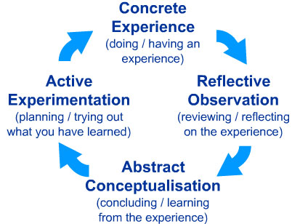 (McLeod, 2017)

The training method of Kolb enabled management to engage with the employees.
The four stages of Kolb have a continuous process, meaning individuals can do the steps numerous times. Throughout the four stages it highlights how different types of individuals prefer to learn. By understanding the cycle will create better training throughout an organisation.
Honey and Mumford’s theory is quite like Kolb’s theory as it was based upon Kolb’s work (University of Leicester 2020). Peter Honey (2016) emphasises that ‘learning to learn is your most important capability since it provides the gateway to everything else you want to develop. How you learn is a Key, if not the key life skill’. The Honey and Mumford learning theory identifies four learning preferences. Activist, Theorist; Pragmatist and reflector, are how we as individuals naturally prefer and approach to enable one to maximise their own personal learning.

Honey and Mumford Theory
Activist – individual who gets involved with activities/ tasks. They are open minded and open to new experiences. (role-play, brainstorming, and group discussion)
Theorist – These learners prefer to perceive the idea behind the action. They have models, ideas, and facts for them to interact with their learning method. Prefer to value highly to analyse and synthesise, by getting new data into a scientific and logical ‘theory’. (Background information, stories, and quotes.)
Pragmatist – Such individuals need to be able to see how learning in the real world can be effective. if they can find a way to bring the concepts into action within their lives, abstract ideas, and games have no use to them. Enjoy experimenting to see the new concepts, hypothesis, and techniques work. (problem solving, discussion, reflect on how to link learning into reality)
Reflector- Through observation and thinking about what’s happened these people learn. They prefer to observe and make judgements and conclude based on a variety of perspectives. (Observation, feedback, and paired discussion)

DISC
Clark (1940) introduced the DISC, this was developed to assess the dominance, influence, steadiness, and conscientiousness in an individual.
Dominance (D) personalities are naturally more confident and focused on successfully getting desired results.
Influence (I) personalities are more receptive and tend to form relationships, can persuade, and influence other people.
Steadiness(S) personalities are reliable, ingenuous and focuses on working in togetherness.
Conscientiousness (C) personalities emphasis on being precise, skilful, and competent
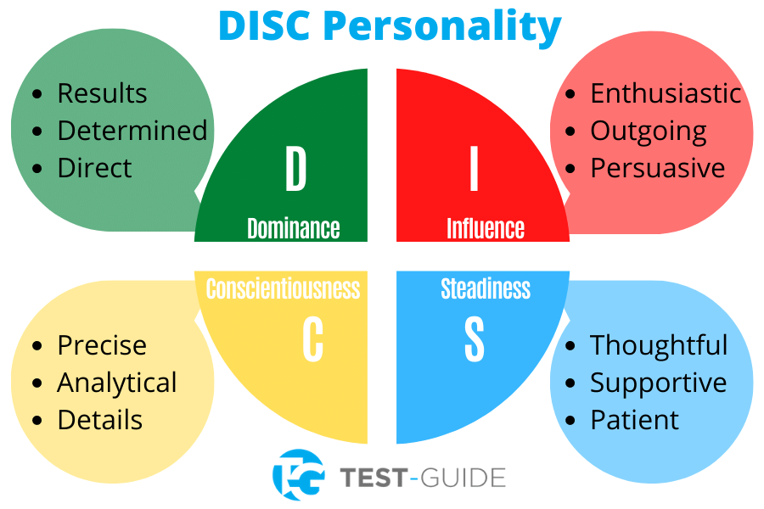(TEST-GUIDE, 2020)
A questionnaire given to employees to take time and answer which identified the four learning preferences, that were more suited for each individual.
The LSQ will highlight what learning style is preferred by individuals, this will be beneficial to the organisation to support the staff access different learning opportunities that are better suited for their predominant style. (Knight, 1983)
By learning in a way suited for the individual will make the learning easier, enjoyable, and effective. The individual can become more flexible in their learning styles, allowing them to have different experiences either informal, formal, or impetuous. Having an increased awareness of how one can learn can open self-analysis and development.
The learning style questionnaire (LSQ) will establish what is the employees preferred learning style by being self-aware.
Having a personal assessment tool can help improve the teamwork, build stronger, more effective working relationships, communication, and productivity within a workplace. Furthermore, the DISC can give people a better understanding of themselves. L.
The amalgamation of characteristics or qualities are what form the individual's distinctive character, and how one interacts and learns.
Mandatory training and keeping up to date with the everchanging rules, regulations and legislations are important when working within a team, dealing with vulnerable, sensitive men, women and families enduring domestic violence.
The training is highly recommended to:
- Elevate knowledge and understanding of the cases and work intended.
- Work within a team where our approach and views will differ with each caseload.
- Turn Conflict into collaboration.
- Be understanding to other people and be adaptable to how people behave.
- Critical thinking and decision making.
- Written skills.
- Have more effective results within the workplace.
- Have an approachable, enjoyable, productive working team.
A brilliant workplace will require to have a mixture of personalities, building staff confidence, understanding their strengths, weaknesses, learning styles and encouraging the development of skills providing positive learning, respectful working experiences to work effectively. By using the social-training methods and theories such as Kolb (1984) making learning fun and through interactive enables people to learn from one each other.
Reflection
Before I started university at UWTSD I wasn’t confident in my skills in learning although I felt confident within myself. I always concentrated on my home life thinking I couldn’t do anything for myself as I would not be able to find a balance. During the beginning of university, I done a PDP and swot analysis and towards the end a personality test - methods used to assess an individual’s strengths, weaknesses character and traits through different situations. The most common personality test used is the Myers Briggs Type Indicator (MBTI) a tool that measures an individual’s traits (Warley, 2020).
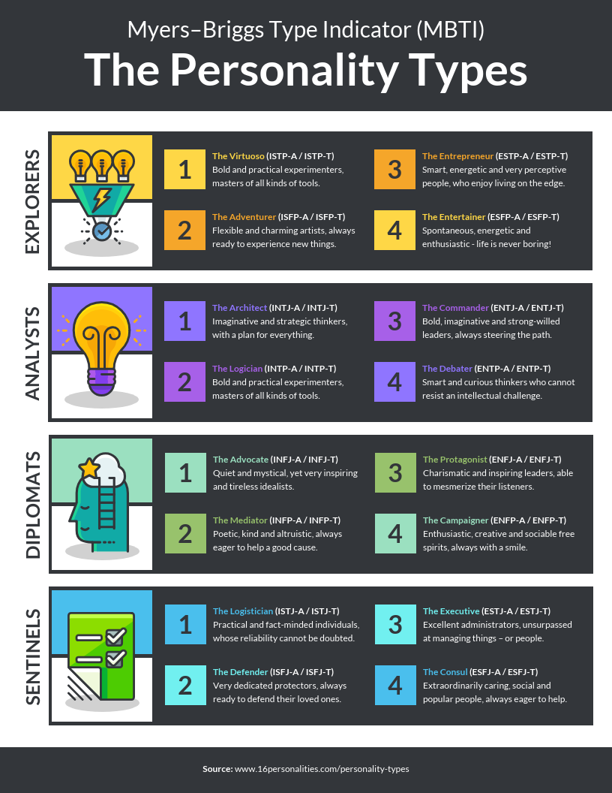(Neris, 2020)
When I done the personality test, I was found to be ISFJ-A an assertive defender this is somewhat true I can relate to these traits, hardworking, reliable, trustworthy, caring, protector, an introvert and more that was highlighted. These tools and methods have helped me understand myself and recognise I am more capable than I thought I was, whilst highlighting areas of improvement and enabling me to set realistic goals and how to start achieving them. I have completed my first year of university whilst working, raising my four children, and having my fifth, doing this has given me great courage and confidence.
During university one of the modules was digital skills, this module has developed me and prepared me for the uncertain circumstances we have all found ourselves in because of Covid-19. I’ve been able to confidently engage in my studies online with ease. Doing presentations which I feel I’m not confident in but successfully done with my peers as well as on my own. I still have room for improvement in presenting this was reflected in the interview that I done. Although I was hired in the presentation interview; this has given me a boost within myself. Some of the improvements I feel were already present on my PDP and swot in what I feel I need to develop, such as understanding and speaking clearer (due to nervousness).
After finishing the first year of university I am continuing into the second and third, hopefully succeeding in gaining a degree in health and social care. Throughout this time, I’m hopeful that that my weaknesses and threats I have highlighted on my swot analysis will diminish The Johari window has given me a great insight into my self-awareness, allowed me to become more open and recognise certain abilities and who I am that was unknown to myself. Within time I feel that I will be a more open person and make the blind, hidden and unknown areas of myself smaller.
Going into my second year of studies I will be more confident in my abilities in learning, I will continue my professional and personal development in attaining the skills I need to fulfil the requirements needed for my desired career as a domestic violence support worker.
References
Committee on the Elimination of Discrimination against Women (CEDAW, UN Women) (1992) General recommendations made by the Committee on the Elimination of Discrimination against Women. Published online: UN Women (Accessed 26 November 2020)
Cottrell, S. (2015) Skills for Success: Personal Development and Employability, Macmillan Education UK, London. Available from: ProQuest Ebook Central. (27 November 2020).
Dewey, J. (1933) How We Think: A Restatement of the Relation of Reflective Thinking to the Educative Process. Boston, MA: D.C. Heath & Co Publishers. (Accessed 27 November 2020)
DISC: The History of DISC Personality Styles. discinsights.com. Peoplekeys.inc (Accessed 27 November 2020)
Honey, P. and Mumford, A., (1992) The Manual of Learning Styles 3rd ed., Maidenhead: Honey (accessed 27 November 2020).
Enhancv. (2020) 4 steps to a success personal development plan. https://enhancv.com (Accessed 23 November 2020)

Knight, K. (1983) The Manual of Learning Styles Peter Honey and Alan Mumford. DOI/10.1177/135050768301400209 (Accessed 23 November 2020)

Kolb, D. A. (1984) Experiential learning: Experience as the source of learning and development (Vol. 1). Englewood Cliffs, NJ: Prentice-Hall. (Accessed 23 November 2020)
Maund, A., Schriek, M., & Tinker, P. (2017) Certificate in Higher Education: Skills For the workplace Yearbook-Workplace Learning and Development. (Accessed 23 November 2020)
McKenzie, E (2019) How to become a Domestic Violence Support Worker. Family Support Worker Job Description (pocketpence.co.uk). (Accessed 23 November 2020)
McLeod, S. A. (2017) Kolb - learning styles and experiential learning cycle. Simply Psychology. https://www.simplypsychology.org/learning-kolb.html (Accessed 23 November 2020)
Mindtools. (2020). Mindtools-Swot Analysis, How to Develop a Strategy for Success. Emerald Works Ltd. www.Mindtools.com (Accessed 26 November 2020)
Morgan, P. (2017) The Business Students Guide to Study and Employability-Personal Development and Learning, SAGE Publications, London. (Accessed 23 November 2020)
Neris, (2020) 16 personalities – Free personality test, type descriptions, relationship, and career advice https://16personalities.com (Accessed 27 November 2020)
Neugebauer, J. & Evans-Brain, J. (2016) In Employability London: SAGE. Ch.5, pg.94-112. (Accessed 24 November 2020)
Nyatyowa, L. (2017) 4 Reasons Why Personal Development Should Be a Priority - Oxbridge Academy Blog. www.oxbridgeacademy.edu.za (Accessed 23 November 2020)
Savelives. (2020) Diploma in Domestic Abuse Safelives. https://savelifes.org.uk (Accessed 26 November 2020)
Smith, M. (1999) Reflection learning and education – infed. https://infed.org/mobi/reflection-learning-and-education/ (Accessed 27 November 2020)
Test-Guide. (2020) DISC Personality Test - Complete Guide to the DISC Assessment. www.test-guide.com (Accessed November 2020)
University of Leicester. (2020) Honey and Mumford — University of Leicester. https://www2.le.ac.uk/ (Accessed 24 November 2020)
Warley, S. (2020) Life Skills That Matter My Personal Self-Assessment https://www.lifeskillsthatmatter.com (Accessed 25 November 2020)

