Dissertation

Student Name: Mariana Acris
Student Number: 2239619
Lecturer Name: Bentil Oduro
Module Name: LCB5000
“Managing Service Efficiency in the UK Supermarket Retail Sector: Operational Challenges and Employee Perspectives (2020–2024)”

Table of Contents
1. Introduction 3
2. Research Aim and Objectives 3
2.1. Research Aim 3
2.2. Research Objectives 3
3. Research Questions 4
4. Literature Review 4
4.1. COVID -19 and Post-Pandemic Operational Pressure 4
4.2. Workforce Shortages and Employee Wellbeing 5
4.3. Digital Transformation and Automation 6
4.4. Supply Chain Instability 6
4.5. Management Strategies for Service Improvement 6
4.6. Internal Service Factors and Employee Influences on Service Quality 7
5. Research Methods 8
5.1. Primary Data Collection 8
5.2. Secondary Data Collection 8
5.3. Data Analysis 8
6. Potential Implications 9
7. Conclusion 10
References 11

1. Introduction
The UK supermarket retail sector is one of the most dynamic and competitive industries, serving millions of customers every week and employing over one million workers. Between 2020 and 2024, the sector underwent significant operational disruption due to the COVID-19 pandemic, supply chain instability, rising operational costs, labour shortages and shifting consumer expectations. These challenges increased pressure on supermarket managers to maintain service efficiency, minimise waiting times, manage stock availability, deploy staff effectively, and adopt digital service innovations such as self-checkout and online delivery.
Service efficiency is essential because it directly influences customer satisfaction, operational costs, and organisational performance. In supermarkets, efficiency is measured through speed of service, queue length, staff responsiveness, product availability, and reliability of digital systems. Employees play a crucial role in delivering these outcomes, yet they also face daily operational barriers such as increased workload, technological issues, and staff shortages. Understanding their perspective is therefore essential for improving service performance.
This study seeks to analyse how UK supermarkets managed service efficiency between 2020 and 2024, with a particular focus on operational challenges identified by employees. Using both primary data (employee survey) and secondary sources (industry reports and academic literature), the study will evaluate current strategies and propose recommendations for improving service efficiency in the sector.

2. Research Aim and Objectives

2.1. Research Aim
To evaluate how UK supermarkets have managed service efficiency between 2020 and 2024, focusing on the operational challenges experienced by employees and the effectiveness of management strategies.

2.2. Research Objectives
- To identify the key operational factors affecting service efficiency in UK supermarkets.
- To explore employee experiences and perceptions of service management challenges.
- To analyse the effectiveness of strategies used by supermarket managers to improve service efficiency.
- To provide recommendations for enhancing service delivery and employee performance in the supermarket retail sector.

3. Research Questions
- What operational challenges have influenced service efficiency in UK supermarkets between 2020 and 2024?
- How do supermarket employees perceive these challenges and their impact on service delivery?
- What strategies have supermarkets introduced to improve service efficiency, and how effective are they?
- What improvements can be recommended to enhance service performance from an employee and operational perspective?

4. Literature Review
Service efficiency is widely recognised as a core determinant of retail performance. Parasuraman, Zeithaml and Berry’s (1988) SERVQUAL model highlights reliability, responsiveness and assurance as central to service quality, all of which rely on efficient operational processes. In supermarket settings, efficiency is particularly important because customer expectations tend to emphasise speed, staff assistance and product availability.

4.1. COVID -19 and Post-Pandemic Operational Pressure

The COVID-19 crisis had a profound effect on the day-to-day functioning of supermarkets. Deloitte (2021) reported that supermarkets faced unprecedented demand, workforce absences and pressure to adopt social-distancing measures. These disruptions slowed down service operations, increased queues and created unpredictable workload patterns. Although conditions improved post-pandemic, many supermarkets continued to face challenges linked to inflation and changing consumer behaviour.
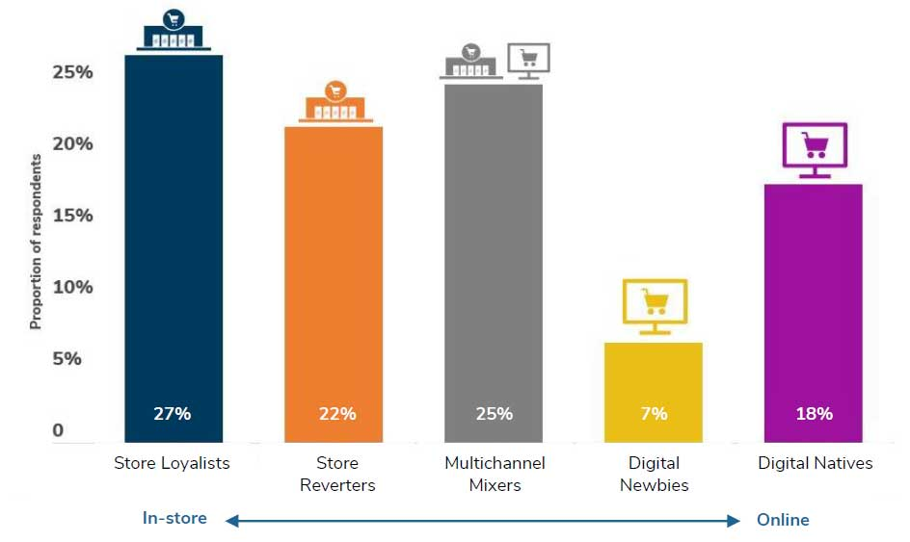
Figure 1. “Five grocery shopper segments have emerged from the Covid-19 crisis.”
Source of https://www.retaileconomics.co.uk/retail-insights/thought-leadership-reports/the-uk-grocery-market-five-key-trends-to-2025-report
Recent research identifies five distinct British grocery shopper segments that emerged during and after the pandemic, based on preferences for physical versus online channels:
Store Loyalists (27%) comprise mainly older consumers who have never used online grocery services and show little interest in doing so, valuing the in-store experience.
Store Reverters (22%) tried online shopping during the pandemic but prefer to return to physical stores, often due to unsatisfactory online experiences.
Multichannel Mixers (25%) are usually younger adults who use both online and in-store channels, but still carry out most grocery purchases in stores.
Digital Newbies (7%), generally under 45, began using online grocery services during the pandemic and now intend to continue shopping online regularly.
Digital Natives (18%) have been consistent online grocery shoppers before, during, and after the pandemic, including both tech-savvy younger consumers and older shoppers who benefit from the convenience.

4.2. Workforce Shortages and Employee Wellbeing
Labour shortages have been consistently identified as a major barrier to efficient service delivery. According to Retail Economics (2022), supermarkets experienced difficulties recruiting and retaining staff due to Brexit-related workforce reductions, sickness absences and rising competition from hospitality and logistics industries. Higher workloads can negatively influence employee morale, leading to reduced performance and increased stress. Homburg, Jozić and Kuehnl (2017) argue that employee wellbeing significantly shapes customer experience, highlighting the need for supportive workplace practices.

4.3. Digital Transformation and Automation
The increased use of digital technologies-including self-checkout systems and online delivery services-has reshaped supermarket operations. 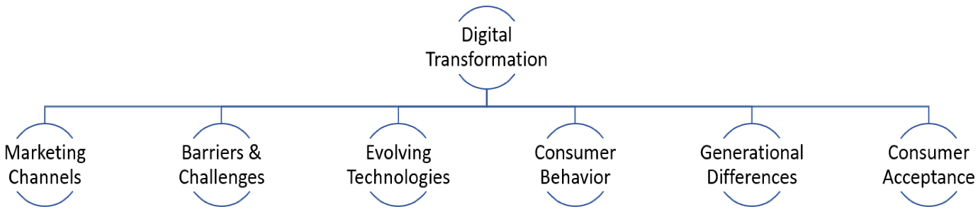
Figure 2.” Interpretive classification schema and analytical framework for study.”
While these tools can enhance efficiency, research also reports mixed outcomes. PwC (2022) suggests that digitalisation improves speed but can create technical problems, workload increases and customer frustration when systems fail. Employees often find themselves monitoring multiple self-checkout machines, dealing with errors and supporting customers who lack technological confidence.

4.4. Supply Chain Instability
Supply chain disruption, partly attributed to Brexit and global shortages, has resulted in delays and inconsistent stock availability. PwC (2022) notes that stock shortages negatively affect customer satisfaction and complicate employee tasks such as shelf replenishment and customer enquiries. These issues undermine service efficiency and increase pressure on frontline staff.

4.5. Management Strategies for Service Improvement
Research on retail operations highlights strategies such as lean management, cross-training, employee empowerment and predictive scheduling (Womack and Jones, 2003; KPMG, 2021). However, the success of such strategies depends on employee acceptance and effective implementation. Much existing literature prioritises technological or managerial perspectives, leaving a gap regarding employees’ lived experiences of operational challenges. This research seeks to fill that gap by incorporating employee viewpoints into the analysis of service efficiency.

4.6. Internal Service Factors and Employee Influences on Service Quality
Another important strand of literature relevant to supermarket service efficiency focuses on internal service factors (ISFs) and how employees’ perceptions of these internal organisational elements shape the quality of service delivered to customers. Research suggests that the internal organisational environment-comprising policies, service expectations, role design and communication systems-plays a crucial role in how employees interpret their responsibilities and interact with customers. A key study by Lings and Brooks (2018) examined the influence of ISFs on service quality from the viewpoint of supermarket employees and found that employee attitudes and organisational support mechanisms strongly predict service outcomes.
Their empirical analysis, based on a sample of 202 supermarket employees, demonstrated that three ISFs have the most significant impact on perceived service quality: service orientation, service role flexibility, and non-standardised scripted behaviour. Service orientation refers to employees’ inherent attitude and willingness to provide high-quality service. This factor was identified as the strongest predictor of positive service outcomes, suggesting that employees with a natural inclination to help and support customers play a critical role in ensuring efficient and satisfying service delivery.
The second key factor-non-standardised scripted behaviour-highlights the limitations of rigid scripts and pre-defined procedures. Employees who are able to adapt conversations, personalise interactions and respond creatively to customer needs were found to deliver superior service compared to those restricted by strict behavioural guidelines. This is particularly relevant in supermarkets where customer expectations can vary significantly.
The third factor, service-role flexibility, emphasises the organisational ability to adapt roles and allow employees to respond to situational demands. Flexible role structures enable workers to shift between tasks such as checkout assistance, shelf replenishment or customer service support during busy periods, thereby contributing to smoother service flow and reduced bottlenecks.
These findings reinforce the argument that efficient service delivery depends not only on technology and operational systems but also on employee empowerment, supportive internal policies and flexible job design. They also highlight the need for supermarkets to develop internal marketing strategies that nurture employee motivation and recognise the importance of staff autonomy and adaptive behaviour.

5. Research Methods
A mixed-methods design will be adopted, combining quantitative and qualitative elements to explore employee experiences of service efficiency. This approach is appropriate because it allows for both numerical assessment of trends and deeper insight into personal experiences.

5.1. Primary Data Collection
Primary data will be collected through an online questionnaire distributed to employees working in major UK supermarkets, including Tesco, ASDA, Sainsbury’s, Aldi and Lidl. Participants will include customer service assistants, checkout operators, shelf replenishers and supervisory staff. A sample size of 20–30 respondents is realistic for an undergraduate project and will offer valuable insights into operational challenges.
The questionnaire will include:
- Closed-ended Likert-scale questions measuring perceptions of workload, staff shortages, technology, queue management and team support.
- Open-ended questions allowing participants to describe their experiences and suggest improvements.
A convenience and snowball sampling strategy will be employed to access participants quickly and ethically.

5.2. Secondary Data Collection
Secondary sources will include academic journal articles, government publications, supermarket reports and industry analyses from Deloitte, PwC, KPMG and Retail Economics. These materials will contextualise primary findings and provide evidence of sector-wide trends.

5.3. Data Analysis
The quantitative survey data will be analysed using descriptive statistics to identify patterns in employee experiences, workload pressures and perceptions of service efficiency. Descriptive statistical techniques are widely used in retail studies to summarise trends and compare operational factors across groups (Bryman, 2016). Qualitative responses will be examined through thematic analysis, following a structured coding process to identify recurring themes such as staffing shortages, technological issues and customer behaviour (Braun and Clarke, 2006). Combining these techniques enables a comprehensive interpretation of employee perspectives and supports the reliability and validity of findings in organisational research (Saunders, Lewis and Thornhill, 2019).

6. Potential Implications
The research is expected to identify the key operational challenges that restrict service efficiency in UK supermarkets and reveal how employees interpret and respond to these pressures. Previous studies show that staffing structures, workflow coordination and organisational communication all play a central role in service outcomes (Parasuraman, Zeithaml and Berry, 1988; Homburg, Jozić and Kuehnl, 2017). The findings may therefore highlight areas where supermarkets need to refine staffing models, strengthen communication, improve employee support systems and enhance the reliability of digital technologies.
In addition, the study is likely to shed light on the unintended consequences of digitalisation. Industry analyses indicate that self-checkout systems, monitoring technologies and automation often increase employee workloads and create new service bottlenecks (PwC, 2022; KPMG, 2021). Digitalisation may also shift responsibilities onto fewer staff, requiring improved training and better workflow design.
For industry practitioners, the results may offer practical recommendations for improving service quality, reducing operational inefficiencies and supporting employee morale during peak service periods (Deloitte, 2021). For policymakers, the findings may inform discussions on workforce development, retail labour standards and post-Brexit labour market planning, particularly given ongoing shortages across the retail sector (Retail Economics, 2022).
For the academic community, the study will contribute to existing literature by providing detailed insights from employees-an internal perspective often overshadowed by consumer-centric or managerial research (Womack and Jones, 2003).

7. Conclusion
This proposal outlines a study examining how UK supermarkets managed service efficiency between 2020 and 2024, emphasising employee perspectives on operational challenges. A mixed-methods approach will enable the collection of both numerical trends and qualitative insights. By bridging the gap in literature regarding employee experiences, the research aims to contribute original and practical recommendations for improving service performance, digital integration and staff wellbeing. The expected findings will contribute to improving operational practice, supporting staff performance and informing retail policy in a rapidly evolving supermarket environment (PwC, 2022; Retail Economics, 2022).

References
Deloitte (2021) UK Retail Industry: Navigating the Impact of COVID-19. Deloitte Insights. Available at: https://www2.deloitte.com (Accessed: [insert date]).
Homburg, C., Jozić, D. and Kuehnl, C. (2017) ‘Customer experience management: Toward implementing an evolving marketing concept’, Journal of the Academy of Marketing Science, 45(3), pp. 377–401.
KPMG (2021) UK Retail Outlook 2021. Available at: https://home.kpmg/uk (Accessed: [insert date]).
Parasuraman, A., Zeithaml, V.A. and Berry, L.L. (1988) ‘SERVQUAL: A multiple-item scale for measuring consumer perceptions of service quality’, Journal of Retailing, 64(1), pp. 12–40.
PwC (2022) UK Retail Outlook 2022. Available at: https://www.pwc.co.uk (Accessed: [insert date]).
Retail Economics (2022) Retail Industry Labour Market Review 2022. Available at: https://www.retaileconomics.co.uk (Accessed: [insert date]).
Womack, J.P. and Jones, D.T. (2003) Lean Thinking: Banish Waste and Create Wealth in Your Corporation. Revised ed. London: Simon & Schuster.
Burt, S., Sparks, L. and Teller, C. (2010) Retailing and Retail Strategy. Oxford: Oxford University Press.
Lings, I.N. and Brooks, R.F. (2018) ‘Internal organisational aspects of service delivery and their influence on service quality from the employee perspective’, Service Industries Journal, 38(5–6), pp. 324–347.
Braun, V. and Clarke, V. (2006) ‘Using thematic analysis in psychology’, Qualitative Research in Psychology, 3(2), pp. 77–101.
Bryman, A. (2016) Social Research Methods. 5th ed. Oxford: Oxford University Press.
Smith, J. (2014) ‘Understanding Big Data: Definitions and Applications’, Journal of Information Science, 40(5), pp. 673–684.
Saunders, M., Lewis, P. and Thornhill, A. (2019) Research Methods for Business Students. 8th ed. Harlow: Pearson.

