A COMPARISON OF THE MARKETING METHODS OF TWO MULTINATIONAL HOTEL BRANDS

Begum Rujina Khatun
2234581

Marketing Essentials BMIH4005
Christopher Wilkin
Word count 1,529

Introduction
Marketing is not just a means to bring in sales but to provide customers with valuable insight to the brand, what it’s values are and what sets it apart from its competitors. This is particularly important in the hotel industry and marketing successfully can help ensure longevity. This essay will use situational analysis, marketing mix theory and segmentation targeting to compare the marketing methods used for two multinational hotel brands, Six Senses and Moxy. Six Senses aims to offer its customers a luxury experience with a focus on wellness and sustainability and appears to focus on an older and wealthier consumer group. Moxy looks to appeal to a younger generation and provides a more affordable option with a modern and playful style to its hotels.

Main Body
Moxy has grown considerably since it’s first launch in 2014 with now 134 hotels around the world (Moxy Hotels, 2019). Six Senses meanwhile launched in 1995 and now has 22 hotels and resorts, two of which will be opening in 2023 (Sixsenses.com, 2019). SWOT analysis (CIPD, 2021) on both these brands (see appendix 1) highlights some differences in how they market their brands and a PESTLE analysis (CIPD, 2021) shows factors that may affect the hotel industry (see appendix 2).
One of the biggest strengths attributing to Moxy’s growth could be its unique concept and design which they partnered with Ikea to create. This partnership ensured they could keep the rooms as small as possible to keep prices low for budget conscious travellers but still practical and modern (King, 2013). It also provides large communal areas and bars which continues the brands playful theme and can help target travellers hoping to meet other travellers (Ismael, 2020). In contrast to this, the strength for Six Senses is that they have focused on being a luxury and sustainable brand and this is most definitely not for the more low budget travellers. Although this could become a weakness for them in terms of losing potential customers due to the high prices, sticking to their core values can help ensure they have a loyal customer base who will still visit their resorts because of what they represent and will choose to pay more for this. The lack of some traditional services and amenities at Moxy hotels such as having a bar instead of a reception desk and their ‘fun hunters’ concept (Rackl, 2018) implying that the hotel is not for rest but for partying, may cause confusion to some customers and potentially make them avoid the hotel if they are just looking for somewhere to rest. One of the threats Moxy faces due to it’s success, is having other hotel chains such as Hilton, launching their own versions also aimed at millennials (Sathyanarayanan, 2016). However, to continue Moxy’s growth and keep it relevant with its target market, Moxy should utilise opportunities for celebrity endorsements through it’s hotel and/or bars as it did when Kendall Jenner, Supermodel, rented out the Little Sister Lounge at Moxy East Village hotel (Whitman, 2022). An opportunity to attract more customers to the Six Senses resorts could be to introduce pet friendly experiences in addition to the wellbeing and family friendly experiences they already have. Globally, there has been a rise in pet ownership particularly amongst millennials (Elad, 2023) and Moxy has already tapped in to this market by making it clear that customers are able to bring their pets to the hotels.
In terms of external factors that may affect the hotel industry, both these hotels may encounter similar issues. For example, Indonesia’s extramarital-sex ban which won’t come in to effect for 3 years, has already received global attention with fears that this law may also be applied to tourists (The Economist, 2022). Both Moxy and Six Senses have hotels based in Indonesia so this could potentially mean less tourists book stays there until they are confident this new law will not apply to them. Economically, the cost of living crisis continues around the world and there is no way to foresee how much this will impact on the profitability for the hotel industry (Price, 2023). This could cause Moxy and Six Senses to increase their prices for their rooms and on other services they provide such as food, spa treatments, etc. Whilst this may not affect the Six Senses target market as much as their customers appear to be able to afford their luxury services already so may continue to be able to despite the crisis, this may not be as easy for Moxy to retain their customer base of consumers who are looking to stay at more low budget hotels. With regards to the use of technology, Moxy is trying to ensure it keeps it’s target market engaged by trying to introduce an interactive mixed reality experience to some of it’s hotels (Wong, 2022). Six Senses keeping true to their brand, are trying to utilise technological advances in sustainable ways for example the Six Senses Svart in Norway which is the world’s first energy positive hotel potentially paving a way for carbon-neutral travel (Sejal, 2022). This project, as well as others such as their plastic free 2022 commitment (Sixsenses.com, 2019), they are continuously finding ways to stay environmentally conscious. Moxy is also trying to lead the way in sustainability making claims such as Moxy Bergen in Norway of being “the most sustainable hotel in the country” (Hahn, 2021).

In terms of the marketing mix theory proposed by McCarthy, 1960 and Booms and Bitner, 1982, the two hotels have similarities and differences in how they market their brand. Prices for the two hotels differ depending on the location of the individual hotels rather than keeping a standard pricing strategy across the board. This means that they can charge less to consumers in areas where the hotels cost are also less subsequently leading to being able to offer their services to a wider market. For example, Six Senses Ibiza is much cheaper to book compared to other Six Senses resorts in other countries and so can attract a more budget conscious traveller who is still seeking a high quality service. Both hotels also have a presence on Instagram and Facebook which provide ease of access to their website, can show any promotional offers and also to highlight any brand events. Both brands have also developed apps for their hotels which give customers the ability to book stays and other services such as Six Senses in room ordering. Moxy also provides a city guide in it’s app to make it easy for customers to navigate their way around the area whilst staying at a Moxy hotel. Six Senses wants to create a meaningful experience for it’s customers surrounded by nature and chooses to base it’s hotels in more remote areas (Stombelli, 2020) appealing to customers wanting a longer stay whilst the locations of Moxy hotels are mainly city based, and some are also based at airports, which may suggest again it’s appeal towards a younger demographic and travelling customers who are looking for short stays. Both hotels consistently have very good reviews on online booking websites suggesting the delivery and quality of their service is well received by their customers.

Consumers are increasingly using their phones rather than desktops to make every day decisions (Singh and Jang, 2020). The Similarweb data (see appendix 4 and 5) proves this to be true for both these brands as it showed a very high percentage of people accessed each of the websites using phones rather than desktops. This shows the importance of finding ways to provide ease of access to their services through mobile phones however, although Moxy appears to target the younger market, Six Senses has had nearly double the amount of visitors on it’s website compared to Moxy overall. Unfortunately no data could be obtained on SimilarWeb to identify the demographic statistics for visitors to Moxy’s website but surprisingly, 56.28% of people accessing the Six Senses website were aged 18-34 years old which conflicts with the initial assumption that the majority of the target market for this brand is an older generation.

Conclusion
Although Moxy tries not to specify an age range for it’s target market, the brand’s concept, the locations of its hotels and it’s designs does appear to be largely aimed at a younger generation, in particular millennials, looking to have a fun time and maybe meet other people as opposed to being a more ‘traditional’ hotel where you book to rest. In comparison, Six Senses hotel as assumed earlier, looks to attract customers who are wanting to focus on resting and wellbeing as this is a big part of it’s brand. However, Six Senses doesn’t appeal to just an older generation as was expected, but actually towards a larger group of younger customers similar to Moxy’s target market. And whilst Six Senses does focus very largely on sustainability, both the brands have essentially relied on methods to market their brands towards a more economically and environmentally conscious target market. This may also bring longevity to both the brands as consumers are becoming more aware of the impact products and services have on individuals and on the environment. (Singla, 2022).

Reference List

Booms, B.H. and Bitner, M.J. (1982). Marketing Services by Managing the Environment. Cornell Hotel and Restaurant Administration Quarterly, 23(1), pp.35–40. doi:https://doi.org/10.1177/001088048202300107.

CIPD (2021). PESTLE analysis. [online] CIPD. Available at: https://www.cipd.co.uk/knowledge/strategy/organisational-development/pestle-analysis-factsheet#gref.

CIPD (2021). SWOT Analysis | Factsheets | CIPD. [online] CIPD. Available at: https://www.cipd.co.uk/knowledge/strategy/organisational-development/swot-analysis-factsheet.

Elad, B. (2023). Pet Ownership Statistics - By Types Of Pets, Region and Breeds. [online] Enterprise Apps Today. Available at: https://www.enterpriseappstoday.com/stats/pet-ownership-statistics.html#:~:text=As%20per%20the%20pet%20ownership%20statistics%2C%20the%20number [Accessed 9 Feb. 2023].

Hahn, J. (2021). Norway’s most sustainable hotel opens in Bergen. [online] THP News. Available at: https://tophotel.news/norways-most-sustainable-hotel-opens-in-bergen/ [Accessed 9 Feb. 2023].

Ismael, A. (2020) ‘The Moxy East Village, a Marriott Bonvoy hotel, trades space for affordable prices — here’s why the small rooms are no compromise’, Business Insider, 14 January. [online] Available at: https://www.insider.com/guides/travel/moxy-east-village-hotel-review-new-york. (Accessed 7th February 2023)

King, D. (2013) ‘Marriott partners with Ikea for budget hotel brand Moxy’, Travel weekly, 05 March. [online] Available at: https://www.travelweekly.com/Travel-News/Hotel-News/Marriott-partners-with-IKEA-to-launch-economy-hotel-brand. (Accessed 7th February 2023)

McCarthy, E.J. (1960). Basic marketing a managerial approach. Homewood, Ill. Irwin.
‌Moxy Hotels. (2019). Moxy Hotels | Stylish Budget Hotels. [online] Available at: https://moxy-hotels.marriott.com/.
Price, K (2023). ‘Mixed fortunes predicted for UK hotel...’ The Caterer, 30 January. [online] Available at: https://www.thecaterer.com/news/mixed-fortunes-predicted-uk-hotel-industry-2023-rsm [Accessed 9 Feb. 2023].

Rackl, L. (2018) ‘Moxy hotel welcomes “fun hunters”’, Chicago tribune, 9 May. [online] Available at: https://www.chicagotribune.com/travel/ct-trav-first-look-new-moxy-hotel-chicago-0520-story.html. (Accessed 7th February 2023)

Sathyanarayanan, D. (2016) ‘Hilton Worldwide targets Millenials with new midscale brand “Tru by Hilton” [Hotels / Restaurants]’, The Economic Times, 28 January. [online] Available at: https://economictimes.indiatimes.com/industry/services/hotels-/-restaurants/hilton-worldwide-targets-millenials-with-new-midscale-brand-tru-by-hilton/articleshow/50759633.cms. (Accessed 7th February 2023)

Sejal, T. (2022). Six Senses Svart - World’s First Energy Positive Hotel | Luxsphere. [online] www.luxsphere.co. Available at: https://www.luxsphere.co/six-senses-svart-norway/ [Accessed 9 Feb. 2023].

SimilarWeb (2022). Similarweb.com - Digital World Market Intelligence Platform. [online] SimilarWeb.com. Available at: https://www.similarweb.com/.

Singh, S. and Jang, S. (2020). Search, purchase, and satisfaction in a multiple-channel environment: How have mobile devices changed consumer behaviors? Journal of Retailing and Consumer Services, p.102200. doi:https://doi.org/10.1016/j.jretconser.2020.102200.

Singla, R (2022) ‘7 branding trends that will emerge in 2022’, The Economic Times, 01 January. [online] Available at: https://economictimes.indiatimes.com/small-biz/marketing-branding/branding/7-branding-trends-that-will-emerge-in-2022/articleshow/88629692.cms.

Sixsenses.com. (2019). Luxury Resorts, Spa Escapes - Six Senses About Us. [online] Available at: https://www.sixsenses.com/en/about-us.

Stombelli, V.M. (2020) ‘Corporate Social Responsibility in hospitality: are sustainability initiatives really sustainable? Case examples from CitizenM, Lefay and Six Senses’, Worldwide hospitality and tourism themes, 12(5), pp. 525–545. Available at: https://doi.org/10.1108/WHATT-06-2020-0041.

The Economist. (2022) ‘Indonesia’s ban on extramarital sex represents a turn for the worse’. [online] Available at: https://www.economist.com/asia/2022/12/08/indonesias-ban-on-extramarital-sex-represents-a-turn-for-the-worse [Accessed 9 Feb. 2023].

Whitman, S. (2022) ‘Kendall Jenner Stuns In Blinding White Strapless Dress For NYC Party: Photos’, Hollywood Life, 23 September. [online] Available at:
https://hollywoodlife.com/2022/09/23/kendall-jenner-strapless-dress-818-tequila-party-photos/. (Accessed 7th February 2023)

Wong, K. (2022) ’Moxy Hotels celebrates inclusivity with virtual space.’ Marketing-Interactive 20 September. [online] Available at: https://www.marketing-interactive.com/moxy-hotels-celebrates-inclusivity-with-virtual-space [Accessed 9 Feb. 2023].
‌

Appendix 1
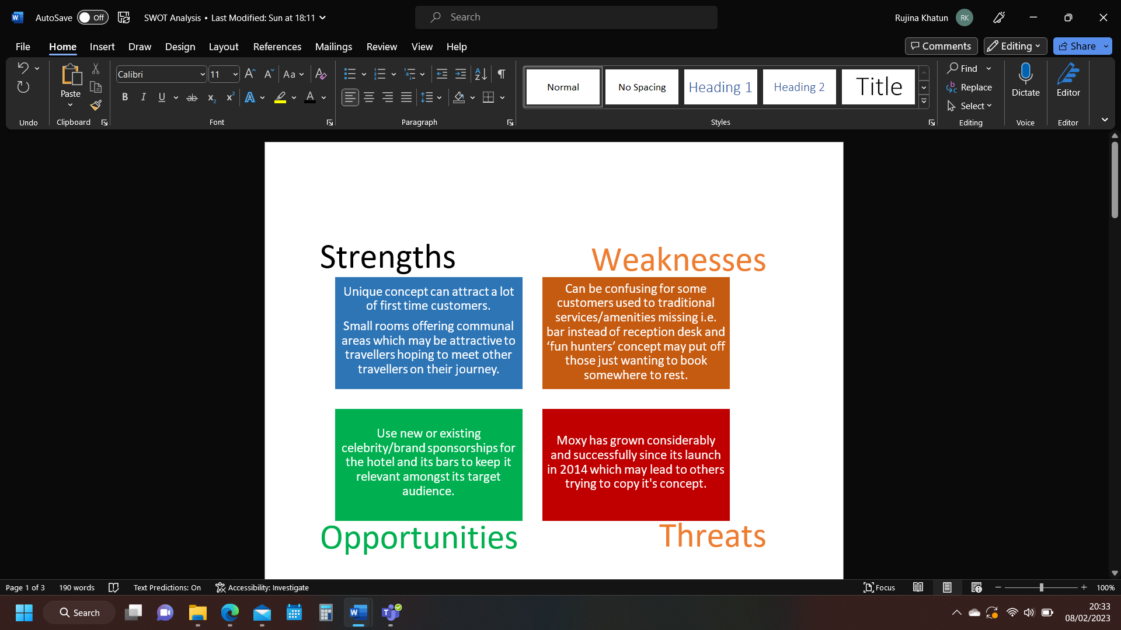
Moxy Hotel SWOT Analysis

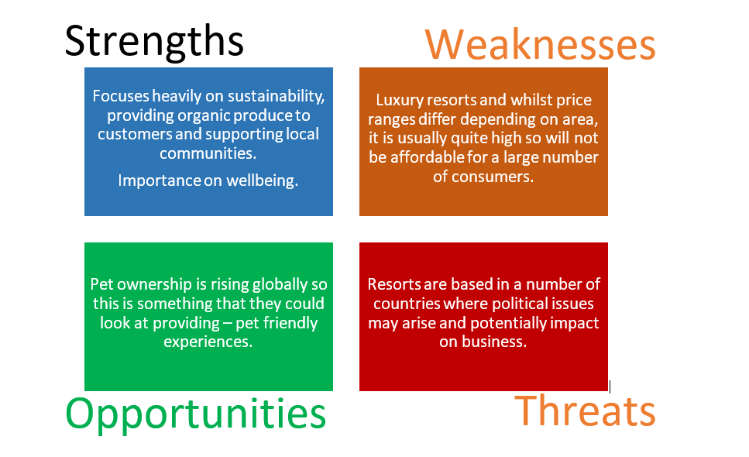
Six Senses SWOT analysis

Appendix 2 – PESTLE Analysis for hotel industry
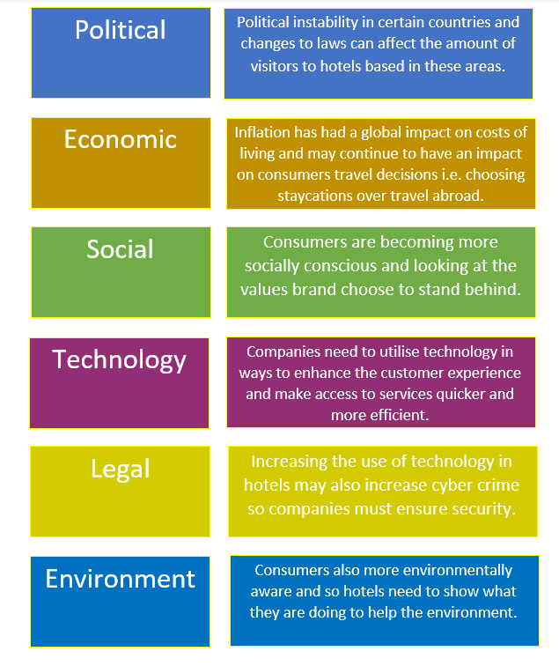

Appendix 3 - Moxy Hotel Similarweb analysis

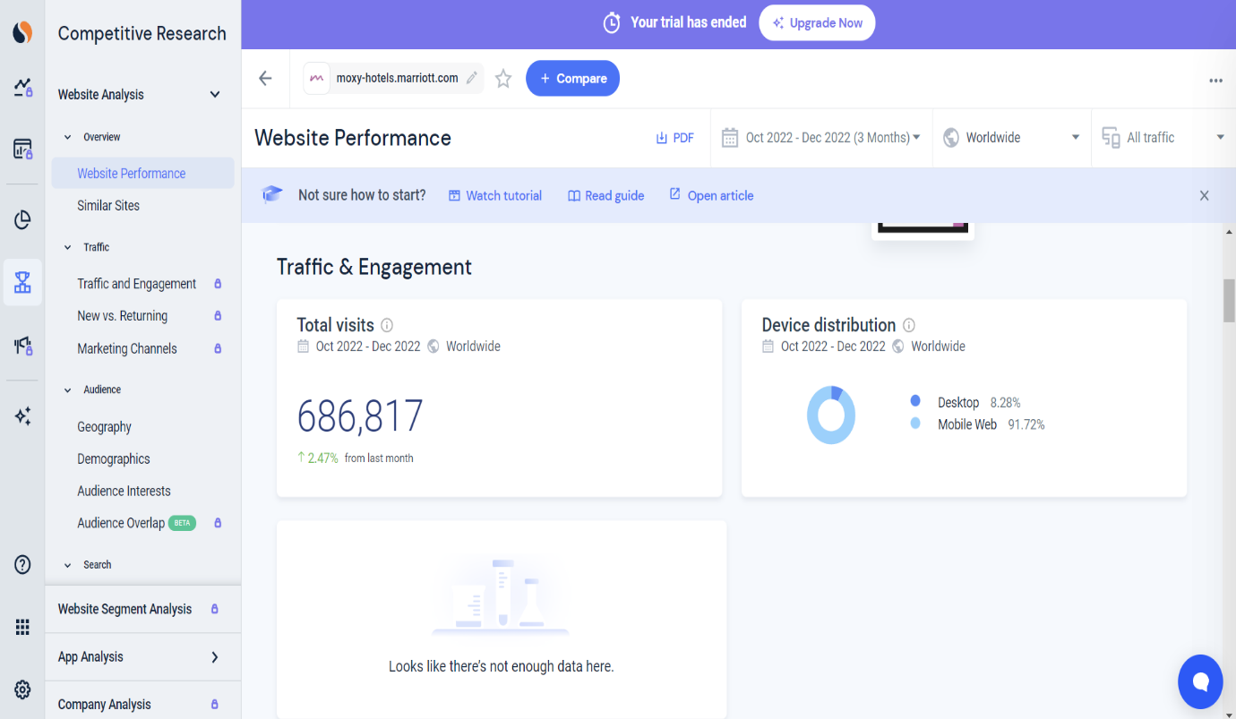

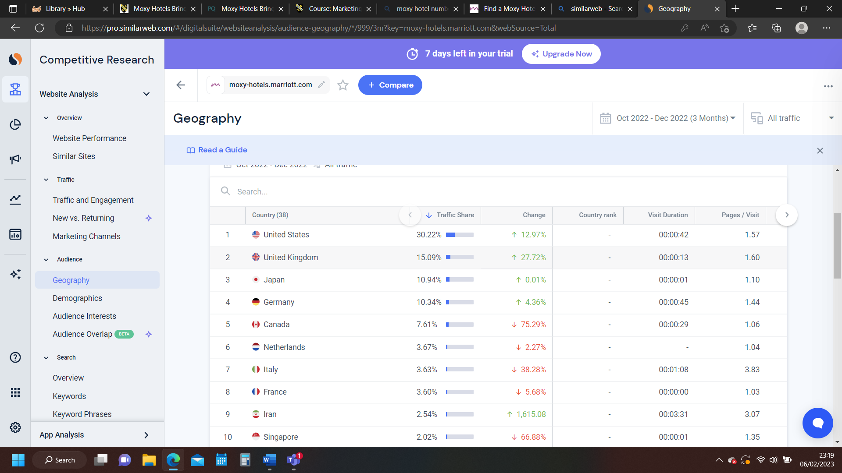

Appendix 4 - Six Senses Similarweb analysis


