
global marketing strategy
Assignment 2 – Implementing the Market entry strategy

May 1, 2020
jESSICA rEES
1703037

Table of Contents

Executive Summary……………………………………………………………..Page 1

Introduction…………………………………………………………………………Page 2

Report Remit………………………………………………………………….Page 2

1.2 Introduction to organisation (previous report)……………….Page 2

Hofstede Cultural Dimensions………………………………………………Page 3 - 5

Marketing Mix………………………………………………………………………Page 5
3.1 Product and Promotion………………………………………………….Page 6

3.2 Place……………………………………………………………………………….Page 7

3.3 Price………………………………………………………………………………..Page 7

3.4 People……………………………………………………………………………..Page 8

3.5 Processes……………………………………………………………………….Page 8

3.6 Physical Evidence……………………………………………………………Page 9

Conclusion…………………………………………………………………………….Page 9

Recommendations…………………………………………………………..Page9

References…………………………………………………………………………….Page 10 -11

List of Figures

Figure One. Hofstede’s Cultural Dimensions Model - Page 3
Figure Two. Italy’s Hofstede Insights – Page 4
Figure Three. Marketing Mix Model – Page 6

Executive Summary

The purpose of this report is to understand how Uber can build a more strong and resilient presence in international markets. To understand this further, models such as the marketing mix 7P’s will be used as well as introducing a different framework, referred to as Hofstede’s Cultural Dimensions which allows Uber to see insights into the key cultural forces that may have an influence on their existing marketing activities or if the company chooses to standardise. It is interesting to note that Uber can learn from their mistakes in 2017, when they initially tried to penetrate the market but were ruled out due to unfair competition (Chapman, 2017). These actions were not thoroughly understood, which is why these models and frameworks are important as they digest every aspect to rule out any risks.
Throughout the research conducted in this report, it is found that Hofstede’s Cultural Dimensions is really useful to understand cultural forces more as these have a big impact on the business, and since Uber have chosen to take a market entry strategy of partnerships, it helps Uber understand that they have high scores for each element of the 6 dimensions which is typically understood that Italians are more emotional people.
It is found that when delving further into the marketing mix by using the 7P’s, facets such as products and promotion is important for multinational companies as minor adjustments can be made instead of revamping altogether. Rique (2019) mentions that Coca Cola incorporate their signature style in all products around the world but then also include the country’s language or create the bottle the same size as other beverages sold in that country’s market. This can be relatable for Uber as the service itself does not change, but the processes and attributes can be shaped to suit the Italian market.
With the findings of this report, firm recommendations can be made, suggesting that Uber can continue to use the marketing mix and Hofstede’s cultural dimensions as these have proven useful for the business to analyse exactly what type of environment they are about to go into as well as considering using partnerships as a method of market entry for other global markets.

1

1.0 Introduction

Report Remit

Following on from the initial report that recommended that Uber should enter into the Italian market using a partnerships market entry strategy, this document will put forth a detailed plan that deals with the practical implementations of this market entry using the marketing mix as a framework to structure this report. From this, firm recommendations will be produced to aid the organisation moving forward. To break down further what Uber need to carry out to implement their global marketing strategy, the marketing mix 7P’s will be used to understand each facet more clearly, as well as using Hofstede’s Cultural Dimensions to analyse culture aspects of penetrating the Italian market using the entry mode of partnerships.

1.2 Introduction to Organisation

Uber started as a simple idea on a cold winter evening in Paris in December 2008. Founders Travis Kalanick and Garrett Camp couldn’t get a taxi, resulting in the birth of Uber. By March 2009, the entrepreneurs had developed a smartphone app with a simple use - tap a button and take a trip. By July 2010, the first Uber ride was requested across San Francisco. (Uber.com, 2020)
One year on and Uber was launched internationally, taken back to its birthplace in Paris which happened 3 years prior. By 2012, Uber’s potential to be more than just a ridesharing business was recognised resulting in on-demand ice cream deliveries launched in 7 cities across the US! From here Uber recognised its potential to create new projects, some of which that help important movements and local communities. Examples of these are the support of the LGBTQ+ community, UberKITTENS, UberMILITARY, Uber Eats, ‘Meals on Wheels’, Uber Health and so forth.
2

2. Hofstede Cultural Dimensions

Created in 1980, Geert Hofstede developed the Hofstede’s cultural dimensions theory, a framework used to further understand the differences of culture around the globe from different national cultures (Hollensen, 2013). Using this model, businesses can understand different cultures, different dimensions of culture and how this impacts a business.
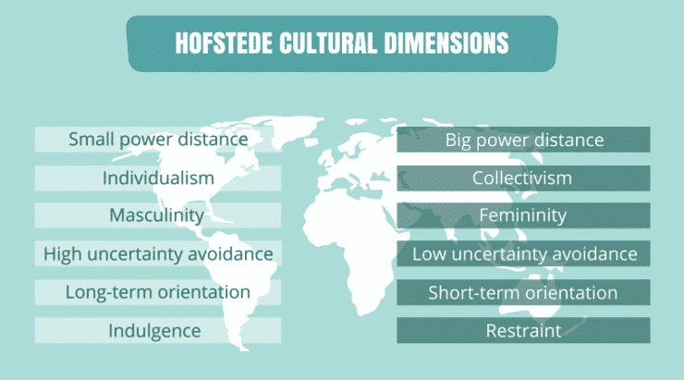
Figure One. Hofstede Cultural Dimensions Model. Source: https://www.cleverism.com/understanding-cultures-people-hofstede-dimensions/

As seen in figure one, the six categories that define culture are:
- Power Distance Index
- Collectivism vs Individualism
- Uncertainty Avoidance Index
- Femininity vs Masculinity
- Short-term vs Long-term orientation
- Restraint vs Indulgence

3
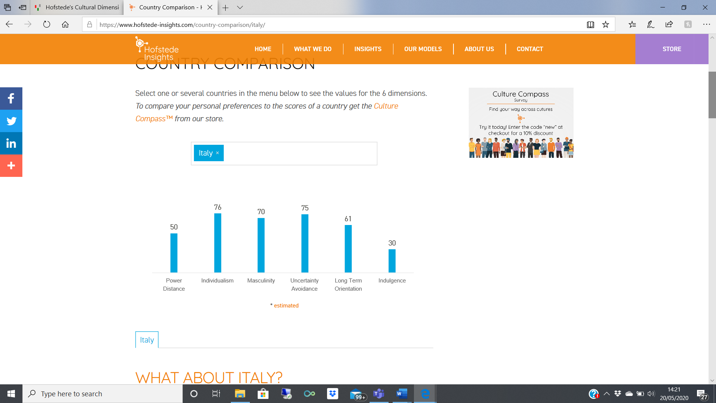
Figure Two. Italy’s Hofstede Insights. Source: https://www.hofstede-insights.com/country-comparison/italy/z

Collectivism vs Individualism
This dimension of the framework looks at level of integration that people have to others within a community (Hofstede, 2009). The individualism facet of the dimension understands how they may be a greater level of looking after personal objectives, whereas collectivism would indicate a greater importance of the goals of a group as a whole, with everything defined as “we” (Soares et al, 2007).
With a score of 76 Italy is mor of an individualist culture, which can mainly be due to the busy crowds of the big cities of the North. Personal objectives are motivating to Italians which is the main fulfilment of personal happiness, although this does vary in Southern Italy where less individualist behaviour is noticed, as if there is a different climate between the north and south. It is worth noting that partnerships between Uber and local taxi drivers/companies can bring a sense of community, restoring a collectivism feel to the big cities, where people are not working alone.

Uncertainty Avoidance Index
Uncertainty Avoidance Index considers how ambiguity and uncertainty are dealt with (Litvin et al, 2004). If a society scores high for UAI, this shows that people have a low tolerance for uncertainty and may be tempted to stop trying to control what they cannot. Typically, this is seen in more religious societies. A low UAI indicates a more open-minded or relaxed group of people, with the unknown more openly accepted (Geert Hofstede, no date).
Another high score of 75 results in showing Italians are not comfortable in uncertain situations and high scores of this facet usually result in detailed planning. The high result of this also shows off the fact that Italians are very emotional people and must express them to others, especially through body language. Uber entering the Italian market through partnerships can bring a sense of certainty for current taxi drivers that they can work for a strong and secure brand that will not bring any surprises.
4

Femininity vs Masculinity
Also known as ‘tough vs tender’, this dimension evaluates the distribution of roles between women and men and the attitude towards equality (Blodgett et al, 2008).
Italy is more of a masculine society, as seen from the score of 70. This is apparent through materialistic possessions just as a nice car, a yacht, or holidays to exotic places. All this show-off the level of success of an Italian, with competition being very strong. This is interesting for Uber’s market entry since Italian’s are quite proud people, it is worth considering that more taxi drivers may be inclined to want to work for Uber as the brand image of the company is more sophisticated.
Using the insights above, it is an indicator that choosing a partnership entry approach to the Italian market is most appropriate as Uber can work and shape the business around the current settings. At the same time, if Uber can bring a collective feeling and a sense of security since it is clear Italian’s avoid uncertain situations, this will allow not only customers but employees to gravitate towards the business confidently.

Marketing Mix

The Marketing mix model is a foundation plan for businesses to understand in depth about putting the right product in the right place, with the right price at the right time (Acutt, 2020). However, for a business to do this well, every aspect of the business plan needs to be clear and precise. Another reason why Uber should use the marketing mix framework is because they can learn from their mistakes. In 2017, Uber failed to penetrate the Italian market due to unfair competition and operations which stirred up protests and made locals unhappy (Chapman, 2017). To combat this, Uber should now precisely look through the marketing mix model to rule out any failures in their systems.
5
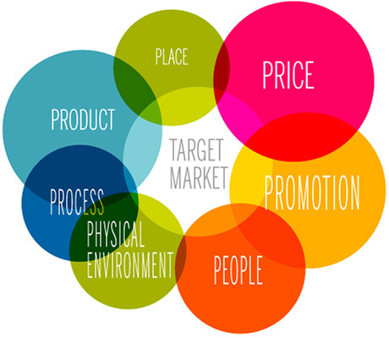
Figure Three: The Marketing Mix 7Ps. Source: https://marketingmix.co.uk/

As seen in figure one, there are different facets to the marketing mix 7P’s: product, place, price, promotion, people, physical environment, and process.

Product and Promotion

A product is the heart of the business, as it is produced to target a certain group pf people. Products however are not just physical, as some can be intangible or tangible as a service or goods instead (Borden, 1964). Typically, the product and promotion elements to the marketing mix are separate but for Uber, it is useful to evaluate these facets together as for multinational companies, minor adjustments can be made instead of revamping for every market. As mentioned by Rique (2019) an example of this is Coca Cola, who incorporate their signature style in all products around the world but then also include the country’s language or create the bottle the same size as other beverages sold in that country’s market.
6
For Uber, they provide a taxi service which is a service for everyone so there is no risk of the service not being in demand as Uber will want their service to be synonymous, but before Uber launches their promotional strategies, they need to define their target market clearly, to ensure that their service will resonate with the potential customers (Hanson, 2003). Typically, Uber promotes itself through its website, app, and social media, however finding the best settings where consumers can be receptive of those advertising. Virender (2010) mentions that it is impossible for a company to communicate a single message in a unified voice to every global market, so it is useful to develop business objectives for global advertising: speaking with one voice, developing economies of scale in the process, maximising effectiveness of adverts, and increasing the implementation process. By using these and ensuring that promotional campaigns are shaped purely by the behaviour of that target market through internal and external influences.

Place

Placement is a very important part of going international as the product or service needs to be positioned in a place that is accessible to potential customers (Rafiq, 1995).
When Uber was previously tested in Italy, it caused Italian taxi companies to retaliate due to unfair advantage as Uber taxi drivers were able to purchase licences in small towns where they cost a lot less but then used them in the bigger cities (Chapman, 2017).
To combat this in the future, Uber can ensure that they are fully compliant with the rules and regulations for taxi companies and do not use any short cuts that could be deemed as an unfair advantage. This also means that Uber will be on a fair playing ground with Italian drivers, considering there is a big socio-cultural issue of power distance.

Price

The price is the amount the customer pays for the product or service they receive and is one of the most important components of the marketing mix. Even for international firms, pricing plays an imperative role in how a company penetrates a market to expand its operations (Luenendonk, 2014). Typically, Uber has a geographical pricing strategy which refers to modifying the sale price of a service or good based on the location of the buyer (Geographical Pricing, no date). Although, usually Uber utilise a dynamic pricing strategy due to the basics of demand and supply as well.
7
Italy is largely a tourist destination with there being many towns and cities tourists want to visit, meaning Uber in Italy is a perfect business opportunity. In terms of pricing for Uber service, there are a number of factors that would affect the price such as popular nights such as Friday or a Saturday, rush hours, big events, popular cities or sightseeing attractions, as well as how long the journey is and how long you want to wait for it.

People

For Uber to operate in Italy, they need to understand all the people directly related to the business.
Typically, finding if there are enough people for the target market is not necessarily something that Uber need to delve too far into as there will always be demand for taxi service around Italy. However, it is important to hire the right people that will deliver the superior service Uber expects and this is can be done by finding people who believe in the service provided. This also can help Uber regarding their market entry strategy of partnerships. By partnering up with current taxi drivers, Uber can be confident that they have employed drivers that are familiar with the areas and enjoy driving.
In any country, Uber look for employees who enjoy driving, enjoy connecting with people and have a passion for the city they are operating in.

Processes

Cowell (1984) refers to processes as either a pay system, distribution system or other systematic process that make the business run smoothly. For Uber, the main process that is generically the backbone of the service to customers is their app, as requests are made through this. Tweaks would need to be made to suit the customers of Italy, for example, up to date maps, language, prices as well as other external environment factors.

8

Physical Evidence

Physical evidence refers to the evidence that the service was delivered and how the products or service are perceived in the marketplace (Acutt, 2020). For Uber, not only in Italy but in any other country they operate in, they want society to brand taxi service with Uber, the same way fast food is associated with McDonalds. As more people in Italy use Uber and turn to Uber as there way of getting around, from then on, when a taxi service is needed Uber will come to mind first.

4.0 Conclusion

To conclude, Uber have a strong global marketing strategy to penetrate the Italian market. With considerations of how to implement these actions, it is imperative that thorough research is conducted and frameworks such as the marketing mix can be useful to dissect each facet thoroughly and properly. Not only this but Hofstede’s Cultural Dimensions model allows Uber to see that their chosen market entry mode of partnerships can bring a lot of benefits as it allows for the business to understand different cultures, different dimensions of culture and how this can impact them. Taking away from this, firm recommendations can be made appropriately moving forward if Uber consider expanding further globally or revamp their marketing objectives to mould with ever-evolving times.

4.1 Recommendations

As recommendations for the future of Uber, they should:
- Continue to analyse their global markets thoroughly using Hofstede’s cultural dimensions and the marketing mix.
9
- Use these implementation strategies to penetrate a new market in the future.

References

Acutt, M., 2020. Marketing Mix Definition - 4Ps & 7Ps Of The Marketing Mix. [online] The Marketing Mix. Available at: <https://marketingmix.co.uk/> [Accessed 18 May 2020].
Beugelsdijk, S., Kostova, T. and Roth, K., 2017. An overview of Hofstede-inspired country-level culture research in international business since 2006. Journal of International Business Studies, 48(1), pp.30-47.
Blodgett, J.G., Bakir, A. and Rose, G.M., 2008. A test of the validity of Hofstede's cultural framework. Journal of consumer marketing.
Borden, N.H., 1964. The concept of the marketing mix. Journal of advertising research, 4(2), pp.2-7.
Chapman, B., 2017. Italy Just Banned Uber. [online] The Independent. Available at: <https://www.independent.co.uk/news/business/news/uber-italy-ban-app-taxi-driver-unfair-competition-court-ruling-decision-trade-unions-legal-action-a7677881.html> [Accessed 20 May 2020].
Corporate Finance Institute. 2016. Hofstede’S Cultural Dimensions Theory - Overview And Categories. [online] Available at: <https://corporatefinanceinstitute.com/resources/knowledge/other/hofstedes-cultural-dimensions-theory/> [Accessed 22 May 2020].
Courses.lumenlearning.com. n.d. Global Marketing Mix | Boundless Marketing. [online] Available at: <https://courses.lumenlearning.com/boundless-marketing/chapter/global-marketing-mix/> [Accessed 19 May 2020].
Cowell, D.W. and Communication Advertising, 1984. The marketing of services. London: Heinemann.
10
Geert Hofstede. n.d. The 6 Dimensions Model Of National Culture By Geert Hofstede. [online] Available at: <https://geerthofstede.com/culture-geert-hofstede-gert-jan-hofstede/6d-model-of-national-culture/> [Accessed 22 May 2020].
Hanson, M., 2003. The global promotion of transparency in emerging markets. Global governance, 9, p.63.
Hofstede Insights. 2020. Compare Countries - Hofstede Insights. [online] Available at: <https://www.hofstede-insights.com/product/compare-countries/> [Accessed 20 May 2020].
Hofstede, G., 2009. Geert Hofstede cultural dimensions.
Hofstede, G., 2011. Dimensionalizing cultures: The Hofstede model in context. Online readings in psychology and culture, 2(1), p.8.
Hollensen, S., 2013. Global marketing 6th ed.,
Litvin, S.W., Crotts, J.C. and Hefner, F.L., 2004. Cross‐cultural tourist behaviour: a replication and extension involving Hofstede's uncertainty avoidance dimension. International Journal of Tourism Research, 6(1), pp.29-37.
Luenendonk, M., 2014. Marketing Mix | Pricing In Four P’S. [online] Cleverism. Available at: <https://www.cleverism.com/pricing-four-ps-marketing-mix/> [Accessed 19 May 2020].
Priceintelligently.com. n.d. Geographical Pricing. [online] Available at: <https://www.priceintelligently.com/geographical-pricing> [Accessed 19 May 2020].
Rafiq, M. and Ahmed, P.K., 1995. Using the 7Ps as a generic marketing mix. marketing intelligence & planning.
Rique, 2019. International Marketing Environment – Global Marketing Professor. [online] Globalmarketingprofessor.com. Available at: <https://globalmarketingprofessor.com/international-marketing-environment/> [Accessed 19 May 2020].
Soares, A.M., Farhangmehr, M. and Shoham, A., 2007. Hofstede's dimensions of culture in international marketing studies. Journal of business research, 60(3), pp.277-284.
Todorova, G., 2015. Marketing communication mix. Trakia Journal of Sciences, 13(1), pp.368-374.
Uber. n.d. About Us | Uber. [online] Available at: <https://www.uber.com/gb/en/about/> [Accessed 18 May 2020].
Virender, S., 2010. Advertising Management. Gyan Publishing House, pp.16
11

