Assessment 2 – Written Report

Tabitha Kalyan

2020004

BMHP6009_BIRM
Living with Care: The Older Person

Assessment 2 – Written Report

Liz Tilly

Table of Contents
Introduction 3
Ageing Population 4
Case Study 5
Health and Social Care Needs of Individual 6
Relevant Support and Intervention for Sadie 7
Theories related to the Sadie’s case 9
Relevant Policy and Legislation 11
Conclusion 13
Recommendations 13
References 15
Appendix – Case Study 18

Introduction
The United Nations considers an older person as somebody who is 60 years of age or older, however in society, families, and communities, additional socio-cultural variables are frequently used to assess someone's age, including physical characteristics, age-related health issues, familial status (such as being grandparents), and physical attractiveness (UNHCR, 2023).
Hearing loss, cataracts, incorrect vision, back and neck discomfort, osteoarthritis, chronic lung disease, diabetes, depression, and dementia are among many health disorders people experience as they age. People are more likely to have many ailments at once as they age. The advent of complicated health conditions known as geriatric syndromes, brought on by several underlying reasons, is another feature of older age. Frailty, urine incontinence, falls, confusion, and pressure ulcers are a few of these syndromes (WHO, 2022).
In the UK, people 65 or older are often considered more senior. However, it might be challenging to define an exact description because people age physiologically at varying rates. For instance, a person who is 75 years old could be in more excellent health than someone 60. The idea of "frailty" significantly contributes to predicting an individual's risk of requiring care and support in addition to age (NHS 75, 2023).
The idea that one should reach retirement age at 65 needs to be updated when working patterns are determined, primarily because there is no longer an officially established retirement age. The period at which people can apply for State Pension is getting older, and an increasing number of people continue to work after age 65. In addition, people are living longer, healthier, and more productive lives. Statistics from the Office for National Statistics (ONS) indicate that, on average, women still have approximately a quarter of their lives to live. In contrast, men only have slightly more than one-fifth (McMullin, 2019).

Aging Population
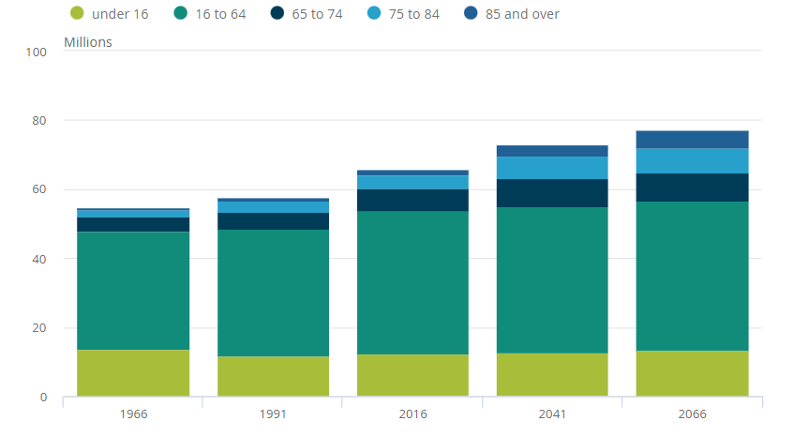
The age range between 85 and above is anticipated to rise fastest. This age group comprised 1.6 million people by the middle of 2016 or 2% of the population. This figure will double by mid-2041 to reach 3.2 million (4% of the population), and it is anticipated to quadruple by 2066 to reach 5.1 million or 7% of the UK population. In contrast, the population between 16 and 64 will grow by just 2% during the following 25 years and by 5% by 2066 (ONS, 2018).
Figure 1: population by age group
Source: (ONS, 2018)

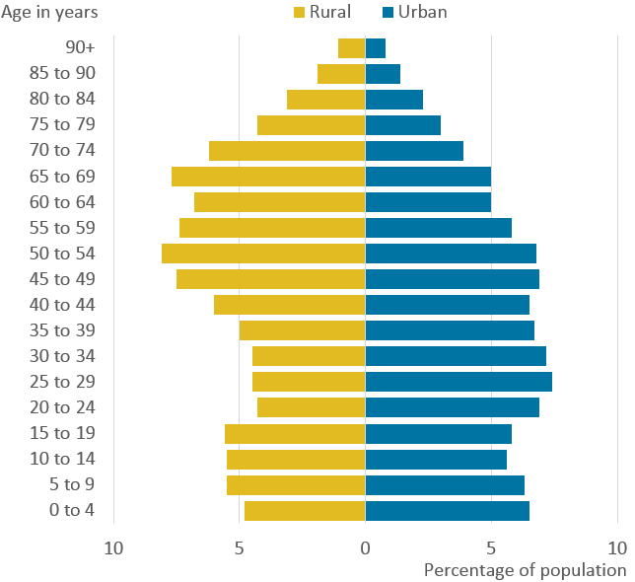
Figure 2 shows that, in comparison to urban areas, rural areas have seen more significant increases in average age over the past few decades. Between 2016 and 2039, it is anticipated that the number of people 65 and older will rise by approximately 50% in both urban and rural areas. On the other hand, the younger population—those under the age of 65—is only expected to grow by 8% in urban areas and almost nothing in rural areas (Figure 3). Subsequently, the proportion of more established people to more youthful people will increment, especially in country regions.
Figure 2: Percentage of population
Source: (ONS, 2018)

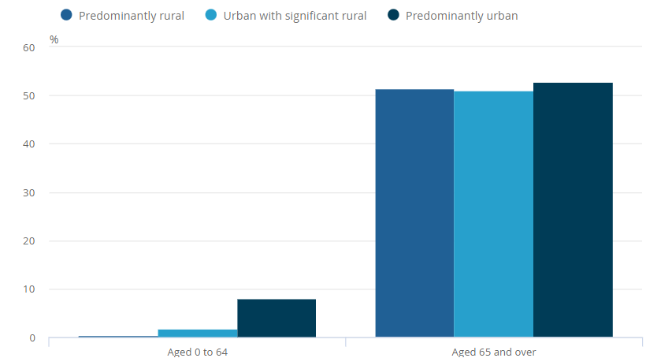

Figure 3: Increase in population
Source: (ONS, 2018)
The effects of aging are being felt by the UK population. Life expectancy rises and fertility falls are the primary drivers of this trend. In 2019, roughly 19% of the UK populace, which compares to around 12.3 million individuals, were matured 65 years or more seasoned. The number of people in this age group increased by 23% between 2009 and 2019, exceeding the overall population growth rate of 7%. The older population in the UK is expected to continue growing, with people 65 and older expected to make up 24% of the population by 2043, or about 17.4 million people. In addition, it is anticipated that the proportion of people aged 75 and older will rise from 8% in 2018 to 13% in 2043, and that the proportion of people aged 85 and older will rise from 2% to 4% (Lewis et al., 2021).

Case Study
The 82-year-old widow Sadie Evans lost her husband, Jack, four years ago. She is a lone resident of a detached three-bedroom home in a remote region with no access to public transportation. Because of a hip replacement she had following a fall, Sadie has restricted mobility and cannot drive. She is financially dependent on her pension and has some savings, but she is reluctant to spend them since she views it as leaving a legacy for her children (Case Study).

Sadie's family consists of Ben, Richard, and Hannah. Hannah lives close and attends to her daily needs, so she frequently sees her. Sadie often prefers her boys and brags about their lifestyle, which strains her connection with Hannah and her kids and causes tension.

Sadie's condition warrants worry. She has deteriorating hearing, bad eyesight and has gained weight. She avoids efforts to promote healthy eating and consumes only convenience meals, sweets, and chocolate. She smokes, which negatively affects her health even more, and her hygiene has gotten worse. Sadie is developing memory challenges, losing items, and denying them when asked (Case Study).

Sadie is experiencing social isolation and loneliness. Since her husband passed away and lost her driving privileges, she has become less involved in her community than she once was. Since so many of her acquaintances have died out, she doesn't seem to enjoy it when her older friends come to hang out. She also perceives a disconnect with her distant, busy sons.

Due to her mobility and health challenges, Sadie fails to keep up with domestic chores. Thus, her surroundings start getting sloppy and dirty in certain spots. A neighbour helped her, but she declined because of her pride and sense of intrusion.

Sadie's condition and health are in danger of getting worse. Her increased weight puts her at risk for diabetes while limiting her mobility. Her unhealthy diet and smoking habit are further causes of her health problems. The deterioration in personal hygiene and forgetting may sometimes indicate underlying health issues (Case Study).

Health and Social Care Needs of Individual
Medical Care: Sadie does require medical attention. She suffers from a number of health conditions, including hearing loss, blurry vision, and rising weight. She is more susceptible to chest infections and her smoking offers extra health hazards. Her amnesia can also point to underlying medical issues that require attention (Wyman et al., 2018).
Mental Health Issues: Sadie's mental state might require attention. Since her spouse passed away, she has been feeling alone and lost, and she believes she is left with nothing. She may not be emotionally healthy due to her troubled connection with the girl she loves and her sense of being abandoned by her sons (Odgers et al., 2020).
Personal Care Needs: Sadie need assistance with personal care activities like dressing and bathing. Her decreasing personal hygiene and refusal to let her daughter help her in private areas indicate that she is having difficulty doing these activities on her own (Arango et al., 2018).
Mobility Assistance: Sadie does require assistance with mobility. Her inability to move about and carry out household activities is a result of her decreased mobility caused by the hip replacement (Shishehgar et al., 2018).
Social Needs: Sadie has important social requirements that need to be met. Particularly since losing her spouse and ceasing to be as involved in her community as she once was, she feels alone and lonely. Her wellbeing could be considerably enhanced by reestablishing social connections and participating in social activities (Boz, 2018).
Sadie would require a comprehensive approach to meet her health and social care needs, including medical care for her physical ailments, mental health and psychological support, assistance with personal hygiene and mobility, and finding methods to meet her social needs to lessen feelings of isolation and feeling alone.

Relevant Support and Intervention for Sadie
Domiciliary Care: Sadie could profit from receiving domiciliary assistance, which might help with everyday tasks including getting dressed, bathing, and preparing food. Additionally, domiciliary care may assist Sadie with mobility challenges and keep her home tidy and secure (Lornstad et al., 2019).
Medical Care: Sadie would benefit from routine medical check-ups along with tracking for managing her poor eyesight, hearing loss, weight increase, and smoking habit. This is because of her health challenges. Healthcare professionals including physicians, nurses, and specialists may be able to give this treatment (Lornstad et al., 2019).
Mental Health Support: To deal with her emotions of loneliness, sadness, and strained connections with her family, Sadie requires mental and emotional help. She may find relief from these problems if she had access to counselling or therapy services.
Social Support: Encourage Sadie to attend her neighbourhood church or community gatherings, get back in touch with her friends, and take part in things she used to like to help her feel less alone (Gopalkrishnan, 2018).
Advocacy: It could be advantageous to have an advocate who can successfully convey Sadie's opinions and wants to hospital and social care personnel. This would guarantee that Sadie's requirements and preferences are considered when making choices regarding her care.
Person-Cantered Support: Sadie should get person-centered assistance and interventions, which means that they should be catered to her individual needs, preferences, and aspirations. The assistance will be more beneficial and significant if her desires are taken into account and she is included in the decision-making process regarding her care (Fazio et al., 2018).
Availability of Support:
Depending on the locale and the services requested, different social and medical support is available. Although domiciliary eldercare services are frequently offered, there may be a waiting list for services that are paid for by the government. Private care solutions could be more widely available, but they might also cost more.
Availability of mental health support might also differ depending on neighbourhood resources. There may be greater wait times for public mental health treatments, however there may be nearby charities or non-profit groups that provide therapy or counselling services with reduced wait times.
Services for advocacy may be provided by businesses that focus on helping senior citizens or those with certain medical issues.
The anticipated future gap between the rising need for health and social care services to the elderly and the resources at hand must be considered. To effectively meet the aging population's expanding requirements, adequate planning, and monetary investment in the treatment of older individuals will be essential.

Theories related to the Sadie’s case:
Disengagement Theory: The disengagement theory of aging suggests that as individuals grow older, they naturally disengage from various social roles and relationships, leading to reduced involvement in social activities. According to this idea, this process of disengagement is not only a normal component of getting older but also advantageous to both the elderly individual and society. Since her husband passed away and she lost her driving privileges, Sadie has seen major changes in her social connections and participation, providing signs of social disengagement (Gonot-Schoupinsky et al., 2022).
Sadie's tremendous sense of loss and sadness following the untimely heart attack death of her spouse of more than 60 years may have led to her decreased social involvement. Sadie withdraws from her prior social engagements since the house, which was previously bustling with family activity, now feels quieter and emptier. Her mobility and freedom have been further constrained by losing her driving privileges, making it challenging for her to take part in neighbourhood events or visit friends (Leung et al., 2021).
In addition, many of Sadie's friends have died away, and the few who are still alive are old and may be struggling to maintain their own social ties. Her growing emotions of loneliness and isolation are probably a result of the loss of intimate company.
Sadie's contacts with others have been made more difficult by her tense connection with her daughter, Hannah. The interactions between Sadie and Hannah have grown difficult as a result of Sadie's expectations and apparent partiality toward her boys, even though Hannah is the only member of Sadie's family who sees her frequently. The interactions between Sadie and Hannah have grown difficult as a result of Sadie's expectations and apparent partiality toward her boys, even though Hannah is the only member of Sadie's family who sees her frequently (de Paula Couto et al., 2022).
Activity Theory: According to the activity hypothesis of aging, older persons who maintain their level of physical, mental, social, and emotional activity report better levels of happiness and general wellbeing. The activity hypothesis emphasizes the value of continuing to be interested and engaged in many facets of life, contrary to the disengagement theory, which indicates a natural withdrawal from social connections as individuals age (Karanasios et al., 2018).
Sadie's level of activity has considerably dropped for a variety of reasons. Her physical skills have been constrained by mobility limitations brought on by a hip replacement following a fall, making it difficult for her to participate in activities she formerly loved. Her bad nutrition and lack of nourishing meals may also have contributed to her low energy and lack of drive to engage in activities (Holland and Lave, 2019).
Encourage Sadie to engage in activities she formerly liked, such attending church or community events, to increase her wellness. She could benefit from these activities in terms of a feeling of direction, chances for social connection, and intellectual stimulation. Religious or communal gatherings offer a supportive environment and the chance to interact with others who have similar interests, which can help individuals feel less alone and lonely.
Finding alternatives that take Sadie's limitations on movement into mind could also be useful. By performing simple exercises or undergoing physical treatment to increase her strength and mobility, she can grow more self-assured and independent. To keep her mind engaged and entertained, encourage her to partake in things she can perform at home like reading, crafts, or puzzles (Mattar, 2018).

Relevant Policy and Legislation
Care Act 2014: The Care Act 2014 is a broad regulation that endeavours to upgrade the personal satisfaction and in general prosperity of individuals who require care and backing. It puts areas of strength for an on needs assessment, individual focused care, and the support of precaution moves toward protect freedom. The Demonstration ensures that Sadie has a privilege to an intensive assessment of her consideration necessities, which ought to think of her as prosperity on all levels. Moreover, it accentuates the meaning of guardians and helps them, as Hannah, Sadie's girl (CQC, 2022).
Social Care for Older People: Home Truths (Age UK): This arrangement record underscores the hardships more seasoned people have getting social help and the prerequisite for framework changes. It features the meaning of giving more seasoned individuals satisfactory and stately consideration, including help and home consideration for the people who like to remain in their homes (The Kings Fund, 2016.).
The Carers Act 2014: This Act is appropriate to Sadie's circumstance since it recognizes the critical job of neglected carers and ensures that they get the help and assist they with requiring. Hannah is qualified for a carer's assessment subsequently, empowering her to get the help she wants to continue to take great consideration of Sadie (CQC, 2022).
Loneliness Strategy (UK Government): The Forlornness Methodology of the UK Government perceives the issue of depression and social prohibition among more established people and tries to address it. The methodology recognizes the worth of social ties for more seasoned individuals' psychological and profound wellbeing, which is particularly appropriate in Sadie's circumstance since she every now and again feels disengaged and detached from her informal community (O’Rourke et al., 2018).
NHS Long Term Plan: The UK's medical services points and drives, including more noteworthy coordination of wellbeing and social consideration administrations, are framed in the NHS Long haul Plan. As it looks to expand admittance to clinical benefits and the coordinated effort of social and clinical benefits to make an incorporated way to deal with her consideration prerequisites, this plan might have ramifications for Sadie's circumstance (Asthana et al., 2019).
With these policies and legislations, the following theories supported the care of Sadie as well:
Attachment Theory: The significance of Sadie's bond with her daughter Hannah and how it affects her wellbeing may be better understood with the aid of attachment theory. Understanding Sadie's attachment tie with her primary caregiver will help support services to fortify and nurture it. In order to resolve any tense dynamics and provide a positive caregiving environment, Sadie and Hannah should be encouraged to communicate openly and understand one another (Johnson, 2019).
Social Support Theory: Social support theory underpins initiatives that alleviate social isolation and loneliness. This idea emphasizes how important it is to keep up social ties since they support resilience and psychological well-being. Encourage Sadie to interact with people, take part in neighbourhood events, and participate in social activities to lessen her sense of isolation and expand her total social support system (Cohen and McKay, 2020).

Conclusion
In result, Sadie, an 82-year-old widow, encounters a number of difficulties in meeting her social and medical demands. She stops participating in social events after losing her spouse and driving privileges, which reinforces the disengagement hypothesis and makes her feel lonely and alone. The activity idea, on the contrary hand, contends that encouraging her involvement in worthwhile activities might enhance her wellbeing. Sadie can get person-centered care and assistance under the guidance of pertinent laws and regulations, such as the Care Act of 2014 and the Loneliness Strategy. Her overall care plan can be improved by using theories like attachment theory and the theory of social support that concentrate on her particular needs and preferences.

Recommendations
Domiciliary Care Services: Assist with personal care, domestic chores, and daily living activities by providing domiciliary care.
- Barrier: Lack of accessibility or protracted waiting lists for services providing domestic care.
- Solution: Prioritize accessibility for older persons with restricted mobility and support requirements and increase financing for domiciliary care.
Social Inclusion Programs: Organize neighbourhood events, facilitate social inclusion initiatives, and provide transportation to make it possible for Sadie to partake in social activities.
- Barrier: Having trouble getting to community activities because of mobility problems.
- Solution: Work together with neighbourhood groups to offer senior citizens accessible transportation options.
Mental Health Services: Give Sadie access to counselling or therapy to help her cope with her loss, loneliness, and damaged relationships.
- Barrier: stigma or hesitation to seek for mental health assistance.
- Solution: Create awareness of the value of mental wellness and offer counselling services that are age- and culturally appropriate.

References
Arango, C., Díaz-Caneja, C.M., McGorry, P.D., Rapoport, J., Sommer, I.E., Vorstman, J.A., McDaid, D., Marín, O., Serrano-Drozdowskyj, E., Freedman, R. and Carpenter, W., 2018. Preventive strategies for mental health. The Lancet Psychiatry, 5(7), pp.591-604.
Asthana, S., Jones, R. and Sheaff, R. 2019. Why does the NHS struggle to adopt eHealth innovations? A review of macro, meso and micro factors. BMC health services research 19, pp.1-7.
Boz, H., 2018. Social Relationship Network and Communication at Old Age. Cypriot Journal of Educational Sciences, 13(1), pp.81-93.
Cohen, S. and McKay, G. 2020. Social support, stress and the buffering hypothesis: A theoretical analysis. In Handbook of psychology and health, Volume IV (pp. 253-267). Routledge.
CQC. 2022. The Care Act and the ‘easements’ to it. [Online]. Available at: https://www.cqc.org.uk/guidance-providers/adult-social-care/care-act-easements-it#:~:text=The%20Care%20Act%202014%20is,the%20impact%20of%20their%20needs
de Paula Couto, M., Fung, H.H., Graf, S., Hess, T.M., Liou, S., Nikitin, J. and Rothermund, K. 2022. Antecedents and consequences of endorsing prescriptive views of active aging and altruistic disengagement. Frontiers in Psychology, 13, p.807726.
Fazio, S., Pace, D., Flinner, J. and Kallmyer, B. 2018. The fundamentals of person-centered care for individuals with dementia. The Gerontologist, 58(suppl_1), pp. S10-S19.
Gonot-Schoupinsky, F., Garip, G. and Sheffield, D. 2022. The engage-disengage model as an inclusive model for the promotion of healthy and successful aging in the oldest-old. Activities, Adaptation & Aging, 46(2), pp.159-181.
Gopalkrishnan, N. 2018. Cultural diversity and mental health: Considerations for policy and practice. Frontiers in public health, 6, p.179.
Holland, D. and Lave, J., 2019. Social practice theory and the historical production of persons. Cultural-Historical Approaches to Studying Learning and Development: Societal, Institutional and Personal Perspectives, pp.235-248.
Johnson, S.M. 2019. Attachment theory. Encyclopedia of Couple and Family Therapy, pp.169-177.
Karanasios, S., Allen, D.K. and Finnegan, P. 2018. Activity theory in Information Systems Research. Inf. Syst. J., 28(3), pp.439-441.
Leung, A.Y., Molassiotis, A. and Carino, D.A. 2021. A challenge to healthy aging: Limited social participation in old age. Aging and disease, 12(7), p.1536.
Lewis, A., Cromarty, H., and Barton, C. 2021. Housing an ageing population: a reading list. [Online]. Available at: https://commonslibrary.parliament.uk/research-briefings/cbp-9239/#:~:text=The%20UK's%20population%20is%20ageing,life%20expectancy%20and%20declining%20fertility.
Lornstad, M.T., Aarøen, M., Bergh, S., Benth, J.Š. and Helvik, A.S. 2019. Prevalence and persistent use of psychotropic drugs in older adults receiving domiciliary care at baseline. BMC geriatrics, 19(1), pp.1-13.
Mattar, J., 2018. Constructivism and connectivism in education technology: Active, situated, authentic, experiential, and anchored learning. RIED. Revista Iberoamericana de Educación a Distancia.
McMullin, T.R. 2019. When Does Old Age Officially Begin? [Online]. Available at: https://todayswillsandprobate.co.uk/when-does-old-age-officially-begin/
NHS 75. 2023. Improving care for older people. [Online]. Available at: https://www.england.nhs.uk/ourwork/clinical-policy/older-people/improving-care-for-older-people/#:~:text=Generally%2C%20someone%20over%20the%20age,be%20considered%20an%20older%20person.
O’Rourke, H.M., Collins, L. and Sidani, S. 2018. Interventions to address social connectedness and loneliness for older adults: a scoping review. BMC geriatrics, 18(1), pp.1-13.
Odgers, C.L. and Jensen, M.R. 2020. Annual research review: Adolescent mental health in the digital age: Facts, fears, and future directions. Journal of Child Psychology and Psychiatry, 61(3), pp.336-348.
ONS. 2018. Living longer: how our population is changing and why it matters. [Online]. Available at: https://www.ons.gov.uk/peoplepopulationandcommunity/birthsdeathsandmarriages/ageing/articles/livinglongerhowourpopulationischangingandwhyitmatters/2018-08-13
Shishehgar, M., Kerr, D. and Blake, J., 2018. A systematic review of research into how robotic technology can help older people. Smart Health, 7, pp.1-18.
The Kings Fund. 2016. Social care for older people: Home truths. [Online]. Available at: https://www.kingsfund.org.uk/publications/social-care-older-people
UNHCR. 2023. Older persons. [Online]. Available at: https://emergency.unhcr.org/protection/persons-risk/older-persons#:~:text=An%20older%20person%20is%20defined,or%20age%2Drelated%20health%20conditions
WHO. 2022. Ageing and health. [Online]. Available at: https://www.who.int/news-room/fact-sheets/detail/ageing-and-health
Wyman, M.F., Shiovitz-Ezra, S. and Bengel, J. 2018. Ageism in the health care system: Providers, patients, and systems. Contemporary perspectives on ageism, pp.193-212.

Appendix – Case Study
Sadie Evans- Aged 82
Sadie is a widow, she sadly lost Jack, her husband of over 60 years four years ago to a sudden heart attack and lives alone. She is not very mobile as she had a hip replacement after a fall two years ago and as a result of this she can no longer drive.
She lives alone in a three bedroom detached house which has been her home since 1963 in a rural area with no public transport links. The house is structurally sound but not in particularly good repair and is getting increasingly messy and dirty in places.
Sadie has been offered help to clean her house by one of her neighbours but she does not want to accept the offer, firstly because she is too proud to accept help and secondly because she feels the neighbour is just being nosey! She lives on a pension and has little money after bills are paid. She owns the house and has some savings but will not use any of this capital as she sees it as her children’s legacy.
Family and Friends
Sadie has three children. Ben, 62 (who is married with three children, James 28, Rachel 26 and Josh, 18 and lives in America) Richard, 60, (who is unmarried and lives in London) and Hannah, 44, (who is divorced and lives 12 miles away with her children Bethan, 14, Josh, 11 and Little Ben who is four years old.
The only one of her children that Sadie sees on a regular basis is Hannah as she lives relatively nearby and it is Hannah who sees to her mother’s everyday needs, something which is difficult for her as she is a single working mother and also because as Sadie’s needs are increasing she is becoming more reliant on her already busy daughter. Sadie feels that her daughter should do everything for her as she lives nearby and also as it is her duty as the only girl! She does have a relationship with Hannah’s three children but this has become strained as there is friction between mother and daughter. Sadie talks about her two sons often and boasts about their lives and achievements to anyone that will listen but rarely says anything nice about her daughter and her children.
Sadie used to be a prominent member of her community and was active in her local church and WI but all this has changed since she lost her husband and then her driving license. She has lost many of her friends (deceased) and the few she has left are themselves elderly, also it must be noted that she is a proud woman and is embarrassed about her situation so does not encourage her remaining friends to visit
Health and Well-being
Sadie has poor eyesight and wears glasses and she is hard of hearing, she is also becoming increasingly overweight, something she puts down to her hip replacement and her age! Her diet is nutritionally poor and she eats a lot of convenience foods, sweets and chocolate, she used to cook a lot but now because of mobility and health issues she finds it difficult to use her kitchen. Her daughter has tried to encourage healthy eating but Sadie gets upset when she tries to limit her sweet treats etc. and says eating is one of the few pleasure she has left. The doctor has told Sadie that if she continues to gain weight she is at risk of developing diabetes as well as other health conditions and that her weight is severely impacting upon her mobility. She is also a smoker which is something that is adversely affecting her health as she is prone to chest infections. Both the doctor and Hannah have tried to get her to consider giving this up but she says it is her choice and if Hannah refuses to bring her cigarettes she telephones the local butcher who brings them with his meat delivery! This is a worry not only on health grounds but also because of fire risk.
Sadie’s personal hygiene is not good, she used to take a pride in her appearance but at the moment she has difficulty washing and dressing (and cannot get into the bath) and does not want her daughter to ‘see her bits’ so will not allow her to help her wash intimate areas of her body.
Sadie is getting very forgetful and increasingly forgets to lock doors, take medication often misplacing things such as money and glasses. When Hannah comments on this she denies it and accuses her daughter of trying to say she is ‘mental’ so that she can put her in a home.
What Sadie Says
Sadie says she is lonely since her husband left her behind and that she has nothing left anymore, she misses her sons and wishes she could see them more but they are so busy. Ben has bought her a lap-top so that she could skype the family but she does not know how to use it and she is too old to learn. She says that she has had her time and she is no use to anyone anymore and that this is the way things are. She does not want strangers in her home and certainly does not want to leave and go into a ‘home’.
After Hannah raising her concerns about her mother to their GP, Sadie was referred to a local domiciliary care company and also given the contact details of Age Cymru as well as local Elderly support services. She is still waiting to be allocated a designated social worker.
TASK 1
You are the team leader of the domiciliary care team in Sadie’s area.
Compile a person centred care plan which will meet all of Sadie’s needs
Task 2
You work for a local Elderly support charity which has been asked to work with Sadie.
Compile a profile that may be used by people who are interacting with Sadie so that they may be able to better understand her background, needs and requirements and how she would like to be treated

