Name: Delwar Hussain
Student ID: 1813780
Programme: BA (Hons) Leadership and Management Skills for the Workplace
Module: Leading and implementing workplace change BMSW6103
Assignment Title: Change management portfolio
Lecturer: Prof Dennis Pepple
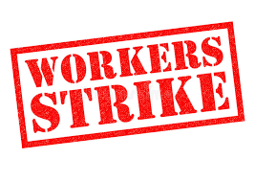


Submission Date: 11/08/22 – 3pm
Table of Contents
Introduction 3
Organisation power and Politics 4
Power 4
Politics 5
Stakeholders 7
Thomas Kilman’s Conflict resolution model 10
Conclusion 14
Recommendations 14
References 15

Introduction

In this assignment I will be looking at the power and politics within an organisation and how it affects the structure, command and control of the organisation. Powell and Tilt (2017) claim that an organisation uses politics and power to determine each person's role in the organisation. In this case study employees at the post office have decided to go for a strike over pay. This report will discuss the effect it will have on the organisation if the employees go on strike.
The report will also discuss the importance of stakeholders to the organisation and using the two relevant stakeholder analysis models will be used in this report which will be critically identified and evaluate the Interrelationship of the models.
By conducting a critical analysis of various conflict resolution strategies, the report will reflect Thomas Kilman's conflict resolution paradigm. A suitable course of action will be recommended for settling conflict. This study will also cover dispute resolution by outlining some potential avenues for resolution.

Organisation power and Politics

What is power and politics with an organisation? according to Ujjainia (2013) Power is the capacity of those involved to shape the perceptions, attitude and behaviours of others within the organisation. Meaning how the chain of command influences lower tier to themselves to do the work loads. Organisational power is defined as the situation in which a person may exert control over others to direct them to do tasks in a particular way. If the person did not have the power, it would be otherwise. Zgrzywa Ziemak (2015). There are many different types of power the however the main 6 are as follows:

Power
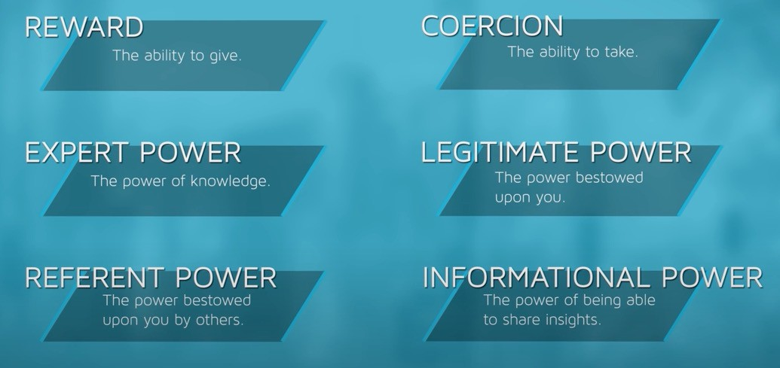
Figure 1
- Reward: It is the capacity to provide reward and organisational value to others through reward, promotion, and even cash rewards if the appointed activity is completed successfully, according to Ujjainia (2013).

- Coercion: The ability to punish people by inflicting unpleasant results is referred to as coercive power. Coercive power results in withholding of intrinsic and extrinsic value, suspension, termination, and other actions.

- Legitimate: Zgrzywa-Ziemak (2015) asserts that legitimate power is transferred to an individual through delegated rights that are part of an organization's legal framework. The person is granted the authority to manage and lead the people who are working for them. According to (Robbins and Judge, 2019), once this authority is attained, the person also gains the right to impose rewards and penalties.

- Expert: Expert power by acquiring unique abilities, knowledge, and skills. Such influence enables an organisation to effectively assess its growth functions (Robbins and Judge, 2019).

- Referent: According to the study by Buelens, Sinding, and Waldstrm (2011), referent power is allegedly shown to be leaned toward the individual and derives from the favourable impression of the linked person. The administrative body is urged to grant management and leadership power to people in order to acquire their respect and appreciation.

- Informational: The individual's current knowledge and information reflect this power. According to information supplied by the person, those reporting to them are persuaded to alter their decisions and perceptions (Buelens, Sinding, and Waldstrm, 2011).

Politics

Politics is committed to utilising power to achieve certain goals. Politics is defined from the perspective of an organisation as the agenda and self-interest of a connected person who wants to attain a personal goal without considering how it would affect the aim (Heimstädt and Dobusch, 2017). It entails authority and power dictating selfish human behaviour and interpersonal relationships. According to Holyoak (2019), politics in an organisation is defined as the tacit process of exerting pressure to achieve one's own ideals and aims. (2017) Provis mentions In this instance, influencing strategies are utilised to guarantee individual control at work. Employees are known to occasionally abuse organisational politics for personal benefit, improper use of authority, etc. The outcomes of organisational politics, according to Kanta and Srivalli (2018), are often unfavourable and lower business productivity. Organisational politics, however, don't always appear to be bad because they're necessary to balance power and
harmony at work. By deciding on organisational politics, relationships between the people are handled.

Organizational politics is frequently used by people for a variety of purposes. Unwillingness to put in a lot of effort is one of the primary causes. According to Vigoda-Gadot and Talmud (2010), individuals may desire to search for a simple method of carrying out a task. Here, they use their authority against others in order to further their own interests. Negative perceptions of the person are oriented toward the people for coping with such action.

It's possible that people or workers aren't prepared to adapt to the scenario. Some workers choose to utilise their position of authority to further their own interests rather than adapt to change. Organizational politics typically develop from human relationships. The associated person could be urged to keep up positive relationships with particular people in order to meet expectations (Graetz, 2016). One of the initial factors used to determine organisational politics is manipulation. Data manipulation may be done with the intention of presenting false information. In this situation, the person uses organisational politics to further personal interests and goals.
The position of persons inside an organisation within the business environment is determined by power and politics within the organisation, is suggest Heimstädt and Dobusch (2017). Employees are assigned organisational responsibilities where the direct person in the leadership capacity has some influence. According to the organisational structure, power is legally entailed, and the linked individual appreciates having this authority to manage and lead a certain team. According to Piercy (2015), authority is organised because it establishes boundaries for those who wish to lead a group of people.

In this case study, It has come to my attention that Post Office employees are considering a o walkout (strike) over a wage issue. In this instance, it might be said that the workers are making use of legal authority to further their objectives. According to UK legislation, every company must provide employees with a minimum level of compensation. As a result, it can be shown that when postal workers receive less money than expected, they have the capacity to speak out against the organisational politics. These workers exercise their rights in accordance with the UK's Employment Tribunal Act (EAT). They have gained the authority from CWU (communication workers union) members through which they may speak out against the government's decision to impose a pay freeze and reduce the rise of salary. This has caused negativity with the post office staff in turn having a detrimental effect on the customers.

In a statement, the Post Office said that the strike has no impact on its operations because there are 11,500 outlets from which clients may obtain their services. Therefore, it can be said that the 24-hour strike will not have an impact on Post Office operations. However, it harms the organization's reputation. The strike will be seen negatively by the public, and Post Office may eventually pay the price. Although just 114 branches appear to have an impact on 11,000 branches, the problem threatens to disturb moral convictions. Because it is the moral responsibility of the organisation to comprehend and accommodate employee needs. Additionally, Customers of the Post Office would suffer from branch closures, which is also against moral principles.

Stakeholders
Using two relevant stakeholder analysis model, critically identify the stakeholders and explain how your chosen model are interrelated in the evaluation of critical stakeholders
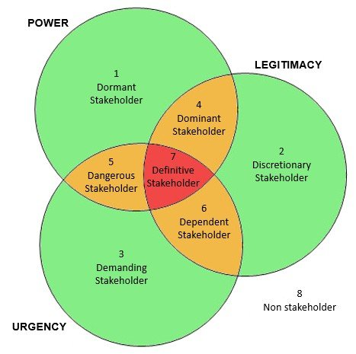
Stakeholders are people who have interests in organisational activities and whose positions have an impact on the firm's decision-making process as defined by Weiss (2014). It might be argued that the study by Azarova (2018) revealed the necessity of identifying the main stakeholders and determining how they relate to the business. The stakeholder analysis approach may be used to determine the context. Here, the salience model and the power interest matrix model for identifying key stakeholders.
Salience model

Figure 2

Demanding stakeholders: Needs of demanding stakeholders must be fulfilled right away because of their urgency (Wethal, 2017). The case suggests that the Post Office's workers are the demanding parties.
Dominant stakeholders: These parties are legitimate and powerful. Due to their authority, they take the initiative and make the decisions (Cordery and Sim, 2017). Administrators at the Post Office are considered as the major stakeholders.
Dangerous stakeholders: The strength and urgency of such stakeholders make them helpful for the job at hand, making them dangerous stakeholders (Jackson-Fossett et al., 2011). Example are Tarde Unions.
Dependent stakeholders: The company could not be motivated to concentrate on their interests. They are urgent and legitimate, but they lack authority (Ditlev Simonsen and Wenstp, 2013). They must be kept up to date on organisational operations by the company.

Definitive stakeholders: According to Ditlev Simonsen and Wenstp (2013), these stakeholders are the most essential element since they combine authority, urgency, and power. For these stakeholders to be pleased, constant communication is necessary.
Firm shareholders are referred to as definite stakeholders.

Power Interest Matrix Model

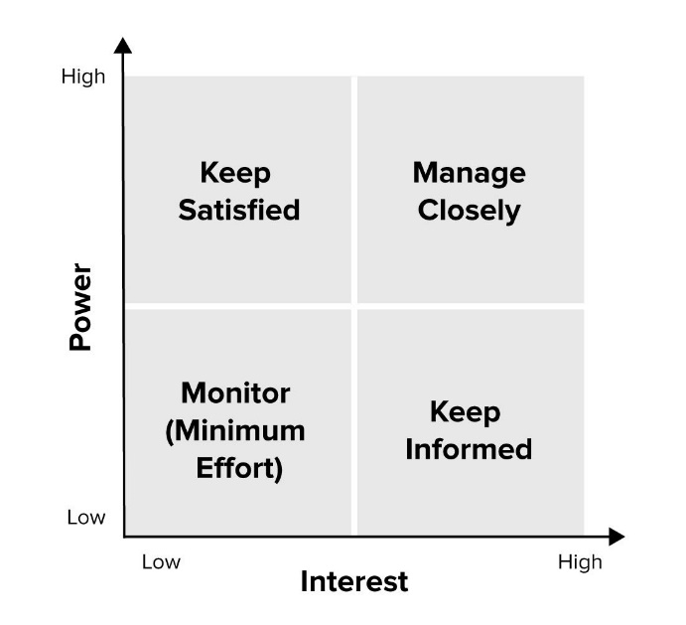
The primary constituencies of the company are its stakeholders, and it is crucial to adequately comprehend their requirements and desires. Stakeholders must be categorised in this situation, power and interest can be used to decide the prospect (Maqbool, Rashid and Ashfaq, 2022). An efficient method of identifying stakeholders is by gauging their interest in each project is the Power Interest Matrix Model (Li, 2019).

Figure 3
High power, high interest: According to Gangl et al. (2022), these stakeholders have the most influence over organisational decision-making because they assess the project's potential for success. Such stakeholders must be pleased, kept in the loop, and informed. Such stakeholders are referred to as the company's shareholders. because they detest having a direct say in how the organisation makes decisions and because they are the company's owner.
High power - low interest: These stakeholders have influence but place little value on the accomplishments of the project and the performance of the organisation. However, because they are powerful, the company must appropriately manage these stakeholders (Li, 2019). They could decide unfavourable outcomes for the company or project if they are dissatisfied with the actions. According to Gangl et al. (2022), government auditors qualify as such stakeholders since they have great power but do not have the same level of intense interest in an organisation's success as other stakeholders.
Low power, high interest: Despite their low influence, these stakeholders need to be updated about the organisation's performance and important events (Maqbool, Rashid and Ashfaq, 2022). However, according to Gangl et al. (2022), they have a strong stake in the organization's performance and may contribute to the firm's success in the right ways. Employees, investors, and others are referred to as such stakeholders depending on the situation.
Low power, low interest: Because these stakeholders do not have much influence on the organisation's success and also show little interest in it, the company does not need to devote much time to them. Communities might be referred to as such grid stakeholders (Gangl et al., 2022).
The study by Nyukorong (2017) revealed that determining the interests of the stakeholders is crucial to the organization's decision-making process. The relevance and interests of the stakeholders must be understood since they have an impact on the firm's decision-making process. Stakeholders are interested in the organisation in specific ways.
POWER | LOW | HIGH
HIGH | High-Low Employees | High-High Owner
LOW | Low-Low Government | Low-High Investors
INTEREST
Figure 4
Owner: A study done by Gangl et al. (2022) shows that shareholders or the owner of the Post Office are considered to be the most important stakeholders because they are the company's owners. The shareholders make up the Board of Directors, and they have voting rights. They have a big interest in organisations activities, so they have a lot of influence and impact on how the management makes decisions.
Investors and Creditors: they are highly interested in organisational activities because they want to know how effectively the company will use the money they have invested and provide a return on their investment (Maqbool, Rashid and Ashfaq, 2022). In the case of creditors, they are interested on the performance of the company and their affordability before giving them credit.
Government: Holyoak's research (2019) shows that the government sets rules and regulations for businesses to follow in order to oversee their financial activities and other types of operations. They also have an impact on how the organisation plans and implements its strategies.
Employees: They want to recognise their potential to further their professional careers by understanding the company's growth and development (Holyoak, 2019).
Limitations of the models
Both models have limitations in the case of the salience model it is time consuming, biased and doing the stakeholder analysis to maintain the model takes time and biased because according to the subjective orientation, the manager maintains the circle of stakeholders. There is a chance that there will be prejudice. As a result, the company might be unable to assess the stakeholders' influence and effectiveness. Although the Power Interest Matrix Model aids in locating the appropriate stakeholders, it is constrained by a number of factors. The model includes a grid-based visualisation process that helps the company identify its most important stakeholders and the activities required to meet their needs. Another type of constraint on the Power Interest Matrix Model is the presence of several stakeholders in the model. Stakeholders are individuals who can be assigned to various grid groups. As a result, using this technique to define the category of stakeholders will not be effective.

Thomas Kilman’s Conflict resolution model

Obeso (2018) states that conflicts of interest are a common problem in all organisations and can arise when coworkers disagree with one another. Conflict or disagreement is the result of values, perceptions, wants, motives, and other factors (Batton, 2002). To ensure productivity within the company, disagreements must be handled because they reduce workplace efficiency and productivity (Shakoor, 2020). Organizations employ a variety of strategies to resolve individual conflicts of interest. There are certain models that may be used to address conflicts of interest.
One of the most influential models for resolving conflict is Thomas Kilman's Conflict Resolution Model. Assertiveness and empathy are the two elements of conflict management that the approach is applied to. The likelihood of being able to stand up for one's own ideas is determined by the first assertiveness component. Positive and negative effects of the surroundings are possible (McGrath and Bates, 2017). Despite the appearance of aggression, assertive behaviour is a powerful means of expressing the self. The likelihood of comprehending another person's point of view is determined by the second component of empathy. The component focuses on how conflicts of interest may be resolved quickly when a person empathises with others (Sarfaraz, 2012).
According to the Thomas Kilman’s model there are five different approaches of managing conflicts.
Competing: This strategy predicts strong aggressiveness and poor empathy, according to McGrath and Bates (2017). When a person becomes aloof and uncooperative with their opponent, competing is used as a conflict resolution strategy. Here, each person believes that the other is not entitled to an edge over them. It is considered as the best way to resolve a dispute. According to Read, Read, and Baillie (2021), resolving disagreement when one is in a position of authority is viewed as a successful strategy. Such a strategy is effective even when the person is short on time and resources. Competing aids in achieving personal objectives. But competition is not necessarily a good thing. When interacting with people, the element causes unpleasant feelings like irritability, hostility, violence, and so on. Because each person does not listen to others, such an approach cannot respect relationships. Additionally, because the opposition is not as motivated to collaborate with the individual in the future, such an approach harms the potential for undertaking future activities with them (Sagel-Grande, 1999). Additionally, we stop working with the opposition. Contrary to what many people think, this strategy is not necessarily harmful. When we are in a position of authority and time is of the importance for coming up with a solution, this tactic could be more successful. When we have to make tough decisions, we must also employ this strategy.
Avoiding: Avoiding is a dispute resolution strategy that demonstrates a lack of empathy and assertiveness. In this instance, the person does not emphasise their own viewpoint or even their own position. It is referred to as the second conflict-resolution tactic (Sagel-Grande, 1999). This method of handling conflicts is employed when one party does not see it necessary to confront another. The person could also be urged to be silent and completely ignore the argument. because the person believes that by staying out of the problem, it can be resolved. Sarfaraz (2012) contends that the method is not thought to be a successful method for identifying the best offers. Because it is considered a passive and weak strategy to ignore disputes. However, avoiding the dispute may make the person happy, which is also a good thing. This tactic comprises avoiding the debate and keeping one's innermost sentiments and opinions to oneself. This strategy is also applied when resolving a disagreement will cost more money than accepting it will.
Accommodating: This type of attitude is accommodating and indicates minimal aggressiveness and considerable empathy. It is recognised as the third method of resolving disputes. It is a tactic for giving in and acting in a way that the other person would expect. In this instance, the person eschews debate and consents to carry out or do the requested action (ACCORD, 2010). It is seen as a useful method of dispute resolution when the individual is weak. Because it fosters a bond and pleasant first impression with the person, the problem may be resolved. However, Sarfaraz (2012) argued that the strategy also had flaws. By handling the accommodation of the dispute, one risks losing control over their own agenda. Even the opposing party may consider and comprehend the person's vulnerability. The Conflict Mode Scale developed by Thomas and Kilmann indicates that individuals in this mode are more cooperative than aggressive. We are prepared to give up on our own viewpoint in order to appease the other side.
Collaboration: According to Kim and Lee (2010), collaboration is a method of problem-solving that emphasises high levels of assertiveness and empathy. One of the main methods for resolving conflicts amongst people is this. In this instance, people may be observed working together to resolve linked problems. Colbry, Hurwitz, and Adair (2014) refer to it as a reasonable approach to issue solving where the people strive to strike a balance between them. When people are willing to cooperate and have a same objective, it may be feasible to accomplish this. When the parties are dedicated to coming to a mutual agreement, it is considered a successful method of dispute resolution. When both sides' goals are achieved, they come to a mutual understanding. Their primary goal is to come to an understanding with one another in order to increase the likelihood that the scenario would succeed. However, the situation might not be at all simple. Due to the need for people to express their personal thoughts and feelings, a failed orientation may ensue. Both parties must value one another in order for there to be trust between them. If there is no trust between the people, the context might not produce useful results.
Compromise: The fifty approaches of the model, which sits in the midway of the assertiveness and empathy scales, is referred as as compromise. The strategy is founded on a win-win situation. Due to the fact that all sides recognise and accept the opposing points of view. They sacrifice certain things in order to get others, and they are more motivated to settle disputes (Colbry, Hurwitz and Adair, 2014). Additionally, the strategy works well for properly resolving disagreements. Because of this, it's necessary for both sides to exercise flexibility and find a healthy balance while resolving disputes. However, Sarfaraz (2012) contends that for the opportunity cost to be useful, the individual must show all the reasons and results. Here, the problem of inadequate assessment and demonstration is prevalent, making it difficult to predict expected results.
Holyoak (2019) claims that the techniques of resolving conflicts of interest that have been addressed above, each of them has advantages and disadvantages. The use of each strategy is influenced by the fact that different projects and organisational contexts may be present. Conflicts arise often and might occur within the organisation on a regular basis. However, cooperation is the greatest strategy for resolving disputes (Ononogbu, 2015). The method is identified as the coping with high levels of empathy and assertiveness. Colbry, Hurwitz, and Adair (2014) claim that because people are committed to working together to solve problems, collaboration is the most suited method for resolving conflicts amongst people. It is said to as a strategic method of problem-solving when people attempt to strike a balance between them. When people are willing to cooperate and have a same objective, it may be feasible to accomplish this. Colbry, Hurwitz, and Adair (2014) view it as a successful method of resolving disputes when the parties are devoted to coming to an understanding. When both sides' goals are achieved, they come to a mutual understanding. Their primary goal is to come to an understanding with one another in order to increase the likelihood that the scenario would succeed. The strategy is referred to as a win-win scenario. Collaboration helps to comprehend the situation and find an appropriate balance to resolve the problem, despite the fact that managing differences is a hard process. The strategy promotes interpersonal relationships. Because it involves mutual trust and commitment, allowing for the full resolution of the problem by understanding the core of the matter. People try to comprehend one other's situations and empathise with them. They can maintain their connection for a very long period as long as they are successful at balancing concerns (Ditlev-Simonsen and Wenstp, 2013).
Dispute resolution: When a disagreement or dispute is resolved, it may not always be necessary to go to court. This is the context of dispute resolution. Negotiation, mediation, arbitration, and lawsuit are all viable options for resolving the problem. The act of resolving differences via the discovery of common ground is referred to as negotiation. Here, both sides come to an understanding through talking about the problem (Colbry, Hurwitz and Adair, 2014). The possibility of resolving problems in the presence of an impartial party is known as mediation. In the formal legal procedure of arbitration, a neutral arbitrator considers the evidence presented by each party before reaching a conclusion. Litigation is referred to when a dispute resolution lawyer is hired to settle the conflict.
Thomas Kilman's Conflict Resolution Model may be used to resolve the dispute between the Post Office and its workers through a cooperative process. In this situation, a negotiating strategy must be chosen in order to resolve the problem. However, the following suggestions can help resolve the conflict:
The conflict should not be ignored by Post Office. Instead, in order to resolve the conflict, the company must clearly describe the issue and take appropriate action. In that situation, the problem must be resolved on neutral ground. To learn about the demands of the communication workers union members on the subject, negotiations should be conducted. In this scenario, it is necessary to identify the arbitration's context.

Conclusion
The organisations functions are carried out by a certain structure in which a chain of orders and direction is sought from a specific level. In an organisation, power and politics are utilised to determine individuals' roles in terms of people management. This paper examined how power and politics showed themselves in the case. An argument has been established demonstrating how workers use power and politics in the organisation. The employees have opted to strike, which is having an influence on the situation, and the context has been discussed in this article. Moral considerations have also been addressed in this instance. Stakeholders are a crucial component of every organisation, and this research has employed two pertinent stakeholder analysis models that have been rigorously analysed in order to establish that fact. This study also explains how the model interacts with the evaluation of important stakeholders. In this study, model limitations have been discussed. By conducting a critical analysis of various conflict resolution strategies, the paper has mirrored Thomas Kilman's conflict resolution model. A suitable strategy has been proposed for settling conflict. This paper also discusses dispute resolution by outlining several approaches that might be taken to resolve conflicts.

Recommendations
The paper discussed power, politics, a methodology for stakeholder analysis, and conflict resolution. The disagreement between the Post Office and the organisation's employees has been discussed in the report.
Here are some suggestions for resolving the conflict between the parties:
In order to keep the situation in balance, Post Office needs to assess its authority and politics positively. The rights of the employees have been violated morally. Consequently, In that situation, the organisation has to assess the stakeholder analysis model to recognise the employees' high level of interest. Employees are the primary stakeholders in achieving organisational goals in an acceptable manner.
The Post Office needs to resolve disputes with its employees through a cooperative process. In that situation, proper negotiation must be established in order to reach a mutual understanding and resolve the problem.

References
Azarovа, I. B. (2018) Identification of project stakeholders based on system analysis, Transport development, (1(2)), pp. 5–11.
Batton, J. (2002) Institutionalizing conflict resolution education: The Ohio model, Conflict Resolution Quarterly, 19(4), pp. 479–494.
Buelens, M., Sinding, K. and Waldstrøm, C. (2011) Organisational behaviour, New York, B Mcgraw-Hill Higher Education ; ‡A London.
Colbry, Hurwitz and Adair (2014) Collaboration Theory, Journal of Leadership Education, 13(4).
Cordery, C. J. and Sim, D. (2017) Dominant stakeholders, activity and accountability discharge in the CSO sector, Financial Accountability & Management, 34(1), pp. 77–96.
Dertwinkel-Kalt, M., Frey, J. and Köster, M. (2020) Optimal Stopping in a Dynamic Salience Model, SSRN Electronic Journal.
Ditlev‐Simonsen, C. D. and Wenstøp, F. (2013) How stakeholders view stakeholders as CSR motivators, Social Responsibility Journal, 9(1), pp. 137–147, [online] Available at: https://www.deepdyve.com/lp/emerald-publishing/how-stakeholders-view-stakeholders-ascsr-motivators-tWgdKhrbx9.
Feris, Jr., I. (2021) The Dormant Monster: Florida’s Intrastate Marijuana Regulation and Its Susceptibility to Dormant Commerce Clause Challenge, FIU Law Review, 15(2).
Gangl, K., Seifert, M., Abstiens, K., Walter, A., Spitzer, F., Kirchler, E., Karmasin, S. and Kimmich, C. (2022) Power and Interest in Sustainability Transitions: Combining Behavioral Insights with Stakeholder Analysis, SSRN Electronic Journal.
Graetz, F. (2016) Managing organisational change, Milton, Qld., John Wiley & Sons Australia.
Heimstädt, M. and Dobusch, L. (2017) Politics of Disclosure: Organizational Transparency as Multiactor Negotiation, Public Administration Review, 78(5), pp. 727–738.
Holyoak, L. (2019) Organisational Culture: Organisational Change?, Leadership & Organization Development Journal, 23(6), pp. 354–355.
Jackson-Fossett, C., Skinner, L., Irvine, D. and Amaya, C. (2011) Dangerous Liaisons: How Stakeholders can Make or Break Your Wastewater Projects, Proceedings of the Water Environment Federation, 2011(17), pp. 759–778.
Kanta, K. N. M. and Srivalli, P. (2018) Moderation Effect of Organisational Politics on Organisational Commitment and Teaching Effectiveness, International Journal of Management Studies, V(4(1)), p. 117.
Kim, D. and Lee, R. P. (2010) Systems Collaboration and Strategic Collaboration: Their Impacts on Supply Chain Responsiveness and Market Performance*, Decision Sciences, 41(4), pp. 955–981.
Lee, W. E. and Sweeney, J. T. (2014) Use of Discretionary Environmental Accounting Narratives to Influence Stakeholders: The Case of Jurors’ Award Assessments, Journal of Business Ethics, 129(3), pp. 673–688.
Li, F. (2019) Testing for the Diffusion Matrix in a Continuous-Time Markov Process Model with Applications to the Term Structure of Interest Rates*, Journal of Financial Econometrics.
Maqbool, R., Rashid, Y. and Ashfaq, S. (2022) Renewable energy project success: Internal versus external stakeholders’ satisfaction and influences of power‐interest matrix, Sustainable Development.
McGrath, J. and Bates, B. (2017) The Little Book of Big Management Theories: ... and How to Use Them, Google Books, Pearson Education Limited.
Nyukorong, R. (2017) Conducting Market Research: An Aid to Organisational Decision Making, European Scientific Journal, ESJ, 13(10), p. 1.
Obeso, J. A. (2018) Ghost writing and conflict of interest - Editor’s comments, Movement Disorders, 33(9), pp. 1509–1509.
Ononogbu, I. (2015) Transformation of Dispute Resolution in Africa, International Journal on Online Dispute Resolution, 2(1).
Owusu, E., Antwi, J. and Kendie, S. B. (2021) Disaster Risk Management: The Exercise of Power, Legitimacy and Urgency in Stakeholder Role in Ghana, International Journal of Environment and Climate Change, pp. 17–33.
Pattanaik, S. S. (2014) Federalising India’s Neighbourhood Policy: Making the States Stakeholders, Strategic Analysis, 38(1), pp. 31–48.
Piercy, N. (2015) Marketing organisation : an analysis of information processing, power and politics, Abingdon, Oxon, Routledge.
Powell, L. and Tilt, C. (2017) The examination of power and politics in a conservation organisation, Accounting, Auditing & Accountability Journal, 30(3), pp. 482–509.
Provis, C. (2017) Ethics and organisational politics, Cheltenham, Edward Elgar.
Read, E. K., Read, M. R. and Baillie, S. (2021) Veterinary Clinical Skills, Google Books, John Wiley & Sons.
Robbins, S. P. and Judge, T. A. (2019) Organizational behavior, 18th ed, New York, New York, Pearson.
Sagel-Grande, I. (1999) Models of Conflict Resolution, Google Books, Maklu.
Sarfaraz, A. (2012) A Fuzzy Conceptual Design Selection Model Considering Conflict Resolution, International Journal of Engineering and Technology, 4(1), pp. 38–45.
Shakoor, R. (2020) Workplace Conflicts and its Effect on Employee Productivity: A Mediating Role of Workplace Politics, International Journal of Psychosocial Rehabilitation, 24(3), pp.
2774–2783.
Ujjainia, G. (2013) Personality, Attitude, Power and Politics Affecting Organisational Behavior, SSRN Electronic Journal.
Vigoda-Gadot, E. and Talmud, I. (2010) Organizational Politics and Job Outcomes: The Moderating Effect of Trust and Social Support, Journal of Applied Social Psychology, 40(11), pp. 2829–2861.
Weiss, J. W. (2014) Business ethics : a stakeholder and issues management approach, San Francisco, Berrett-Koehler Publishers.
Wethal, U. (2017) Passive Hosts or Demanding Stakeholders? Understanding Mozambique’s Negotiating Power in the Face of China, Forum for Development Studies, 44(3), pp. 493–516.
Zgrzywa-Ziemak, A. (2015) The Impact of Organisational Learning on Organisational Performance, Management and Business Administration. Central Europe, 23(4), pp. 98–112.

